Supporting Information
Figure S1
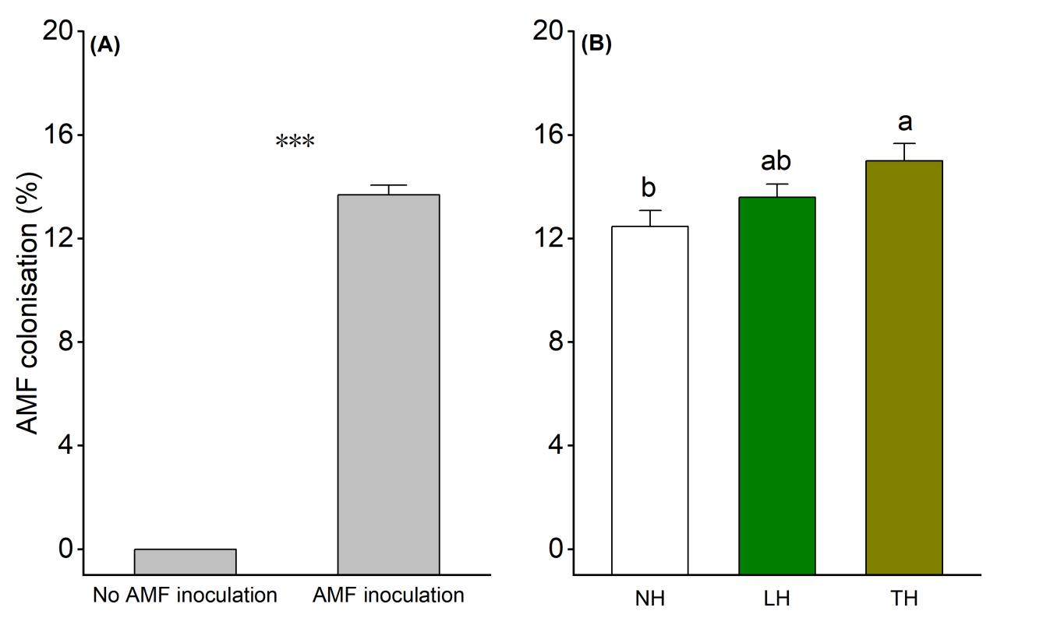
Fig. S1. (A)AMF colonisation rate of plants with/without AMF inoculation. Differences between treatments were determined by t test ( *** P<0.001). (B) Effects of Phthorimaea operculella herbivory(no herbivory(NH), leaf herbivory(LH) and tuber herbivory(TH)) on AMF colonisation. Different letters show significant differences. Data are means±SE.

Table S1. Results of two-way ANOVAs analyses on the effects of AMF (No AMF inoculation and AMF inoculation) and herbivory by Phthorimaea operculella (no herbivory, leaf herbivory and tuber herbivory) on plant productivity and subsequent insect performance.
Variable | AMF (A) |  |  |  |  | Herbivory (H) |  |  |  | A×H
Variable | d.f |  | F | P |  | d.f | F | P |  | d.f | F | P
Plant productivity
Shoot biomass |  | 1 | 118.8512 | <0.001 |  | 2 | 6.889 | 0.002 |  | 2 | 1.688 | 0.191
Root biomass |  | 1 | 80.241 | <0.001 |  | 2 | 3.349 | 0.040 |  | 2 | 1.143 | 0.324
Tuber biomass |  | 1 | 93.884 | <0.001 |  | 2 | 28.917 | <0.001 |  | 2 | 0.443 | 0.644
Total biomass |  | 1 | 146.754 | <0.001 |  | 2 | 20.181 | <0.001 |  | 2 | 1.110 | 0.334
Insect performance
Weight gain (leaf) |  | 1 | 0.298 | 0.586 |  | 2 | 30.426 | <0.001 |  | 2 | 1.906 | 0.152
Weight gain (tuber) |  | 1 | 44.203 | <0.001 |  | 2 | 2.227 | 0.111 |  | 2 | 9.217 | <0.001
Note：Significant results are in bold (P<0.05).

Table S2. Results of orthogonal contrasts on the effects of AMF (No AMF inoculation, AMF inoculation) and herbivory by Phthorimaea operculella (No herbivory (NH), Leaf herbivory (LH), Tuber herbivory (TH)) on plant productivity and subsequent insect performance.
Variable | LH vs NH |  |  |  | TH vs NH |  |  |  | AMF×(LH vs NH) |  |  |  | AMF×(TH vs NH)
Variable | d.f. | F | P |  | d.f. | F | P |  | d.f. | F | P |  | d.f. | F | P
Plant productivity
Shoot biomass | 1 | 14.749 | <0.001 |  | 1 | 2.826 | 0.098 |  | 1 | 2.552 | 0.116 |  | 1 | 2.401 | 0.127
Root biomass | 1 | 5.737 | 0.020 |  | 1 | 4.729 | 0.034 |  | 1 | 0.233 | 0.631 |  | 1 | 2.097 | 0.153
Tuber biomass | 1 | 2.723 | 0.105 |  | 1 | 34.997 | <0.001 |  | 1 | 0.508 | 0.479 |  | 1 | 0.885 | 0.351
Total biomass | 1 | 8.494 | 0.005 |  | 1 | 12.872 | 0.001 |  | 1 | 1.459 | 0.232 |  | 1 | 1.981 | 0.165
Insect performance
Weight gain (leaf) | 1 | 0.944 | 0.338 |  | 1 | 51.732 | <0.001 |  | 1 | 0.317 | 0.577 |  | 1 | 3.39 | 0.074
Weight gain (tuber) | 1 | 0.877 | 0.355 |  | 1 | 0.643 | 0.428 |  | 1 | 1.858 | 0.181 |  | 1 | 4.313 | 0.045
Note：Significant results are in bold (P<0.05).

Table S3. Results of two-way ANOVAs analyses on the effects of AMF (No AMF inoculation and AMF inoculation) and herbivory by Phthorimaea operculella (no herbivory, leaf herbivory and tuber herbivory) on plant primary metabolites in leaves, roots and tubers, and on the tuber allocation ratio for protein, sugar and starch.
Variable | AMF (A) |  |  |  | Herbivory (H) |  |  |  | A×H
Variable | d.f | F | P |  | d.f | F | P |  | d.f | F | P
Leaf metabolites
Leaf carbon (C) | 1 | 2.444 | 0.122 |  | 2 | 0.205 | 0.815 |  | 2 | 0.273 | 0.762
Leaf nitrogen (N) | 1 | 0.898 | 0.346 |  | 2 | 3.707 | 0.029 |  | 2 | 2.344 | 0.102
Leaf C: N | 1 | 0.054 | 0.817 |  | 2 | 1.630 | 0.202 |  | 2 | 1.818 | 0.169
Leaf protein | 1 | 4.045 | 0.048 |  | 2 | 3.295 | 0.042 |  | 2 | 0.752 | 0.474
Leaf sugar | 1 | 94.925 | <0.001 |  | 2 | 9.011 | <0.001 |  | 2 | 3.195 | 0.046
Leaf starch | 1 | 6.009 | 0.016 |  | 2 | 13.604 | <0.001 |  | 2 | 1.932 | 0.151
Root metabolites
Root carbon (C) | 1 | 12.381 | 0.001 |  | 2 | 0.317 | 0.729 |  | 2 | 0.097 | 0.908
Root nitrogen (N) | 1 | 0.430 | 0.514 |  | 2 | 0.928 | 0.400 |  | 2 | 0.193 | 0.825
Root C: N | 1 | 0.294 | 0.589 |  | 2 | 0.847 | 0.432 |  | 2 | 0.213 | 0.808
Root protein | 1 | 19.737 | <0.001 |  | 2 | 0.431 | 0.651 |  | 2 | 0.781 | 0.461
Root sugar | 1 | 2.213 | 0.141 |  | 2 | 0.845 | 0.433 |  | 2 | 0.256 | 0.775
Root starch | 1 | 21.060 | <0.001 |  | 2 | 1.687 | 0.191 |  | 2 | 1.386 | 0.256
Tuber metabolites metabolitessients
Tuber carbon (C) | 1 | 5.466 | 0.022 |  | 2 | 13.058 | <0.001 |  | 2 | 0.234 | 0.792
Tuber nitrogen (N) | 1 | 2.866 | 0.094 |  | 2 | 1.762 | 0.178 |  | 2 | 1.613 | 0.205
Tuber C: N | 1 | 1.497 | 0.224 |  | 2 | 1.581 | 0.212 |  | 2 | 1.740 | 0.182
Tuber protein | 1 | 171.813 | <0.001 |  | 2 | 108.514 | <0.001 |  | 2 | 0.930 | 0.399
Tuber sugar | 1 | 19.269 | <0.001 |  | 2 | 29.203 | <0.001 |  | 2 | 0.095 | 0.909
Tuber starch | 1 | 22.684 | <0.001 |  | 2 | 83.461 | <0.001 |  | 2 | 6.637 | 0.002
Tuber allocation ratio
Protein | 1 | 17.282 | <0.001 |  | 2 | 46.006 | <0.001 |  | 2 | 1.96 | 0.147
Sugar | 1 | 68 | <0.001 |  | 2 | 0.765 | 0.469 |  | 2 | 5.815 | 0.004
Starch | 1 | 7.597 | 0.007 |  | 2 | 61.06 | <0.001 |  | 2 | 6.261 | 0.003
Note：Significant results are in bold (P<0.05).

Table S4. Results of orthogonal contrasts on the effects of AMF (No AMF inoculation, AMF inoculation) and herbivory by Phthorimaea operculella (No herbivory (NH), Leaf herbivory (LH), Tuber herbivory (TH)) on plant primary metabolites in leaves, roots and tubers, and on the tuber allocation ratio for protein, sugar and starch.
Variable | LH vs NH |  |  |  | TH vs NH |  |  |  | AMF×(LH vs NH) |  |  |  | AMF×(TH vs NH)
Variable | d.f | F | P |  | d.f | F | P |  | d.f | F | P |  | d.f | F | P
Leaf metabolites
Leaf carbon (C) | 1 | 0.432 | 0.514 |  | 1 | 0.124 | 0.726 |  | 1 | 0.576 | 0.451 |  | 1 | 0.111 | 0.741
Leaf nitrogen (N) | 1 | 4.560 | 0.037 |  | 1 | 7.318 | 0.009 |  | 1 | 0.720 | 0.400 |  | 1 | 5.977 | 0.018
Leaf C: N | 1 | 1.915 | 0.172 |  | 1 | 3.315 | 0.074 |  | 1 | 1.343 | 0.251 |  | 1 | 4.281 | 0.043
Leaf protein | 1 | 6.822 | 0.012 |  | 1 | 0.768 | 0.384 |  | 1 | 0.716 | 0.401 |  | 1 | 0.152 | 0.698
Leaf sugar | 1 | 2.689 | 0.107 |  | 1 | 6.409 | 0.014 |  | 1 | 8.884 | 0.004 |  | 1 | 0.616 | 0.436
Leaf starch | 1 | 5.496 | 0.023 |  | 1 | 26.633 | <0.001 |  | 1 | 2.483 | 0.121 |  | 1 | 0.013 | 0.910
Root metabolites
Root carbon (C) | 1 | 0.117 | 0.734 |  | 1 | 0.699 | 0.407 |  | 1 | 0.149 | 0.701 |  | 1 | 0.007 | 0.935
Root nitrogen (N) | 1 | 2.146 | 0.149 |  | 1 | 0.285 | 0.595 |  | 1 | 0.214 | 0.645 |  | 1 | 0.350 | 0.556
Root C: N | 1 | 1.645 | 0.205 |  | 1 | 0.022 | 0.883 |  | 1 | 0.129 | 0.720 |  | 1 | 0.414 | 0.523
Root protein | 1 | 0.069 | 0.794 |  | 1 | 0.809 | 0.372 |  | 1 | 0.816 | 0.370 |  | 1 | 0.094 | 0.760
Root sugar | 1 | 1.077 | 0.304 |  | 1 | 0.012 | 0.915 |  | 1 | 0.251 | 0.618 |  | 1 | 0.031 | 0.861
Root starch | 1 | 3.235 | 0.077 |  | 1 | 0.172 | 0.680 |  | 1 | 2.852 | 0.097 |  | 1 | 0.471 | 0.496
Tuber metabolites
Tuber carbon | 1 | 0.049 | 0.826 |  | 1 | 19.94 | <0.001 |  | 1 | 0.379 | 0.541 |  | 1 | 0.335 | 0.565
Tuber nitrogen | 1 | 3.208 | 0.079 |  | 1 | 0.252 | 0.618 |  | 1 | 1.106 | 0.297 |  | 1 | 0.490 | 0.487
Tuber C:N | 1 | 2.862 | 0.096 |  | 1 | 0.546 | 0.463 |  | 1 | 1.041 | 0.312 |  | 1 | 0.720 | 0.400
Tuber protein | 1 | 45.244 | <0.001 |  | 1 | 77.357 | <0.001 |  | 1 | 0.753 | 0.389 |  | 1 | 0.255 | 0.616
Tuber sugar | 1 | 0.370 | 0.545 |  | 1 | 52.673 | <0.001 |  | 1 | 0.144 | 0.706 |  | 1 | 0.010 | 0.919
Tuber starch | 1 | 13.982 | <0.001 |  | 1 | 69.742 | <0.001 |  | 1 | 3.797 | 0.056 |  | 1 | 2.839 | 0.098
Tuber allocation ratio
Protein | 1 | 1.368 | 0.247 |  | 1 | 40.353 | <0.001 |  | 1 | 4.563 | 0.037 |  | 1 | 0.001 | 0.990
Sugar | 1 | 0.008 | 0.929 |  | 1 | 0.523 | 0.473 |  | 1 | 11.901 | 0.001 |  | 1 | 1.682 | 0.200
Starch | 1 | 0.336 | 0.564 |  | 1 | 66.944 | <0.001 |  | 1 | 13.470 | 0.001 |  | 1 | 0.023 | 0.879
Note：Significant results are in bold (P<0.05).

Table S5. Results of two-way ANOVAs analyses on the effects of AMF (No AMF inoculation and AMF inoculation) and herbivory by Phthorimaea operculella (no herbivory, leaf herbivory and tuber herbivory) on plant defensive metabolites.
Variable | AMF (A) |  |  |  |  | Herbivory (H) |  |  |  | A×H
Variable | d.f |  | F | P |  | d.f | F | P |  | d.f | F | P
Leaf defence
Leaf phenolics |  | 1 | 162.605 | <0.001 |  | 2 | 19.560 | <0.001 |  | 2 | 4.797 | 0.011
Leaf α-solanine |  | 1 | 1.297 | 0.258 |  | 2 | 11.748 | <0.001 |  | 2 | 1.862 | 0.162
Leaf α-chaconine |  | 1 | 1.212 | 0.274 |  | 2 | 46.815 | <0.001 |  | 2 | 0.032 | 0.969
Root defence
Root phenolics |  | 1 | 3.786 | 0.055 |  | 2 | 1.496 | 0.230 |  | 2 | 6.987 | 0.002
Root α-solanine |  | 1 | 0.787 | 0.377 |  | 2 | 0.264 | 0.768 |  | 2 | 0.964 | 0.386
Root α-chaconine |  | 1 | 0.716 | 0.400 |  | 2 | 3.669 | 0.030 |  | 2 | 0.852 | 0.430
Tuber defence
Tuber phenolics |  | 1 | 5.737 | 0.019 |  | 2 | 3.316 | 0.041 |  | 2 | 0.617 | 0.542
Tuber α-solanine |  | 1 | 0.207 | 0.650 |  | 2 | 0.787 | 0.458 |  | 2 | 0.108 | 0.898
Tuber α-chaconine |  | 1 | 0.111 | 0.740 |  | 2 | 10.355 | <0.001 |  | 2 | 4.283 | 0.017
Note：Significant results are in bold (P<0.05).

Table S6. Results of orthogonal contrasts on the effects of AMF (No AMF inoculation, AMF inoculation) and herbivory by Phthorimaea operculella (No herbivory (NH), Leaf herbivory (LH), Tuber herbivory (TH)) on plant defensive metabolites.
Variable | LH vs NH |  |  |  |  | TH vs NH |  |  |  | AMF×(LH vs NH) |  |  |  | AMF×(TH vs NH)
Variable | d.f |  | F | P |  | d.f | F | P |  | d.f | F | P |  | d.f | F | P
Leaf defence
Leaf phenolics |  | 1 | 9.988 | 0.003 |  | 1 | 36.748 | <0.001 |  | 1 | 0.103 | 0.749 |  | 1 | 7.482 | 0.008
Leaf α-solanine |  | 1 | 1.531 | 0.221 |  | 1 | 17.914 | <0.001 |  | 1 | 2.509 | 0.119 |  | 1 | 3.006 | 0.088
Leaf α-chaconine |  | 1 | 4.668 | 0.035 |  | 1 | 52.763 | <0.001 |  | 1 | 0.034 | 0.854 |  | 1 | 0.061 | 0.806
Root defence
Root phenolics |  | 1 | 0.910 | 0.344 |  | 1 | 2.575 | 0.114 |  | 1 | 7.836 | 0.007 |  | 1 | 11.87 | 0.001
Root α-solanine |  | 1 | 0.193 | 0.662 |  | 1 | 0.455 | 0.503 |  | 1 | 2.054 | 0.157 |  | 1 | 0.002 | 0.966
Root α-chaconine |  | 1 | 4.934 | 0.030 |  | 1 | 0.282 | 0.598 |  | 1 | 1.426 | 0.237 |  | 1 | 0.008 | 0.928
Tuber defence
Tuber phenolics |  | 1 | 2.127 | 0.150 |  | 1 | 1.137 | 0.291 |  | 1 | 0.503 | 0.481 |  | 1 | 1.027 | 0.315
Tuber α-solanine |  | 1 | 1.391 | 0.243 |  | 1 | 0.700 | 0.406 |  | 1 | 0.075 | 0.785 |  | 1 | 0.184 | 0.669
Tuber α-chaconine |  | 1 | 20.067 | <0.001 |  | 1 | 1.179 | 0.282 |  | 1 | 7.621 | 0.008 |  | 1 | 0.126 | 0.724
Note：Significant results are in bold (P<0.05).

