Supplementary Information for

Lithospheric thinning due to hydration and melting at oceanic transform plate boundaries
Zhikai Wang, Satish C. Singh, Cécile Prigent, Emma P. M. Gregory, Milena Marjanović

Correspondence to: Satish C. Singh (singh@ipgp.fr)

This PDF file includes:

Supplementary Figures. 1 to 19

Supplementary Tables 1 to 2

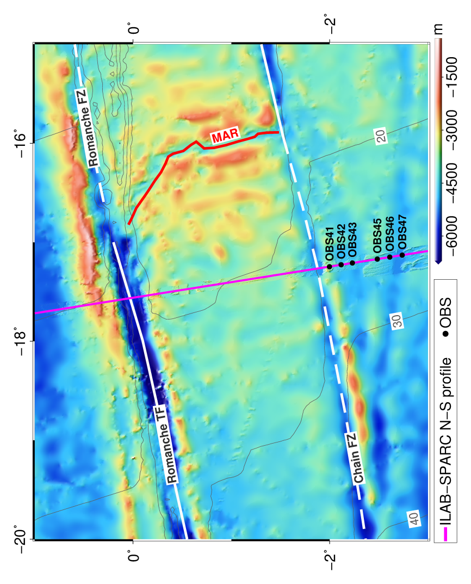
Supplementary Figure 1 | Bathymetry map. The locations of the six OBSs on which far-offset mantle refractions are observed and shown in Fig S2.

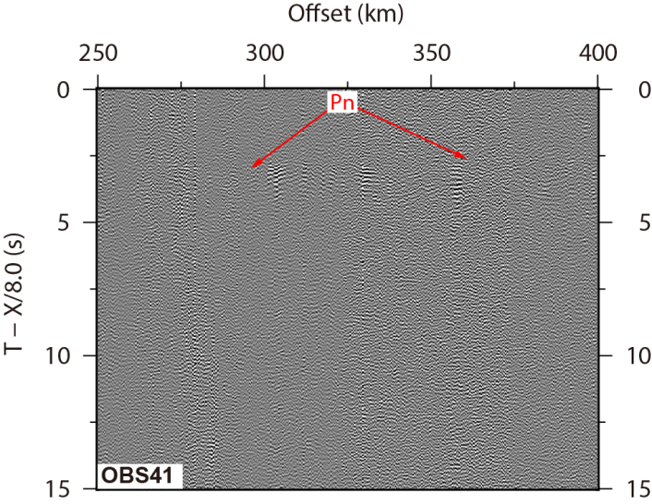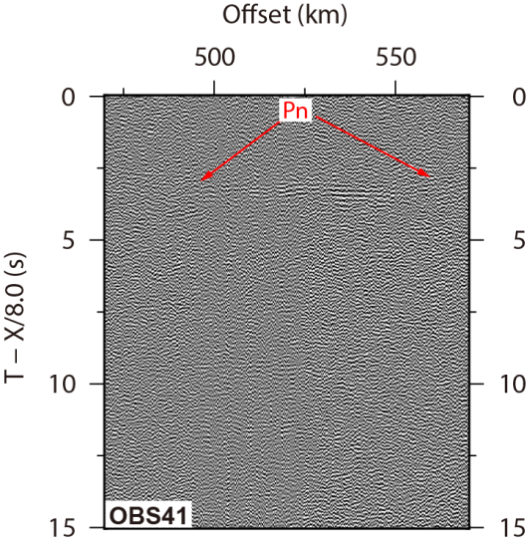

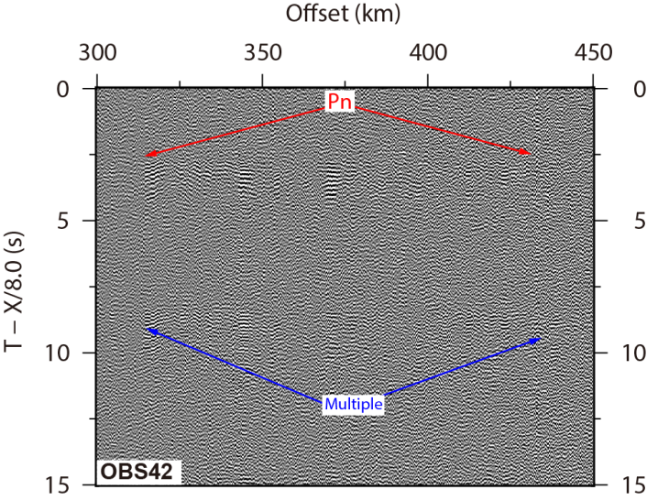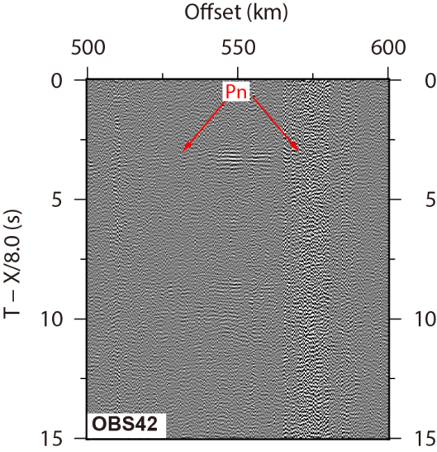

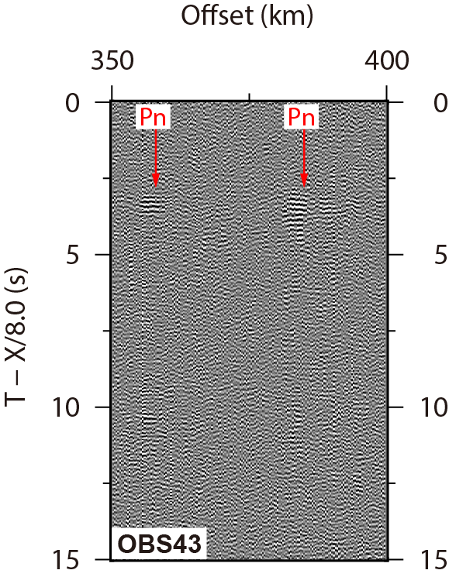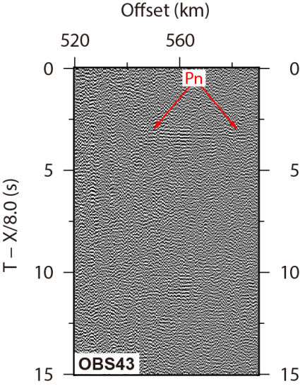
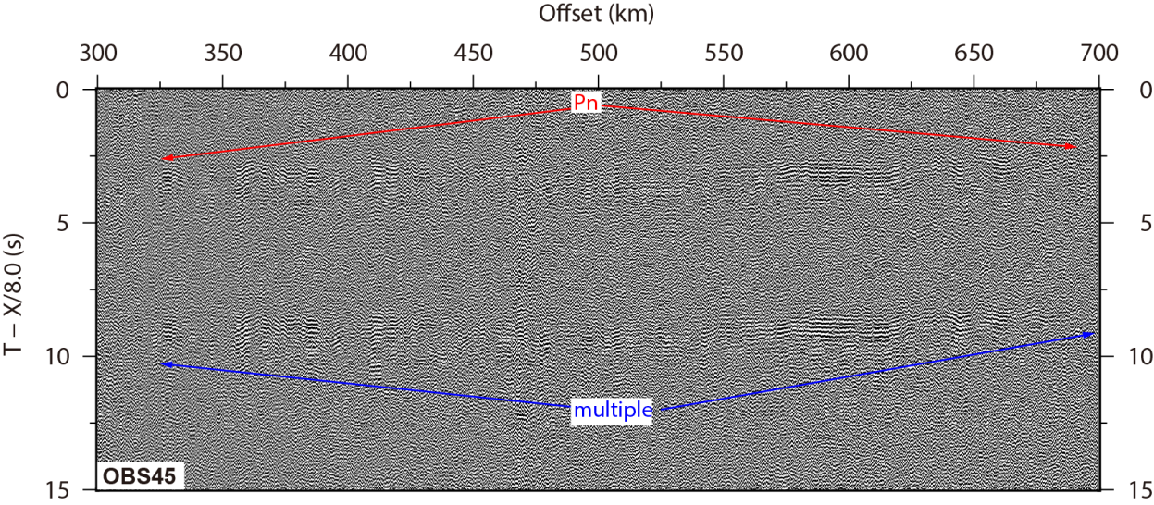

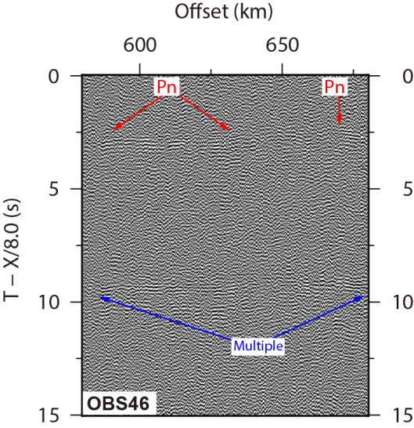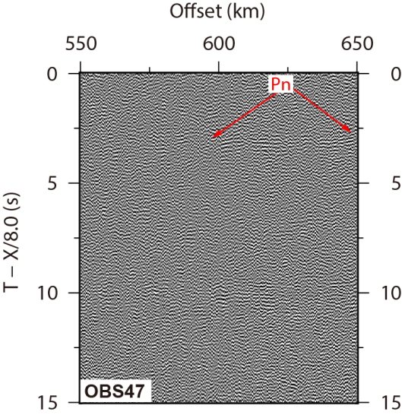

Supplementary Figure 2 | Far offset seismic data. Far-offset mantle refractions (Pn) observed on different OBSs. The travel time is reduced using a reduction velocity of 8.0 km/s. The effect of bathymetry variations is removed assuming a water velocity of 1.5 km/s. The locations of these OBSs are shown in Supplementary Figure 1.

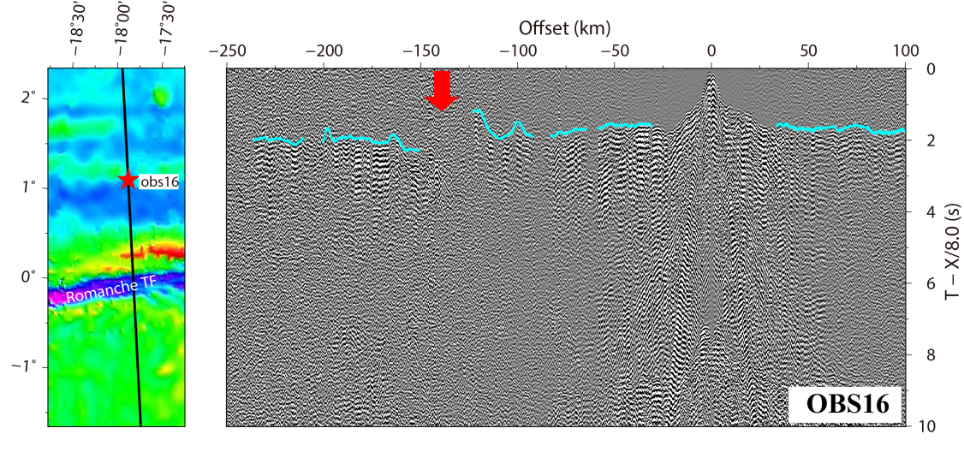

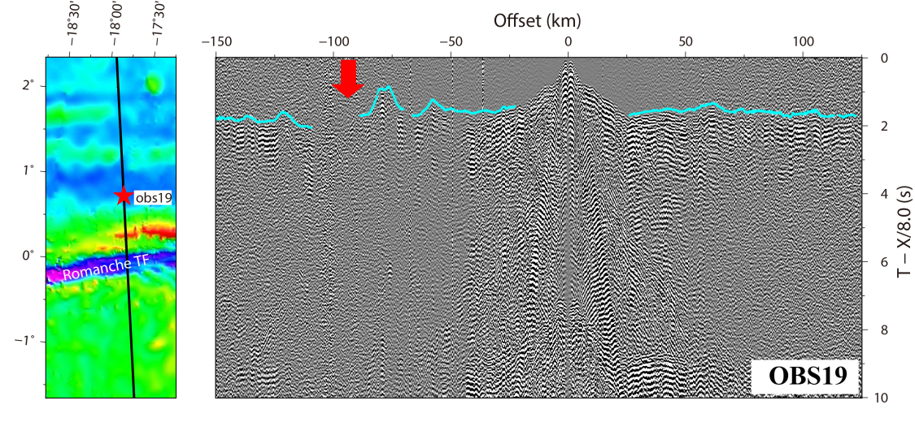

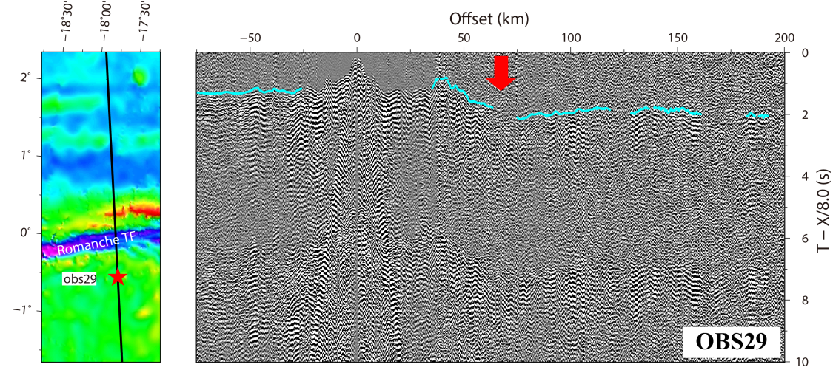

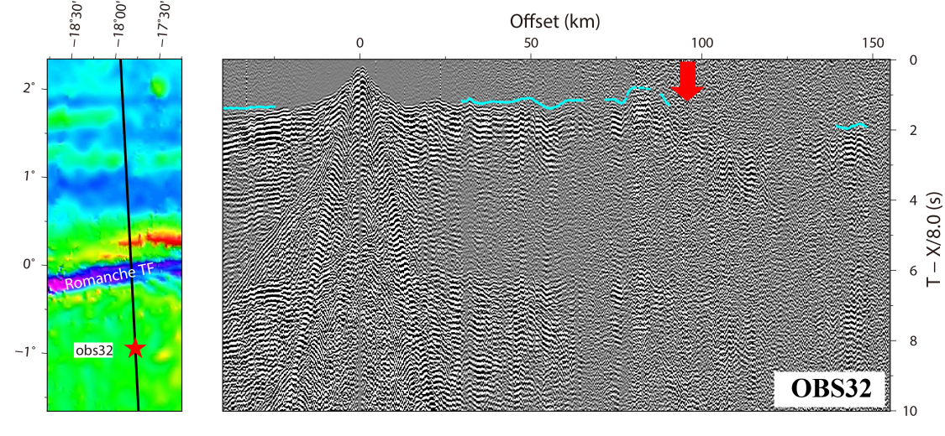
Supplementary Figure 3 | OBS data at intermediate offsets. Locations and seismic sections of four OBSs from the ILAB-SPARC N-S profile. The seismic data are plotted at travel time reduced at a reduction velocity of 8.0 km/s. The effect of bathymetry variations is removed by subtracting the propagating time in water, assuming a water velocity of 1.5 km/s. The black lines on the bathymetry map represent the part of the seismic data shown on the right and the red stars show the locations of OBSs. The red arrows on the seismic plots indicate the location of the Romanche TF. The cyan lines indicate the mantle refraction picks. A travel time delay and amplitude weakening are observed on the seismic sections where the seismic wave enters the Earth within the Romanche TF zone. The weak amplitude could be due to higher attenuation below the TF.

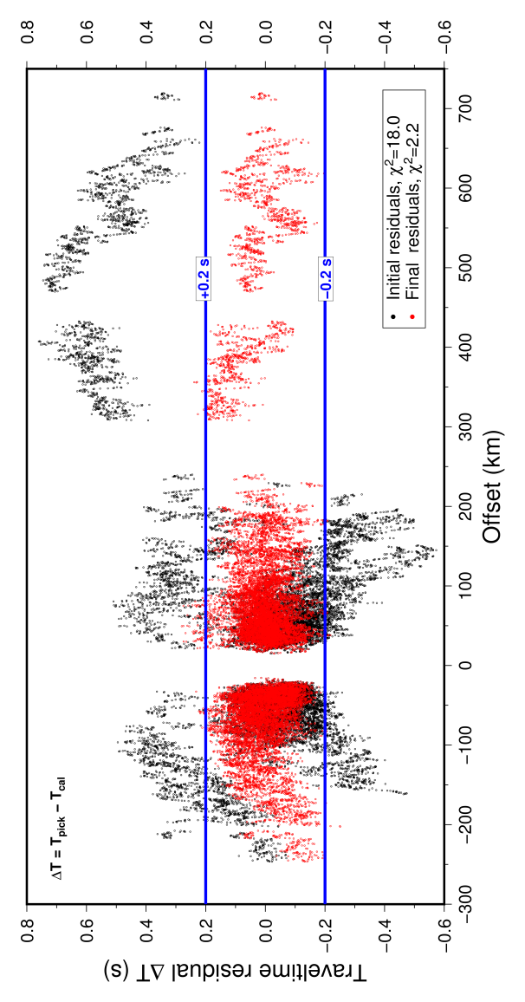
Supplementary Figure 4 | Travel time residuals. The travel time residuals and χ² before (black dots) and after the tomography (red dots) of mantle arrivals.

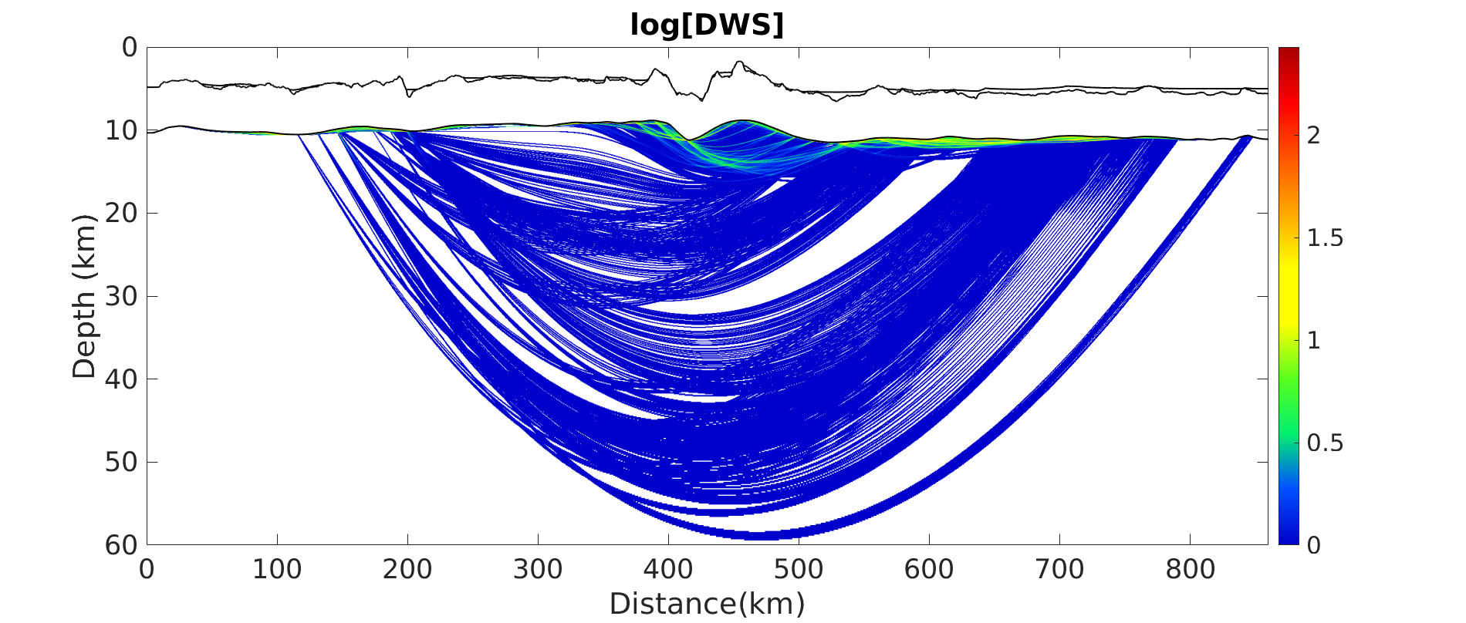
Supplementary Figure 5 | Density of ray coverage. The maximum ray sampling depth is ~60 km in the final inverted model. DWS: Derivative weighted sum⁵¹.

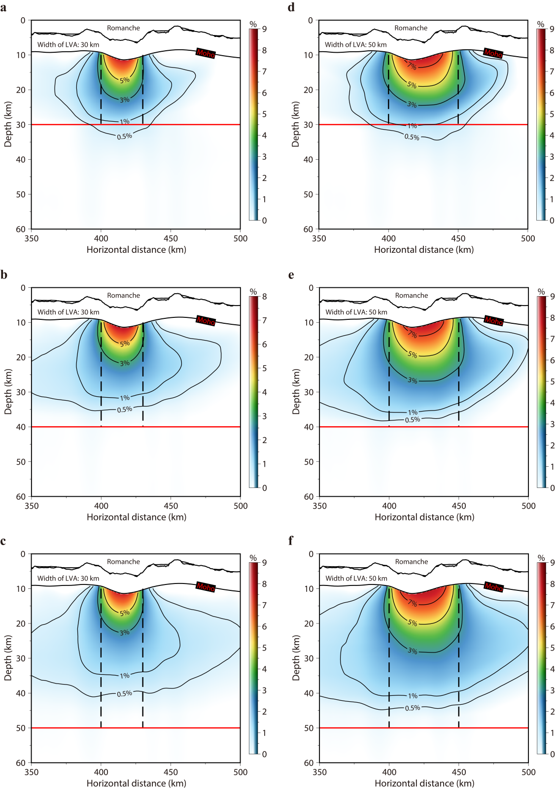
Supplementary Figure 6 | Vertical smearing tests. Smearing effect tests for a LVA in the mantle extending to 30 km (a & d), 40 km (b & e) or 50 km (c & f) depth beneath the Romanche TF. The width of the inserted LVA is 30 km in (a-c) and 50 km in (d-f). The black dashed lines represent the side boundaries of the inserted LVAs and the red solid lines show the base of the LVAs. The numbers labelled on the contours represent velocity reduction in percentage after the inversion.

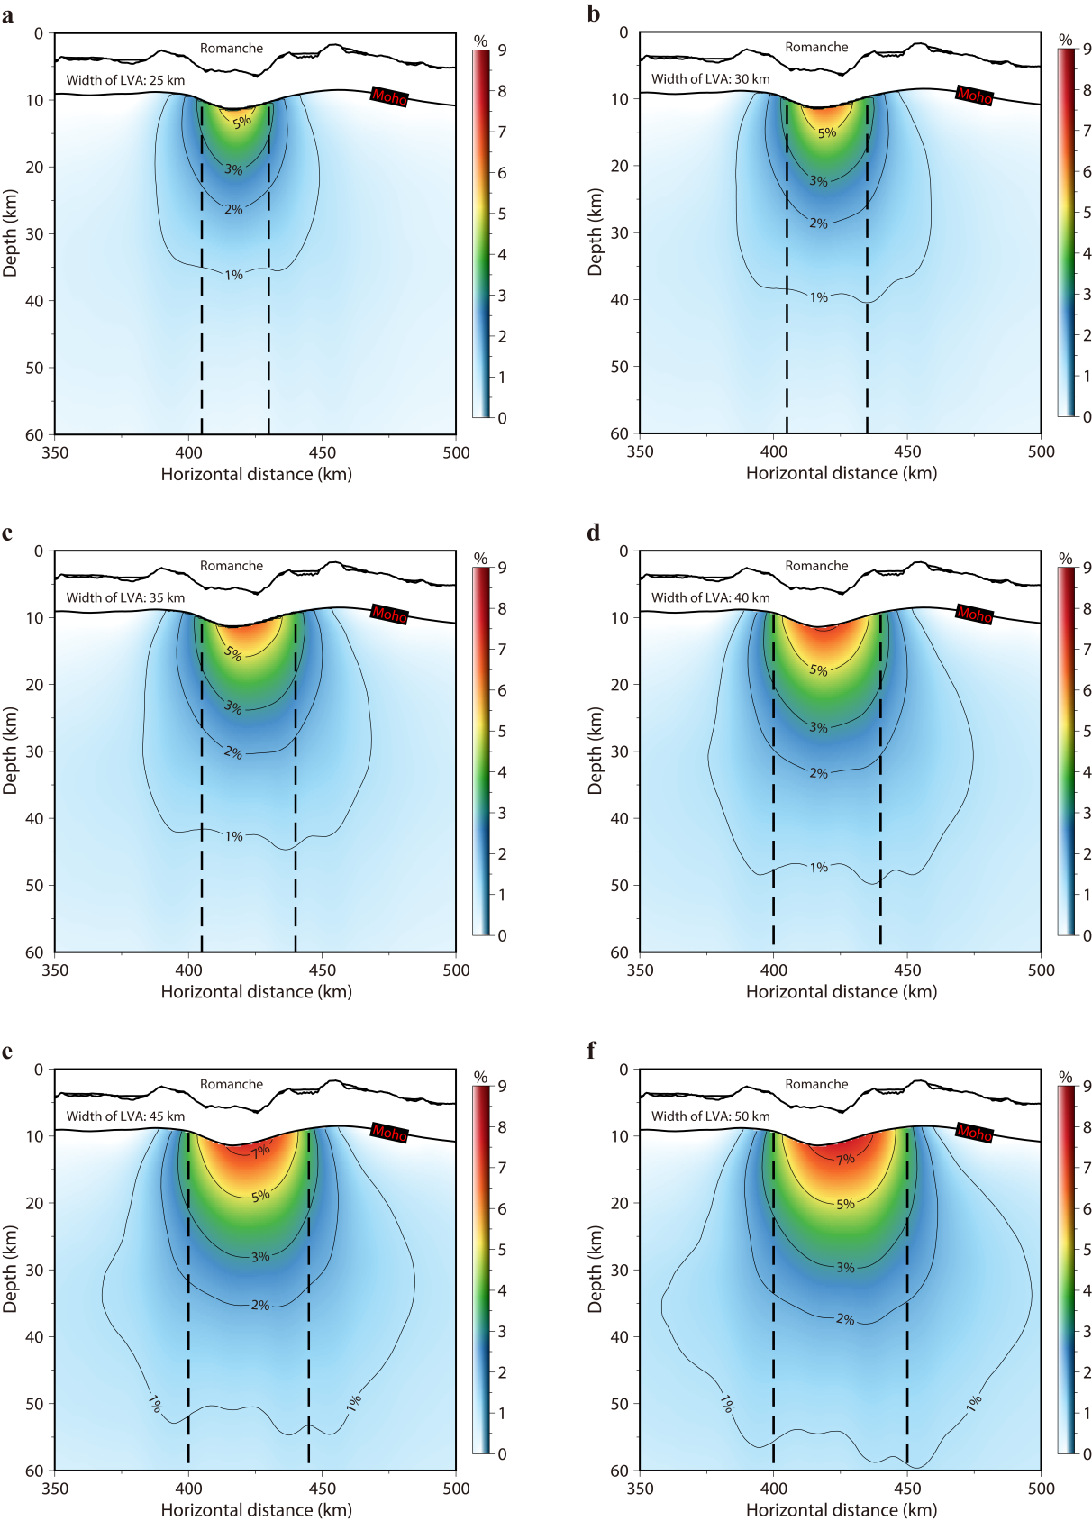

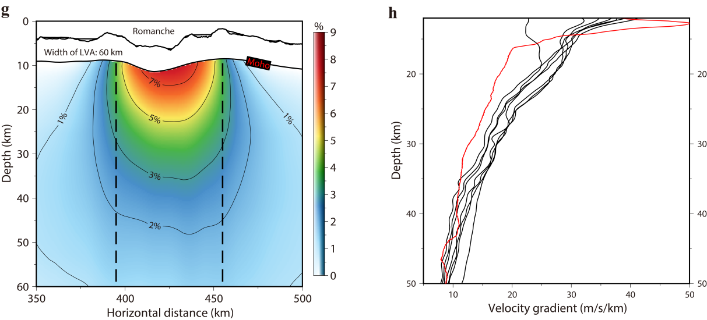

Supplementary Figure 7 | Width resolution tests. (a-g) Resolution tests for a LVA with different width in the mantle beneath the Romanche TF. The black dashed lines represent the side boundaries of the LVA in the designed synthetic velocity model extending from Moho down to the base of the model. The numbers labelled on the contours represent the velocity reduction in percentage after the inversion. (h) Comparison of recovered vertical mantle velocity gradients within the LVA using synthetic data (black curves) and OBS data (red curve, same as shown in Fig. 3b).

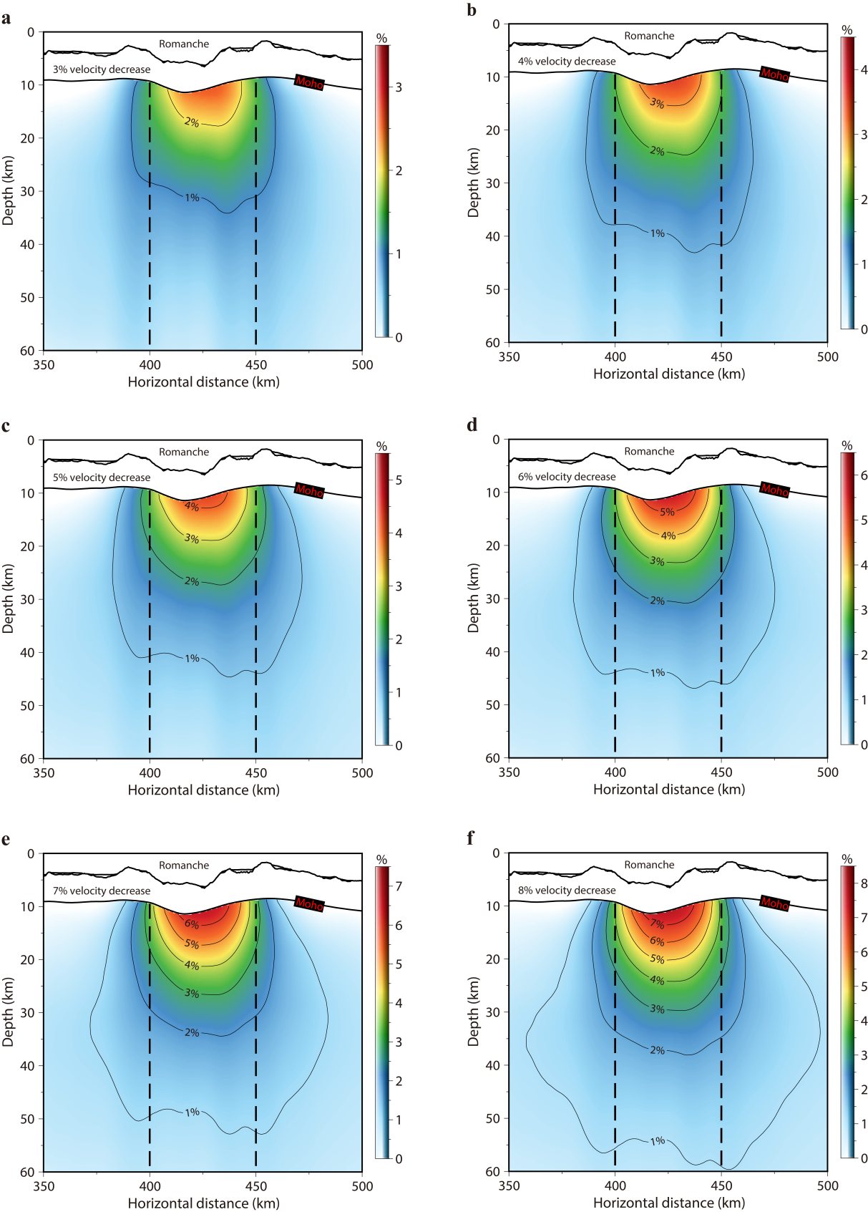

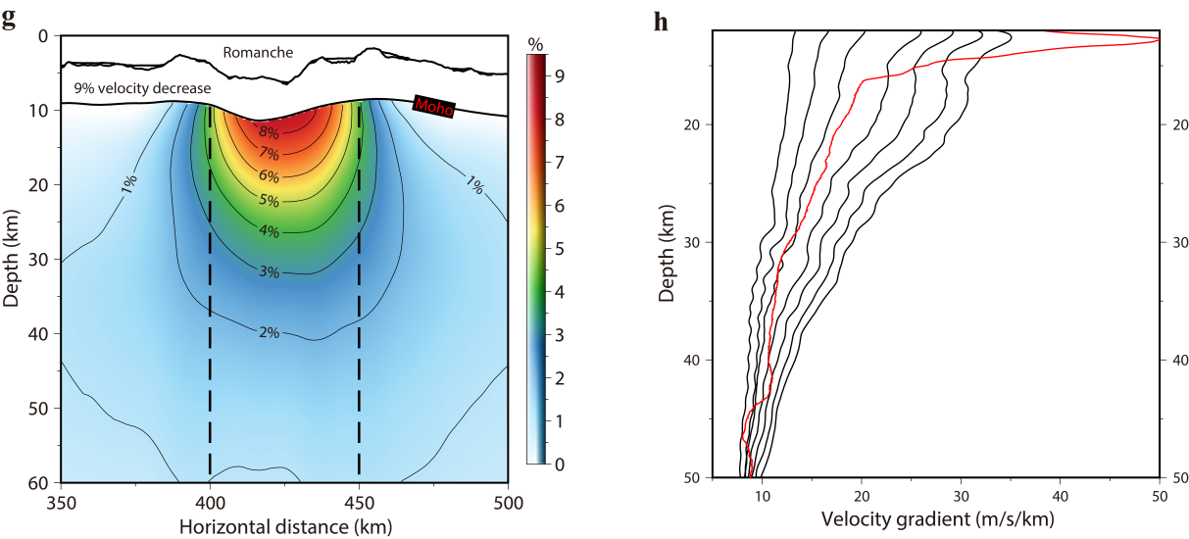

Supplementary Figure 8 | Percentage of velocity reduction tests. (a-g) Resolution tests for a LVA with different mantle velocity reductions beneath the Romanche TF from 3% to 9%. The width of the LVA is 50 km. The black dashed lines represent the side boundaries of the LVA in the designed synthetic velocity model extending from Moho down to the base of the model. The numbers labelled on the contours represent the velocity reduction in percentage after the inversion. (h) Comparison of recovered vertical mantle velocity gradients within the LVA using synthetic data (black curves) and OBS data (red curve, same as shown in Fig. 3b).

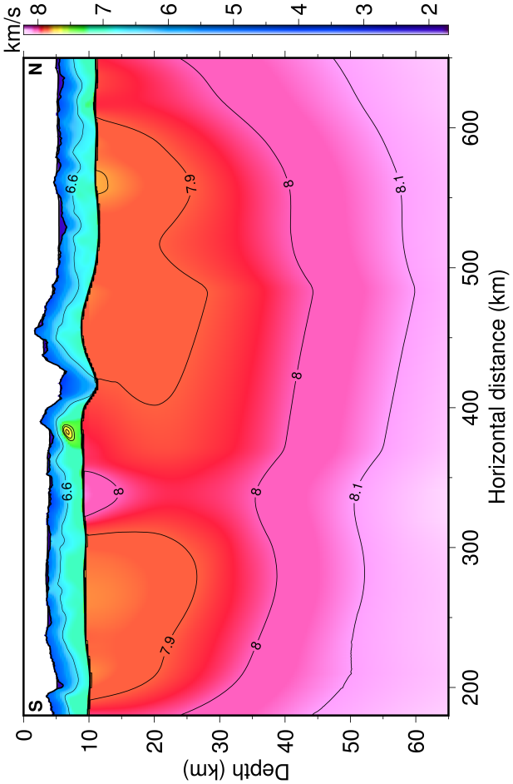
Supplementary Figure 9 | Modified velocity model (Model A) after removing the LVA from the tomographic result from OBS data. The LVA in the tomographic result using OBS data is removed and the seismic velocity of the mantle beneath the Romanche transform valley is interpolated using the mantle velocity beneath the ridge segments on both sides.

Fig. S10.

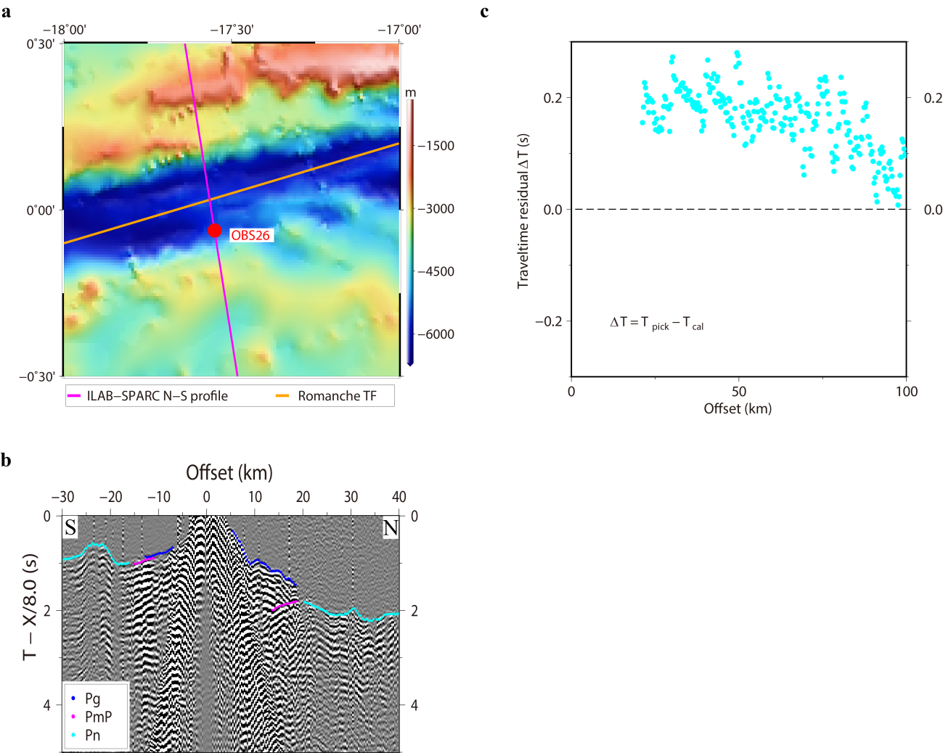

Supplementary Figure 10 | (a) Bathymetry map showing the location of OBS26. (b) Seismic plot of OBS26 showing the high-quality crustal refractions (Pg), mantle refractions (Pn) and Moho reflections (PmP). (c) Travel time residuals of OBS26 with offsets ranging from 0 km to 100 km.

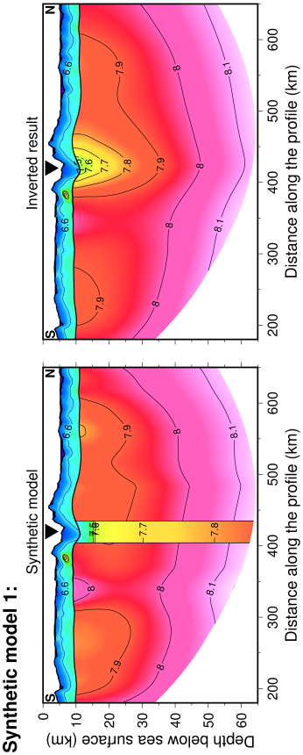

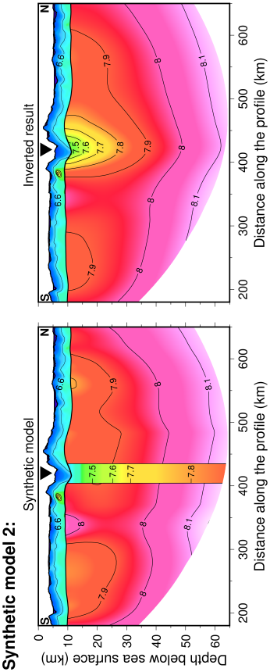

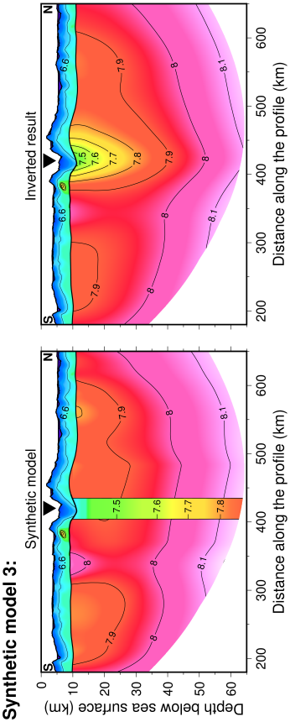

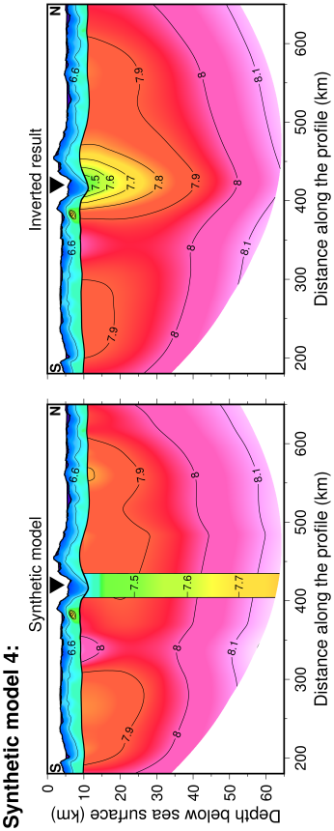

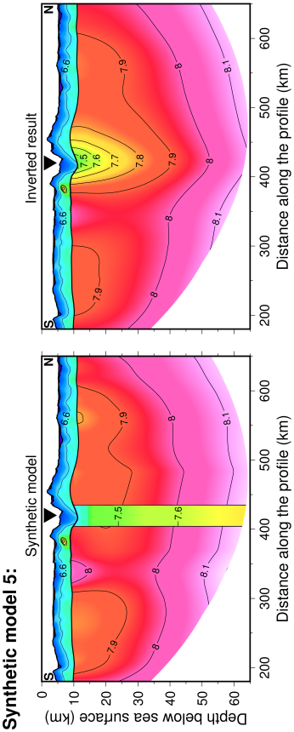

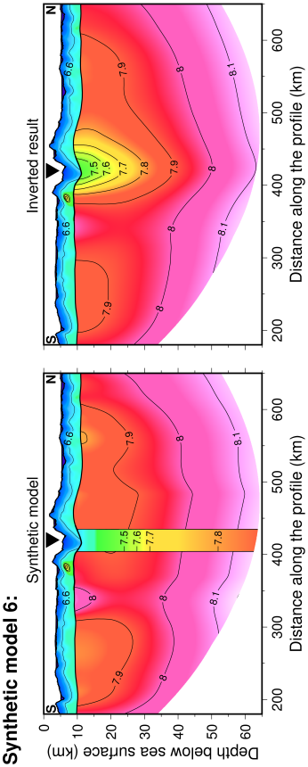

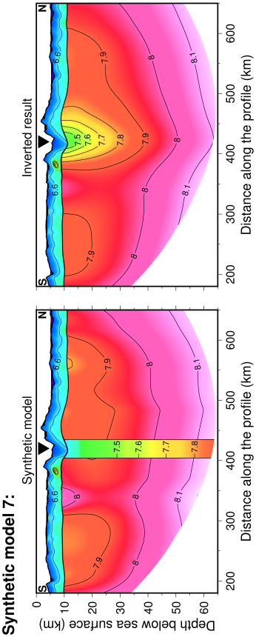

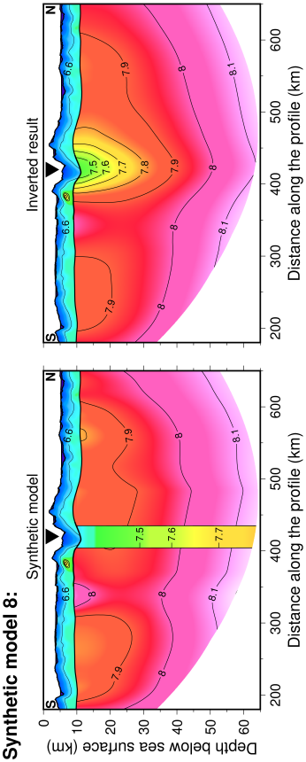
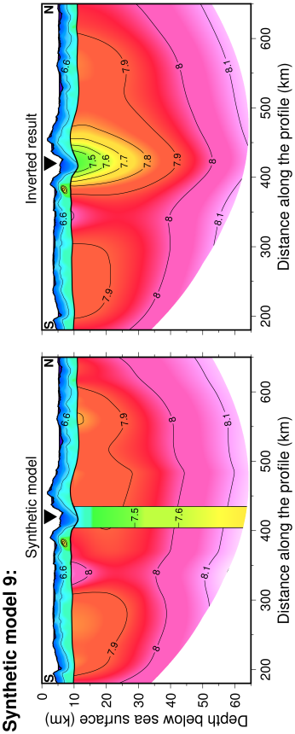
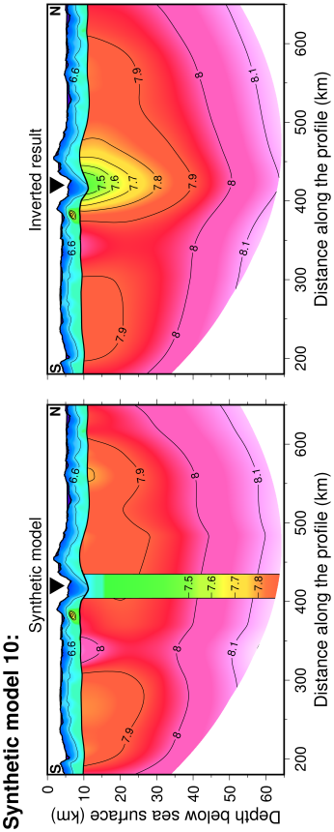

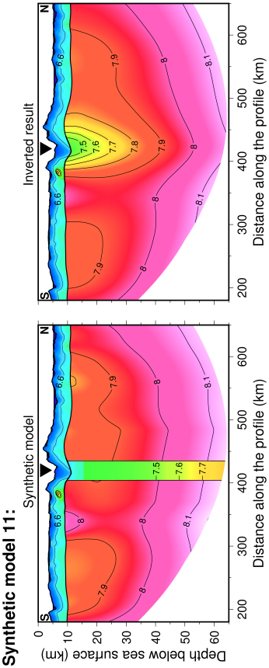
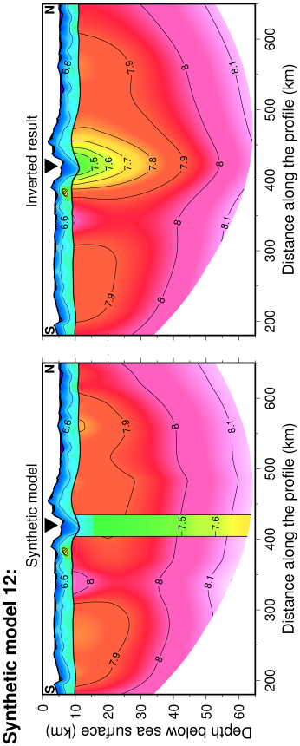
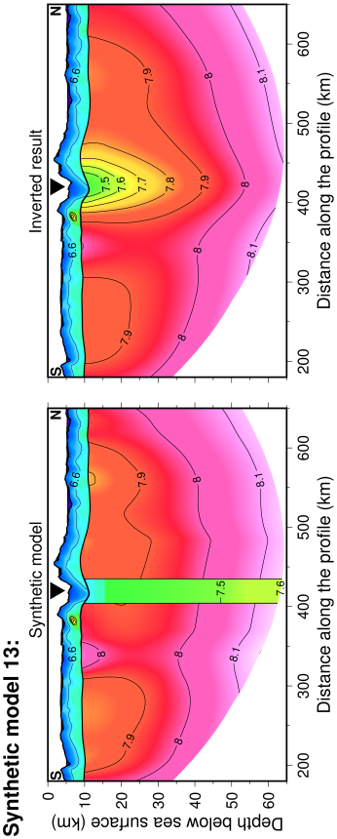
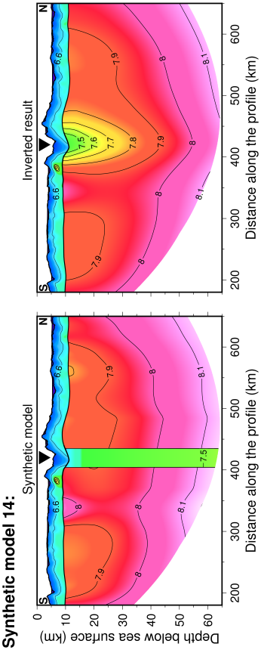
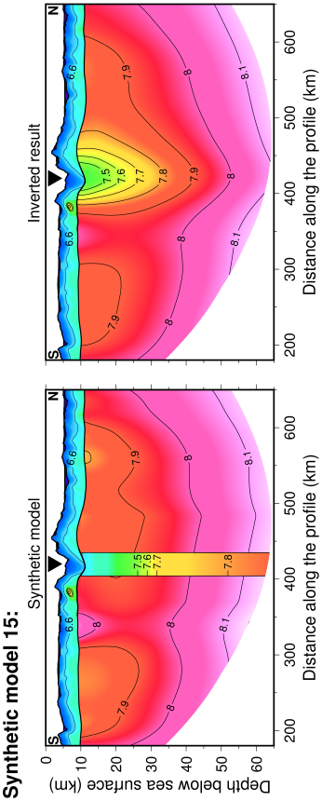

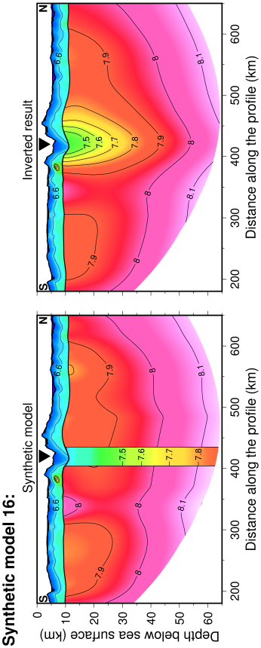
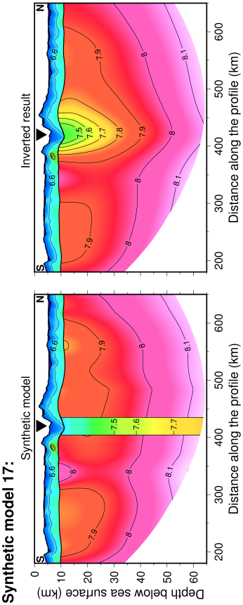
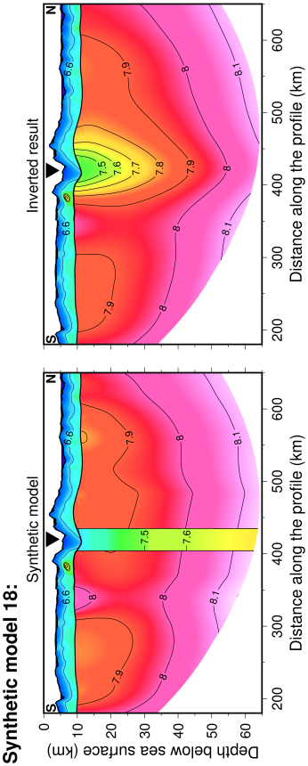
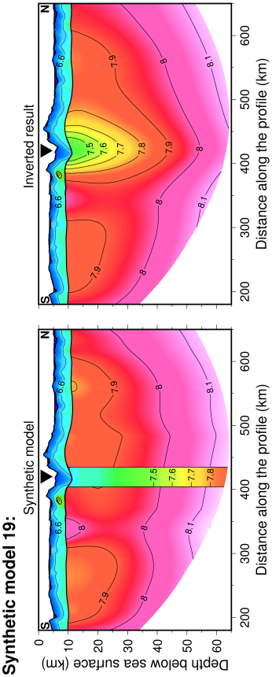
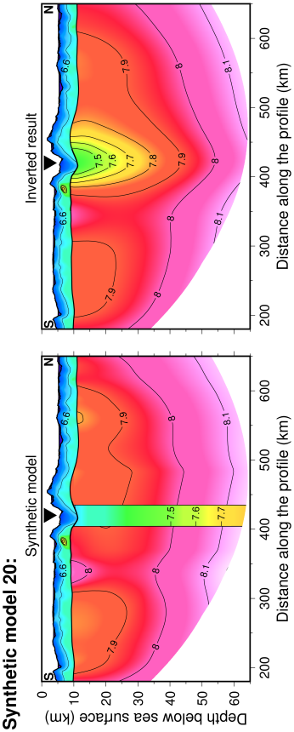

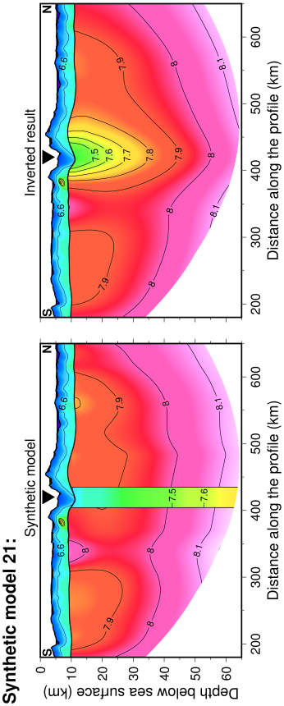
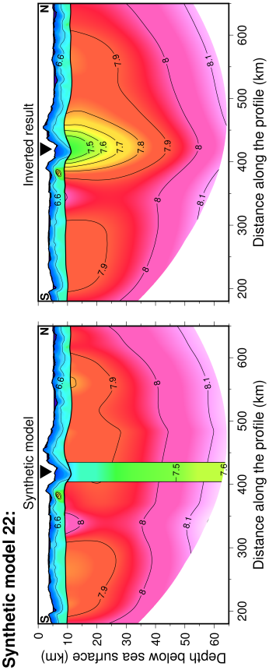
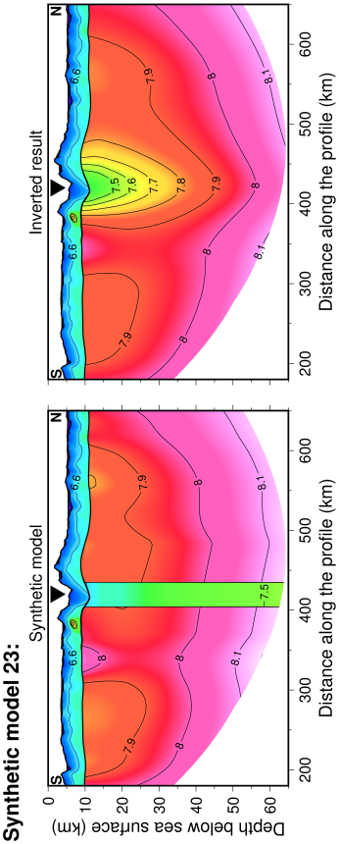
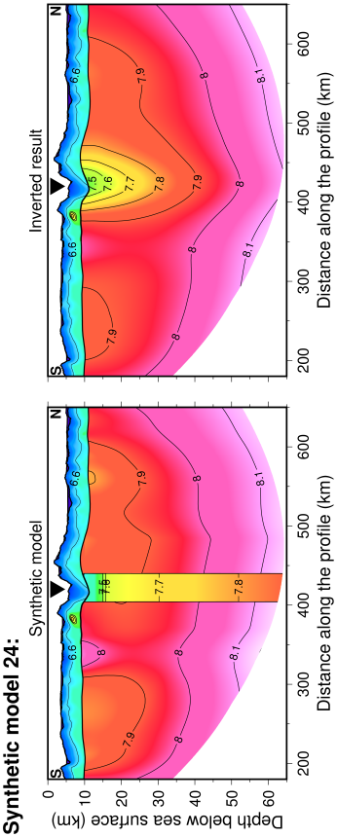
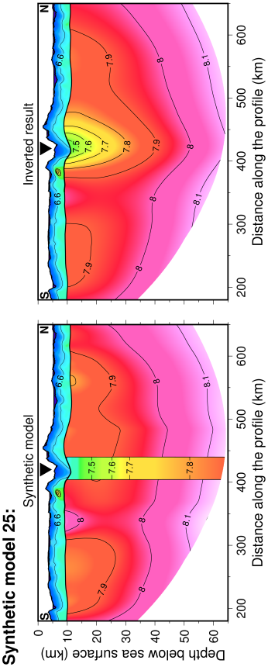

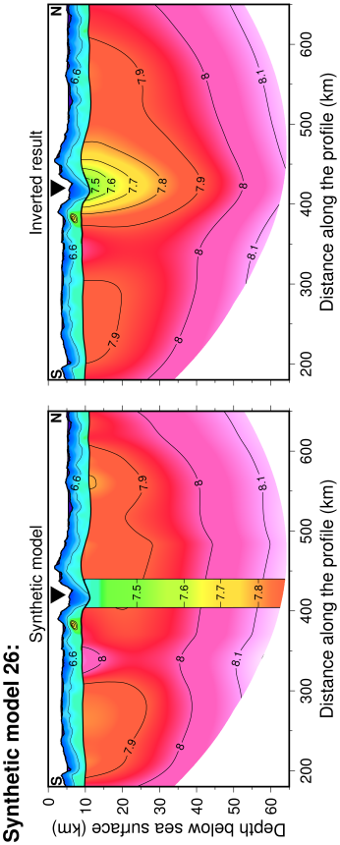
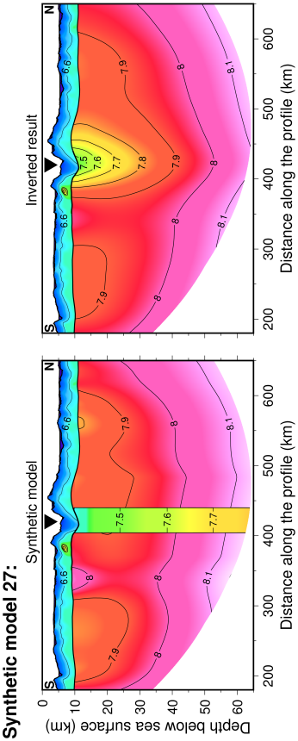
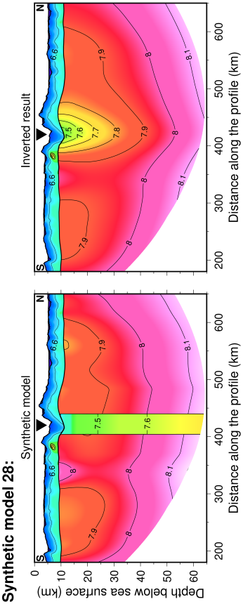
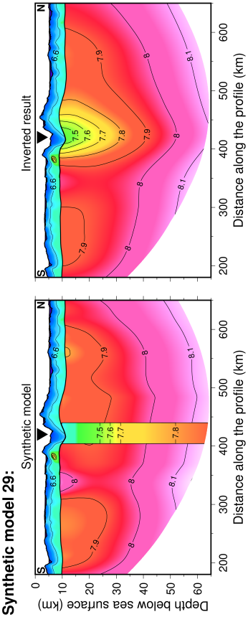
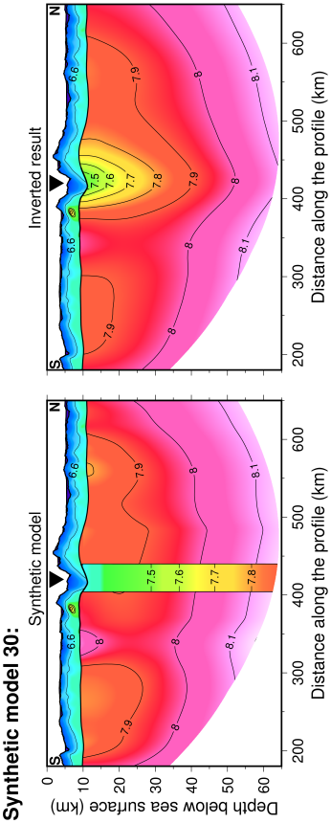

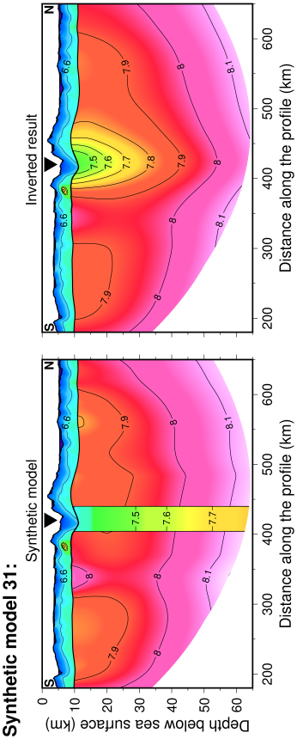
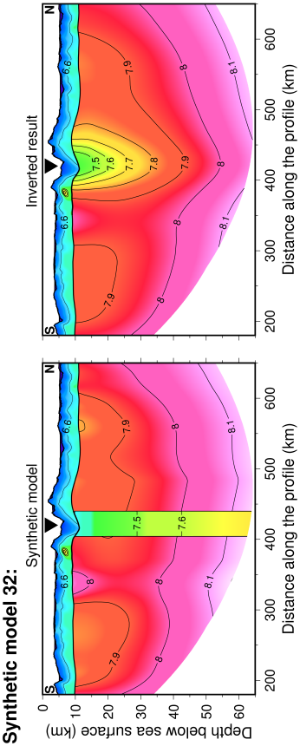
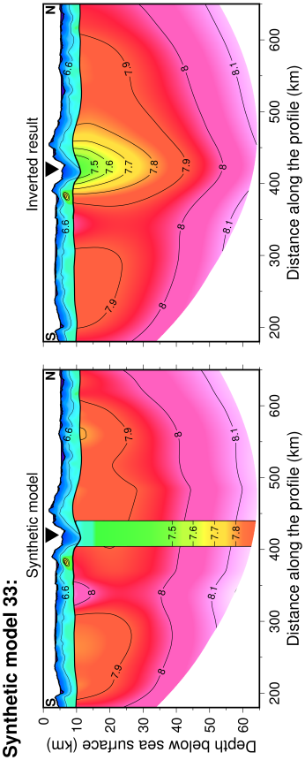
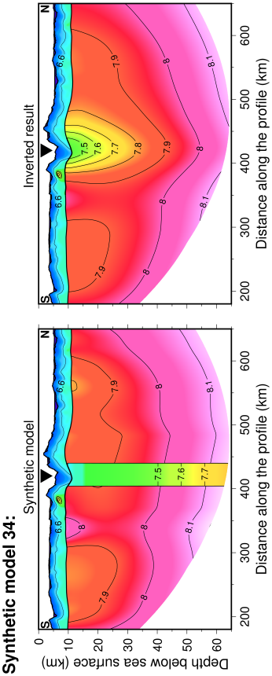
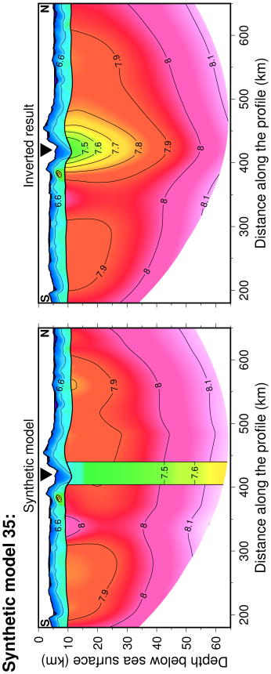

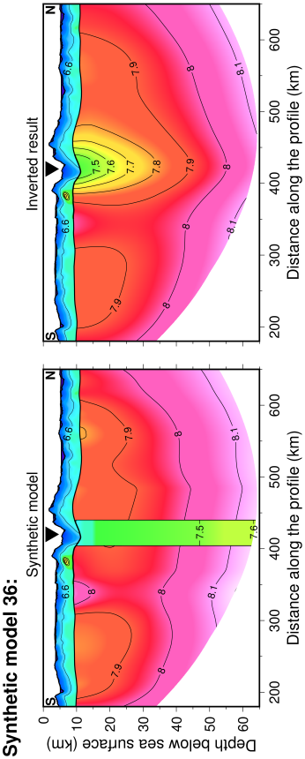
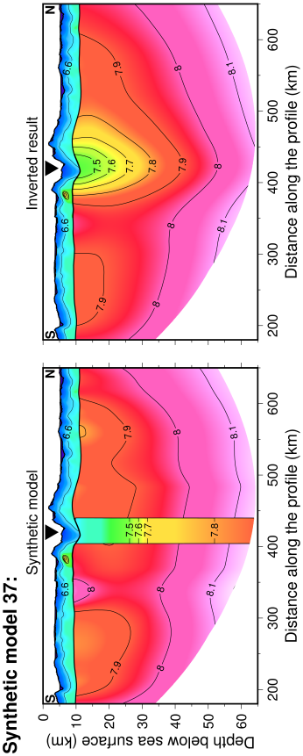
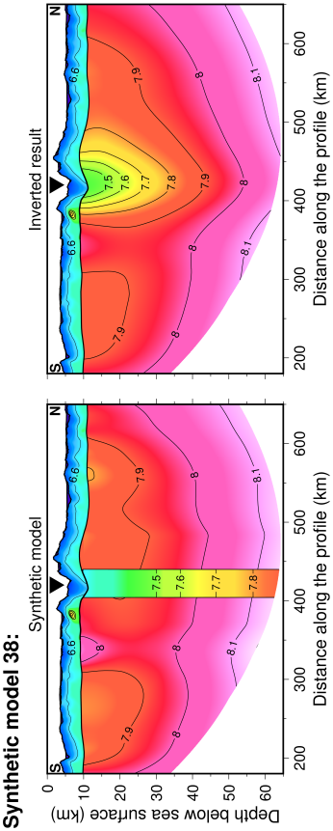
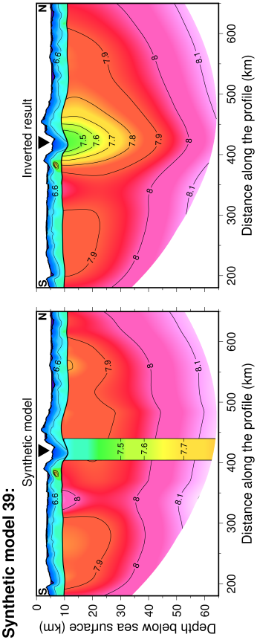
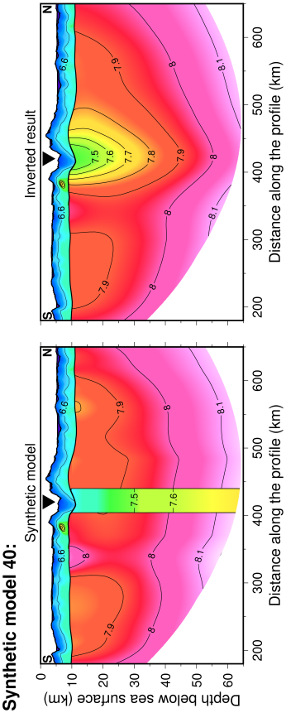

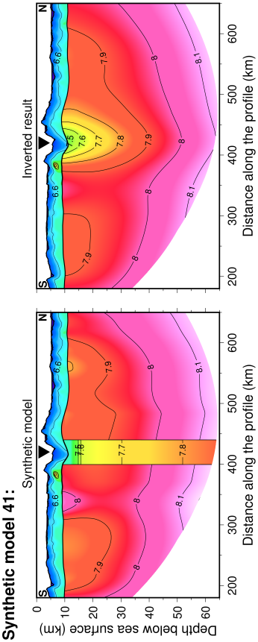
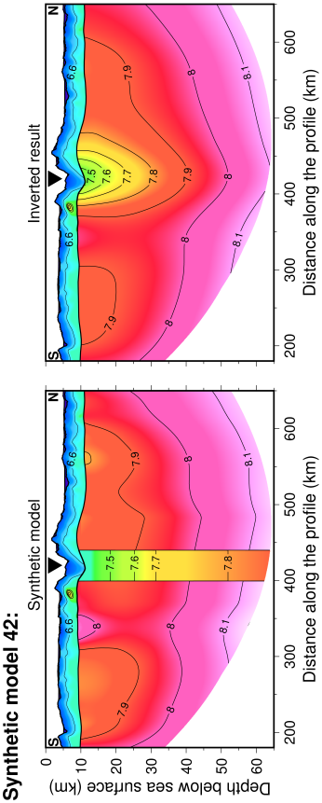
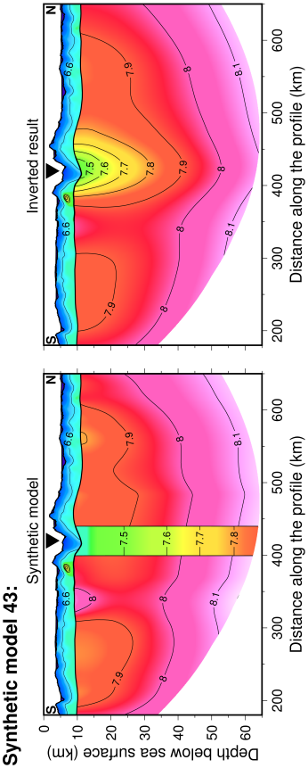
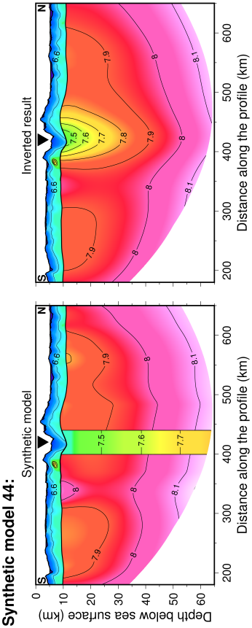
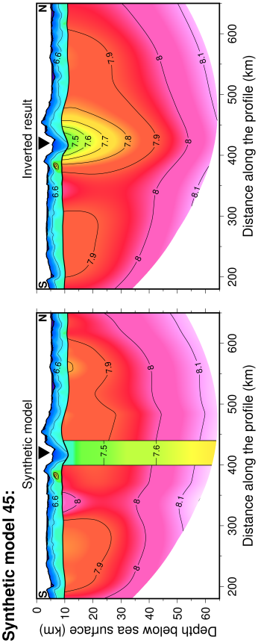

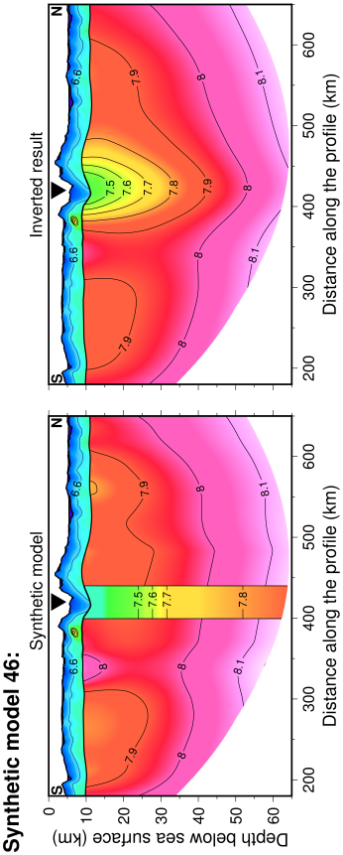
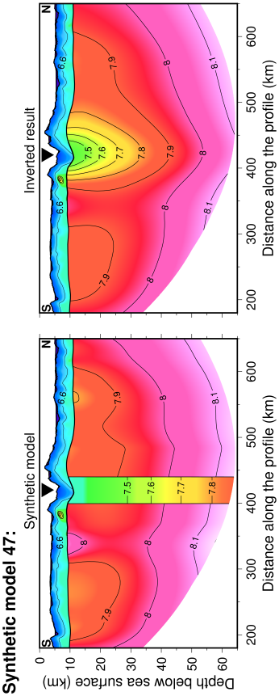
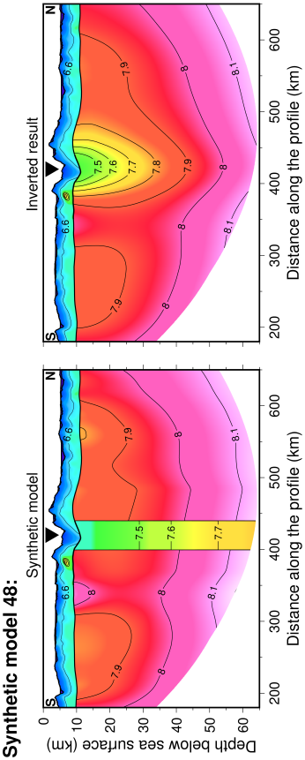
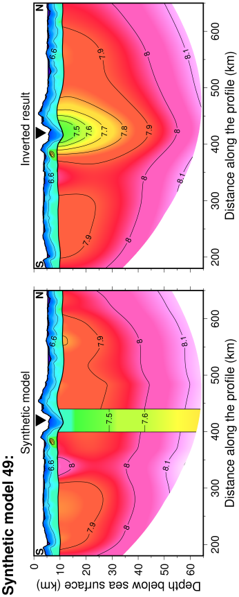
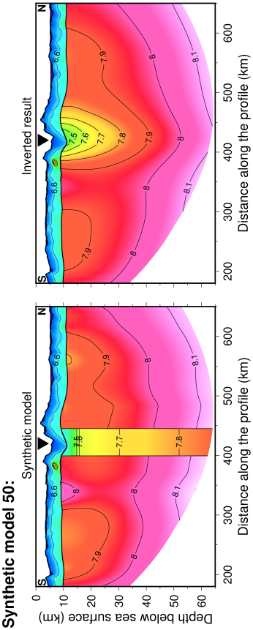

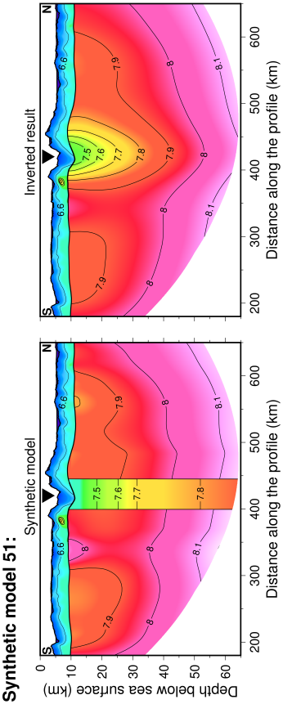
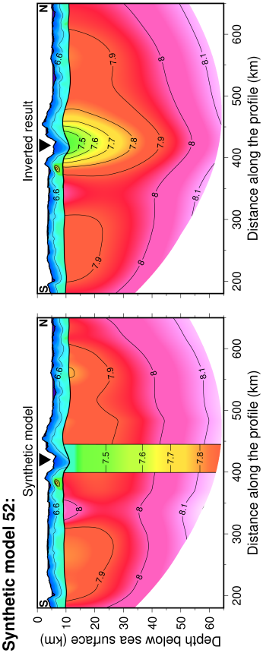
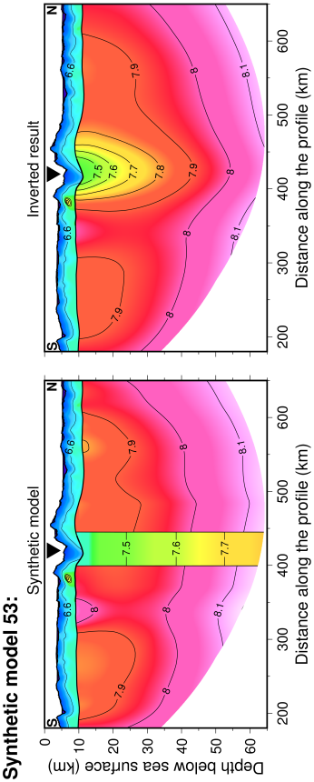
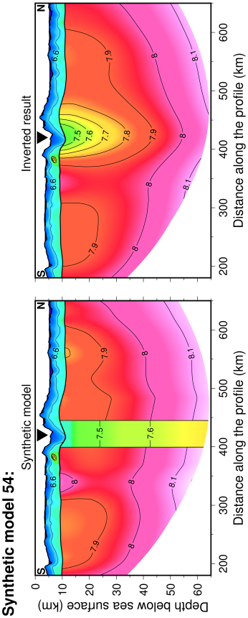
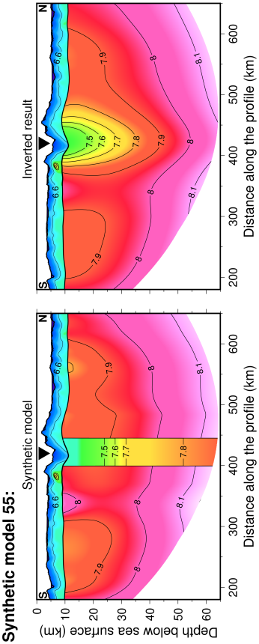

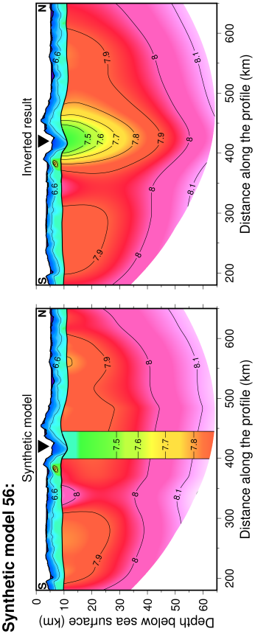
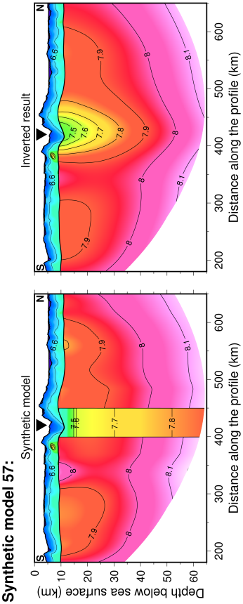
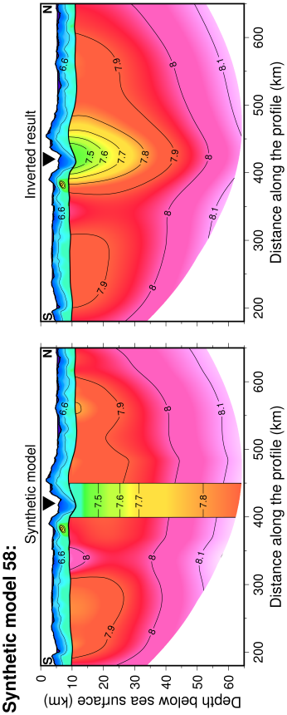
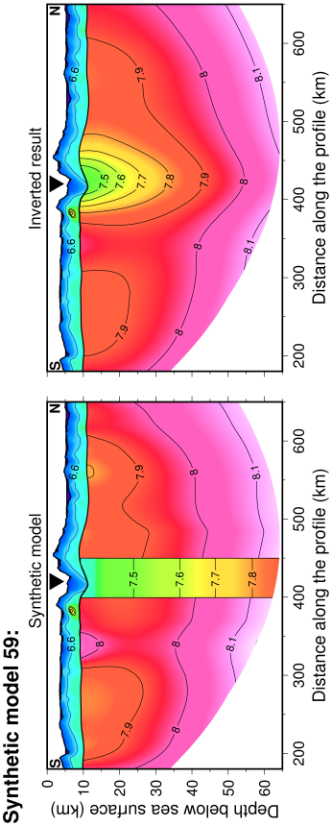
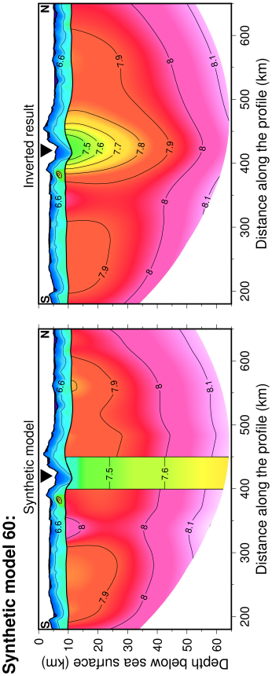

Supplementary Figure 11 | Synthetic (left column) and inverted (right column) models. The model parameters of synthetic models 1 to 60 are listed in Supplementary Table 1. The inverted models on the right are obtained by inverting the synthetic travel time datasets modelled using the synthetic models on the left.

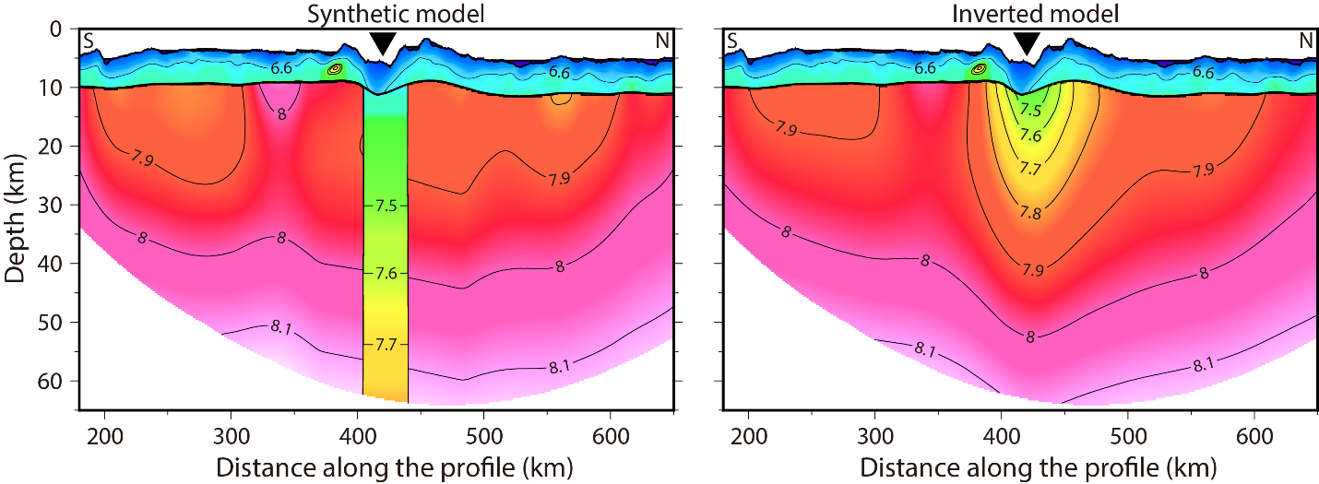

Supplementary Figure 12 | (Left) Synthetic mantle velocity structure including a LVA with the final estimated width and velocity (Fig. 3c). (Right) Tomographic result of the travel times modelled using the synthetic model on the left. The inverted black triangles indicate the location of the Romanche transform valley.

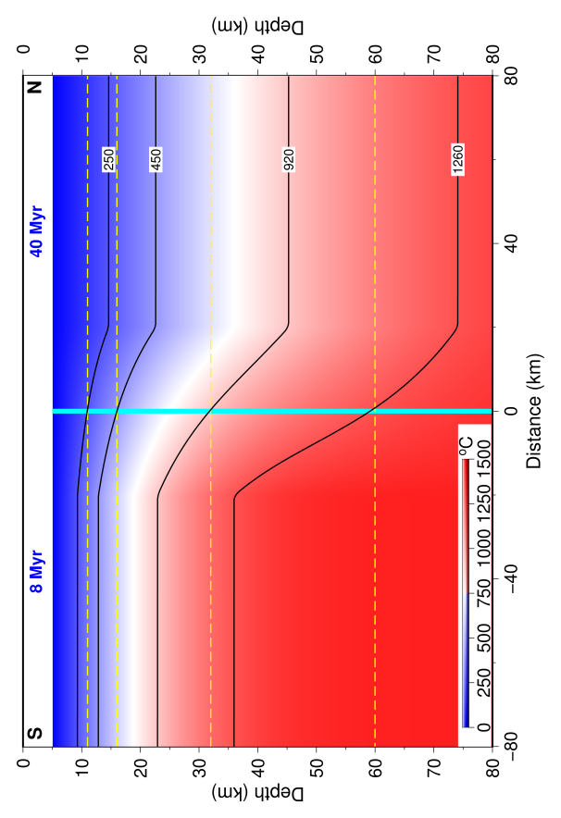
Supplementary Figure 13 | Thermal structure. Isotherms across the Romanche TF estimated using the plate cooling model²². The values labelled on contours are in ºC. The temperature at the center of the TF is used as the temperature of TF, which is indicated by the bold cyan line in the figure. The yellow dashed lines from top to bottom represent the Moho, 16 km, 32 km and 60 km depths below the sea surface.

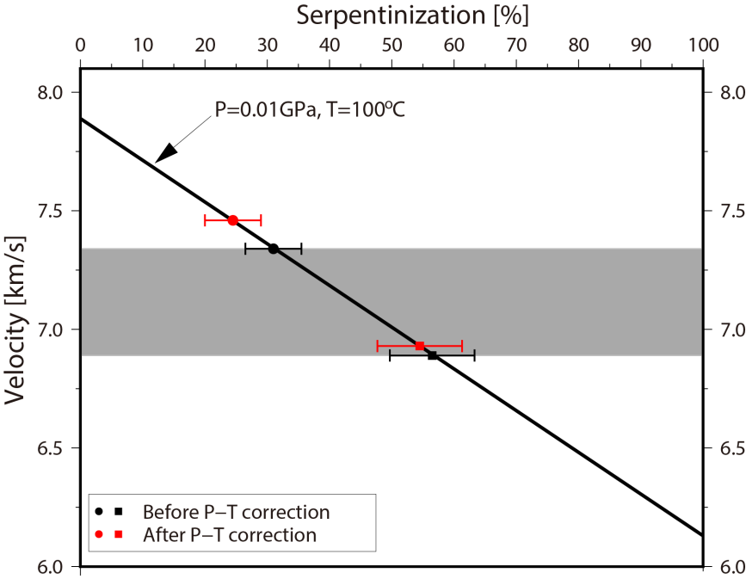

Supplementary Figure 14 | Serpentinization estimation. The mantle P-wave velocity as a function of the degree of mantle serpentinization. The gray zone represents the estimated mantle velocity within the Romanche TF above 16 km depth. The squares and dots represent the mantle velocities at the Moho and at 16 km depth, respectively. The bars indicate the uncertainty bounds.

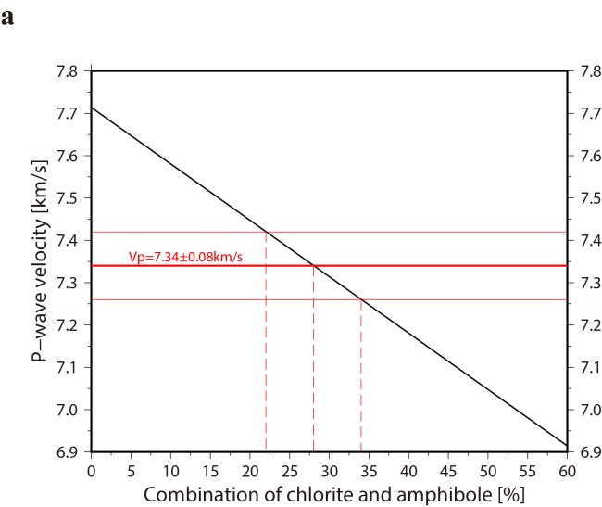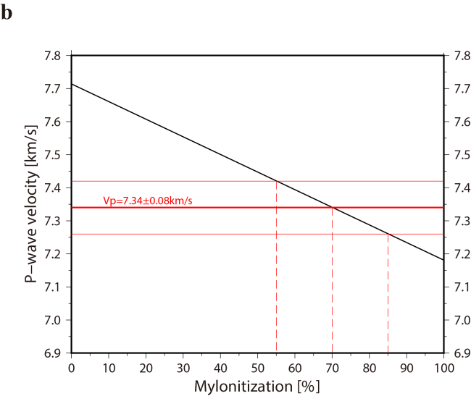

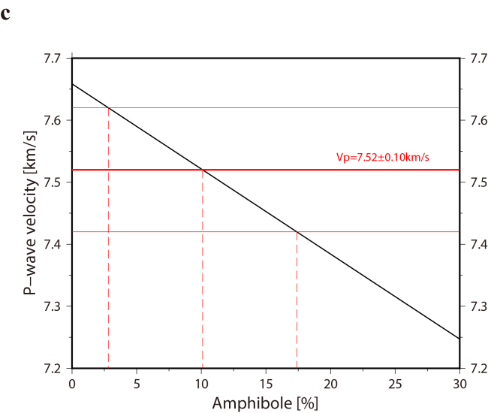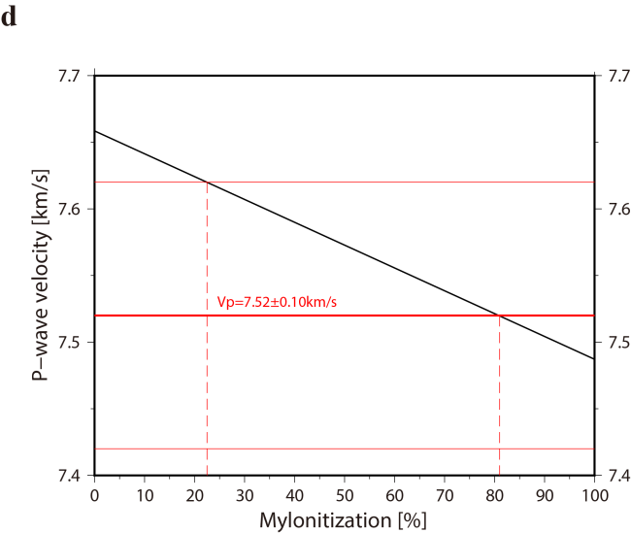

Supplementary Figure 15 | Hydration and mylonitization estimations. The mantle P-wave velocity (black line) as a function of (a & c) degree of hydration or (b & d) degree of mylonitization. (a & b) are for 16 km depth, and (c & d) for 32 km depth. The thick red solid lines indicate the velocities at 16 km and 32 km and thin red lines are uncertainty bounds. The red dashed lines are bounds in %.

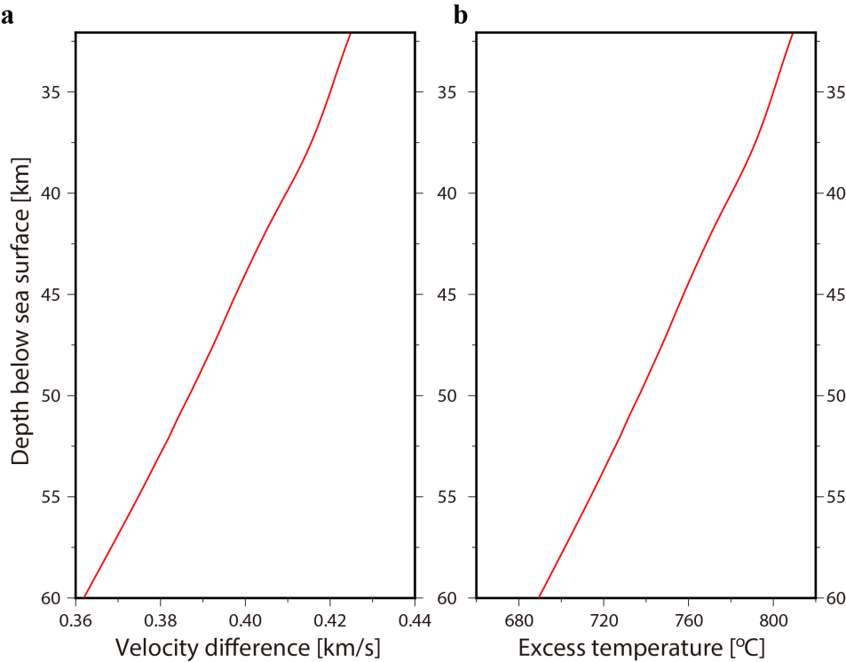

Supplementary Figure 16 | Excess temperature estimation. (a) Difference between the mantle velocity of the 40 Myr-old lithosphere and the estimated mantle velocity within the Romanche TF. (b) Excess temperature calculated using a constant derivative (-0.525 m/s/ºC) of velocity with respective to temperature.

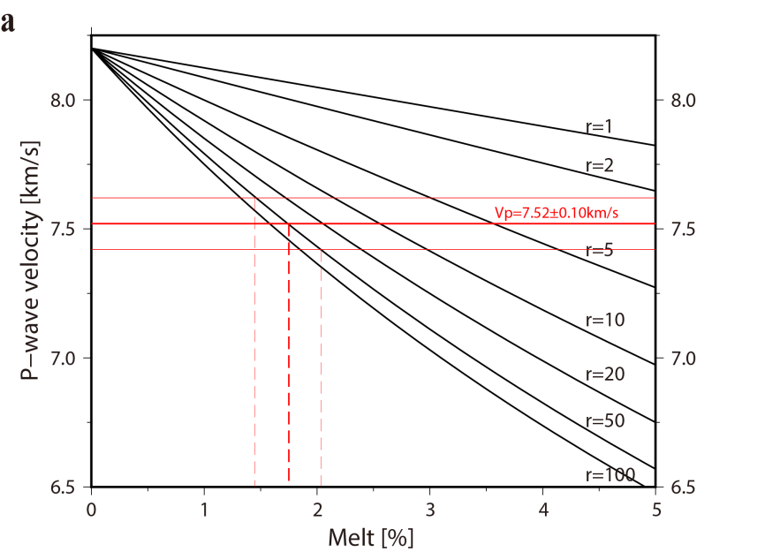

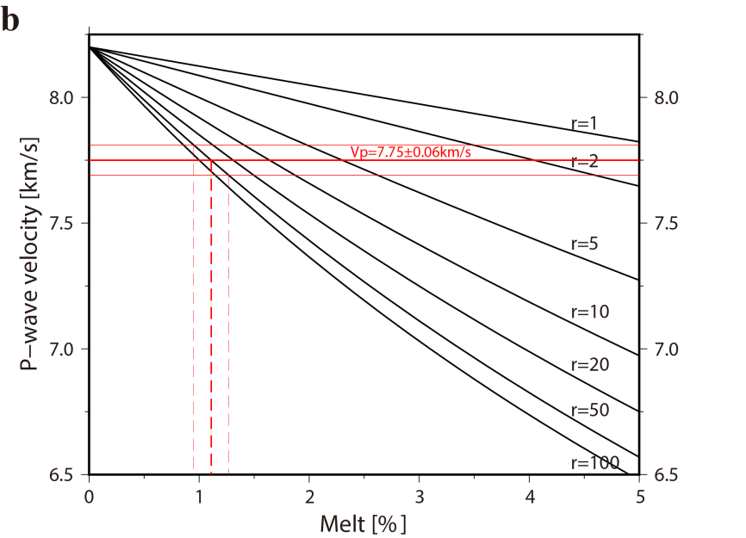

Supplementary Figure 17 | Melt fraction estimation. P-wave velocity variation as a function of melt fraction at (a) 32 km and (b) 60 km depths below sea surface. The aspect ratio of melt r=50 is used in the estimation. The thick red solid lines indicate the velocity at each depth and the thin red lines are uncertainty bounds. The thick red dashed lines indicate the estimated melt fractions and the thin dashed lines are uncertainty bounds.

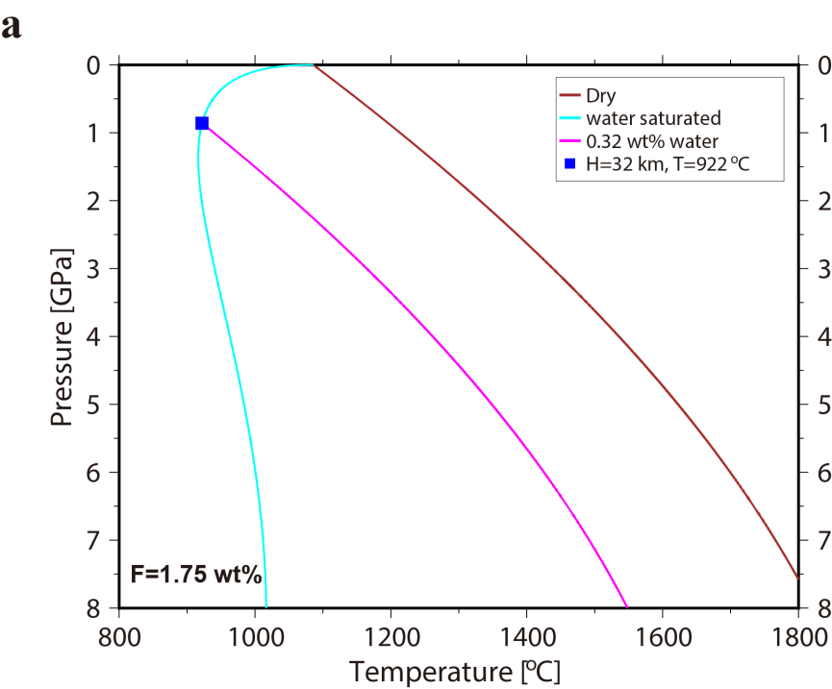

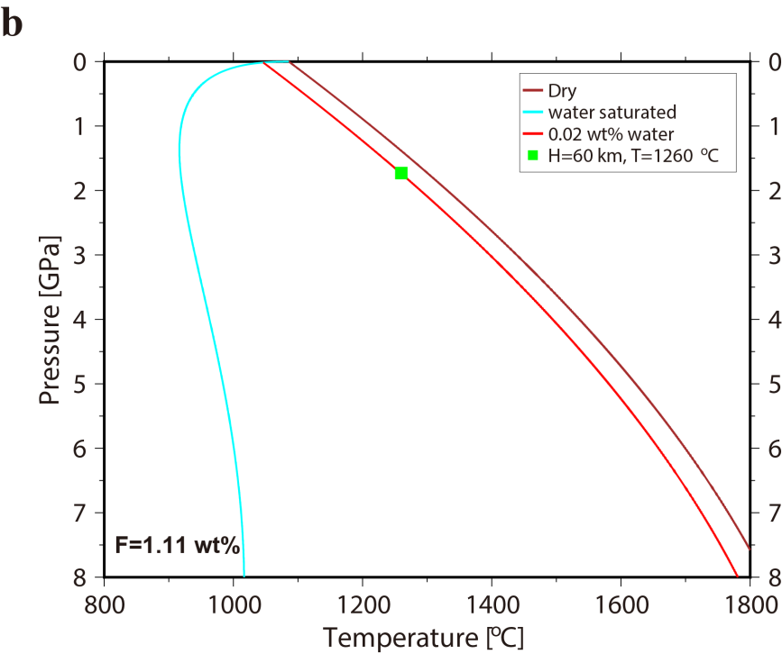

Supplementary Figure 18 | Solidus of mantle with different bulk of water at different pressure-temperature conditions. Minimum water contents for hydrous mantle melting at (a) 32 km and (b) 60 km depths. We take the 1260ºC isotherm as the base of the oceanic lithosphere¹⁵.

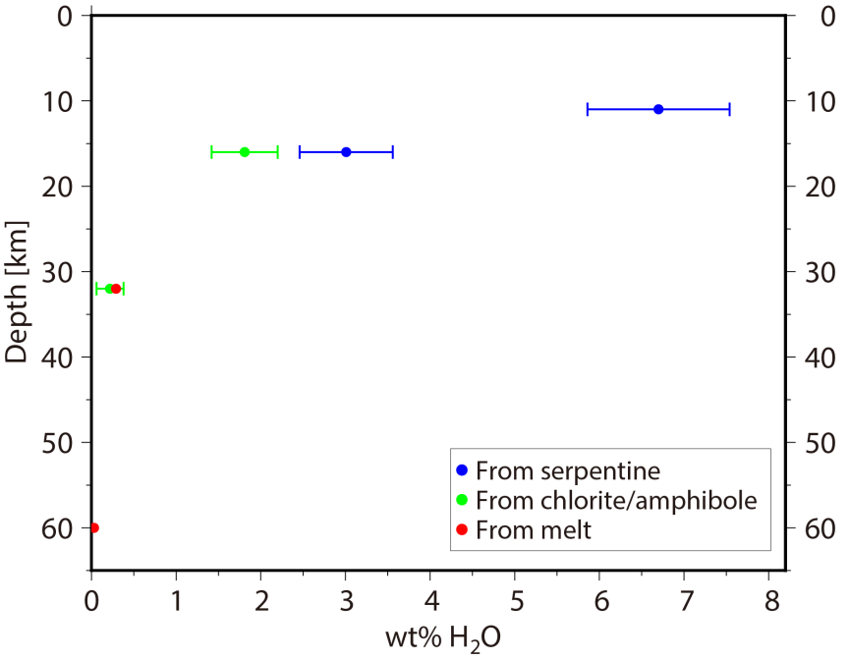

Supplementary Figure 19 | Water content variation with depth. The blue, green and red dots represent the water contents estimated using serpentine, chlorite/amphibole and melt, respectively.

Supplementary Table 1 | Parameters and misfits of synthetic models. The rows marked in green, blue and brown represent the synthetic models that fit the tomographic result using OBS data in Window 1, Window 2 or both, respectively.

Model  ID | Width  (km) | Velocity reduction at Moho | Velocity reduction at 16 km | Velocity reduction at 32 km | Velocity reduction at 60 km | in Window 1 | <20 | in Window 2 | <20
1 | 30 | 14% | 4% | 4% | 4% | 148.6 |  | 162.3
2 | 30 | 14% | 6% | 4% | 4% | 38.9 |  | 80.9
3 | 30 | 14% | 6% | 6% | 4% | 15.5 | √ | 7.6 | √
4 | 30 | 14% | 6% | 6% | 5% | 13.3 | √ | 6.6 | √
5 | 30 | 14% | 6% | 6% | 6% | 14.9 | √ | 6.9 | √
6 | 30 | 14% | 8% | 4% | 4% | 12.5 | √ | 21.5
7 | 30 | 14% | 8% | 6% | 4% | 9.4 | √ | 16.3 | √
8 | 30 | 14% | 8% | 6% | 5% | 12.3 | √ | 11.8 | √
9 | 30 | 14% | 8% | 6% | 6% | 27.5 |  | 14.6 | √
10 | 30 | 14% | 8% | 8% | 4% | 10.4 | √ | 10.6 | √
11 | 30 | 14% | 8% | 8% | 5% | 21.6 |  | 15.9 | √
12 | 30 | 14% | 8% | 8% | 6% | 34.2 |  | 40.8
13 | 30 | 14% | 8% | 8% | 7% | 29.0 |  | 26.7
14 | 30 | 14% | 8% | 8% | 8% | 27.0 |  | 48.9
15 | 30 | 14% | 10% | 4% | 4% | 96.6 |  | 29.7
16 | 30 | 14% | 10% | 6% | 4% | 106.9 |  | 64.0
17 | 30 | 14% | 10% | 6% | 5% | 85.6 |  | 70.3
18 | 30 | 14% | 10% | 6% | 6% | 111.6 |  | 74.5
19 | 30 | 14% | 10% | 8% | 4% | 107.5 |  | 85.1
20 | 30 | 14% | 10% | 8% | 5% | 126.5 |  | 77.1
21 | 30 | 14% | 10% | 8% | 6% | 130.7 |  | 120.6
22 | 30 | 14% | 10% | 8% | 7% | 138.5 |  | 94.9
23 | 30 | 14% | 10% | 8% | 8% | 165.3 |  | 169.9
24 | 35 | 12% | 4% | 4% | 4% | 32.7 |  | 7.9 | √
25 | 35 | 12% | 6% | 4% | 4% | 14.5 | √ | 6.1 | √
26 | 35 | 12% | 6% | 6% | 4% | 18.1 | √ | 6.9 | √
27 | 35 | 12% | 6% | 6% | 5% | 18.6 | √ | 7.8 | √
28 | 35 | 12% | 6% | 6% | 6% | 15.6 | √ | 9.1 | √
29 | 35 | 12% | 8% | 4% | 4% | 11.8 | √ | 5.9 | √
30 | 35 | 12% | 8% | 6% | 4% | 11.1 | √ | 5.2 | √
31 | 35 | 12% | 8% | 6% | 5% | 35.4 |  | 39.1
32 | 35 | 12% | 8% | 6% | 6% | 49.9 |  | 55.9
33 | 35 | 12% | 8% | 8% | 4% | 20.7 |  | 34.6
34 | 35 | 12% | 8% | 8% | 5% | 22.7 |  | 43.7
35 | 35 | 12% | 8% | 8% | 6% | 31.2 |  | 59.7
36 | 35 | 12% | 8% | 8% | 7% | 33.9 |  | 71.6
37 | 35 | 12% | 10% | 4% | 4% | 47.7 |  | 25.5
38 | 35 | 12% | 10% | 6% | 4% | 72.3 |  | 65.5
39 | 35 | 12% | 10% | 6% | 5% | 65.5 |  | 69.0
40 | 35 | 12% | 10% | 6% | 6% | 102.6 |  | 141.5
41 | 40 | 10% | 4% | 4% | 4% | 34.4 |  | 12.7 | √
42 | 40 | 10% | 6% | 4% | 4% | 14.1 | √ | 5.2 | √
43 | 40 | 10% | 6% | 6% | 4% | 7.6 | √ | 8.9 | √
44 | 40 | 10% | 6% | 6% | 5% | 7.3 | √ | 12.3 | √
45 | 40 | 10% | 6% | 6% | 6% | 7.4 | √ | 26.1
46 | 40 | 10% | 8% | 4% | 4% | 58.1 |  | 36.5
47 | 40 | 10% | 8% | 6% | 4% | 43.3 |  | 46.6
48 | 40 | 10% | 8% | 6% | 5% | 60.8 |  | 63.6
49 | 40 | 10% | 8% | 6% | 6% | 60.0 |  | 96.1
50 | 45 | 10% | 4% | 4% | 4% |  |  | 4.6 | √
51 | 45 | 10% | 6% | 4% | 4% |  |  | 16.4 | √
52 | 45 | 10% | 6% | 6% | 4% |  |  | 37.1
53 | 45 | 10% | 6% | 6% | 5% |  |  | 46.3
54 | 45 | 10% | 6% | 6% | 6% |  |  | 53.9
55 | 45 | 10% | 8% | 4% | 4% |  |  | 119.0
56 | 45 | 10% | 8% | 6% | 4% |  |  | 156.3
57 | 50 | 10% | 4% | 4% | 4% |  |  | 12.8 | √
58 | 50 | 10% | 6% | 4% | 4% |  |  | 32.0
59 | 50 | 10% | 6% | 6% | 4% |  |  | 52.5
60 | 50 | 10% | 6% | 6% | 6% |  |  | 83.5

Supplementary Table 2 | Estimated width and velocity reduction on the controlling nodes using different misfit thresholds.

Misfit threshold | Controlling node | Velocity reduction | Width of LVA (km)
<15 | At Moho | 12.31±1.73% | 34.2±4.3
 | 16 km depth | 6.92±1.00%
 | 32 km depth | 5.37±1.13%
 | 60 km depth | 4.53±0.75% | 35.8±5.4
<20 | At Moho | 12.35±1.57% | 34.1±3.9
 | 16 km depth | 6.71±0.96%
 | 32 km depth | 5.45±1.23%
 | 60 km depth | 4.50±0.72% | 35.6±5.7
<30 | At Moho | 12.54±1.53% | 33.6±3.8
 | 16 km depth | 7.09±1.00%
 | 32 km depth | 5.36±1.35%
 | 60 km depth | 4.60±0.89% | 35.6±5.5

Reference
51. Toomey DR, Foulger GR. Tomographic inversion of local earthquake data from the Hengill-Grensdalur Central Volcano Complex, Iceland. J Geophys Res 1989, 94(B12): 17497-17510.

