The intersection of biological sex and gender in adverse events following seasonal influenza vaccination in older adults

Supplemental Materials

Table of contents
Supplemental Tables 2
Supplemental table 1. Regression models investigating the effects of sex, age, and their interaction on the odds of reporting an adverse event 2
Supplemental table 2. Regression models investigating the effects of sex, age, and their interaction on the odds of reporting an adverse event 3
Supplemental table 3. The effects of gender categories and gender scores on the odds of reporting an adverse event 3
Supplemental Figures 4
Supplemental figure 1. Effect of sex and age on hormone levels. 4
Supplemental figure 2. Impact of testosterone and cortisol on adverse event reporting. 5

Supplemental Tables

Supplemental table 1. Regression models investigating the effects of sex, age, and their interaction on the odds of reporting an adverse event
 | Males |  |  | Females
 | No AE | Any AE | p-valueª | No AE | Any AE | p-valueª | p-valueª
N | 39 | 7 |  | 42 | 24
GMT (CI)
H1N1 D0 | 34.1 (24.6 - 47.3) | 59.4 (28.7 - 123.0) | 0.198 | 32.8 (24.9 - 43.2) | 38.9 (21.7 - 69.6) | 0.529 | 0.169
H1N1 D28 | 174.9 (107.8 - 283.8) | 262.5 (88.0 - 782.8) | 0.443 | 137.9 (98.6 - 192.9) | 190.3 (110.8 - 326.7) | 0.330 | 0.223
H3N2 D0 | 40.7 (24.0 - 69.0) | 22.1 (9.3 - 52.3) | 0.339 | 48.8 (30.4 - 78.2) | 42.4 (21.4 - 84.0) | 0.725 | 0.344
H3N2 D28 | 338.0 (195.7 - 583.7) | 195.0 (18.9 - 2009.5) | 0.429 | 304.5 (186.2 - 498.1) | 349.0 (175.6 - 693.5) | 0.753 | 0.710
GMFR (CI)
H1N1 | 5.1 (3.6 - 7.3) | 4.4 (1.3 - 14.6) | 0.748 | 4.2 (3.0 - 5.9) | 4.9 (2.9 - 8.4) | 0.600 | 0.912
H3N2 | 8.3 (5.7 - 12.1) | 8.8 (1.5 - 51.0) | 0.900 | 6.2 (4.3 - 9.0) | 8.2 (5.1 - 13.3) | 0.372 | 0.487
Seroconversion
- n (%)
H1N1 | 26 (66.7) | 3 (42.9) | 0.241 | 27 (64.3) | 19 (79.2) | 0.211 | 0.241
H3N2 | 32 (82.1) | 5 (71.4) | 0.519 | 31 (73.8) | 20 (83.3) | 0.378 | 0.519
ª P-values indicate the significance of the difference between those who had an AE and those who did not among males, females, or the overall population. P-values were derived from linear (GMT and GMFR) or logistic (seroconversion) regression models with binary main effects for sex and the presence of an AE and an interaction term between the main effects.
Abbreviations: CI: confidence interval; D: day; Diff: difference; GMT: geometric mean titer; GMFR: geometric mean fold rise

Supplemental table 2. Regression models investigating the effects of sex, age, and their interaction on the odds of reporting an adverse event
OR (p-value) | Any AE | Local AE | Systemic AE
Base models
Female sex | 4.038 (0.0007) | 5.164 (0.0002) | 2.870 (0.1354)
Older age | 0.849 (0.0001) | 0.840 (0.0001) | 0.805 (0.0069)
Adjusted models
Female sex | 3.373 (0.0024) | 4.343 (0.0006) | 1.948 (0.3229)
Older age | 0.864 (0.0002) | 0.857 (0.0002) | 0.819 (0.0106)
Interaction model
Older age in males | 0.941 (0.3479) | 0.916 (0.2264) | 1.026 (0.7976)
Older age in females | 0.830 (0.0002) | 0.834 (0.0003) | 0.737 (0.0021)

Supplemental table 3. The effects of gender categories and gender scores on the odds of reporting an adverse event
 | All | Male | Female
Descriptive analysis - Any AE/N (%)
Masculine | 20/65 (31) | 8/37 (22) | 12/28 (43)
Feminine | 17/70 (24) | 4/21 (19) | 13/49 (27)
Androgynous | 28/115 (24) | 4/35 (11) | 24/80 (30)
Undifferentiated | 18/89 (20) | 5/34 (15) | 13/55 (24)
Regression analysis - OR (p-value)ª
Gender roles^{b}
Masculine | 1.491 (0.430) | 1.333 (0.735) | 2.065 (0.263)
Androgynous | 1.009 (0.985) | 0.492 (0.439) | 1.266 (0.641)
Undifferentiated | 0.818 (0.676) | 0.775 (0.773) | 0.888 (0.832)
Gender scores
Femininity | 0.785 (0.392) | 0.578 (0.283) | 0.739 (0.384)
Masculinity | 1.092 (0.669) | 0.750 (0.474) | 1.255 (0.338)
ª Outcome = any AE
^{b} Reference group = feminine

Supplemental Figures

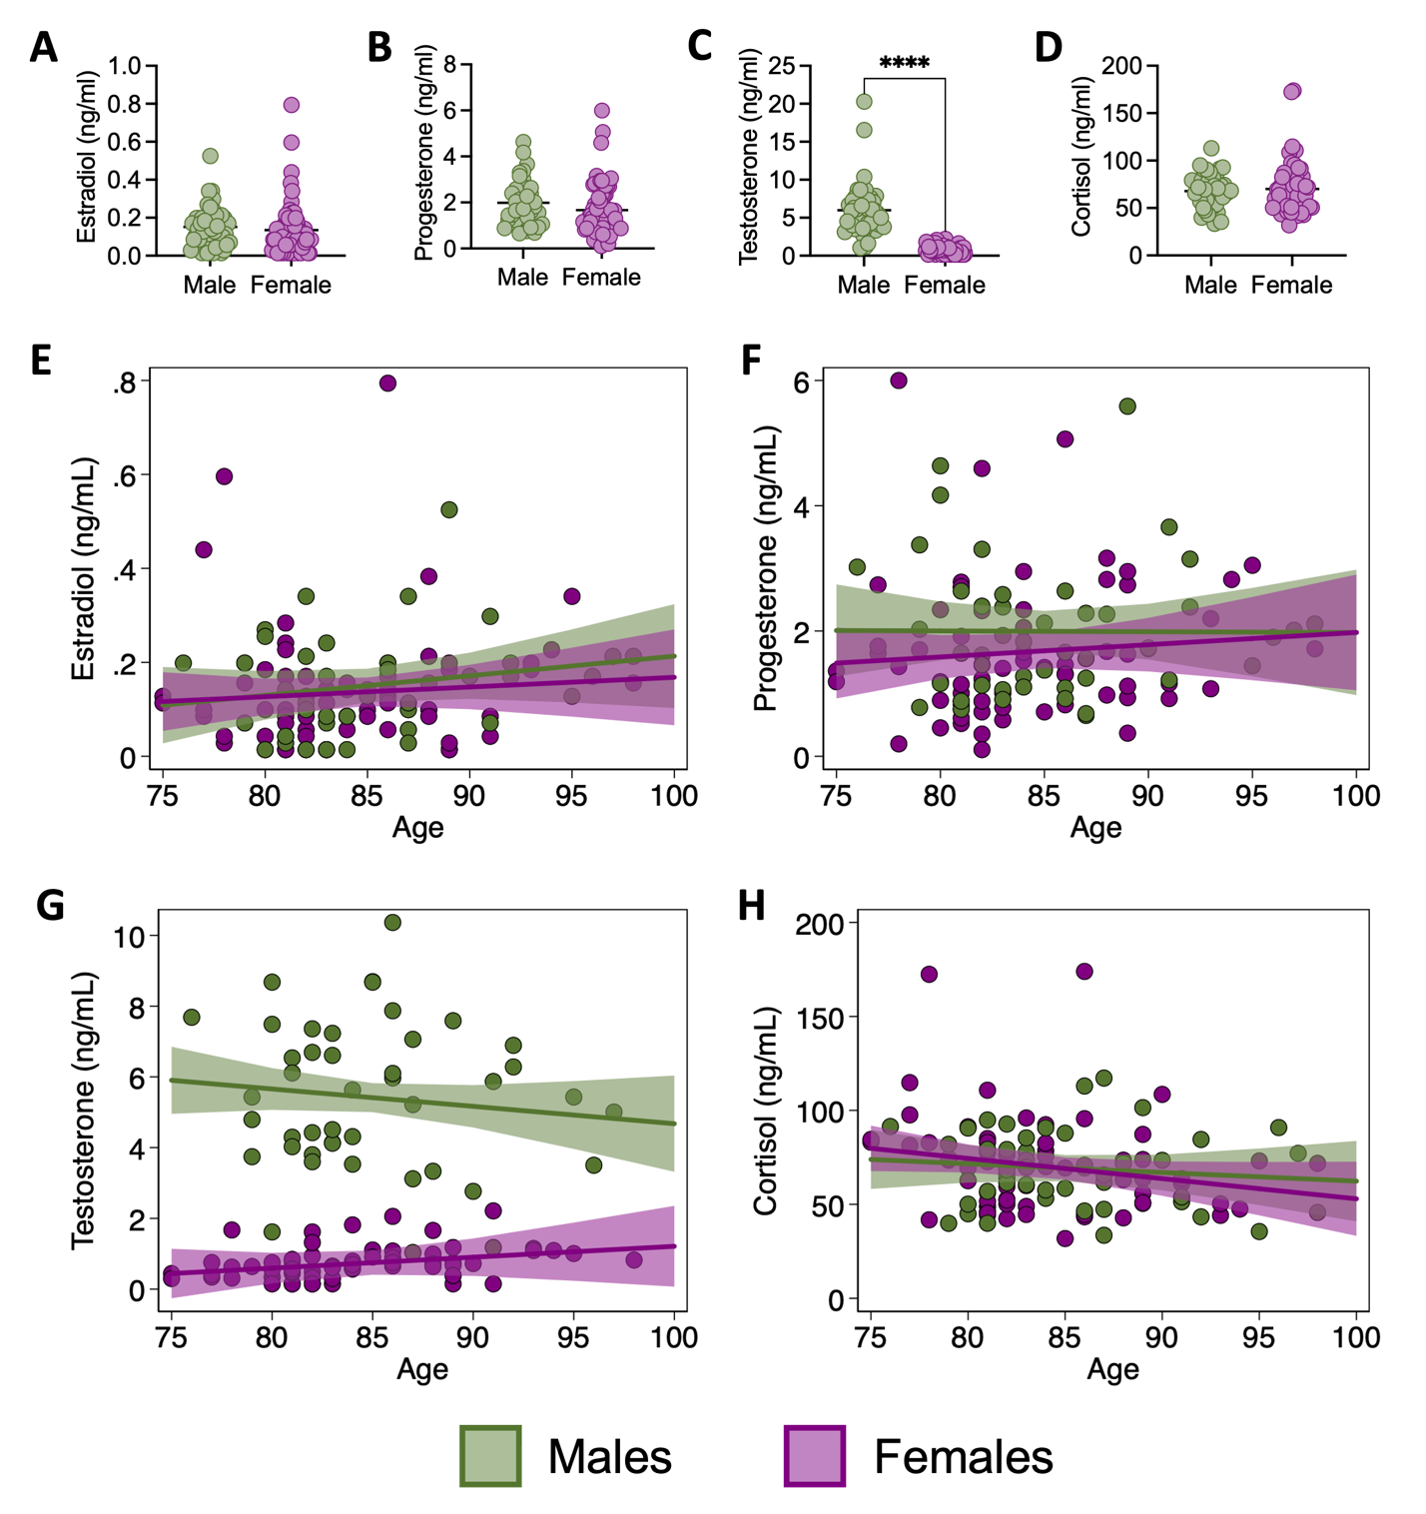

Supplemental figure 1. Effect of sex and age on hormone levels.
Hormones were measured in plasma samples collected prior to influenza vaccination during the 2020-2021 season. The concentrations of estradiol (A), progesterone (B), testosterone (C), and cortisol (D) were compared between males and females using simple t-tests. The associations between estradiol (E), progesterone (F), testosterone (G), or cortisol (H) and age were tested for males and females using linear regression models with an interaction term between age and sex.

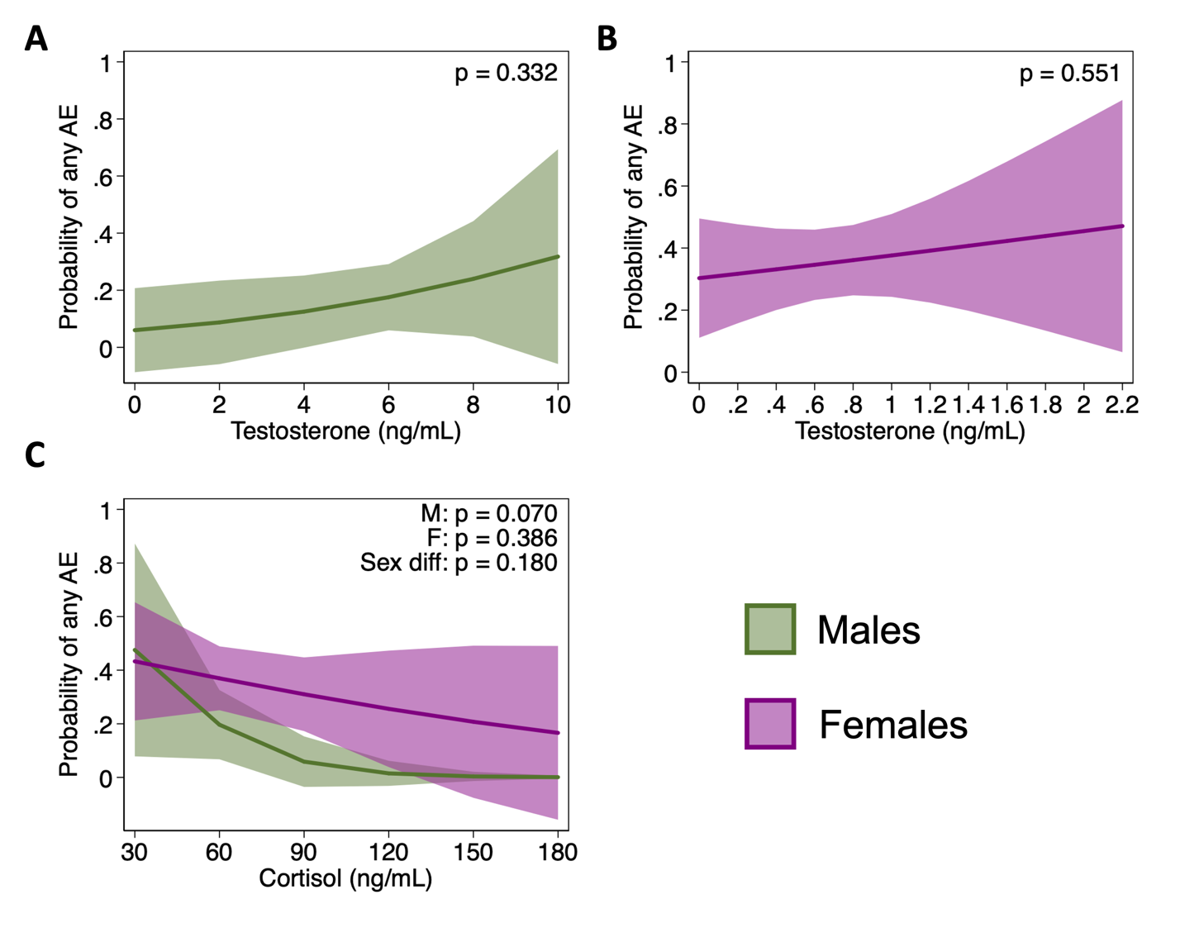

Supplemental figure 2. Impact of testosterone and cortisol on adverse event reporting.
The effect of testosterone (A-B) and cortisol (B) on the probability of reporting any AE was estimated for males and females using logistic regression models with interaction terms between hormone concentrations and sex.

