Supplementary Figure 1. Scree plot of the first 20 principal components (PCs) derived from the principal component analysis. PCs are along with x-axis and percent variance is along the y-axis.

Supplementary Figure 2. LD decay plots based on pairwise comparisons of loci for the A genome chromosomes. The red lines indicate the estimated LD points. The horizontal line is the LD significance based on the estimated LD value for half decay. The green line shows the distance in Mb for half decay, with the half decay distance shown in green along the bottom of each plot. These values were calculated as described by Remington et al. (2001).

Supplementary Figure 3. LD decay plots based on pairwise comparisons of loci for the B genome chromosomes. The red lines indicate the estimated LD points. The horizontal line is the LD significance based on the estimated LD value for half decay. The green line shows the distance in Mb for half decay, with the half decay distance shown in green along the bottom of each plot. These values were calculated as described by Remington et al. (2001).

Supplementary Figure 4. LD decay plots based on pairwise comparisons of loci for the D genome chromosomes. The red lines indicate the estimated LD points. The horizontal line is the LD significance based on the estimated LD value for half decay. The green line shows the distance in Mb for half decay, with the half decay distance shown in green along the bottom of each plot. These values were calculated as described by Remington et al. (2001).

Supplementary Figure 5. Histograms displaying the distribution of infiltration scores in the winter wheat panel for reactions to the NEs SnToxA, SnTox1, SnTox3, SnTox5, SnTox267, and Ptr ToxB.

Supplementary Figure 6. World maps displaying the average infiltration scores in the winter wheat panel to the NEs SnToxA, SnTox1, SnTox3, SnTox5, SnTox267, and Ptr ToxB. Countries in gray had no lines represented in the panel. Darker colors indicate lower average scores (0 as minimum), and lighter colors indicate higher average scores (3 as maximum).

Supplementary Figure 7. Histograms displaying the distribution of disease reactions to the P. nodorum isolates Sn4, AR2-1, Sn2000, SnIr05H71a, and NOR4, and the P. tritici-repentis isolates Pti2 (race 1), 86-124 (race 2), DW5 (race 5), and AR CrossB10. Replicates of each were statistically homogeneous and therefore combined.

Supplementary Figure 8. World maps displaying the average disease reaction scores in the winter wheat panel to the P. nodorum isolates Sn4, AR2-1, Sn2000, SnIr05H71a, and NOR4. Countries in gray had no lines represented in the panel. Darker colors indicate lower average scores (0 as minimum), and lighter colors indicate higher average scores (5 as maximum).

Supplementary Figure 9. World maps displaying the average disease reaction scores in the winter wheat panel to the P. tritici-repentis isolates Pti2 (race 1), 86-124 (race 2), DW5 (race 5), and AR CrossB10. Countries in gray had no lines represented in the panel. Darker colors indicate lower average scores (1 as minimum), and lighter colors indicate higher average scores (5 as maximum).

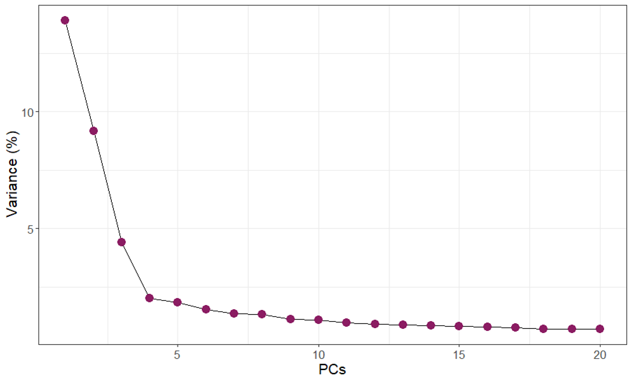
Supplementary Figure 1. Scree plot of the first 20 principal components (PCs) derived from the principal component analysis. PCs are along with x-axis and percent variance is along the y-axis.

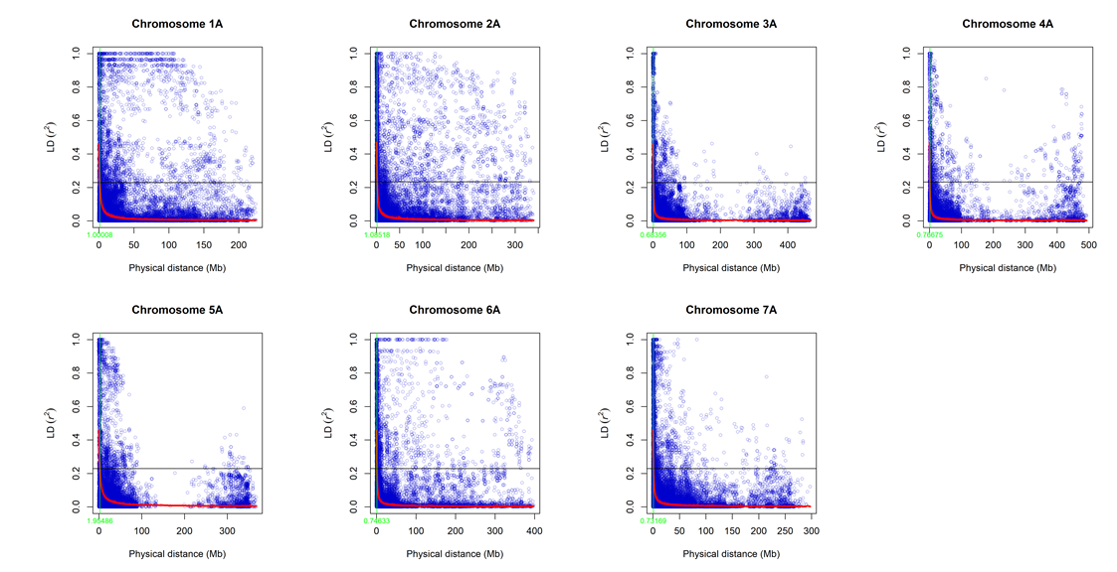
Supplementary Figure 2. LD decay plots based on pairwise comparisons of loci for the A genome chromosomes. The red lines indicate the estimated LD points. The horizontal line is the LD significance based on the estimated LD value for half decay. The green line shows the distance in Mb for half decay, with the half decay distance shown in green along the bottom of each plot. These values were calculated as described by Remington et al. (2001).

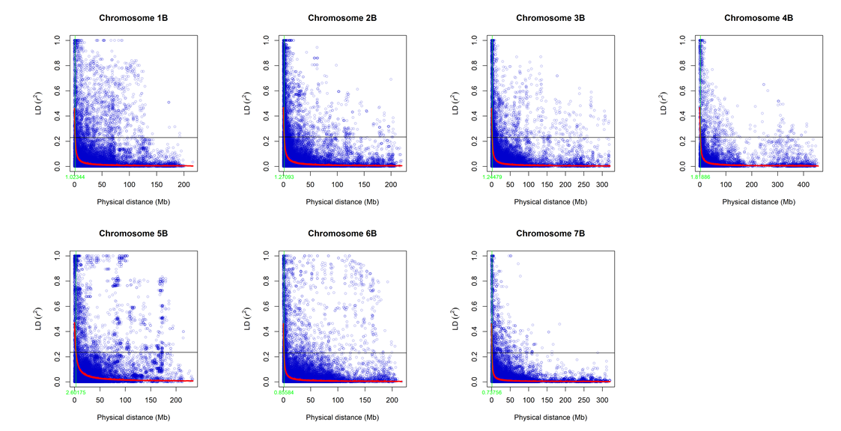
Supplementary Figure 3. LD decay plots based on pairwise comparisons of loci for the B genome chromosomes. The red lines indicate the estimated LD points. The horizontal line is the LD significance based on the estimated LD value for half decay. The green line shows the distance in Mb for half decay, with the half decay distance shown in green along the bottom of each plot. These values were calculated as described by Remington et al. (2001).

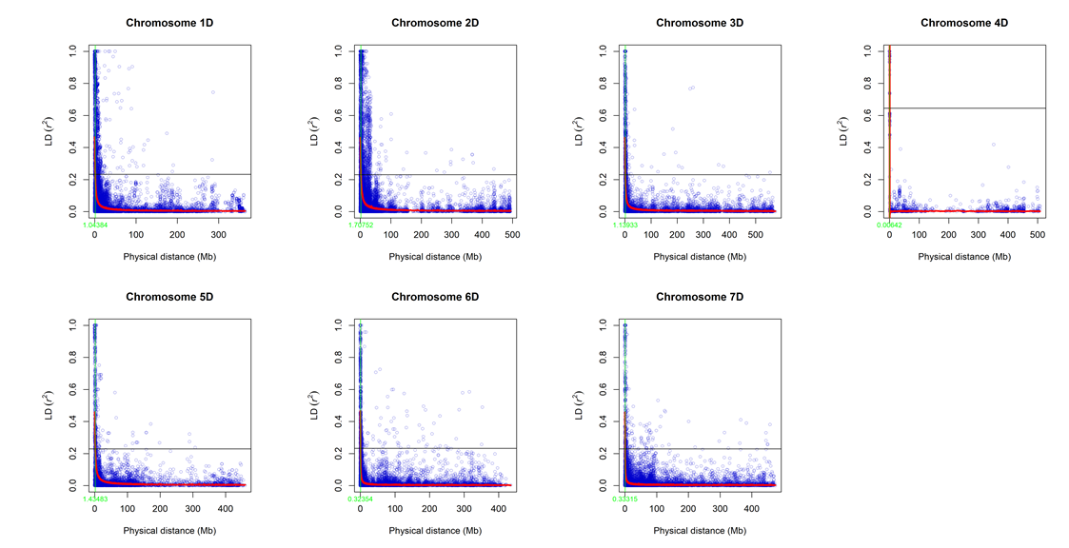
Supplementary Figure 4. LD decay plots based on pairwise comparisons of loci for the D genome chromosomes. The red lines indicate the estimated LD points. The horizontal line is the LD significance based on the estimated LD value for half decay. The green line shows the distance in Mb for half decay, with the half decay distance shown in green along the bottom of each plot. These values were calculated as described by Remington et al. (2001).

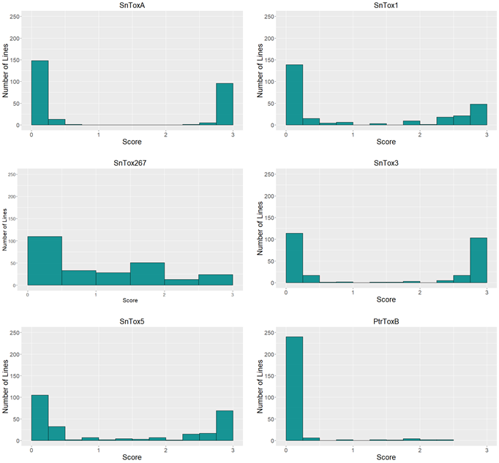
Supplementary Figure 5. Histograms displaying the distribution of infiltration scores in the winter wheat panel for reactions to the NEs SnToxA, SnTox1, SnTox3, SnTox5, SnTox267, and Ptr ToxB.

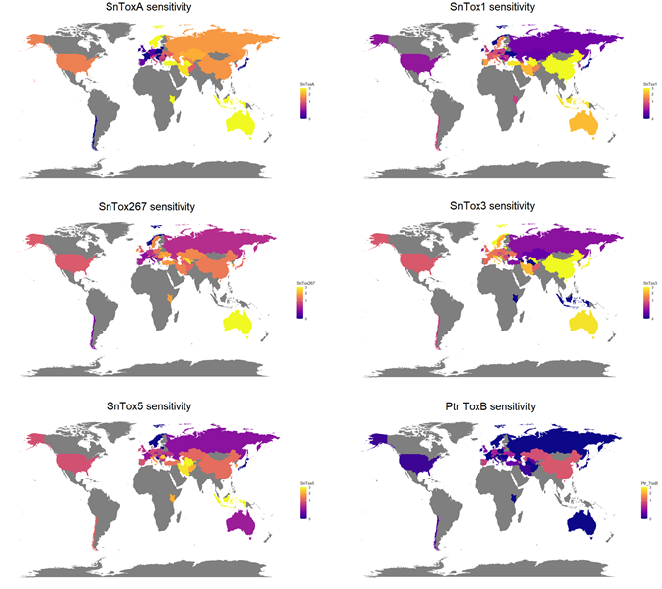
Supplementary Figure 6. World maps displaying the average infiltration scores in the winter wheat panel to the NEs SnToxA, SnTox1, SnTox267, SnTox3, SnTox5, and Ptr ToxB. Countries in gray had no lines represented in the panel. Darker colors indicate lower average scores (0 as minimum), and lighter colors indicate higher average scores (3 as maximum).

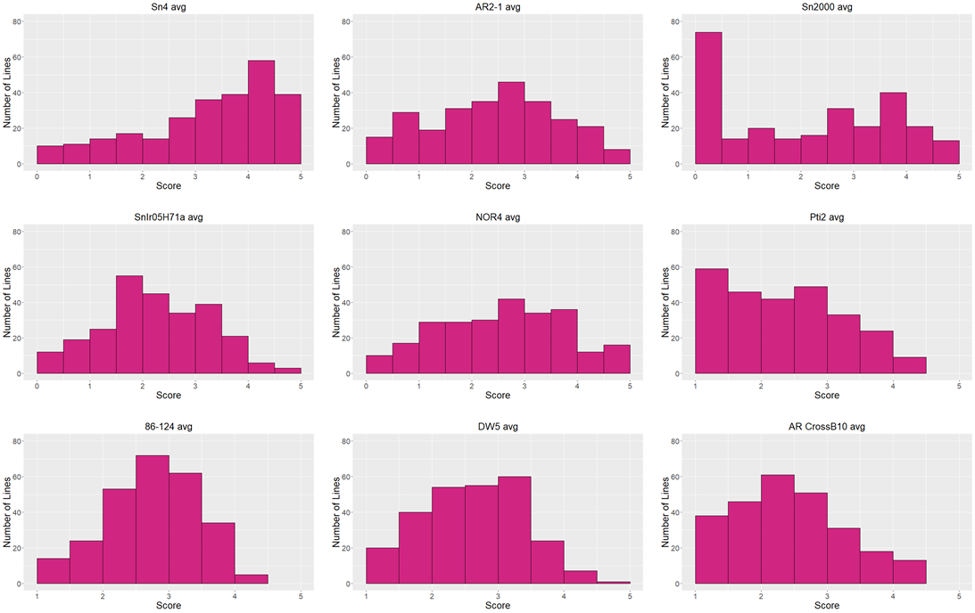
Supplementary Figure 7. Histograms displaying the distribution of disease reactions to the P. nodorum isolates Sn4, AR2-1, Sn2000, SnIr05H71a, and NOR4, and the P. tritici-repentis isolates Pti2 (race 1), 86-124 (race 2), DW5 (race 5), and AR CrossB10. Replicates of each were statistically homogeneous and therefore combined.
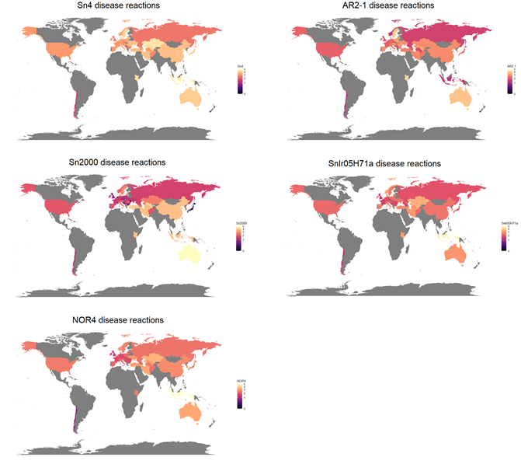
Supplementary Figure 8. World maps displaying the average disease reaction scores in the winter wheat panel to the P. nodorum isolates Sn4, AR2-1, Sn2000, SnIr05H71a, and NOR4. Countries in gray had no lines represented in the panel. Darker colors indicate lower average scores (0 as minimum), and lighter colors indicate higher average scores (5 as maximum).
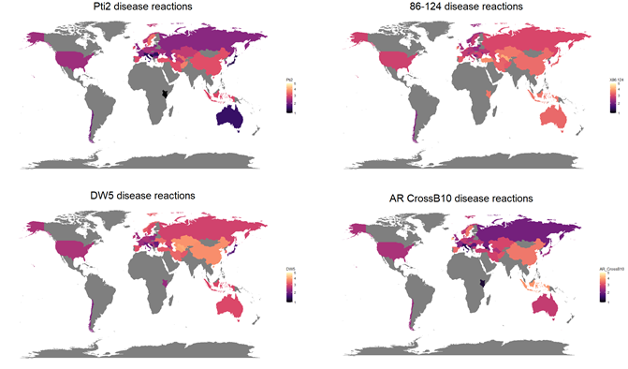
Supplementary Figure 9. World maps displaying the average disease reaction scores in the winter wheat panel to the P. tritici-repentis isolates Pti2 (race 1), 86-124 (race 2), DW5 (race 5), and AR CrossB10. Countries in gray had no lines represented in the panel. Darker colors indicate lower average scores (1 as minimum), and lighter colors indicate higher average scores (5 as maximum).

