Table 6
Description of Two Adolescents’ Experience with the Holotropic Breathwork Technique
Subject | Session | Mandala | Description
LYI | 1 | 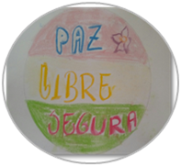 | Peace  Free  Safe
LYI | 2 | 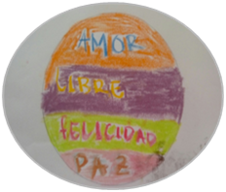 | Love  Free  Happiness  Peace
LYI | 3 | 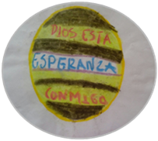 | God is with me  Hope  “I experienced remorse. The color purple represents something that still doesn’t leave me (change); green is hope.”
NVZ | 1 | 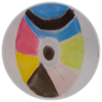 | She felt her hands fall asleep and wanted to leave.
NVZ | 2 |  | “The grey is like how I used to be. I focused on my happy memories and became blue”; “easier, good, more relaxed.”
NVZ | 3 |  | “I relived all the bad stuff. I felt embarrassed to be seen. I didn’t realize it and sat down to cry.”
Source: Prepared by the authors

