Supplementary Information 13
Archaeological Interpretation of Our Ancient DNA Analyses

§1. Authentication of Ancient DNA Data Generated in this Study
We applied multiple methods to ensure the authentication of our ancient genetic data in this study. We first tabulated the C -> T and G -> A deamination rate at 3’ and 5’ ends respectively. As expected, a high DNA damage rate at 5’ and 3’ ends was observed (SI 13 Fig. 1). Such a pattern is considered as a signature of large quantities of ancient DNA preserved in the samples. Second, we estimated the mitochondrial DNA contamination for all the ancient individuals with sufficient coverage (>10X) in this study with the Schmutzi programme. Specifically, we mapped adapter-removed reads to the revised Cambridge Reference Sequence of the human mitochondrial genome (rCRS; NC_012920.1), with an extension of 500 bp at the end to preserve DNA sequences passing through the origin. We then wrapped the alignment to the circular reference genome using circularmapper v1.1. The contDeam and schmutzi modules of the Schmutzi program were successively run with the world-wide allele frequency database from 197 individuals, resulting in estimated mitochondrial DNA contamination rates for each individual. We restricted our analysis to samples with mitochondrial DNA coverage higher than 10X to ensure the accuracy of the estimation. Eight out of 33 were successfully estimated, and a low mitochondrial DNA contamination was obtained (See qpAdm admixture modeling in SI 16 and sequencing details in SI 17). Last, we estimated the nuclear contamination rate in males based on the heterogeneity on the X chromosome. Since males only have a single copy of the X chromosome, there should be no polymorphisms on X chromosome sequences if contamination is absent. Because many individuals were low in coverage, and the contamination was not adequately estimated by the above-mentioned methods, 8 individuals with SNPs overlapping with the ‘1240k’ data set smaller than 10,000 were directly excluded from the down-stream analyses. We further applied a PCA constructed from present-day Eurasian populations and projected the ancient Korean and Japanese individuals as well as the 40,000-year-old Tianyuan individual from China and the Hòabìnhian hunter-gatherer from Laos onto the top two variation. As is shown in SI 13 Figure 2A, 8 individuals were projected outside of the East Asian variation, beyond the positioning of Tianyuan and Hòabìnhian and shifted to the west Eurasians, indicating some degree of modern human DNA contamination. We further plotted another PCA with the damaged-restricted reads only for all the ancient individuals, in the assumption that modern human DNA does not have such characters. As observed in SI 13 Figure 2B, almost all individuals fall onto the East Asian variation between the ancient Tianyuan/Hòabìnhian hunter-gatherers and other present-day East Asians with the exclusion of TYD004, which was directly excluded from down-stream analyses. As analyses on damage-restricted reads also rule out the endogenous DNA in large numbers, we only applied this method to the Eurasia outlier samples to leverage the resolution of the data and the contamination. Five individuals were further excluded due to the poor quality after reads filtering. After these criteria, a final total of 20 individuals were left for down-stream analyses.

§2. Archaeological Interpretation of the Ancient DNA Results

§2.1 Korea
By analysing the first collection of ancient genomes from the Korean Peninsula, we provide direct evidence that Jōmon ancestry had been prevalent on the Peninsula by at least 6000 years ago (SI 13 Fig. 3B). All ancient Korean individuals as lie on a cline formed by the Jōmon individuals from Japanese islands and ancient individuals from China (Extended Fig. 8). Such observation is echoing the admixture models that all ancient Korean individuals can be explained by 2-way admixture — one related to Jōmon and the other mostly related to mainland East Asian millet farmers (Fig. 3B; SI 16). One individual from the Late Neolithic Yokchido site on the southern coast of Korea shows a high affinity to individuals with Jōmon ancestry (SI 13 Fig. 3) and was modelled as harbouring as much as 95% Jōmon ancestry, suggesting population migration from Japan to Korea.
The Japanese islands were never isolated from the Eurasian continent and, in particular, there is considerable archaeological evidence for contact and exchange between Kyushu and southern Korea in both the Palaeolithic and Neolithic. In the Neolithic, these relations are often interpreted as localised and limited exchange between deep-sea fishing groups. Our present results, however, suggest a quite different model of extensive admixture between Jōmon and Korean Chulmun populations. Many archaeologists have previously concluded that, despite interaction between Kyushu and Korea, a basic cultural or ethnic boundary was maintained. Several scholars have proposed that this boundary was also linguistic; because of linguistic differences, ‘the meaning of Jōmon pottery was not understood’ on the peninsula. Our results suggest such conclusions are overly simplistic. Jōmon individuals who voyaged to Korea did not necessarily make Jōmon pottery if they stayed on the peninsula for any length of time; those individuals could have simply adopted the local ceramics in use in Korean Neolithic societies.

§2.2. Population history of the Japanese Islands
Since the late nineteenth century, the population history of Japan has been one of the most debated problems in anthropology. The so-called ‘dual structure hypothesis’, which proposes that Neolithic Jōmon populations admixed with Bronze Age (Yayoi period) migrants to form the modern Japanese, has been the consensus theory for the last three decades. However, several unresolved issues with the hypothesis have continued to be discussed. Our present study provides the clearest support so far obtained for large-scale immigration and admixture in Japanese population history. Indigenous Jōmon ancestry was very homogenous (Extended Fig. 8; SI 13 Figs. 4 and 5) even though the representative samples were from different parts of Japan. All the Yayoi individuals, as well as modern Japanese including the Ryukyuans, show their affinity not only to the Jōmon but also to mainland East Asians (SI 13 Fig. 6), and were genetically modelled to contain not only Jōmon ancestry, but also large ancestry proportions of mainland East Asians, such as West Liao River farmers from west of the Korean Peninsula (Fig. 3B).
Archaeological and linguistic evidence, together with the mountainous topography of the Japanese archipelago, lead us to expect complex regional differences in admixture between Jōmon and immigrant Bronze Age populations. Recent work in France has used genomic analyses to highlight diverse patterns of interaction between Mesolithic hunter-gatherers and Neolithic farmers, and future work in Japan needs to look at regional histories of admixture in similar detail.

§2.2.1. Northwest Kyushu and the Shimomotoyama site
In terms of cranial morphology, the two skeletons from Shimomotoyama (Nagasaki) have been classified as belonging to a ‘northwest Kyushu Yayoi type’, usually understood as representing hunter-gatherer populations who continued a ‘traditional’ Jōmon lifestyle long after the arrival of cereal farming in north-central Kyushu,. However, our genetic analyses confirm previous findings that, notwithstanding the continued presence of Jōmon type cranial morphology, genetic admixture with Yayoi populations was already quite advanced in the region. In fact, the two Shimomotoyama individuals have more than 60% mainland East Asian related ancestry (Fig. 3B). In the light of these results, the relationship between farming and foraging economies in northwest Kyushu during the Yayoi and Kofun periods requires further research.

§2.2.2. The Ryukyu Islands
Several Palaeolithic sites are known in the Ryukyu islands, some with human skeletal remains. Debate continues over whether this Palaeolithic settlement was from the north or south,. At most Ryukyu sites there is no evidence of settlement continuity between the Palaeolithic and Neolithic. In the northern (Amami) and central (Okinawa) islands, there seems to have been re-settlement from Kyushu in the middle Holocene. In the southern (Sakishima) islands, the Shiraho-Saonetabaru site on Ishigaki has a longer sequence of human skeletal remains, but it is unclear if the same population continued to inhabit the island. Elsewhere in the southern Ryukyus, no Holocene sites are known until the third millennium BC. Archaeological research began in the southern Ryukyus in 1889 and over 50 prehistoric sites are currently known dating to between ca. 2300 BC and AD 1000. None of these sites have any clear archaeological evidence of contact with Okinawa or Japan to the north. Two cultural phases are usually recognised: an Early Neolithic or Shimotabaru phase dated ca. 2300 – 1200 BC and a Late Neolithic or a-ceramic phase dated ca. 800 BC to AD 1000. A hiatus of perhaps 400 years between these two phases is usually understood as reflecting a transition between two different populations. Given that no archaeological evidence exists of contact with the Jōmon world, most scholars have assumed that the Neolithic populations of the southern Ryukyus arrived from the Austronesian world to the south. Early Neolithic Shimotabaru pottery has similarities with Taiwan and an origin on that island has been seen as most probable,. The appearance of the first Early Neolithic sites in the southern Ryukyus at around the same time as the onset of Austronesian voyaging from Taiwan may suggest a link between the two processes. In the Late Neolithic, pottery was no longer used or made and Tridacna shell adzes became the most diagnostic artefacts (see SI 12 Fig. 13). For some archaeologists this has suggested the possibility that the Late Neolithic people re-colonised the southern Ryukyus from the Philippines.
Our results suggest the need for a major re-evaluation of existing interpretations of the prehistory of the southern Ryukyus. Instead of an origin in Taiwan or the Philippines, the DNA of the prehistoric inhabitants of the Nagabaka site shows that they were probably originated in the Jōmon world to the north. The Okinawa islands 250 km to the north are the most likely source, but a longer voyage from Japan cannot be ruled out. As explained in SI 12, the stratigraphy of the Nagabaka site provides no evidence for a hiatus in occupation between the Early and Late Neolithic phases. We have samples from both the Early (‘Nagabaka_early’) and Late (‘Nagabaka_late’) Neolithic phases on Miyako island. Our DNA data likely supports continuity between the Early and Late Nagabaka samples (SI 13 Figs. 3 and 7); although the former was low in coverage and might be subject to some degree of West Eurasian contamination (See qpAdm admixture modelling in SI 16), the latter can be safely identified as harbouring a characteristic Jōmon genetic profile (SI 13 Figs. 3 and 8). By historic times, new ancestry ultimately related to West Liao River Basin millet farmers was added to the preceding populations, changing their genetic profile from majority Jōmon ancestry to majority millet farmer ancestry (SI 13 Fig. 9). We find no evidence of genetic contribution from Taiwan to the Nagabaka individuals (See qpAdm admixture modelling in SI 16), although we cannot rule out the possibility that other Neolithic sites in the southern Ryukyus were settled from Taiwan. The southern Ryukyu islands are extremely important as the prehistoric boundary between the Jōmon and Austronesian worlds and further research is needed to explore the population history of this region.

SI 13 Fig. 1. Ancient DNA damage patterns for selected ancient individuals in this study. The level of DNA damage is measured by the rate of cytosine deamination-based misincorporation of bases as a function of position on reads. Red and blue lines represent C>T and G>A misincorporations, respectively.

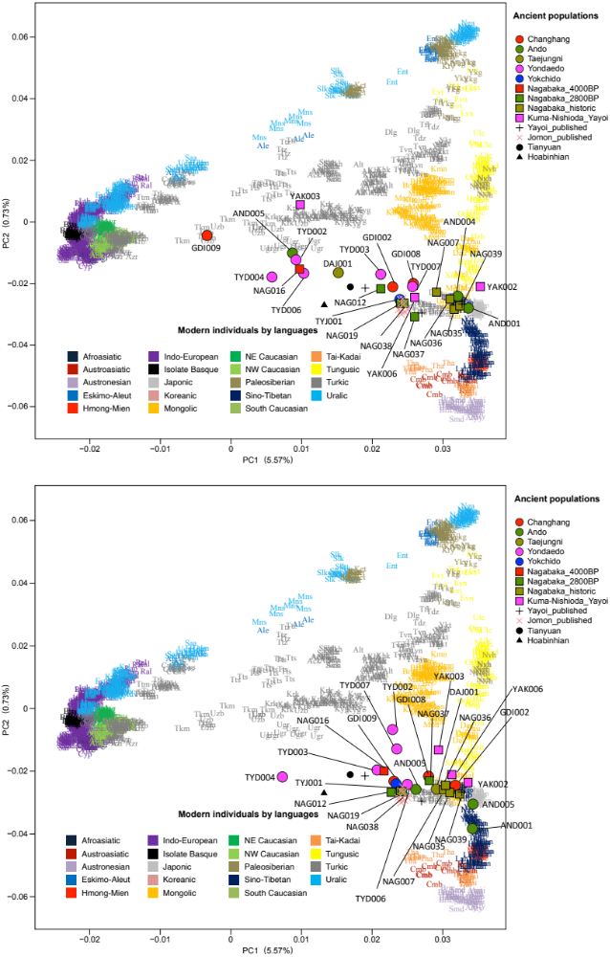
SI 13 Fig. 2. PCA constructed from present-day Eurasian populations. Individuals from this study were projected on the top two variations of the PCA constructed from the modern Eurasian populations.

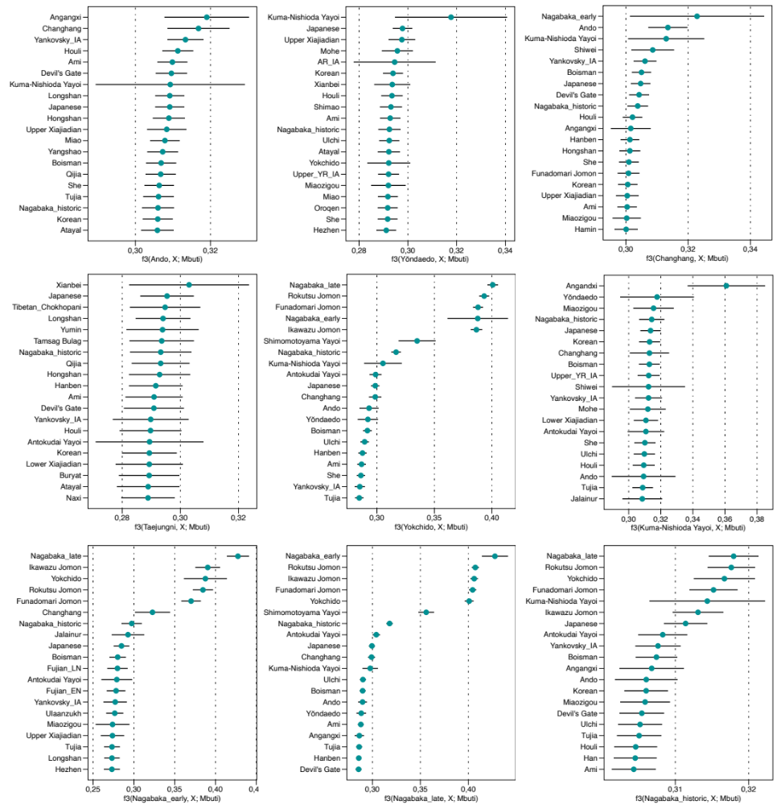

SI 13 Fig. 3. Close genetic affinity of ancient Korean and Japanese populations to the Jōmon-related populations from Japan and ancient populations from China. We present the top 20 outgroup-f3 signals for each population among the 174 non-sub-Saharan African populations. Horizontal bars represent the point estimate ± 1 s.e.m, respectively. s.e.m. are estimated using 5cM block jackknifing.

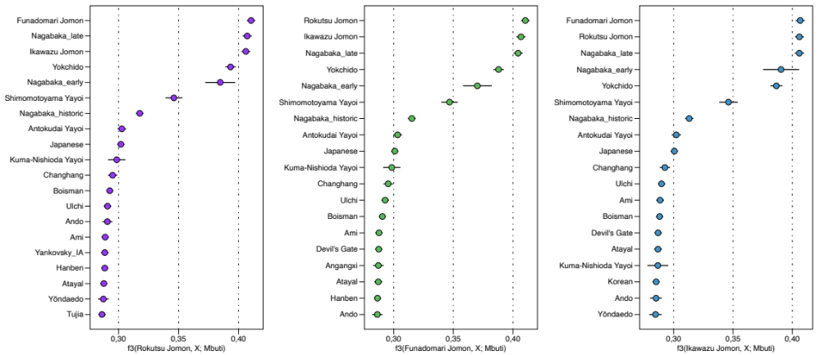
SI 13 Fig. 4. Close genetic affinity between Jōmon individuals. We present the top 20 outgroup-f3 signals for each population among the 174 non-sub-Saharan African populations. Horizontal bars represent the point estimate ± 1 s.e.m, respectively. s.e.m. are estimated using 5cM block jackknifing.

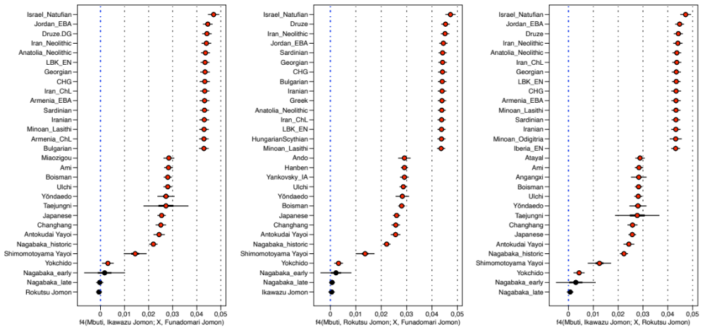
SI 13 Fig. 5. Cladality of Jōmon individuals with respect to other modern and ancient Eurasian populations. We present 15 most positive (upper side) and 15 most negative (lower side) f4(Jōmon1, X; Jōmon2, Mbuti) statistics across 174 world-wide populations. Horizontal bars represent the point estimate ± 3 (thin) and ± 1 (thick) s.e.m, respectively. s.e.m. are estimated using 5 cM block jackknifing.

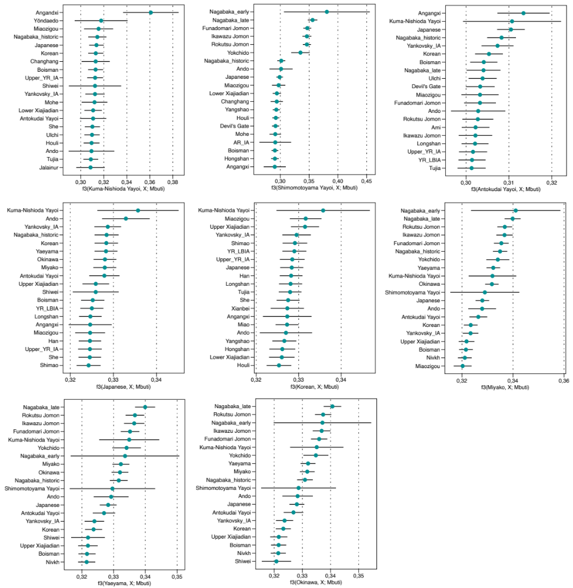
SI 13 Fig. 6. Genetic affinity of Yayoi individuals and modern Ryukyuans from Japan. We present the top 20 outgroup-f3 signals for the Yayoi populations among the 174 non-sub-Saharan African populations in the ‘1240k’ panel. Outgroup-f3 signals for modern mainland Japanese and Korean as well as populations from Ryukyu islands such as Miyako, Yaeyama and Okinawa were estimated from ‘1240k-Illumina’ panel. Horizontal bars represent the point estimate ± 1 s.e.m, respectively. s.e.m. are estimated using 5cM block jackknifing.

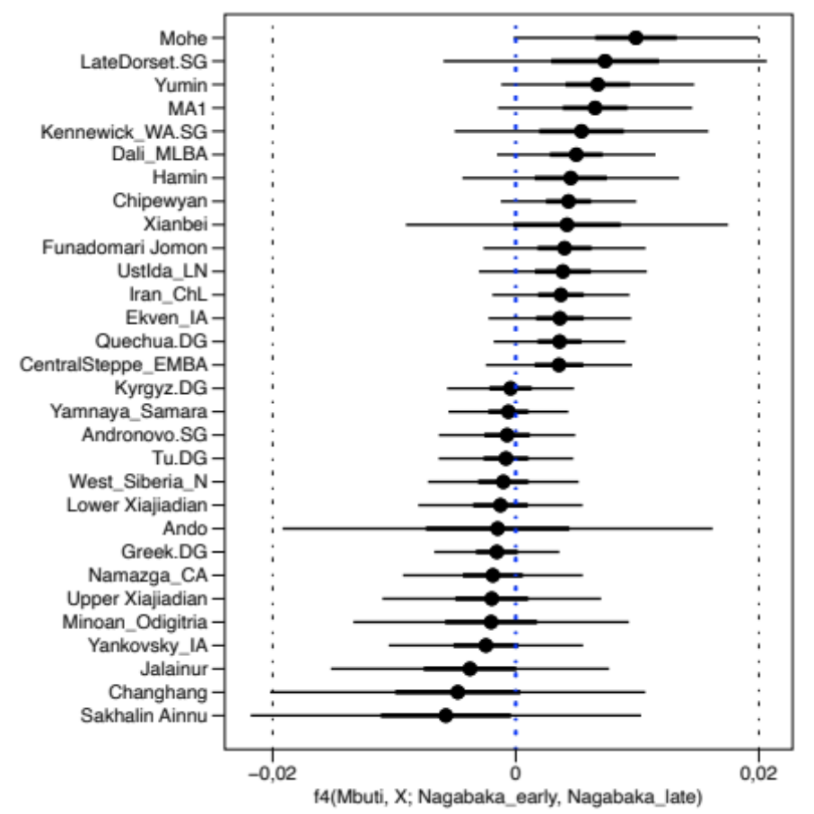
SI 13 Fig. 7. The genetic difference between Early and Late Nagabaka individuals from Miyako island. We present 15 most positive (upper side) and 15 most negative (lower side) f4(Mbuti, X; Nagabaka_early, Nagabaka_late) statistics across 174 world-wide populations. Horizontal bars represent the point estimate ± 3 (thin) and ± 1 (thick) s.e.m, respectivley. s.e.m. are estimated using 5 cM block jackknifing. F4 statistics deviating three s.e.m. or more from zero are marked in red. No significant positive or negative statistics are shown, suggesting a general cladality of between the early and late phase of Nagabaka populations.

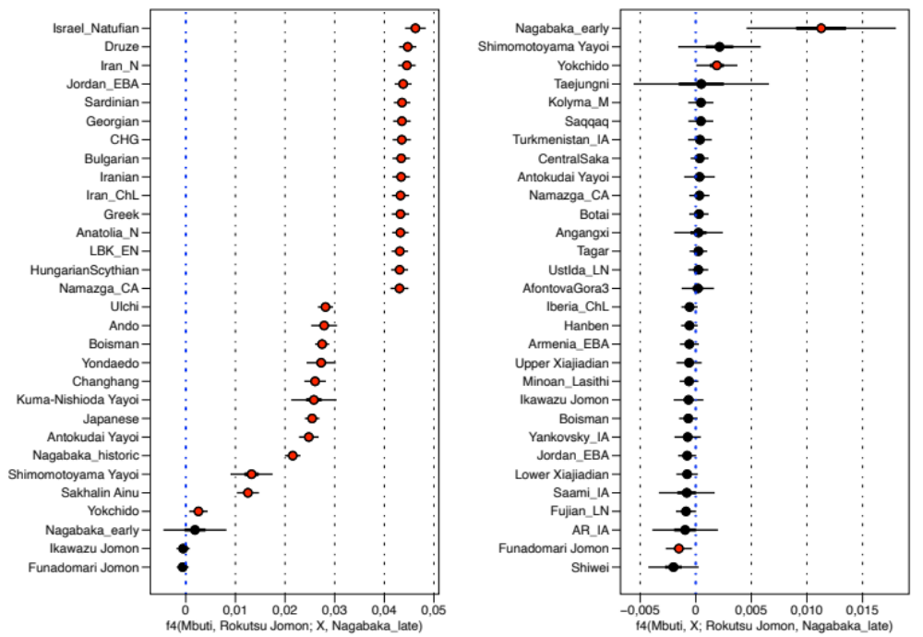SI 13 Fig. 8. The genetic cladality between the Late Nagabaka individuals and Jōmon. We present 15 most positive (upper side) and 15 most negative (lower side) f4(Mbuti, Rokutsu Jomon; X, Nagabaka_late) statistics across 174 world-wide populations. Horizontal bars represent the point estimate ± 3 (thin) and ± 1 (thick) s.e.m, respectivley. s.e.m. are estimated using 5 cM block jackknifing. F4 statistics deviating three s.e.m. or more from zero are marked in red.

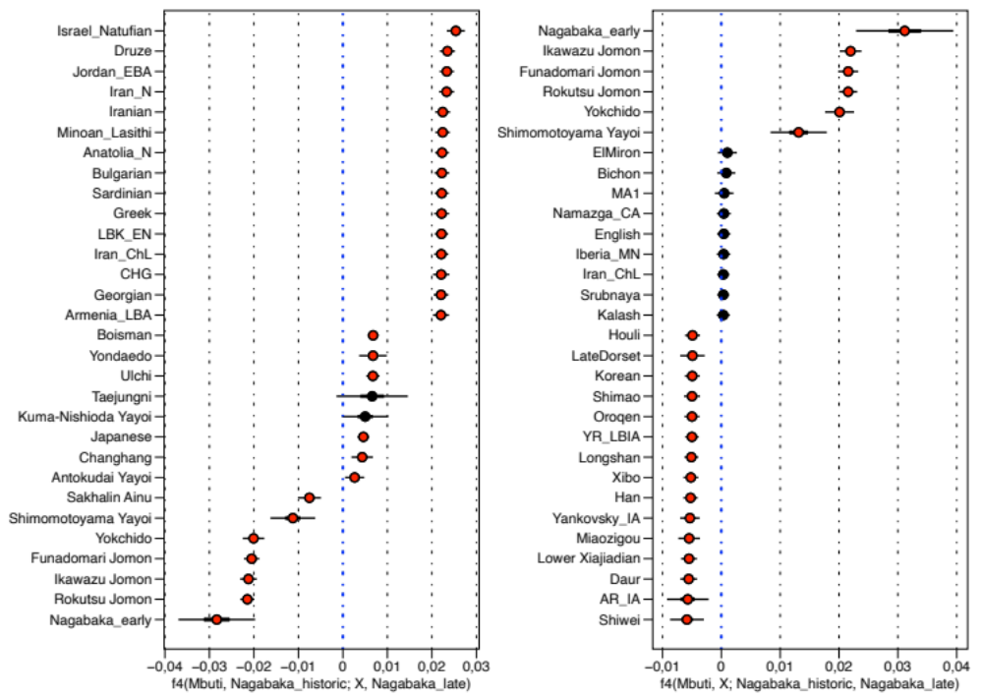
SI 13 Fig. 9. The genetic difference between Late and historic Nagabaka individuals from Miyako island. We present 15 most positive (upper side) and 15 most negative (lower side) f4(Mbuti, Nagabaka_historic; X, Nagabaka_late) and f4(Mbuti, X; Nagabaka_historic, Nagabaka_late) statistics across 174 world-wide populations. Horizontal bars represent the point estimate ± 3 (thin) and ± 1 (thick) s.e.m, respectivley. s.e.m. are estimated using 5 cM block jackknifing. F4 statistics deviating three s.e.m. or more from zero are marked in red.
References

Renaud, G., Slon, V., Duggan, A.T. & Kelso, J. Schmutzi: estimation of contamination and endogenous mitochondrial consensus calling for ancient DNA. Genome Biol. 16, e224 (2015).
Peltzer, A., Jäger, G., Herbig, A., Seitz, A., Kniep, C., Krause, J. & Nieselt, K. EAGER: efficient ancient genome reconstruction. Genome Biol. 17, e60 (2016).
Bausch, I. in The Routledge Handbook of Archaeology and Globalization (ed Hodos, T.) 413-437 (Routledge, 2017).
Imamura, K. Prehistoric Japan: New Perspectives on Insular East Asia (London: UCL Press, 1996).
Kobayashi, T. Jōmon bunka ga Nihonjin no mirai o hiraku (Tokyo: Tokuma shoten, 2018).
Hudson, M.J. Ruins of Identity: Ethnogenesis in the Japanese Islands (Univ. Hawai‘i Press, 1999).
Hanihara, K. Dual structure model for the population history of the Japanese. Jpn. Rev. 2, 1-33 (1991).
Hudson, M.J., Nakagome, S. & Whitman, J.B. The evolving Japanese: the dual structure hypothesis at 30. Evol. Hum. Sci. 2, e6 (2020).
De Boer, E., Yang, M.A., Kawagoe, A. & Barnes, G.L. Japan considered from the hypothesis of farmer/language spread. Evol. Hum. Sci. 2, e13 (2020).
Rivollat, M. et al. Ancient genome-wide DNA from France highlights the complexity of interactions between Mesolithic hunter-gatherers and Neolithic farmers. Sci. Adv. 6, e5344 (2020).
Nakahashi, T. in Interdisciplinary Perspectives on the Origins of the Japanese (ed Omoto, K.) 127-142 (Kyoto: International Research Center for Japanese Studies, 1999).
Hoover, K. & Hudson, M.J. Resilience in prehistoric persistent hunter-gatherers in northwest Kyushu, Japan as assessed by population health and archaeological evidence. Quat. Int. 405(B), 22-33 (2016).
Kaifu, Y., Fujita, M., Yoneda, M. & Yamasaki, S. in Emergence and Diversity of Modern Human Behavior in Paleolithic Asia (ed Kaifu, Y., Izuho, M., Goebel, T., Sato, H. & Ono, A.) 345-361 (Texas A&M Univ. Press, 2015).
Kaifu, Y. et al. Palaeolithic seafaring in East Asia: testing the bamboo raft hypothesis. Antiquity 93, 1424-1441 (2019).
Kaifu, Y., Kuo, T-H., Kubota, Y. & Jan, S. Palaeolithic voyage for invisible islands beyond the horizon. Sci. Rep. 10, e19785 (2020).
Takamiya, H., Hudson, M., Yonenobu, H., Kurozumi, T. & Toizumi, T. An extraordinary case in human history: prehistoric hunter-gatherer adaptation to the islands of the central Ryukyus (Okinawa and Amami archipelagos), Japan. Holocene 26, 408-422 (2015).
Nakagawa, R., Doi, N., Nishioka, Y., Nunami, S., Yamauchi, H., Fujita, M., Yamazaki, S., Yamamoto, M., Katagiri, C., Mukai, H., Matsuzaki, H., Gakuhari, T., Takigami, M. & Yoneda, M. Pleistocene human remains from Shiraho-Saonetabaru cave on Ishigaki island, Okinawa, Japan and their radiocarbon dating. Anthropol. Sci. 118, 173-183 (2010).
Pearson, R. Ancient Ryukyu: An Archaeological Study of Island Communities (Univ. of Hawai‘i Press, 2013).
Summerhayes, G.R. & Anderson, A. An Austronesian presence in southern Japan: early occupation in the Yaeyama islands. Bull. Indo-Pac. Prehist. Assoc. 29, 76-91 (2009).
Hudson, M.J. ‘Austronesian’ and ‘Jōmon’ identities in the Neolithic of the Ryukyu islands. Doc. Praehist. 29, 257-262.
Hudson, M.J. in New Perspectives in Southeast Asian and Pacific Prehistory (ed Piper, P., H. Matsumura, H. & Bulbeck, D.) 189-199 (Canberra: ANU Press, 2017).
Asato, S. The distribution of Tridacna shell adzes in the southern Ryukyu islands. Bull. Indo-Pac. Prehist. Assoc. 10, 282-291 (1991).

