Photo-click hydrogels for 3D in situ differentiation of pancreatic progenitors from induced pluripotent stem cells

Matthew R. Arkenberg¹, Yoshitomo Ueda², Eri Hashino ^{2,3} and Chien-Chi Lin^{1,4,5,}*

¹Weldon School of Biomedical Engineering, Purdue University, West Lafayette, IN 47907, USA
²Department of Otolaryngology-Head and Neck Surgery, Indiana University School of Medicine, Indianapolis, IN 46202, USA
³Stark Neurosciences Research Institute, Indiana University School of Medicine, Indianapolis, IN 46202, USA
⁴Department of Biomedical Engineering, Indiana University-Purdue University Indianapolis, Indianapolis, IN 46202, USA
⁵Indiana University Simon Comprehensive Cancer Center, Indianapolis, IN 46202, USA

(Supporting Information)

*To whom correspondence should be sent:

Chien-Chi Lin, PhD.
Thomas J. Linnemeier Guidant Foundation Endowed Chair & Professor
Department of Biomedical Engineering
Purdue School of Engineering & Technology
Indiana University-Purdue University Indianapolis
723 W. Michigan St. SL220K
Indianapolis, IN 46202, USA
Phone: (317) 274-0760
Email: lincc@iupui.edu

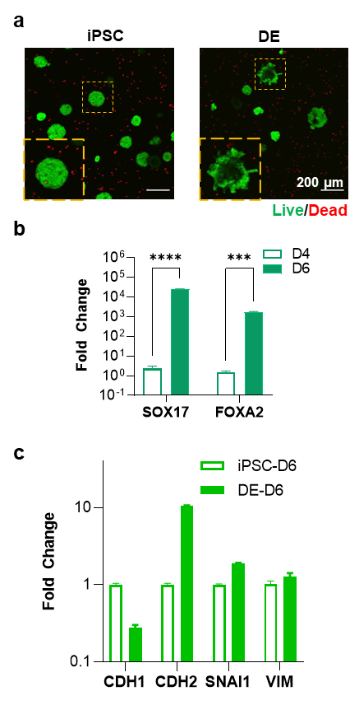
Figure S1. (a) Representative z-stacked images of live/dead stained cell-laden hydrogels. At least 3 regions of interest were imaged (10 slices in each z-stack with a slice height of 10 µm) (b) SOX17/FOXA2 mRNA expression levels pre- and post-DE differentiation in hydrogels. (c) EMT-associated mRNA expression including CDH1, CDH2, SNAI1, and VIM in the IPSCs and DE differentiated samples. Unpaired t-tests were utilized to assess statistical significance (**, ***, and **** represent p-value < 0.01, 0.001, and 0.0001, respectively, N = 3 samples per condition).

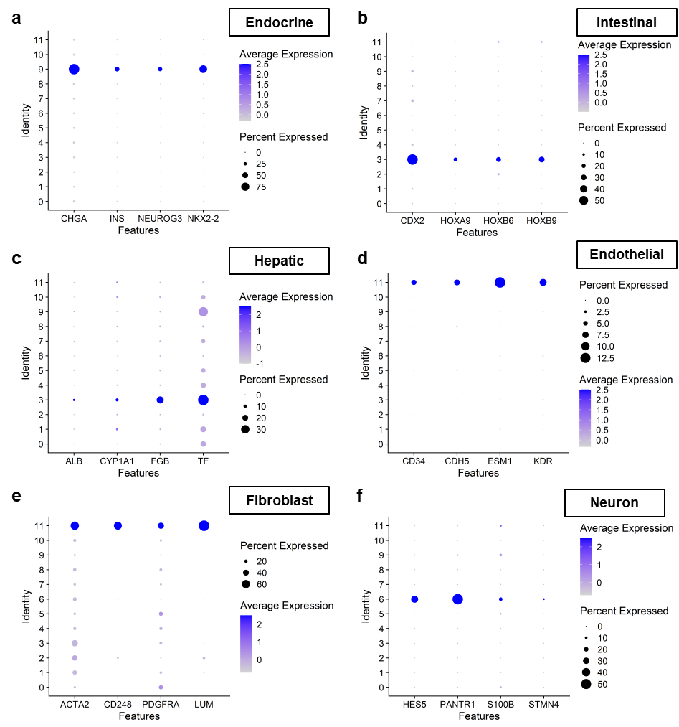

Figure S2. Dot plots of endoderm-associated features for (a) endocrine, (b) intestinal, (c) hepatic cells populations, as well as non-endoderm-associated features for (d) endothelial, (e) fibroblast, and (f) neuron.

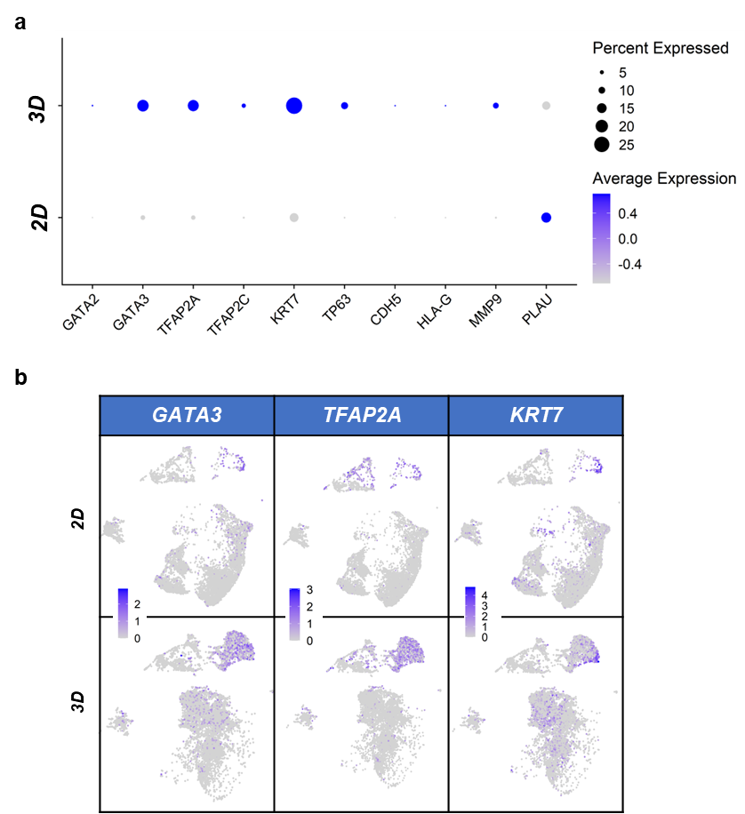
Figure S3. (a) Dot plots of common extra-embryonic markers and GATA3. (b) Feature plots of GATA3, TFAP2A, and KRT7 expression in 2D and 3D conditions.
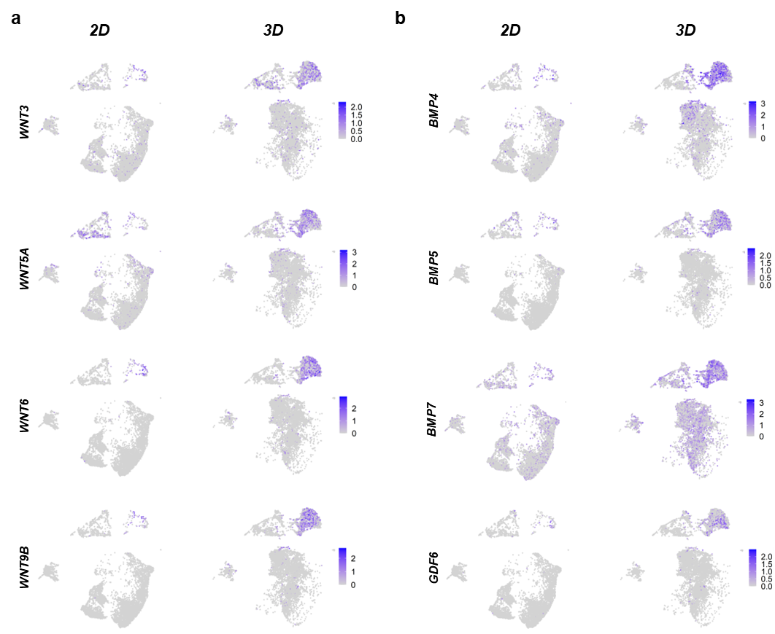
Figure S4. Feature plots of expressed (a) Wnts and (b) BMPs in 2D and 3D conditions.
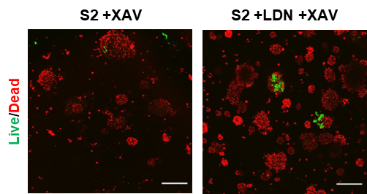
Figure S5. Live/dead staining and imaging of XAV and LDN/XAV treated differentiating iPSCs starting at stage 2 of differentiation.

Table S1. List of antibodies used in studies.
Primary antibodies | Supplier | Species | Type | Dilution
NKX6.1 | Cell Signaling | Rabbit | Monoclonal | 1:200
PDX1 | Santa Cruz | Mouse | Monoclonal | 1:50
GATA4 | Cell Signaling | Rabbit | Monoclonal | 1:200
SOX9 | Santa Cruz | Mouse | Monoclonal | 1:100
TFAP2A | Santa Cruz | Mouse | Monoclonal | 1:50
Secondary antibodies
Anti-rabbit Alexa Fluor 488 | Thermo Scientific | Donkey | Polyclonal | 1:200
Anti-mouse Alexa Fluor 647 | Thermo Scientific | Goat | Polyclonal | 1:200
Anti-goat CruzFluor 647 | Santa Cruz | Mouse | Monoclonal | 1:200

Table S2. List of primers used in studies.
Gene | Forward (5’->3’) | Reverse (5’->3’) | Ref
18S | ATCCCTGAAAAGTTCCAGCA | CCTCTTGGTGAGGTCAATG | ¹
SOX17 | GTGGACCGCACGGAATTTG | GGAGATTCACACCGGAGTCA | ²
FOXA2 | GGAGCAGCTACTATGCAGAGC | CGTGTTCATGCCGTTCATCC | ²
CDH1 | GAAAGCGGCTGATACTGACC | GAAAGCGGCTGATACTGACC | ³
CDH2 | TGTTTGACTATGAAGGCAGTGG | TCAGTCATCACCTCCACCAT | ³
SNAI1 | GAGGCGGTGGCAGACTAG | GACACATCGGTCAGACCAG | ⁴
VIM | GAACGCCAGATGCGTGAAATG | CCAGAGGGAGTGAATCCAGATTA | ⁵
PDX1 | CGTCCGCTTGTTCTCCTC | CCTTTCCCATGGATGAAGTC | ⁶
NKX6.1 | CTTCTGGCCCGGAGTGATG | GGGTCTGGTGTGTTTTCTCTTC | ⁷
SOX9 | AGCGAACGCACATCAAGAC | CTGTAGGCGATCTGTTGGGG | ⁸
PTF1A | AGAGAGTGTCCTGCTAGGGG | CCAGAAGGTCATCATCTGCC | ⁹

Table S3. List of top 30 DEGs in each cluster.
cluster | gene | pct.1 | pct.2 | p_val_adj | avg_log2FC
0 | SPINK1 | 1 | 0.9 | 0 | 2.520169
0 | CPA2 | 0.599 | 0.112 | 0 | 2.403104
0 | DLK1 | 1 | 0.809 | 0 | 2.310845
0 | IGF2 | 1 | 0.711 | 0 | 2.014122
0 | MEST | 0.884 | 0.678 | 0 | 1.573631
0 | AMBP | 0.988 | 0.665 | 0 | 1.503813
0 | H19 | 0.626 | 0.438 | 6.30E-141 | 1.483958
0 | CLPS | 0.116 | 0.024 | 1.20E-109 | 1.457765
0 | RTL1 | 0.641 | 0.137 | 0 | 1.449048
0 | SERPINA1 | 1 | 0.91 | 0 | 1.446966
0 | CPA1 | 0.47 | 0.073 | 0 | 1.369801
0 | STAT1 | 0.84 | 0.536 | 0 | 1.252174
0 | ONECUT1 | 0.963 | 0.557 | 0 | 1.251947
0 | SERPINA3 | 0.593 | 0.209 | 0 | 1.207238
0 | SOX9 | 0.907 | 0.608 | 0 | 1.177684
0 | TM4SF4 | 0.778 | 0.328 | 0 | 1.172812
0 | SERPINA5 | 0.841 | 0.404 | 0 | 1.166969
0 | CLU | 0.982 | 0.819 | 0 | 1.087501
0 | SLC4A4 | 0.808 | 0.438 | 0 | 1.079502
0 | MEG3 | 0.581 | 0.16 | 0 | 1.068314
0 | SFRP5 | 0.649 | 0.244 | 0 | 1.053501
0 | AUXG01000058.1 | 0.539 | 0.323 | 1.56E-141 | 1.034765
0 | LEFTY1 | 0.4 | 0.144 | 2.11E-217 | 0.938402
0 | CLMN | 0.67 | 0.228 | 0 | 0.931646
0 | FLRT2 | 0.948 | 0.632 | 0 | 0.931559
0 | CCND1 | 0.978 | 0.916 | 2.45E-229 | 0.929242
0 | MTUS1 | 0.835 | 0.525 | 0 | 0.921436
0 | GATM | 0.58 | 0.285 | 1.37E-235 | 0.911363
0 | LAPTM4B | 1 | 0.984 | 0 | 0.898356
0 | F3 | 0.487 | 0.221 | 5.75E-203 | 0.884992
1 | THBS1 | 0.787 | 0.271 | 0 | 2.011831
1 | PLA2G2A | 0.383 | 0.088 | 0 | 1.68496
1 | FST | 0.704 | 0.315 | 0 | 1.391653
1 | EDN1 | 0.484 | 0.191 | 4.76E-213 | 1.343089
1 | NUDT4 | 0.862 | 0.564 | 6.12E-293 | 1.065797
1 | RGS5 | 0.601 | 0.199 | 0 | 1.05972
1 | DKK1 | 0.347 | 0.078 | 2.78E-293 | 1.025131
1 | TTR | 0.743 | 0.405 | 6.04E-297 | 1.006702
1 | C1GALT1 | 0.836 | 0.548 | 6.31E-301 | 0.989206
1 | PRSS2 | 0.607 | 0.284 | 5.74E-203 | 0.968094
1 | JUN | 0.91 | 0.62 | 2.84E-278 | 0.968063
1 | DCDC2 | 0.882 | 0.561 | 2.62E-299 | 0.935941
1 | PAGE4 | 0.191 | 0.029 | 2.93E-210 | 0.910853
1 | FN1 | 1 | 0.977 | 2.88E-210 | 0.862382
1 | VCAN | 1 | 0.975 | 1.19E-293 | 0.8189
1 | TPPP3 | 0.395 | 0.104 | 1.72E-280 | 0.795449
1 | ETFB | 0.976 | 0.908 | 1.22E-239 | 0.77577
1 | NR2F2 | 0.8 | 0.531 | 8.74E-206 | 0.770972
1 | GASK1B | 0.611 | 0.255 | 1.31E-257 | 0.762892
1 | MAP4K4 | 0.968 | 0.931 | 2.79E-150 | 0.727934
1 | SLIT3 | 0.58 | 0.289 | 7.91E-178 | 0.725999
1 | BEX5 | 0.4 | 0.261 | 4.92E-45 | 0.71483
1 | SERPINE2 | 0.736 | 0.456 | 2.02E-148 | 0.712743
1 | CCND2 | 0.98 | 0.92 | 9.80E-169 | 0.708745
1 | EPSTI1 | 0.479 | 0.191 | 2.31E-203 | 0.700716
1 | CYYR1 | 0.499 | 0.245 | 2.47E-159 | 0.69622
1 | HAS2 | 0.595 | 0.285 | 5.39E-174 | 0.686123
1 | FBLN2 | 0.514 | 0.171 | 2.09E-259 | 0.682068
1 | DPYSL3 | 0.789 | 0.654 | 1.35E-77 | 0.673731
1 | SLC2A3 | 0.776 | 0.51 | 3.61E-135 | 0.66176
2 | CXCL14 | 0.78 | 0.071 | 0 | 4.670497
2 | MIR205HG | 0.937 | 0.213 | 0 | 2.712285
2 | S100A3 | 0.576 | 0.073 | 0 | 2.316735
2 | FABP5 | 0.956 | 0.898 | 2.25E-156 | 2.216499
2 | NPY | 0.487 | 0.073 | 0 | 2.180049
2 | CCDC80 | 0.901 | 0.317 | 0 | 2.047503
2 | ARHGAP29 | 0.851 | 0.41 | 0 | 2.023437
2 | CRABP2 | 0.989 | 0.586 | 0 | 1.9889
2 | ANXA1 | 0.664 | 0.088 | 0 | 1.874636
2 | BMP4 | 0.739 | 0.128 | 0 | 1.841113
2 | ARL4C | 0.947 | 0.549 | 0 | 1.707661
2 | COL1A2 | 0.948 | 0.474 | 0 | 1.666447
2 | TFAP2B | 0.712 | 0.039 | 0 | 1.582863
2 | S100A9 | 0.101 | 0.008 | 5.94E-167 | 1.577778
2 | ADAMTS5 | 0.554 | 0.047 | 0 | 1.511961
2 | STC1 | 0.758 | 0.346 | 0 | 1.500886
2 | CDK6 | 0.87 | 0.47 | 0 | 1.498471
2 | MEIS2 | 0.983 | 0.756 | 0 | 1.474401
2 | WNT6 | 0.628 | 0.019 | 0 | 1.462856
2 | WLS | 0.966 | 0.854 | 0 | 1.45024
2 | SFN | 0.468 | 0.049 | 0 | 1.421455
2 | EFEMP1 | 0.69 | 0.132 | 0 | 1.415267
2 | SYNPO2 | 0.604 | 0.038 | 0 | 1.391273
2 | DLX5 | 0.619 | 0.024 | 0 | 1.385081
2 | COL5A2 | 0.734 | 0.116 | 0 | 1.38261
2 | BMP7 | 0.763 | 0.319 | 0 | 1.382441
2 | TPM1 | 0.999 | 0.99 | 0 | 1.381936
2 | MMP9 | 0.261 | 0.023 | 0 | 1.338517
2 | NET1 | 0.83 | 0.478 | 0 | 1.33828
2 | KRT7 | 0.427 | 0.176 | 2.67E-156 | 1.327358
3 | LCN15 | 0.861 | 0.147 | 0 | 4.572456
3 | AFP | 0.32 | 0.106 | 1.39E-149 | 4.554451
3 | GNRH2 | 0.482 | 0.039 | 0 | 4.308458
3 | APOA2 | 0.927 | 0.361 | 0 | 3.905241
3 | APOA1 | 0.931 | 0.494 | 0 | 3.862622
3 | CKB | 0.999 | 0.963 | 0 | 3.407218
3 | TTR | 0.781 | 0.412 | 4.07E-291 | 3.252864
3 | FGB | 0.251 | 0.025 | 0 | 3.120716
3 | IGFBP6 | 0.88 | 0.252 | 0 | 3.082922
3 | APOA4 | 0.101 | 0.013 | 2.46E-110 | 2.885224
3 | LGALS3 | 0.844 | 0.224 | 0 | 2.711253
3 | FABP1 | 0.266 | 0.134 | 3.53E-47 | 2.540421
3 | APOC3 | 0.133 | 0.056 | 6.18E-30 | 2.431893
3 | CST1 | 0.515 | 0.04 | 0 | 2.192997
3 | FN1 | 1 | 0.978 | 0 | 2.004816
3 | SERPINE2 | 0.893 | 0.448 | 0 | 1.919227
3 | FBLN2 | 0.806 | 0.15 | 0 | 1.917749
3 | RBP4 | 0.241 | 0.024 | 0 | 1.834013
3 | FGG | 0.185 | 0.009 | 0 | 1.829754
3 | SLC2A3 | 0.909 | 0.504 | 0 | 1.799002
3 | TF | 0.385 | 0.142 | 2.08E-153 | 1.796666
3 | NENF | 0.948 | 0.711 | 0 | 1.749585
3 | APOB | 0.355 | 0.155 | 1.15E-95 | 1.650781
3 | TFF1 | 0.216 | 0.046 | 1.35E-155 | 1.538058
3 | CST3 | 1 | 0.988 | 0 | 1.534802
3 | SAT1 | 0.991 | 0.896 | 0 | 1.531935
3 | SHH | 0.63 | 0.098 | 0 | 1.531338
3 | PRSS2 | 0.565 | 0.299 | 3.15E-112 | 1.530248
3 | KRT18 | 1 | 0.984 | 0 | 1.51588
3 | APOC1 | 0.726 | 0.496 | 7.88E-94 | 1.449754
4 | TOP2A | 0.997 | 0.43 | 0 | 2.383934
4 | CENPF | 0.992 | 0.506 | 0 | 2.246173
4 | UBE2C | 0.951 | 0.283 | 0 | 2.111425
4 | MKI67 | 0.963 | 0.286 | 0 | 2.084409
4 | NUSAP1 | 0.989 | 0.374 | 0 | 1.960066
4 | ASPM | 0.895 | 0.248 | 0 | 1.871586
4 | DLGAP5 | 0.952 | 0.263 | 0 | 1.85873
4 | TPX2 | 0.953 | 0.363 | 0 | 1.816758
4 | CCNB1 | 0.917 | 0.359 | 0 | 1.800165
4 | HMGB2 | 0.997 | 0.549 | 0 | 1.768797
4 | CDK1 | 0.943 | 0.31 | 0 | 1.662588
4 | CENPE | 0.832 | 0.259 | 0 | 1.661175
4 | PRC1 | 0.936 | 0.31 | 0 | 1.571097
4 | BIRC5 | 0.938 | 0.302 | 0 | 1.531907
4 | PTTG1 | 0.974 | 0.627 | 0 | 1.510881
4 | KIF11 | 0.903 | 0.275 | 0 | 1.488125
4 | CCNB2 | 0.84 | 0.253 | 0 | 1.46089
4 | SGO2 | 0.876 | 0.307 | 0 | 1.429415
4 | GTSE1 | 0.837 | 0.201 | 0 | 1.367315
4 | TACC3 | 0.848 | 0.245 | 0 | 1.349959
4 | KPNA2 | 0.924 | 0.592 | 2.02E-302 | 1.338933
4 | HMMR | 0.762 | 0.177 | 0 | 1.320319
4 | PBK | 0.881 | 0.25 | 0 | 1.287185
4 | H19 | 0.559 | 0.461 | 2.80E-35 | 1.286789
4 | ARL6IP1 | 0.995 | 0.95 | 3.14E-302 | 1.284183
4 | CALB1 | 0.435 | 0.162 | 7.41E-139 | 1.265265
4 | KIF20B | 0.911 | 0.384 | 0 | 1.264747
4 | CDC20 | 0.665 | 0.179 | 0 | 1.264178
4 | AURKA | 0.711 | 0.191 | 0 | 1.255954
4 | ECT2 | 0.881 | 0.374 | 0 | 1.254768
5 | GAL | 0.84 | 0.186 | 0 | 2.83142
5 | AREG | 0.789 | 0.221 | 0 | 2.642556
5 | SERPINA1 | 0.999 | 0.919 | 0 | 2.381188
5 | TIMP1 | 0.993 | 0.919 | 0 | 2.312675
5 | PMEPA1 | 0.931 | 0.45 | 0 | 1.963181
5 | ATF3 | 0.751 | 0.331 | 9.78E-284 | 1.916405
5 | KLF6 | 0.941 | 0.604 | 0 | 1.879021
5 | PDGFB | 0.816 | 0.303 | 0 | 1.842
5 | AKAP12 | 0.746 | 0.352 | 1.25E-226 | 1.817617
5 | MRC2 | 0.926 | 0.4 | 0 | 1.749678
5 | IGFBP5 | 0.916 | 0.696 | 7.12E-155 | 1.650647
5 | PON2 | 0.991 | 0.801 | 0 | 1.623518
5 | LYPD1 | 0.884 | 0.353 | 0 | 1.619127
5 | RHOB | 0.948 | 0.543 | 0 | 1.598089
5 | TGFB1 | 0.981 | 0.588 | 0 | 1.592307
5 | CXCL8 | 0.281 | 0.044 | 4.02E-237 | 1.582444
5 | BGN | 0.859 | 0.253 | 0 | 1.550139
5 | IGFBP7 | 0.936 | 0.482 | 0 | 1.54886
5 | SERPINA3 | 0.758 | 0.233 | 0 | 1.526408
5 | IER3 | 0.897 | 0.687 | 4.54E-207 | 1.501583
5 | NPW | 0.905 | 0.34 | 0 | 1.472192
5 | CTSZ | 0.836 | 0.431 | 0 | 1.469369
5 | DUSP1 | 0.707 | 0.259 | 0 | 1.463834
5 | CRLF1 | 0.768 | 0.258 | 0 | 1.460689
5 | TESC | 0.917 | 0.411 | 0 | 1.457609
5 | TCIM | 0.956 | 0.627 | 0 | 1.445446
5 | JUNB | 0.88 | 0.469 | 0 | 1.429882
5 | SPP1 | 0.89 | 0.55 | 4.82E-227 | 1.348997
5 | LEFTY1 | 0.595 | 0.152 | 0 | 1.295413
5 | RND1 | 0.632 | 0.192 | 0 | 1.280294
6 | CRABP1 | 0.524 | 0.098 | 0 | 3.686032
6 | PTN | 0.94 | 0.411 | 0 | 3.66019
6 | PTPRZ1 | 0.854 | 0.07 | 0 | 2.623853
6 | NR2F1 | 0.932 | 0.404 | 0 | 2.286106
6 | SFRP2 | 0.648 | 0.034 | 0 | 2.101507
6 | MAP1B | 0.987 | 0.702 | 0 | 1.913277
6 | SOX2 | 0.83 | 0.232 | 0 | 1.828432
6 | ZIC1 | 0.491 | 0.018 | 0 | 1.695366
6 | NEFM | 0.361 | 0.089 | 2.40E-187 | 1.659873
6 | FGFBP3 | 0.587 | 0.093 | 0 | 1.620184
6 | ZEB2 | 0.644 | 0.062 | 0 | 1.51782
6 | TMSB15A | 0.973 | 0.597 | 0 | 1.510977
6 | NEFL | 0.475 | 0.054 | 0 | 1.490287
6 | HES5 | 0.335 | 0.007 | 0 | 1.449624
6 | VIM | 1 | 0.948 | 0 | 1.439477
6 | PEG10 | 0.982 | 0.92 | 4.97E-142 | 1.432386
6 | PANTR1 | 0.521 | 0.009 | 0 | 1.397549
6 | HIST1H1D | 0.578 | 0.354 | 7.70E-88 | 1.392305
6 | METRN | 0.919 | 0.589 | 0 | 1.384726
6 | PRTG | 0.832 | 0.551 | 2.86E-202 | 1.379481
6 | POU3F2 | 0.539 | 0.044 | 0 | 1.339131
6 | TUBB2B | 0.995 | 0.891 | 0 | 1.303567
6 | FZD3 | 0.896 | 0.602 | 0 | 1.286246
6 | GAP43 | 0.295 | 0.044 | 2.76E-257 | 1.272973
6 | RMST | 0.43 | 0.077 | 0 | 1.222694
6 | HMGN2 | 0.999 | 0.973 | 3.75E-210 | 1.22184
6 | TUBA1A | 0.999 | 0.961 | 6.31E-262 | 1.203968
6 | HMGB2 | 0.89 | 0.562 | 4.41E-164 | 1.177889
6 | HIST2H2AC | 0.475 | 0.265 | 3.22E-79 | 1.165758
6 | TOP2A | 0.789 | 0.451 | 1.53E-108 | 1.155316
7 | CALB1 | 0.664 | 0.153 | 0 | 2.069207
7 | NKX6-2 | 0.634 | 0.171 | 1.97E-292 | 1.558897
7 | H19 | 0.669 | 0.456 | 3.05E-71 | 1.429815
7 | ONECUT1 | 0.995 | 0.6 | 1.52E-303 | 1.394989
7 | SLC4A4 | 0.925 | 0.472 | 1.24E-265 | 1.264102
7 | ANXA4 | 0.955 | 0.608 | 6.87E-256 | 1.223946
7 | ONECUT2 | 0.72 | 0.286 | 5.93E-199 | 1.172834
7 | CCND1 | 0.983 | 0.922 | 4.85E-138 | 1.141106
7 | CLU | 0.993 | 0.836 | 8.46E-200 | 1.117644
7 | AMBP | 0.984 | 0.701 | 1.96E-197 | 1.099869
7 | AC011139.1 | 0.422 | 0.081 | 9.63E-265 | 1.072505
7 | HABP2 | 0.729 | 0.272 | 6.57E-242 | 1.057018
7 | SPP1 | 0.638 | 0.572 | 1.21E-12 | 1.055086
7 | IGF2 | 0.989 | 0.744 | 1.99E-171 | 1.050554
7 | SFRP5 | 0.8 | 0.28 | 2.04E-267 | 1.015968
7 | FZD5 | 0.891 | 0.535 | 8.77E-175 | 0.998779
7 | CDH6 | 0.909 | 0.617 | 1.78E-140 | 0.946218
7 | RGS2 | 0.539 | 0.294 | 5.31E-68 | 0.936034
7 | GUCY1A2 | 0.79 | 0.489 | 4.54E-117 | 0.902924
7 | UPK1B | 0.475 | 0.128 | 1.50E-197 | 0.89846
7 | CD24 | 1 | 0.997 | 1.44E-238 | 0.88481
7 | SAMD5 | 0.722 | 0.318 | 2.21E-167 | 0.866456
7 | SPRY2 | 0.924 | 0.739 | 4.42E-142 | 0.848477
7 | TOX3 | 0.797 | 0.531 | 1.89E-118 | 0.823774
7 | LHFPL3-AS2 | 0.596 | 0.236 | 5.98E-147 | 0.799659
7 | LYZ | 0.459 | 0.159 | 1.86E-129 | 0.799395
7 | MECOM | 0.832 | 0.535 | 4.35E-129 | 0.787331
7 | NDFIP2 | 0.82 | 0.533 | 2.15E-129 | 0.776555
7 | ADGRG6 | 0.801 | 0.482 | 1.95E-115 | 0.75984
7 | LINC00261 | 0.837 | 0.591 | 2.77E-88 | 0.749694
8 | LTB | 0.929 | 0.139 | 0 | 3.843795
8 | IL32 | 0.972 | 0.3 | 0 | 3.512208
8 | AREG | 0.765 | 0.232 | 0 | 3.108937
8 | NPPB | 0.486 | 0.109 | 5.98E-268 | 3.099501
8 | PLAU | 0.718 | 0.103 | 0 | 2.370889
8 | TAGLN | 0.92 | 0.687 | 3.39E-220 | 2.222018
8 | TM4SF1 | 0.994 | 0.631 | 0 | 2.218327
8 | TACSTD2 | 0.964 | 0.413 | 0 | 2.12194
8 | CXCL8 | 0.382 | 0.042 | 0 | 2.050739
8 | S100A6 | 0.999 | 0.959 | 0 | 2.04341
8 | GDF15 | 0.716 | 0.372 | 5.69E-168 | 2.004313
8 | CCL2 | 0.375 | 0.06 | 1.15E-275 | 1.915174
8 | CGA | 0.57 | 0.128 | 0 | 1.831189
8 | AC022075.1 | 0.749 | 0.213 | 0 | 1.651015
8 | SDC4 | 0.966 | 0.564 | 0 | 1.639428
8 | PDGFB | 0.753 | 0.315 | 1.62E-223 | 1.631025
8 | CXCL12 | 0.79 | 0.24 | 0 | 1.619514
8 | RAB11FIP1 | 0.952 | 0.596 | 0 | 1.609861
8 | ACTC1 | 0.279 | 0.128 | 3.04E-39 | 1.584921
8 | ANKRD1 | 0.436 | 0.329 | 1.89E-15 | 1.579639
8 | ACTA1 | 0.206 | 0.029 | 1.66E-162 | 1.577883
8 | AKAP12 | 0.681 | 0.363 | 7.82E-115 | 1.570104
8 | IL11 | 0.57 | 0.113 | 0 | 1.555362
8 | CDH6 | 0.977 | 0.613 | 0 | 1.555028
8 | TNC | 0.756 | 0.302 | 1.68E-233 | 1.535558
8 | TMEM265 | 0.826 | 0.177 | 0 | 1.52326
8 | TESC | 0.936 | 0.418 | 0 | 1.478538
8 | MYL9 | 0.914 | 0.59 | 7.52E-219 | 1.45901
8 | CLDN6 | 0.995 | 0.819 | 0 | 1.434595
8 | NEAT1 | 0.996 | 0.974 | 1.45E-246 | 1.429404
9 | CHGA | 0.982 | 0.12 | 0 | 6.95249
9 | INS | 0.383 | 0.032 | 0 | 5.104942
9 | SST | 0.119 | 0.045 | 3.44E-20 | 4.835964
9 | CRYBA2 | 0.789 | 0.015 | 0 | 3.277838
9 | NEUROD1 | 0.934 | 0.011 | 0 | 3.185694
9 | C1QL1 | 0.955 | 0.043 | 0 | 3.177797
9 | STMN2 | 0.939 | 0.034 | 0 | 3.151428
9 | DDC | 0.91 | 0.038 | 0 | 3.138343
9 | INSM1 | 0.904 | 0.021 | 0 | 2.966475
9 | FEV | 0.908 | 0.014 | 0 | 2.954617
9 | SCGN | 0.976 | 0.193 | 0 | 2.922571
9 | ASCL1 | 0.68 | 0.017 | 0 | 2.921318
9 | SCG2 | 0.781 | 0.02 | 0 | 2.809784
9 | SCG3 | 0.926 | 0.063 | 0 | 2.619034
9 | PCSK1N | 0.994 | 0.702 | 0 | 2.562034
9 | C9orf16 | 0.991 | 0.866 | 0 | 2.452468
9 | MIR7-3HG | 0.881 | 0.013 | 0 | 2.431983
9 | CACNA2D1 | 0.883 | 0.06 | 0 | 2.422323
9 | CPE | 0.999 | 0.757 | 0 | 2.415722
9 | KCTD12 | 0.828 | 0.068 | 0 | 2.338746
9 | SEZ6L | 0.855 | 0.044 | 0 | 2.335642
9 | CXXC4 | 0.977 | 0.548 | 0 | 2.286293
9 | PCSK1 | 0.649 | 0.007 | 0 | 2.280192
9 | PPP1R1A | 0.877 | 0.181 | 0 | 2.20847
9 | RUNX1T1 | 0.831 | 0.065 | 0 | 2.15156
9 | ALDH1A1 | 0.904 | 0.239 | 0 | 2.097081
9 | GC | 0.409 | 0.017 | 0 | 2.043033
9 | SIM1 | 0.838 | 0.239 | 0 | 1.96672
9 | FABP7 | 0.544 | 0.07 | 0 | 1.9504
9 | PTPRN | 0.827 | 0.015 | 0 | 1.928723
10 | SOX2 | 0.916 | 0.24 | 0 | 2.044643
10 | IGFBP5 | 0.926 | 0.701 | 3.09E-133 | 1.613425
10 | PLEKHA5 | 0.908 | 0.623 | 2.24E-238 | 1.436514
10 | NPY | 0.376 | 0.106 | 1.10E-124 | 1.346548
10 | ANGPT2 | 0.743 | 0.358 | 1.18E-180 | 1.325598
10 | CLDN18 | 0.319 | 0.156 | 2.72E-38 | 1.256242
10 | SULF1 | 0.358 | 0.107 | 5.45E-120 | 1.223218
10 | PTPN13 | 0.669 | 0.253 | 1.41E-216 | 1.192291
10 | TXNIP | 0.973 | 0.773 | 1.21E-216 | 1.16848
10 | HOTAIRM1 | 0.696 | 0.308 | 9.19E-174 | 1.149465
10 | SOX21 | 0.576 | 0.076 | 0 | 1.110427
10 | TNNT1 | 0.81 | 0.403 | 3.62E-182 | 1.108047
10 | SPINK5 | 0.301 | 0.036 | 1.59E-269 | 1.107743
10 | PCDH19 | 0.435 | 0.057 | 0 | 1.072445
10 | CADM1 | 0.95 | 0.902 | 4.58E-91 | 1.040017
10 | DMD | 0.566 | 0.185 | 1.66E-195 | 1.034482
10 | LINC02381 | 0.925 | 0.65 | 1.84E-181 | 1.02006
10 | CEACAM6 | 0.373 | 0.05 | 2.04E-302 | 0.97752
10 | FRZB | 0.326 | 0.099 | 6.00E-98 | 0.972747
10 | CD9 | 0.711 | 0.245 | 1.43E-220 | 0.943281
10 | TMSB4X | 1 | 1 | 8.94E-138 | 0.93442
10 | KLF5 | 0.702 | 0.427 | 1.51E-97 | 0.928805
10 | AGR3 | 0.387 | 0.055 | 5.72E-298 | 0.926341
10 | C19orf33 | 0.55 | 0.226 | 2.89E-120 | 0.89594
10 | NUDT4 | 0.814 | 0.59 | 8.33E-83 | 0.894451
10 | MIR205HG | 0.671 | 0.275 | 1.16E-133 | 0.871283
10 | SCNN1A | 0.639 | 0.222 | 2.51E-201 | 0.861507
10 | IGDCC3 | 0.888 | 0.646 | 2.39E-118 | 0.855897
10 | PLA2G2A | 0.151 | 0.125 | 1 | 0.788237
10 | NR2F2 | 0.771 | 0.554 | 8.88E-67 | 0.782999
11 | COL3A1 | 0.883 | 0.097 | 0 | 4.132443
11 | LGALS1 | 0.914 | 0.26 | 0 | 3.818895
11 | COL1A1 | 0.955 | 0.479 | 2.29E-240 | 3.425046
11 | LUM | 0.777 | 0.035 | 0 | 3.406115
11 | ACTA2 | 0.604 | 0.231 | 3.34E-105 | 3.214171
11 | ACTC1 | 0.392 | 0.13 | 4.88E-63 | 2.976214
11 | COL1A2 | 0.959 | 0.516 | 4.90E-225 | 2.908414
11 | COL6A3 | 0.682 | 0.039 | 0 | 2.781894
11 | TAGLN | 0.968 | 0.694 | 1.90E-164 | 2.628687
11 | ITGA1 | 0.75 | 0.156 | 1.16E-298 | 2.525444
11 | COL4A1 | 0.806 | 0.385 | 1.42E-136 | 2.508119
11 | SPARC | 0.964 | 0.54 | 2.82E-197 | 2.484634
11 | CCN2 | 0.775 | 0.399 | 7.88E-97 | 2.456752
11 | TPM2 | 0.991 | 0.761 | 2.00E-215 | 2.373501
11 | ESM1 | 0.131 | 0.003 | 1.75E-224 | 2.312091
11 | DCN | 0.493 | 0.015 | 0 | 2.238922
11 | TPM1 | 0.998 | 0.991 | 3.50E-155 | 2.235557
11 | GNG11 | 0.831 | 0.084 | 0 | 2.23294
11 | ANXA1 | 0.727 | 0.138 | 7.43E-286 | 2.209857
11 | CDH11 | 0.829 | 0.102 | 0 | 2.199465
11 | TIMP3 | 0.752 | 0.179 | 5.19E-236 | 2.17102
11 | IGFBP7 | 0.851 | 0.507 | 1.22E-120 | 2.110698
11 | CALD1 | 1 | 0.966 | 3.88E-182 | 2.105211
11 | PAPPA | 0.403 | 0.147 | 1.50E-56 | 2.079364
11 | MT2A | 0.473 | 0.046 | 0 | 2.062394
11 | MYL9 | 0.939 | 0.6 | 1.24E-167 | 2.060777
11 | VIM | 1 | 0.951 | 8.04E-212 | 2.027305
11 | COL5A2 | 0.883 | 0.167 | 0 | 2.017326
11 | COL5A1 | 0.707 | 0.227 | 6.52E-154 | 1.950573
11 | CCDC80 | 0.876 | 0.371 | 4.50E-162 | 1.928981

References
1. Pombo-Suarez, M.; Calaza, M.; Gomez-Reino, J. J.; Gonzalez, A., Reference genes for normalization of gene expression studies in human osteoarthritic articular cartilage. BMC molecular biology 2008, 9 (1), 1-7.
2. Hildebrand, L.; Rossbach, B.; Kühnen, P.; Gossen, M.; Kurtz, A.; Reinke, P.; Seemann, P.; Stachelscheid, H., Generation of integration free induced pluripotent stem cells from fibrodysplasia ossificans progressiva (FOP) patients from urine samples. Stem Cell Research 2016, 16 (1), 54-58.
3. Alexander, N. R.; Tran, N. L.; Rekapally, H.; Summers, C. E.; Glackin, C.; Heimark, R. L., N-cadherin gene expression in prostate carcinoma is modulated by integrin-dependent nuclear translocation of Twist1. Cancer research 2006, 66 (7), 3365-3369.
4. Messai, Y.; Noman, M. Z.; Derouiche, A.; Kourda, N.; Akalay, I.; Hasmim, M.; Stasik, I.; Ben Jilani, S.; Chebil, M.; Caignard, A., Cytokeratin 18 expression pattern correlates with renal cell carcinoma progression: relationship with Snail. International journal of oncology 2010, 36 (5), 1145-1154.
5. Lou, C.; Zhang, F.; Yang, M.; Zhao, J.; Zeng, W.; Fang, X.; Zhang, Y.; Zhang, C.; Liang, W., Naringenin decreases invasiveness and metastasis by inhibiting TGF-β-induced epithelial to mesenchymal transition in pancreatic cancer cells. PloS one 2012, 7 (12), e50956.
6. Velazco-Cruz, L.; Song, J.; Maxwell, K. G.; Goedegebuure, M. M.; Augsornworawat, P.; Hogrebe, N. J.; Millman, J. R., Acquisition of dynamic function in human stem cell-derived β cells. Stem cell reports 2019, 12 (2), 351-365.
7. Taylor, B. L.; Liu, F.-F.; Sander, M., Nkx6. 1 is essential for maintaining the functional state of pancreatic beta cells. Cell reports 2013, 4 (6), 1262-1275.
8. Liu, Q.; Zhang, X.; Dai, L.; Hu, X.; Zhu, J.; Li, L.; Zhou, C.; Ao, Y., Long noncoding RNA related to cartilage injury promotes chondrocyte extracellular matrix degradation in osteoarthritis. Arthritis & rheumatology 2014, 66 (4), 969-978.
9. McGrath, P. S.; Watson, C. L.; Ingram, C.; Helmrath, M. A.; Wells, J. M., The basic helix-loop-helix transcription factor NEUROG3 is required for development of the human endocrine pancreas. Diabetes 2015, 64 (7), 2497-2505.

