SUPPLEMENTARY INFORMATION

Supplementary Figure 1 Evaluation of the model on the age > 45 cohort. a: Receiver Operating Characteristic (ROC) curve, comparing Conditional LSTM (solid green), XGBoost (solid yellow), logistic regression (solid gray), and clinical guidelines (red). b: Precision-Recall (PR) curve, comparing the same models (colors) as in a.
Supplementary Figure 2 Evaluation of the model on the FULL validation set. a: Receiver Operating Characteristic (ROC) curve, comparing Conditional LSTM (solid green), XGBoost (solid yellow) and logistic regression (solid gray). b: Precision-Recall (PR) curve comparing the same models (colors) as in a. c: fraction of negative patients doing unnecessary tests when following the recommendations of the same models (colors) as in a, as function of probability threshold. The area under the cost curve (auC) is the average fraction of negative patients doing unnecessary tests (see Methods). d: fraction of positive patients to whom the test is not recommended adopting the same models (colors) as in a, as function of probability threshold. The area under the miss rate curve (auM) is the average fraction of positive patients to whom the test is not recommended. e: calibration curve, i.e., the fraction of positive samples in every decile as function of the predicted risk of the same models (colors) as in a (n = 1,069,658 for panels A-E).

Supplementary Figure 3 Evaluation of methods on the URBAN cohort. a: Receiver Operating Characteristic (ROC) curve, comparing Conditional LSTM (solid green), XGBoost (solid yellow) and Logistic Regression (solid gray). b: Precision-Recall (PR) curve comparing the same models (colors) as in a. c: the fraction of negative patients doing unnecessary tests when following the recommendations of the same models (colors) as in a, as function of probability threshold. The area under the cost curve (auC) is the average fraction of negative patients doing unnecessary tests. d: the fraction of positive patients to whom the test is not recommended adopting the same models (colors) as in a, as function of probability threshold. The area under the miss rate curve (auM) is the average fraction of positive patients to whom the test is not recommended. e: calibration curve, i.e., the fraction of positive samples in every decile as function of the predicted risk of the same models (colors) as in a (n = 488,778 for panels A-E).
Supplementary Figure 4 Evaluation of methods on the TEMPORAL cohort. a: Receiver Operating Characteristic (ROC) curve, comparing Conditional LSTM (solid green), XGBoost (solid yellow) and Logistic Regression (solid gray). b: Precision-Recall (PR) curve comparing the same models (colors) as in a. c: the fraction of negative patients doing unnecessary tests when following the recommendations of the same models (colors) as in a, as function of probability threshold. The area under the cost curve (auC) is the average fraction of negative patients doing unnecessary tests. d: the fraction of positive patients to whom the test is not recommended adopting the same models (colors) as in a, as function of probability threshold. The area under the miss rate curve (auM) is the average fraction of positive patients to whom the test is not recommended. e: calibration curve, i.e., the fraction of positive samples in every decile as function of the predicted risk of the same models (colors) as in a (n = 225,082 for panels A-E).

a  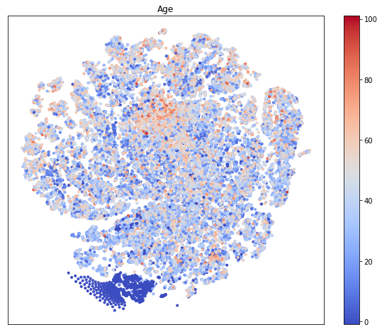 | b  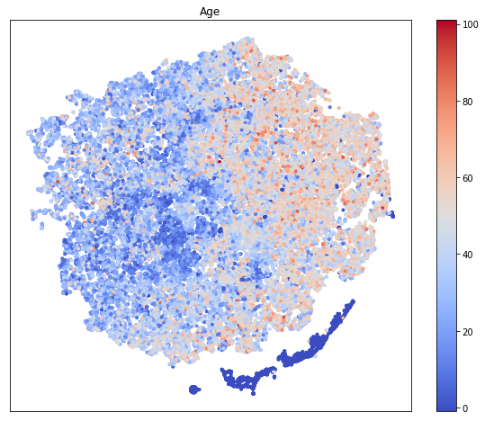
c  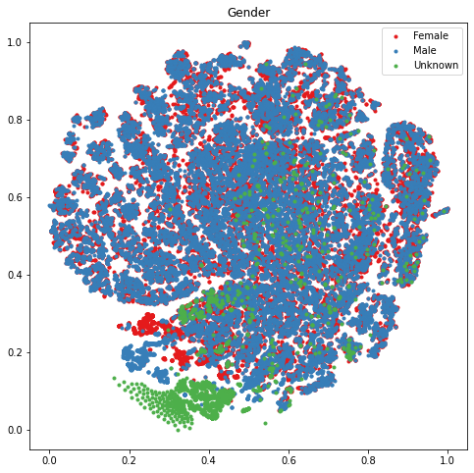 | d  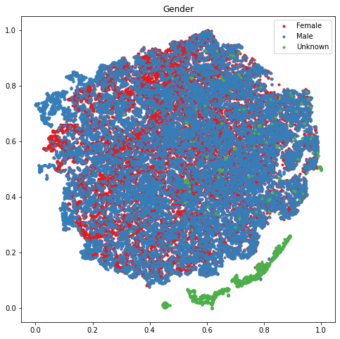

Supplementary Figure 5 Patients’ learned representations of the overall validation set adopting t-SNE for dimensionality reduction. Each point in the figure represents a patient. a: different levels of age before training. b: different levels of age after training. c: different genders before training. d: different genders after training.

Supplementary Table 1 Laboratory tests and abbreviations.
HEMO | Hemoglobin | LDL4 | LDL 4
LYMP | Lymphocytes/100 leukocytes | GLUC | Glucose in Serum/Plasma
HDLT | HDL Total | ERYR | Erythrocytes Distribution Ratio
SYBP | Systolic blood pressure | EOSI | Eosinophils/100 leukocytes
LDLT | LDL Total | HEIGT | height
D3 | Vitamin D3 or Cholecalciferol | IRON | Iron
UREA | Urea nitrogen | ALBGLOB | Albumin/Globulin
ERHM | Erythrocytes Hemoglobin Mass | SODI | Sodium
ALKALI | Alkaline phosphatase | PROT | Protein
TRIG | Triglycerides | DIBP | diastolic blood pressure
POTAS | Potassium | HA1C | Hemoglobin A1c over Total Ratio
BASO | Basophils/100 leukocytes | LDL1 | LDL 1
HDL2 | HDL 2 | LDL2 | LDL 2
LDLC | LDL Calculated | ERYV | Erythrocytes Volume
HDL3 | HDL 3 | GLOB | Globulin
B12 | Vitamin B12 or Cobalamin | TEMP | body temperature
HEMA | Hematocrit | FERR | Ferritin
LHDL | LDL/HDL ratio | ASPART | Aspartate aminotransferase
LEUK | Leukocytes | ERYC | Erythrocytes Blood Count
TCHL | Total Choleterol | HRTR | heart rate
FSTG | Fasting Glucose in Serum/Plasma | CREA | Creatine
THDL | total cholesterol/hdl ratio | ALANINE | ALANINE
D2 | Vitamin D2 or Calciferol | ERHC | Erythrocytes Hemoglobin Concentration
CALC | Calcium | MONO | Monocytes/100 leukocytes
EGFR | Estimated Glomerular filtration rate | NEUT | Neutrophils/100 leukocytes
WEIGT | body weight | PHOS | Phosphate
BMIX | bmi | MAG | Magnesium
Supplementary Table 2 Elixhauser Comorbidity Regex Patterns (of ICD10 codes).
congestive_heart_failure | ^I099|^I110|^I130|^I132|^I255|^I420|^I425|^I426|^I427|^I428|^I429|^I43|^I50|^P290
cardiac_arrhythmia | ^I441|^I442|^I443|^I456|^I459|^I47|^I48|^I49|^R000|^R001|^R008|^T821|^Z450|^Z950
valvular_disease | ^A520|^I05|^I06|^I07|^I08|^I091|^I098|^I34|^I35|^I36|^I37|^I38|^I39|^Q230|^Q231|^Q232|^Q233|^Z952|^Z953|^Z954
pulmonary_circulation_disorder | ^I26|^I27|^I280|^I288|^I289
peripheral_vascular_disorder | ^I70|^I71|^I731|^I738|^I739|^I771|^I790|^I792|^K551|^K558|^K559|^Z958|^Z959
hypertension_uncomplicated | ^I10
hypertension_complicated | ^I11|^I12|^I13|^I15
paralysis | ^G041|^G114|^G801|^G802|^G81|^G82|^G830|^G831|^G832|^G833|^G834|^G839
other_neurological_disorder | ^G10|^G11|^G12|^G13|^G20|^G21|^G22|^G254|^G255|^G312|^G318|^G319|^G32|^G35|^G36|^G37|^G40|^G41|^G931|^G934|^R470|^R56
chronic_pulmonary_disease | ^I278|^I279|^J40|^J41|^J42|^J43|^J44|^J45|^J46|^J47|^J60|^J61|^J62|^J63|^J64|^J65|^J66|^J67|^J684|^J701|^J703
diabetes_uncomplicated | ^E100|^E101|^E109|^E110|^E111|^E119|^E120|^E121|^E129|^E130|^E131|^E139|^E140|^E141|^E149
diabetes_complicated | ^E102|^E103|^E104|^E105|^E106|^E107|^E108|^E112|^E113|^E114|^E115|^E116|^E117|^E118|^E122|^E123|^E124|^E125|^E126|^E127|^E128|^E132|^E133|^E134|^E135|^E136|^E137|^E138|^E142|^E143|^E144|^E145|^E146|^E147|^E148
hypothyroidism | ^E00|^E01|^E02|^E03|^E890
renal_failure | ^I120|^I131|^N18|^N19|^N250|^Z490|^Z491|^Z492|^Z940|^Z992
liver_disease | ^B18|^I85|^I864|^I982|^K70|^K711|^K713|^K714|^K715|^K717|^K72|^K73|^K74|^K760|^K762|^K763|^K764|^K765|^K766|^K767|^K768|^K769|^Z944
peptic_ulcer_disease_excluding_bleeding | ^K257|^K259|^K267|^K269|^K277|^K279|^K287|^K289
aids_hiv | ^B20|^B21|^B22|^B24
lymphoma | ^C81|^C82|^C83|^C84|^C85|^C88|^C96|^C900|^C902
metastatic_cancer | ^C77|^C78|^C79|^C80
solid_tumor_wo_metastasis | ^C00|^C01|^C02|^C03|^C04|^C05|^C06|^C07|^C08|^C09|^C10|^C11|^C12|^C13|^C14|^C15|^C16|^C17|^C18|^C19|^C20|^C21|^C22|^C23|^C24|^C25|^C26|^C30|^C31|^C32|^C33|^C34|^C37|^C38|^C39|^C40|^C41|^C43|^C45|^C46|^C47|^C48|^C49|^C50|^C51|^C52|^C53|^C54|^C55|^C56|^C57|^C58|^C60|^C61|^C62|^C63|^C64|^C65|^C66|^C67|^C68|^C69|^C70|^C71|^C72|^C73|^C74|^C75|^C76|^C97
rheumatoid_arhritis | ^L940|^L941|^L943|^M05|^M06|^M08|^M120|^M123|^M30|^M310|^M311|^M312|^M313|^M32|^M33|^M34|^M35|^M45|^M461|^M468|^M469
coagulopathy | ^D65|^D66|^D67|^D68|^D691|^D693|^D694|^D695|^D696
obesity | ^E66
weight_loss | ^E40|^E41|^E42|^E43|^E44|^E45|^E46|^R634|^R64
fluid_and_electrolyte_disorders | ^E222|^E86|^E87
blood_loss_anemia | ^D500
deficiency_anemia | ^D508|^D509|^D51|^D52|^D53
alcohol_abuse | ^F10|^E52|^G621|^I426|^K292|^K700|^K703|^K709|^T51|^Z502|^Z714|^Z721
drug_abuse | ^F11|^F12|^F13|^F14|^F15|^F16|^F18|^F19|^Z715|^Z722
psychoses | ^F20|^F22|^F23|^F24|^F25|^F28|^F29|^F302|^F312|^F315
depression | ^F204|^F313|^F314|^F315|^F32|^F33|^F341|^F412|^F432

