Supplementary File 1

Computational biology predicts metabolic engineering targets for increased production of 102 valuable chemicals in yeast

Iván Domenzain, Yao Lu, Junling Shi, Hongzhong Lu, Jens Nielsen

Table of content

1.- ecFactory: a multi-step method for prediction of metabolic engineering gene targets……….2
1.1. FSEOF for ecModels………………………………………………………………...2
1.2. Identification of flux leaks………………………………………….………………..3
1.3. Discarding essential genes from deletion targets………………….………………..3
1.4. Identification of enzyme groups in the candidate targets………….………………..3
1.5. Computing enzyme demands with flux variability analysis……….…………….…..4
1.6. Reducing the list of candidates according to enzyme variability ranges……….…..5
1.7. Finding an optimal combination of genetic modifications……….………………....7
2.- Supplementary figures …… ………………………………………………………………….8
Figure S1………………………………………………………………………………....8
Figure S2………………………………………………………………………………....9
Figure S3………………………………………………………………………………..10
Figure S4………………………………………………………………………………..11
Figure S5………………………………………………………………………………..12
Figure S6………………………………………………………………………………..13
Figure S7………………………………………………………………………………..14
Figure S8………………………………………………………………………………..15
3.- Supplementary tables ………………………………………………………………………..16
Table S1…………………………………………………………………………………16
Table S2…………………………………………………………………………………19
Table S3…………………………………………………………………………………20
4.- References ……………………………………………………………………………………22

1.- ecFactory: a multi-step method for prediction of metabolic engineering gene targets

The ecFactory method is a series of sequential steps for identification of metabolic engineering gene targets. These targets show which genes should be subject to overexpression, modulated expression (knock-down) or deletion (knock-out), with the objective of increasing production of a given metabolite. This method was developed by combining the principles of the FSEOF algorithm (flux scanning with enforced objective function)¹ together with the features of GECKO enzyme-constrained metabolic models (ecModels)², which incorporate enzymes as part of genome-scale metabolic networks. All the sequential steps of this method are included in the main function run_ecFactory and are explained in the following numbered sections.

1.1. FSEOF for ecModels
As a first step, the ecFactory pipeline runs the function run_ecFSEOF, available in the utilities folder of the GECKO toolbox³. This is an implementation of the FSEOF algorithm for a specified cellular objective (e.g. secretion rate of a given metabolite) suited for the characteristics and format of ecModels. The algorithm solves a series of 16 different FBA problems, using fixed biomass yield as constraints at regularly decreasing intervals, spanning from 100% to 25% of the maximum predicted value (0.48 g_{biomass}/g_{glucose} for ecYeastGEM v8.3.4). Reactions whose flux increases or decreases consistently across the resulting 16 optimal flux distributions are identified as reaction step targets for engineering. For each of these reactions, an overall flux score is calculated as:

${V_{score}}_{i}= \frac{\sum_{j=1}^{n}{v_{ij}}}{n\left(v_{i}^{{bio}_{MAX}}\right)}$

Where $v_{i}^{{bio}_{MAX}}$ represents the flux carried by reaction i at the maximum biomass yield condition; and $\frac{\sum_{j=1}^{n}{v_{ij}}}{n}$, the average flux carried by reaction i across all flux distributions (n=16 steps). In contrast to classic FSEOF, flux scores are computed as rescaled mean flux values across the spanned conditions, instead of considering a constant slope in between the initial and final simulation scenarios, due to possible changes of metabolic regime (respiratory to mixed fermentative) while spanning suboptimal biomass yields. Any ${V_{score}}_{i}$ value higher than 1000 is truncated to 1000, in order to avoid infinity values. Undetermined values (zero divided by zero) are assigned with a value of 1. Then, gene scores, referred to as K-scores from here onwards, are computed as the average of reaction flux scores (${V_{score}}_{i}$) across all the reactions that are encoded by each gene:

$$K_{{score}_{i}}=\frac{\sum_{j=1}^{m}{{V_{score}}_{j}}}{m}$$

Where $K_{{score}_{i}}$ is the score for gene target i; $\sum_{j=1}^{m}{{V_{score}}_{j}}$ is the sum of the reaction scores of all reactions that are catalysed by gene product i; m is the total number of reactions catalysed by gene product i. Genes with a K-score higher than 1 are suggested as targets for overexpression; genes with 0.05 < K-scores < 0.5 as targets for knock-down; and those with K-scores < 0.05 as knock-out targets.

1.2. Identification of flux leaks
In the FSEOF algorithm, gene engineering targets are identified based on the assumption that there is a trade-off between biomass formation and product secretion or accumulation. Nevertheless, additional ways of enhancing production can be found by focusing on other characteristics of the metabolic network. Reaction steps that consume the product of interest, which may decrease accumulation or secretion, are often elusive to the FSEOF algorithm. These reactions might not be relevant for biomass formation, especially for those located in metabolic pathways outside of central carbon metabolism. In order to capture this kind of reactions in the list of gene target candidates, all genes that encode for enzymes catalyzing these reaction steps, possibly being detrimental, are added to the list of candidates by the funciont find_flux_leaks.

1.3. Discarding essential genes from deletion targets
Experimentally validated essential genes (retrieved from the Saccharomyces genome deletion project, available at: http://www-sequence.stanford.edu/group/yeast_deletion_project/downloads.html) are discarded from the list of knock-down and knock targets.

1.4. Identification of enzyme groups in the candidate targets
As ecModels are capable of capturing complex reaction-gene relations, isoenzymes and enzyme complexes, some of the gene products predicted as targets by FSEOF may fall into one of these categories. Isoenzymes and enzyme complex subunits are identified by finding all groups of identical vectors in a metabolite-gene matrix, which connects all genes with the metabolites involved in the reactions catalysed by their corresponding enzymes. In an ecModel, the metabolite-gene matrix is defined as:
$$MG=logical(S)*RxnGeneMat$$

Where $logical(S)$ is the Boolean form of the model’s stoichiometric matrix, representing all metabolites as rows and reactions as columns; $RxnGeneMat$, is a Boolean matrix that establishes the relationship between enzyme-encoding genes and biochemical reactions in the ecModel, in which a value of 1 indicates genes whose protein products catalyze a given reaction. The MG matrix is computed by the function getMetGeneMatrix which feeds it into getGeneGroups, a function that finds groups of enzymes related to exactly the same metabolites and also identifies all enzymes that are unique, in their metabolites association, from the list of targets. This information is used later in the ecFactory pipeline in order to decide which genes should be modified simultaneously for a given objective.
1.5. Computing enzyme demands with flux variability analysis
In order to compute enzymatic demands for each of the gene candidates under different production scenarios, flux variability analysis (FVA) is run for the corresponding enzyme usage reactions in the ecModel. A feasible enzyme usage variability range is defined as:

$$Δ_{e_{i}}= e_{i}^{max}-e_{i}^{min}$$

The values for $e_{i}^{max}$ and $e_{i}^{min}$, are obtained by optimizing (maximization and minimization) the following linear programming problem:

Min or Max. $z=e_{i} ∀ i=1,…,m$
s.t. $Sv=0,$
$${LB}_{j}≤v_{j}≤{UB}_{j}, j=1,…, n$$

Where $e_{i}$ represents the usage reaction for enzyme i; m is the number of metabolic enzymes associated to the gene target candidates; $S$ is the stoichiometric matrix of the metabolic network, representing metabolites in its rows and reactions in its columns, negative coefficients are assigned to reaction substrates whilst positive signs are assigned to products; $v$, is the vector of reaction fluxes in the network; ${LB}_{j}$ is the lower bound value for reaction j; ${UB}_{j}$ is the lower bound value for reaction j and $n$ is the total number of reactions in the model. In the ecFactory pipeline, enzyme usage variability range profiles are obtained for two different scenarios:

- Fixed glucose uptake rate of 1 mmol/gDw h, fixed biomass production rate, equal to the maximum attainable value under this glucose uptake ($v_{bio}^{max}$). Which represents the enzyme demand ranges for an optimal growing strain (growth scenario).

- Fixed glucose uptake rate of 1 mmol/gDw h, a lower bound of 0.5*$v_{bio}^{max}$
for the biomass production pseudoreaction and a fixed value of $v_{prod}^{max}$ for the production reaction of interest, which corresponds to the maximum attainable production value under a unit glucose uptake rate and the specified biomass production. The variability ranges obtained by this represent profiles of enzyme demands for the predicted targets in an enhanced production scenario.

This analysis is run by the function enzymeUsage_FVA, part of the ecFactory pipeline. Additionally, a parsimonious flux distribution is obtained by minimizing the total enzyme mass demand (protein pool usage pseudo-reaction), while subjected to the same set of constraints used for each of the conditions specified above.

1.6. Reducing the list of candidates according to enzyme variability ranges
Enzyme usage variability ranges for the two aforementioned scenarios are used to classify the enzyme targets. Figure S4 illustrates a reduced network, with the metabolic task of reaching node D starting from A, in which the second enzymatic step (B → C) can be catalised by three different isoenzymes ($E_{2A}$, $E_{2B}$ and $E_{2C}$). In this case, any of the three isoforms can be used for production of D, therefore the three enzymes display a usage variability range that spans from zero to a specific maximum value (occurring when all the reaction flux is carried by a single isoform). Nonetheless, in parsimonious flux distributions (those that minimize the total sum of fluxes in the solution) usually just the most efficient isoenzyme of a given group will carry a non-zero flux⁴, in this case very close to its maximum feasible value, therefore, in ecFactory such enzymes are classified as “optimal for production”, whilst the other isoforms as “suboptimal for production”. $E_{3}$ represents a typical case of an “essential” enzyme, whose usage flux cannot take a zero value and its whole range is confined to a region close to its maximum feasible value. The network shows that $E_{4}$ is a “futile” enzyme for achieving the metabolic task of producing D, therefore its maximum, minimum and parsimonious flux are all equal to zero.

This classification of enzymes can be based on the profiles of variability ranges both for optimal production and optimal growth scenarios, additionally, provides the following criteria for reduction of the number of gene targets predicted by the ecFactory method:

- Discard OE target candidates classified as futile for production
- Discard OE target candidates classified as suboptimal for production, focusing on optimal isoforms when needed.
- Discard enzymes essential for production from KO target candidates.
- Discard isoenzyme groups that contain an optimal isoform for biomass formation from KD and KO target candidates. This aims to reduce mutant complexity, as in order to have an effect in redirecting flux from biomass to production, coordinated modification of all the isoenzymes in the group would be necessary. Focusing on essential enzymes for biomass production is recommended for KD targets and futile ones for production for KO targets.

For each enzyme in the list of candidate targets, comparison in between the two different demand scenarios enables classification of differential demand patterns as: distinct, overlapped and undistinguishable (Figure S5). Enzymes with undistinguishable demand patterns (Figure S5C and S5F) are discarded from the candidates list. Moreover, enzymes with distinct demand patterns are assigned a degree of priority of 1 whilst a value of 2 is assigned to those with overlapped demand patterns, in order to inform experimental design for testing modifications.

1.7. Finding an optimal combination of genetic modifications
The enzyme usage ranges under the production scenario for the candidate targets provide an approximation to enzyme expression levels characteristic of an optimal producing strain. In order to simulate this optimal behaviour, each of the enzymes in the list of remaining targets are constrained according to the following:
$$e_{i_{p}}^{Prod}≤e_{i}≤e_{i_{max}}^{Prod}, i=1,…, n$$
Where $e_{i}$ is the usage reaction for enzyme i; $e_{i_{p}}^{Prod}$ is the parsimonious usage value for enzyme i, subjected to the optimal production scenario constraints; $e_{i_{max}}^{Prod}$ is the maximum feasible usage value for enzyme i, subjected to the optimal production scenario constraints; and $n$ represents the number of gene targets with an associated enzyme in the ecModel. The suboptimal biomass production value, used as lower bound for the enzyme usage variability analysis in the optimal production scenario, is also used as a constraint in this step, then the optimal production rate is computed by maximization of its corresponding reaction rate. Once a maximum production value has been obtained, it is used to fix both the lower and upper bounds for its corresponding reaction and the glucose uptake rate is then minimized, in order to compute a maximum optimal product yield. These production values are representative of an optimal strain, in which expression levels of key enzymes (encoded by the gene candidate targets) have been fine-tunned (OE, KD or KO), and differentiated from those in the optimal biomass formation scenario (wild-type), in order to redirect flux towards the product of interest. However, as metabolism is highly interconnected and kinetic parameters of enzymes are heterogenous in nature, it is possible that not all of the constrained enzyme targets contribute to achieve the optimal production phenotype. To investigate this, the constraints for each of the enzyme targets are “returned” to their optimal biomass producing levels (wild-type expression) as follows:
$$e_{i_{p}}^{Bio}≤e_{i}≤e_{i_{max}}^{Bio}, ∀ i=1,…, n$$
Where $e_{i_{p}}^{Bio}$ represents the parsimonious usage of enzyme i in the optimal biomass formation scenario; $e_{i_{max}}^{Bio}$ is the maximum feasible value for the usage of enzyme i under the same conditions. Enzymes are modified independently in an iterative procedure, computing the following evaluation metric at each step:
$$η_{i}=\frac{1}{2}\frac{v_{P}^{mod}}{v_{P}^{Opt}}\left(1+\frac{v_{glc}^{Opt}}{v_{glc}^{mod}}\right)$$
Where $v_{P}^{mod}$ represents the maximum production value for the product of interest, obtained when $e_{i}$ has been “returned” to its wild-type demand values, while keeping the rest of enzyme targets on their optimal production ranges; $v_{P}^{Opt}$ is the maximum production rate for the optimal production scenario; $v_{glc}^{mod}$ is the minimum glucose uptake rate obtained when $e_{i}$ has been “returned” to its wild-type demand values, while keeping the rest on their optimal production ranges; $v_{glc}^{Opt}$ is the minimum glucose uptake rate under the optimal production scenario conditions. A $η_{i}$<1 indicates that modified expression levels of enzyme i, in comparison to the wild-type enzyme allocation profile, are needed to achieve the optimal production scenario, therefore the gene encoding for enzyme i is kept in the list of target candidates. Values $η_{i}$=1 indicate that modification of the expression levels of enzyme i is not necessary to reach optimal production, therefore the gene encoding for it would be removed from the list of candidate targets, and the bound for its respective enzyme usages are kept as those needed for optimal biomass formation (wild-type) for the rest of the iterations.

This iterative approach assesses the effects of combined genetic modifications in the simulated phenotype, by comparing performance under two different enzyme usage profiles instead of relying on imposing arbitrary values for overexpression or knock-down levels over the bounds of enzyme usage reactions. All these steps are performed by the function constructMinimalMutant in the ecFactory pipeline, which returns an optimal mutant with the minimal subset of genetic modifications to achieve the optimal production scenario and a list describing each of the successfully combined genetic modifications. Moreover, the subtractive approach of removing non-essential modifications from an optimal mutant ensures robustness of results, regarding the order in which each modification is tested. This is a major improvement in the method, in contrast to its previous version, with a cumulative approach to “optimal” strain construction, which is highly dependent on the order in which modifications are implemented into the model. The analysis of randomized test of modifications on the results can be explored in the following MATLAB live script available at:
https://github.com/SysBioChalmers/ecFactory/blob/feat/test_targets_randomization/tutorials/test_randperm.mlx

2.- Supplementary Figures
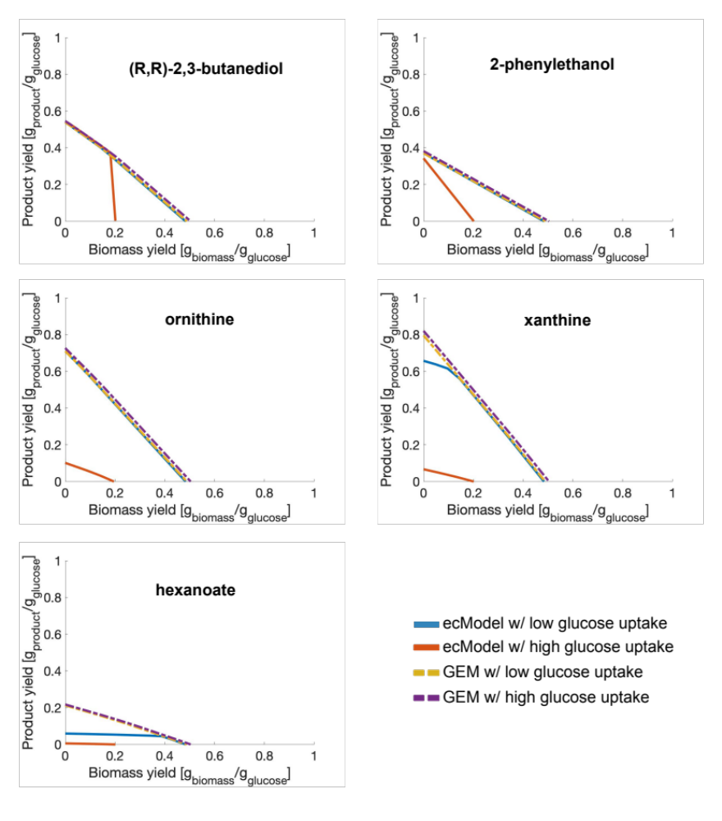
Figure S1.- Production yield space for selected native metabolites in yeast with different degree of enzymatic limitations.

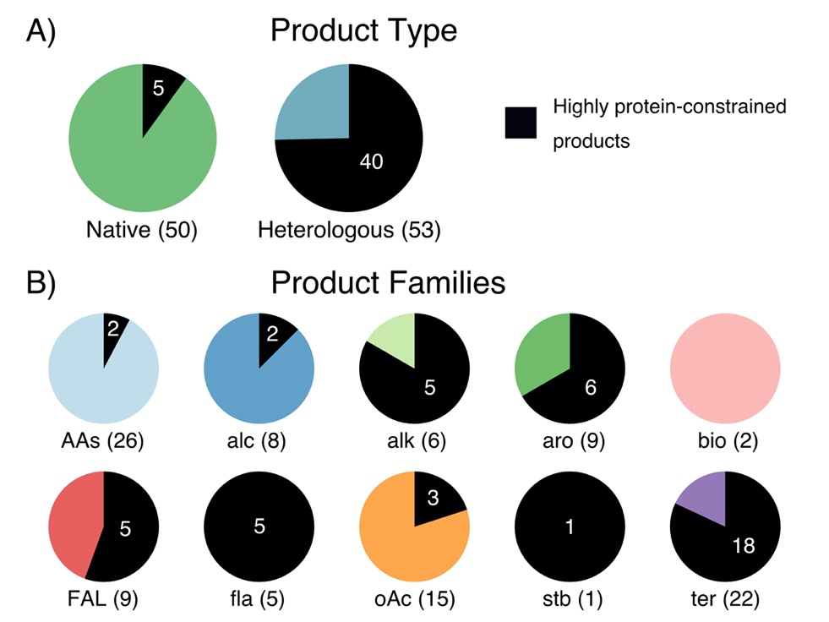

Figure S2.- Classification of 102 chemical products studied with ecYeastGEM. A) Distribution of chemicals divided by origin (native or heterologous), according to S. cerevisiae’s metabolic network. B) Number of products per chemical family. Black sections and white numbers indicate the amount of products whose production was found to be protein-limited at low glucose uptake rates (1 mmol/gDw h).
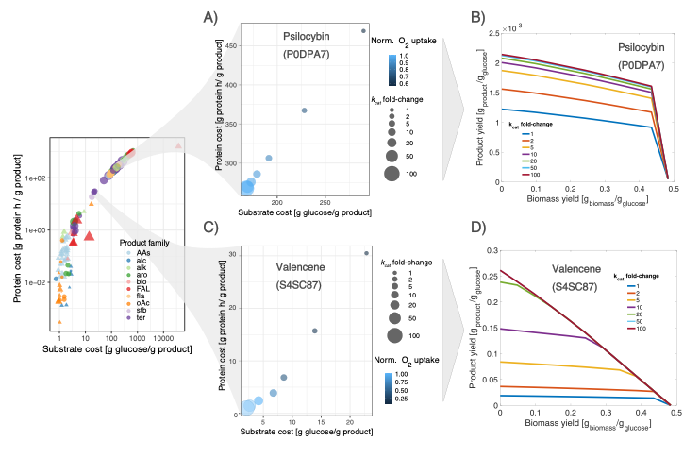
Figure S3.- Enzyme capacity and production capabilities. A) Effect of P0DPA7 (tryptamine 4-monooxygenase) enzyme capacity on the production cost for psilocybin production. B) Psilocybin production space predicted by ecYeastGEM. C) Effect of S4SC87 (terpene synthase) enzyme capacity on the valencene production space. D) Valencene production space predicted by ecYeastGEM.

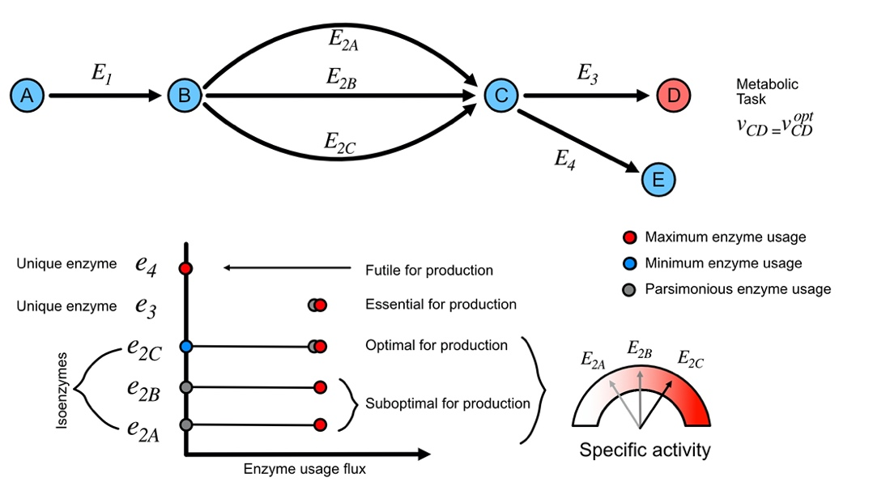
Figure S4.- Classification of gene targets according to their enzyme usage variability ranges. Upper section represents a simple metabolic pathway with enzymatic redundancy (presence of isoenzymes). Lower section represents a classification of enzymes (E_{i})in the pathway according to the variability ranges of their respective enzyme usages (e_{i}) allowed by a fixed metabolic objective.

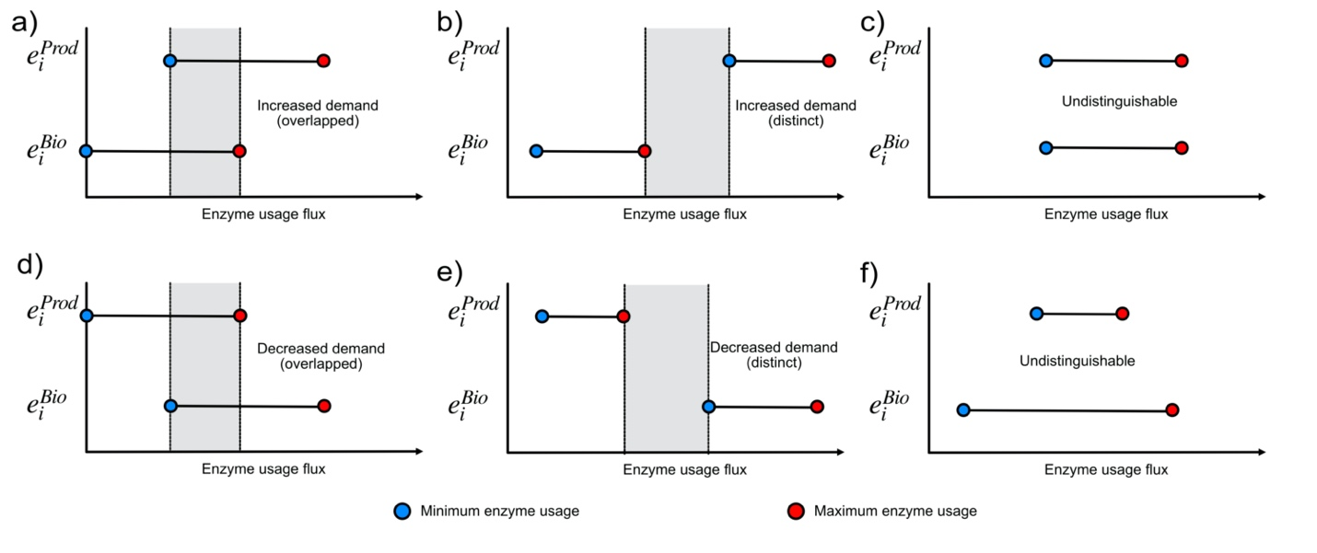
Figure S5.- Enzyme usage variability ranges under two scenarios: 1) maximization of product formation, while subject to a suboptimal biomass production, and 2) maximization of biomass formation subject to a minimal product formation. A) Increased enzyme demands with an overlapped region between objectives. B) Increased enzyme demands with distinct ranges in between objectives. C) Undistinguishable demand patterns between the two objectives, equal ranges. D) Decreased enzyme demands overlap with overlap between objectives. E) Decreased enzyme usage with distinct demand ranges in between objectives. F) Undistinguishable demand ranges, enzyme usage range for optimal production is a subset of the usage range for optimal biomass formation.

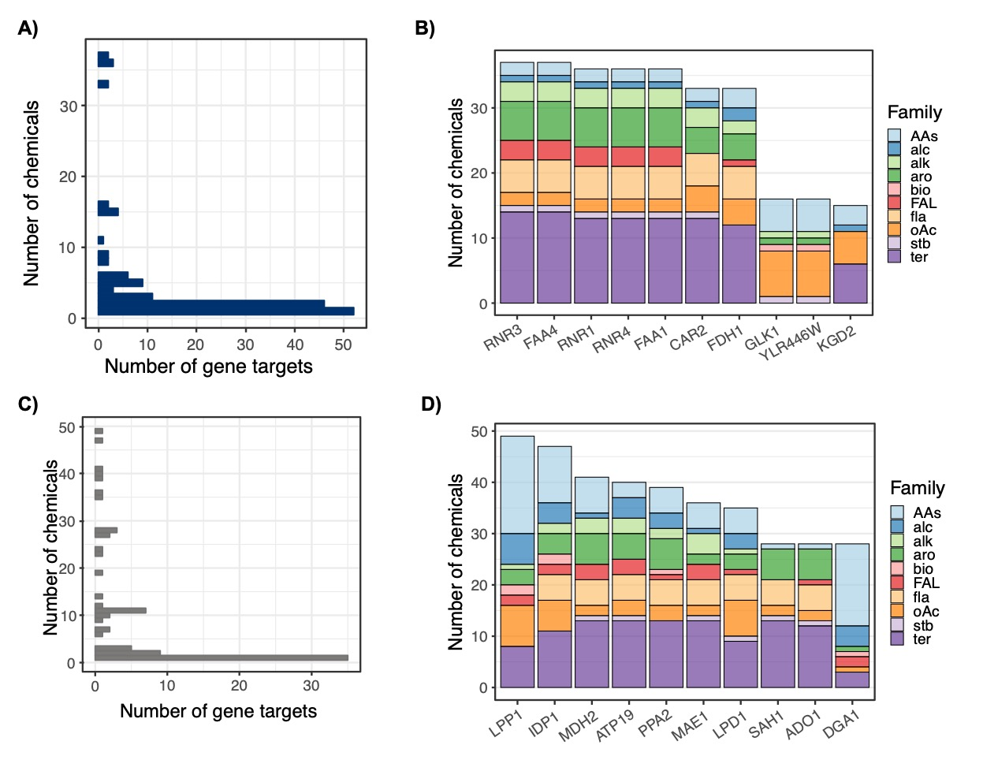
Figure S6.- Analysis of predictions for KO and KD gene targets across 102 chemicals. A) Distribution of the degree of product-specificity for KO gene targets across all chemicals. B) Top 10 most common gene KO tartets across products and chemical classes. Short gene names correspond to ribonucleoside-diphosphate reductase large chain 2 (RNR3), long-chain-fatty-acid—CoA ligase 4 (FAA4), ribonucleoside-diphosphate reductase large chain 1 (RNR1), ribonucleoside-diphosphate reductase small chain 2 (RNR4), long-chain-fatty-acid—CoA ligase 1 (FAA1), ornithine aminotransferase (CAR2), formate dehydrogenase 1 (FDH1), glucokinase 1 (GLK1), putative hexokinase (YLR446W), and multifunctional 2-oxoglutarate metabolism enzyme (KGD2). C) Distribution of the degree of product-specificity for KD gene targets across all chemicals. D) Top 10 most common gene KO targets across products and chemical classes. Short gene names indicate lipid phosphate phosphatase 1 (LPP1), isocitrate dehydrogenase [NADP] (IDP1), cytoplasmic malate dehydrogenase (MDH2), ATP synthase subunit K (ATP19), mitochondrial inorganic pyrophosphatase (PPA2), NAD-dependent malic enzyme (MAE1), mitochondrial dihydrolipoyl dehydronase (LPD1), adenosylhomocysteinase (SAH1), adenosine kinase (ADO1), diacylglycerol O-acyltransferase 1 (DGA1). Abbreviations for chemical family names indicate amino acids (AA), alcohols (alc), alkaloids (alk), aromatics (aro), bioamines (bio), fatty acids and lipids (FAL), flavonoids (fla), organic acids (oAc), stillbenoids (stb) and terpenes (ter).

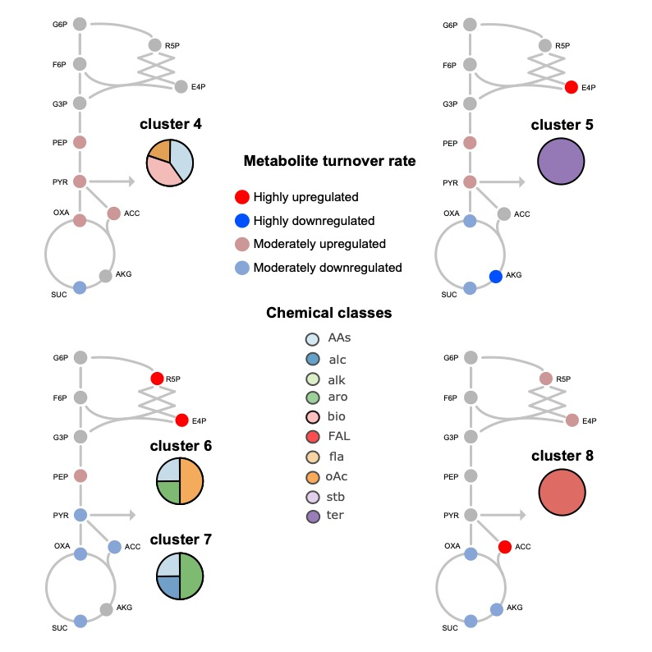

Figure S7.- Changes in the turnover of metabolic precursors required for optimal chemical production in yeast platform strains (product clusters). Metabolic precursors with a $\left|\log_{2}{FC}\right|≥2$ in their turnover rate, when comparing optimal production to wild-type simulations, are referred as “highly up/down-regulated” metabolic precursors. Metabolites with $1.5<\left|\log_{2}{FC}\right|<2$ in their turnover rate are classified as moderately “up/down-regulated”.

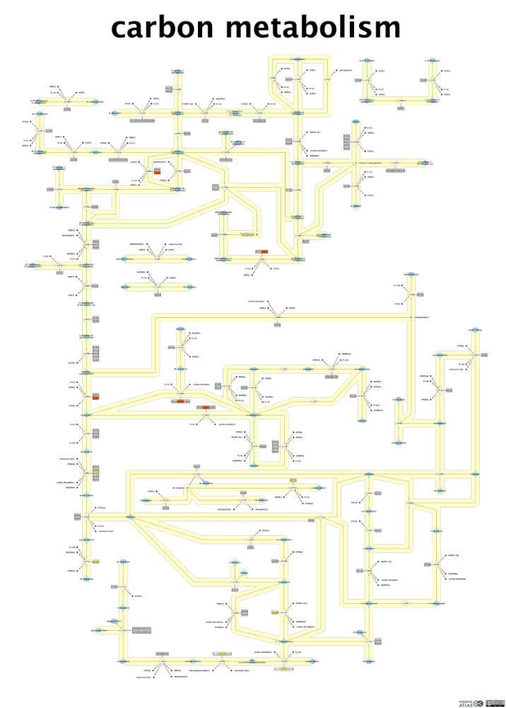
Figure S8.- Map of S. cerevisiae’s central carbon metabolism from metabolic atlas. Gene targets for increased production of the terpene patchoulol are shown in red, for overexpressions; yellow for down-regulated targets; and white for predicted gene deletions.

3.- Supplementary Tables

Table S1. 102 chemicals simulated with ecYeastGEM.
Name | Formulac | KEGG_ID | CHEBI_ID | MW | Origin | Chemical class | limitation
L-phenylacetylcarbinol | C9H10O2 | NA | 149766 | 150.174 | heterologous | alcohol | substrate
n-butanol | C4H10O | C06142 | 28885 | 74.23 | heterologous | alcohol | protein
docosanol | C22H46O | D03884 | 31000 | 326.61 | heterologous | alcohol | protein
(R,R)-2,3-butanediol | C4H10O2 | C03044 | 16982 | 90.121 | native | alcohol | substrate
2-phenylethanol | C8H10O | C05853 | 49000 | 122.1644 | native | alcohol | substrate
glycerol | C3H8O3 | C00116 | 17754 | 92.09382 | native | alcohol | substrate
isoamylol | C5H12O | C07328 | 15837 | 88.14818 | native | alcohol | substrate
isobutanol | C4H10O | C14710 | 46645 | 74.1216 | native | alcohol | substrate
(S)-Reticuline | C19H23NO4 | C02105 | 16718 | 329.39 | heterologous | alkaloid | protein
psilocybin | C12H17N2O4P | C07576 | 8614 | 284.248101 | heterologous | alkaloid | protein
cinnamoyltropine | C17H22ClNO2 | NA | NA | 307.82 | heterologous | alkaloid | protein
choline | C5H14NO | C00114 | 15354 | 104.1708 | native | alkaloid | protein
hypoxanthine | C5H4N4O | C00262 | 17368 | 136.11162 | native | alkaloid | substrate
xanthine | C5H4N4O2 | C00385 | 17712 | 152.11102 | native | alkaloid | substrate
Nicotianamine | C12H21N3O6 | C05324 | 17721 | 303.3116 | heterologous | amino acid | protein
ergothioneine | C9H15N3O2S | C05570 | 4828 | 229.3 | heterologous | amino acid | protein
glutathione | C10H17N3O6S | C00051 | 16856 | 307.32 | native | amino acid | substrate
L-alanine | C3H7NO2 | C00041 | 16977 | 89.09322 | native | amino acid | substrate
L-arginine | C6H14N4O2 | C00062 | 16467 | 174.201 | native | amino acid | substrate
L-asparagine | C4H8N2O3 | C00152 | 17196 | 132.118001 | native | amino acid | substrate
L-aspartate | C4H7NO4 | C00049 | 17053 | 133.1027 | native | amino acid | substrate
L-citrulline | C6H13N3O3 | C00327 | 16349 | 175.18584 | native | amino acid | substrate
L-cysteine | C3H7NO2S | C00097 | 17561 | 121.158 | native | amino acid | substrate
L-glutamate | C5H8NO4 | C00025 | 29985 | 146.12136 | native | amino acid | substrate
L-glutamine | C5H10N2O3 | C00064 | 18050 | 146.14458 | native | amino acid | substrate
L-glycine | C2H5NO2 | C00037 | 15428 | 75.06664 | native | amino acid | substrate
L-histidine | C6H9N3O2 | C00135 | 15971 | 155.15468 | native | amino acid | substrate
L-homoserine | C4H9NO3 | C00263 | 15699 | 119.1192 | native | amino acid | substrate
L-isoleucine | C6H13NO2 | C00407 | 17191 | 131.175 | native | amino acid | substrate
L-leucine | C6H13NO2 | C00123 | 15603 | 131.17296 | native | amino acid | substrate
L-lysine | C6H15N2O2 | C00047 | 32551 | 147.19558 | native | amino acid | substrate
L-methionine | C5H11NO2S | C00073 | 16643 | 149.21238 | native | amino acid | substrate
L-phenylalanine | C9H11NO2 | C00079 | 17295 | 165.18918 | native | amino acid | substrate
L-proline | C5H9NO2 | C00148 | 17203 | 115.1305 | native | amino acid | substrate
L-serine | C3H7NO3 | C00065 | 17115 | 105.09262 | native | amino acid | substrate
L-threonine | C4H9NO3 | C00188 | 16857 | 119.1192 | native | amino acid | substrate
L-tryptophan | C11H12N2O2 | C00078 | 16828 | 204.22526 | native | amino acid | substrate
L-tyrosine | C9H11NO3 | C00082 | 17895 | 181.18858 | native | amino acid | substrate
L-valine | C5H11NO2 | C00183 | 16414 | 117.14638 | native | amino acid | substrate
ornithine | C5H13N2O2 | C01602 | 46912 | 133.169 | native | amino acid | substrate
4-hydroxymandelic | C8H8O4 | C11527 | 16388 | 168.148 | heterologous | aromatic | substrate
cinnamate | C9H8O2 | C00423 | 15669 | 148.1586 | heterologous | aromatic | substrate
mandelic acid | C8H8O3 | C01984 | 17756 | 152.1473 | heterologous | aromatic | substrate
p-coumaric acid | C9H8O3 | C00811 | 32374 | 164.0473 | heterologous | aromatic | protein
rosmarinate | C18H16O8 | C01850 | 50371 | 360.31 | heterologous | aromatic | protein
Salidroside | C14H20O7 | C06046 | 9009 | 300.307 | heterologous | aromatic | protein
Tyrosol | C8H10O2 | C06044 | 1879 | 138.164 | heterologous | aromatic | protein
vanillin β-glucoside | C14H18O8 | NA | 179508 | 314.29 | heterologous | aromatic | protein
β-ionone | C13H20O | C12287 | 32325 | 192.3 | heterologous | aromatic | protein
putrescine | C4H14N2 | C00134 | 326268 | 90.1674 | native | bioamine | substrate
spermine | C10H30N4 | C00750 | 45725 | 206.372 | native | bioamine | substrate
ARA | C20H32O2 | C00219ÔøΩ | 15843 | 304.474 | heterologous | fatty acids and lipids | protein
DHA | C22H32O2 | C06429 | 28125 | 328.488 | heterologous | fatty acids and lipids | protein
EPA | C20H30O2 | C06428 | 28364 | 302.451 | heterologous | fatty acids and lipids | protein
Free fatty acids | NA | NA | NA | 396.64836 | native | fatty acids and lipids | substrate
laurate | C12H23O2 | C02679 | 18262 | 199.31 | native | fatty acids and lipids | protein
oleate | C18H34O2 | C00712 | 16196 | 282.4614 | native | fatty acids and lipids | substrate
palmitoleate | C16H29O2 | C08362 | 32372 | 253.40026 | native | fatty acids and lipids | substrate
triacylglycerol | C6H5O6R3 | C00422 | 17855 | 173.1003 | native | fatty acids and lipids | substrate
ergosterol | C28H44O | C01694 | 16933 | 396.64836 | native | fatty acids and lipids | substrate
catechin | C15H14O6 | C06562 | 15600 | 290.26 | heterologous | flavonoid | protein
genistein | C15H10O5 | C06563 | 28088 | 270.241 | heterologous | flavonoid | protein
kaempferol | C15H10O6 | C05903 | 28499 | 286.23 | heterologous | flavonoid | protein
naringenin | C15H12O5 | C00509 | 17846 | 272.257 | heterologous | flavonoid | protein
quercetin | C15H10O7 | C00389 | 16243 | 302.236 | heterologous | flavonoid | protein
Adipic acid | C6H10O5 | C023060 | 30832 | 146.14 | heterologous | organic acid | substrate
cis,cis-muconate | C6H6O4 | C02480 | 16508 | 142.11 | heterologous | organic acid | substrate
Itaconic acid | C5H6O4 | C00490 | 17240 | 130.1 | heterologous | organic acid | substrate
caffeic acid | C9H8O4 | C01197 | 36281 | 180.16 | heterologous | organic acid | protein
succinate | C4H6O4 | C00042 | 26806 | 118.09 | native | organic acid | substrate
(S)-lactate | C3H6O3 | C00186 | 16651 | 89.07 | native | organic acid | substrate
(S)-malate | C4H6O5 | C00149 | 15589 | 132.07156 | native | organic acid | substrate
2-oxoglutarate | C5H6O5 | C00026 | 16810 | 144.08226 | native | organic acid | substrate
acetate | C2H4O2 | C00033 | 15366 | 60.052 | native | organic acid | substrate
citrate | C6H8O7 | C00158 | 16947 | 189.0997 | native | organic acid | substrate
fumarate | C4H4O4 | C00122 | 18012 | 116.0722 | native | organic acid | substrate
glycolate | C2H4O3 | C00160 | 17497 | 76.05136 | native | organic acid | substrate
hexanoate | C6H12O2 | C01585 | 17120 | 115.15034 | native | organic acid | protein
pyruvate | C3H3O3 | C00022 | 15361 | 87.05412 | native | organic acid | substrate
resveratrol | C14H12O3 | C03582 | 27881 | 228.25 | heterologous | stilbenoids | protein
astaxanthin | C40H52O4 | C08580 | 40968 | 596.841 | heterologous | terpene | protein
betaxanthin | C18H18N2O7 | C08565 | 8341 | 358.3 | heterologous | terpene | protein
β-carotene | C40H56 | C02094 | 17579 | 536.8726 | heterologous | terpene | protein
artemisinic acid | C15H22O2 | C20309 | 63749 | 234.33 | heterologous | terpene | substrate
alpha-Farnesene | C15H24 | C09665 | 10280 | 204.36 | heterologous | terpene | substrate
amorphadiene | C15H24 | C16028 | 52026 | 204.351 | heterologous | terpene | substrate
Geraniol | C10H18O | C01500 | 17447 | 154.25 | heterologous | terpene | substrate
Limonene | C10H16 | C06078 | 15384 | 136.24 | heterologous | terpene | substrate
linalool | C10H18O | C03985 | 17580 | 154.25 | heterologous | terpene | protein
lupeol | C30H50O | C08628 | 6570 | 426.72 | heterologous | terpene | protein
Oleanolic acid | C30H48O3 | C17148 | 37659 | 456.7 | heterologous | terpene | protein
patchoulol | C15H26O | C19755 | 7940 | 222.36 | heterologous | terpene | protein
protopanaxadiol | C30H52O3 | C20715 | 75950 | 460.73 | heterologous | terpene | protein
Santalene | C15H24 | C19736 | 10440 | 204.35 | heterologous | terpene | substrate
β-Amyrin | C30H50O | C08616 | 10352 | 426.72 | heterologous | terpene | substrate
glycyrrhetinic acid | C30H46O4 | C02283 | 30853 | 470.7 | heterologous | terpene | protein
lycopene | C40H56 | C05432 | 15948 | 536.873 | heterologous | terpene | protein
miltiradiene | C20H32 | C20711 | 65037 | 272.5 | heterologous | terpene | protein
nootkatone | C15H22O | C17914 | 81377 | 218.33 | heterologous | terpene | protein
squalene | C30H50 | C00751 | 15440 | 410.73 | heterologous | terpene | protein
taxadien-5alphayl-acetate | C22H34O2 | NA | 30042 | 330.5 | heterologous | terpene | protein
valencene | C15H24 | C17277 | 61700 | 204.35 | heterologous | terpene | protein

Table S2.
Average number of genetic modification targets per product predicted after each of the sequential steps of the ecFactory method.

Family | Step | OEs | KDs | KOs
alcohols | 1 | 28.32 | 42.15 | 14.85
alcohols | 2 | 16.48 | 10.63 | 6.50
alcohols | 3 | 7.80 | 8.70 | 5.38
alkaloids | 1 | 44.00 | 47.67 | 13.17
alkaloids | 2 | 24.00 | 10.67 | 6.83
alkaloids | 3 | 12.67 | 10.00 | 6.00
amino acids | 1 | 32.96 | 29.15 | 12.46
amino acids | 2 | 19.73 | 10.81 | 4.85
amino acids | 3 | 8.42 | 8.69 | 3.27
aromatics | 1 | 18.56 | 49.44 | 24.89
aromatics | 2 | 10.78 | 10.22 | 18.22
aromatics | 3 | 5.78 | 8.44 | 18.11
bioamines | 1 | 44.00 | 29.00 | 4.00
bioamines | 2 | 28.00 | 12.50 | 4.00
bioamines | 3 | 12.00 | 9.50 | 3.50
fatty acids and lipids | 1 | 28.33 | 38.67 | 9.22
fatty acids and lipids | 2 | 15.44 | 12.22 | 4.00
fatty acids and lipids | 3 | 9.00 | 10.00 | 3.44
flavonoids | 1 | 24.80 | 74.00 | 20.40
flavonoids | 2 | 11.80 | 12.40 | 8.40
flavonoids | 3 | 6.8 | 12.4 | 8.4
organic acids | 1 | 27.93 | 34.79 | 18.86
organic acids | 2 | 19.07 | 8.71 | 10.43
organic acids | 3 | 4.36 | 6.64 | 7.93
stilbenoids | 1 | 20.00 | 80.00 | 21.00
stilbenoids | 2 | 10.00 | 11.00 | 14.00
stilbenoids | 3 | 5.00 | 11.00 | 14.00
terpenes | 1 | 23.64 | 51.36 | 18.27
terpenes | 2 | 10.41 | 11.55 | 5.68
terpenes | 3 | 6.36 | 9.86 | 5.36

Table S3.

Gene targets predicted for 2-phenylethanol increased production.
Genes | Enzymes | Short names | Pathways | Target type | Enzyme type
YDR380W | Q06408 | ARO10 | sce00360 Phenylalanine metabolism | OE | Essential for production
YNL316C | P32452 | PHA2 | sce00400 Phenylalanine, tyrosine and tryptophan biosynthesis sce01110 Biosynthesis of secondary metabolites sce01130 Biosynthesis of antibiotics sce01230 Biosynthesis of amino acids | OE | Essential for production
YPR060C | P32178 | ARO7 | sce00400 Phenylalanine, tyrosine and tryptophan biosynthesis sce01110 Biosynthesis of secondary metabolites sce01130 Biosynthesis of antibiotics sce01230 Biosynthesis of amino acids | OE | Essential for production
YDR127W | P08566 | ARO1 | sce00400 Phenylalanine, tyrosine and tryptophan biosynthesis sce01110 Biosynthesis of secondary metabolites sce01130 Biosynthesis of antibiotics sce01230 Biosynthesis of amino acids | OE | Essential for production
YGL148W | P28777 | ARO2 | sce00400 Phenylalanine, tyrosine and tryptophan biosynthesis sce01110 Biosynthesis of secondary metabolites sce01130 Biosynthesis of antibiotics sce01230 Biosynthesis of amino acids | OE | Essential for production
YBR249C | P32449 | ARO4 | sce00400 Phenylalanine, tyrosine and tryptophan biosynthesis sce01110 Biosynthesis of secondary metabolites sce01130 Biosynthesis of antibiotics sce01230 Biosynthesis of amino acids | OE | Essential for production
YNL241C | P11412 | ZWF1 | sce00030 Pentose phosphate pathway sce00480 Glutathione metabolism sce01110 Biosynthesis of secondary metabolites sce01130 Biosynthesis of antibiotics sce01200 Carbon metabolism | OE | Essential for production
YHR163W | P38858 | SOL3 | sce00030 Pentose phosphate pathway sce01110 Biosynthesis of secondary metabolites sce01130 Biosynthesis of antibiotics sce01200 Carbon metabolism | OE | Optimal for production
YHR183W | P38720 | GND1 | sce00030 Pentose phosphate pathway sce00480 Glutathione metabolism sce01110 Biosynthesis of secondary metabolites sce01130 Biosynthesis of antibiotics sce01200 Carbon metabolism | OE | Optimal for production
YOR175C | Q08548 | ALE1 | sce00561 Glycerolipid metabolism sce00564 Glycerophospholipid metabolism sce01110 Biosynthesis of secondary metabolites | KD | Biomass coupled
YDR503C | Q04396 | LPP1 | sce00561 Glycerolipid metabolism sce00564 Glycerophospholipid metabolism sce01110 Biosynthesis of secondary metabolites | KD | Biomass coupled
YKL029C | P36013 | MAE1 | sce00620 Pyruvate metabolism sce01200 Carbon metabolism | KO | Unnecessary for production

4. References

1. Choi, H. S., Lee, S. Y., Kim, T. Y. & Woo, H. M. In silico identification of gene amplification targets for improvement of lycopene production. Appl. Environ. Microbiol. 76, 3097–3105 (2010).
2. Sánchez, B. J. et al. Improving the phenotype predictions of a yeast genome‐scale metabolic model by incorporating enzymatic constraints. Mol. Syst. Biol. 13, 935 (2017).
3. Domenzain, I. et al. Reconstruction of a catalogue of genome-scale metabolic models with enzymatic constraints using GECKO 2.0. bioRxiv 2021.03.05.433259 (2021). doi:10.1101/2021.03.05.433259
4. Österberg, L. et al. A novel yeast hybrid modeling framework integrating Boolean and enzyme-constrained networks enables exploration of the interplay between signaling and metabolism. PLOS Comput. Biol. 17, e1008891 (2021).

