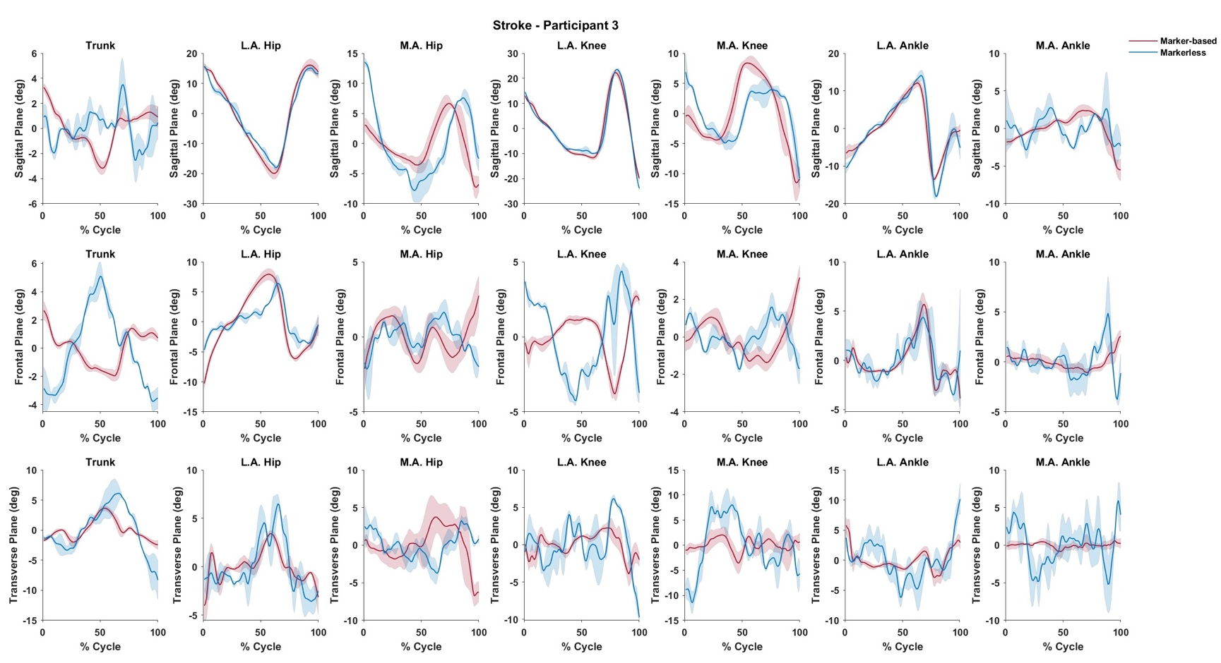
Appendix J – Time-series joint angle waveforms for a representative adult subject with chronic stroke. This subject was 7.57 years post-stroke and used a left ankle foot orthosis and right single-point cane. Waveforms are normalized to 100% of a gait cycle defined as initial contact to initial contact. Shaded regions represent one standard deviation about the solid line which represent ensemble means.

