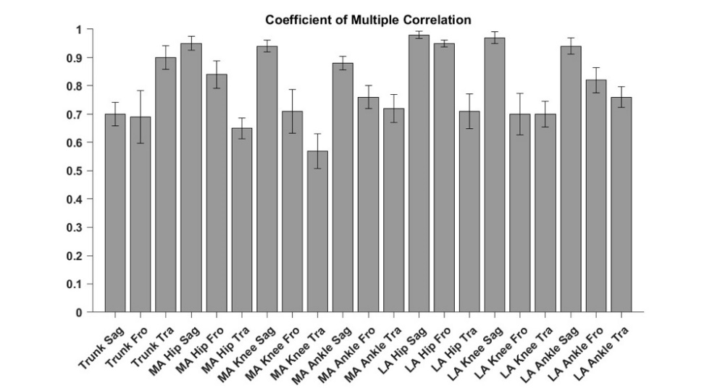 | 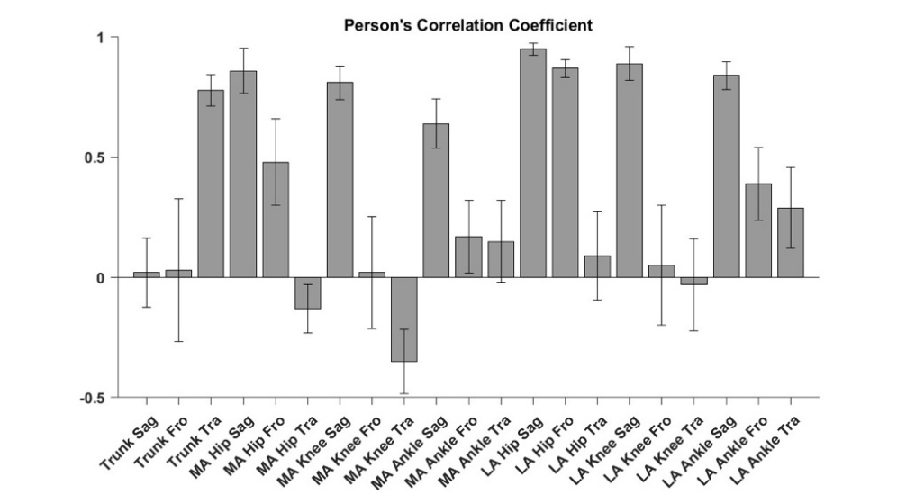
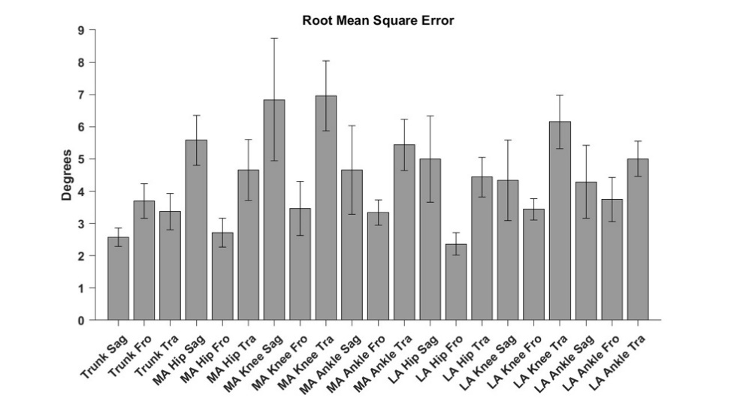 | 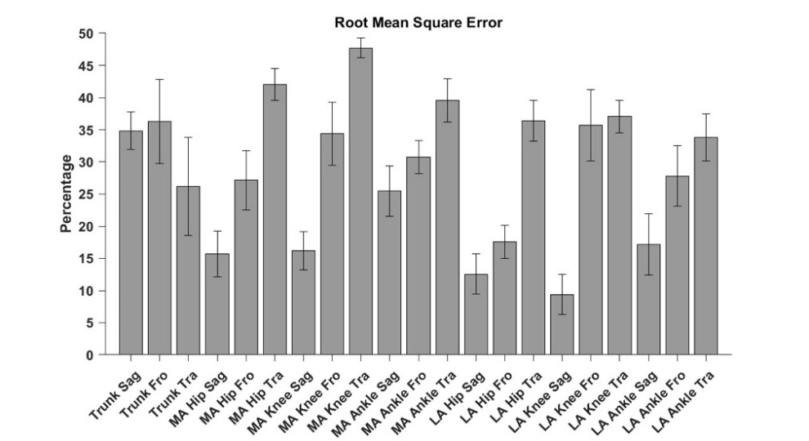

Appendix F – Coefficient of multiple correlation (top left), Pearson's correlation coefficient (top right), absolute root mean square error (bottom left) and normalized root mean square error (bottom right) between the marker-based and markerless methods. Error bars represent one standard deviation.

