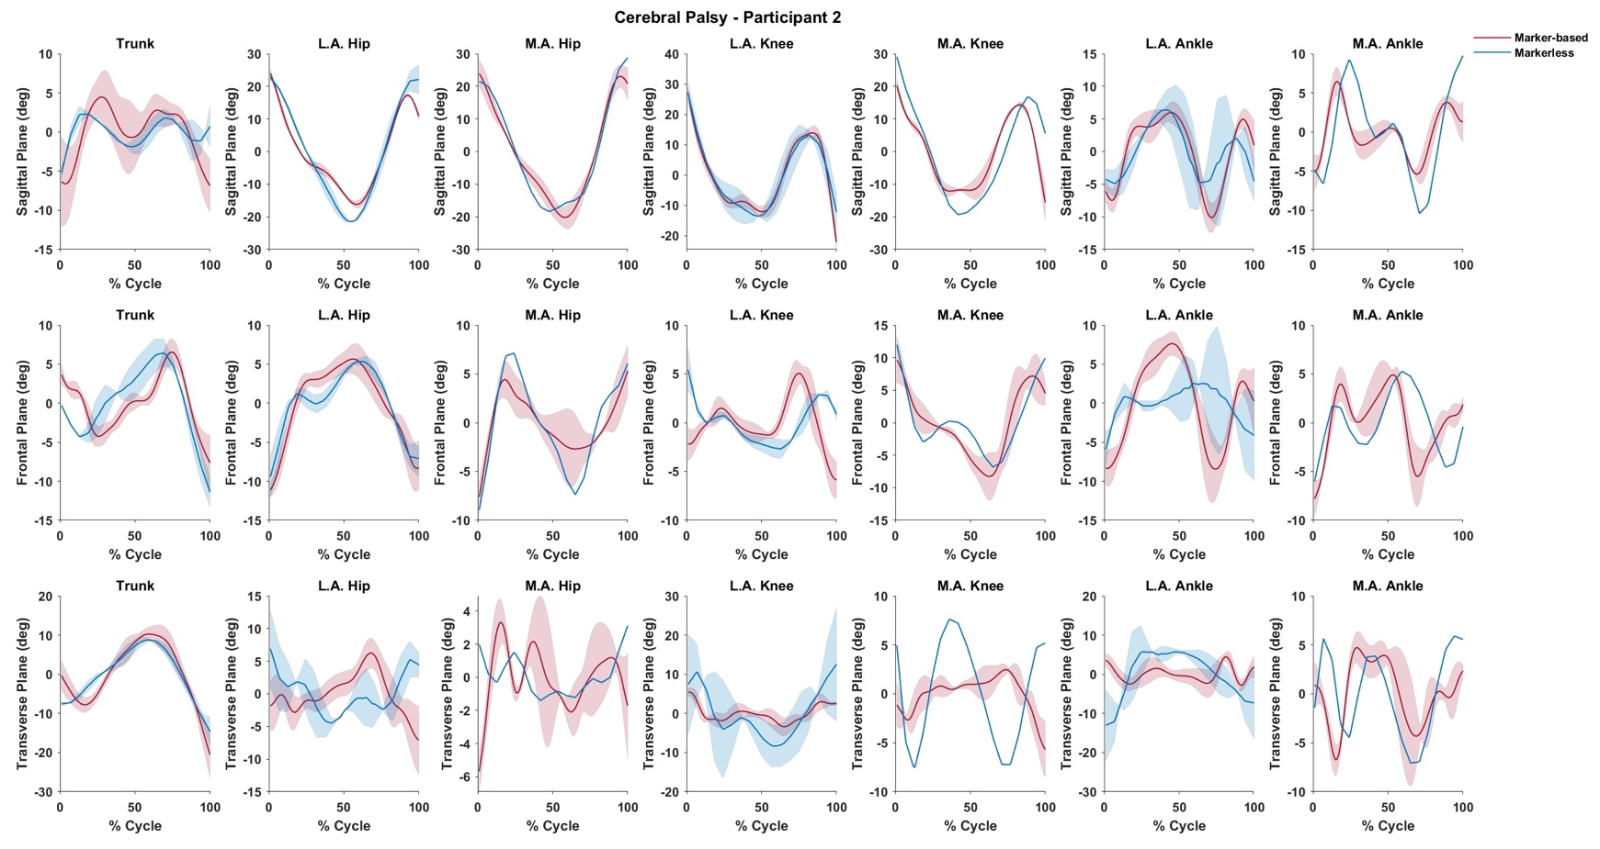
Appendix G – Time-series joint angle waveforms for a representative child subject with cerebral palsy. This subject was a Gross Motor Function Classification System (GMFCS) level 3, which implies an assistive device is needed for ambulation (a rear walker in this case). Waveforms are normalized to 100% of a gait cycle defined as initial contact to initial contact. Shaded regions represent one standard deviation about the solid line which represent ensemble means.

