Table 6: Bacterial mutagenicity prediction results for Cilnidipine and its degradants (KD1 to KD4 and CD1 to CD3)
S. No | Name of the compound | Chemical Structure | Toxicity prediction results
S. No | Name of the compound | Chemical Structure | Derek Nexus (Rule Based) | Sarah Nexus (Statistical Based) | Conclusion / Classification as per ICH M7
1 | Cilnidipine | 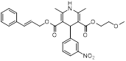 | Inactive | Negative | Negative / Class-5
2 | KD1 | 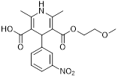 | Inactive | Negative | Negative / Class-5
3 | KD2 | 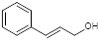 | Inactive | Negative | Negative / Class-5
4 | KD3 | 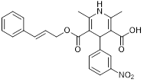 | Inactive | Negative | Negative / Class-5
5 | KD4 | 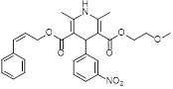 | Inactive | Negative | Negative / Class-5
6 | CD1 | 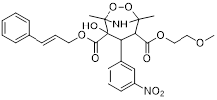 | Positive | Out of domain | Positive/  Class-3
7 | CD2 | 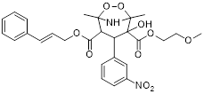 | Positive | Out of domain | Positive/  Class-3
8 | CD3 | 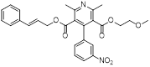 | Positive | Equivocal | Positive/  Class-3

