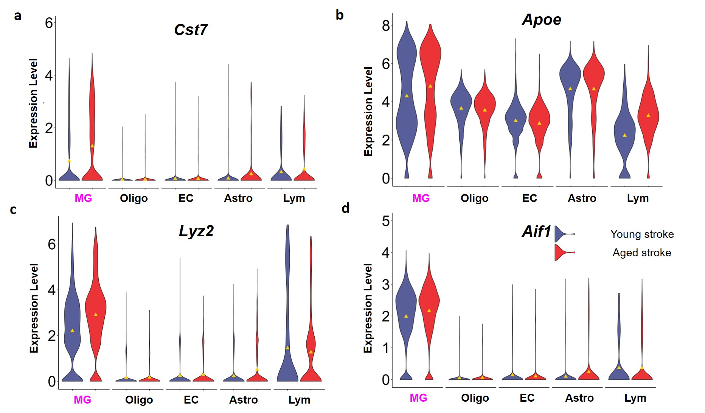
Extended Data Figure 1. Comparison of young and aged stroke on cell type-specific expression of (a) Cst7, (b) Apoe, (c) Lyz2 and (d) Aif1. Violin plots demonstrating the effect of aging on MG specific gene expression after stroke.

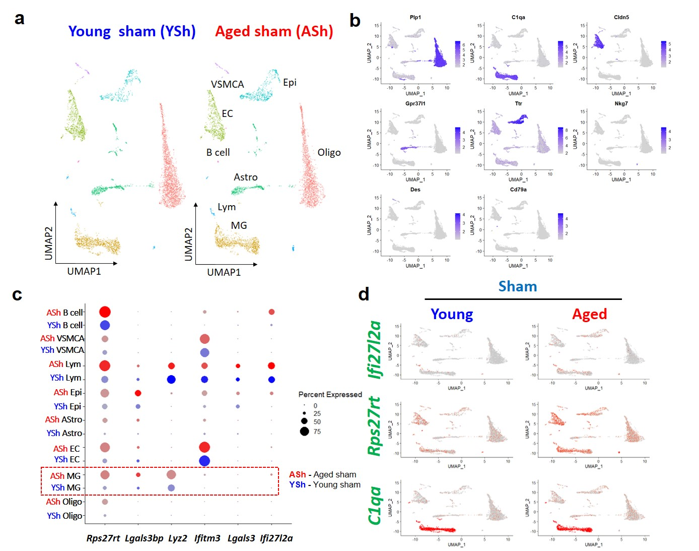
Extended Data Figure 2. scRNAseq from young and aged brains of sham surgery control mice reveals elevated Ifi27l2a expression in the aged brain. (a) UMAP plot showing distinct clusters from brain of young and aged shams (Seurat FindClusters resolution at 0.02). Abbreviations: Oligo; oligodendrocytes, MG; microglia, EC; endothelial cells, Epi; Epithelial cells, Astro; Astrocyte, Ependy; Ependymal cells, VSMCA; Vascular smooth muscle cells, arterial, Lym; Lymphocytes. (b) Feature plot showing the validation of clustering assignments by representative cell specific marker genes. (c) Evaluation of aging on genes that were found to be upregulated in MG after stroke (Lyz2, Ifitm3, Lgals3, and Ifi27l2a). Also, evaluation of aging on expression of Rps27rt (found to be upregulated in aging). Dot plots show aged sham (red dot) compared to young sham (blue dot) for different cell types. (d) Feature plot showing the cellular distribution of Ifi27l2a, Rps27rt and C1qa (a marker gene for MG). The data show clear increase of Ifi27l2a and Rps27rt in aged brain.

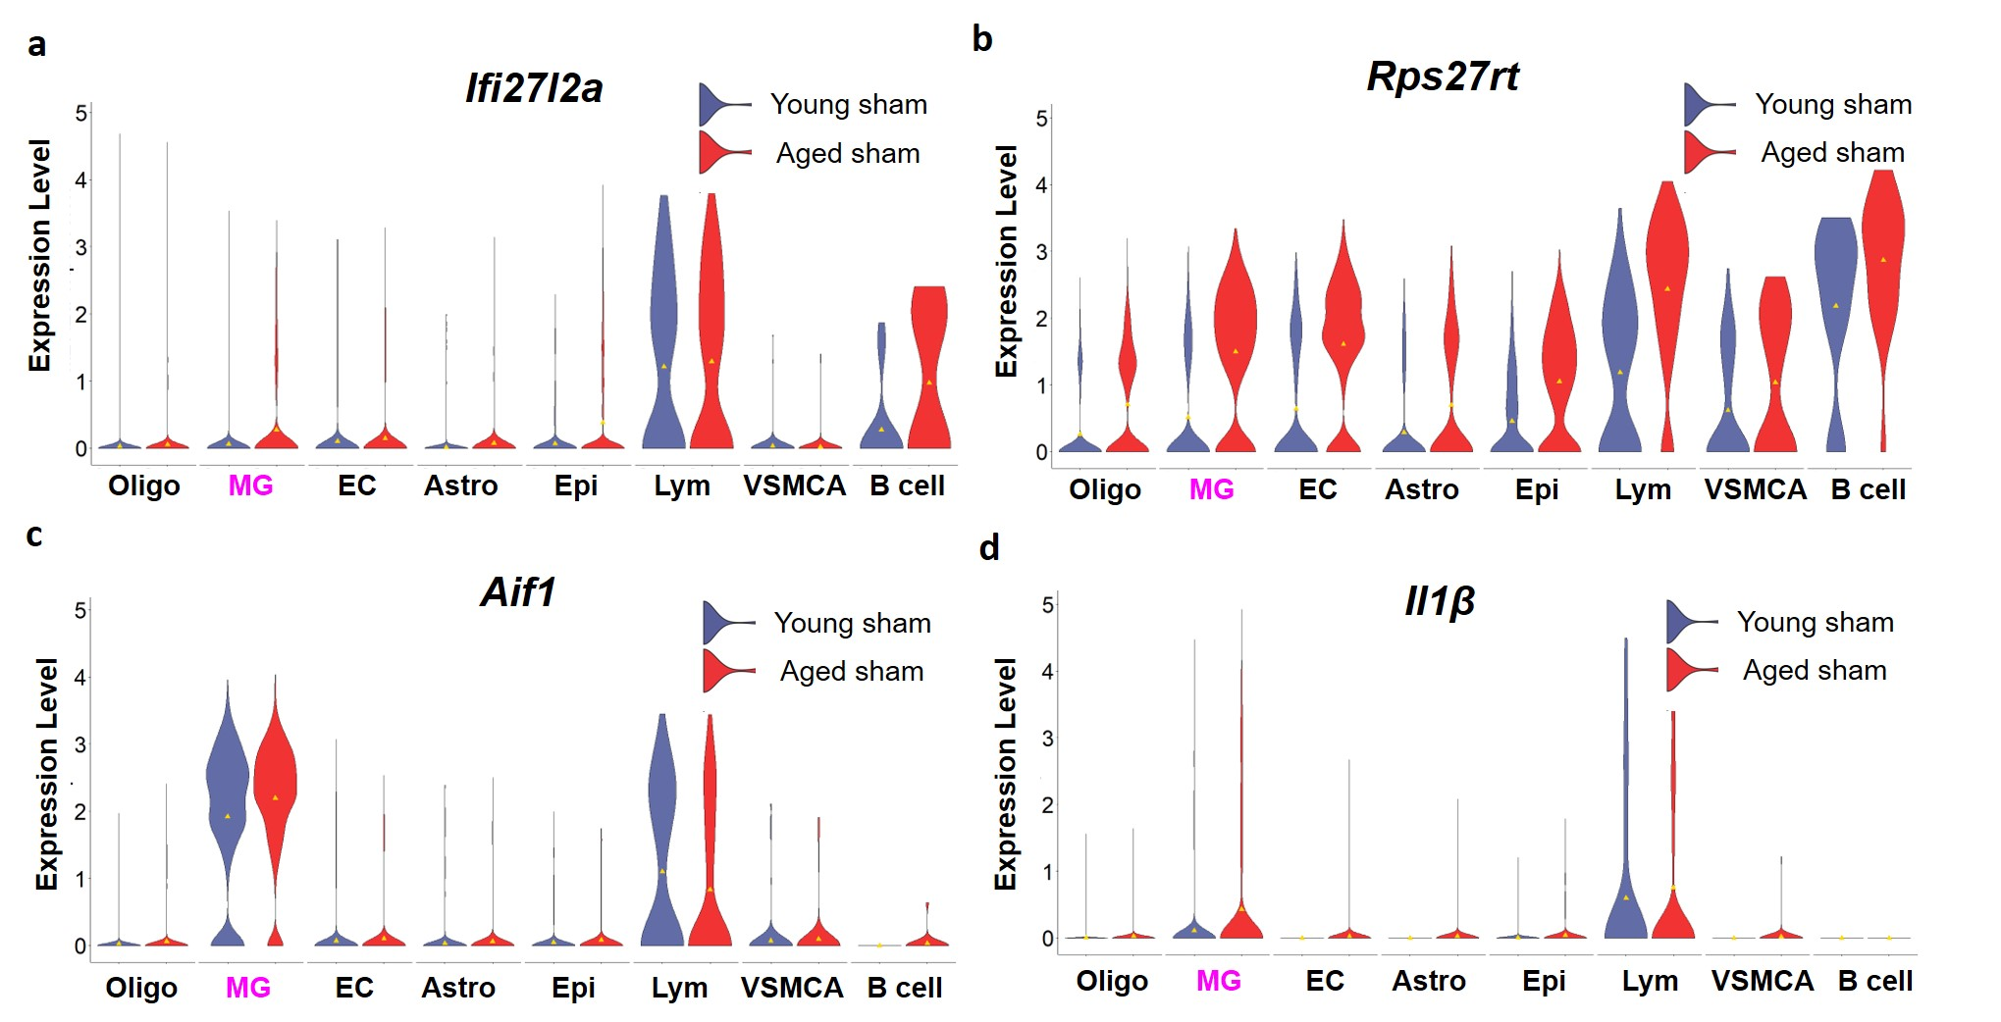
Extended Data Figure 3. Comparison of young and aged sham brains shows age-dependent increase in Ifi27l2a expression in MG and B cell clusters. (a) Violin plot shows increased Ifi27l2a expression in MG and B cell clusters from aged brain, whereas expression in Lym clusters was similar. Age-dependent expression of (b) Rps27rt (ribosomal protein gene), (c) Aif1 (MG marker gene), and (d) IL-1β (pro-inflammatory gene).

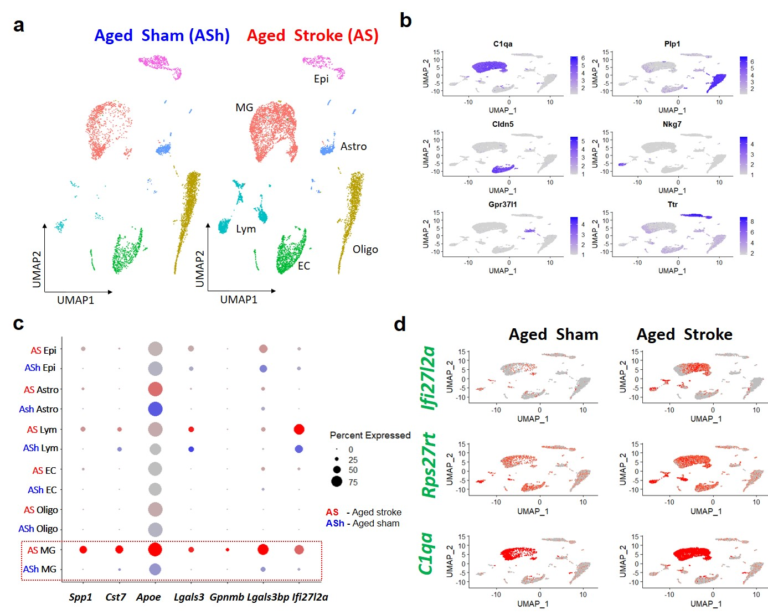
Extended Data Figure 4. Comparison of scRNAseq from aged sham and age stroke brains reveals elevated expression of multiple genes linked with MG phenotype, including Ifi27l2a. (a) UMAP plot showing clusters in aged sham and aged stroke (Seurat FindClusters resolution at 0.02). Abbreviations: Oligo; oligodendrocytes, MG; microglia, EC; endothelial cells, Epi; Epithelial cells, Astro; Astrocyte, Lym; Lymphocytes. (b) Feature plot showing the validation of clustering assignments by representative cell specific marker genes. (c) Evaluation of stroke on expression of Ifi27l2a and other top regulated genes in MG (Spp1, Cst7, Apoe, Lgals3, Gpnmb, Lgals3bp). In each case, expression was increased in MG from aged stroke brain (red dots) compared with aged sham brain (blue dots). (d) Feature plot showing the cellular distribution of Ifi27l2a, Rps27rt and C1qa (a marker gene for MG). The data show clear upregulation of Ifi27l2a and Rps27rt in MG from aged stroke brain.

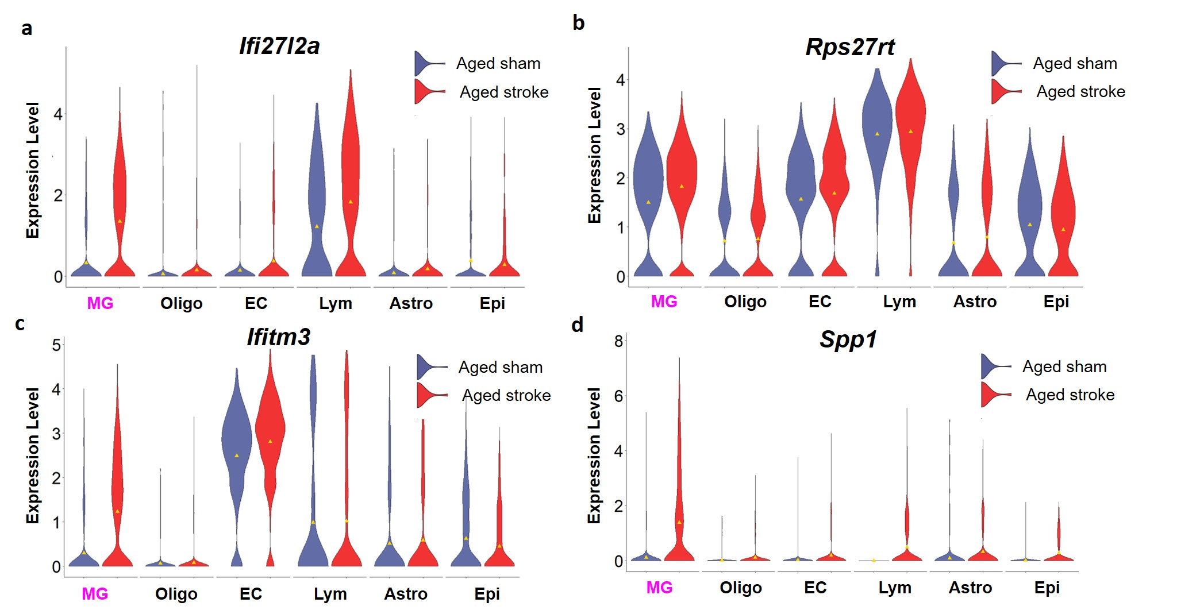
Extended Data Figure 5. Comparison of aged sham and stroke brains shows increased Ifi27l2a expression in MG and Lym clusters. (a) Violin plot showing increased Ifi27l2a expression in MG and Lym clusters from aged stroke brains. Violin plots showing elevated expression of (b) Rps27rt, (c) Ifitm3, and (d) Spp1 in MG from aged stroke brain versus aged shams.

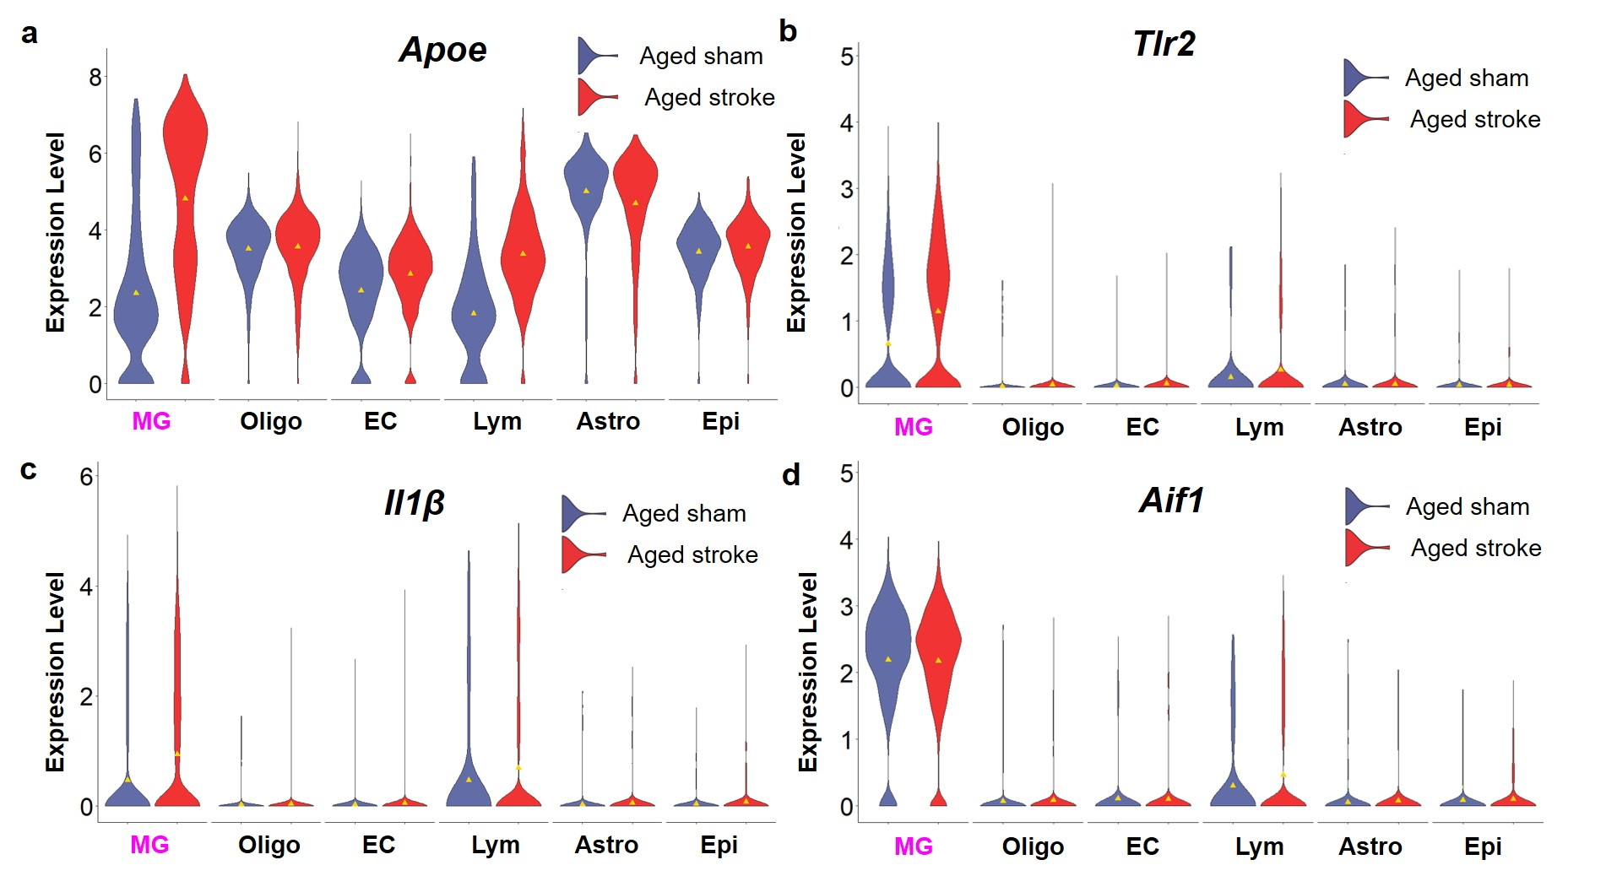
Extended Data Figure 6. Comparison of genes associated with MG activation from aged sham and aged stroke brains. Violin plots showing increased expression of (a) Apoe, (b) Tlr2, and (c) Il-1β in MG from aged stroke brain. (d) Violin plot showing similar expression level of Aif1 between groups (used to validate cluster assignment).

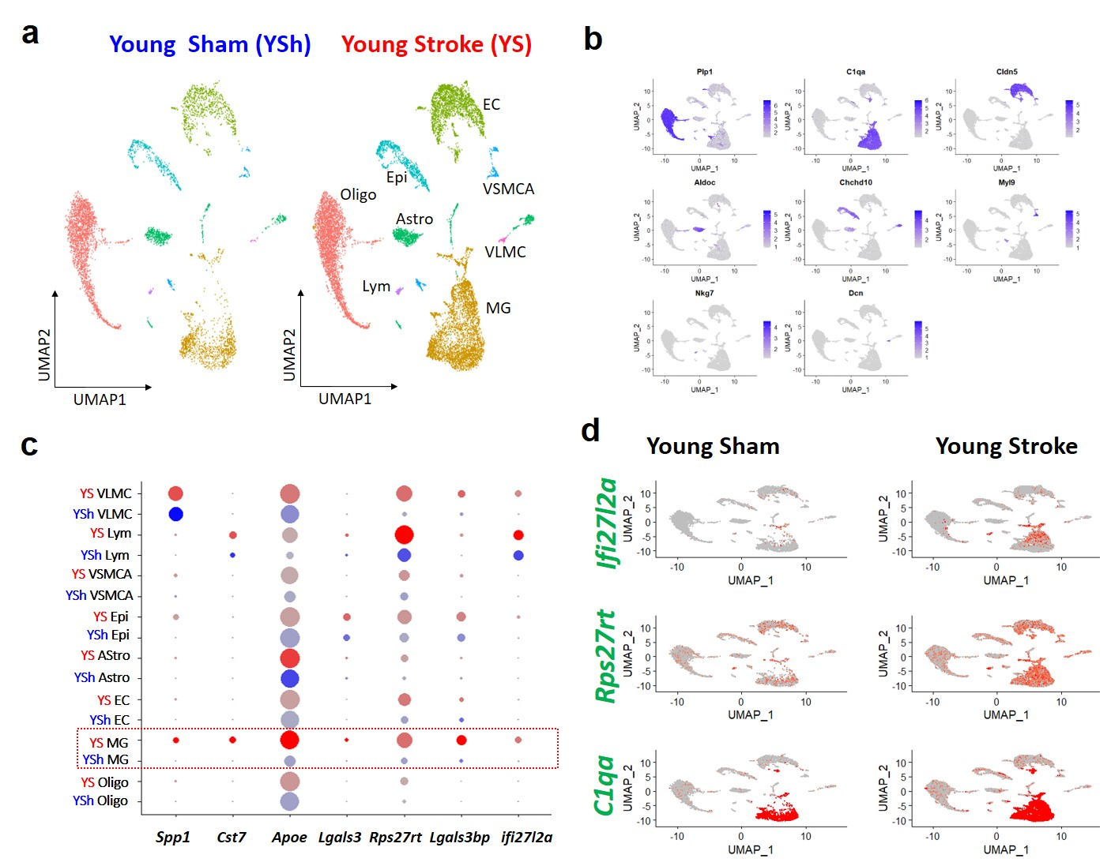
Extended Data Figure 7. Comparison of scRNAseq from young sham and young stroke brains reveals elevated expression of multiple genes linked with MG phenotype, including Ifi27l2a. (a) UMAP plot showing distinct clusters from brain of young sham and young stroke (Seurat FindClusters resolution at 0.02). Abbreviations: Oligo; oligodendrocytes, MG; microglia, EC; endothelial cells, Epi; Epithelial cells, Astro; Astrocyte, VSMCA; Vascular smooth muscle cells, arterial, Lym; Lymphocytes, and VLMC; Vascular leptomeningeal cells. (b) Feature plot showing the validation of clustering assignments by representative cell specific marker genes. (c) Evaluation of stroke on Ifi27l2a and other highly upregulated genes in MG. Dot plots show young sham (blue dot) compared to young stroke (red dot) for different cell types. (d) Feature plot that showing cellular distribution of Ifi27l2a, Rps27rt and C1qa (a marker gene for MG). The data show elevated expression of Ifi27l2a and Rps27rt in MG of young stroke brain, compared with young sham brain.

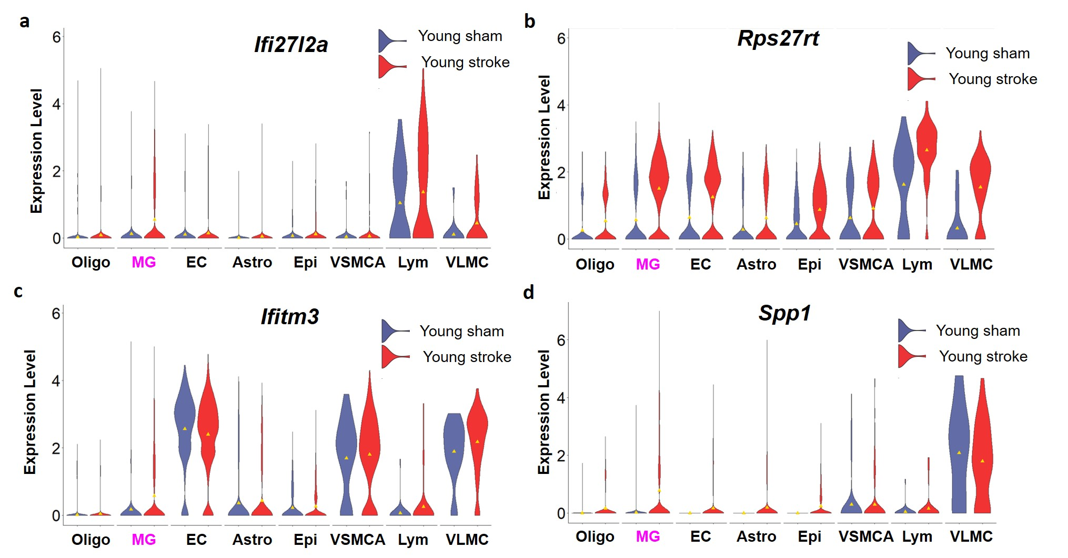
Extended Data Figure 8. Evaluation of the effect of stroke on expression of Ifi27l2a, other highly upregulated genes (Spp1, Rps27rt), and another interferon related gene (Ifitm3) in young brain. (a) Violin plots showing elevated Ifi27l2a expression in MG, Lym, and VLMC clusters of young stroke brain compared with young sham brain. Violin plots of (b) Rps27rt, and (c) Ifitm3, and (d) Spp1 for young sham and young stroke brains.

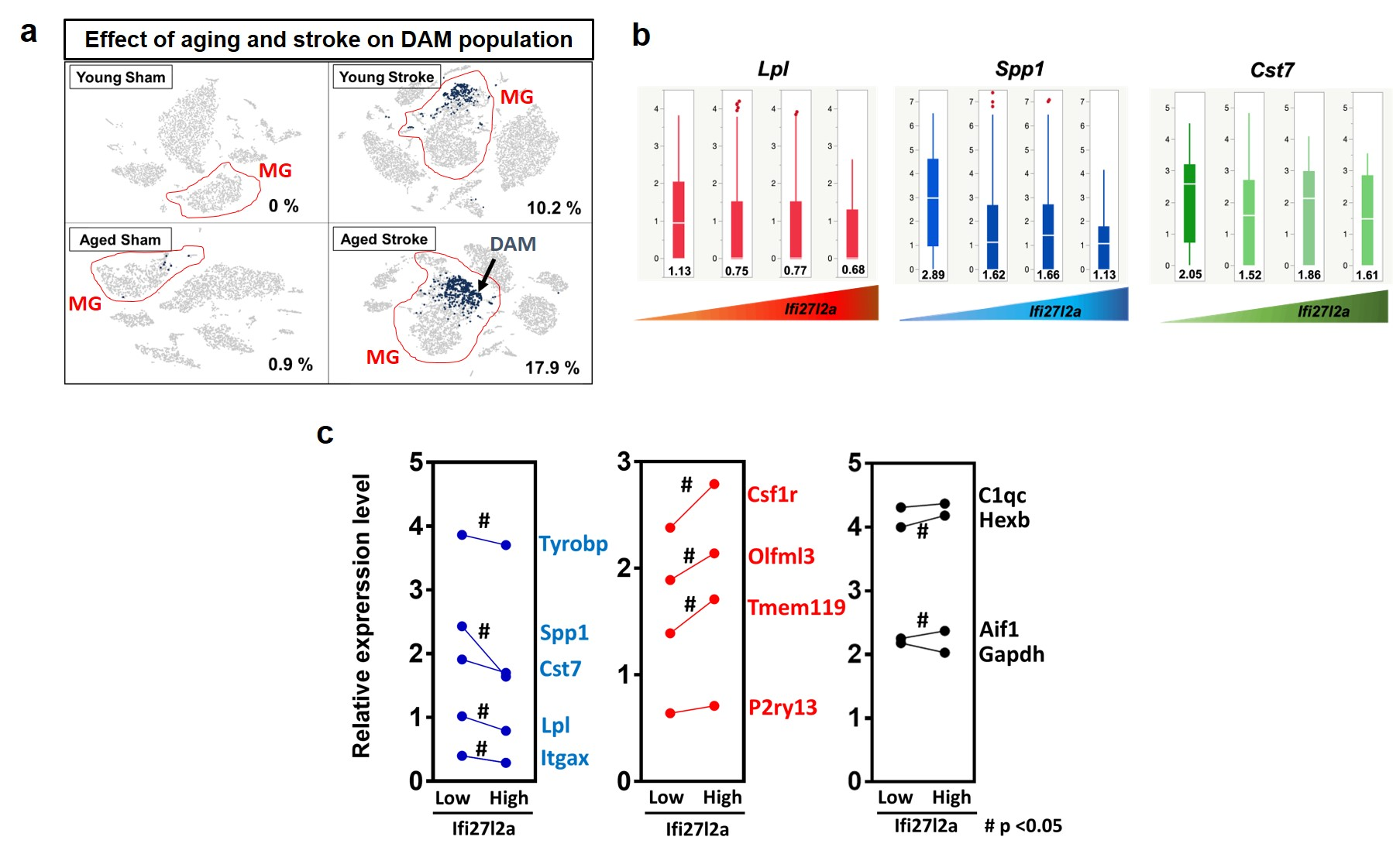
Extended Data Figure 9. Inverse correlation between Ifi27l2a and genes expressed in the DAM cell type. (a) Feature plots showing the relative proportion of DAM cells among the MG population (DAM defined as: Aif1+, Spp1+, Cst7+, and Lpl+). The DAM population frequency is slightly increased by aging and significantly increased following stroke. (b) MG cells from the aged stroke group were sub-grouped (sub-clusters) based on Ifi27l2a expression level (left to right: 0.3 to 1; 1 to 2; 2 to 3; >3). The expression level of genes associated with the DAM cell type (Lpl, Spp1, and Cst7) were then plotted with boxplot for each Ifi27l2a expression level. The expression of each indicated gene is summarized as median value (horizontal white line) and mean value (value on plot). (c) Comparison of DAM distinguishing genes (Tyrobp, Spp1, Lpl, and Itgax) versus other MG genes according to “low” and “high” Ifi27l2a expression level. A consistent negative correlation is evident between Ifi27l2a level and DAM genes. Further, a positive correlation was found in genes known to be reduced in the DAM phenotype (Csf1, Olfml3, and Tmem119). # p <0.05

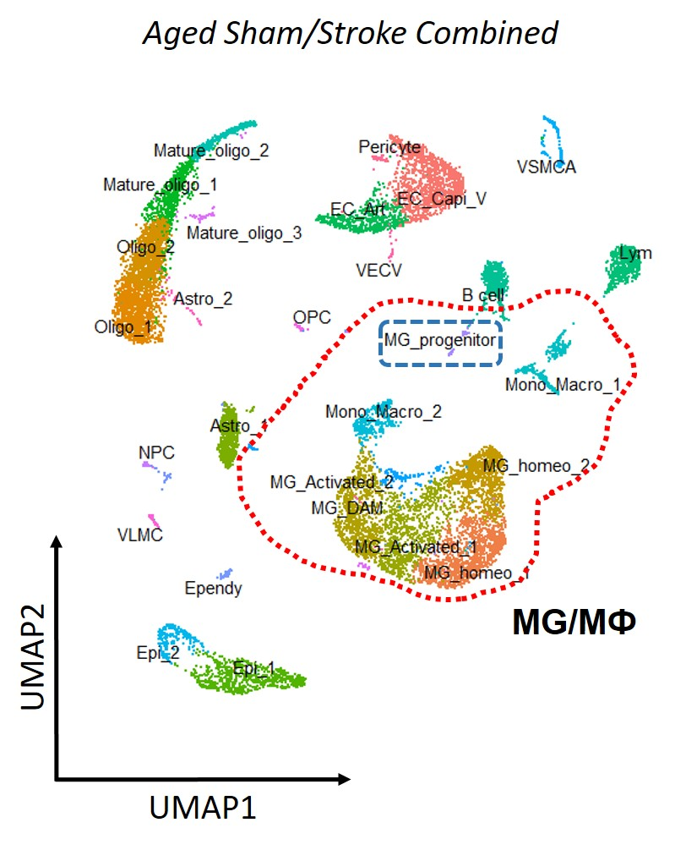
Extended Data Figure 10. Higher clustering resolution applied to the combined aged sham/stroke population reveals additional MG sub-clusters, including DAM and progenitor MG cells. UMAP plot (Seurat FindClusters resolution at 1) shows distinct clusters of MG/Macrophage in aged sham and aged stroke. The red dashed line demarcates the MG sub-clusters, including MG_homeo_1, MG_homeo_2, MG_Activated_1, MG_Activated_2, MG_DAM, MG_progenitor, Mono-macro_1, and Mono-macro_2. Further characterization of the putative MG progenitor sub-cluster from aged sham and stroke brain (demarcated by blue dashed line).

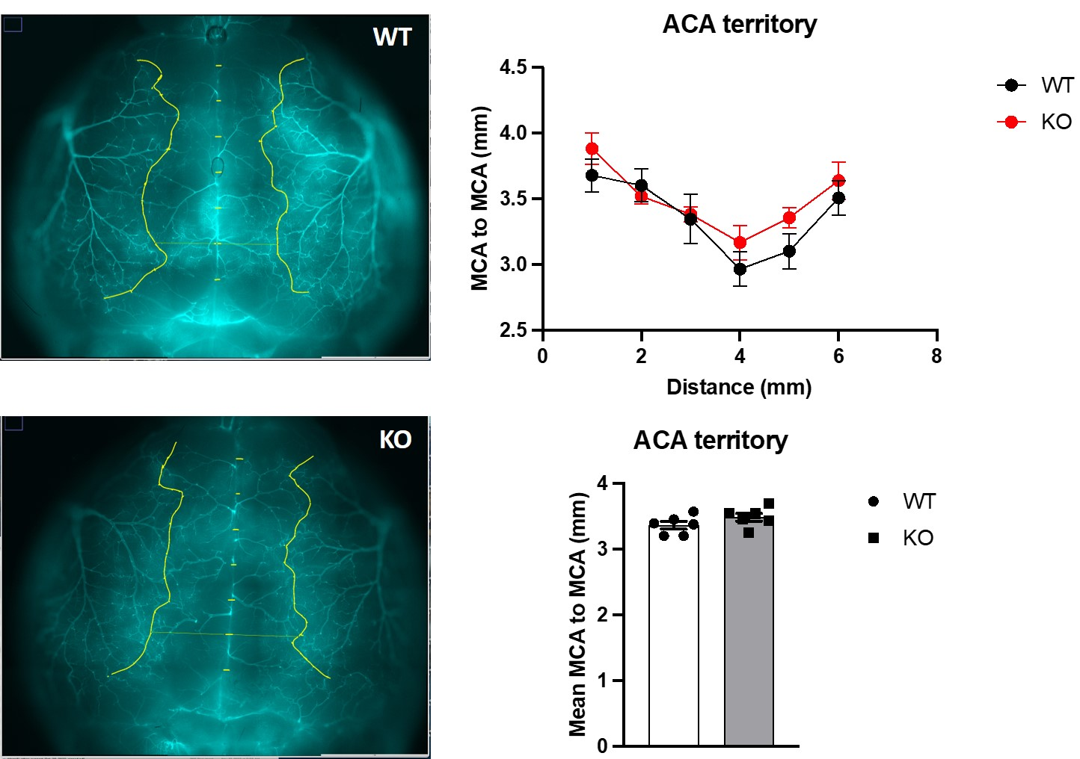
Extended Data Figure 11. No difference in vascular territory between WT and Ifi27l2a KO. Distance from MCA in one hemisphere to MCA in opposite hemisphere was measured after lectin injection. The distance between MCA territories represents the ACA territory and is used to evaluate if the MCA territory is altered by Ifi27l2a deletion. Vascular territory analysis revealed that there is no difference in distance between MCA territories at 1 mm increments along the midline (top summary) or as mean distance along midline (bottom summary; n=6, p=0.19).

Gene – mouse | Forward | Reverse
Ifi27l2a | CTGTTTGGCTCTGCCATAGGAG | CCTAGGATGGCATTTGTTGATGTGG
Cst7 | ACCAATAACCCAGGAGTGCTT | TGACCCAGACTTCAGAGTAGC
Lpl | GGGAGTTTGGCTCCAGAGTTT | TGTGTCTTCAGGGGTCCTTAG
Tyrobp | GAGTGACACTTTCCCAAGATGC | CCTTGACCTCGGGAGACCA
ApoE | CTGAACCGCTTCTGGGATTACCTG | CATAGTGTCCTCCATCAGTGCCGTC
Tmem119 | GTGTCTAACAGGCCCCAGA | AGCCACGTGGTATCAAGGAG
C1qa | AAAGGCAATCCAGGCAATATCA | TGGTTCTGGTATGGACTCTCC
C1qb | CCACGCAACGGCAAGTTCAC | CGGCCACGAACGAGATTCAC
Ifitm3 | TTCTGCTGCCTGGGCTTCATAG | ACCAAGGTGCTGATGTTCAGGC
Il1b | CTGTGTCTTTCCCGTGGACC | CAGCTCATATGGGTCCGACA
Extended data Table 1. Mouse primers used in this study

Extended data Table 2. Top 5 genes that are upregulated in MG from aged brains.

Top 5  Genes | Young Sham (expression level) | Aged Sham  (expression level) | Ave_log FC | Ave _FC
  Rpl35
  Apoe
  Rps27rt
  Rps28
  Il1b
  0.73
  3.49
  0.93
  2.08
  0.59
  1.75
  4.48
  1.86
  2.99
  1.49
  1.02
  0.98
  0.93
  0.87
  0.87
  2.03
  1.98
  1.90
  1.87
  1.87

