Small peptides isolated from enzymatic hydrolysates of Pneumatophorus japonicus head have protective effects on GES-1 cells against alcohol damage

Yi-Ying Tang^{a,e,1}, Ming-Hui Gao^{a,e,1}, Jie-Shuai Zhangª, Ning-ping Tao^{a, b, c, d}, Xi-Chang Wang^{a, b, c, d}, Ping Wang^{f}, Shang-Gui Deng^{g}, Miao-Si Hong^{h,*}, Chang-Hua Xu^{a, b, c, d}**, Ying Luª, Jing-Ya Yangª
ª College of Food Science & Technology, Shanghai Ocean University, Shanghai 201306, PR China
^{b} Shanghai Engineering Research Center of Aquatic-Product Processing & Preservation, Shanghai 201306, China
^{c} Laboratory of Quality and Safety Risk Assessment for Aquatic Products on Storage and Preservation (Shanghai), Ministry of Agriculture, Shanghai 201306, China
^{d} National R&D Branch Center for Freshwater Aquatic Products Processing Technology (Shanghai), Shanghai 201306, China
^{e} Shanghai Qinpu Biotechnology Pte Ltd, Shanghai 201306, China
^{f} School of Chinese Materia Medica, Tianjin University of Traditional Chinese Medicine, Tianjin 300193, China
^{g} College of Food and Pharmacy, Zhejiang Ocean University, Zhoushan 316000, Zhejiang, China
^{h} Shanghai Sixth People's Hospital, Shanghai 201306, China

Table S1. Experimental group
Group | Gastric  mucin | <1 kDa PHPs low-does | <1 kDa PHPs high-does | 1-3 kDa PHPs low-does | 1-3 kDa PHPs high-does | 3-10 kDa PHPs low-does | 3-10 kDa PHPs high-does
Code | GM | PHP1L | PHP1H | PHP2L | PHP2H | PHP3L | PHP3H

Table S2. The absorbance values (570 nm) of alcohol on GES-1 cells （ n＝6 ）
Alcohol Concentration (%) | 2h | 3h | 4h | 5h | 6h
0 | 0.692 ± 0.01 | 0.698 ± 0.02 | 0.679 ± 0.02 | 0.688 ± 0.02 | 0.657 ± 0.03
2 | 0.612 ± 0.02 | 0.595 ± 0.05 | 0.585 ± 0.01 | 0.549 ± 0.02 | 0.538 ± 0.05
4 | 0.609 ± 0.02 | 0.531 ± 0.03 | 0.52 ± 0.02 | 0.514 ± 0.02 | 0.502 ± 0.02
6 | 0.599 ± 0.02 | 0.526 ± 0.05 | 0.507 ± 0.02 | 0.496 ± 0.01 | 0.493 ± 0.02
8 | 0.526 ± 0.03 | 0.421 ± 0.02 | 0.419 ± 0.01 | 0.399 ± 0.01 | 0.349 ± 0.03
10 | 0.429 ± 0.03 | 0.391 ± 0.03 | 0.365 ± 0.03 | 0.343 ± 0.05 | 0.331 ± 0.04

Table S3. Distribution of main characteristic absorption peaks of IR of GES-1 cells under different treatment conditions
Peak position(cm⁻¹) | Main functional groups
~3289 | υ (NH₃)
3000-2800 | υ_{as} (CH₃), υ_{as} (CH₂)；υ_{s} (CH₃)，υ_{s} (CH₂)
1775-1735 | υ_{s} (C=O)
~1650 | Amide I
~1540 | Amide II
~1460 | υ_{as} (CH₃), υ (CH₂)
~1395 | δ_{s} (CH₃), υ_{s} (COO-)
1085、1240 | υ_{s} (PO₂⁻), υ_{as} (PO₂⁻)
1085-1041 | δ (C-C), υ (C-O)
980-930 | δ_{out-plane} (C-H), δ (C-O), υ (C-C)
υ: stretching vibration, δ: flexural vibration, s: symmetry, as: antisymmetric.

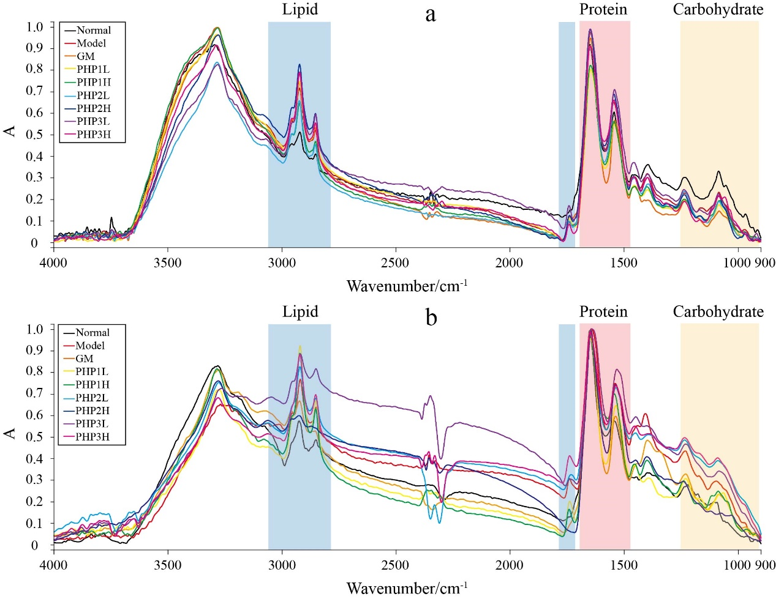
Figure S1. IR of GES-1 cells. (a) Cells were treated through BD; (b) Cells were treated through AD.

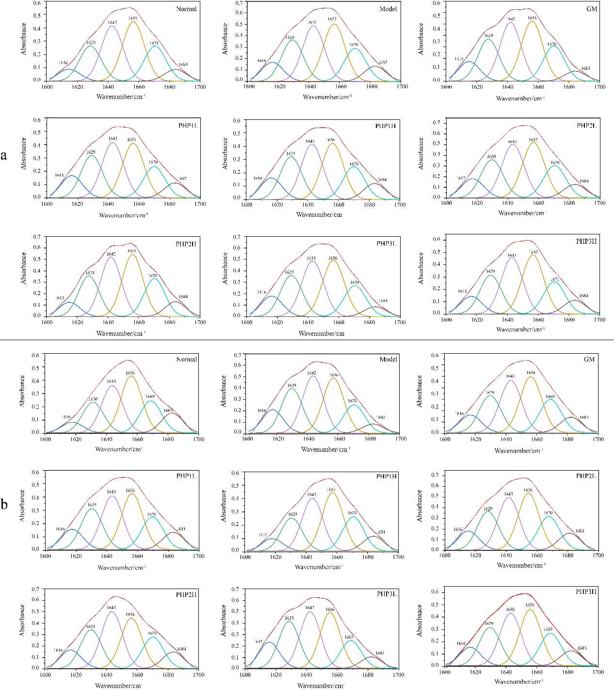
Figure S2. Fitting of protein Amide I under different treatment conditions. (a) Cells were treated through BD; (b) Cells were treated through AD.

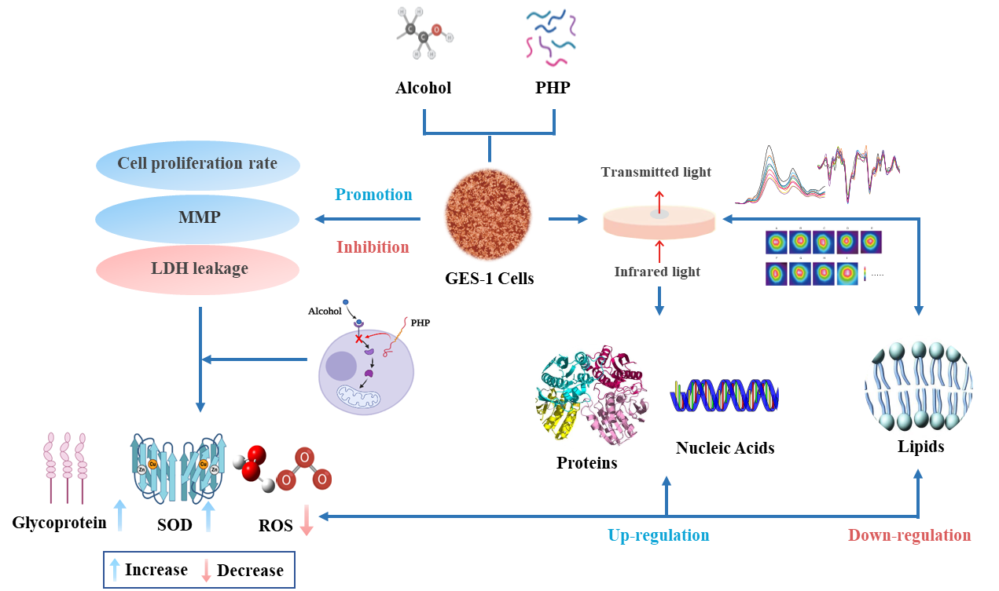
Figure S3. Protection and repair mechanisms of PHPs against GES-1 damage induced by alcohol.

*Corresponding author. **Correspondence to: C.H. Xu, College of Food Science & Technology, Shanghai Ocean University, Shanghai 201306, PR China.: E-mail addresses: hongmiaosi@126.com (M. -S. Hong); chxu@shou.edu.cn (C.-H. Xu)

