Fig.5
a.The relative levels of E-cadherin to the control β-actin expression in breast cancer cells were quantified by Western blot.
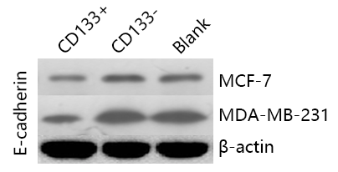

Original figure:

CD133+
Blank
CD133-

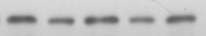
MCF-7

CD133+
Blank
CD133-

MDA-MB-231
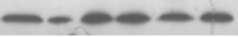

Blank
CD133-
CD133+

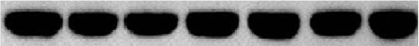
β-actin
b.The relative levels of N-cadherin to the control β-actin expression in breast cancer cells were quantified by Western blot.
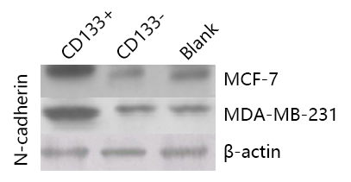

Original figure:

CD133-
CD133+
Blank

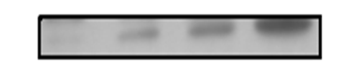
MCF-7

Blank
CD133-
CD133+

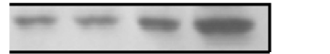
MDA-MB-231

Blank
CD133-
CD133+

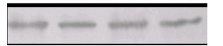
β-actin

c.The relative levels of Vimentin to the control β-actin expression in breast cancer cells were quantified by Western blot.
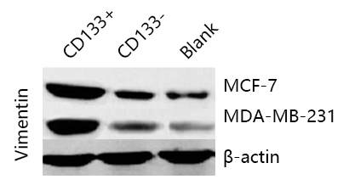

Original figure:

Blank
CD133-
CD133+

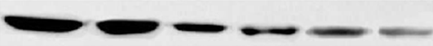
MCF-7

CD133-
CD133+
Blank

MDA-MB-231

Blank
CD133-
CD133+

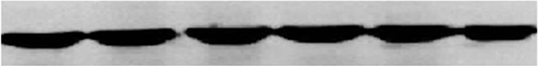
β-actin

