Supplementary Information for

Mott insulating ruthenium oxides for highly efficient water oxidation

Xianbing Miao¹*, Jingda Zhang²*, Zhenpeng Hu^{2†} & Shiming Zhou^{1†}

¹Hefei National Research Center for Physical Sciences at the Microscale, University of Science and Technology of China, Hefei, Anhui 230026, P. R. China

²School of Physics, Nankai University, Tianjin 300071, P. R. China

*These authors contributed equality to this work.
†Corresponding author: Z.H. (email: zphu@nankai.edu.cn) or S.Z. (email: zhousm@ustc.edu.cn)

Supplementary Figures
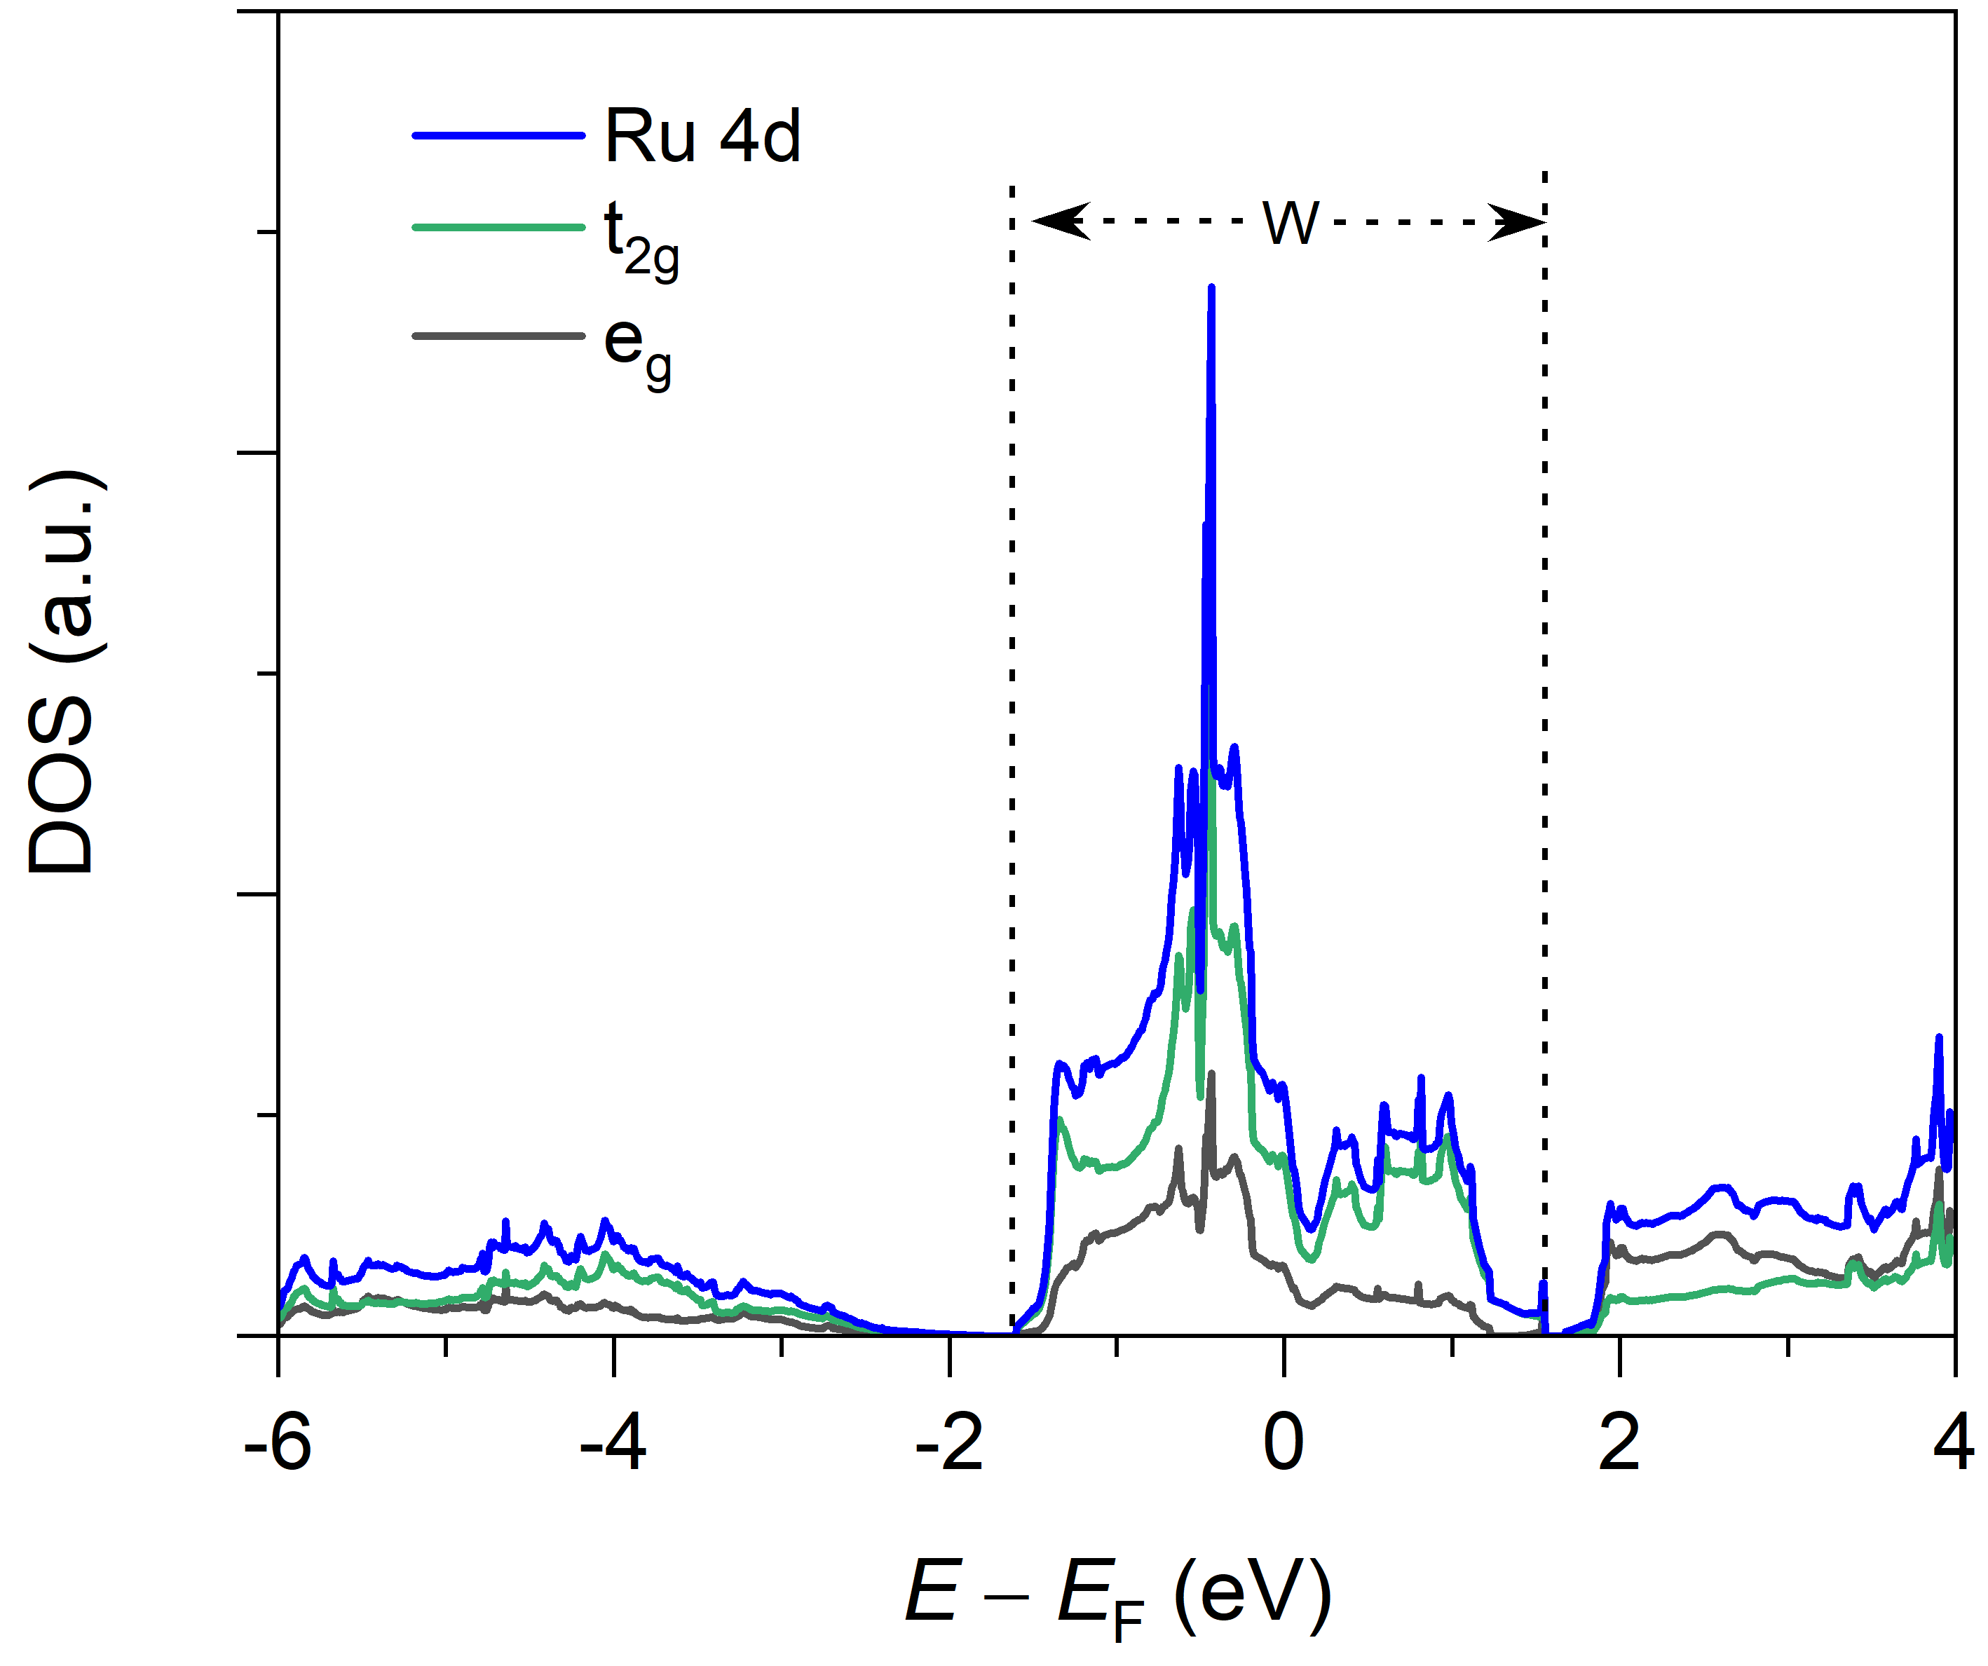

Supplementary Figure 1 | Partial DOS from Ru 4d-band with U = 0 eV for rutile RuO₂. The occuppied state around Fermi level are mainly from Ru 4d t_{2g} orbitals. W: Ru 4d t_{2g}-bandwidth.

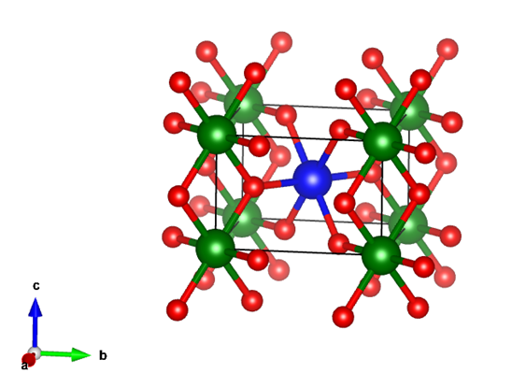

Supplementary Figure 2 | Antiferromagnetic structure of rutile RuO₂ predicted by spin-polarization DFT+U calculations. Color code: Ru (spin up, green), Ru (spin down, blue), and O (red).

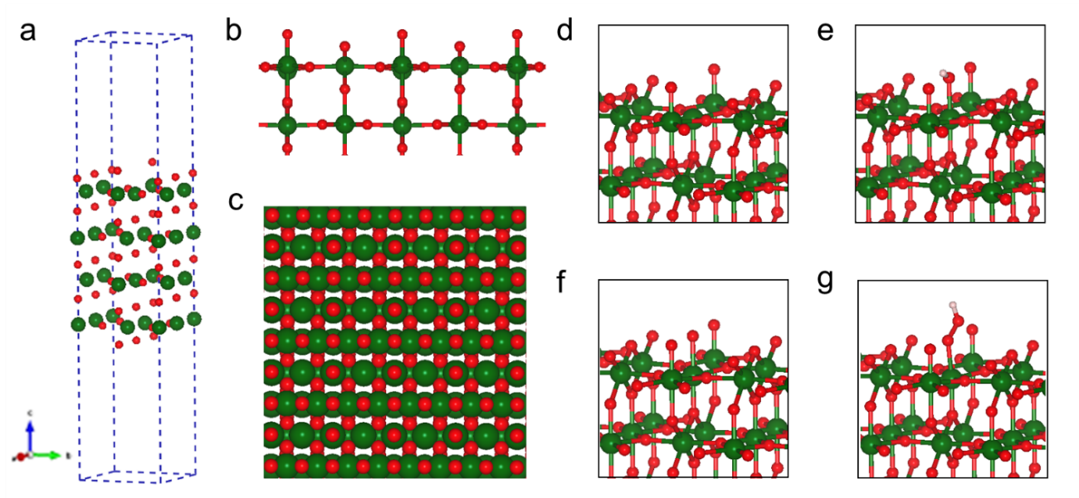

Supplementary Figure 3 | Slab model, surface views, and adsorption stuctures for rutile RuO₂ (110) surface. a, Slab model. b, Side view. c, Top view. d-g, Optimized structures of *OH, *O, and *OOH adsorpotions on rutile RuO₂ (110) surface. Color code: Ru (green), and O (red).

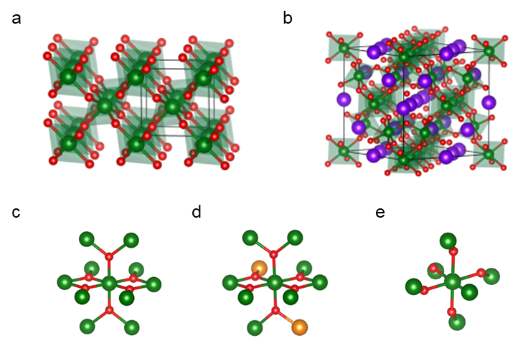

Supplementary Figure 4 | RuO₆ octahedra networks in rutile and pyrochlore structures. a, Rutile structure. b, Pyrochlore structure. c-e, Neighboring Ru atoms in rutile (c), doped rutile (d), and pyrochlore (e) lattices, respectively. Color code: Ru (green), A-site ions in pyrochlore (purple), doped hetero-ions (orange), and O (red).

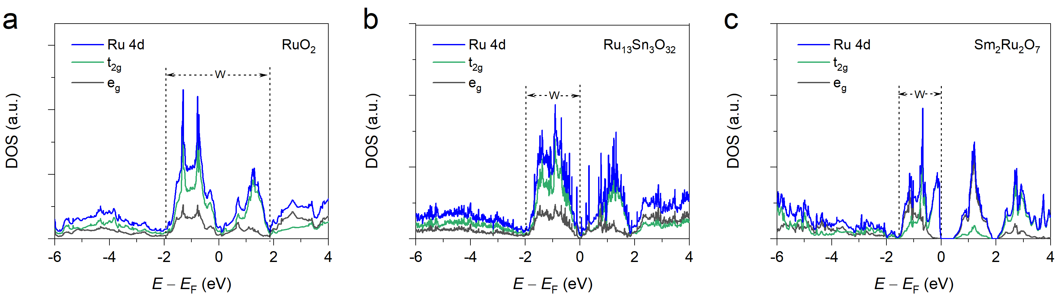

Supplementary Figure 5 | Partial DOS from Ru 4d-band with U = 2 eV for rutile RuO₂, Ru₁₃Sn₃O₃₂, and pyrochlore Sm₂Ru₂O₇. a, RuO₂. b, Ru₁₃Sn₃O₃₂. c, Sm₂Ru₂O₇. The occuppied states around Fermi level are mainly from Ru 4d t_{2g} orbitals for these compounds. W: Ru 4d t_{2g}-bandwidth.

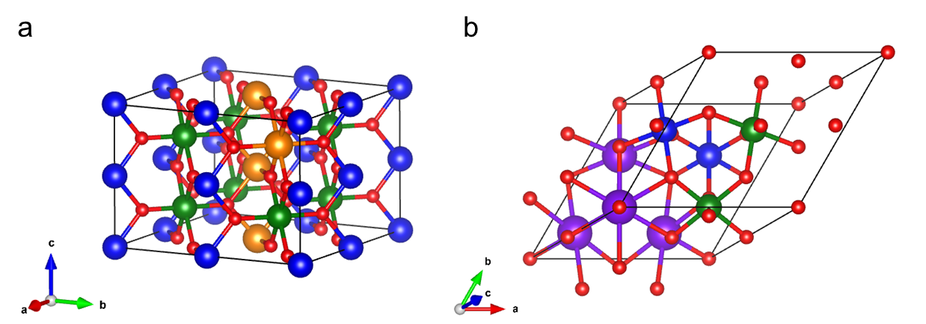

Supplementary Figure 6 | Antiferromagnetic structures of rutile Sn-doped RuO₂ (Ru₁₃Sn₃O₃₂) and pyrochlore Sm₂Ru₂O₇ predicted by spin-polarization DFT+U calculations. a, Ru₁₃Sn₃O₃₂. b, Sm₂Ru₂O₇. U = 2 eV. Color code: Ru (spin up, green), Ru (spin down, blue), Sn (orange), Sm (purple), and O (red).

Supplementary Figure 7 | Morphological and structural characterizations for as-prepared Ru_{0.8}Sn_{0.2}O₂ and Sm₂Ru₂O₇. a, b, SEM image (a) and XRD pattern (b) for Ru_{0.8}Sn_{0.2}O₂. c, d, SEM image (c) and XRD pattern (d) for Sm₂Ru₂O₇. The particle sizes of Ru_{0.8}Sn_{0.2}O₂ and Sm₂Ru₂O₇ are tens and hundreds of nanometers, respectively.

Supplementary Figure 8 | Polarization curves for as-prepared Ru_{0.8}Sn_{0.2}O₂, Sm₂Ru₂O₇, and commercial RuO₂ measured in O₂-saturated 0.5 M H₂SO₄ solution.

Supplementary Figure 9 | Nitrogen adsorption-desorption isotherm curves. a, Commercial rutile RuO₂. b, As-prepared Ru_{0.8}Sn_{0.2}O₂. c, As-prepared Sm₂Ru₂O₇.

Supplementary Figure 10 | SEM images for as-prepared rutile Ru_{1-x}M_{x}O₂ (M = Sn and Cr) and pyrochlore A₂Ru₂O₇ (A = Bi_{x}Y_{1-x}, Eu, and Gd). a-h, Ru_{0.9}Sn_{0.1}O₂, Ru_{0.8}Cr_{0.2}O₂, Ru_{0.5}Cr_{0.5}O₂, Bi_{0.6}Y_{1.4}Ru₂O₇, Bi_{0.4}Y_{1.6}Ru₂O₇, Bi_{0.2}Y_{1.8}Ru₂O₇, Eu₂Ru₂O₇, and Gd₂Ru₂O₇, respectively. The particle sizes of Ru_{1-x}M_{x}O₂ are tens of nanometers, and the particle sizes of A₂Ru₂O₇ are hundreds of nanometers.

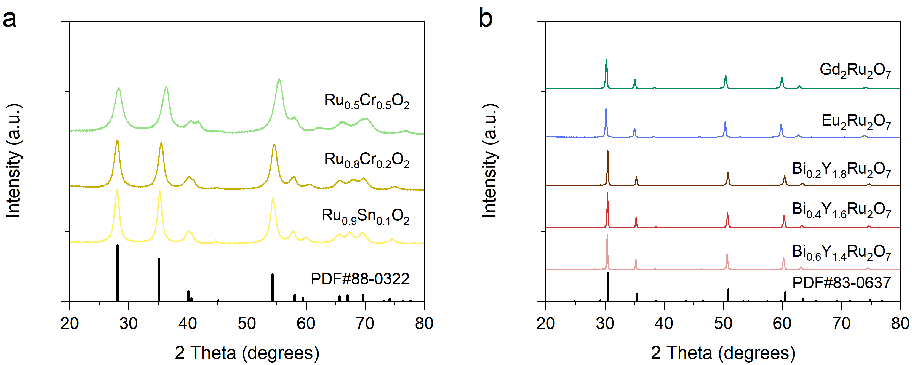

Supplementary Figure 11 | XRD patterns for as-prepared rutile Ru_{1-x}M_{x}O₂ (M = Sn and Cr) and pyrochlore A₂Ru₂O₇ (A = Bi_{x}Y_{1-x}, Eu, and Gd).

Supplementary Figure 12 | Nitrogen adsorption-desorption isotherm curves for as-prepared rutile Ru_{1-x}M_{x}O₂ (M = Sn and Cr) and pyrochlore A₂Ru₂O₇ (A = Bi_{x}Y_{1-x}, Eu, and Gd).

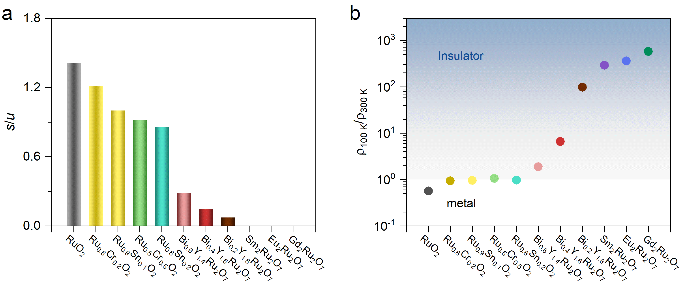

Supplementary Figure 13 | The relative intensities between s and u peaks (s/u) from fitting XPS and the normalized resistivities ρ_{100 K}/ρ_{300 K} for rutile Ru_{1-x}M_{x}O₂ and pyrochlore A₂Ru₂O₇. a, The ratio of s/u. b, ρ_{100 K}/ρ_{300 K}.

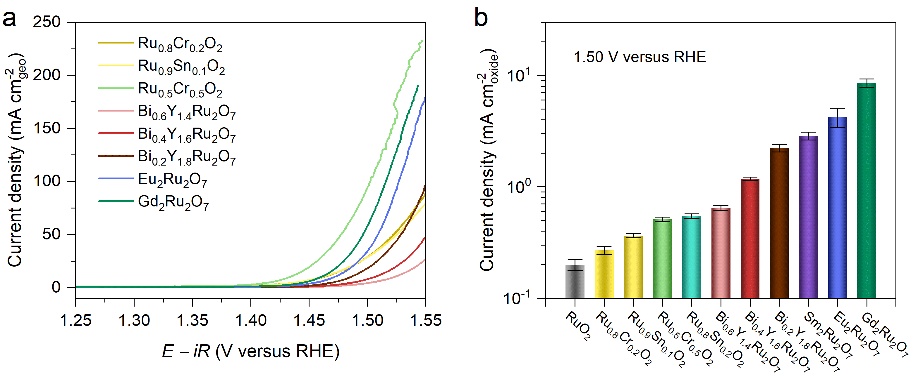

Supplementary Figure 14 | OER activity for rutile Ru_{1-x}M_{x}O₂ and pyrochlore A₂Ru₂O₇. a, Polarization curves measured in O₂-saturated 0.5 M H₂SO₄ solution. b, Specific current densities at 1.50 V (versus RHE). Error bars represent s.d. from at least three independent measurements.

Supplementary Figure 15 | Chronopotentiometric curves of pyrochlore Gd₂Ru₂O₇ measured at a constant current density of 10 mA cm⁻²_{geo}. The commercial RuO₂ is referenced.

Supplementary Figure 16 | XRD and SEM-EDS spectra for Gd₂Ru₂O₇ catalyst before and after the OER durability test. a, XRD patterns before and after the OER durability test. b, SEM-EDS spectra before and after the OER durability test.

Supplementary Figure 17 | Representative HRTEM images for Gd₂Ru₂O₇ catalyst before and after the OER durability test. No visiable surface reconstruction or amorphous structures was found.

Supplementary Figure 18 | ECSA analysis for pyrochlore Gd₂Ru₂O₇ catalyst. a, Polarization curves measured in O₂-saturated 0.5 M H₂SO₄ for 1-100 cycles. b, Cyclic voltammograms (CV) after the polarization curve measurement for 1-100 cycles. c, Normalized surface charge calculated from CV as a function of cycle number. No obvious change was found in the current and surface charge after 100 cycles. For these electrochemical measurements, no activated carbon was added during the preparation of working electrode.

Supplementary Tables
Supplementary Table 1 | Optimized lattice parameters and total energy with different magnetic structures for rutile RuO₂ under different U.
U (eV) | Magnetic order | Lattice parameter (Å) | Total energy per unit (eV)
0 | NM^{[a]} | 4.523, 4.523, 3.119 | -22.29
2 | NM | 4.519, 4.519, 3.130 | -20.16
2 | FM | 4.519, 4.519, 3.130 | -20.16
2 | AFM | 4.539, 4.539, 3.146 | -20.25
4 | NM | 4.517, 4.517, 3.150 | -18.13
4 | FM | 4.587, 4.587, 3.164 | -18.36
4 | AFM | 4.568, 4.568, 3.148 | -18.56
NM: non magnetic; FM: ferromagnetic; AFM: antiferromagnetic.
^{[a]} FM and AFM configurations do not survive and collapse to NM one.

Supplementary Table 2 | Bandgap, Ru 4d-band center (ε_{d}), and free-energy differences on O-covered RuO₂ (110) surface with different U.
U (eV) | Bandgap (eV) | ε_{d} (eV) | ΔG₁(eV) | ΔG₂ (eV) | ΔG₃ (eV) | ΔG₄ (eV)
0 | Metallic | -2.55 | 0.74 | 1.04 | 2.10 | 1.04
2 | Metallic | -3.20 | 0.47 | 1.25 | 1.76 | 1.44
4 | 0.60 | -3.96 | 0.40 | 1.49 | 1.56 | 1.47
ΔG₁ = ΔG_{O}; ΔG₂ = ΔG_{O}−ΔG_{OH}; ΔG₃ = ΔG_{OOH}−ΔG_{O}; ΔG₄ = ΔG_{O2(g)}−ΔG_{OOH}
Supplementary Table 3 | Optimized lattice parameters, band gap, and total energy with different magnetic structures for Ru₃Sn₃O₃₂ and Sm₂Ru₂O₇ under U = 2 eV.
 | Magnetic order | Lattice parameter (Å) | Total energy per unit (eV) | Band gap (eV)
Ru₁₃Sn₃O₃₂ | NM | 9.093, 9.093, 6.286 | -39.52 | Metallic
Ru₁₃Sn₃O₃₂ | AFM^{[a]} | 9.093, 9.093, 6.286 | -39.74 | ~ 0
Sm₂Ru₂O₇ | NM | 10.352 | -162.73 | Metallic
Sm₂Ru₂O₇ | FM | 10.405 | -164.43 | ~ 0
Sm₂Ru₂O₇ | AFM | 10.393 | -164.74 | 0.44
NM: non magnetic; FM: ferromagnetic; AFM: antiferromagnetic.
^{[a]} FM configuration does not survive and collapse to AFM one.

Supplementary Table 4 | Comparison of OER activities for Gd₂Ru₂O₇ and other reported Ru-based catalysts.
Catalysts | Loading  (mg/cm²) | η (mV)@10  mA/cm²_{geo} | BET surface  area (m² g⁻¹) | Current density (mA/cm²_{oxide}) |  | Reference
Gd₂Ru₂O₇^{[a]} | 0.25 | 230 | 2.84 | 0.86@1.45V  8.21@1.50V | This work
RuO₂^{[a]} | 0.25 | 284 | 15.36 | 0.20@1.50V | This work
Cr_{0.6}Ru_{0.4}O₂^{[a]} | 0.279 | 178 | 86.1 | 0.17@1.45V | 19
W_{0.2}Er_{0.1}Ru_{0.7}O_{2-δ}^{[a]} | 0.33 | 168 | 123.18 | 0.17@1.45V | 20
Ru₅W₁O_{x}^{[a]} | 0.32 | 227 | 53.86 | 0.34@1.50V | 23
Mn_{0.06}Ru_{0.94}O_{2-δ}^{[a]} | 0.275 | 158 | 160.28 | 0.14@1.45V | 24
Cu_{0.13}Ru_{0.87}O_{2-δ}^{[a]} | 0.275 | 188 | 63.35 | 0.18@1.45V | 25
Y₂Ru₂O_{7-δ}^{[b]} | 0.025 | 323 | 7.2 | 2.23@1.50V | 26
Electrolyte solutions: ^{[a]} 0.5 M H₂SO₄; ^{[b]} 0.1 M HClO₄.

Supplementary Table 5 | ICP analysis of dissolved ions for Gd₂Ru₂O₇ after the OER durability test.
Sample amount (mg) | 2.0 | 2.0 | 2.0
Concentration of Gd ion (μg ml⁻¹) | 1.231 | 1.162 | 1.083
Concentration of Ru ion (μg ml⁻¹) | 0.336 | 0.302 | 0.235
Loss of mass (Gd) | 3.69% | 3.48% | 3.25%
Loss of mass (Ru) | 1.57% | 1.41% | 1.09%
Average mass loss (Gd)^{[a]} | 3.47%
Average mass loss (Ru)^{[a]} | 1.35%
^{[a]}Less than 4% Gd and 2% Ru ions were detected to be dissolved in the electrolyte.

