Supplementary material
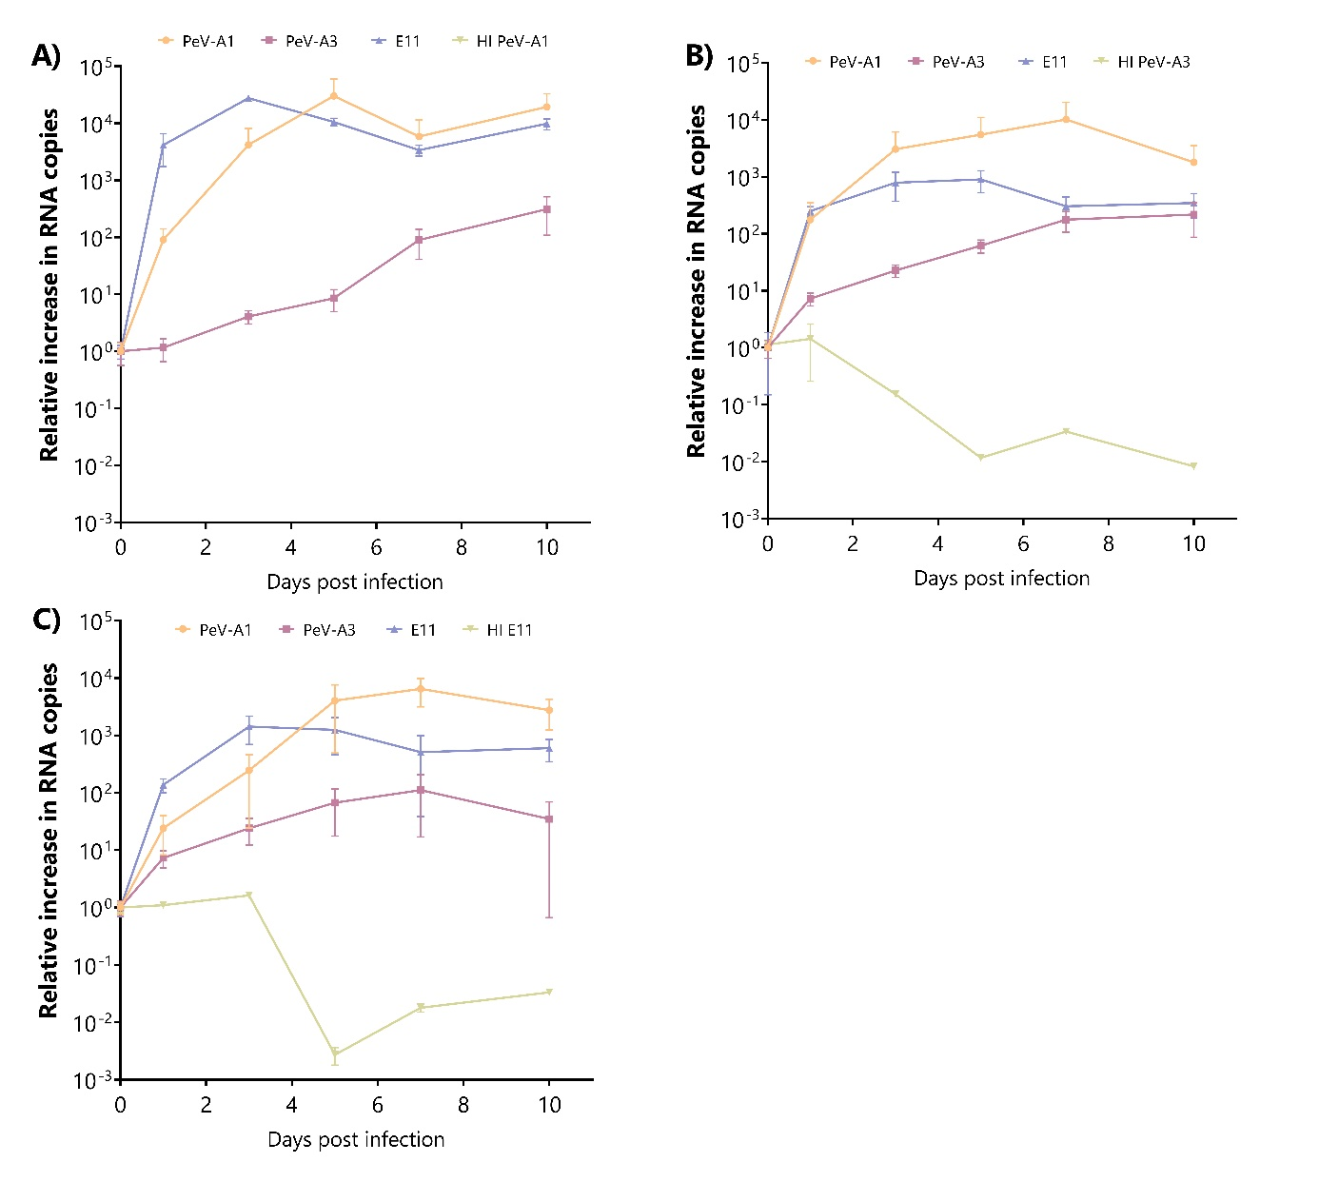
Supplementary Figure 1. Relative increase in viral RNA copies in samples collected from supernatant at different time points for PeV-A1, PeV-A3, E11, heat-inactivated PeV-A1 (A), heat-inactivated PeV-A3 (B), and heat-inactivated E11 (C) on UNOs. In all cases, data represents the mean ± SEM of three technical replicates in one batch of organoids. HI = heat inactivated. HI PeV-A1 RNA copies were undetectable.

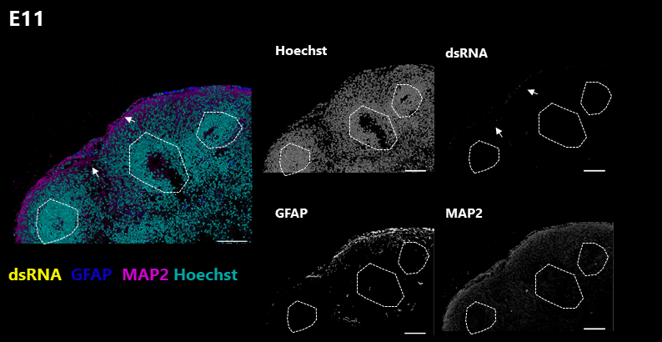

Supplementary Figure 2. Confocal z-stacks from E11 infected UNOs at 10dpi. Labelled for nuclei (cyan), dsRNA (yellow), GFAP (blue) and MAP2 (magenta). Arrows indicate regions with positive dsRNA staining.

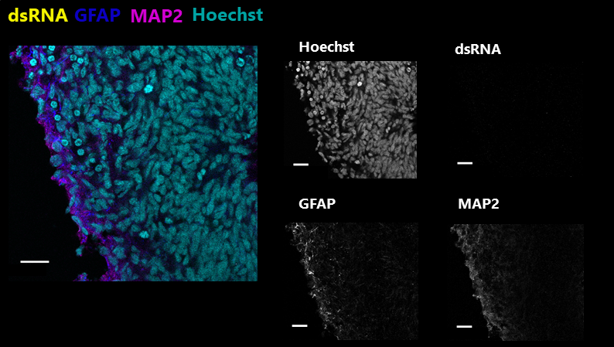
Supplementary Figure 3. Confocal image of MOCK infected UNOs. Labelled for nuclei (cyan), and immunolabelled for dsRNA (yellow), GFAP (blue), and MAP2 (magenta). Scale bars 20 µm.

A)  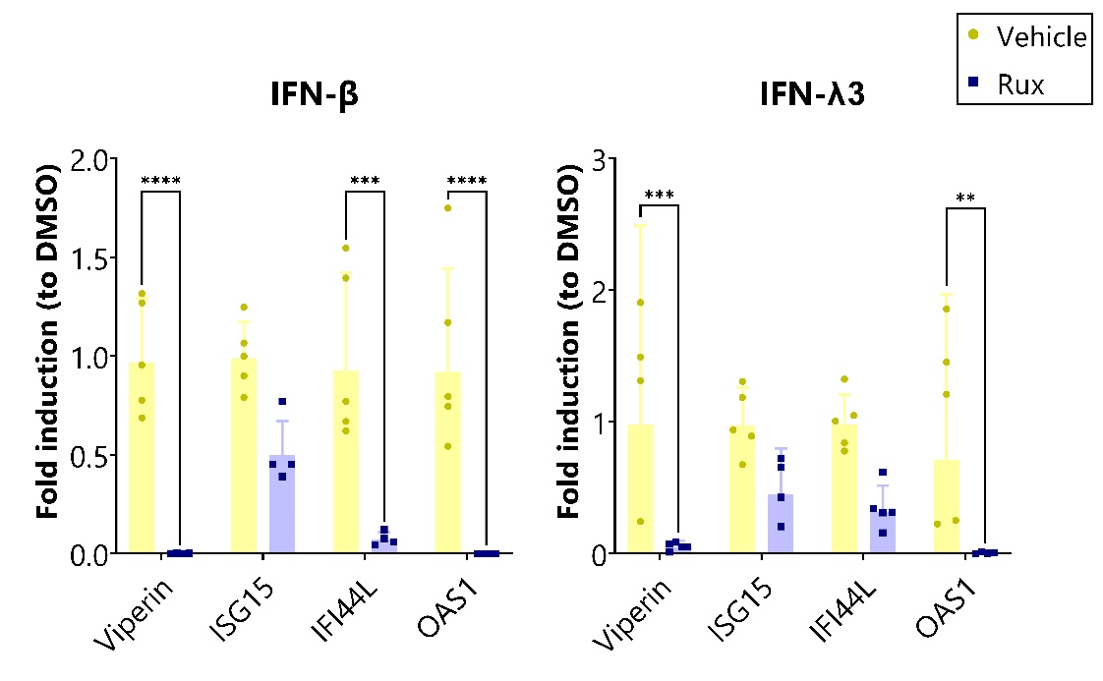 | B)
Supplementary Figure 4. Rux inhibition of IFN-stimulated ISG induction in UNOs. RT-qPCR analysis of ISGs upon stimulation with (A) 500 ng of IFN-β, or (B) 500 ng of IFN-λ3 and treated with Rux or vehicle control (DMSO). Data represents the geometric mean fold induction from vehicle treated organoids ± geometric SD of five different organoids. Statistical significance was analyzed by two-way ANOVA with Šídák’s multiple comparisons tests for each specific cytokine, ** p-value <0.01; *** p-value <0.001; **** p-value <0.0001.

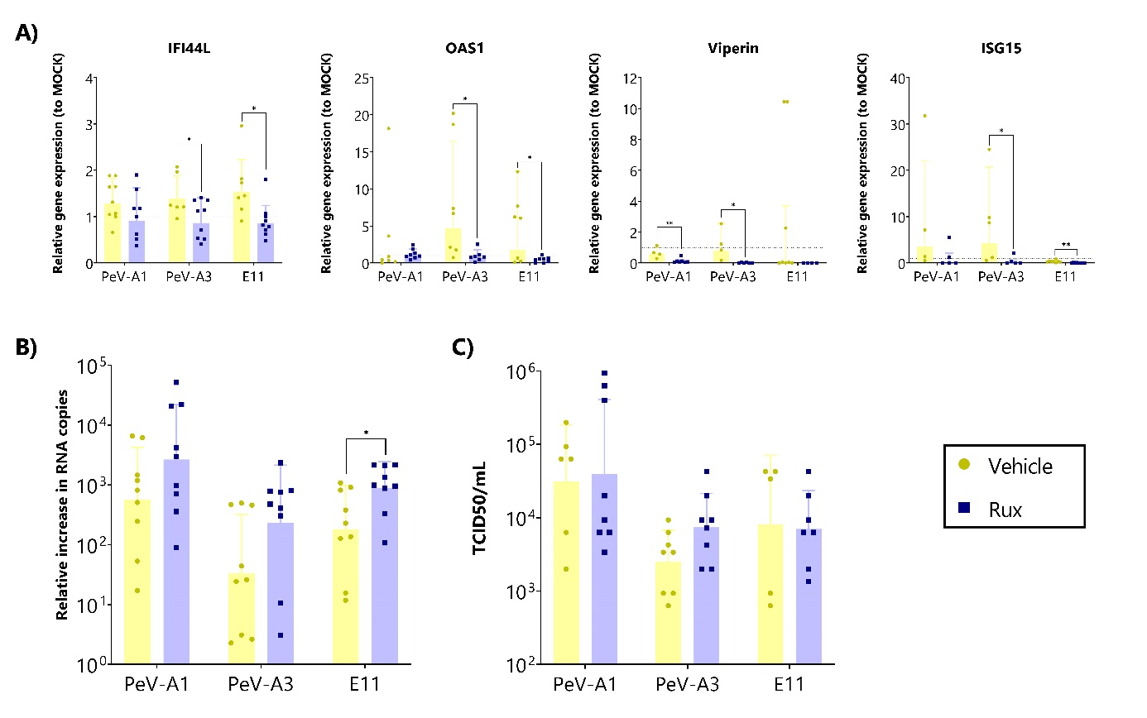
Supplementary Figure 5. (A) Relative gene expression of ISGs in Rux or vehicle (DMSO) treated organoids. (B) Relative increase in RNA copies at 10dpi for Rux or vehicle-treated organoids from supernatant samples. (C) Virus titer at 10 dpi from supernatant collected samples of Rux or vehicle treated organoids. Titers were determined by TCID₅₀. In all cases, data represents the geometric mean ± geometric SD of three technical replicates in three biological replicates. Statistical significance was determined using a Student’s t-test, * p-value < 0.05. For A-B values above the dashed line represent an upregulation of the gene expression relative to the MOCK.
Supplementary Table 1. List of primers used in this study with forward and reverse sequences.
Target | Forward sequence (5’-3’) | Reverse sequence (5’-3’)
PeV-A | CTGGGGGCCAAAAGCCA | GGTACCTTCTGGGCATCCTTC
PeV-A Probe | (6’FAM)-AAACACTAGTTGTAWGGCCC | ---
Pan-EV | GGCCCTGAATGCGGCTAAT | GGGATTGTCACCATAAGCC
CXCL10 | GGTGAGAAGAGATGTCTGAATCC | GTCCATCCTTGGAAGCACTGCA
CX3CR1 | GTGGTGCTGACAAAGCTTGGAA | TCACTGGGTGCCATCGTAAGAA
IFI44L | TGCACTGAGGCAGATGCTGCG | TCATTGCGGCACACCAGTACAG
IFN-α2 | TGGGCTGTGATCTGCCTCAAAC | CAGCCTTTTGGAACTGGTTGCC
IFN-β1 | CTTGGATTCCTACAAAGAAGCAGC | TCCTCCTTCTGGAACTGCTGCA
IFN-λ1 | AACTGGGAAGGGCTGCCACATT | GGAAGACAGGAGAGCTGCAACT
IFN-λ2/3 | TCGCTTCTGCTGAAGGACTGCA | CCTCCAGAACCTTCAGCGTCAG
IκB-α | GCTGAAGAAGGAGCGGCTACT | TCGTACTCCTCGTCTTTCATGGA
ISG15 | CTCTGAGCATCCTGGTGAGGAA | AAGGTCAGCCAGAACAGGTCGT
MCP-1 | CCTTCATTCCCCAAGGGCTC | GGTTTGCTTGTCCAGGTGGT
NFκB | GCAGCACTACTTCTTGACCACC | TCTGCTCCTGAGCATTGACGTC
OAS1 | AGGAAAGGTGCTTCCGAGGTAG | GGACTGAGGAAGACAACCAGGT
RPLP0 | TGGTCATCCAGCAGGTGTTCGA | ACAGACACTGGCAACATTGCGG
RPLP2 | TCTTGGACAGCGTGGGTATCGA | CAGCAGGTACACTGGCAAGCTT
Viperin | CCAGTGCAACTACAAATGCGGC | CGGTCTTGAAGAAATGGCTCTCC

Supplementary Table 2. List of antibodies used in this study.
Antigen (abbreviation) | Host | Dilution factor | Company | Catalogue #
Special AT-rich sequence-binding protein 2 (SATB2) | Mouse | 1:400 | Abcam | Ab51502
Chicken ovalbumin upstream promoter transcription factor-interacting protein 1 (CTIP2) | Rat | 1:500 | Abcam | Ab18465
Paired box protein 6 (PAX6) | Rabbit | 1:300 | Stemcell Technologies | STC60094
Glial fibrillary acidic protein (GFAP) | Goat | 1:500 | Abcam | Ab53554
Sex determining region Y-box 2 (SOX2) | Rabbit | 1:400 | Cell Signaling Technologies | 34516
Microtubule-associated protein 2 (MAP2) | Mouse | 1:500 | Thermo Fisher | MA5-12826
dsRNA clone rJ2 | Mouse | 1:60 | Sigma-Aldrich | MABE1134
Secondary Antibody | Host | Dilution factor | Company | Catalogue #
Anti-mouse Alexa Fluor 546 | Donkey | 1:750 | Thermo Fisher | A10036
Anti-rat Alexa Fluor 488 (donkey) | Donkey | 1:750 | Thermo Fisher | A48268
Anti-rabbit Alexa Fluor 680 (donkey) | Donkey | 1:750 | Abcam | Ab175772
Anti-goat Alexa Fluor 594 (donkey) | Donkey | 1:750 | Thermo Fisher | A11058

