Supplementary materials

Supplementary figure 1 – covariates scatterplots

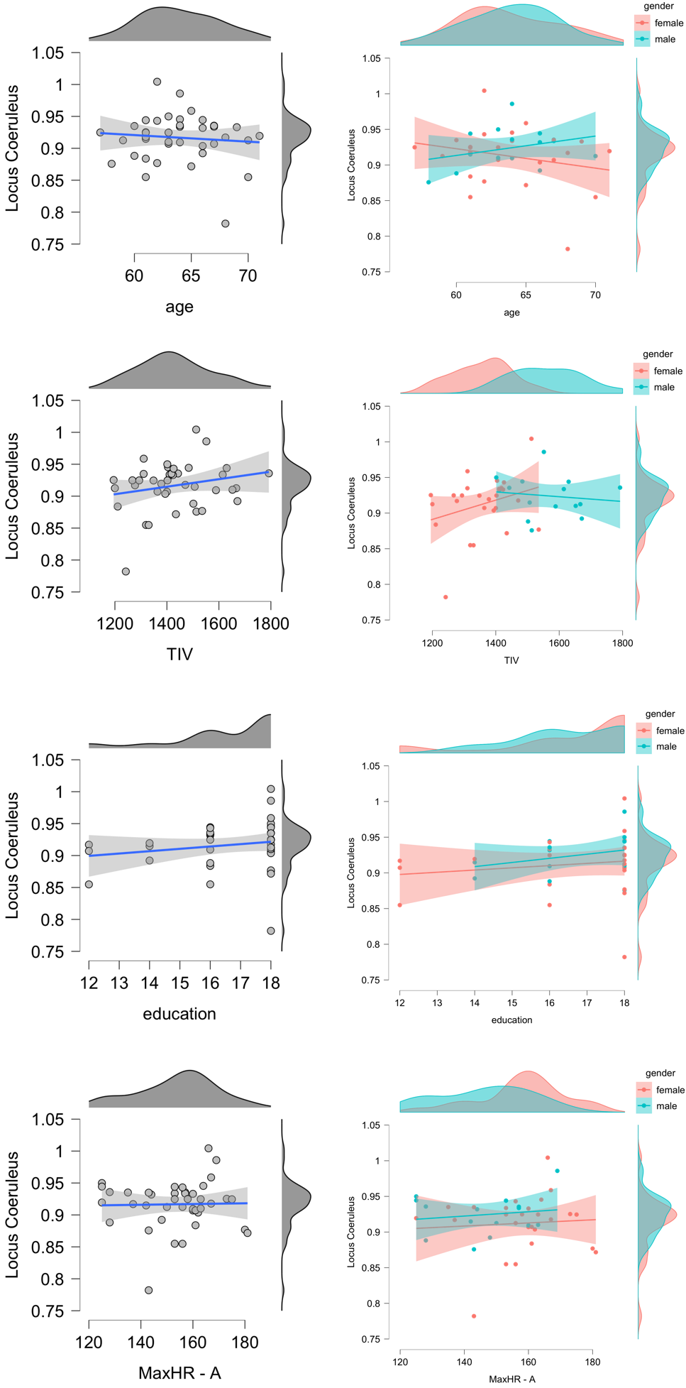
Supplementary figure 2 – vo2max-Locus Coeruleus association and gender variation
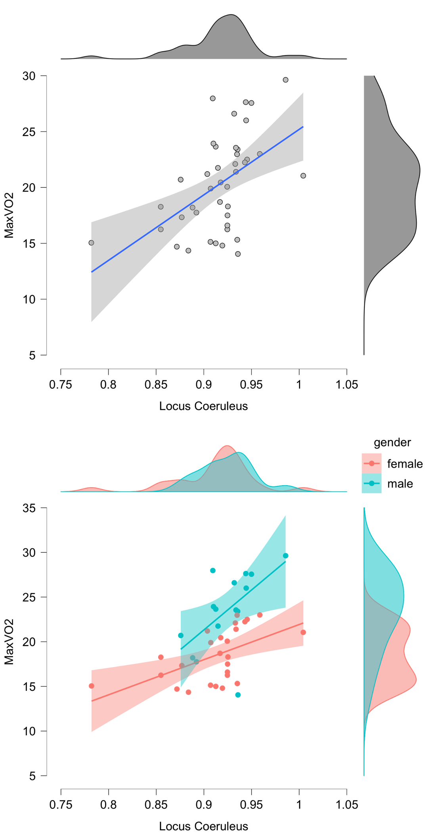
Supplementary Figure 3 reporting the relationship between BrainPAD and Locus Coeruleus signal intensity in a sample of 41 healthy subjects (age range 60-72). Results are covaried for Age, Gender, Education, Total Intracranial Volume for P>0.01 and P>0.001*. The upper portion of the figure, along with the scatterplot shows the Bayesian modelling revealing the “extreme” evidence supporting such association, namely, greater LC integrity related to reduced grey matter degeneration. The lower portion of the figure show the 3D reconstruction of the LC findings on a 3D reconstruction of the Brian. The LC cluster is displayed on the LC omni-comprehensive mask by Plini et al. 2021, and its spatial extent is compared with the previously published LC atlases and masks.

Supplementary Table 1
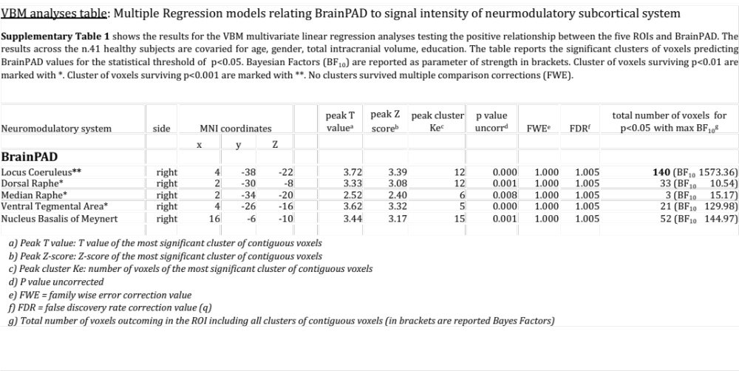

Supplementary Figure 4 reporting the relationship between TOSL and Locus Coeruleus signal intensity in a sample of 41 healthy subjects (age range 60-72). Results are covaried for Age, Gender, Education, Total Intracranial Volume for P>0.01 and P>0.001*. The upper portion of the figure, along with the scatterplot shows the Bayesian modelling revealing the “very strong” supporting such association, namely, greater LC integrity related to greater cognitive functioning. The lower portion of the figure show the 3D reconstruction of the LC findings on a 3D reconstruction of the Brian. The LC cluster is displayed on the LC omni-comprehensive mask by Plini et al. 2021, and its spatial extent is compared with the previously published LC atlases and masks.

Supplementary Table 2
