Supplementary Information
Microbial Ecology
Microbiome changes in a stranding simulation of the holopelagic macroalgae Sargassum natans and Sargassum fluitans
Inara R. W. Mendonça¹*, Tom Theirlynck², Erik R. Zettler³, Linda A. Amaral-Zettler² and Mariana Cabral Oliveira¹

¹Department of Botany, Institute of Biosciences, University of Sao Paulo, São Paulo, Brazil
²NIOZ Royal Netherlands Institute for Sea Research, Texel, The Netherlands
Institute for Biodiversity and Ecosystem Dynamics, University of Amsterdam, The Netherlands
³NIOZ Royal Netherlands Institute for Sea Research, Texel, The Netherlands

*Corresponding author e-mail: inara.regina@gmail.com (Inara Mendonça)

Fig. S1 Sargassum dissection experiment set up. A) Sargassum pile placed inside 70 x 70 cm tray, covered with 3 x 3 cm net to avoid biomass losses by wind, and sensor data logger (Hobo Logger) placed at tray’s border. B) After 24 hrs of exposure experiment, the outer layers of Sargassum seemed dehydrated, so samples were taken from inside the pile, indicated by an arrow, where the biomass was humid and decomposing
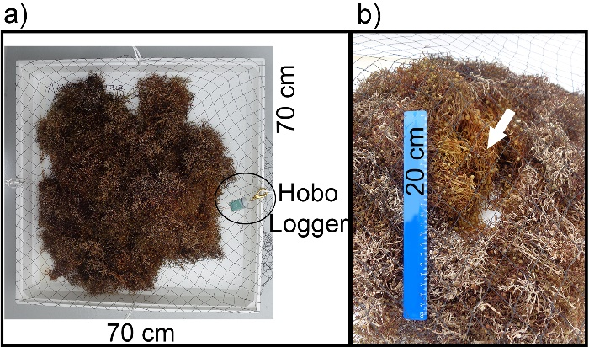

Fig. S2 Rarefaction curves from samples of Sargassum fluitans III and S. natans VIII generated during the stranding simulation. Sargassum fluitans III (shades of grey lines) and S. natans VIII (shades of green lines)

Fig. S3 Alpha-diversity of ASVs. Shannon index measures of ASVs associated with Sargassum fluitans III and S. natans VIII along the stranding simulation. Mean values and bars of standard error (n = 3). Equal letters indicate that there were no significant differences found by pairwise Tukey HSD testing. Significance level 0.05
Table S3 Abiotic conditions. Seawater salinity, temperature, and nutrients concentration at Sargassum fluitans III and S. natans VIII sampling sites (a). Light intensity and air temperature registered at the stranding simulation site, and additional air temperature data recorded by ship’s shaded meteorological thermometer (b). Sargassum wet biomass changes during stranding simulation (c)
 | a) Abiotic conditions of the seawater at sampling sites
 |  | Salinity | Temperature (°C) | PO₄⁻³ µmol/L | NO₃ + NO₂ µmol/L |  | NO₂ µmol/L | Si µmol/L
S. fluitans III |  | 35 | 28.5 | 0.006 | 0.035 |  | 0.007 | 0.890
S. natans VIII |  | 32 | 29.9 | 0.010 | 0.033 |  | 0.013 | 9.790
b) Abiotic conditions at stranding simulation site
 |  |  | On site measurements Hobo Logger |  |  |  | Meteorological station
 |  |  | Illuminance (Lux) | Air temperature (°C) |  |  | Air temperature (°C)
S. fluitans III |  | Maximum | 187,379 | 59.6 |  |  | 28.4
 |  | Minimum | 11 | 24.2 |  |  | 25.3
 |  | Mean ± sd | 44,119 ± 57,045 | 31.7 ± 8 |  |  | 27.5 ± 0.5
S. natans VIII |  | Maximum | 198,000 | 48.9 |  |  | 28.4
 |  | Minimum | 11 | 25.1 |  |  | 25.1
 |  | Mean ± sd | 24,224 ± 33,601 | 30.3 ± 6 |  |  | 27.6 ± 0.6
c) Biomass wet weight changes
 |  | Time | Biomass (kg)
S. fluitans III |  | 0 hr | 2
 |  | 24 hrs | 1.7
 |  | 48 hrs | 0.9
S. natans VIII |  | 0 hr | 0.8
 |  | 24 hrs | 0.4
 |  | 48 hrs | 0.3

Table S4 Microbial communities Permutational Multivariate ANOVA (PERMANOVA) results at order level. PERMANOVA of microbiome orders abundance and presence/absence data between Sargassum species (n = 9) and during the stranding simulation within each Sargassum species (n = 3 per sampling time) (df: degrees of freedom; SS Sum of Squares; MS Mean of Squares; F-model test, R² Correlation). Significance level 0.05
 | Source | df | SS | MS | F-model | R² | p-value
Abundance | Sargassum | 1 | 0.088 | 0.088 | 3.072 | 0.023 | 0.081
Abundance | Times within Sargassum | 4 | 3.337 | 0.834 | 29.205 | 0.886 | <0.001
Abundance | Residuals | 12 | 0.343 | 0.029 |  | 0.091
Abundance | Total | 17 | 3.768 |  |  | 1.000
Presence/Absence | Sargassum | 1 | 0.251 | 0.251 | 4.993 | 0.134 | 0.003
Presence/Absence | Times within Sargassum | 4 | 1.022 | 0.255 | 5.074 | 0.544 | <0.001
Presence/Absence | Residuals | 12 | 0.604 | 0.050 |  | 0.322
Presence/Absence | Total | 17 | 1.877 |  |  | 1.000

Table S5 Microbial communities Permutational Multivariate ANOVA (PERMANOVA) results at ASVs level. PERMANOVA of 628 ASVs shared between Sargassum species. Structure and composition of microbial communities between Sargassum species (n = 9) and during the stranding simulation within each Sargassum species (n = 3 per sampling time) (df: degrees of freedom; SS Sum of Squares; MS Mean of Squares; F-model test, R² Correlation). Significance level 0.05
 | Source | df | SS | MS | F-model | R² | p-value
Shared ASVs Abundance | Sargassum | 1 | 0.308 | 0.308 | 5.367 | 0.068 | 0.013
Shared ASVs Abundance | Times within Sargassum | 4 | 3.529 | 0.882 | 15.377 | 0.780 | <0.001
Shared ASVs Abundance | Residuals | 12 | 0.689 | 0.057 |  | 0.152
Shared ASVs Abundance | Total | 17 | 4.526 |  |  | 1.000
ASV Community Structure | Sargassum | 1 | 0.465 | 0.466 | 9.090 | 0.100 | 0.002
ASV Community Structure | Times within Sargassum | 4 | 3.577 | 0.894 | 17.499 | 0.768 | <0.001
ASV Community Structure | Residuals | 12 | 0.613 | 0.051 |  | 0.132
ASV Community Structure | Total | 17 | 4.655 |  |  | 1.000
ASV Community Composition | Sargassum | 1 | 0.662 | 0.662 | 6.254 | 0.150 | 0.001
ASV Community Composition | Times within Sargassum | 4 | 2.484 | 0.621 | 5.863 | 0.562 | <0.001
ASV Community Composition | Residuals | 12 | 1.271 | 0.106 |  | 0.288
ASV Community Composition | Total | 17 | 4.418 |  |  | 1.000

Table S6 Richness one-way ANOVA. ANOVA of ASVs Shannon index between Sargassum species and during the stranding simulation within each species. (df: degrees of freedom; SS Sum of Squares; MS Mean of Squares). Pairwise – Tukey HSD test between stranding simulation sampling times (Diff: Difference, Low: Lower, Upp: Upper). Significance level 0.05
One-way ANOVA
 | df | SS | MS | Pseudo-F | p-value
Sargassum | 1 | 0.002 | 0.002 | 0.011 | 0.917
Times within Sargassum | 4 | 13.703 | 3.462 | 24.380 | <0.001
Residuals | 12 | 1.686 | 0.141
Pairwise - Tukey HSD
S. fluitans III |  | Diff | Low | Upp | p. ajusted
0 hr x 24 hrs |  | -2.127 | -3.155 | -1.099 | <0.001
0 hr x 48 hrs |  | -2.030 | -3.058 | -1.002 | <0.001
24 hrs x 48 hrs |  | 0.097 | -0.931 | 1.125 | 0.999
S. natans VIII
0 hr x 24 hrs |  | -1.747 | -2.775 | -0.719 | 0.001
0 hr x 48 hrs |  | -0.387 | -1.415 | 0.641 | 0.798
24 hrs x 48 hrs |  | 1.360 | 0.332 | 2.388 | 0.008

