Supplementary Information for
Acoustic Structure Inverse Design and Optimization Using Deep Learning
Xuecong Sun^{1,2}, Han Jia^{2,3*}, Yuzhen Yang¹, Han Zhao ^{1,2}, Yafeng Bi¹, Zhaoyong Sun¹ and Jun Yang^{1,2*}
¹ Key Laboratory of Noise and Vibration Research, Institute of Acoustics, Chinese Academy of Sciences, Beijing 100190, People’s Republic of China
² University of Chinese Academy of Sciences, Beijing 100049, People’s Republic of China
³ State Key Laboratory of Acoustics, Institute of Acoustics, Chinese Academy of Sciences, Beijing 100190, People’s Republic of China
* Authors to whom correspondence should be addressed: hjia@mail.ioa.ac.cn and jyang@mail.ioa.ac.cn

S1. The Transfer Matrix Method for THR
The theoretical analysis of the THR can be performed by using the transfer matrix method (TMM)¹. Fig. S1 shows the 2D schematics and the transfer matrixes of the THR. The relationship between sound pressure $p_{1}$ and velocity $v_{1}$ at the neck of the THR and pressure $p_{2}$ and velocity $v_{2}$ at the end of the THR can be expressed as:
$$\begin{aligned}\left[\begin{matrix}p_{1} \\ v_{1}\end{matrix}\right]=M_{nt}M_{n}^{1}M_{nc}^{11}M_{c}^{1}M_{nc}^{21}M_{n}^{2}M_{nc}^{22}M_{c}^{2}\left[\begin{matrix}p_{2} \\ v_{2}\end{matrix}\right]=M_{total}\left[\begin{matrix}p_{2} \\ v_{2}\end{matrix}\right].\#\left(S1\right)\end{aligned}$$
Here, $M_{n}^{i}=\left[\begin{matrix}\cos\left(k_{n}l_{i}\right) & jz_{n}sin\left(k_{n}l_{i}\right) \\ j\sin\left(k_{n}l_{i}\right)/z_{n} & \cos\left(k_{n}l_{i}\right)\end{matrix}\right]\left(i=1,2\right)$ is the matrix for the i^{th} order neck, where $k_{n}^{i}=\frac{ω}{c_{0}}\left(1+\frac{δ\left(1-j\right)}{\sqrt{2}a_{i}}\left(1+\frac{γ-1}{\sqrt{Pr}}\right)\right)$ and $z_{n}^{i}=\frac{ρ_{0}c_{0}}{πa_{i}^{2}}\left(1+\frac{δ\left(1-j\right)}{\sqrt{2}a_{i}}\left(1-\frac{γ-1}{\sqrt{Pr}}\right)\right)$ are the wavenumber and effective impedance of the i^{th} order neck; $M_{c}^{i}=\left[\begin{matrix}cos⁡\left(k_{c}h_{i}\right) & jz_{c}sin\left(k_{c}h_{i}\right) \\ j\sin\left(k_{c}h_{i}\right)/z_{c} & cos⁡\left(k_{c}h_{i}\right)\end{matrix}\right]\left(i=1,2\right)$ is the matrix for the i^{th} order cavity, where $k_{c}^{i}=\frac{ω}{c_{0}}\left(1+\frac{δ\left(1-j\right)}{\sqrt{2}r_{i}}\left(1+\frac{γ-1}{\sqrt{Pr}}\right)\right)$ and $z_{c}^{i}=\frac{ρ_{0}c_{0}}{πr_{i}^{2}}\left(1+\frac{δ\left(1-j\right)}{\sqrt{2}r_{i}}\left(1-\frac{γ-1}{\sqrt{Pr}}\right)\right)$ are the wavenumber and effective impedance of the cavity; $M_{nc}^{ij}=\left[\begin{matrix}1 & jz_{n}k{∆l}_{ij} \\ 0 & 1\end{matrix}\right]$ stands for the matrixes according to the pressure radiations at the discontinuity from the i^{th} neck to the j^{th} cavity, where ${∆l}_{ij}=0.82\left[1-1.35\frac{a_{i}}{r_{j}}+ {0.31\left(\frac{a_{i}}{r_{j}}\right)}^{3}\right]a_{i}$is the corresponding correction length; $M_{nt}=\left[\begin{matrix}1 & jz_{n}k{∆l}_{nt} \\ 0 & 1\end{matrix}\right]$ stands for the matrixes according to the pressure radiations at the discontinuity from the 1st neck to the tube, where ${∆l}_{nt}=0.82\left[1-0.235\frac{a_{1}}{r_{t}}-{1.32\left(\frac{a_{1}}{r_{t}}\right)}^{2}+ {1.54\left(\frac{a_{1}}{r_{t}}\right)}^{3}-{0.86\left(\frac{a_{1}}{r_{t}}\right)}^{4}\right]a_{1}$ is the corresponding correction length, and $r_{t}$ is the radius of the tube. The values of the physical constants can be seen in Table S2.
Considering that the sound velocity at the end of THR is $v_{2}=0$, the equivalent impedance of the THR can be derived as $Z_{THR}=M_{total}\left(1,1\right)/M_{total}\left(2,1\right)$. When the THR is a side branch of a tube, the matrix for the tube with the THR can be expressed as $T=\left[\begin{matrix}1 & 0 \\ 1/Z_{THR} & 1\end{matrix}\right]$, and the STL can be expressed as
$$\begin{aligned}t=20\lg{\frac{\left|T_{11}+{T_{12}}/{Z_{t}}+T_{21}Z_{t}+T_{22}\right|}{2}}, \#\left(S2\right)\end{aligned}$$
where $Z_{t}=\frac{ρ_{0}c_{0}}{S}$ is the traveling-plane-wave impedance of the tube.

S2. Prediction Results of the Trained DNN on the Test Set
To test the generalization capability of the networks, we performed the design task based on the samples from the test set. As mentioned in the main text, the networks were trained using the training set and validation set, and the samples in the test set were not learned in the process of model training. In Fig. S2, we show the prediction results of the networks for the various desired STL spectra. We fed the desired spectra into the trained DNN and obtained the predictive GPs. Then we calculated the DL spectra based on the predictive GPs through TMM and FEM and presented all those spectra for comparison. In all the cases, there is excellent agreement between the desired STL spectrum and the predictive STL spectrum. The success of these cases would indicate that the networks have learned to generalize far beyond their training set.

S3. The Details about the Genetic Algorithm
Here, we want to maximize the average STL at the target resonant frequencies, which can be recast as Eq. (2) in main text. To add constraints, the punishment mechanism is introduced into the cost function $F(f_{1}^{target},f_{2}^{target},gp)$, which can be expressed as:
$$\begin{aligned}F=\left\{\begin{matrix}-\left[t\left(f_{1}^{target},gp\right)+t\left(f_{2}^{target},gp\right)\right] & if t\left(f_{2}^{target},gp\right), t\left(f_{2}^{target},gp\right)>10dB \\ λ-\left[t\left(f_{1}^{target},gp\right)+t\left(f_{2}^{target},gp\right)\right] & else\end{matrix}\right.,\#\left(S3\right)\end{aligned}$$
where $λ$ is the penalty parameter, which is expected to help the real resonant frequencies of the individuals $f_{1}$ and $f_{2}$ be near $f_{1}^{target}$ and $f_{2}^{target}$. Therefore, the penalty parameter $λ$ can be set as:
$$\begin{aligned}λ=\left\{\begin{matrix}10+\left|f_{1}-f_{1}^{target}\right|+\left|f_{2}-f_{2}^{target}\right|, & if 101≤ f_{1},f_{2}≤600 \\ 1000, & else\end{matrix}\right..\#\left(S4\right)\end{aligned}$$
The cost function $F(f_{1}^{target},f_{2}^{target},gp)$ was minimized through the GA, which was realized by an open-source evolutionary algorithm toolbox and framework for Python, Geatpy². We used the soea_SEGA module of Geatpy with the default algorithmic parameters.

Supplementary References
1. Long, H., Cheng, Y. & Liu, X. Reconfigurable sound anomalous absorptions in transparent waveguide with modularized multi-order Helmholtz resonator. Sci. Rep. 8, 1–9 (2018).
2. Jazzbin, et. al. geatpy: The genetic and evolutionary algorithm toolbox with high performance in python. (2020).

Supplementary Tables
Range of the resonant frequency |  | Number of samples
$$100<f_{1}≤150$$ | $$150<f_{2}≤200$$ | 5000
$$100<f_{1}≤150$$ | $$200<f_{2}≤250$$ | 5000
$$100<f_{1}≤150$$ | $$250<f_{2}≤300$$ | 5000
$$100<f_{1}≤150$$ | $$300<f_{2}≤350$$ | 5000
$$100<f_{1}≤150$$ | $$350<f_{2}≤400$$ | 5000
$$100<f_{1}≤150$$ | $$400<f_{2}≤450$$ | 5000
$$100<f_{1}≤150$$ | $$450<f_{2}≤500$$ | 5000
$$100<f_{1}≤150$$ | $$500<f_{2}≤550$$ | 5000
$$100<f_{1}≤150$$ | $$550<f_{2}≤600$$ | 5000
$$150<f_{1}≤200$$ | $$200<f_{2}≤250$$ | 5000
$$150<f_{1}≤200$$ | $$250<f_{2}≤300$$ | 5000
$$150<f_{1}≤200$$ | $$300<f_{2}≤350$$ | 5000
$$150<f_{1}≤200$$ | $$350<f_{2}≤400$$ | 5000
$$150<f_{1}≤200$$ | $$400<f_{2}≤450$$ | 5000
$$150<f_{1}≤200$$ | $$450<f_{2}≤500$$ | 5000
$$150<f_{1}≤200$$ | $$500<f_{2}≤550$$ | 5000
$$150<f_{1}≤200$$ | $$550<f_{2}≤600$$ | 5000
$$200<f_{1}≤250$$ | $$250<f_{2}≤300$$ | 5000
$$200<f_{1}≤250$$ | $$300<f_{2}≤350$$ | 5000
$$200<f_{1}≤250$$ | $$350<f_{2}≤400$$ | 5000
$$200<f_{1}≤250$$ | $$400<f_{2}≤450$$ | 5000
$$200<f_{1}≤250$$ | $$450<f_{2}≤500$$ | 5000
$$200<f_{1}≤250$$ | $$500<f_{2}≤550$$ | 5000
$$200<f_{1}≤250$$ | $$550<f_{2}≤600$$ | 5000
$$250<f_{1}≤300$$ | $$300<f_{2}≤350$$ | 0
$$250<f_{1}≤300$$ | $$350<f_{2}≤400$$ | 5000
$$250<f_{1}≤300$$ | $$400<f_{2}≤450$$ | 5000
$$250<f_{1}≤300$$ | $$450<f_{2}≤500$$ | 5000
$$250<f_{1}≤300$$ | $$500<f_{2}≤550$$ | 5000
$$250<f_{1}≤300$$ | $$550<f_{2}≤600$$ | 5000
$$300<f_{1}≤350$$ | $$350<f_{2}≤400$$ | 0
$$300<f_{1}≤350$$ | $$400<f_{2}≤450$$ | 5000
$$300<f_{1}≤350$$ | $$450<f_{2}≤500$$ | 5000
$$300<f_{1}≤350$$ | $$500<f_{2}≤550$$ | 5000
$$300<f_{1}≤350$$ | $$550<f_{2}≤600$$ | 5000
$$350<f_{1}≤400$$ | $$400<f_{2}≤450$$ | 0
$$350<f_{1}≤400$$ | $$450<f_{2}≤500$$ | 0
$$350<f_{1}≤400$$ | $$500<f_{2}≤550$$ | 5000
$$350<f_{1}≤400$$ | $$550<f_{2}≤600$$ | 5000
Table S1. Data distribution of datasets.

Name | Value
Sound speed | $$c_{0}=1.21 kg/m^{3}$$
Static air density | $$ρ_{0}=343 m/s$$
Thickness of the viscous boundary layer | $$δ=\sqrt{2η/ρ_{0}ω}$$
Dynamic viscosity of air | $$η=1.8e^{-5} Pa∙s$$
Prandtl constant | $$Pr=0.702$$
Specific heat ratio of air | $$γ=1.4$$
Table S2. Values of the physical constants.

Supplementary Figures
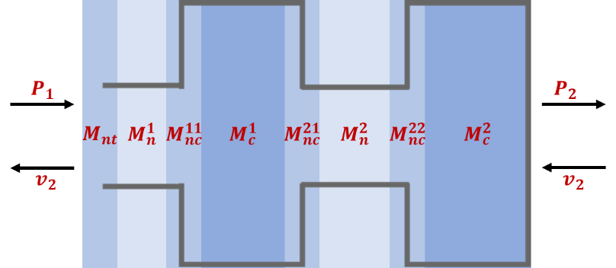
Fig. S1 2D schematics of the THR.

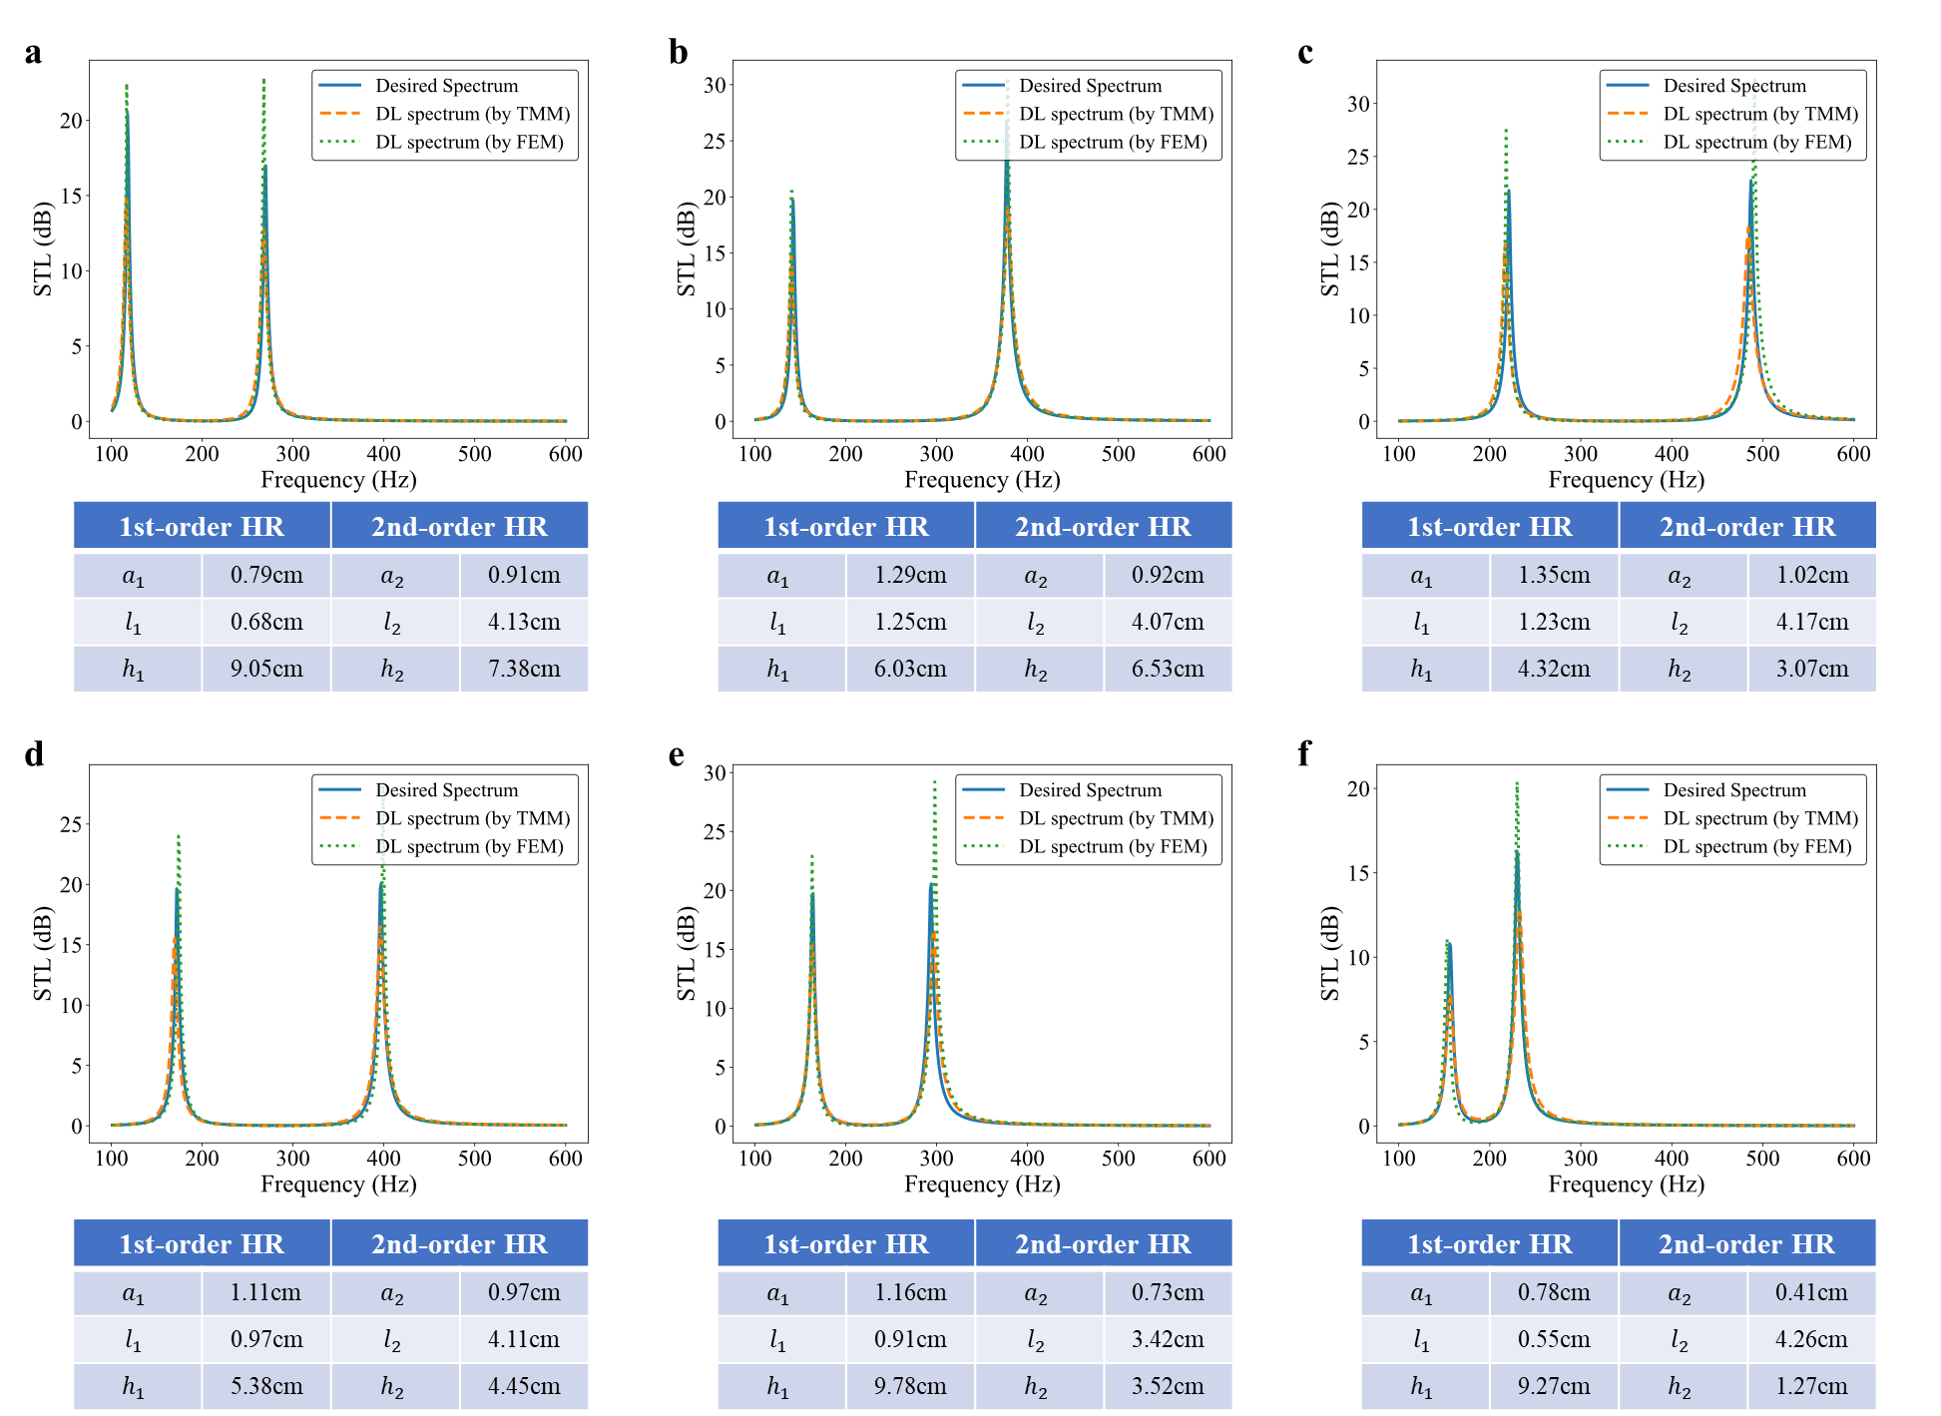
Fig. S2 Prediction results of the trained DNN on the test set. The desired spectra selected from the test set are depicted in blue solid lines. The DL predicted GPs are represented in the table. The DL spectra based on the predicted GPs are depicted as yellow dotted lines (calculated by TMM) and green dotted lines (calculated by FEM).

