Supplementary Information
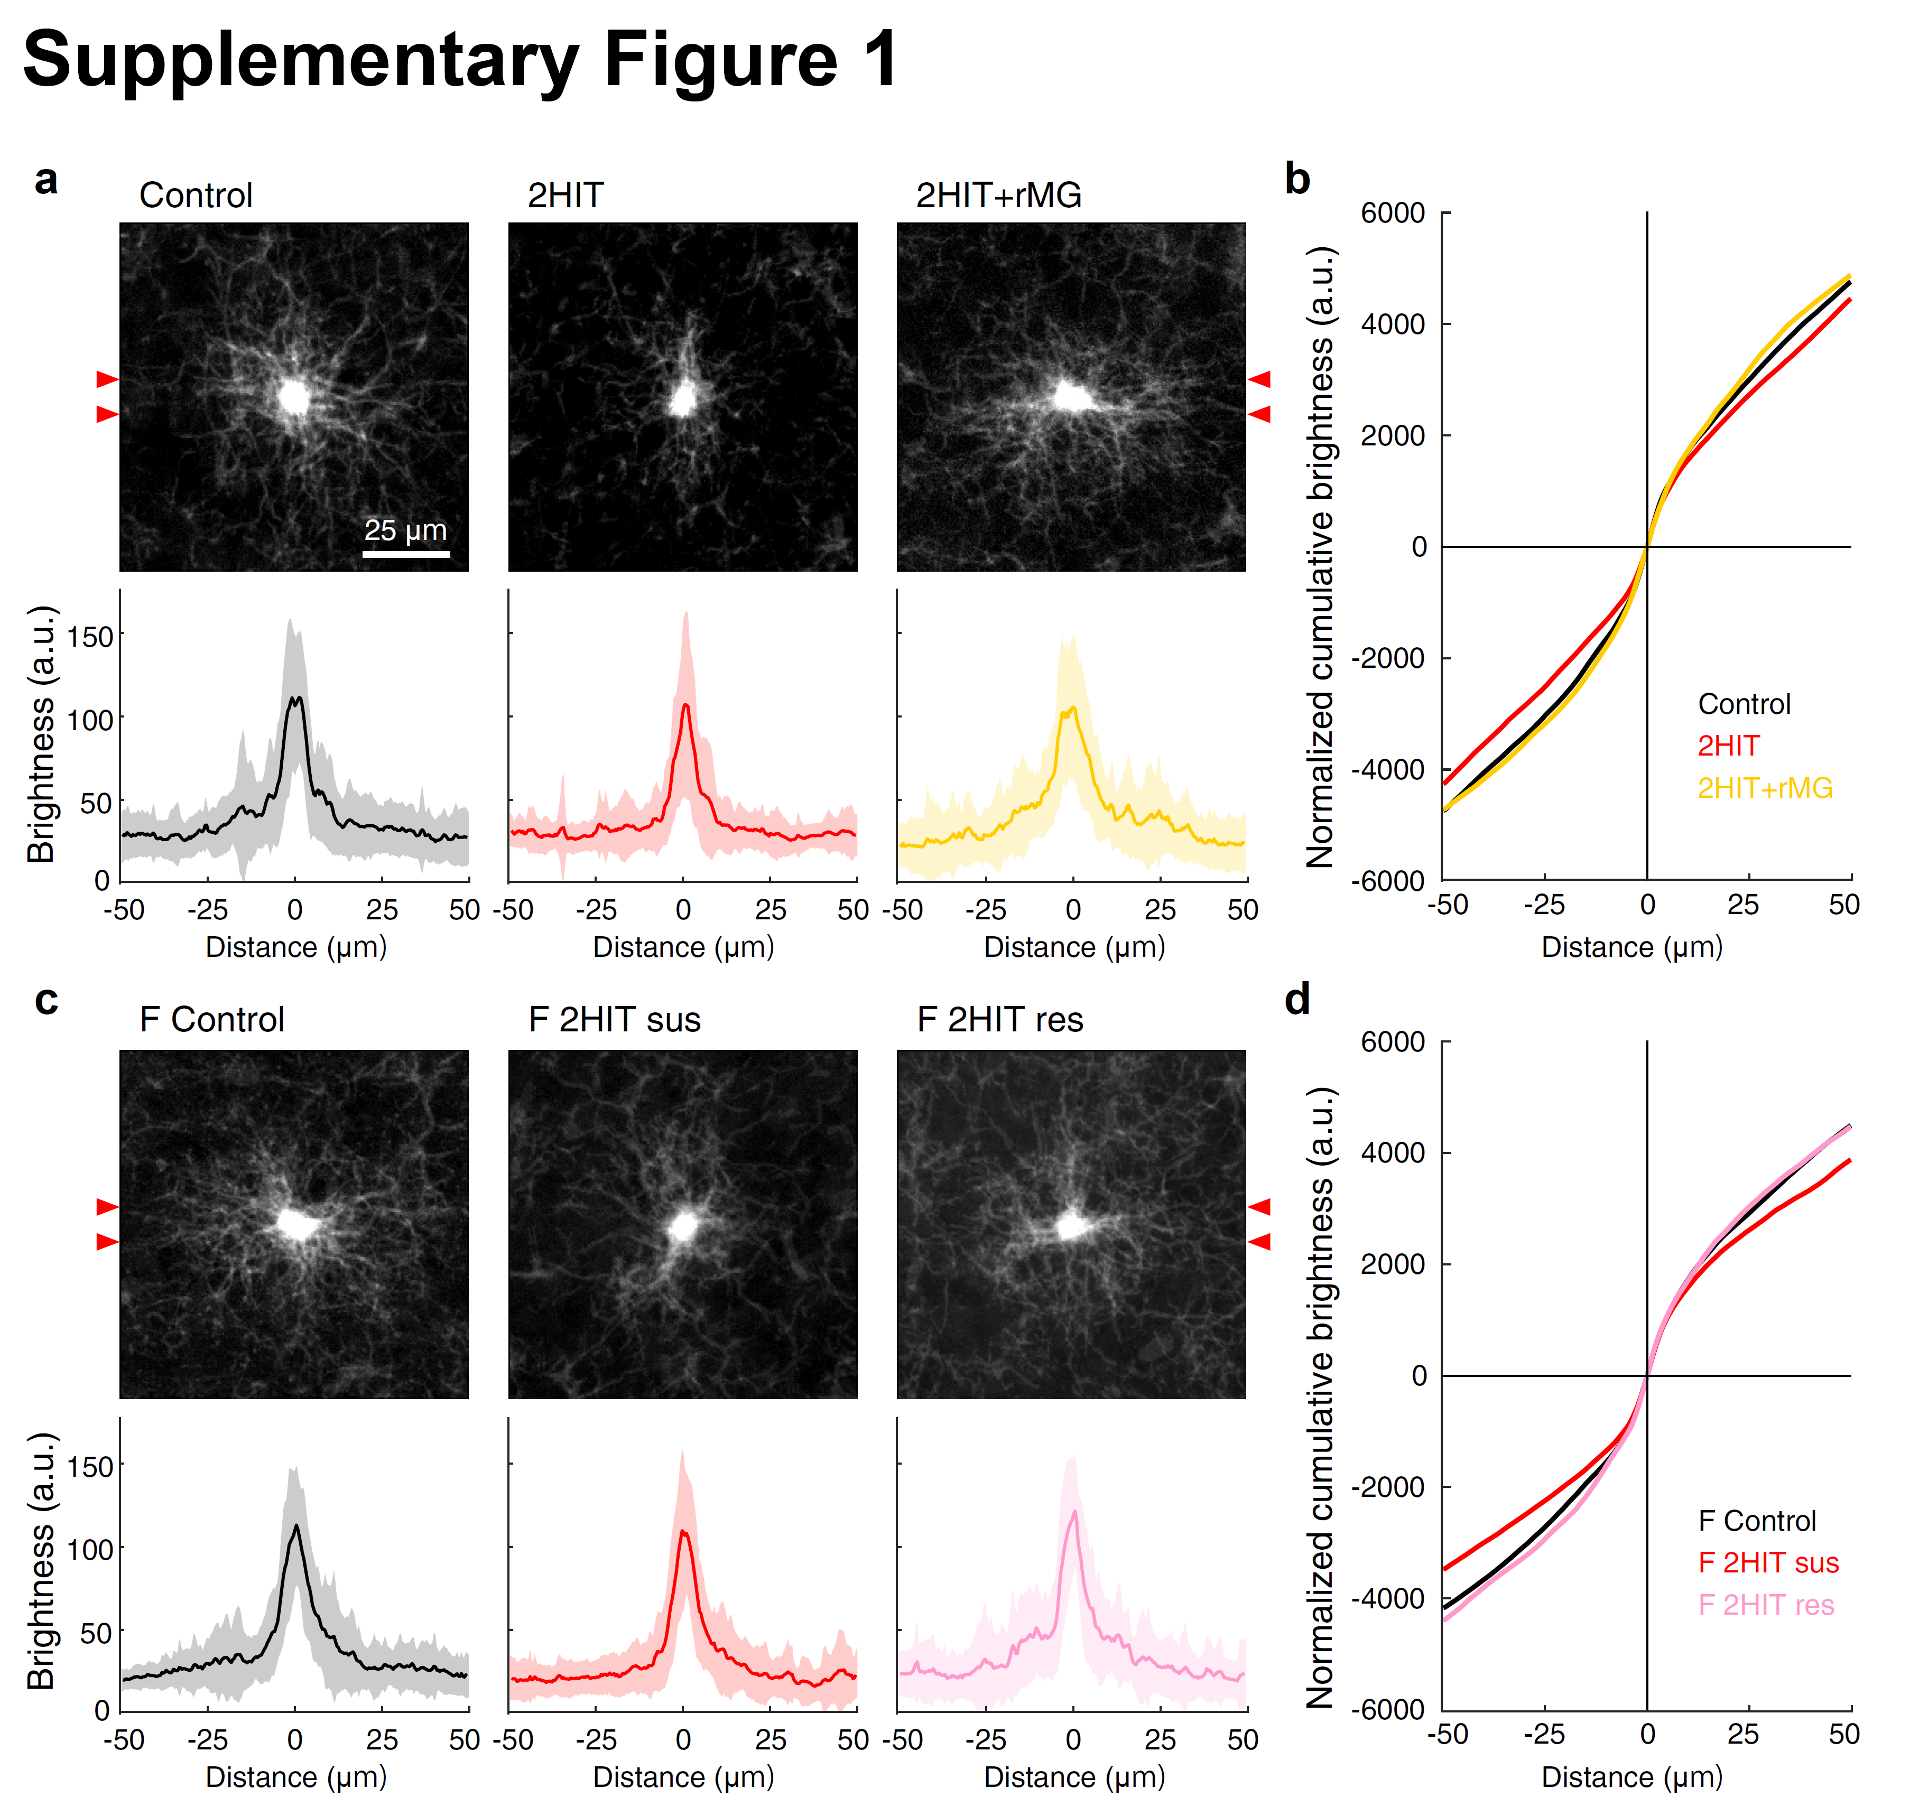

Supplementary Figure 1. Brightness of the microglia soma across stress conditions.
a, Averaged stuck projection image of microglia in male mice. Top, 21, 24, and 25 microglia from male Control, 2HIT, and 2HIT+microglia-replacement were superimposed and averaged, respectively. Bottom, the brightness of the microglia soma. The intensity of the Iba-1 fluorescence was measured from the delineated region by lines around the soma center (arrowheads) and averaged (bold line). Shadow indicates standard deviation.
b, Normalized cumulative brightness of microglia in males. The average intensity of the Iba-1 fluorescence was accumulated, and the soma position was centered.
c, Averaged stuck projection image of microglia in female mice. Top, 27, 21, and 23 microglia from male Control, 2HIT susceptible, and 2HIT resilient were superimposed and averaged, respectively.
d, Normalized cumulative brightness of microglia in females.
Across experiments, there is no substantial difference in Iba-1 fluorescence brightness at the center of immune cells but an identifiable difference at the process edge.
Supplementary Figure 2. Microglia counting from staining images.
From the raw plane image of Iba-1 and DAPI images of the brain section, we applied noise reduction with FFT/IFFT preprocessing (1). Next, we extracted the position of microglia soma from the denoised image (red circles) and obtained the nuclei position from the DAPI denoised image (2, 3). We refined cell recognition by omitting the duplication (green circles) (4). Please find the details in Methods.
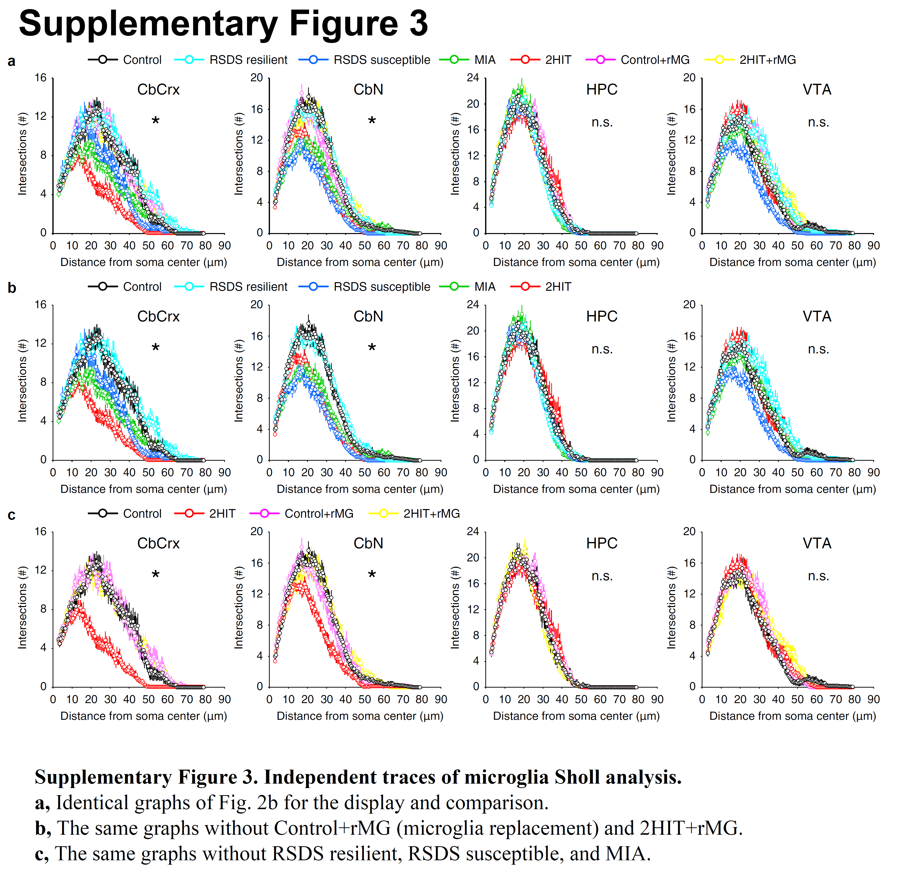
Supplementary Figure 3. Independent traces of microglia Sholl analysis.
a, Identical graphs of Fig. 2b for the display and comparison.
b, The same graphs without Control+rMG (microglia replacement) and 2HIT+rMG.
c, The same graphs without RSDS resilient, RSDS susceptible, and MIA.
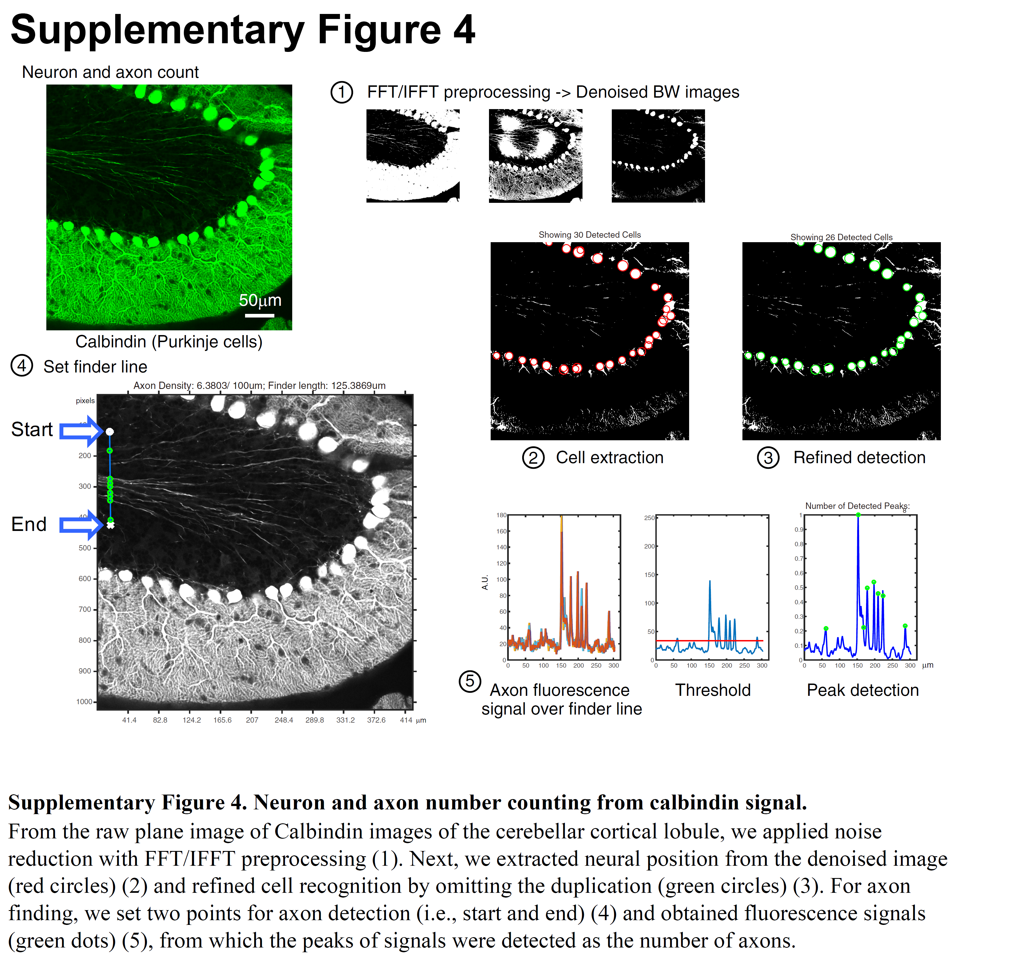
Supplementary Figure 4. Neuron and axon number counting from calbindin signal.
From the raw plane image of Calbindin images of the cerebellar cortical lobule, we applied noise reduction with FFT/IFFT preprocessing (1). Next, we extracted neural position from the denoised image (red circles) (2) and refined cell recognition by omitting the duplication (green circles) (3). For axon finding, we set two points for axon detection (i.e., start and end) (4) and obtained fluorescence signals (green dots) (5), from which the peaks of signals were detected as the number of axons.
Supplementary Figure 5. Calbindin(+) interneurons in medial prefrontal cortex.
a, Representative medial prefrontal cortex (mPFC) Calbindin(+) neurons. b, Bar graphs of Calbindin(+) mPFC interneurons across stress conditioning are shown. There is no significant difference across the experiments by one-way ANOVA.
Supplementary Figure 6. Representative IMC images with markers specific cell type.
The figure shows representative images with cell-type specific markers by HyperionTM imaging masscytometry (IMC). The astrocyte is marked by GFAP and AQP4. The granule cell in the cerebellar cortex is marked by MAP2. The endothelial cell and pericyte of the vasculature and capillary are marked by Claudin-5 and PDGFRβ.

Supplementary Figure 7. Expression pattern of the marker-molecules of stress-associated microglia/macrophages in 2HIT cerebellum.
Cell-specific mean IMC signal intensity of each marker in a representative cell from 2HIT SAM (a), 2HIT immune cell (b), and Control immune cell (c) within a 100 μm × 100 μm rectangle around the cell. Red lines indicate cell diameter, an arrowhead indicates cell position, and a line graph shows the intensity values of the marker in the corresponding position of the gray image. Please note that 2HIT SAM (a), 2HIT immune cell (b), and Control immune cell (c) are categorized into 2HIT cluster 12, 2HIT cluster 5, and Control cluster 6, respectively.
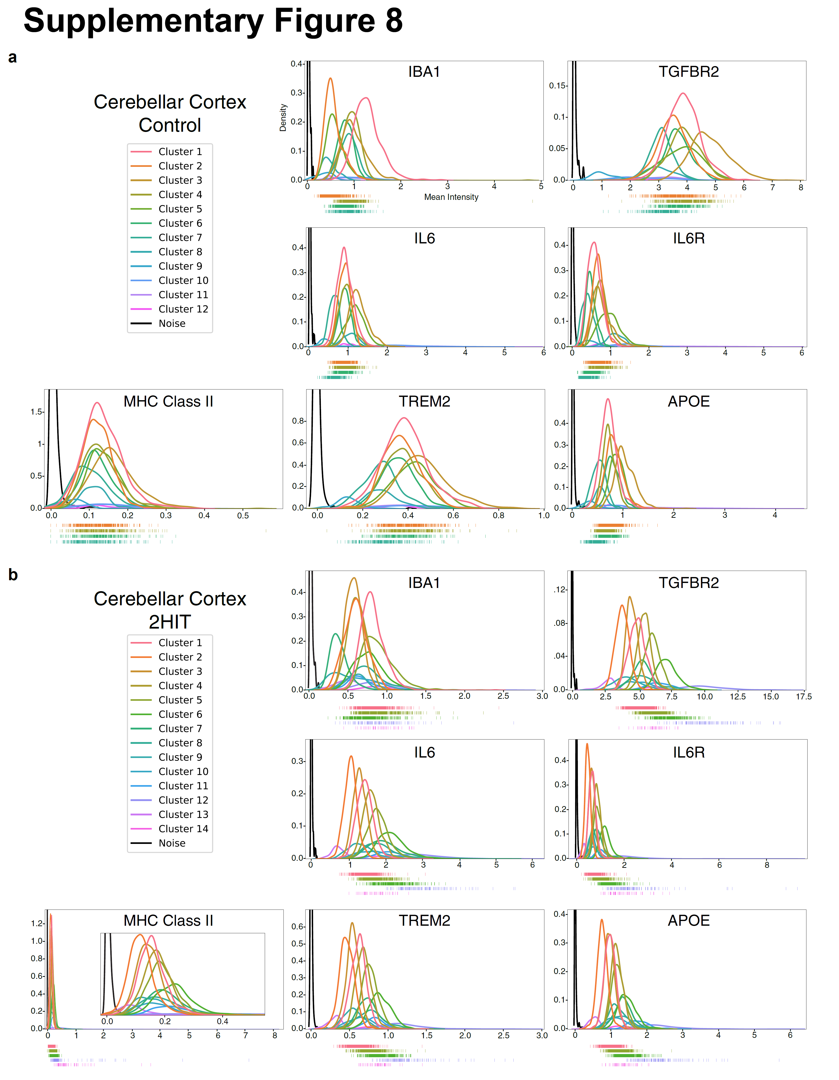
Supplementary Figure 8. Expression intensity of stress-associated markers in each cluster of Control and 2HIT.
Cluster-wise mean intensity of SAM-related markers in Control (a) and 2HIT (b). The mean intensity of those markers in immune cell clusters was illustrated with a rug plot at the bottom to show the variation of their expression between the clusters. Please note that the signals of void space of IMC images are plotted as noise (black lines).
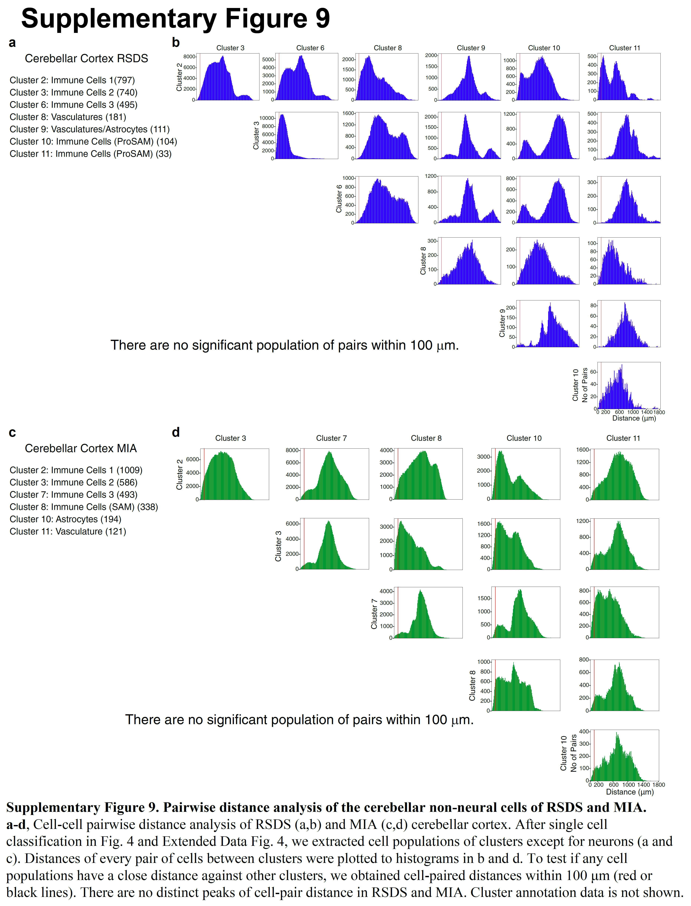

Supplementary Figure 9. Pairwise distance analysis of the cerebellar non-neural cells of RSDS and MIA.
a-d, Cell-cell pairwise distance analysis of RSDS (a,b) and MIA (c,d) cerebellar cortex. After single cell classification in Fig. 4 and Extended Data Fig. 4, we extracted cell populations of clusters except for neurons (a and c). Distances of every pair of cells between clusters were plotted to histograms in b and d. To test if any cell populations have a close distance against other clusters, we obtained cell-paired distances within 100 μm (red lines). There are no distinct peaks of cell-pair distance in RSDS and MIA. Cluster annotation data is not shown.
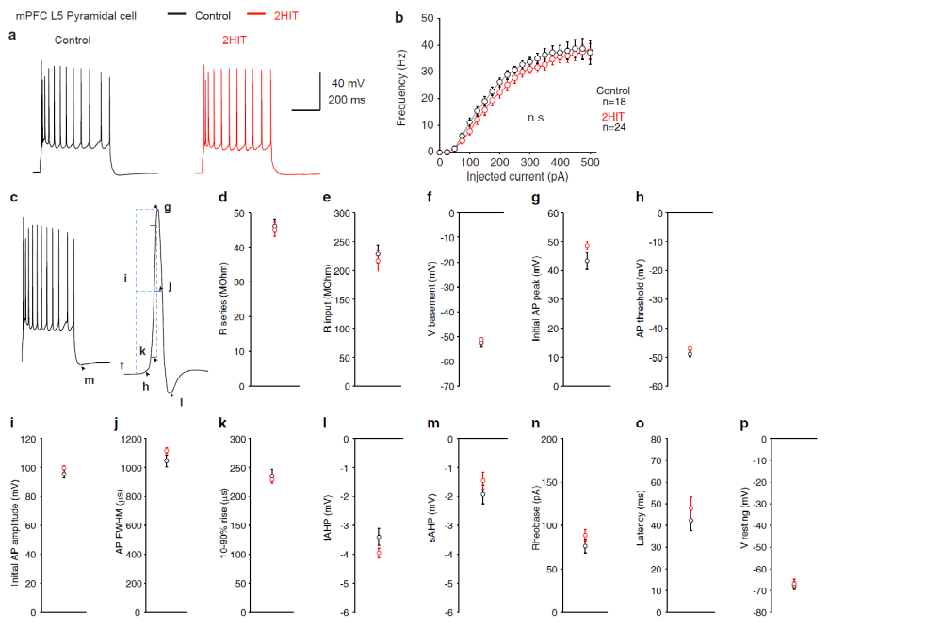

Supplementary Figure 10. Intrinsic membrane properties and action-potential waveform parameters of the mPFC pyramidal cells.
a,b, Firing frequency of medial prefrontal cortex (mPFC) layer 5 (L5) pyramidal neurons.
(a) shows the representative action potential by 200-pA, 500-ms-depolarization of the mPFC L5 pyramidal neurons of Control and 2HIT (Control, n = 18; 2HIT, n = 24. N.s., no significant difference in Student's t-test). action potential firing of mPFC pyramidal neurons in (b) was evoked by applying step pulses from 0 to 500 pA by 25 pA.
c-p, L5 pyramidal cell action potential property, including series resistance (d), input resistance (e), basement potential of action potential (f), peak voltage of action potential (g), action potential threshold (h), amplitude of action potential (i), FWHM (j), rise time (k), fAHP (l), sAHP by 400 pA pulse (m), rheobase (n), latency (o), and resting potential (p) is shown. All action potentials were measured in the initial action potential when evoked by the minimum depolarization pulses with a 25-pA step. Data are mean ± SEM. No significant differences were found with Student's t-test.
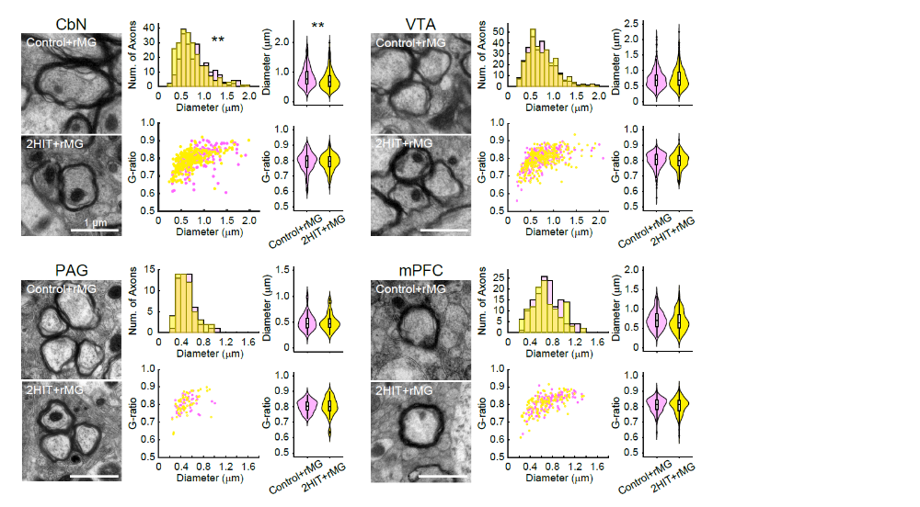

Supplementary Figure 11. Partial amelioration of the axon diameter associated with dysconnectivity across brain regions by microglia depletion.
Electron microscopy analysis of neural axons of Control and 2HIT four weeks after rMG (i.e., 9–11 weeks old). Representative axon images are shown on the left. The axon number histogram against axon diameter and g-ratio vs. axon diameter plot is shown in the middle column. Violin plots with a whiskered box of the axon diameter and g-ratio are shown on the right. Particularly, the g-ratio recovered in CbN and VTA of 2HIT four weeks after rMG. The scale bar represents 1 μm.
Data are represented as mean ± SEM. **p < 0.01: two-sample Kolmogorov-Smirnov test or Wilcoxon rank sum test applied Bonferroni correction.
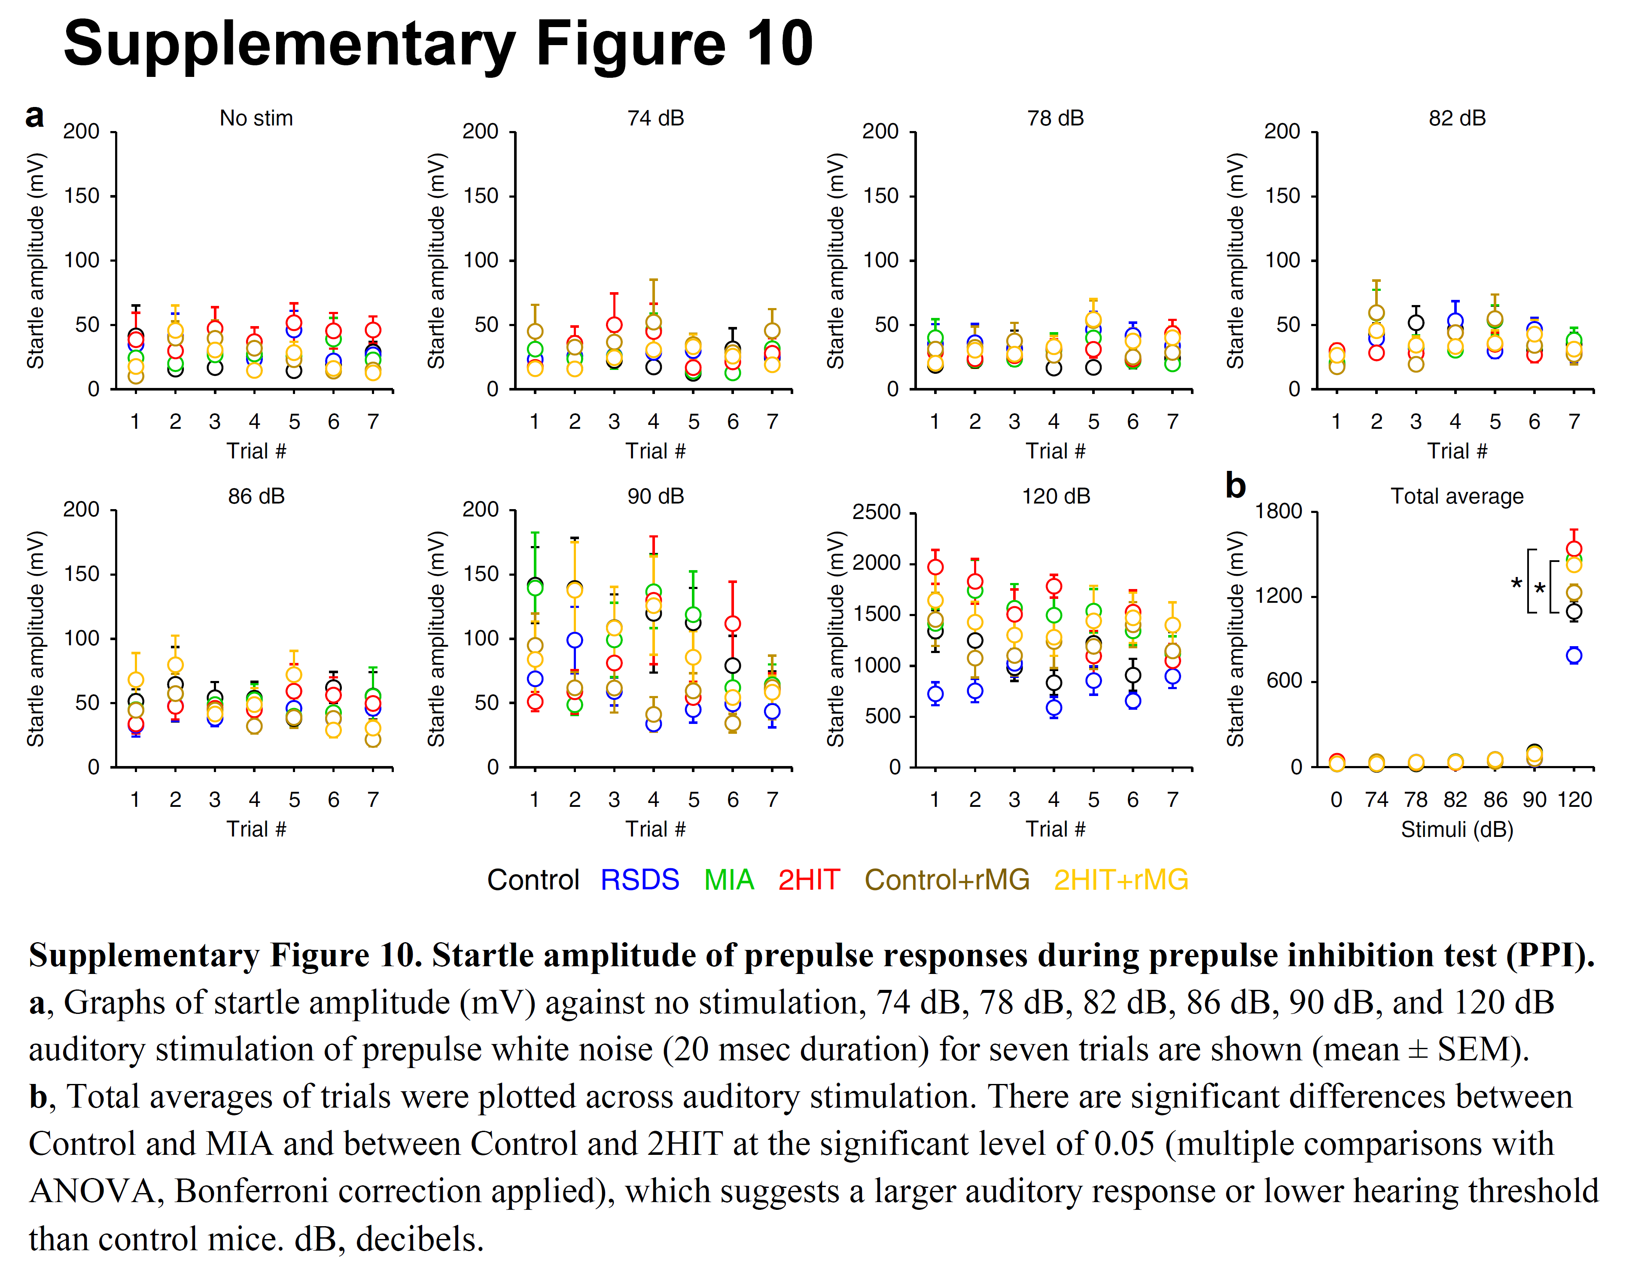
Supplementary Figure 12. Startle amplitude of prepulse responses during prepulse inhibition test (PPI).
a, Graphs of startle amplitude (mV) against no stimulation, 74 dB, 78 dB, 82 dB, 86 dB, 90 dB, and 120 dB auditory stimulation of prepulse white noise (20 msec duration) for seven trials are shown (mean ± SEM).
b, Total averages of trials were plotted across auditory stimulation. There are significant differences between Control and MIA and between Control and 2HIT at the significant level of 0.05 (multiple comparisons with ANOVA, Bonferroni correction applied), which suggests a larger auditory response or lower hearing threshold than control mice. dB, decibels.

