Supplementary Material

Physical and chemical characteristics

X-ray Diffraction (XRD). The structural changes of the lamellar mineral after the calcination process and the crystalline phases of all the synthesized hydrogels were investigated through X-ray diffraction (XRD). The X-ray source used was a copper anode irradiated by a current of 30 mA, accelerated by a ddp of 30 kV, and the emitted radiation was monochromatized by a nickel filter, resulting in radiation of 0.154 nm, referring to the Cu kα emission. The diffractograms were obtained under a routine of continuous scanning with a rate of 2° min⁻¹ in the 2θ range from 5 to 70° in Shimadzu XRD-6000 equipment.

Fourier Transform Infrared (FTIR). The displacements of characteristic bands in the synthesized hydrogels due different lamellar materials were investigated by the Fourier Transform Infrared Spectroscopy, using the infrared spectrometer (Bruker, model Vertex 70) with software Opus v 7.2. The measurements were made in hydrogels with a higher proportion of lamellar material (1:1), using attenuated reflectance reading (ATR). FTIR spectra were obtained by registering 32 scans from 400 to 4000 cm⁻¹, with normalization and correction at the baseline being applied to all spectra from the Opus software.

Nuclear Magnetic Resonance (NMR). The structural properties and the presence of residual acrylamide monomer in the hydrogels obtained after the purification process was observed through Nuclear Magnetic Resonance. The ¹³C spectra for methylcellulose, acrylamide, calcined hydrotalcite and hydrogels - HG, HG550 (1:1) and HG300 (1:1) - were obtained with the parameters: CPMAS sequence (cross-polarization with magic angle rotation), 10 kHz rotation, contact time = 3 ms, relaxation time = 5 s, acquisition time = 20 ms, number of scans = 2048 and hexamethyl benzene (HMB) was used as a chemical shift reference standard (methyl line at 17.3 ppm). In addition, the ²⁷Al spectra were obtained with the parameters: single pulse sequence, 10 kHz rotation; pulse time = 1.5 μs; relaxation time = 1 s, acquisition time = 20 ms, number of scans = 64 and reference standard = Al(NO₃)₃ at 0 ppm. The hydrogels analyzed were previously lyophilized and then packed in a zirconia rotor (5.0 mm in diameter). The RMN spectra were acquired using an Avance III HD Bruker 9.4 T (400 MHz) with a solid probe.

Scanning Electron Microscopy (SEM). The morphology of the synthesized materials and the lamellar nanoparticles' agglomeration effect were studied using the Scanning Electron Microscopy technique. The images were acquired using a JEOL JSM 6510. The samples were deposited on carbon tape bonded to the surface of a metal disc (stub), coated with gold in an ionization chamber (BALTEC Med. 020) and analyzed.

FIGURE
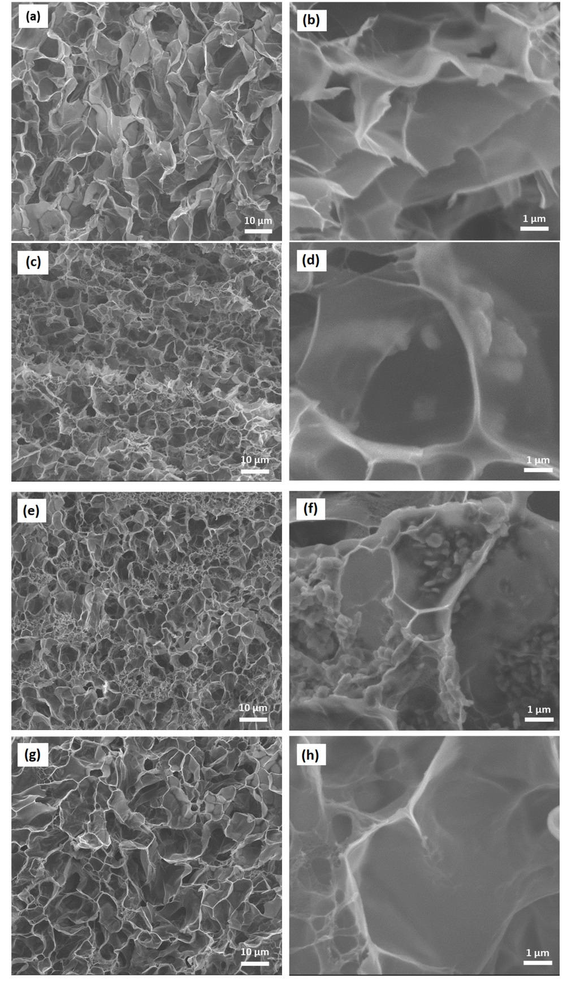
Figure S1. Original Scanning Electron Microscopy (SEM) images with two different magnifications for the materials: (a-b) HG (1:0), (c-d) HG550 (1:1), (e-f) HG300 (1:1) and (g-h) HGMMt (1:1).

