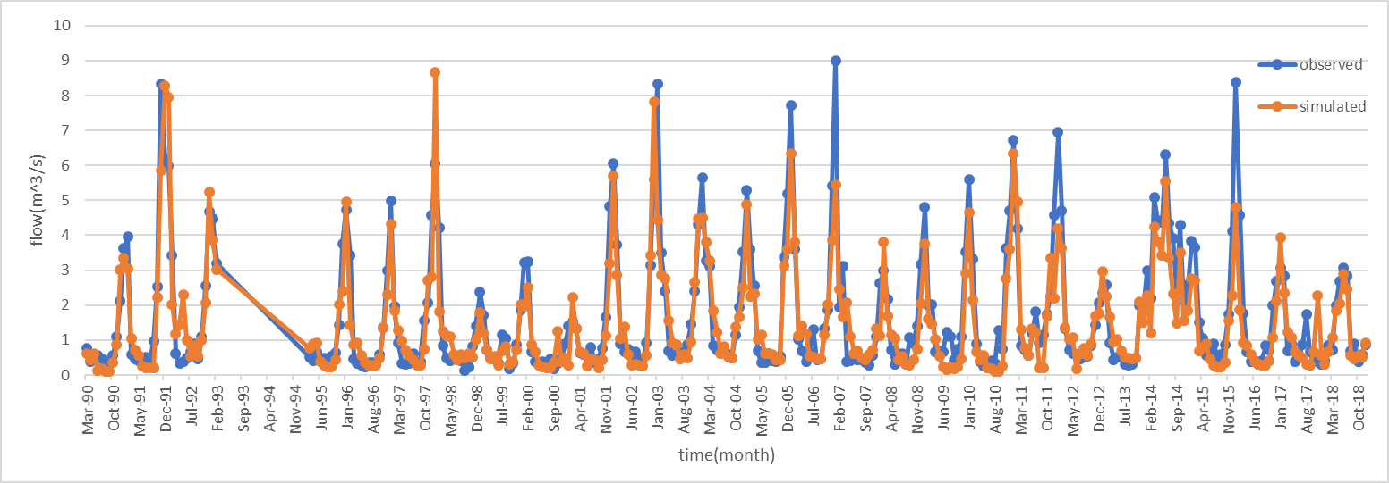 | 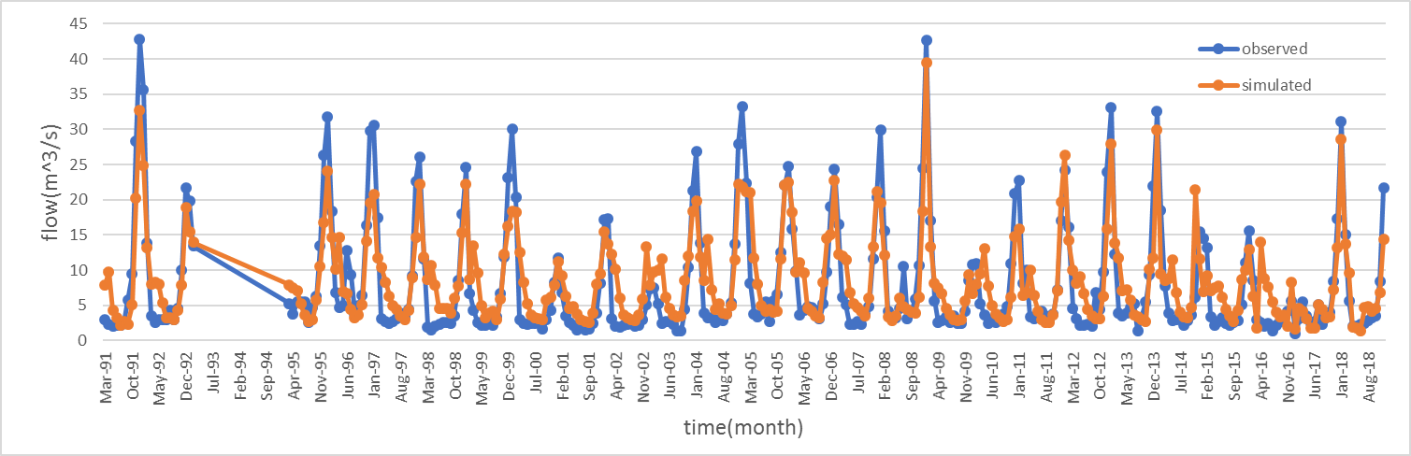
Comparison diagram of simulation and observation flow of Alizan station | Comparison diagram of simulation and observation flow of Jostan station
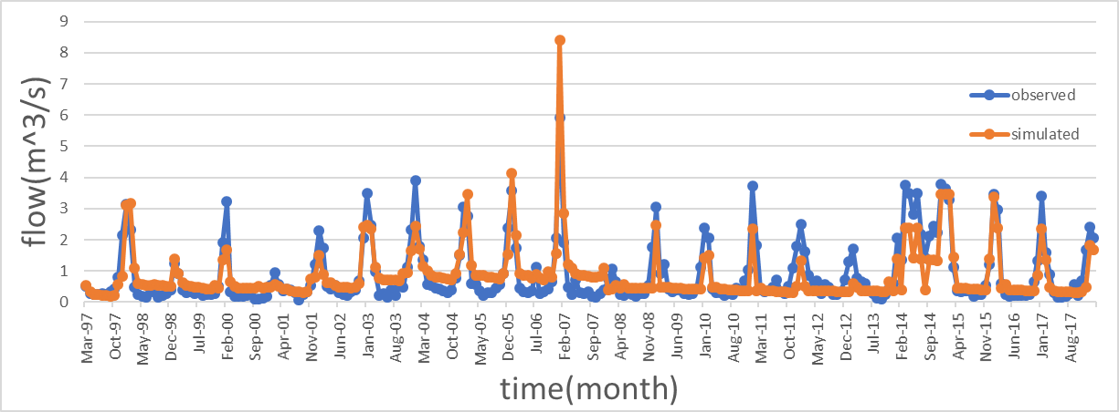 | 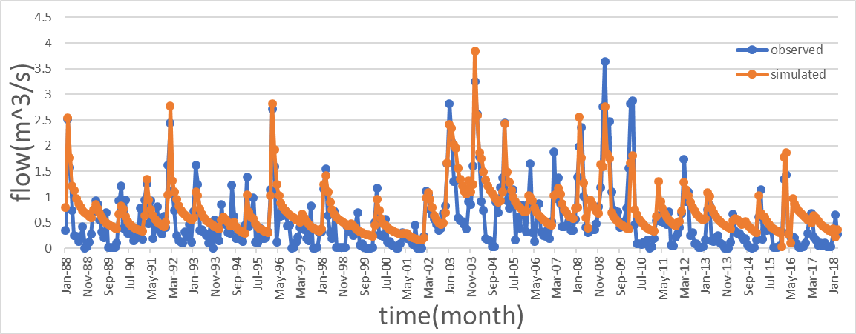
Comparison chart of simulation and observation flow of Dehdar station | Comparison chart of simulated and observed discharge of Narin station
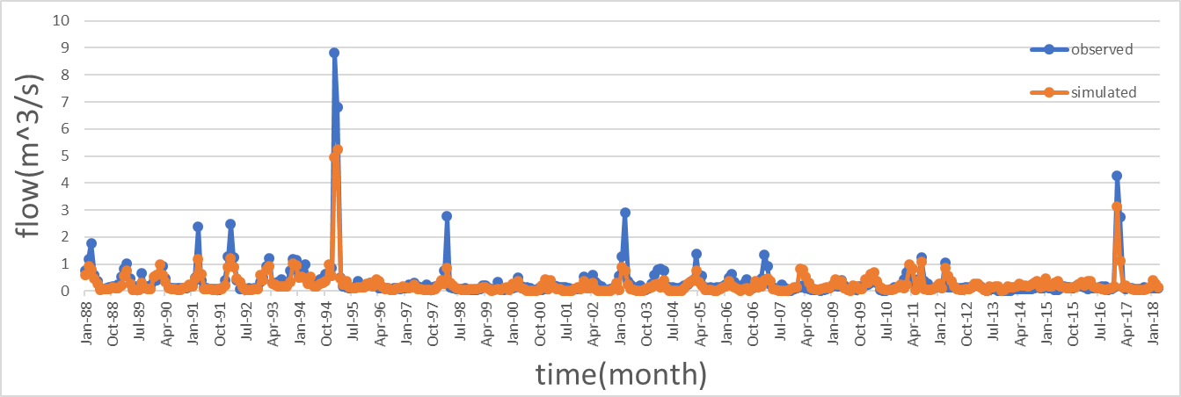 | 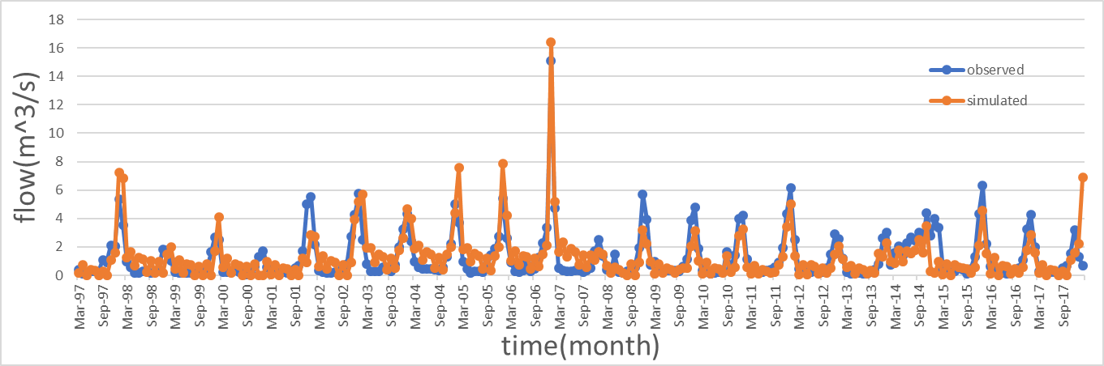
Comparison chart of simulated and observed discharge of Taleghan station | Comparison chart of flow simulation and observations of Goethe station
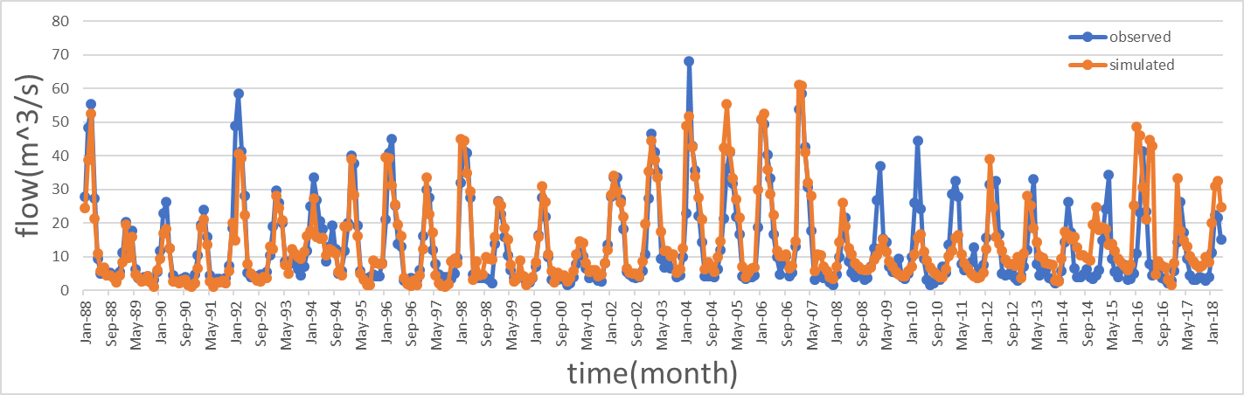 | 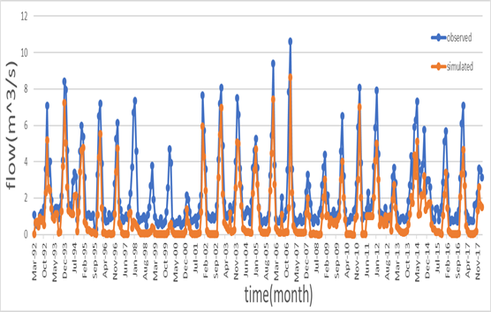
Comparison chart of flow simulation and observations of Glink station | Comparison chart of simulated and observed discharge of Mehran station
Table 1. Comparison diagram of simulation and observation flow of taleghan stations

No. | Station | Calibration |  |  |  | Validation
No. | Station | NSE | R² | P-FACTOR | R-FACTOR | NSE | R² | P-FACTOR | R-FACTOR
1 | GoteDeh | 0.64 | 0.73 | 0.07 | 0.03 | 0.58 | 0.67 | 0.03 | 0
2 | DAhdar | 0.72 | 0.77 | 0.26 | 0.42 | 0.67 | 0.71 | 0.2 | 0
3 | Joestan | 0.73 | 0.77 | 0.29 | 0.26 | 0.66 | 0.7 | 0.1 | 0
4 | Alizan | 0.8 | 0.81 | 0.44 | 0.4 | 0.75 | 0.81 | 0.3 | 0
5 | Glinc | 0.65 | 0.72 | 0.4 | 0.3 | 0.56 | 0.65 | 0.2 | 0
6 | Mehran | 0.56 | 0.65 | 0.56 | 0.32 | 0.45 | 0.56 | 0.1 | 0
7 | Narin | 0.53 | 0.67 | 0.37 | 0.71 | 0.48 | 0.58 | 0.3 | 0
8 | Taleghan | 0.76 | 0.88 | 0.35 | 0.13 | 0.61 | 0.61 | 0.09 | 0

Table 2. Evaluating the efficiency of the model in the calibration stage

No. | parameter | Parameter intoduction | min | max
1 | Alpha_Bf | Coefficient α of groundwater | 0 | 1
2 | Alpha_Bnk | Coefficient α of base water for canal coastal storage | 0 | 1
3 | Canmx | Water retained by vegetation (mm H2O) | 0 | 100
4 | Ch_K2 | Effective hydraulic conductivity of the main river bed (mm/hr) | 0 | 150
5 | Ch_N2 | Manning coefficient for the main river | 0 | 1
6 | Cn2 | Curve number | 20 | 90
7 | Esco | Soil evaporation coefficient | 0 | 1
8 | Epco | Plant maintenance compensation factor | 0 | 1
9 | Gw_Delay | The delay time of water transfer from the last profile of the soil layer | 0 | 500
10 | Gw_REVAP | Coefficient of determination of infiltration into deep underground water or capillary rise from shallow water table | 0 | 1.5
11 | Gwqmn | Minimum required depth of stagnation level in shallow aquifers for flow to occur | 0 | 5000
12 | Gw_Spyld | Special production coefficient of shallow table | 0 | 0.4
13 | Ov_N | Manning coefficient for surface flow | 0.01 | 30
14 | Rchrg_Dp | Percentage of deep aquifer feeding from shallow or unconfined aquifer | 0 | 1
15 | Revapmn | The minimum amount of water storage in the aquifer that is required to start the evaporation of groundwater through mowing (mm H2O) | 0 | 500
16 | Sftmp | (C °) average air temperature to turn rain into snow | -5 | 5
17 | Shallst | (mm H2O) storage value of the shallow aquifer at the beginning of the simulation | 0 | 1000
18 | Slope | (m/m) HRU Average land slope per | 0 | 0.6
19 | Slsubbsn | (M) HRU average slope length per | 10 | 150
20 | Smfmn | mmH2O/°C-day) snowmelt rate on December 21 | 0 | 10
21 | Smfmx | (mmH2O/°C-day) snowmelt rate on 21 June | 0 | 10
22 | Smtmp | (C °) melting temperature of the mass | 0 | 2.5
23 | Sol_Alb | Albedo coefficient of moist soil | 0 | 0.25
24 | Sol_Awc | Available water capacity of the soil | 0 | 1
25 | Sol_Bd | Density of soil in wet state | 0.9 | 2.5
26 | Sol_K | Saturated hydraulic conductivity of soil layers (mm/hr) | 0 | 2000
27 | Sol_Z | Depth of soil layers (mm) | 0 | 25
28 | Surlag | Runoff delay coefficient | 1 | 24
29 | Timp | Snow compression temperature delay factor | 0 | 1
30 | Tlaps | Temperature change rate with height in each sub-region (°C/km) | 0 | 50
31 | CH-WDR | The ratio of width to depth of the river in each sub-basin | 0 | 10000
32 | LAT-TTIME | The delay time of subsurface flows to the river in each HRU | 0 | 180
33 | IRR-AMT | (mm H2O/day) water required for irrigation | 0 | 100
Table 3. Determining the optimal values of sensitive parameters after calibration

No | Parameter | Change range |  | Optimum amount
1 | Alpha_Bf | 1 | 0 | 0.64
2 | Alpha_Bnk | 1 | 0 | 0.69
3 | Canmx | 100 | 0 | 20
4 | SURLAG | 1 | 0 | 0.09
5 | Ch_N2 | 1 | 0 | 0.2
6 | Cn2 | 0.6 | 0.6- | 0.1-
7 | Esco | 1 | 0 | 0.26
8 | Epco | 1 | 0 | 0.32
9 | Gw_Delay | 500 | 0 | 459
10 | Gw_REVAP | 50 | 0 | 0.15
11 | Gwqmn | 500 | 0 | 1.3
12 | Ch_L2 | 500 | 0 | 454
13 | Ch_S2 | 10 | 0 | 10
14 | Rchrg_Dp | 1 | 0 | 0.82
15 | TIMP | 1 | 0 | 0.2
16 | Sftmp | 20 | 20- | 1.82-
17 | Shallst | 10 | 0 | 0.92
18 | GWHT | 50 | 0 | 50
19 | TLAPS | 10 | 10- | 9
20 | Smfmn | 20 | 0 | 7.62
21 | Smfmx | 20 | 0 | 3.25
22 | CH_S1 | 20 | 0 | 6.54
23 | Ch_L1 | 20 | 0 | 6.73
24 | SLSOIL | 152 | 0 | 5.5
25 | OV_N | 30 | 0 | 0.9
26 | LAT_TTIME | 180 | 0 | 168
27 | Sol_k | 0.8 | 0.8- | 0.05-
28 | Sol_bd | 0.8 | 0.8- | 0.7
Table 4. parameters affecting the amount of runoff in the SWAT-CUP model

Sub-basin number | specific erosion (tons per hectare) | sedimentation percentage of the sub-basin compared to the whole basin | area of the sub-basin (hectares) | average rainfall (mm) | dominant land use
1 | 408.4069146 | 4.71% | 8041 | 76.222 | Garden, arable land, pasture, pasture and meadow, pasture
2 | 609.8282443 | 0.92% | 1048 | 76.218 | Garden, arable land, pasture
3 | 1628.698225 | 15.78% | 6760 | 181.204 | Garden, arable land, pasture, bush and meadow
4 | 1.574762947 | 0.09% | 41130 | 260.633 | arable land, pasture,
5 | 741.8579016 | 10.61% | 9979 | 95.675 | Garden, arable land, pasture, shrubland and meadow, pasture
6 | 1.722957701 | 0.08% | 30970 | 260.631 | arable land, pasture,
7 | 1358.51272 | 4.98% | 2555 | 181.199 | Garden, arable land, pasture, pasture and meadow, pasture
8 | 1.827402863 | 0.13% | 48900 | 260.63 | arable land, pasture
9 | 821.6827124 | 5.63% | 4778 | 130.195 | Garden, arable land, pasture, pasture and meadow, pasture
10 | 844.1070846 | 7.41% | 6126 | 95.674 | Garden, arable land, pasture, pasture and meadow, pasture
11 | 1813.829787 | 6.84% | 2632 | 181.198 | Agricultural land, pasture, pasture and meadow, pasture
12 | 1.573498965 | 0.02% | 8694 | 130.19 | Agricultural land, pasture, pasture
13 | 1.633478531 | 0.04% | 16070 | 130.19 | Agricultural land, pasture, pasture
14 | 559.6130593 | 1.33% | 1654 | 144.753 | Agricultural land, pasture, pasture
15 | 1.885527673 | 0.16% | 58180 | 260.634 | Garden, arable land, pasture, pasture
16 | 1.435691841 | 0.19% | 92290 | 144.744 | Agricultural land, pasture, pasture and meadow,
17 | 1.650868878 | 0.21% | 88620 | 144.746 | Agricultural land, pasture, pasture and meadow,
18 | 0.880681818 | 0.07% | 54560 | 266.029 | Agricultural land, pasture
19 | 601.3765978 | 0.88% | 1017 | 144.751 | Agricultural land, pasture, forest, pasture
20 | 1.872108198 | 0.23% | 84290 | 148.6 | Agricultural land, pasture
21 | 1.602080123 | 0.12% | 51920 | 260.629 | Agricultural land, pasture
22 | 1.650797166 | 0.21% | 90320 | 148.6 | Agricultural land, pasture
23 | 1.706528765 | 0.15% | 61880 | 133.052 | Garden, arable land, pasture, pasture
24 | 1.980724493 | 0.17% | 60180 | 133.049 | Agricultural land, pasture
25 | 1.622145329 | 0.03% | 14450 | 130.189 | Garden, pasture, pasture
26 | 1.641271746 | 0.02% | 8335 | 130.19 | Garden, pasture, pasture
27 | 1.453628063 | 0.17% | 83240 | 144.744 | Agricultural land, pasture, pasture
28 | 807.8423322 | 1.13% | 974.2 | 133.052 | Agricultural land, pasture, forest, pasture
29 | 629.8254892 | 3.41% | 3782 | 76.219 | Garden, arable land, pasture, pasture, city, pasture and meadow
30 | 1.800430504 | 0.17% | 65040 | 133.048 | Agricultural land, pasture, city
31 | 1.653658537 | 0.19% | 82000 | 133.047 | Agricultural land, pasture, pasture,
32 | 1.773174873 | 0.07% | 29450 | 260.631 | Pasture
33 | 1.145530816 | 0.02% | 9297 | 133.05 | Agricultural land, pasture, pasture,
34 | 1.736233342 | 0.20% | 79540 | 133.047 | Agricultural land, pasture
35 | 1.749174917 | 0.17% | 69690 | 133.046 | Agricultural land, pasture, pasture, city
36 | 1.53070508 | 0.06% | 26380 | 260.63 | garden, pasture, pasture,
37 | 693.0604982 | 1.12% | 1124 | 130.186 | pasture
38 | 326.2398557 | 2.59% | 5545 | 130.187 | Garden, pasture, forest, pasture and meadow, pasture
39 | 1091.43062 | 4.36% | 2789 | 260.623 | Agricultural land, pasture, pasture
40 | 836.2369338 | 1.72% | 1435 | 260.624 | Agricultural land, pasture, pasture
41 | 2091.97731 | 7.40% | 2468 | 130.185 | Garden, pasture, pasture
42 | 1255.653507 | 4.70% | 2609 | 133.042 | Agricultural land, pasture, pasture
43 | 1271.630834 | 3.48% | 1907 | 133.043 | Agricultural land, pasture, pasture
44 | 553.3948583 | 1.20% | 1517 | 133.042 | Agricultural land, pasture, pasture
45 | 971.2556732 | 3.68% | 2644 | 260.623 | Agricultural land, pasture, pasture, shrubland
46 | 8.35622E-10 | 0.00% | 2622 | 130.184 | Pasture, pasture
47 | 824.0601504 | 3.14% | 2660 | 144.738 | Agricultural land, pasture and meadow, pasture, pasture
Table 5. Characteristics of erosion, amount of runoff and type of land use of each sub-basin

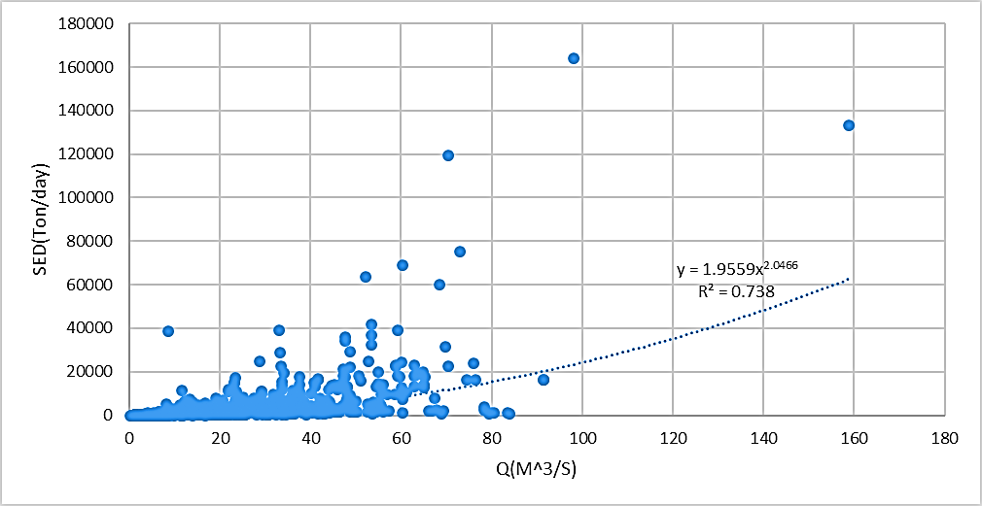 | 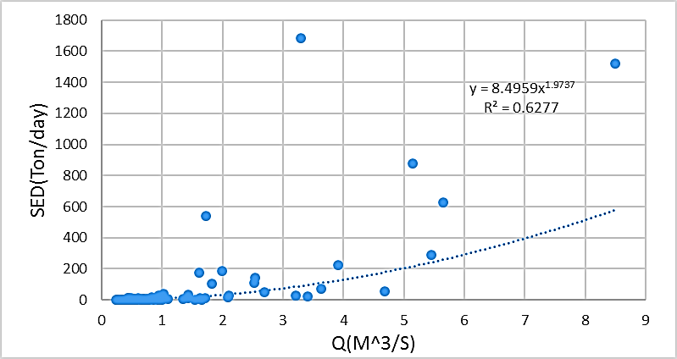
Gauge curve of Glink station | The gauge curve of Naron station
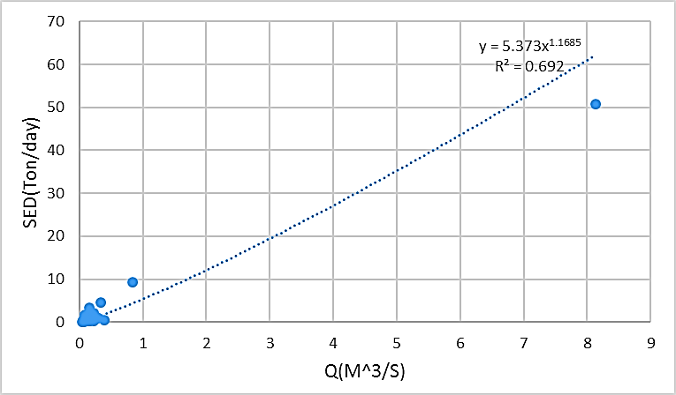 | 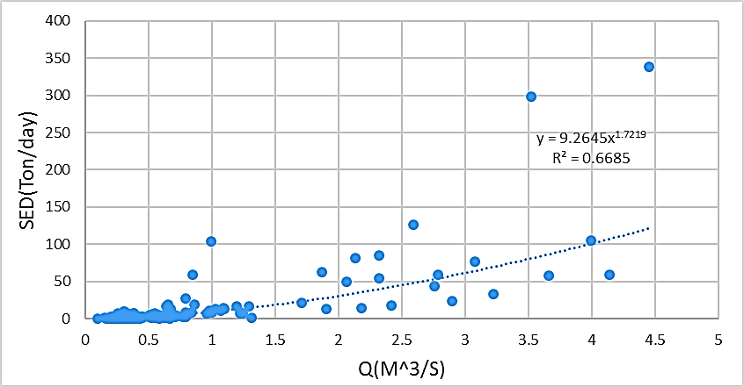
Gauge curve of Taleghan station | Gauge curve of Dehdar station
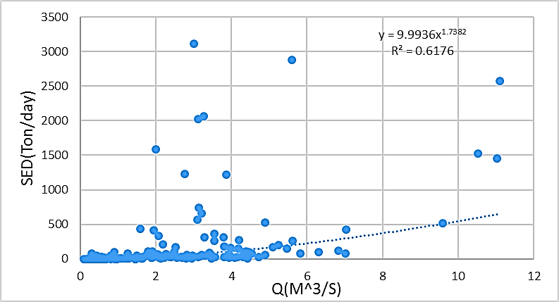 | 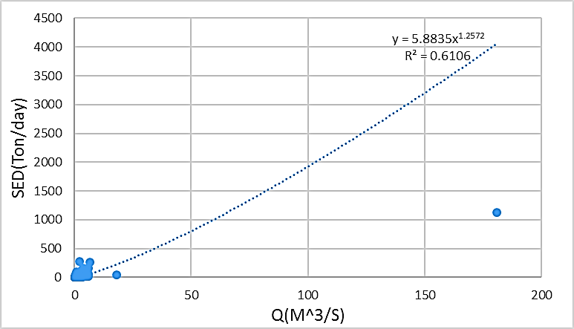
Gauge curve of Alizan station | Gauge curve of Goethe station
Gauge curve of Mehran station
Table 6. Hydrometric and sediment information

No. | Station | Calibration |  |  |  | Validation
No. | Station | NSE | R² | P-FACTOR | R-FACTOR | NSE | R² | P-FACTOR | R-FACTOR
1 | GoteDeh | 0.48 | 0.63 | 0.07 | 0.03 | 0.45 | 0.65 | 0.3 | 0
2 | DAhdar | 0.58 | 0.65 | 0.02 | 0.03 | 0.49 | 0.71 | 0.2 | 0
3 | Alizan | 0.65 | 0.67 | 0.18 | 0.16 | 0.50 | 0.75 | 0.05 | 0
4 | Alizan | 0.52 | 0.57 | 0.21 | 0.53 | 0.55 | 0.62 | 0.2 | 0
5 | Mehran | 0.50 | 0.65 | 0.56 | 0.32 | 0.44 | 0.56 | 0.1 | 0
6 | Narin | 0.68 | 0.87 | 0.05 | 0.05 | 0.59 | 0.63 | 0.05 | 0
7 | Taleghan | 0.89 | 0.9 | 0.23 | 0.09 | 0.58 | 0.62 | 0.05 | 0
Table 7. Another Evaluating the efficiency of the model in the calibration stage

