Supplement

Supplementary Figure 1 . Relative importance of top predictors for angiographic findings, 1-year mortality and 1-year risk of recurrent ACS

Supplementary Figure 2. Study design
RIKS-HIA + SCAAR
2015-2021
Cohort (n=9314)
6137 Males
3177 Females
Inclusion criteria
Angiographic findings
Predicting angiographic findings
Predicting 1-year survival
Association between troponin level and survival
Association between troponin level and prevalence of significant stenoses
Admitted for chest pain.
Normal hs-troponin levels
Underwent angiography
No discharge diagnosis of AMI
1
2
3
4
Analyses
Predicting 1-year risk of ACS
5

Supplementary Figure 3. Hyperparameter tuning for extreme gradient boosting for 1-year survival

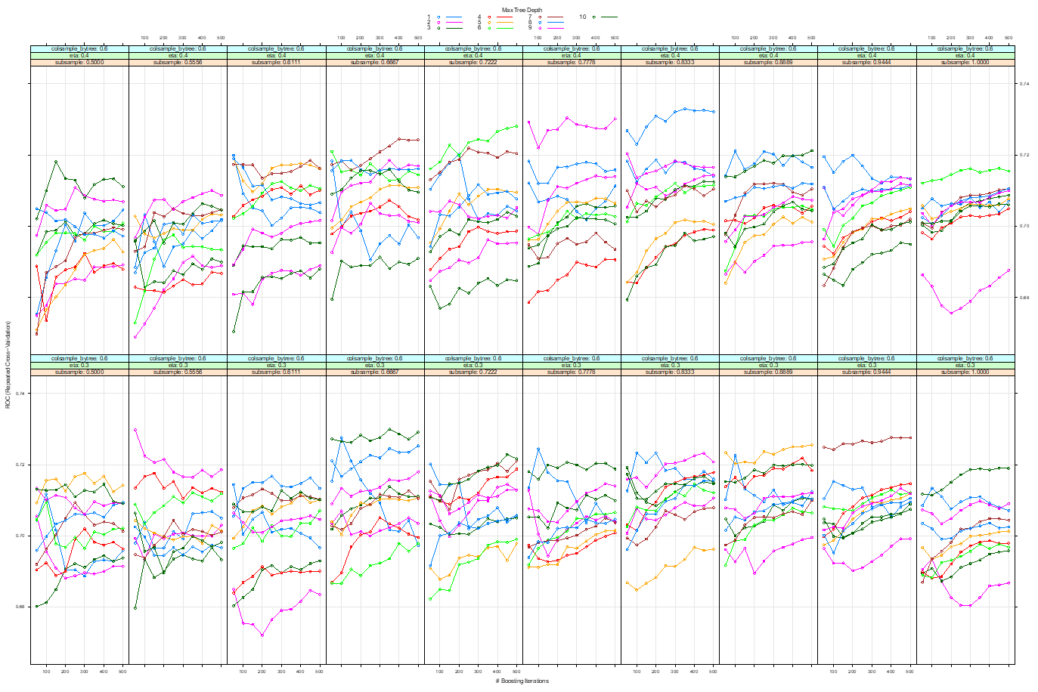

Supplementary Figure 4. Hyperparameter tuning for extreme gradient boosting for ACS within 1 year
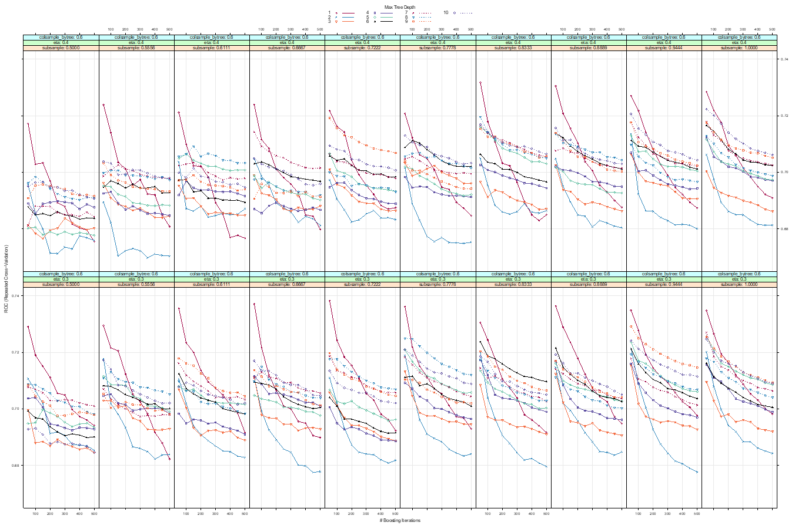

Supplementary Figure 5. Hyperparameter tuning for extreme gradient boosting for unnecessary angiography

