Imageology interpretation
Imageology characteristics were collected from electronic imaging dataset. All imaging results were reviewed and interpreted by experienced clinicians. Imageological features of tumor laterality, location, presence of contrast enhancement and extent of resection were collected. Comparing of magnetic resonance image (MRI) preoperatively and postoperatively within 72h, extent of resection was divided into gross total resection (GTR, no postoperative imageology evidence of residual tumor) and subtotal resection (STR, postoperative imageology evidence of residual tumor).
Histological and molecular characteristics
Histopathological records and molecular information of glioma biomarkers were extracted, including IDH mutation status, MGMT promoter methylation status, telomerase reverse transcriptase (TERT) promoter mutation, and chromosome 1p19q co-deletion status. Molecular characteristics were obtained via next generation sequencing (NGS), and MGMT promoter methylation status were detected by pyrosequencing. Fluorescence in situ hybridization (FISH) was performed to delineate 1p19q co-deletion status. All enrolled patients were classified into GBM, GBM-NOS, and astrocytoma WHO grade 4, according to the latest 2021 version of WHO criteria. Specifically, tumor with pathologically microvascular proliferation or necrosis and essential molecular characteristics (IDH-wildtype) is classified as GBM; tumor with histopathological feature of GBM but without essential molecular characteristic (IDH-mutant) is classified as astrocytoma WHO grade 4; tumor with histopathological feature of GBM but without available molecular information is classified as GBM not otherwise specified (NOS).
Definition of clinical characteristics
History of epilepsy is defined as patients once had or endured any types of epilepsy before surgical intervention of brain tumor. History of anti-epilepsy drug is defined as any usage of such agents before surgical intervention. Enzyme inducing anti-epilepsy drug (EIAED) is defined as the anti-epileptic agents that induce activity of hepatic mixed function oxidase enzymes, which is interferential to the kinetics of other drugs. History of heart disease is defined as any types of heart disease including both vascular and non-vascular. History of hypertension is defined as blood pressure exceed 140/90 (mmHg) at any time point or within persistence, and was clinically diagnosed in medical institution. History of diabetes is defined as formal diagnosis of diabetes made in medical institution prior to neurosurgery. Trauma history is defined as any types of traumas (not limited to cerebral trauma). Family history of malignancy is defined as any types of malignancies, but not benign tumors. History of cerebrovascular disease is defined as both hemorrhagic and ischemic diseases. Location of lesion is categorized by tumor site in left, right, or bilateral hemisphere of brain.
Tumor volume estimation
A gross-resection style of surgery is performed within high precedence when possible. We therefore obtained tumor samples with relatively higher integrity, which is fundamental for the veracity of recorded tumor diameters. All resected samples were recorded with diameters that measured promptly after surgery. Tumor volume (TV) estimation was achieved according to the formula, TV= α (longest diameter) × β (shortest diameter) × γ (height) × 6/π.
Treatment strategy
All patients underwent surgical resection, followed by conventional radiation therapy administrated at 200 cGy per fraction daily for five days per week to a total of approximately 60 Gy, and patients additionally had daily concomitant temozolomide orally (75mg/m²) followed by standard maintenance temozolomide chemotherapy (150-200mg/m²/d for 5 days every 28 days for 6 cycles), according to the protocol established by the European Organisation for Research and Treatment of Cancer (EORTC) Brain Tumor and Radiotherapy Groups and the National Cancer Institute of Canada (NCIC) Clinical Trials Group.

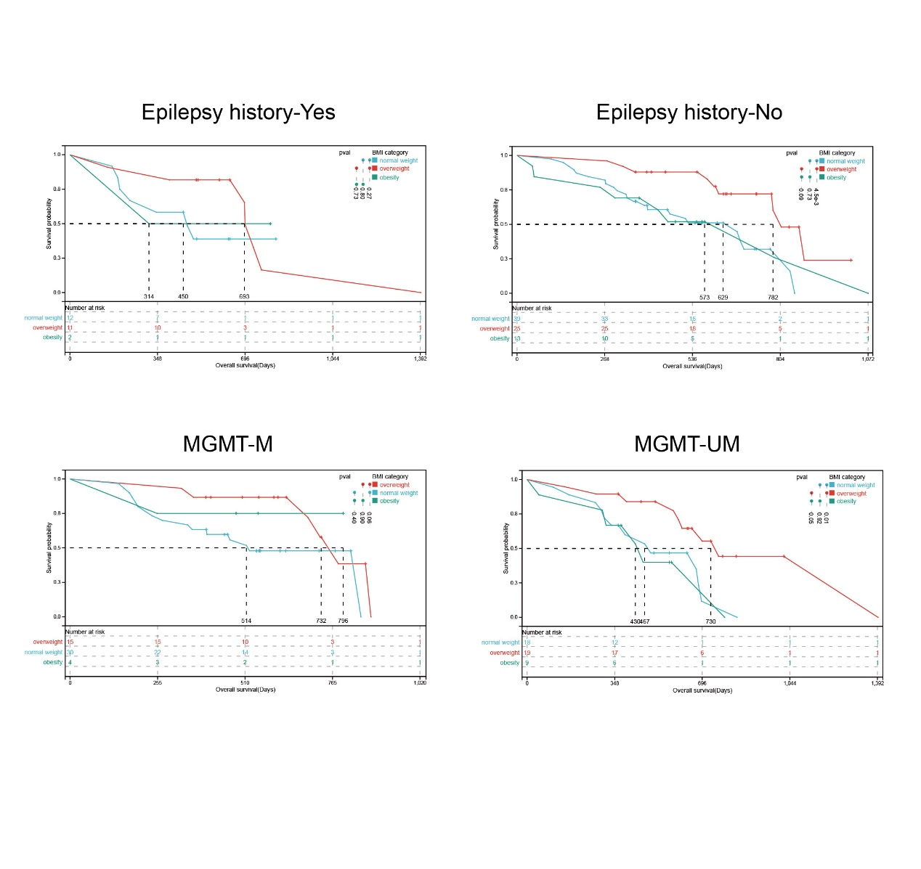
Supplementary Fig1 Kaplan-Meier plots of subgroup analyses. Survival analyses of different subgroup settings. Median survival times and significances were shown in the annotations.

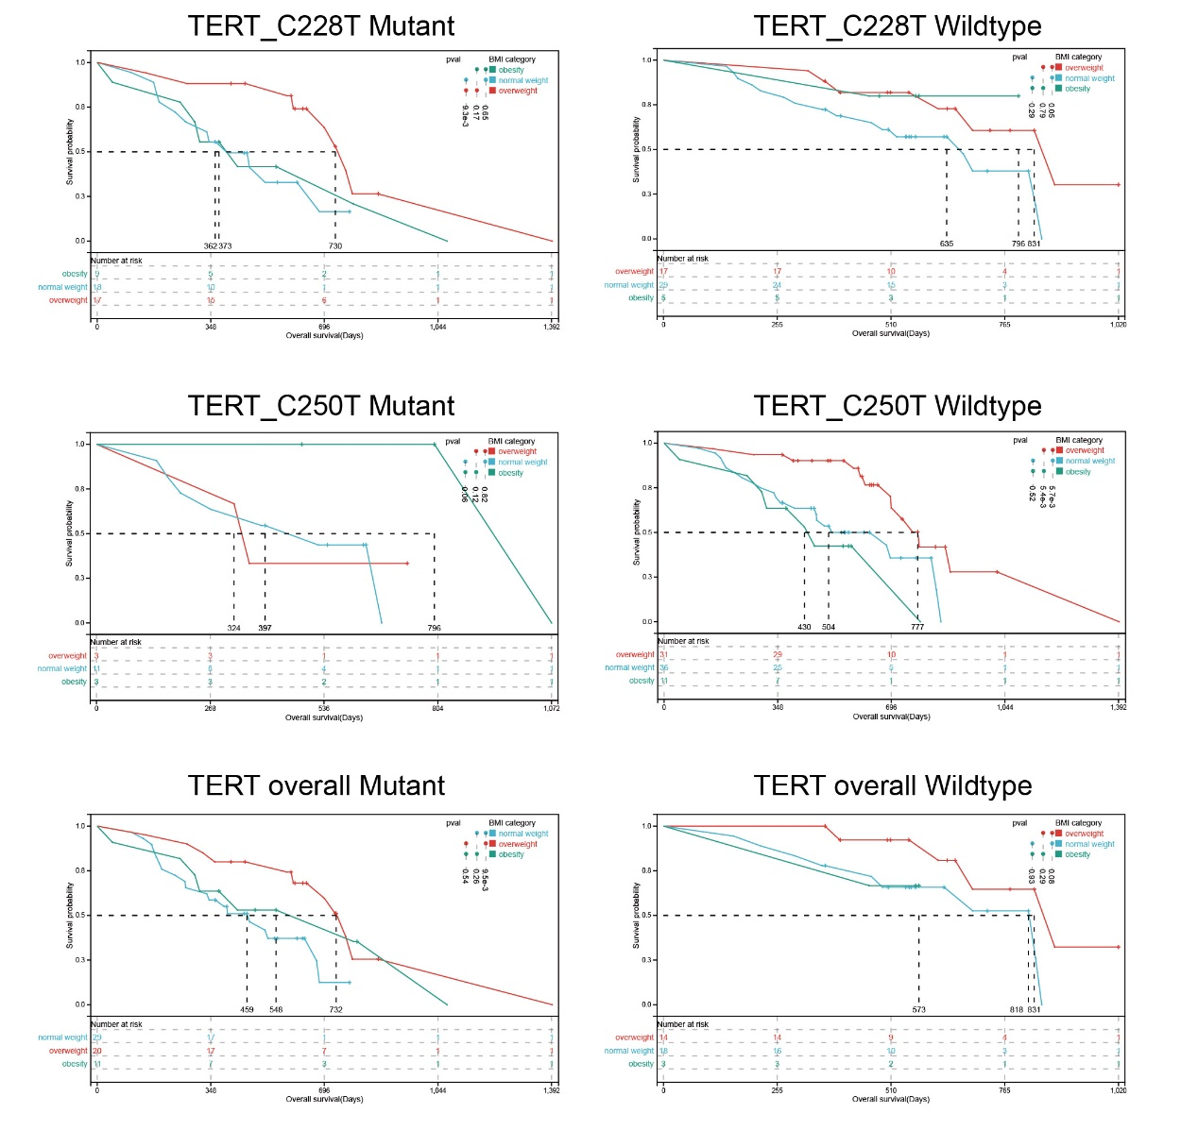
Supplementary Fig2 Kaplan-Meier plots of subgroup analyses. Survival analyses of different subgroup settings. Median survival times and significances were shown in the annotations.

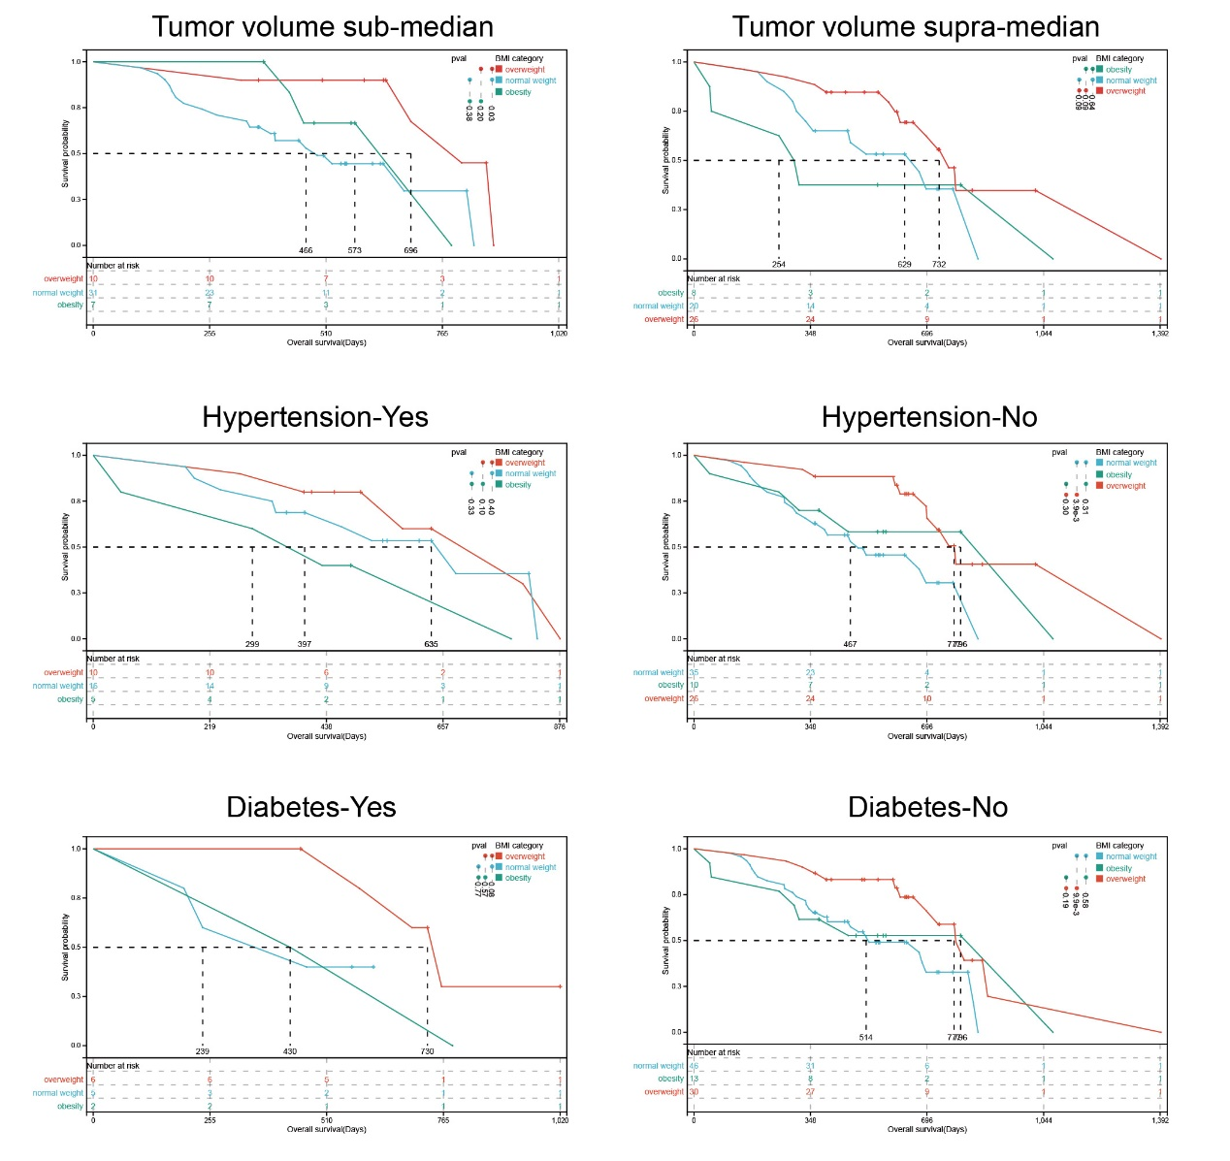
Supplementary Fig3 Kaplan-Meier plots of subgroup analyses. Survival analyses of different subgroup settings. Median survival times and significances were shown in the annotations.

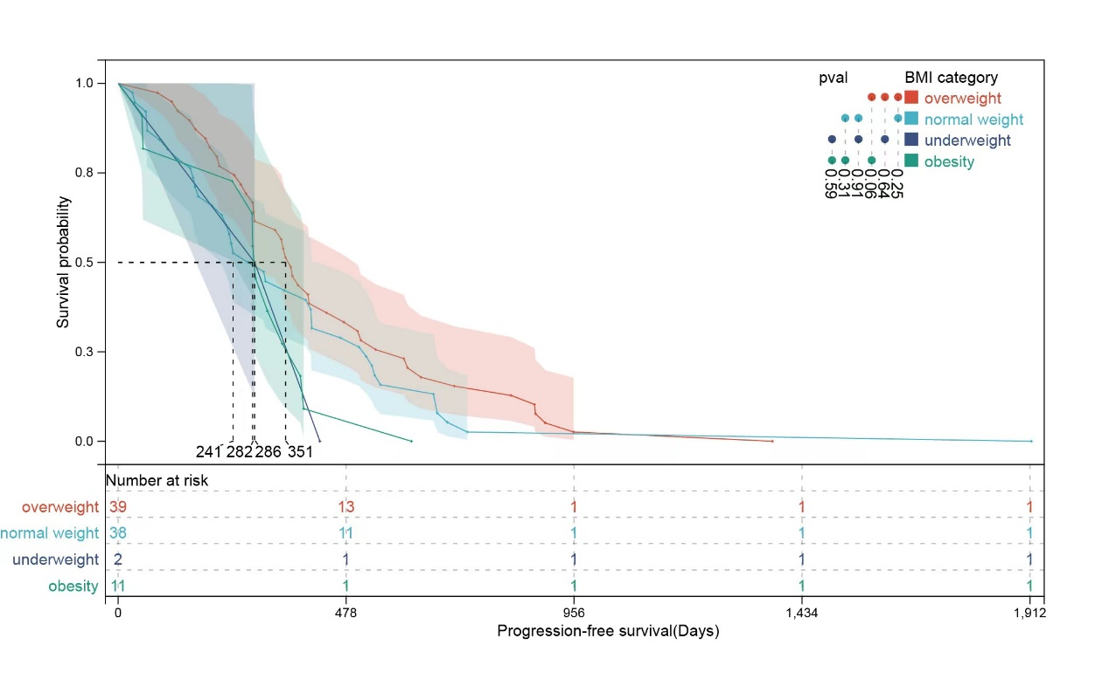
Supplementary Fig4 Kaplan-Meier plot (PFS as outcome) of BMI categories. A: Kaplan-Meier plot of patients from different BMI categories.

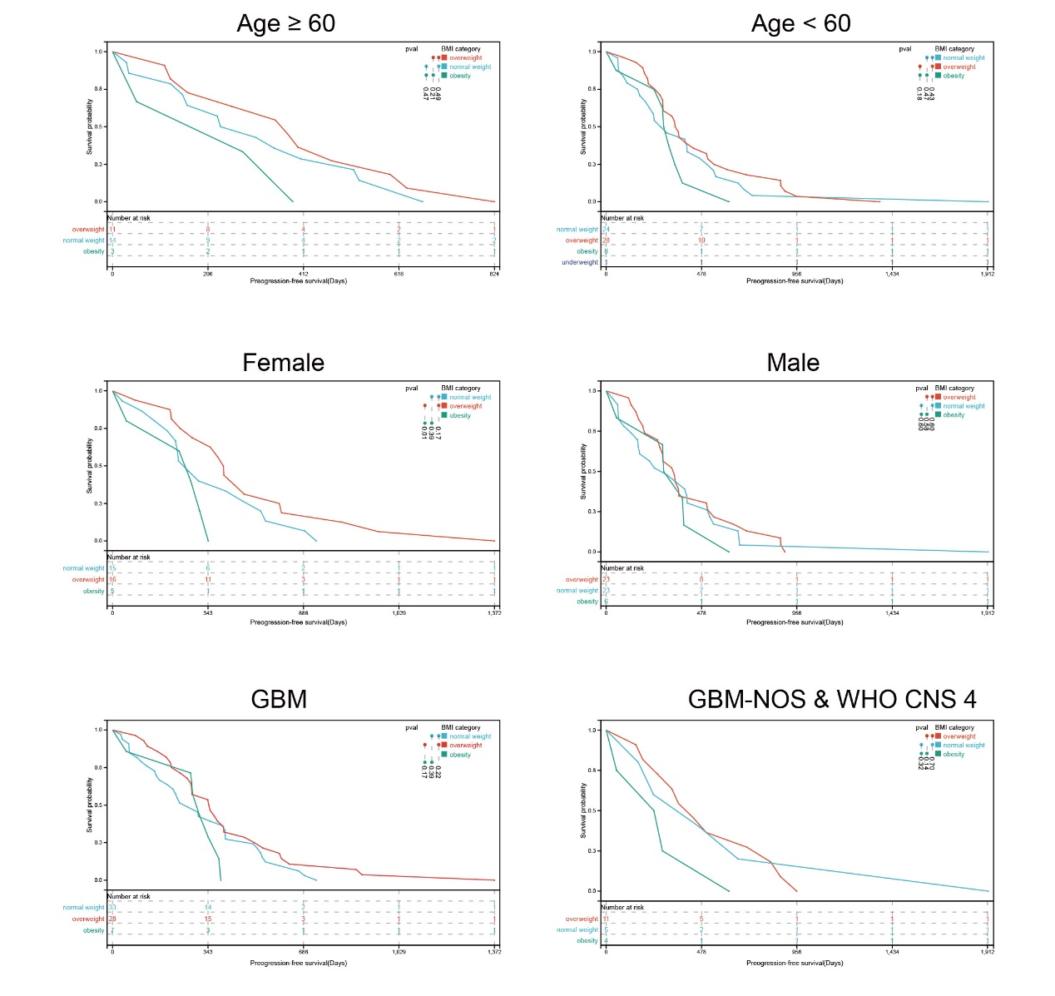
Supplementary Fig5 Kaplan-Meier plots of subgroup analyses. Survival analyses of different subgroup settings (PFS as outcome). Median survival times and significances were shown in the annotations.

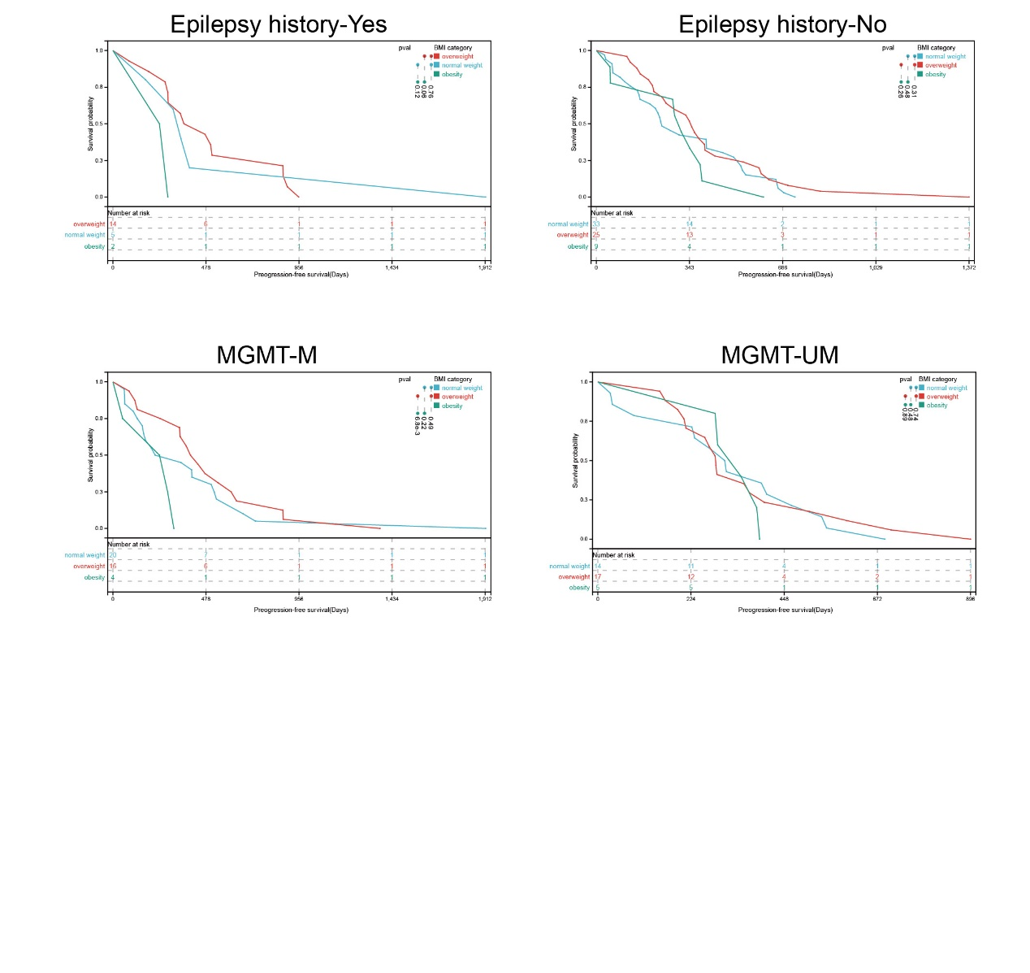
Supplementary Fig6 Kaplan-Meier plots of subgroup analyses. Survival analyses of different subgroup settings (PFS as outcome). Median survival times and significances were shown in the annotations.

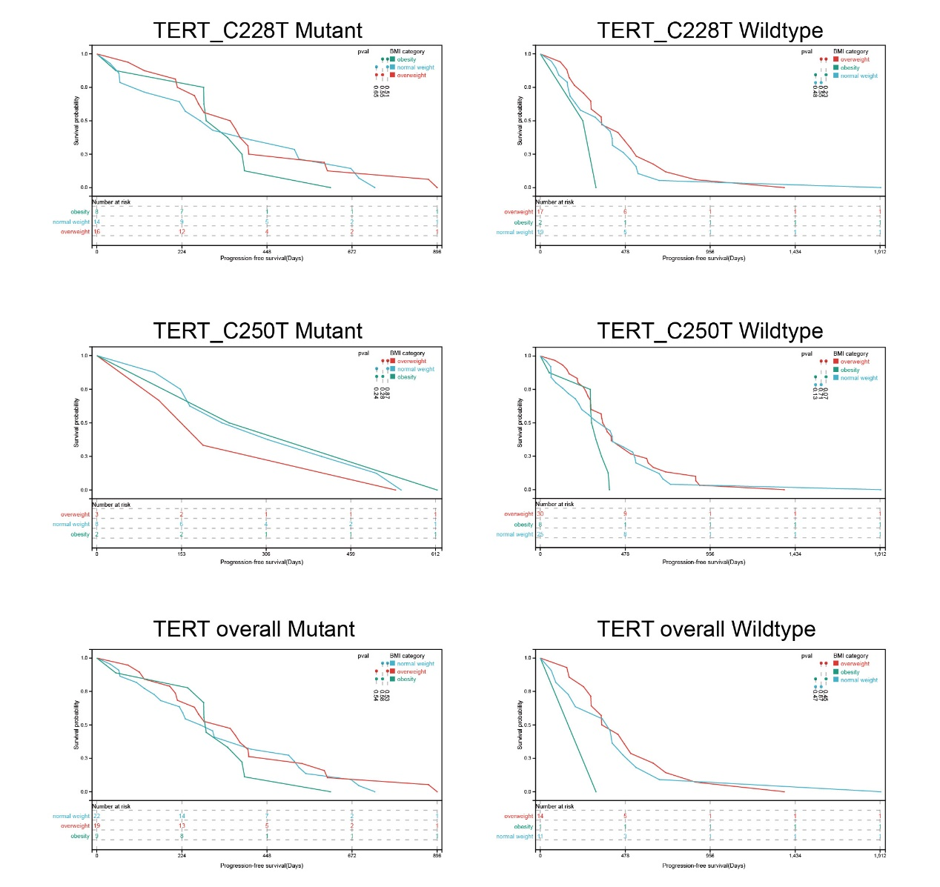
Supplementary Fig7 Kaplan-Meier plots of subgroup analyses. Survival analyses of different subgroup settings (PFS as outcome). Median survival times and significances were shown in the annotations.

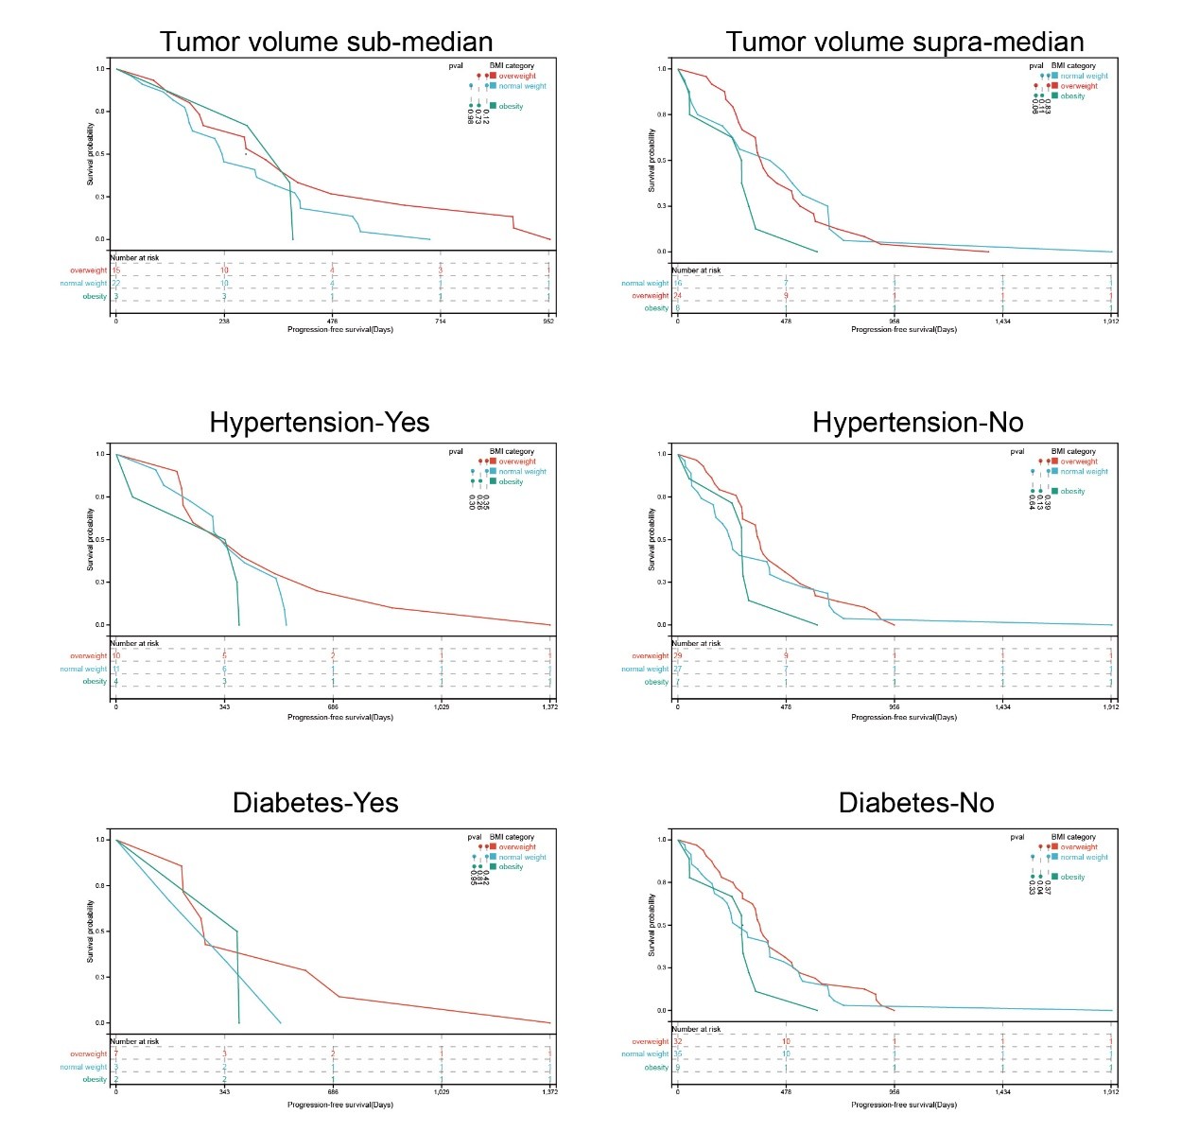
Supplementary Fig8 Kaplan-Meier plots of subgroup analyses. Survival analyses of different subgroup settings (PFS as outcome). Median survival times and significances were shown in the annotations.

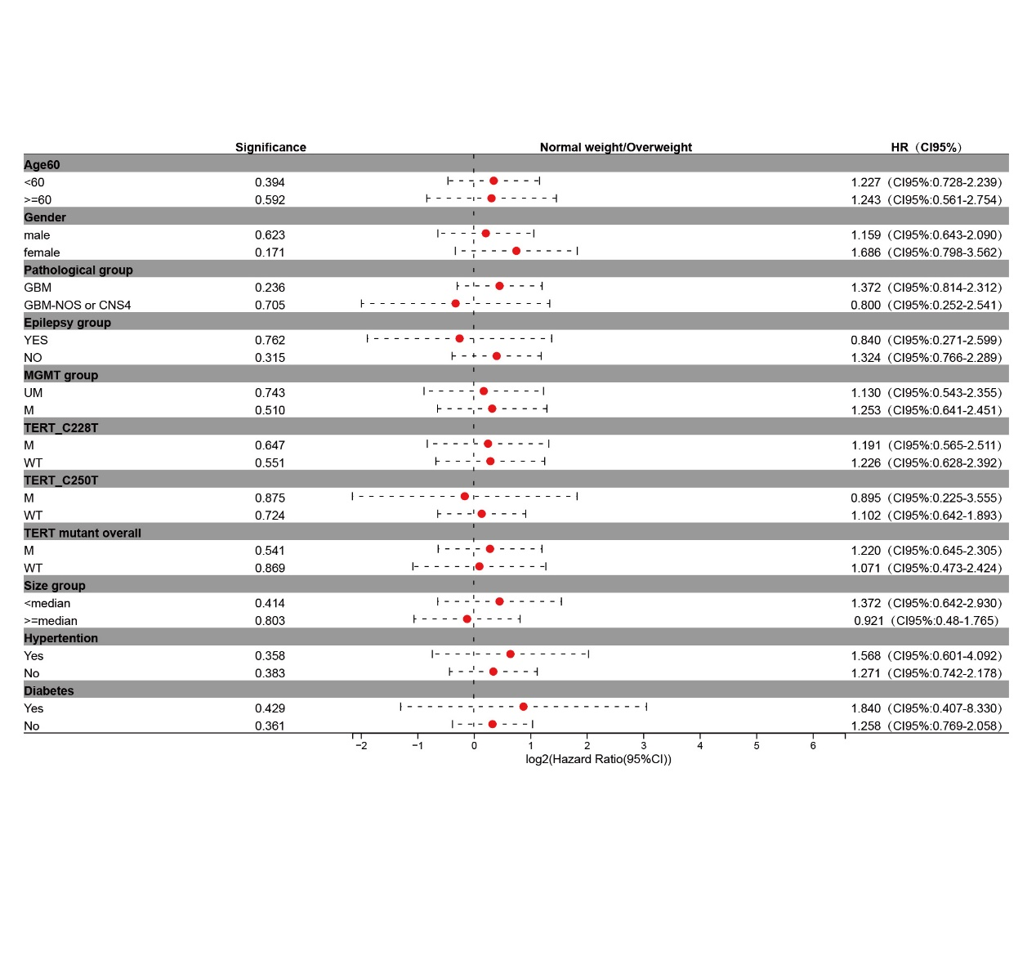
Supplementary Fig9 Forest plot of meta data of hazard ratios for different subgrouping setting. Hazard ratios for comparison of normal weight vs overweight setting.

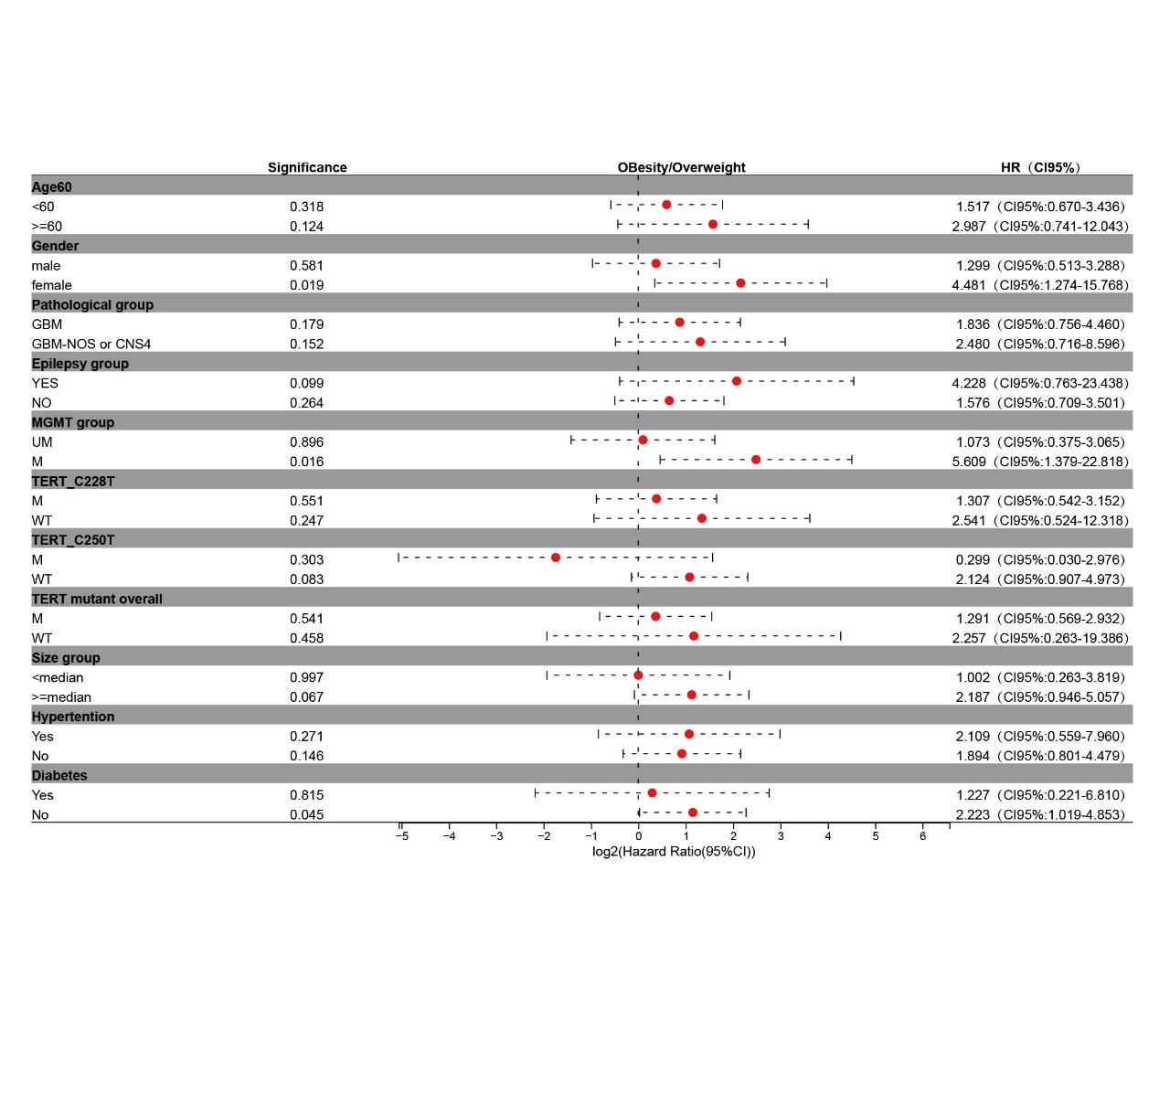
Supplementary Fig10 Forest plot of meta data of hazard ratios for different subgrouping setting. Hazard ratios for comparison of obesity vs overweight setting.

