Supporting Information
for
Research progress, trends, and updates on pollutants removal by Bi₂WO₆-based photocatalysts under visible light irradiation
Jingjie Yang ^{a,b}, Jian Yang ^{b}, Dandi Cai ^{a,c}, Jue Wang^{d}, Jing Duan^{e}, Shuang Zhong ^{a,c *}

ª Key Laboratory of Groundwater Resources and Environment, Ministry of Education, Jilin University, Changchun 130021, P.R. China.
^{b}Key Laboratory of Songliao Aquatic Environment, Ministry of Education, College of Municipal and Environmental Engineering, Jilin Jianzhu University, Changchun 130118, P. R. China
^{c}Jilin University School of New Energy and Environment, Changchun 130021, P.R. China.
^{d} Emergency Management Teaching and Research Department, Jilin Provincial Party School，Changchun 130012, P.R. China.
^{e} Huaneng Songyuan Thermal Power Plant, Songyuan 138000, P.R. China.

Figures: 5

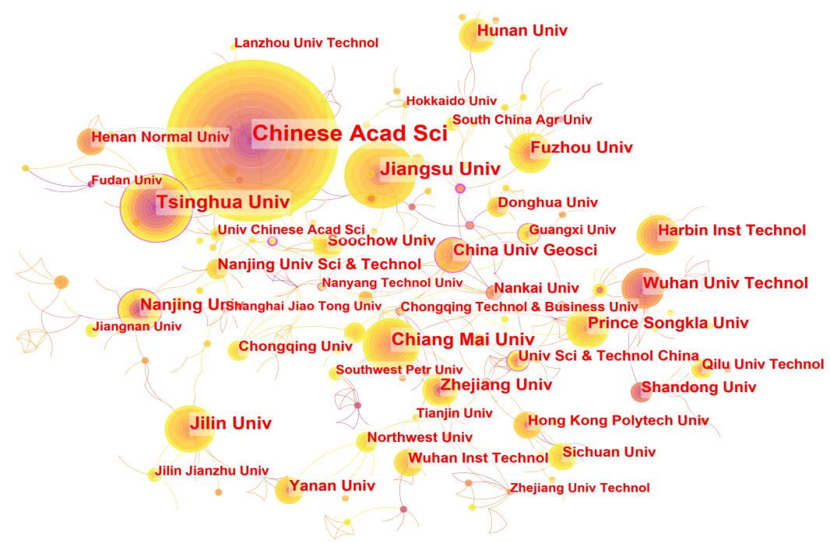
Fig. S1. Combinatorial mapping and clustering of institution.

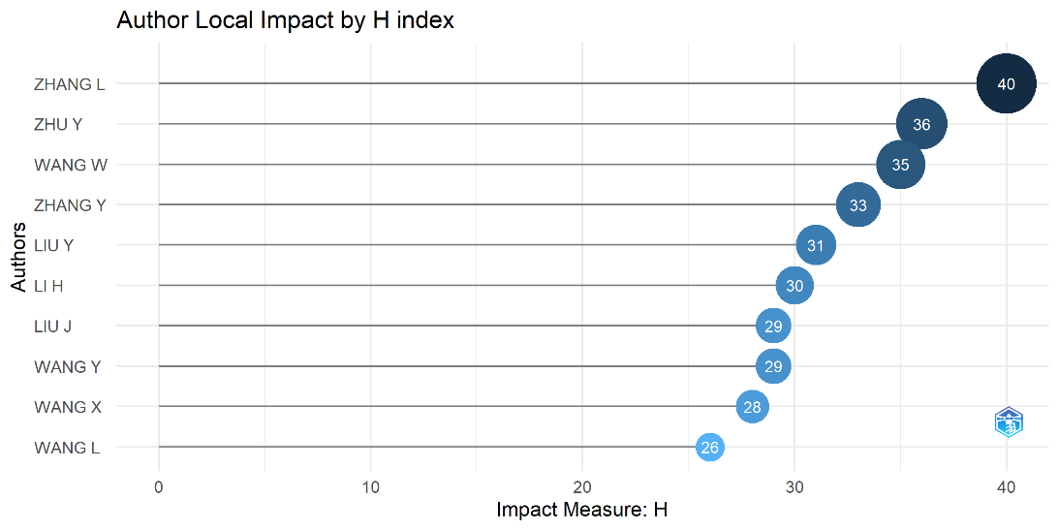
Fig. S2. Influence of the top 10 most cited authors.

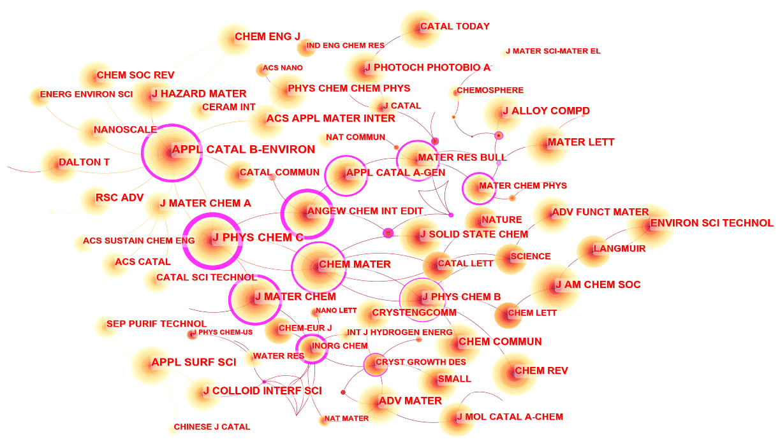
Fig. S3. Combined priming and clustering of journal citations.

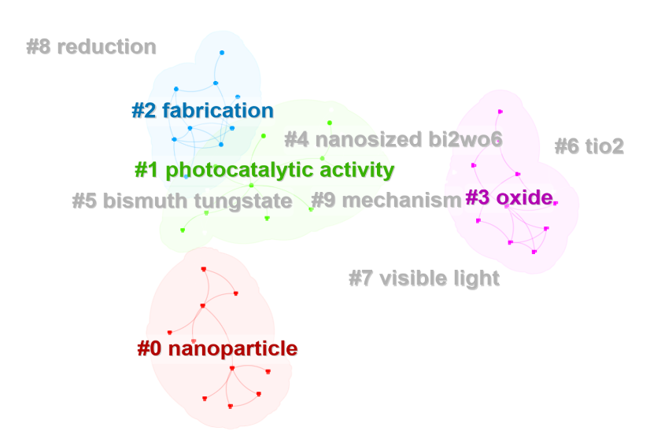
Fig. S4. Keyword clustering analysis.

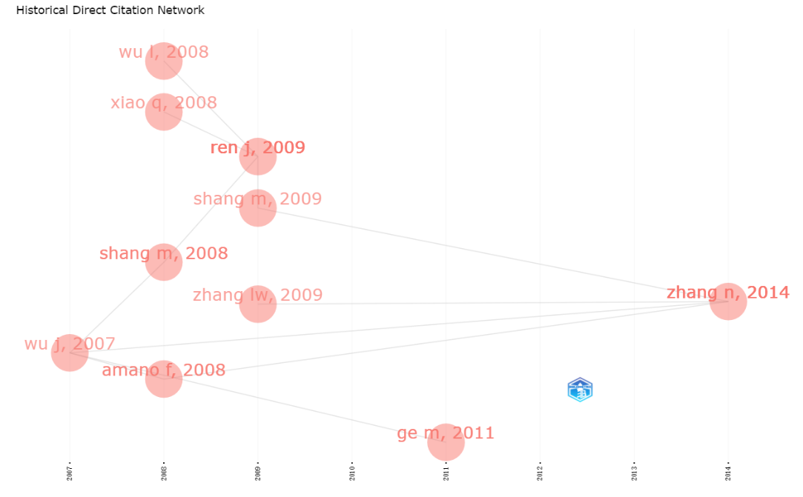
Fig. S5. Historical Direct Citation Network. Each node represents an important article, connection represents a reference relationship between two articles.

