Table 1
Consolidated Temperature Data
Table 2
Monthly Dry Bulb Temperature
 | Monthly Dry Bulb Temperature Chart
Chennai | 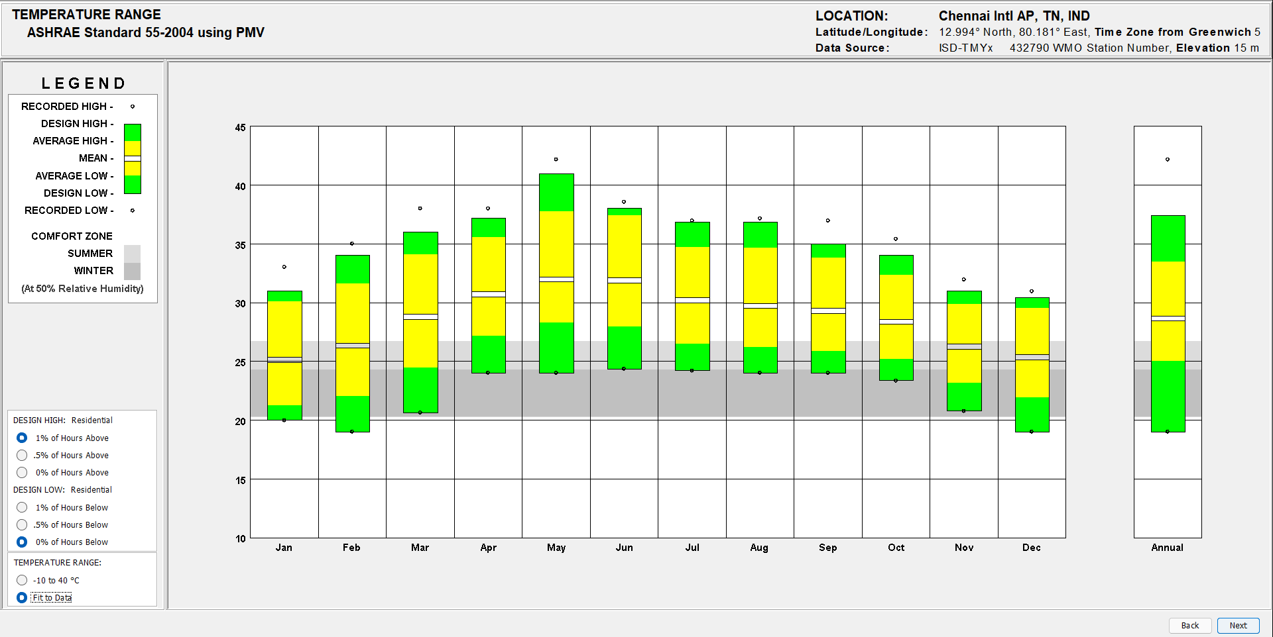
Coimbatore | 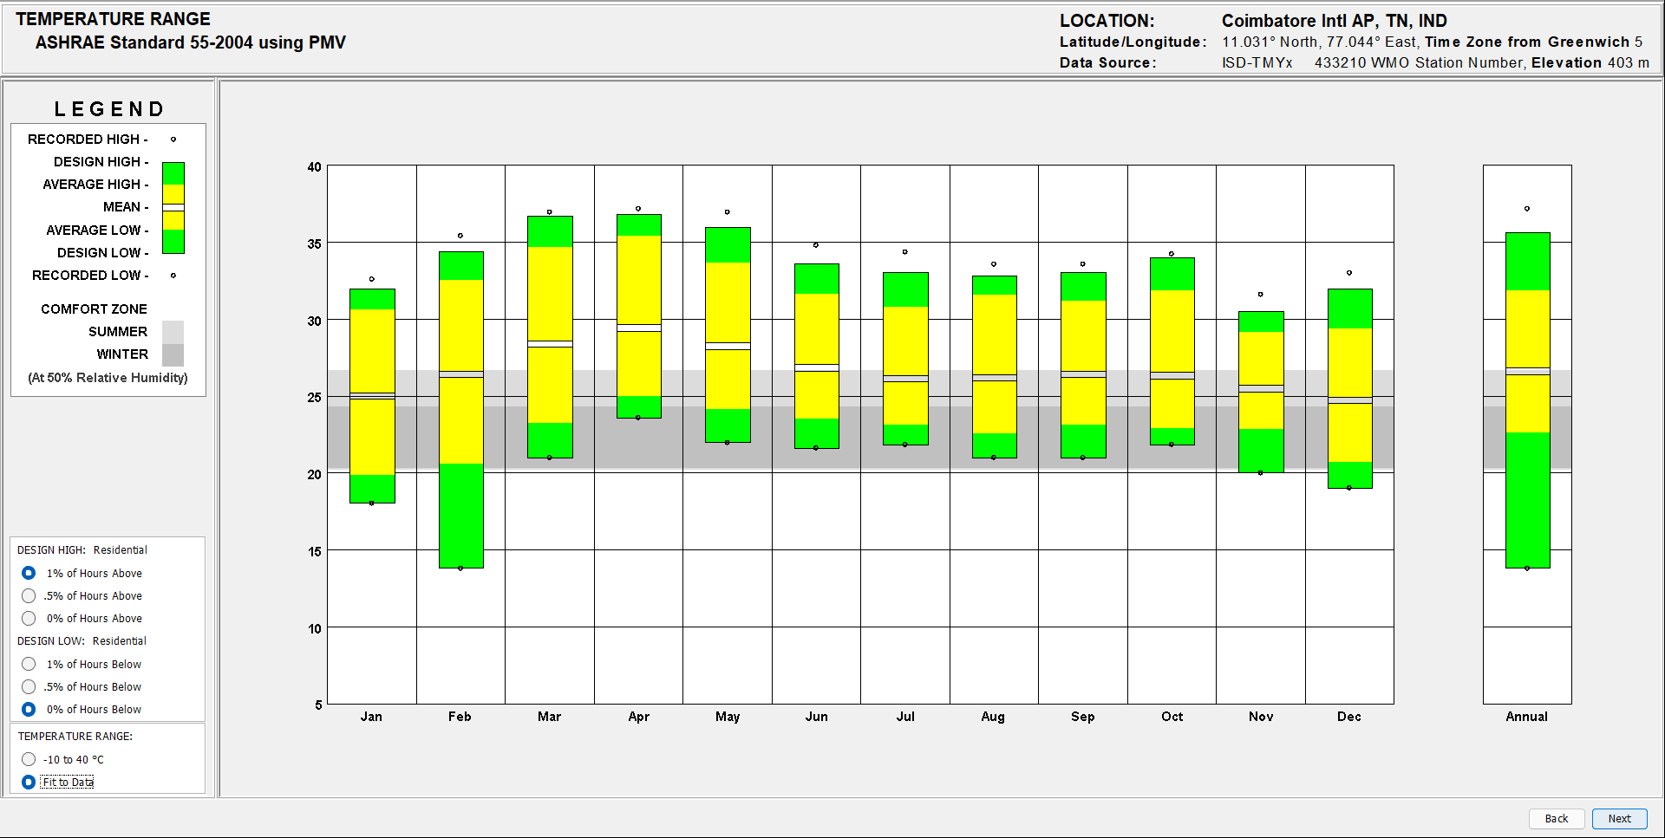
Tiruchirappalli | 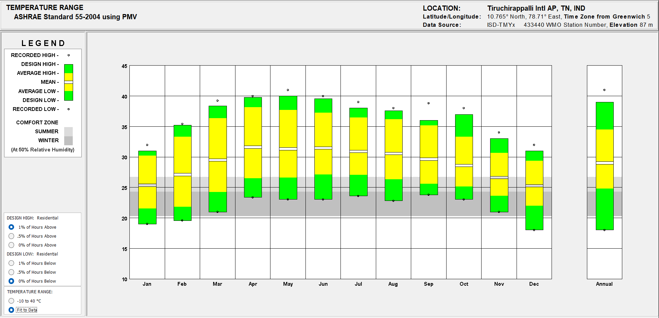
Nagapattinam | 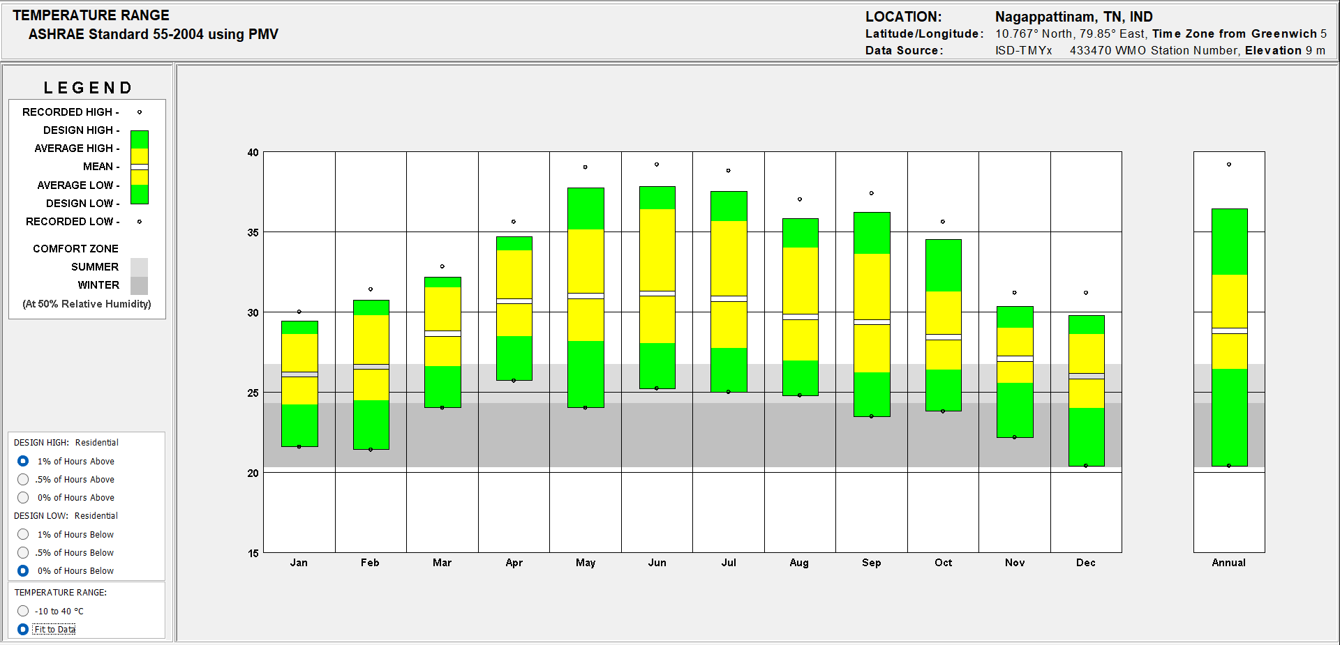
Cuddalore | 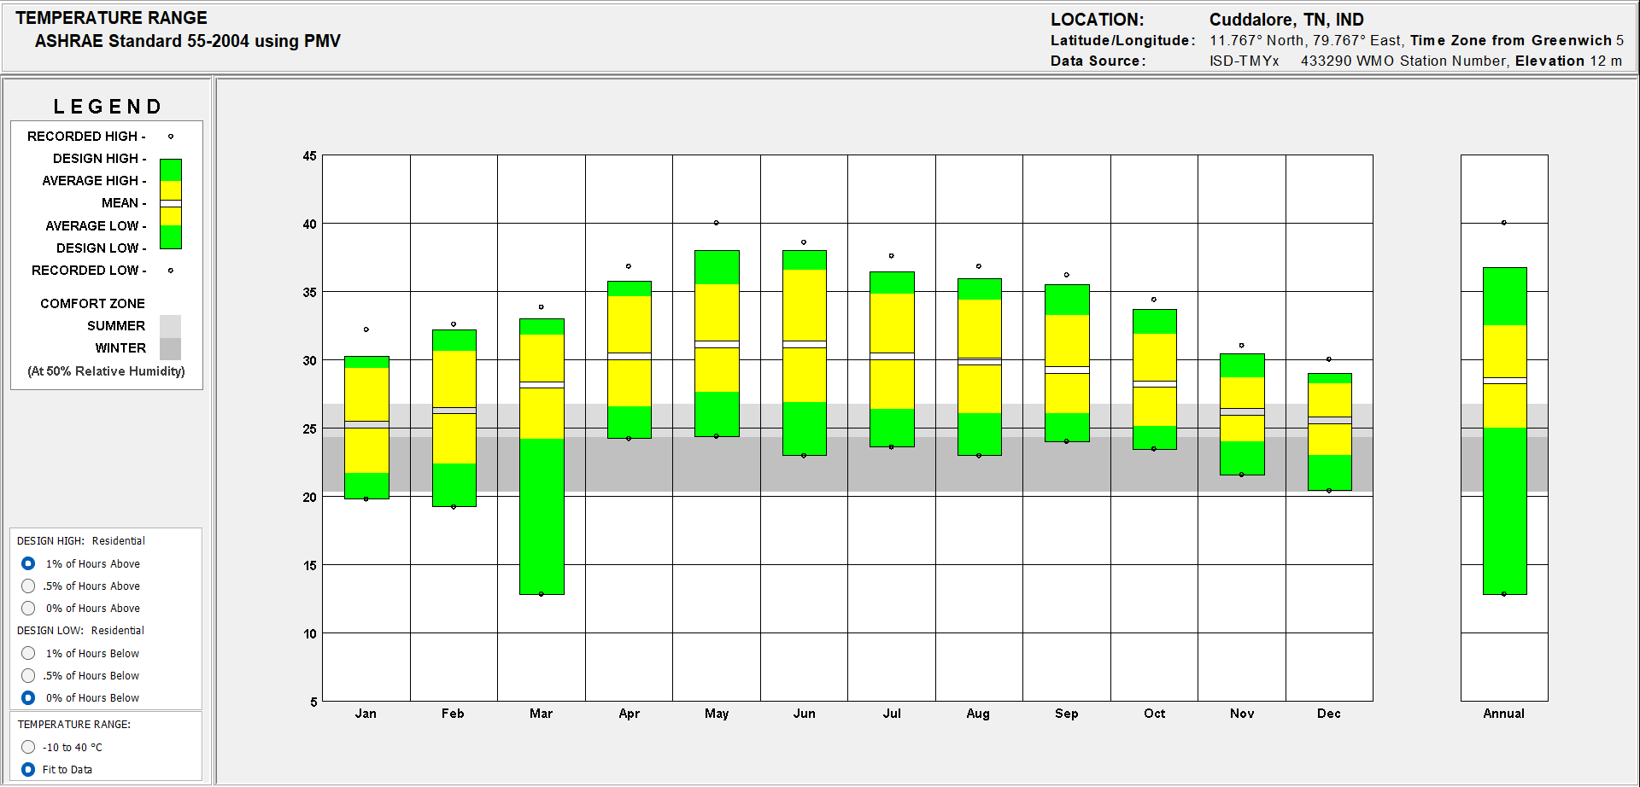

Table 3
Daily Dry Bulb Temperature 3D Plot
 | Daily Dry Bulb Temperature 3D Plot
Chennai | 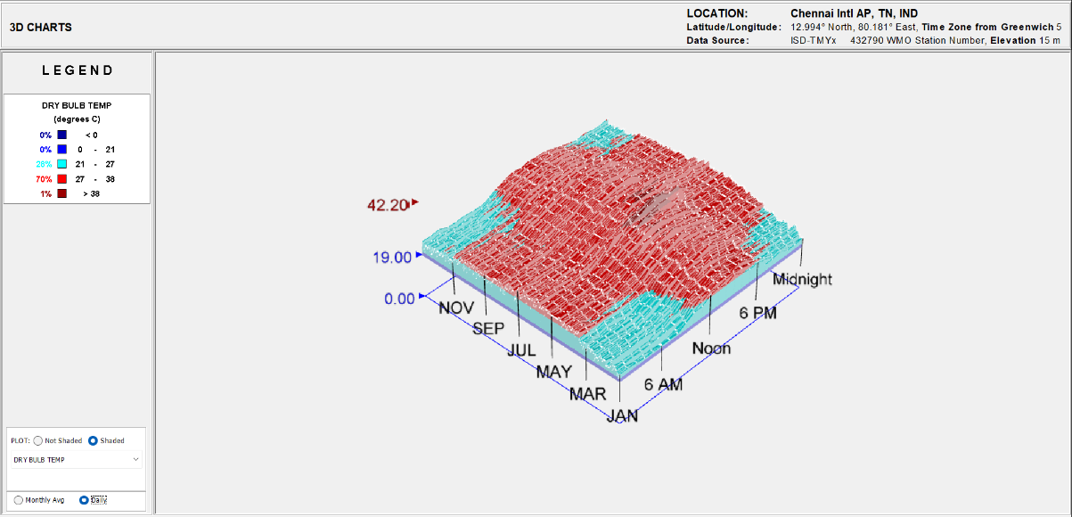
Coimbatore | 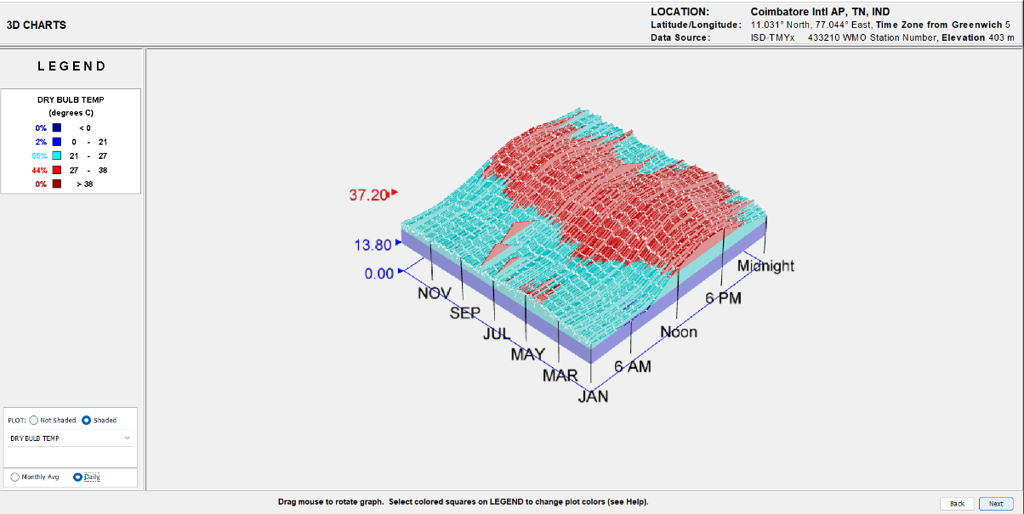
Tiruchirappalli | 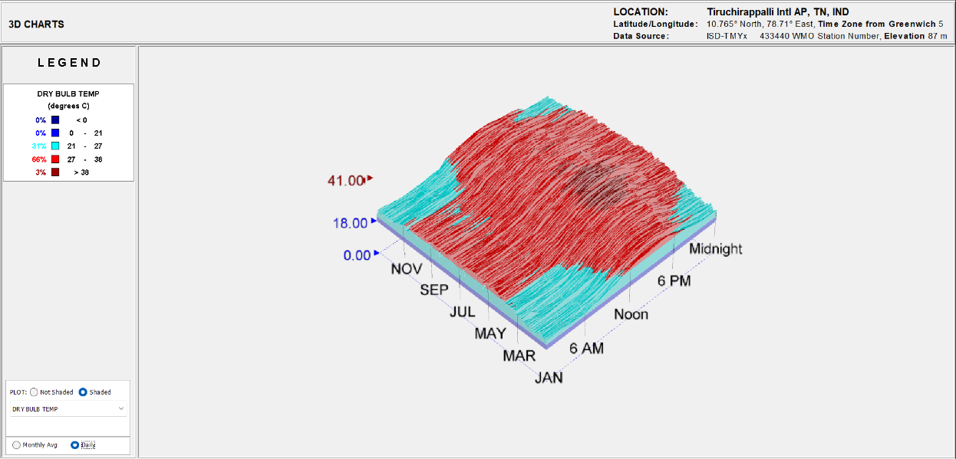
Nagapattinam | 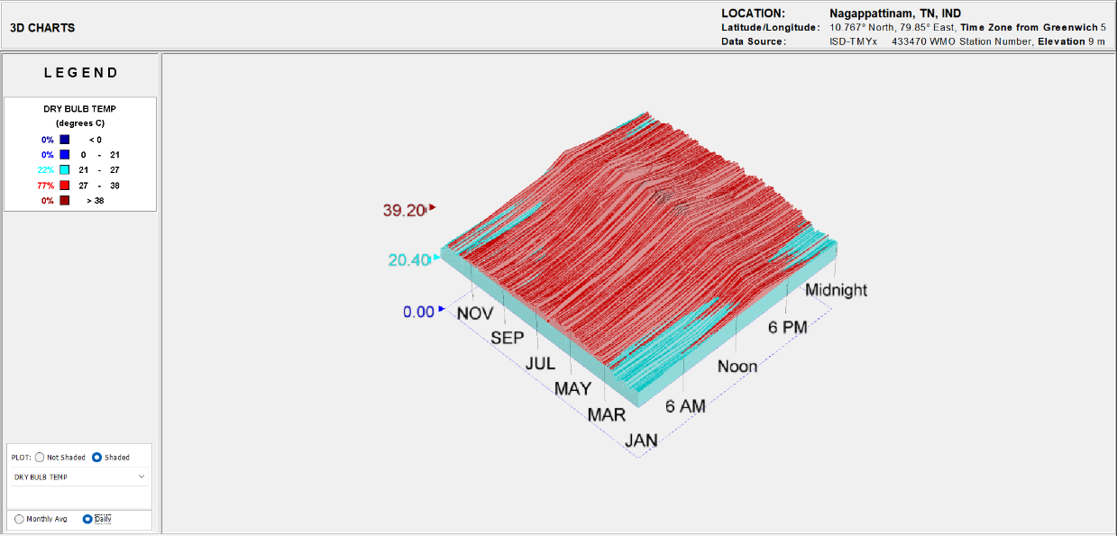
Cuddalore | 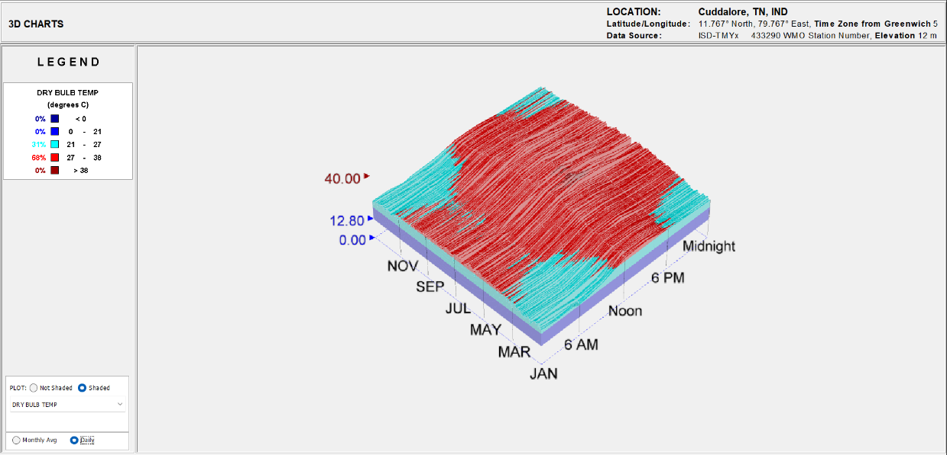

Table 4
The comparative chart on Population Density, Population, Urban Size, and Temperature in June
 | Population Density (Persons/sq.km) | Population (Persons) | Urban Size (sq. Km) | Temperature (Degree Celsius)
Chennai | 26553 | 4646775 | 175 | 37.40667
Coimbatore | 732 | 3457236 | 4723 | 31.640003
Cuddalore | 704 | 2606912 | 3703 | 36.58
Nagapattinam | 629 | 1615901 | 2569 | 36.333336
Tiruchirappalli | 604 | 2723436 | 4509 | 37.273335

