Tables:

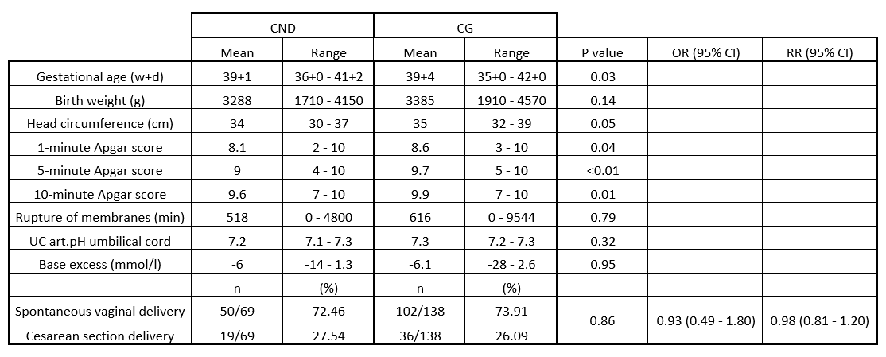
Tab. 1: Demographic data of study collective. CND = Central neurotropic drug, CG = Control group; OR = Odds ratio; RR= Relative risk.

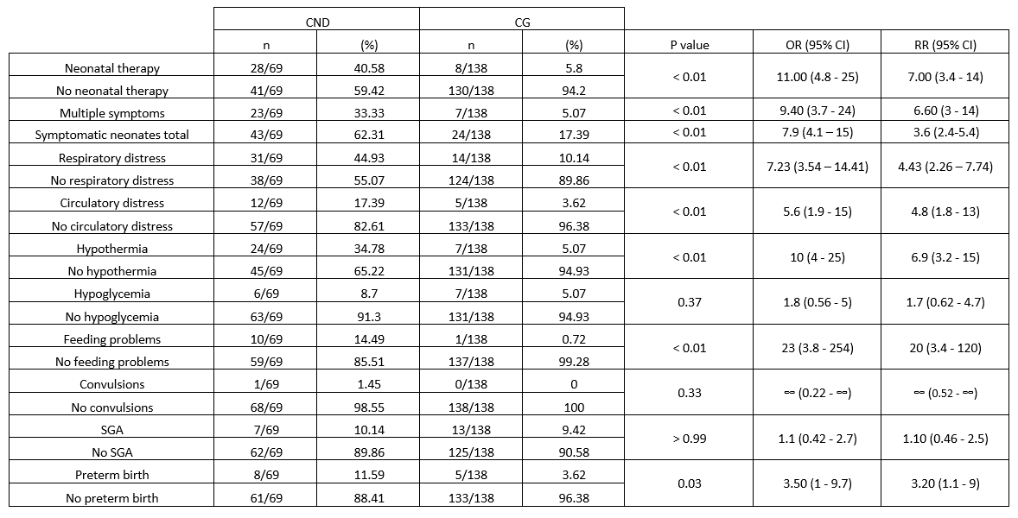
Tab. 2: Need for neonatal therapy and symptoms. CND = Central neurotropic drug, CG = Control group; SGA = Small for gestational age; OR = Odds ratio; RR= Relative risk.

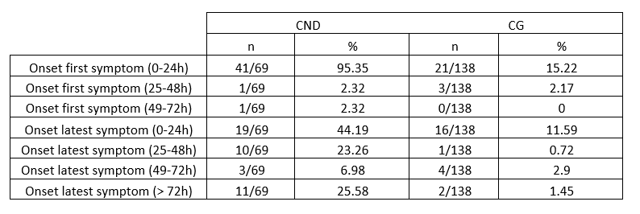
Tab. 3: Description of all neonatal symptoms and onset of first and latest. CND = Central neurotropic drug, CG = Control group.

