Electronic supplementary material for:
Solubility of Na₂O·xAl₂O₃ in NaF-KF-AlF₃-based low-temperature electrolyte
Ye Kuangª, Hengwei Yan^{a,b}＊, Zhanwei Liu^{a,b}＊, Yonghui Yangª

ª Faculty of Metallurgical and Energy Engineering, Kunming University of Science and Technology, Kunming 650093, China;
^{b} National Engineering Laboratory for Vacuum Metallurgy, Kunming University of Science and Technology, Kunming 650093, China.
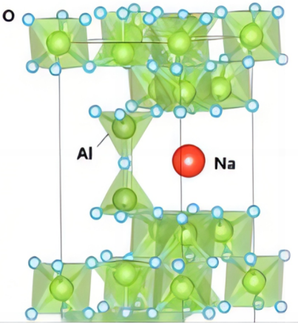
Fig. S-1. Crystal structure of β-Al₂O₃

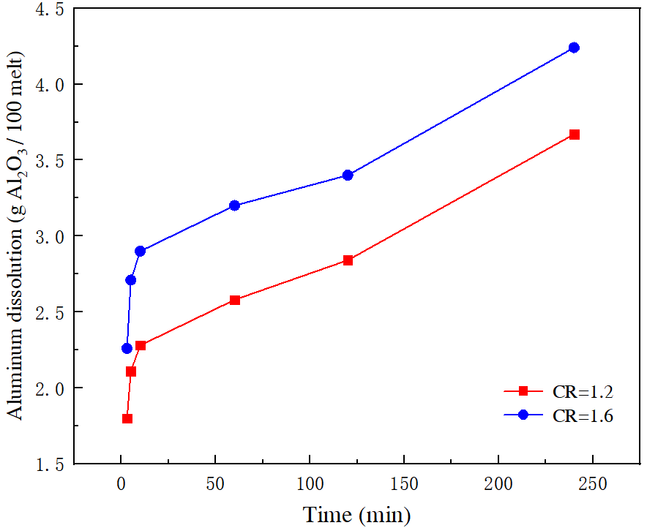
Fig. S-2. Relationship between alumina concentration and dissolution time of Na₂O·70Al₂O₃ in NaF-KF-AlF₃ system

Table S-Ⅰ. Dissolution rate of aluminum oxide with CR is 1.2 and 1.6 in 0-5min
extracting time(min) | CR | 0 | 1 | 3 | 5
Na₂O·70Al₂O₃ dissolution rate  (g Al₂O₃/100g melt) | 1.2 | 0.25 | 0.41 | 0.56 | 1.95
Na₂O·70Al₂O₃ dissolution rate  (g Al₂O₃/100g melt) | 1.6 | 0.41 | 0.73 | 0.95 | 2.67

Table S-Ⅱ. Values of C_{a}-C₀ when the CR is 1.2 and 1.6
extracting time(min) | CR | 2 | 4 | 5
C_{a}-C₀  (g Al₂O₃/100g melt) | 1.2 | -1.43 | -1.58 | -1.87
C_{a}-C₀  (g Al₂O₃/100g melt) | 1.6 | -1.63 | -1.81 | -2.10

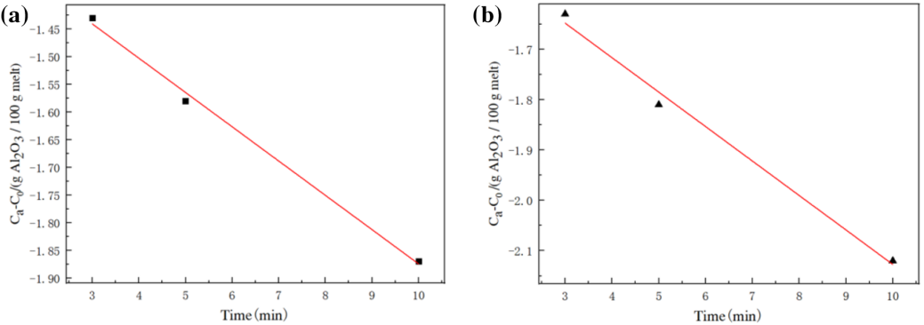
Fig. S-3. Zero order reaction with CR is 1.2 and 1.6
Where (a): CR=1.2, (b): CR=1.6

Table S-Ⅲ. Dissolution rate of Al₂O₃ with CR is 1.2 and 1.6 in 30-120min
extracting time(min) | CR | 30 | 60 | 90 | 120
Al₂O₃ dissolution rate  (g Al₂O₃/100g melt) | 1.2 | 2.94 | 3.24 | 3.35 | 3.57
Al₂O₃ dissolution rate  (g Al₂O₃/100g melt) | 1.6 | 3.52 | 3.61 | 3.78 | 4.12

Table S-Ⅳ. Values of ln(C_{a})-ln(C₀) when the CR is 1.2 and 1.6
Time (min) | CR | 0 | 30 | 60
ln(C_{a})-ln(C₀)  (g Al₂O₃/100g melt) | 1.2 | -0.028 | -0.0597 | -0.079
ln(C_{a})-ln(C₀)  (g Al₂O₃/100g melt) | 1.6 | -0.041 | -0.0815 | -0.12

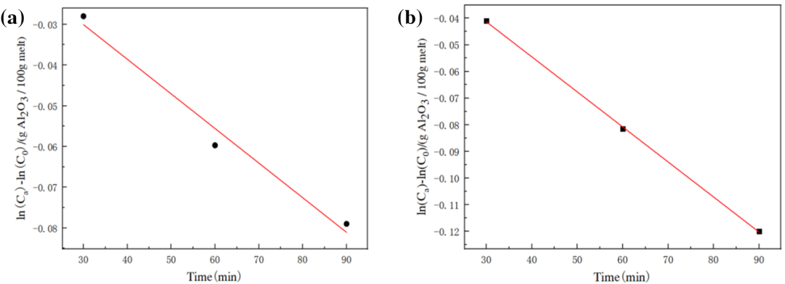
Fig. S-4. First order reaction with CR is 1.2 and 1.6
Where (a): CR=1.2, (b): CR=1.6

