Supporting information for
Drug-Drug Interaction risk of SH-1028, a third-generation EGFR-TKI : In Vitro and Clinical Trials
Xiaoli Li^{a, †}, Yuyan Liu^{b, †}, Yuanyuan Xu^{a, d, †}, Jiaxiang Ding^{a, c}, Ying Wang^{a, d}, Rongfang Shan^{a, d}, Yuanyuan Liuª, Bingyan Liuª, Yuzhou Dingª, Jing Xieª, Huan Zhou^{a, c,d,} *, Zhiqiang Wang^{e,} *, Hongtao Li^{a,} *

ª Clinical Trial Center, The First Affiliated Hospital of Bengbu Medical College, Bengbu 233009, China
^{b} Center of Drug Metabolism and Pharmacokinetics, China Pharmaceutical University, Nanjing 210009, China
^{c} School of Public Foundation, Bengbu Medical College, Bengbu 233030, China
^{d} School of Pharmacy, Bengbu Medical College, Bengbu 233030, China
^{e} School of Pharmaceutical Sciences, China Pharmaceutical University, Nanjing 210009, China
* Co-corresponding authors: Huan Zhou, Zhiqiang Wang and Hongtao Li
† These authors made equal contributions to this work.

Table S1. Materials for in vitro studies
Study | Material | Supplier
Metabolism Studies | human recombinant enzymes (CYP 1A2, 2B6, 2C8, 2C9, 2C19, 2D6 and 3A4) | Cypex, UK
Metabolism Studies | NADPH, K₂HPO₄, MeOH, ACN | Sigma, USA
Metabolism Studies | Buspirone HCl | Meilune, China
Inhibitory Potential of SH-1028 for CYPs | Pooled human liver microsomes | Bioreclamation IVT, USA
Inhibitory Potential of SH-1028 for CYPs | Phenacetin, Amodiaquine, Diclofenac, S-Mephenytoin, Dextromethorphan, α-Naphthoflavone, Quercetin, Sulfaphenazolum, Ticlopidine, Quinidine, Ketoconazole | Sigma, USA
Inhibitory Potential of SH-1028 for CYPs | Bupropion, Testosterone, Thiotepa | Sohon, China
Inhibitory Potential of SH-1028 for CYPs | Midazolam | National Institutes for Food and Drug Control, China
Inhibitory Potential of SH-1028 for CYPs | NADPH | Roche, Switzerland
Induction Potential of SH-1028 for CYPs | Primary-cultured human hepatocytes  Donor 1 lot no. HNN (male), Donor 2 lot  no. RMH (male), Donor 3 lot no. DJJ (male) | Bioreclamation IVT, USA
Induction Potential of SH-1028 for CYPs | Omeprazole, Rifampicin, Phenacetin, Bupropion, | Sigma, USA
Induction Potential of SH-1028 for CYPs | Phenobarbital | National Institutes for Food and Drug Control, China
Induction Potential of SH-1028 for CYPs | Testosterone | Sohon, China

Table S2. Demographics and baseline characteristics of participants in the clinical trial.
Characteristic | Group A  (N=20) | Group B  (N=20)
Male, n (%) | 20 ( 100%) | 20 ( 100%)
Age (years) | 27.6 (20-39) | 27.4 (19-42)
Weight (kg) | 68.3 (53.1-79.1) | 65.1 (55.4-75.1)
Height (cm) | 173 (159-184) | 170 (163-181)
BMI (kg/m²) | 22.8 (19.6-25.8) | 22.4 (19.2-26.0)
Values presented for the population as mean (range) unless stated otherwise. BMI: body mass index.
Table S3. Summary of possibly medicine-related adverse events (as assessed by the investigator).

Adverse events | Group A (N=20) |  |  | Group B (N=20)
Adverse events | SH-1028 | Itraconazloe | SH-1028+Itraconazloe | SH-1028 | Rifampicin | SH-1028+Rifampicin
Adverse events | n (%) | n (%) | n (%) | n (%) | n (%) | n (%)
Increased total bile acid | 5 (25.0%) | 2 (10.0%) | 1 (5.0%) | 3 (15.0%) | 1 (5.0%) | 0
Increased serum creatinine | 0 | 0 | 4 (20.0%) | 0 | 1 (5.0%) | 0
Decreased serum potassium | 0 | 1 (5.0%) | 0 | 1 (5.0%) | 1 (5.0%) | 1 (5.0%)
Increased C-reactive protein | 0 | 0 | 1 (5.0%) | 0 | 0 | 0
Increased lymphocyte count | 1 (5.0%) | 0 | 0 | 0 | 0 | 0
Decreased white blood cell count | 0 | 0 | 0 | 0 | 0 | 1 (5.0%)
Increased serum triglycerides | 0 | 0 | 1 (5.0%) | 0 | 0 | 0
Increased alanine aminotransferase | 0 | 0 | 0 | 1 (5.0%) | 0 | 0
Urine erythrocyte | 0 | 0 | 0 | 0 | 1 (5.0%) | 0
Decreased neutrophil count | 0 | 0 | 0 | 0 | 0 | 1 (5.0%)
Erythra | 1 (5.0%) | 0 | 0 | 0 | 0 | 0
Canker sore | 0 | 0 | 1 (5.0%) | 0 | 0 | 0
Diarrhea | 0 | 0 | 0 | 0 | 0 | 1 (5.0%)
Emesis | 0 | 0 | 0 | 0 | 0 | 1 (5.0%)
Total | 6 *(30.0%) | 3 (15.0%) | 8 (40.0%) | 4* (20.0%) | 4 (20.0%) | 4 (20.0%)
* One subject had two adverse events

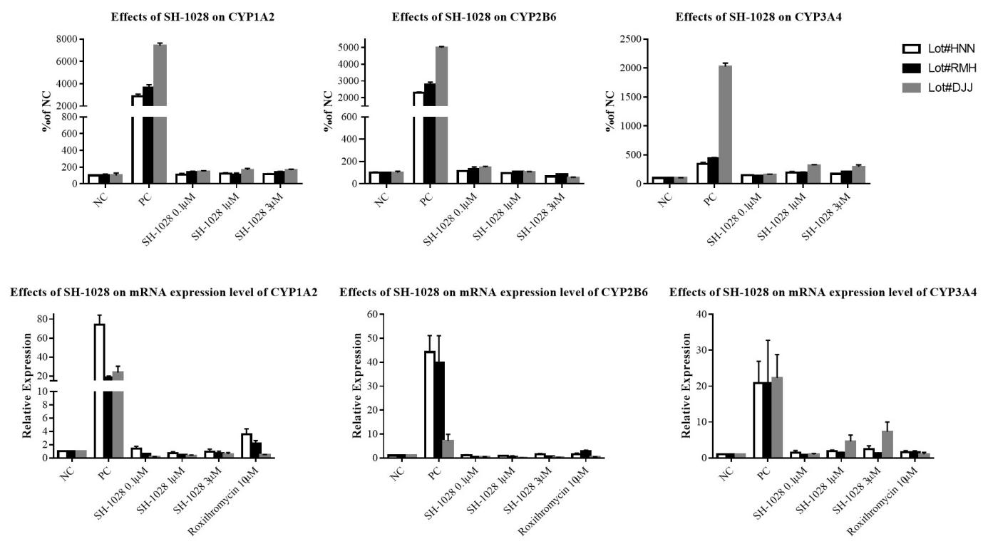
Figure S1. Effects of SH-1028 on activity and mRNA expression of CYP1A2, 2B6 and 3A4 in three batches of human primary hepatocytes (Donors lot no.HNN, RMH and DJJ).

Supplementary Methods: Bioanalytical Methods Used in the Clinical Trials
The validation of bioanalytical methods and analysis of study samples were conducted in accordance with the internal standard operating procedures of the clinical study organization, the relevant guidelines of the NMPA, and the GLP and GCP principles of the FDA and OECD.
To determine the concentrations of the SH-1028, the K₂EDTA plasma samples were separated on Shim-pack GIST-HP, C18-AQ, 3 μm, (2.1 × 50 mm, Shimadzu). Triple Quad 5500 mass spectrometer was used for detection. Imp7 and Imp9 were used as internal standards for quantitative analysis. The linear range of SH-1028 was 0.200-100 ng /mL, compared to0.400-200 ng /mL for Imp2, and 0.200-100 ng /mL for Imp3. All samples were stored at –80°C. Stability data indicated that the analytes were stable during the storage period.

