s-Figure 1. Flow Chart Detailing Infant Gastroschisis Causality Study Cohort

Live births from April 1, 2004 to March 31, 2020
N = 4 435 732 (1419)ª

Excluded:
12 601 Missing or unknown or <22 or >42 weeks of gestation, birthweight or birth month or mother-newborn linkage number

Eligible mother-liveborn dyads
4 423 131

Excluded:
3832 Maternal age <13 or >44 years at conception
9583 non-Canadian or unknown residence (4)ª

Mother-liveborn dyads
N = 4 409 716 (1415)ª

Conception in non-exposure season
Total (%) Case (%)
Jul - Aug 719 861 (16.3) 159 (11.3)
Conception in exposure season
Total (%) Case (%)
Jan-Feb 765 147 (17.4) 258 (18.2)
Mar-April 700 015 (15.9) 211 (14.9)
May-June 691 528 (15.7) 250 (17.7)
Sep-Oct 750 468 (17.0) 258 (18.2)
Nov-Dec 782 697 (17.7) 279 (19.7)

Data source: Canadian Information for Health Institute Birth Database

ª Denotes number of gastroschisis case in bracket.

s-Figure 2. Directed Acyclic Graph

The directed acyclic graph (DAG) above represents associations between covariates (including measured and unmeasured/proxies) and primary exposure (periconception depressive disorder) and outcome (infant gastroschisis). This graph is also used to guide the data analysis.

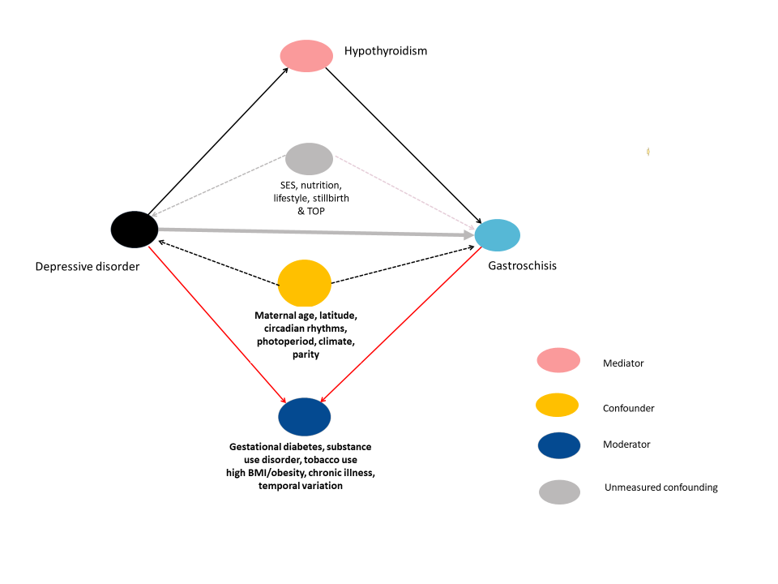

s-Table 1

The Canadian Version of the 10th Revision of the International Classification of Disease
(ICD-10 CA) Codes

Definition | ICD-10 CA codes
Newborn outcome
Gastroschisis | Q79.3
Omphalocele | Q79.2
Down syndrome | Q90
Chromosomal anomalies | Q91-Q92, Q96-Q99
Maternal characteristic/covariate
Gestational diabetes mellitus | O24.0-O24.4, O24.7-O24.9
Problematic tobacco use | F17, T51.2, Z50.8, Z71.6, Z72.0
Substance use disorder
Problematic use of alcohol | F10, K70,Y15, X45, X65, K29.2, K86.0, K86.9, T51.0, T51.8, T51.9, R78.0,O35.4, Z50.2, Z50.8, Z71.4, Z72.1, Z86.40
Opiate or opioids | F11, R78.1, P96.1
Cannabinoids | F12, T40.7
Cocaine | F14, R82.5, R78.2, T40.5
Other specified substances | F13, F15, F16, F18, F19
Miscellaneous | O35.5, R78.3, R78.4, R78.5, X42, X62, Y12-Y14, Z50.3, Z71.5, Z72.2, Z86.4
Subclinical iodine-deficiency | E02, E03
hypothyroidism /other hypothyroidism
Depressive episode/recurrent depressive | F32, F33
disorder
Obesity | E66
Chronic illness/condition
Pregestational diabetes mellitus type 1 | E10
Pregestational diabetes mellitus type 2 | E11
Hyperthyroidism | E05, E06
Bipolar disorder, anxiety, and other specific mental disorders | F20, F22, F23, F25, F28-F31, F34, F40, F41
Epilepsy | G40
Lupus | L93.0-L93.2, M013, M32
Migraine | G43

s-Table 2. Secondary analysis: Mediation Analysis Explaining the Lower Infant Gastroschisis Rate in Summer than Winter

Mediation model/ Exposure | Mediator | Effect category | Multivariate mediation analysis
Mediation model/ Exposure | Mediator | Effect category | Mean Ratio & 95% CI | P value
Winter versus Summer | Gestational diabetes | Total effect | 1.545 (1.290 – 1.799) | <0.001
 |  | Direct effect | 1.548 (1.292 – 1.804) | <0.001
 |  | Indirect effect | 0.9990 (0.9984 – 0.9997) | <0.001
 |  | Excess indirect effect | -0.0015 (-0.0026 to -0.0004) | <0.01
 | Latitude | Total effect | 1.545 (1.290 - 1.800) | <0.001
 |  | Direct effect | 1.546 (1.291 - 1.801) | <0.001
 |  | Indirect effect | 0.9994 (0.9990 - 0.9997) | <0.001
 |  | Excess indirect effect | -0.0009 (-0.0015 to -0.0004) | 0.001
 | Depressive disorder | Total effect | 1.546 (1.291 - 1.802) | <0.001
 |  | Direct Effect | 1.250 (1.003 to 1.496) | <0.001
 |  | Indirect effect | 0.9997 (0.9995 to 1.0000) | <0.001
 |  | Excess indirect effect | -3.3×10⁻⁴ (-6.4×10⁻⁴ to -0.3×10⁻⁴) | <0.05

Note:
- As required by mediation analysis modeling, “treatment” and “mediator” must be numerical, thus, winter seasons (January to June and September to December) =1, summer season (i.e., July and August) =0, and specific mediators (presence =1, no presence =0), and latitudes: far North =1, North = 0.5, North-to-South = 0.2, South = 0.
- In each model, while a factor is used a mediator, all other factors (listed in Table 1) were included in the covariate list.

s-Table 3. Seasonal Variations in Gestational Diabetes between Periconception
Exposures to Winter and Summer

Exposure  /conception month | Rate  (%) | Crude rate ratio  & 95% CI | P value | Adjusted rate ratio & 95% CI ª | P value
2-season comparison
Winter | 6.51 | 1.021 (1.011 to 1.031) | <0.0001 | 1.019 (1.009 – 1.029) | 0.0002
Summer | 6.37 | 1.000 (reference) |  | 1.000 (reference)
2-month comparison
January to February | 6.67 | 1.046 (1.033 to 1.059) | <0.0001 | 1.045 (1.032 - 1.059) | <0.0001
March to April | 6.81 | 1.069 (1.055 to 1.083) | <0.0001 | 1.063 (1.050 – 1.077) | <0.0001
May to June | 6.64 | 1.041 (1.028 to 1.055) | <0.0001 | 1.035 (1.022 – 1.049) | <0.0001
July to August | 6.37 | 1.000 (reference) |  | 1.000 (reference)
September to October | 6.09 | 0.956 (0.943 – 0.968) | <0.0001 | 0.958 (0.946 - 0.971) | <0.0001
November to December | 6.36 | 0.998 (0.986 - 1.011) | 0.76 | 0.998 (0.986 – 1.011) | 0.80

ª Poisson regression adjusting for all covariates in Table 1

s-Figure 3. Gestational Diabetes Rate (per 100 livebirths) according to Conception Month in Canada, 2004 – 2020

s-Figure 4. Prevalence of Specific Chromosomal Anomalies
with 95% CI by Conception Month in Canada (excluding province of Quebec), 2004-2020

x-axis: conception month. y-axis: prevalence of selected chromosomal anomalies (per 10 000 live births) with 95% confidence interval

Note: Down syndrome cases are not included as some cases may be associated with gestational diabetes.
s-Table 4. No seasonal variation in infant prevalence of omphalocele and selected chromosomal anomalies among mother-infant dyads, Canada, 2004 through 2020

Month of Conception | Number of mother (%) | Omphalocele |  | Chromosomal anomalies
Month of Conception | Number of mother (%) | Number (%) | 95% Confidence interval | Number (%) | 95% Confidence interval
Exposure
Jan – Feb | 765 147 (17.4) | 115 (18.3) | 1.11 (0.85 – 1.46) | 324 (17.8) | 1.07 (0.92 – 1.26)
Mar – Apr | 700 015 (15.9) | 93 (14.8) | 0.99 (0.74 – 1.31) | 293 (16.1) | 1.06 (0.90 – 1.25)
May – Jun | 691 528 (15.7) | 120 (19.1) | 1.26 (0.97 – 1.65) | 306 (16.7) | 1.12 (0.95 – 1.32)
Sep - Oct | 750 468 (17.0) | 102 (16.2) | 1.00 (0.76 – 1.32) | 308 (17.3) | 1.04 (0.89 – 1.22)
Nov – Dec | 782 697 (17.7) | 101 (16.1) | 0.96 (0.73 – 1.26) | 300 (16.5) | 0.97 (0.83 - 1.14)
Non-Exposure
Jul - Aug | 719 861 (16.3) | 98 (15.6) | 1.00 | 284 (15.6) | 1.00
Total | 4 409 716 (100.0) | 629 (100.0) |  | 1815 (100.0)
ª Down’s syndrome cases are not included.

s-Table 5. Mediation analysis showing no relation between maternal hypothyroidism and offspring omphalocele or selected chromosomal anomaliesª

Multivariate mediation analysis | Omphalocele |  | Chromosomal anomalies ª
Multivariate mediation analysis | Adjusted mean ratio & 95% Confidence interval |  | Adjusted mean ratio & 95% Confidence interval
Natural Direct effect | 1.059 (0.831 to 1.288) | <0.0001 | 1.049 (0.917 to 1.183) | <0.0001
Natural Indirect effect | 1.000 (1.000 to 1.000) | <0.0001 | 1.000 (1.000 to 1.000) | <0.0001
Total effect | 1.059 (0.831 to 1.288) | <0.0001 | 1.050 (0.916 to 1.182) | <0.0001
Excess total effect | 0.060 (-0.170 to 0.290) | 0.61 | 0.050 (-0.083 to 0.183) | 0.46
Excess direct effect | 0.59 (-0.17 to 0.29) | 0.61 | 0.050 (-0.083 to 0.183) | 0.46
Excess indirect effect | 1.2 x10-6 (-0.3 x 10-4 to 0.3 x 10-4) | 0.94 | -5.1x10-7 (-0.1 x 10-4 to 0.1 x 10-4) | 0.94

ª Down’s syndrome cases are not included.

s-Table 6. Mediation analysis showing no relation between gestational diabetes and offspring omphalocele or selected chromosomal anomalies ª

Multivariate mediation analysis | Omphalocele |  | Chromosomal anomalies ª
Multivariate mediation analysis | Adjusted mean ratio & 95% Confidence interval |  | Adjusted mean ratio & 95% Confidence interval
Natural Direct effect | 1.055 (0.828 to 1.283) | <0.0001 | 1.049 (0.916 to 1.182) | <0.0001
Natural Indirect effect | 1.0004 (0.9998 to 1.0001) | <0.0001 | 1.0002 (0.9999 to 1.0006) | <0.0001
Total effect | 1.056 (0.828 to 1.283) | <0.0001 | 1.049 (0.916 to 1.182) | <0.0001
Excess direct effect | 0.055 (-0.172 to 0.283) | 0.63 | 0.049 (-0.0837 to 0.1822) | 0.47
Excess indirect effect | 0.0041 (-0.00023 to 0.0011) | 0.21 | 0.00024 (-0.0001 to 0.0006) | 0.20
Excess total effect | 0.056 (-0.174 to 0.279) | 0.65 | 0.0485 (-0.0845 to 0.1815) | 0.48

ª Down’s syndrome cases are not included.

