Supplementary Information for the paper: «Influence of the filter grain morphology on separation efficiency in dielectrophoretic filtration»
Mariia Kepper¹, Md Nurul Karim², Michael Baune¹, Jorg Thöming^{1,3}, Georg R. Pesch^{1,4}
¹ University of Bremen, Faculty of Production Engineering, Chemical Process Engineering (CVT), P.O. box 330 440, 28334 Bremen, Germany
² University of Bremen, Faculty of Production Engineering, Advanced Ceramics, P.O. box 330 440, 28334 Bremen, Germany
³ MAPEX Center for Materials and Processes, University of Bremen, Bremen, Germany
⁴ University College Dublin, School of Chemical and Bioprocess Engineering, Belfield, Dublin, Ireland
- Particle size distribution
Mesh |  | d10, µm | d50, µm | d90, µm | D [3, 2], µm | D [4, 3], µm | SPAN value
150 | Sand,  COV | 164.7 | 228.1 | 315.2 | 220.8 | 235.2 | 0.66
150 | Sand,  COV | 0.5% | 0.5% | 0.5% | 0.5% | 0.5% | 0.66
150 | Glass beads, COV | 169.8 | 232.2 | 317 | 225.9 | 239.2 | 0.63
150 | Glass beads, COV | 2.0% | 2.2% | 4.3% | 2.1% | 2.6% | 0.63
150 | Crushed glass,  COV | 160.2 | 228.1 | 326.6 | 220.0 | 237.3 | 0.73
150 | Crushed glass,  COV | 2.9% | 7.3% | 13.0% | 5.9% | 7.5% | 0.73
250 | Sand,  COV | 266.7 | 365.2 | 497.1 | 354.2 | 375.7 | 0.63
250 | Sand,  COV | 0.6% | 0.6% | 0.5% | 0.6% | 0.5% | 0.63
250 | Glass beads,  COV | 235.6 | 321.7 | 439.2 | 312.8 | 331.4 | 0.63
250 | Glass beads,  COV | 1.1% | 1.2% | 1.5% | 1.1% | 1.2% | 0.63
250 | Crushed glass,  COV | 266 | 389.7 | 568.5 | 372.9 | 405.8 | 0.78
250 | Crushed glass,  COV | 1.5% | 1.8% | 2.6% | 1.7% | 2.0% | 0.78
355 | Sand,  COV | 358.5 | 492.7 | 672.2 | 478.3 | 506.9 | 0.64
355 | Sand,  COV | 0.9% | 2.5% | 5.2% | 2.3% | 3.2% | 0.64
355 | Glass beads,  COV | 348 | 473.9 | 641.4 | 460.4 | 486.0 | 0.62
355 | Glass beads,  COV | 1.0% | 2.0% | 3.4% | 1.9% | 2.2% | 0.62
355 | Crushed glass,  COV | 395.7 | 550.2 | 767.3 | 532.9 | 569.1 | 0.68
355 | Crushed glass,  COV | 5.3% | 3.2% | 1.7% | 3.6% | 3.0% | 0.68
Table S1 Main parameters of particle size distribution of the three packed-bed samples in three size fractions with indications (in %) of the coefficients of variation (COV) of these parameters obtained in the reproducibility tests with a repetition rate of n $≥$3. COV calculation is provided in online repository and are based on the standard deviation of the values. Additionally, parameters of surface-weighted mean D[3, 2] (most sensitive towards fine particles) and volume-weighted mean D[4, 3] (most sensitive towards coarse particles) are shown for a complete comparison. The SPAN value is characterizing the distribution width and was calculated as $\frac{d_{90}-d_{10}}{d_{50}}$.

- Conductivity of PS particles
The conductivity of PS particles is controlled by their surface conductance, K_{S,} which is expected to be approximately 1 nS for PS particles [1, 2]. It leads to a net conductivity of PS particles of 4 μS/cm–40 μS/cm [3], which is much higher than the overall medium conductivity in this experiment (below 2 μS/cm). At this conductivity, PS particles are more conductive than the surrounding fluid and, thus, can be trapped by pDEP.
- Zeta potential measurements
The streaming potential measurements were done using a SURPASS 2 electrokinetic analyser (Anton Paar GmbH, Germany). All the filters were measured in the size fraction of mesh 150.
The crushed glass sample was stored in a sealed contained after crushing for at least two weeks before its usage in DEP experiment and before the zeta potential test. Because the crushed glass sample is produced from the identical material as the glass beads and is stored for a while on the shelf before testing, it was expected that zeta potential values of both materials would be close. An approximation of zeta potential of the PS particles was taken from the literature and was not experimentally tested in this study [4, 5].
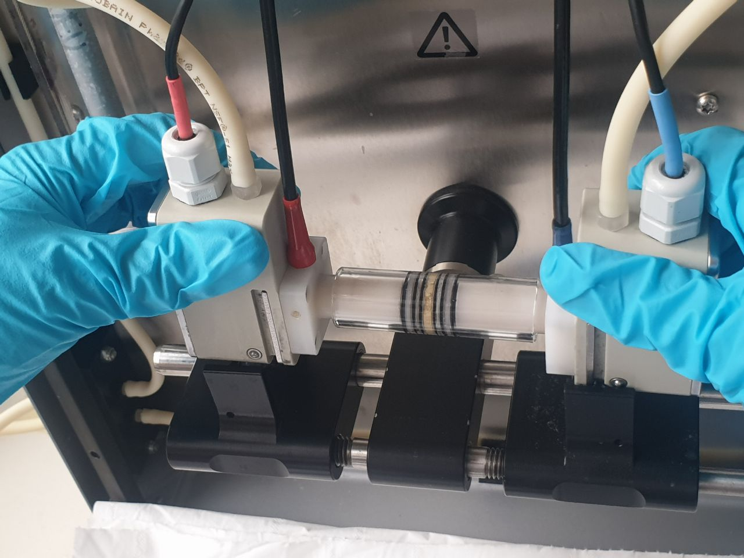
Figure S1 Cylindrical cell with the loaded sand sample.

Zeta potential | Glass beads | Sand | Crushed glass
pH 6 | -59 ± 2 mV | -27 ± 2mV | -53 ± 4mV
Table S2 Zeta potentials for different grained filters at pH 6 (extracted as mean values from the conducted tests with their standard deviations).
- Packing of the grained filters
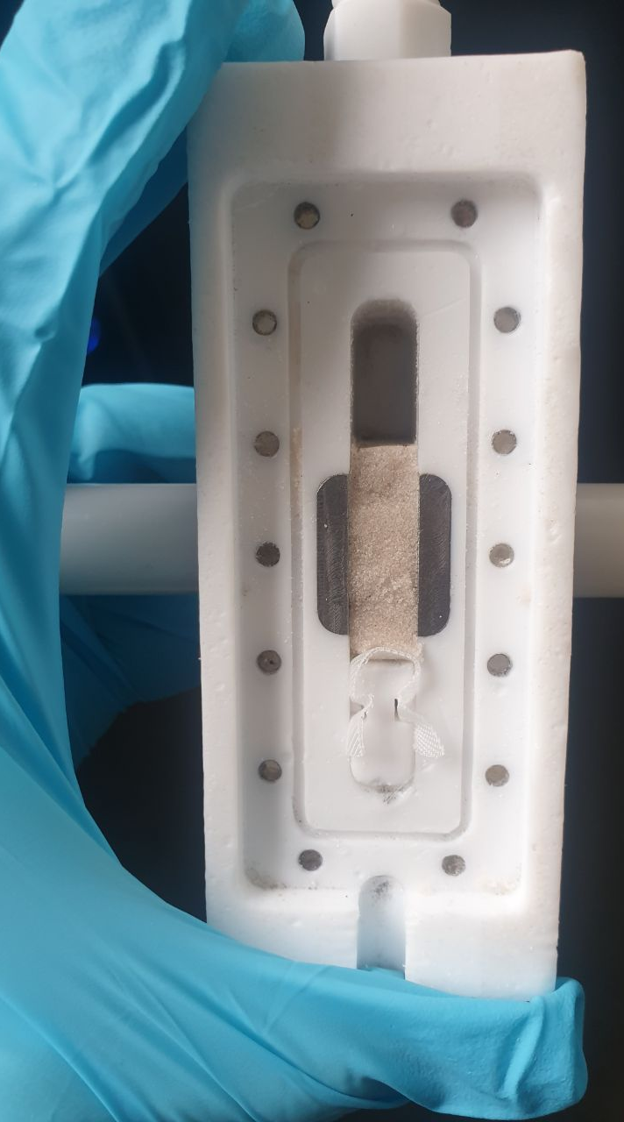
Figure S2 Packed bed of sand inside the filter cell (located between two metal electrodes).
Each sample was installed inside the filter cell in the following way: the grains were kept in place by a polyamide mesh (with a regular pore size of 110 µm) that sealed the 8 x 19 mm gap of the fluid flow (shown on one of the white holders inside the filter, Fig. S2). The cell was carefully closed on top, rotated 90° and flushed with ethanol and pure deionized water through the inlet before the experiment started.
To verify that filter loading procedure is consistent, the sand filter (mesh 250) was installed from the storage reservoir three times (resulting in testing of three different fractions referred below as three different packs). Each time 13 g of grains were taken from the storage reservoir, sonicated in pure water, loaded to the filter cell, flushed with ethanol for one minute and with pure deionized water for another five minutes. This experiment was conducted by two different people to assure an independent reproducibility of results (the data is referred as rearrangement DEP test in the online repository folder). The DEP results (Fig. S3) have shown that the trapping efficiency is consistent within the packs and the measurement with the packed bed grained filer is considered to be sufficiently stable.
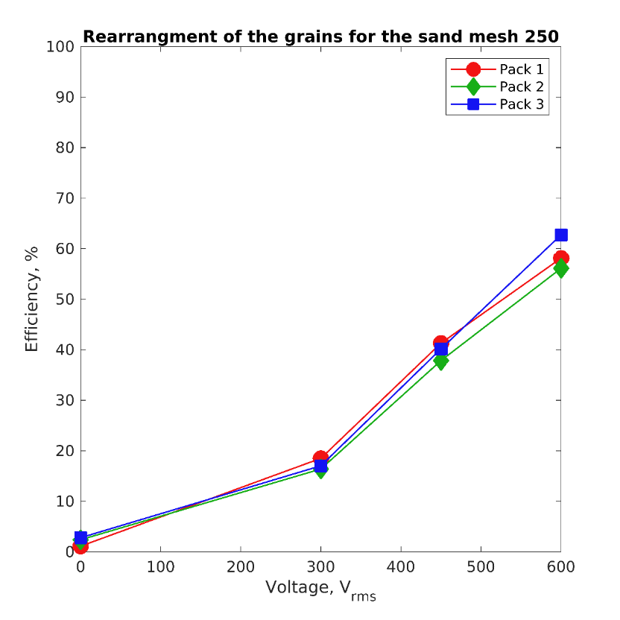
Figure S3 DEP efficiency of the sand filer (mesh 250), which was loaded in three different packs to the setup. The values at the highest voltage differ no more than ±3 % from their mean value and fit to the expected range. The experimental parameters are 1 kHz, 11 mL/min, target particles are identical to those in the main manuscript (PS, 500 nm).
- Milling of the glass
To test the consistency of the crushed glass milling process, the procedure was repeated in-house once for one of the size fractions (mesh 350). The glass sample was milled, sieved, cleaned and tested for its DEP efficiency with identical PS particles (500 nm), at 11 mL/min at the single voltage and frequency (600 $V_{rms}$, 1 kHz). The DEP efficiency was found to be 75, 76 and 74 % for 600 $V_{rms}$, which falls in the range of the expected values (Fig.4 in the main manuscript).

References
1. Ermolina, I. & Morgan, H. The electrokinetic properties of latex particles: comparison of electrophoresis and dielectrophoresis. J. Colloid Interface Sci. 285, 419–428 (2005).
2. Arnold, W. M., Schwan, H. P. & Zimmermann, U. Surface conductance and other properties of latex particles measured by electrorotation. J. Phys. Chem. 91, 5093–5098 (1987).
3. Giesler, J. et al. Polarizability-Dependent Sorting of Microparticles Using Continuous-Flow Dielectrophoretic Chromatography with a Frequency Modulation Method. Micromachines 11, (2020).
4. Yazbeck, R., Alibakhshi, M. A., Von Schoppe, J., Ekinci, K. L. & Duan, C. Characterization and manipulation of single nanoparticles using a nanopore-based electrokinetic tweezer. Nanoscale 11, 22924–22931 (2019).
5. Lorenz, M. Dielectrophoretic filtration of particles in porous media : Concept , design , and selectivity. (University of Bremen, 2021). https://doi.org/10.26092/elib/593.

