Table S1. Phylogroups, Virulence genes and MAR indices of E. coli isolates of both human and poultry samples
Ser. no | Isolate ID | Virulence factors identified in E. coli isolates of human origin | Phylogroup
1 | E. coli H2 | ecpA fimH traT | Average MAR index (0.73)  A (40%)
2 | E. coli H3 | papC ecpA fimH traT | Average MAR index (0.73)  A (40%)
3 | E. coli H8 | papC ecpA fimH traT | Average MAR index (0.73)  A (40%)
4 | E. coli H9 | papC ecpA fimH traT | Average MAR index (0.73)  A (40%)
5 | E. coli H11 | OmpT papC ecpA fimH traT | Average MAR index (0.73)  A (40%)
6 | E. coli H13 | Vat ecpA fimH traT | Average MAR index (0.73)  A (40%)
7 | E. coli H1 | OmpT papC ecpA fimH traT Aggr | Average MAR index (0.54)  B2 (33.3 %)
8 | E. coli H27 | Vat papC ecpA fimH | Average MAR index (0.54)  B2 (33.3 %)
9 | E. coli H15 | Vat papC ecpA fimH traT | Average MAR index (0.54)  B2 (33.3 %)
10 | E. coli H16 | Vat ecpA fimH | Average MAR index (0.54)  B2 (33.3 %)
11 | E. coli H22 | Vat papC ecpA fimH | Average MAR index (0.54)  B2 (33.3 %)
12 | E. coli H5 | PapC ecpA fimH traT | D (26.6 %)  Average MAR index (0.73)
13 | E. coli H6 | ecpA fimH traT stx1 | D (26.6 %)  Average MAR index (0.73)
14 | E. coli H19 | ecpA fimH traT | D (26.6 %)  Average MAR index (0.73)
15 | E. coli H12 | Vat papC ecpA fimH traT | D (26.6 %)  Average MAR index (0.73)
S. no | Isolate ID | Virulence factors identified in E coli isolates of Poultry origin | Phylogroup
1 | E. coli P7 | OmpT Aggr ecpA fimH traT | D (34.6 %)  Average MAR index (0.782)
2 | E. coli P19 | Aggr ecpA fimH traT | D (34.6 %)  Average MAR index (0.782)
3 | E. coli P23 | OmpT Aggr papC ecpA fimH traT | D (34.6 %)  Average MAR index (0.782)
4 | E. coli P27 | OmpT papC ecpA fimH traT | D (34.6 %)  Average MAR index (0.782)
5 | E. coli P28 | OmpT Aggr ecpA fimH traT | D (34.6 %)  Average MAR index (0.782)
6 | E. coli P39 | PapC ecpA fimH traT | D (34.6 %)  Average MAR index (0.782)
7 | E. coli P49 | Aggr papC ecpA fimH traT | D (34.6 %)  Average MAR index (0.782)
8 | *E. coli P25  (QZJM25) | Aggr papC ecpA fimH traT | D (34.6 %)  Average MAR index (0.782)
9 | E. coli P33 | OmpT Aggr papC ecpA fimH traT | D (34.6 %)  Average MAR index (0.782)
10 | E. coli P63 | Aggr papC ecpA fimH traT | B1 (23.1%)  Average MAR index (0.83)
11 | E. coli P64 | OmpT Aggr ecpA fimH traT | B1 (23.1%)  Average MAR index (0.83)
12 | E. coli P66 | Aggr papC ecpA fimH traT | B1 (23.1%)  Average MAR index (0.83)
13 | E. coli P68 | Aggr papC ecpA fimH traT | B1 (23.1%)  Average MAR index (0.83)
14 | E. coli P70 | papC fimH traT | B1 (23.1%)  Average MAR index (0.83)
15 | E. coli P73 | OmpT Vat papC ecpA fimH traT | B1 (23.1%)  Average MAR index (0.83)
16 | E. coli P6 | papC ecpA fimH traT | A (19.2%)  Average MAR index (0.78)
17 | E. coli P34 | ecpA fimH traT | A (19.2%)  Average MAR index (0.78)
18 | E. coli P47 | Aggr papC ecpA fimH traT | A (19.2%)  Average MAR index (0.78)
19 | E. coli P48 | papC ecpA fimH traT | A (19.2%)  Average MAR index (0.78)
20 | E. coli P45 | OmpT papC ecpA fimH traT | A (19.2%)  Average MAR index (0.78)
21 | E. coli P1 | Vat Aggr papC ecpA fimH traT | Clade I (15.4%)  Average MAR index (0.86)
22 | E. coli P2 | OmpT Vat Aggr ecpA fimH traT | Clade I (15.4%)  Average MAR index (0.86)
23 | E. coli P36 | ecpA fimH traT | Clade I (15.4%)  Average MAR index (0.86)
24 | E. coli P46 | OmpT papC ecpA fimH traT | Clade I (15.4%)  Average MAR index (0.86)
25 | E. coli P51 | PapC ecpA fimH traT | F (3.8%)
26 | E. coli P69 | papC ecpA fimH traT | B2 (3.8 %)
*E. coliP25 isolate is later named as QZJM25 (OK086691) and is used for isolation of bacteriophages resistance profile of QZJM25 is given in supplementary table 2

Table S2. Resistance profile of E. coli isolates of both human and poultry origin
S. # | Antibiotics Class | Antibiotic | CODE | Concentration (µg/disc) | (%) Resistant  E. coli H E. coli P (n=15) (n=26)
1 | Aminoglycosides | Neomycin | NEO | 30µg/ml | 82% | 81%
2 | Aminoglycosides | Kanamycin | Kn | 30 µg/ml | 41% | 70%
3 | Aminoglycosides | Streptomycin | STR | 25µg/ml | 53% | 93%
4 | Sulphonamide/ Folic Acid Inhibitors | Sulphamethoxazole | SXT | 25µg/ml | 65% | 85%
5 | Sulphonamide/ Folic Acid Inhibitors | Trimethoprim | W | 30µg/ml | 82% | 89%
6 | Beta-Lactams | Ampicillin | AMP | 10µg/ml | 100% | 100%
7 | Cephalosporins | Cefotaxime | CTX | 30µg/ml | 100% | 15%
8 | Quinolone | Nalidixic Acid | NAL | 30µg/ml | 70.5% | 96%
9 | Tetracycline | Tetracycline | TET | 30µg/ml | 71% | 100%
10 | Phenicol | Chloramphenicol | C | 30 µg/ml | 35% | 81%
11 | Macrolide | Erythromycin | ERY | 15µg/ml | 94% | 100%

Table S3; Resistance profile of QZJM25 Escherichia coli host strain used for bacteriophage isolation.
Antibiotics Class | Antibiotics | Code | Concentration | Zone diameter (mm) | Sensitivity
Antibiotics Class | Antibiotics | Code | µg/ml | Zone diameter (mm) | Sensitivity
β-Lactams | Penicillin G | P | 10 | ----- | R
β-Lactams | Amoxycillin | AML | 10 | ----- | R
β-Lactams | Amoxycillin-clavulanic acid | AMC | 30 | ----- | R
β-Lactams | Amoxycillin | AML | 25 | ------ | R
β-Lactams | Imipenem | IPM | 10 | ----- | R
β-Lactams | Meropenem | MEM | 10 | 23mm | I
β-Lactams | Piperacillin+ tazobactam | TPZ | 110 | 19mm | I
β-Lactams | Ampicillin | AM | 10 | ----- | R
β-Lactams | Flucloxacillin | FL | 5 |  | R
β-Lactams | Cefoperazone/ sulbactam | CES | 105 | 20mm | I
β-Lactams | Ceftazidime | CAZ | 30 | ------ | R
Aminoglycosides | Streptomycin | S | 10 | 16mm | S
Aminoglycosides | Gentamicin | CN | 10 | 6mm | R
Aminoglycosides | Kanamycin | K | 30 | 11 mm | R
Tetracyclines | Tetracycline | TE | 30 | ----- | R
Quinolones | Levofloxacin | LEV | 5 | 9mm | R
Quinolones | Norfloxacin | NOR | 10 | 9mm | R
Quinolones | Nalidixic acid | NA | 30 | ------ | R
Quinolones | Ciprofloxacin | CIP | 5 | 8mm | R
Quinolones | (Fluoroquinolone)
Glycopeptides | Vancomycin | VA | 30 | 8mm | R
Phenicols | Chloramphenicol | C | 30 | 24mm | S
Macrolides | Azithromycin | AZM | 15 | 17mm | S
Macrolides | Erythromycin | E | 15 | ----- | R
Sulphonamides | Sulphamethoxazole/ | SXT | 25 | 22mm | S
Sulphonamides | Trimethoprim
Lincosamides | Lincomycin | L | 2 | ----- | R
Aminocoumarin | Novobiocin | NV | 30 | ----- | R
Ansamycin | Rifampicin | RD | 5 | 11 | R

Table S4. Primers used in this study for pathotyping and phylotyping of E. coli isolates.
Gene | Primer  Nucleotide sequence (5´-3´) | Size (bp) | Reference
aggR | GTATACACAAAAGAAGGAAGC  ACAGAATCGTCAGCATCAGC | 254 | (1)
eae | TCAATGCAGTTCCGTTATCAGTT  GTAAAGTCCGTTACCCCAACCTG | 482 | (1)
ST | AATTGCTACTATTCATGCTTTCAGGAC  TCTTTTTCACCTTTC GCTCAGG | 133 | (2)
Stx1 | ACA CTG GAT GAT CTC AGT GG  CTG AAT CCC CCT CCA TTA TG | 614 | (3)
Stx1 | GAATTTACCTTAGACTTCTCGAC  TCCTGTTAACAAATCCTGTCAC | 250 | (3)
Stx2 | CCATGA CAA CGG ACA GCA GTT  CCT GTC AAC TGA GCA CTT TG | 779 | (3)
cnf1 | GCTCAACGAGACTATGCTCTG  ACGCTGCTAAGTACCTCCTGG | 278 | (4)
vat | GTATATGGGGGGCAACATAC  GTGTCAGAACGGAATTGTCG | 1337 | (5)
ompT | ATCTAGCCGAAGAAGGAGGC  CCCGGGTCATAGTGTTCATC | 559 | (6)
iroN | AAGTCAAAGCAGGGGTTGCCCG  GACGCCGACATTAAGACGCAG | 667 | (6)
ecpA | TGA AAA AAA AGG TTC TGG CAA TAG C  CGCTGA TGA GGA GAA AGT GAA | 541 | (7)
papC | GTGGCAGTATGA GTA ATG ACC GTT A  ATATCC TTT CTG CAG GGA TGC AAT A | 200 | (7)
fimH | TGC AGA ACG GAT AAG CCG TGG  GCA GTC ACC TGC CCT CCG GTA | 508 | (7)
traT | GGT GTG GTG CGA TGA GCA CAG  CAC GGT TCA GCG ATC CCT GAG | 290 | (7)
sfa/  fogDE | CTC CGG AGA ACT GGG TGC ATC TTA C  CGG AGG AGT AAT TAC AAA CCT GGC A | 410 | (7)
Gene | Nucleotide sequence (5´-3´) | Size (bp) | Reference
chuA | ATGGTACCGGACGAACCAAC  TGCCGCCAGTACCAAAGACA | 288 | (8)
yjaA | CAAACGTGAAGTGTCAGGAG  AATGCGTTCCTCAACCTGTG | 211 | (8)
TspE4.C2 | CACTATTCGTAAGGTCATCC  AGTTTATCGCTGCGGGTCGC | 152 | (8)
arpA | AACGCTATTCGCCAGCTTGC  TCTCCCCATACCGTACGCTA | 400 | (8)

Table S5 ; SKA49 and SKA64 host range as tested on field isolates of Escherichia coli
Serial No. | APEC Escherichia coli strains (Isolated from poultry) | Escherichia phage SKA49 | Escherichia phage SKA64
1 | E. coli p 1 | + | +
2 | E. coli p 2 | +++ | -
3 | E. coli p 6 | - | -
4 | E. coli p 7 | ++++ | -
5 | E. coli p 19 | - | -
6 | *E. coli p 25 (QZJM25) | - | -
7 | E. coli p 27 | ++++ | ++++
8 | E. coli p 28 | - | -
9 | E. coli p 33 | - | -
10 | E. coli p 34 | - | -
11 | E. coli p 36 | +++ | -
12 | E. coli p 39 | +++ | -
13 | E. coli p 45 | - | +++
14 | E. coli p 46 | ++ | -
15 | E. coli p 47 | +++ | -
16 | E. coli p 48 | ++ | -
17 | E. coli p 49 | + | -
18 | E. coli p 51 | + | +
19 | E. coli p 66 | +++ | +
20 | E. coli p 68 | + | +
21 | E. coli p 69 | + | -
Serial No. | UPEC Escherichia coli  (Isolated from human urine samples) | SKA49 | SKA64
1 | E. coli H1 | - | +
2 | E. coli H 2 | - | -
3 | E. coli H 3 | ++++ | -
4 | E. coli H 5 | + | +
5 | E. coli H 6 | - | -
6 | E. coli H19 | - | -
7 | E. coli H 8 | +++ | -
8 | E. coli H 9 | +++ | -
9 | E. coli H 11 | +++ | -
10 | E. coli H 12 | - | -
11 | E. coli H 13 | + | +
12 | E. coli H 27 | +++ | -
13 | E. coli H 15 | - | -
14 | E. coli H16 | + | -
15 | E. coli H22 | + | -

E. coli p (isolates of poultry origin) , E. coli H (isolates of human origin), * Host strain for SKA49 and SKA64 isolation, (++++) clear lysis, (+++) Too numerous to count plaques, TNTC, (++) countable plaques (+) light zone, (-) no lysis.

Table S6; SKA49 predicted ORFs and their amino acid homology with closest relatives (BLAST P)
ORF | nucleotide seq | Total AA | Putative Function | Query coverage | Similarity | GB Ac. NO | Organism
 | 2115bp | 704AA | Putative RNA polymerase | 98% | 98.15% | QEM42537.1 | Escherichia phage vB_EcoM_Bp10
 | 129bp | 42AA | Hypothetical protein | 97% | 95.24% | QQO91003.1 | Yersinia phage PYps3T
 | 174bp | 57AA | Hypothetical protein | - | - | - | -
 | 249bp | 82AA | hypothetical protein | 98% | 91.46% | YP_009850474.1 | Escherichia phage Mangalitsa
 | 243bp | 80AA | hypothetical Protein (putative EaE protein) | 98% | 91.25% | QEM42569.1 | Escherichia phage vB_EcoM_Bp10
 | 189bp | 62AA | hypothetical protein | 98% | 98.39% | YP_009790665.1 | Escherichia phage ST32
 | 165bp | 54AA | hypothetical protein | 98% | 98.15% | QQO90928.1 | Yersinia phage PYps23T
 | 183bp | 60AA | Hypothetical protein | 88% | 40.74% | YP_009790666.1 | Escherichia phage ST32
 | 174bp | 57AA | Hypothetical protein | 98 | 94.74% | YP_009790668.1 | Escherichia phage ST32
 | 297bp | 98AA | hypothetical protein | 98% | 70.41% | YP_009850479.1 | Escherichia phage Mangalitsa
 | 264bp | 87AA | hypothetical protein | 98% | 100.00% | YP_009855568.1 | Escherichia phage flopper
 | 228bp | 75AA | Hypothetical protein | 98% | 97.33% | YP_009790672.1 | Escherichia phage ST32
 | 291bp | 96AA | hypothetical protein | 98% | 100.00% | YP_009790674.1 | Escherichia phage ST32
 | 234bp | 77AA | Hypothetical protein | 98% | 85.71% | YP_009855564.1 | Escherichia phage flopper
 | 288bp | 95AA | hypothetical protein | 98% | 98.95% | YP_009790676.1 | Escherichia phage ST32
 | 153bp | 50AA | Hypothetical protein | 98% | 92% | QQO91017.1 | Yersinia phage PYps3T
 | 381bp | 126AA | single-stranded DNA-binding protein | 99% | 90.48% | YP_001595410.1 | Escherichia phage phiEcoM-GJ1
 | 477bp | 158AA | hypothetical protein | 99% | 91.77% | YP_009850487.1 | Escherichia phage Mangalitsa
 | 351bp | 116AA | hypothetical protein | 99% | 99.14% | YP_009790681.1 | Escherichia phage ST32
 | 234bp | 77AA | Hypothetical Protein | 99% | 100% | UIU26832.1 | Escherichia phage vB_EcoM_SA91KD
 | 267 | 88AA | Hypothetical protein | 98% | 90.91% | YP_009850491.1 | Escherichia phage Mangalitsa
 | 417bp | 138AA | Imidazole glycerol phosphate synthase, Putative endolysin | 99% | 99.28% | YP_009790684.1 | Escherichia phage ST32
 | 546bp | 181AA | putative anti-restriction protein | 99% | 82.87% | YP_001595417.1 | Escherichia phage phiEcoM-GJ1
 | 240bp | 79AA | Hypothetical protein | 98% | 98.73% | YP_009790687.1 | Escherichia phage ST32
 | 318bp | 105AA | hypothetical protein | 99% | 74.29 | YP_009850499.1 | Yersinia phage PYps16N
 | 309bp | 102AA | Hypothetical protein | 99% | 100% | YP_009850500.1 | Escherichia phage Mangalitsa
 | 675bp | 224AA | hypothetical protein | 99% | 100.00% | YP_001595423.1 | Escherichia phage phiEcoM-GJ1
 | 339bp | 112AA | hypothetical protein | 99% | 99.11% | YP_001595424.1 | Escherichia phage phiEcoM-GJ1
 | 192bp | 63AA | Putative endolysin | 84% | 81.48% | QQO91037.1 | Yersinia phage PYps3T
 | 141bp | 46AA | conserved hypothetical_179 | 97% | 100.00% | YP_009790695.1 | Escherichia phage ST32
 | 237bp | 78AA | Phage protein putative endolysin, a spannin | 98% | 93.59% | YP_009850507.1 | Escherichia phage Mangalitsa
 | 231bp | 76AA | Putative tail tape measure protein | 98% | 98.68% | YP_009790697.1 | Escherichia phage ST32
 | 651bp | 216AA | thymidylate synthase, flavin-dependent, thyX_182 | 99% | 99.54% | QDJ96616.1 | Escherichia phage vB_EcoP_Bp7
 | 1764bp | 587AA | replicative DNA helicase, dnaB_183 | 99% | 100.00% | YP_009790699.1 | Escherichia phage ST32
 | 1935bp | 644AA | DNA polymerase | 99% | 98.45% | YP_001595432.1 | Escherichia phage phiEcoM-GJ1
 | 264bp | 81AA | Hypothetical protein | 98% | 98.73% | YP_009790687.1 | Escherichia phage ST32
 | 867bp | 288AA | hypothetical protein | 99% | 99.65% | YP_001595434.1 | Escherichia phage phiEcoM-GJ1
 | 429bp | 142AA | Base plate wedge protein | 99% | 95.07% | QQO90963.1 | Yersinia phage PYps23T
 | 1026bp | 341AA | 5’-3’ exonuclease, RNaseH  DNA polymerase I, polA_188 | 99% | 92.67% | YP_009850517.1 | Escherichia phage Mangalitsa
 | 525bp | 174AA | Putative Replicative endonuclease VII | 99% | 99.43% | QDJ96622.1 | Escherichia phage vB_EcoP_Bp7
 | 756bp | 251AA | DNA ligase D, ligase domain, ligD_190 | 99% | 99.20% | YP_001595437.1 | Escherichia phage phiEcoM-GJ1
 | 627bp | 208AA | Putative adénylate kinase | 99% | 99.52% | YP_009855608.1 | Escherichia phage flopper
 | 600bp | 199AA | deoxyuridine 5'-triphosphate nucleotide hydrolase (dUTP ) | 99% | 84.21% | YP_009790707.1 | Escherichia phage ST32
 | 330bp | 109AA | Hypothetical protein | 99% | 99.25% | YP_001595440.1 | Escherichia phage phiEcoM-GJ1
 | 186bp | 61AA | Hypothetical protein | 98% | 98.36% | YP_009850523.1 | Escherichia phage Mangalitsa
 | 2019bp | 672AA | Putative terminase large subunit | 99% | 100.00% | QDJ96627.1 | Escherichia phage vB_EcoP_Bp7
 | 213bp | 70AA | Major head subunit precursor protein | 98% | 97.14% | QQO91059.1 | Yersinia phage PYps3T
 | 1317bp | 438AA | Portal protein | 99% | 100.00% | YP_009790713.1 | Escherichia phage ST32
 | 1065bp | 355AA | Major head subunit precursor protein | 99% | 98.5% | YP_001595446.1 | Escherichia phage phiEcoM-GJ1
 | 474bp | 157AA | hypothetical protein | 99% | 98.09% | YP_009790715.1 | Escherichia phage ST32
 | 213bp | 70AA | Hypothetical protein | 98% | 88.57 | QDJ96593.1 | Escherichia phage vB_EcoP_Bp7
 | 1008bp | 335AA | major capsid protein | 99% | 98.21% | QEM42515.1 | Escherichia phage vB_EcoM_Bp10
 | 441bp | 146AA | Putative head tail adaptor protein | 99% | 100.00% | QEM42516.1 | Escherichia phage vB_EcoM_Bp10
 | 390bp | 129AA | Tail complétion protein | 99% | 100.00% | QDJ96634.1 | Escherichia phage vB_EcoP_Bp7
 | 363bp | 120AA | Putative Head tail adapter protein | 99% | 100% | YP_001595451.1 | Escherichia phage phiEcoM-GJ1
 | 513bp | 170AA | Putative tail completion protein | 99% | 98.24% | YP_009790721.1 | Escherichia phage ST32
 | 1449bp | 482AA | Tail sheath protein | 99% | 97.10% | YP_009850535.1 | Escherichia phage Mangalitsa
 | 456bp | 151AA | Tail tube protein | 99% | 99.3% | YP_009850536.1 | Escherichia phage Mangalitsa
 | 459bp | 152AA | Putative tail assembly chaperon protein | 99% | 99.34% | YP_001595455.1 | Escherichia phage phiEcoM-GJ1
 | 3276bp | 1241AA | Putative tail fiber protein | 99% | 99.11% | YP_009790726.1 | Escherichia phage ST32
 | 1095bp | 364AA | Putative Minor baseplate protein | 99% | 98.35% | YP_009850539.1 | Escherichia phage Mangalitsa
 | 903bp | 300AA | Tail tube initiator protein | 99% | 98.67% | YP_009850542.1 | Escherichia phage Mangalitsa
 | 369bp | 123AA | Minor baseplate protein | 99% | 96.72% | YP_009850541.1 | Escherichia phage Mangalitsa
 | 795bp | 264AA | Putative base plate assembly protein | 99% | 97.73% | YP_009850542.1 | Escherichia phage Mangalitsa
 | 372bp | 123AA | Tail tube polymerization initiator protein | 98% | 97.54% | YP_009850543.1 | Escherichia phage Mangalitsa
 | 1158bp | 385AA | Base plate wedge protein | 99% | 96.88% | YP_009850544.1 | Escherichia phage Mangalitsa
 | 642bp | 213AA | Base plate wedge protein | 99% | 92.5% | YP_009850545.1 | Escherichia phage Mangalitsa
 | 1146bp | 381AA | Putative tail fiber protein | 99% | 93.96% | YP_009850546.1 | Escherichia phage Mangalitsa
 | 1392bp | 463AA | Phage minor tail protein | 99% | 91.59% | YP_009850547.1 | Escherichia phage Mangalitsa
 | 1074bp | 357AA | putative tail fiber protein | 99% | 69.25% | YP_009850548.1 | Escherichia phage Mangalitsa
 | 342bp | 113AA | phage holin, lambda family | 99% | 99.12% | YP_009790737.1 | Escherichia phage ST32
 | 555bp | 184AA | Spore cortex lytic enzyme (Putative cell wall hydrolase) | 100% | 99.32% | YP_009855578.1 | Escherichia phage flopper
 | 1101 | 366AA | ribonucleoside-diphosphate reductase, class 1b, | 99% | 99.18% | YP_009855577.1 | Escherichia phage flopper

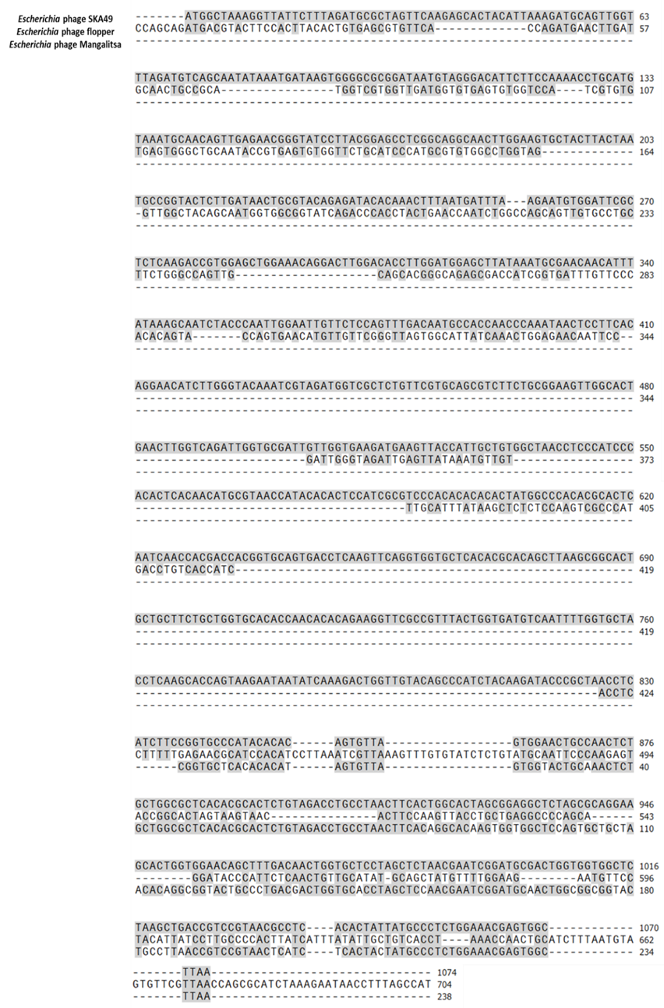

Figure S1; Nucleotide sequence comparison of tail fiber genes of SKA49 homologs. Name of pages given on top left hand. Gray shading indicates nucleotides that resemble SKA49

Table S7; SKA64 predicted ORFs and their amino acid homology with closest relatives (BLAST P)
ORF | ORF (bp) | Total AA | Putative Function | Query coverage | Similarity | GB Ac. NO | Organism
1 | 2076 | 691 | phage terminase large subunit | 99% | 100% | YP_009985582.1 | Escherichia phage anhysbys
2 | 393 | 130 | phage lysis regulatory protein, LysB family_34 | 99% | 100% | YP_007348513.1 | Escherichia phage phAPEC8
4 | 297 | 98 | RNA polymerase sigma factor
11 | 354 | 117 | putative transposase-like protein | 99% | 100% | CAA7332674.1 | Escherichia phage vB_EcoM_UP17
16 | 609 | 202 | putative DNA binding protein | 99% | 87.62% | DAU99217.1 | Myoviridae sp.
20 | 552 | 183 | Metallo-phosphoesterase, DNA ligase-associated protein | 99% | 100% | QPI12963.1 | Escherichia phage PNJ1809-36
21 | 933 | 310 | putative RNA ligase/RNA repair | 99% | 100% | YP_010356424.1 | Dompiswa phage TSP7_1
22 | 405 | 134 | dephospho-CoA kinase, coaE_54 | 99% | 100% | YP_009803359.1 | Klebsiella phage ZCKP1
26 | 1116 | 371 | DNA ligase I, ATP-dependent (dnl1) | 99% | 100% | YP_009987099.1 | Escherichia phage Mt1B1_P17
29 | 726 | 241 | Putative NTP phosphohydrolase | 99% | 100% | WP_016069135.1 | Escherichia coli
30 | 879 | 292 | putative exonuclease RdgC | 99% | 100% | WP_229510944.1 | Escherichia coli
32 | 690 | 229 | putative exonuclease | 99% | 99.56% | YP_009986143.1 | Escherichia phage nieznany
33 | 960 | 319 | DNA polymerase III, epsilon subunit, dnaQ_65 | 99% | 100% | YP_009786566.1 | Escherichia phage ESCO13
39 | 999 | 332 | thymidylate synthase, flavin-dependent, thyX_71 | 99% | 100% | YP_007348481.1 | Escherichia phage phAPEC8
42 | 2241 | 746 | ribonucleoside-diphosphate reductase, alpha subunit | 99% | 100% | YP_009986579.1 | Escherichia phage tuntematon
43 | 1086 | 361 | ribonucleoside-diphosphate reductase, class 1b, | 99% | 100% | YP_007348476.1 | [Escherichia phage phAPEC8]
45 | 153 | 50 | chaperone protein DnaJ, dnaJ_77 | 98 | 100 | YP_009986826.1 | Escherichia phage ukendt
48 | 993 | 330 | dTDP-glucose 4,6-dehydratase, rfbB_80 | 99% | 100% | YP_009984956.1 | Escherichia phage vB_EcoM-Ro121c4YLVW
49 | 879 | 292 | glucose-1-phosphate thymidylyltransferase, rfbA_81 | 99% | 100% | YP_009984957.1 | Escherichia phage vB_EcoM-Ro121c4YLVW
50 | 567 | 188 | dTDP-4-dehydrorhamnose 3,5-epimerase, rfbC_82 | 99 | 99.47 | YP_007348469.1 | Escherichia phage phAPEC8
51 | 843 | 280 | dTDP-4-dehydrorhamnose reductase, rfbD_83 | 99% | 100% | QPI12932.1 | Escherichia phage PNJ1809-36
52 | 261 | 86 | glutaredoxin 3, grxC_84 | 98% | 98.84% | YP_009787073.1 | Escherichia phage ESCO5
54 | 501 | 166 | tyrosine 2,3-aminomutase (Lysozyme) | 99% | 100% | YP_009786544.1 | Escherichia phage ESCO13
55 | 759 | 252 | CRISPR-associated helicase Cas3_87 | 99% | 100% | YP_009786543.1 | Escherichia phage ESCO13
57 | 693 | 230 | ATP-dependent protease HslVU, peptidase subunit | 99% | 100% | YP_007348462.1 | Escherichia phage phAPEC8
65 | 744 | 247 | polynucleotide kinase-phosphatase_97 | 99% | 100% | YP_007348454.1 | Escherichia phage phAPEC8
79 | 801 | 266 | putative Sir2-like protein [Escherichia phage p | 99% | 99.25% | QPI12904.1 | Escherichia phage PNJ1809-36
88 | 450 | 149 | putative zinc finger/helix-turn-helix protein, | 99% | 100% | WP_016069063.1 | Escherichia coli
89 | 198 | 65 | DNA ligase | 99% | 100% | YP_010356356.1 | Dompiswa phage TSP7_1
101 | 672 | 223 | Resolvase/ invertase | 99% | 100% | WP_016069063.1 | Escherichia coli
110 | 198 | 65 | Flagellar assembly protein FliH | 98% | 100% | WP_229504070.1 | Escherichia coli
126 | 462 | 153 | transcription-repair coupling factor, mfd_158 | 98% | 99.34% | YP_010356318.1 | Dompiswa phage TSP7_1
168 | 981 | 326 | Putative H endonuclease | 99% | 75.31% | YP_007348621.1 | Escherichia phage phAPEC8
169 | 1140 | 379 | DnaA regulatory inactivator Hda, hda_202 | 99% | 99.74% | QPI12812.1 | Escherichia phage PNJ1809-36
196 | 1593 | 530 | DNA helicase II, uvrD_229 | 99% | 100% | YP_009803461.1 | Klebsiella phage ZCKP1
198 | 558 | 185 | putative seryl-tRNA synthetase | 99% | 99.46% | YP_007348592.1 | Escherichia phage phAPEC8
200 | 1815 | 604 | anaerobic ribonucleoside-triphosphate reductase large subunit | 99% | 100% | YP_009985387.1 | Escherichia phage anhysbys
201 | 471 | 156 | anaerobic ribonucleoside-triphosphate reductase small subunit | 99% | 100% | YP_007348589.1 | Escherichia phage phAPEC8
204 | 657 | 218 | HAD hydrolase, REG-2-like, family IA_237 | 99% | 100% | YP_007348586.1 | Escherichia phage phAPEC8
205 | 828 | 275 | phosphoribosyl transferase family protein | 99% | 100% | QPI12774.1 | Escherichia phage PNJ1809-36
213 | 591 | 196 | SprT family zinc-dependent metalloprotease | 99% | 100% | YP_009803445.1 | Klebsiella phage ZCKP1
224 | 522 | 173 | Spore cortex lytic enzyme SleB family protein | 99% | 100% | YP_007348567.1 | Escherichia phage phAPEC8
233 | 1779 | 592 | replicative DNA helicase, dnaB_266 | 99% | 100% | YP_007348558.1 | Escherichia phage phAPEC8
235 | 795 | 264 | putative DNA N6-adenine methyltransferase | 99% | 100% | WP_229504230.1 | Escherichia coli
236 | 2598 | 865 | DNA polymerase I, polA_269 | 99% | 100% | YP_007348555.1 | Escherichia phage phAPEC8
240 | 594 | 197 | putative tRNA nucleotidyl transferase / poly(A) | 99% | 100% | YP_007348551.1 | Escherichia phage phAPEC8
243 | 2676bp | 891AA | Tail fiber protein | 99% | 99.78% | YP_009786631.1 | Escherichia phage ESCO13
244 | 1650 | 549 | putative phage tail fiber protein | 99% | 99.27% | QPI13012.1 | Escherichia phage PNJ1809-36
245 | 3054 | 1017 | colanic acid biosynthesis protein WcaM, wcaM_1 | 99% | 100% | WP_016069188.1 | Escherichia coli
247 | 546 | 181 | putative tail fiber assembly protein | 99% | 99.45% | YP_009987047.1 | Escherichia phage Mt1B1_P17
248 | 1062 | 353 | putative gpH domain protein Tail fiber protein | 99% | 99.43% | YP_010356201.1 | Dompiswa phage TSP7_1
249 | 630bp | 210 | Base plate protein | 99% | 99.52% | YP_009787153.1 | Escherichia phage ESCO5
250 | 1488 | 495 | Putative base plate wedge protein | 99% | 99.80% | YP_009987050.1 | Escherichia phage Mt1B1_P17
252 | 345 | 114 | tail spike protein | 73% | 79.76% | YP_009803406.1 | Klebsiella phage ZCKP1
253 | 2550 | 849 | Putative tail spike protein | 91% | 79.77% | QEG09597.1 | Escherichia phage Pisces
254 | 2154 | 717 | Non-contractile tail sheath | 99% | 99.58% | WAX14384.1 | non-contractile tail sheath
255 | 2877 | 958 | Tail fiber protein | 99% | 99.90% | YP_009986348.1 | Escherichia phage nieznany
257 | 627 | 208 | base plate wedge protein | 99% | 99.52% | YP_009985601.1 | Escherichia phage anhysbys
258 | 735 | 244 | base plate central spike protein | 99% | 99.59% | YP_009985600.1 | Escherichia phage anhysbys
259 | 1011 | 336 | Putative base plate hub | 99% | 100% | YP_009787144.1 | Escherichia phage ESCO5
261 | 702 | 233 | Putative tail tube initiator protein | 99% | 99.57% | YP_007348531.1 | Escherichia phage phAPEC8
262 | 1989 | 662 | putative tail tape measure protein | 99% | 100% | YP_009987060.1 | Escherichia phage Mt1B1_P17
263 | 483 | 160 | Tail assembly chaperon | 99% | 100% | WP_016069170.1 | Escherichia coli
264 | 480 | 159 | tail tube protein | 99% | 99.37% | YP_009987063.1 | Escherichia phage Mt1B1_P17
265 | 1374 | 457 | tail sheath protein | 99% | 99.78% | YP_009787138.1 | Escherichia phage ESCO5
266 | 660 | 219 | Putative tail completion protein | 99% | 100% | YP_009984901.1 | Escherichia phage vB_EcoM-Ro121c4YLVW
267 | 417 | 138 | minor capsid protein | 99% | 100% | YP_007348524.1 | Escherichia phage phAPEC8
268 | 489 | 162 | virion morphogenesis protein | 99% | 100% | YP_009803387.1 | Klebsiella phage ZCKP1
269 | 549 | 182 | tail capping protein | 99% | 99.38% | YP_009787135.1 | Escherichia phage ESCO5
270 | 1002 | 333 | putative major head protein | 99% | 100% | OL739525.1 | Escherichia phage dw-ec
271 | 399 | 132 | putative head stabilization/decoration protein | 99% | 99.24% | YP_009985586.1 | Escherichia phage anhysbys
272 | 1116 | 371 | scscaffold protein | 99% | 99.24% | YP_009985586.1 | Escherichia phage anhysbys
273 | 480 | 159 | serine protease | 99% | 99.37% | YP_009985584.1 | Escherichia phage anhysbys
274 | 1566 | 521 | putative portal protein | 99% | 99.81% | YP_009786600.1 | Escherichia phage ESCO13
ORF number corresponds to labelling in genome map given in main manuscript (Figure 7). Only those ORFs are listed that resemble characterized proteins in NCBI.

Table S8A; Comparison of SKA49 with close homologs of the genus Carltongylesvirus
Phage | Total  ORF | Genome  Size (bp) | G+C  Content  (%) | Accession  No | Identity  (%) *
Escherichia phage SKA49 | 73 | 51548 | 44% | OL741059.1 | 100%
Escherichia phage vB_EcoM_Bp10 | 72 | 52288 | 44% | MN122072.1 | 85.7%
Escherichia phage Mangalitsa | 81 | 52329 | 44% | NC_048799.1 | 84.6%
Escherichia phage flopper | 71 | 52092 | 44% | NC_048845.1 | 84.5%
Escherichia phage vB_EcoP_Bp7 | 64 | 52615 | 44% | MN117721.1 | 84.1%
Escherichia phage ST32 | 79 | 53092 | 44% | NC_047830.1 | 84%
Escherichia phage phiEcoM-GJ1 | 75 | 52975 | 44% | EF460875.1 | 81.5%
Escherichia phage vB_EcoM_SA91KD | 78 | 53673 | 44% | OL960574.1 | 83.4%

Table S8B; Comparison of SKA49 with close homologs of the genus Phapecoctavirus
Phage | Total  ORF | Genome  Size (bp) | G+C  Content  (%) | Accession  No | Identity  (%) *
Escherichia phage SKA64 | 275 | 152.401Kb | 39% | OM362897.1 | 100%
Escherichia phage PNJ1809-36 | 292 | 152.343Kb | 39% | OL741059.1 | 94.3%
Escherichia phage phAPEC8 | 274 | 147.737Kb | 39% | NC_020079 | 93.4%
Dompiswa phage  TSP7_1 | 283 | 150.9 kb | 39% | NC_062742 | 92.8%
Escherichia phage  Mt1B1_P17 | 295 | 151.02Kb | 39% | NC_052662 | 92.1%
Escherichia phage  anhysbys | 282 | 149.335Kb | 39% | NC_052656 | 90.8%
Escherichia phage  vB_EcoM-Ro121lw | 292 | 149.8Kb | 39% | MH160766 | 92.8%
Klebsiella phage  ZCKP1 | 267 | 150.925Kb | 39% | NC_047994 | 89.4%

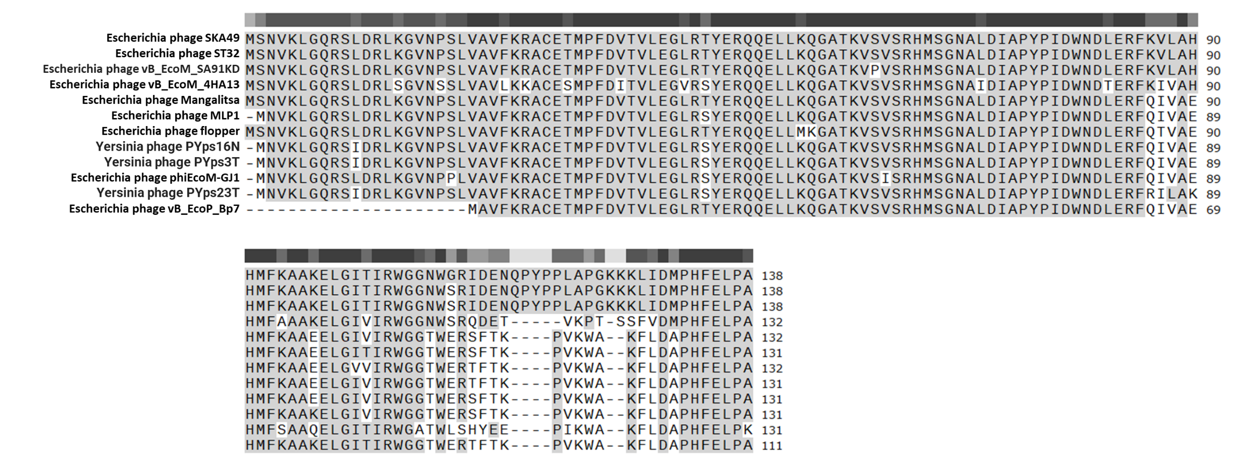

Figure S4A. Amino acid sequence comparison of D-Alanyl-D glutamate Endolysin (ORF 22) from SKA49 with close homologs in BLASTp. N terminus of protein is conserved whereas C terminus has variation. Gray shading indicates residues that resemble SKA49 endolysin protein sequence.

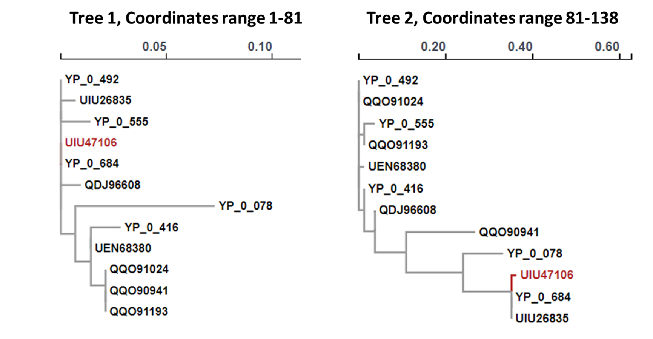

Figure S4B. The GARD analysis of amino acid sequence of D-Alanyl-D-glutamate Endolysin (ORF 22) from SKA49. This analysis identifies a recombination hotspot at amino acid 81-82, which produces two distinct homology trees for N-terminus and C-terminus of protein indicating its chimeric nature.

1. Bokhari H, Shah MA, Asad S, Akhtar S, Akram M, Wren BW. Escherichia coli pathotypes in Pakistan from consecutive floods in 2010 and 2011. American Journal of Tropical Medicine and Hygiene. 2013;88(3):519–25.
2. Hamid T, Wahab A dulaimi H, Ali A. Molecular Characterization and Antibiotic Susceptibility of Diarrheagenic Escherichia coli from Children Molecular Characterization and Antibiotic Susceptibility of Diarrheagenic Escherichia coli from Children College of Science for Women , Babylon Univer. 2015;(September 2016).
3. Hospitals C, Iqbal A, Mustafa MZ, Ahmad I, Rahman S. Incidence of Diarrheagenic. 2019;51(6):2015–21.
4. Kavitha K, Prabhakar K, Rajendran S, Uma B, Sarayu YL. Isolation of necrotoxigenic Escherichia coli from paediatric patients with acute diarrhoea. J Med Microbiol. 2010;59(4):503–4.
5. Nichols KB, Totsika M, Moriel DG, Lo AW, Yang J, Wurpel DJ, et al. Molecular characterization of the vacuolating autotransporter toxin in uropathogenic Escherichia coli. J Bacteriol. 2016;198(10):1487–98.
6. Jeong YW, Kim TE, Kim JH, Kwon HJ. Pathotyping avian pathogenic Escherichia coli strains in Korea. J Vet Sci. 2012;13(2):145–52.
7. López-Banda DA, Carrillo-Casas EM, Leyva-Leyva M, Orozco-Hoyuela G, Manjarrez-Hernández ÁH, Arroyo-Escalante S, et al. Identification of virulence factors genes in escherichia coli isolates from women with urinary tract infection in Mexico. Biomed Res Int. 2014;2014.
8. Clermont O, Christenson JK, Denamur E, Gordon DM. The Clermont Escherichia coli phylo-typing method revisited: Improvement of specificity and detection of new phylo-groups. Environ Microbiol Rep. 2013;5(1):58–65.

