Supplementary information

Flexible self-supporting interconnected cobalt sulfide nanosheets enable high-loading and long-cycling Li-S batteries with high areal capacity

Xiaohui Tian ¹, Lukang Che ¹, Mengdie Liu, Naomie Beolle Songwe Selabi, Yingke Zhou∗

The State Key Laboratory of Refractories and Metallurgy, Institute of Advanced Materials and Nanotechnology, College of Materials and Metallurgy, Wuhan University of Science and Technology, Wuhan 430081, P. R. China.

Fig. S1. The initial discharge-charge profile (a) and cycling performance (b) of the Co₉S₈-CC electrode at a current density of 167 mA g⁻¹.

Fig. S2. Galvanostatic discharge-charge profiles of the Co₉S₈-CC/Li₂S₆ electrode (a) and CC/Li₂S₆ electrode (b) at various rates.

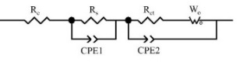
Fig. S3. EIS curves of CC/Li₂S₆ and Co₉S₈-CC/Li₂S₆ electrodes before (a) and after (b) 100 cycles at 0.5 C. The inset in (b) corresponds to the equivalent circuit. The relationship between Z_{re} and ω^{-1/2} before and after 100 cycles at 0.5 C of Co₉S₈-CC/Li₂S₆ electrode (c) and CC/Li₂S₆ electrode (d).

Table S1. Resistance parameters from fitting of EIS spectroscopy.

Cathode |  |  | R_{e} (Ω) | R_{s} (Ω) | R_{ct} (Ω)
CC/Li₂S₆ | Before cycling |  | 4.5 | - | 34.4
CC/Li₂S₆ | After 100 cycles at 0.5 C |  | 5.4 | 12.7 | 13.6
Co₉S₈-CC/Li₂S₆ | Before cycling |  | 3.9 | - | 14.6
Co₉S₈-CC/Li₂S₆ | After 100 cycles at 0.5 C |  | 4.3 | 0.9 | 4.4

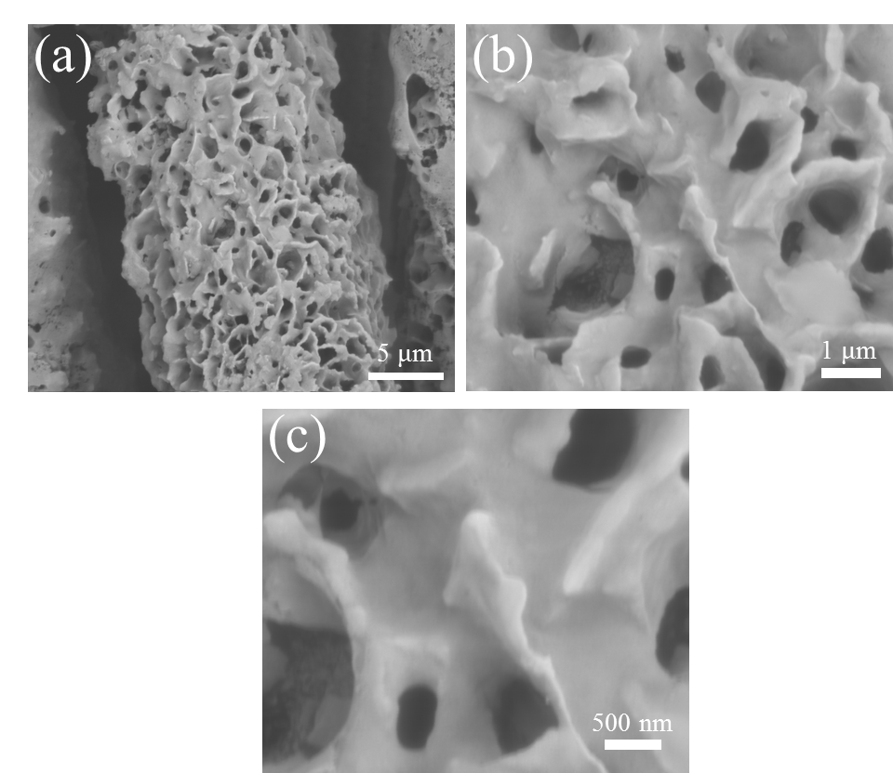
Fig. S4. SEM images of Co₉S₈-CC/Li₂S₆ electrode after 1500 cycles at 2 C.

Fig. S5. (a) Galvanostatic discharge-charge profiles and (b) rate performance of Co₉S₈-CC/Li₂S₆ electrode with high areal sulfur-loading of 6.2 mg cm⁻² at different rates. (c) Cycle performance of Co₉S₈-CC/Li₂S₆ electrode with high areal sulfur-loading of 6.2 mg cm⁻² at 0.5 C.

Table S2. Performance comparison of Li-S batteries in this work with those previously reported based on Co₉S₈ composite hosts.

Host | Sulfur-loading  (mg cm⁻²) | Current density  (C) | Initial capacity  (mAh g⁻¹) | Areal capacity  (mAh cm⁻²) | Capacity decay rate  (%/cycle) | Ref.
Hollow NiCo-LDH/Co₉S₈ heterostructure  (H-LDH/Co₉S₈) | 1.5-2 | 0.1 | 1339.1 | 2-2.68 | - | [1]
Hollow NiCo-LDH/Co₉S₈ heterostructure  (H-LDH/Co₉S₈) | 1.5-2 | 0.5 | 963.5 | 1.44-1.93 | 0.07  (500 cycles) | [1]
Hollow NiCo-LDH/Co₉S₈ heterostructure  (H-LDH/Co₉S₈) | 1.5-2 | 1 | 866.1 | 1.3-1.73 | 0.06  (1500 cycles) | [1]
Hollow NiCo-LDH/Co₉S₈ heterostructure  (H-LDH/Co₉S₈) | 1.5-2 | 2 | 669.6 | 1-1.34 | - | [1]
Co₉S₈ inlaid carbon nanoboxes (Co₉S₈@C NBs) | ~1.6 | 0.1 | 1267 | ~2.03 | - | [2]
Co₉S₈ inlaid carbon nanoboxes (Co₉S₈@C NBs) | ~1.6 | 0.5 | 1059 | ~1.69 | 0.06  (100 cycles) | [2]
Co₉S₈ inlaid carbon nanoboxes (Co₉S₈@C NBs) | ~1.6 | 1 | 970 | ~1.55 | 0.043  (400 cycles) | [2]
Co₉S₈ inlaid carbon nanoboxes (Co₉S₈@C NBs) | ~1.6 | 2 | 802 | ~1.28 |  | [2]
Co₉S₈ nanocrystal coated hollow carbon nanosphere  (HCS@Co₉S₈) | 1-2 | 0.1 | 1285 | 1.29~2.57 | - | [3]
 | 1-2 | 0.5 | 890 | 0.89-1.78 | 0.033  (400 cycles) | [3]
 | 1-2 | 2 | 710 | 0.71-1.42 | - | [3]
Graphene decorated with hetero-Co₉S₈-NiS sheets (BMS-G) | 1.2-1.5 | 0.2 | 1142.9 | 1.37-1.71 | - | [4]
Graphene decorated with hetero-Co₉S₈-NiS sheets (BMS-G) | 1.2-1.5 | 1 | 788 | 0.95-1.18 | 0.031  (800 cycles) | [4]
Graphene decorated with hetero-Co₉S₈-NiS sheets (BMS-G) | 1.2-1.5 | 2 | 705.8 | 0.85-1.06 | - | [4]
Hollow sphere-like Co₉S₈ | 1 | 0.1 | 1100 | 1.1 | - | [5]
Hollow sphere-like Co₉S₈ | 1 | 0.5 | 836 | 0.84 | 0.36  (100 cycles) | [5]
Hollow sphere-like Co₉S₈ | 1 | 1 | 781 | 0.78 | - | [5]
Co₉S₈ inlaid carbon hollow nanopolyhedra  (Co₉S₈/C) | 1.5 | 0.2 | 1160 | 1.74 | - | [6]
Co₉S₈ inlaid carbon hollow nanopolyhedra  (Co₉S₈/C) | 1.5 | 2 | 950 | 1.43 | 0.041  (1000 cycles) | [6]
Co₉S₈ inlaid carbon hollow nanopolyhedra  (Co₉S₈/C) | 3.0 | 0.1 | 950 | 2.85 | - | [6]
Co₉S₈ nanoparticle-embedded in N-doped carbon nanotube hollow polyhedron  (Co₉S₈@NCNHP) | 1.3 | 0.2 | 1107 | 1.44 | 0.14  (200 cycles) | [7]
 | 1.3 | 2 | 689 | 0.9 |  | [7]
 | 2.1 | 0.2 | 910 | 0.91 | 0.11  (200 cycles) | [7]
 | 3.2 | 0.2 | 780 | 2.5 | 0.15  (200 cycles) | [7]
Co₉S₈ nanotube/GO | 0.7-1 | 0.1 | 1397 | 0.98~1.40 | 0.033  (100 cycles) | [8]
Co₉S₈ nanotube/GO | 0.7-1 | 1 | 513.4 | 0.36~0.51 | 0.027  (200 cycles) | [8]
Co₉S₈ nanotube/GO | 0.7-1 | 2 | 361 | 0.25~0.36 | - | [8]
Co₉S₈ nanotubes | 1.5-1.6 | 0.1 | 913 | 1.37~1.46 | 0.28  (100 cycles) | [9]
Co₉S₈ nanotubes | 1.5-1.6 | 2 | 425.7 | 0.64~0.68 | - | [9]
MWCNT/Co₉S₈ | 1 | 0.1 | 1271 | 1.27 | 0.55  (100 cycles) | [10]
MWCNT/Co₉S₈ | 1 | 0.5 | 563 | 0.56 | - | [10]
MWCNT/Co₉S₈ | 1 | 1 | 431 | 0.43 | - | [10]
Graphene-like Co₉S₈ nanosheet | 1.5 | 0.05 | 1130 | 1.70 | - | [11]
Graphene-like Co₉S₈ nanosheet | 1.5 | 0.5 | - | - | 0.045  (1500 cycles) | [11]
Graphene-like Co₉S₈ nanosheet | 4.5 | 0.05 | - | 4.30 | - | [11]
Co₉S₈-CC | 2.5 | 0.1 | 1315.1 | 3.29 | - | This work
Co₉S₈-CC | 2.5 | 0.5 | 1105.4 | 2.76 | 0.05  (100 cycles) | This work
Co₉S₈-CC | 2.5 | 2 | 872.4 | 2.18 | 0.02  (1500 cycles) | This work
Co₉S₈-CC | 6.2 | 0.1 | 1115.1 | 6.91 | 0.129  (200 cycles) | This work

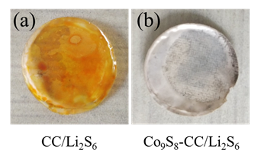
Fig. S6. Optical photos of separators used in (a) CC/Li₂S₆ and (b) Co₉S₈-CC/Li₂S₆ cells after 100 cycles at 0.5 C.

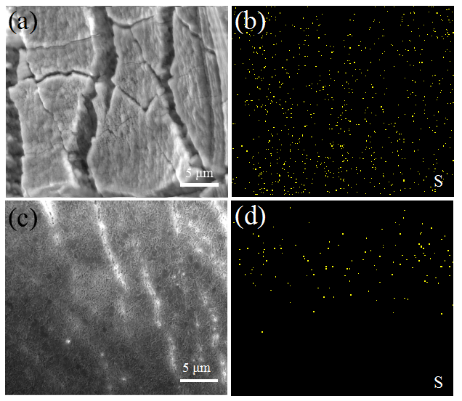
Fig. S7. SEM images and the corresponding S element mapping of Li metal anodes used for CC/Li₂S₆ cell (a, b) and Co₉S₈-CC/Li₂S₆ cell (c, d) after 100 cycles at 0.5 C.

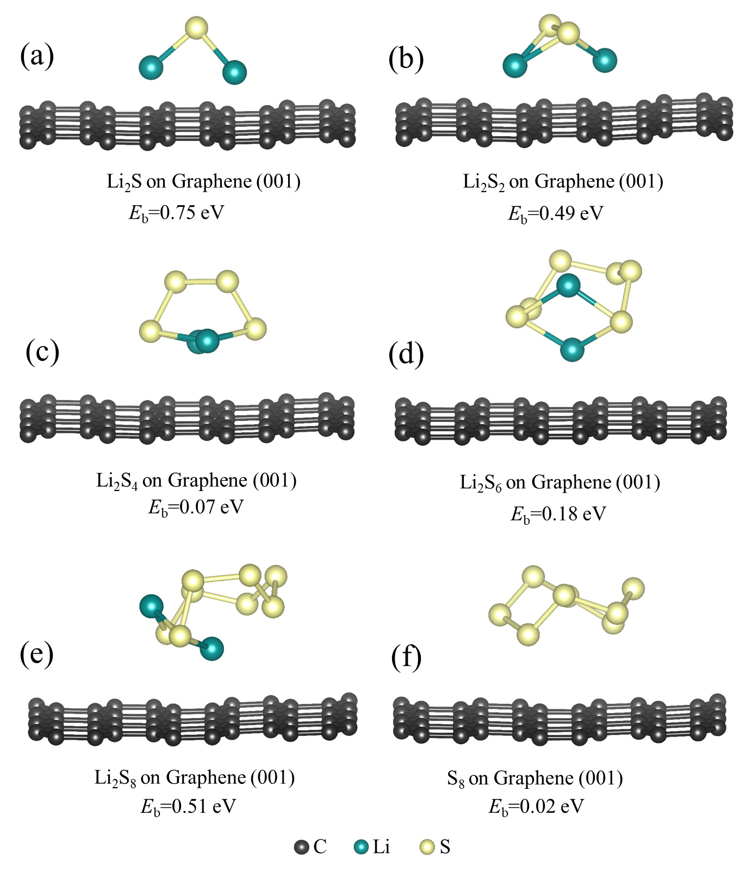
Fig. S8. Optimal configurations and corresponding binding energies of (a) Li₂S, (b) Li₂S₂, (c) Li₂S₄, (d) Li₂S₆, (e) Li₂S₈ and (f) S₈ adsorbed on graphene (001).

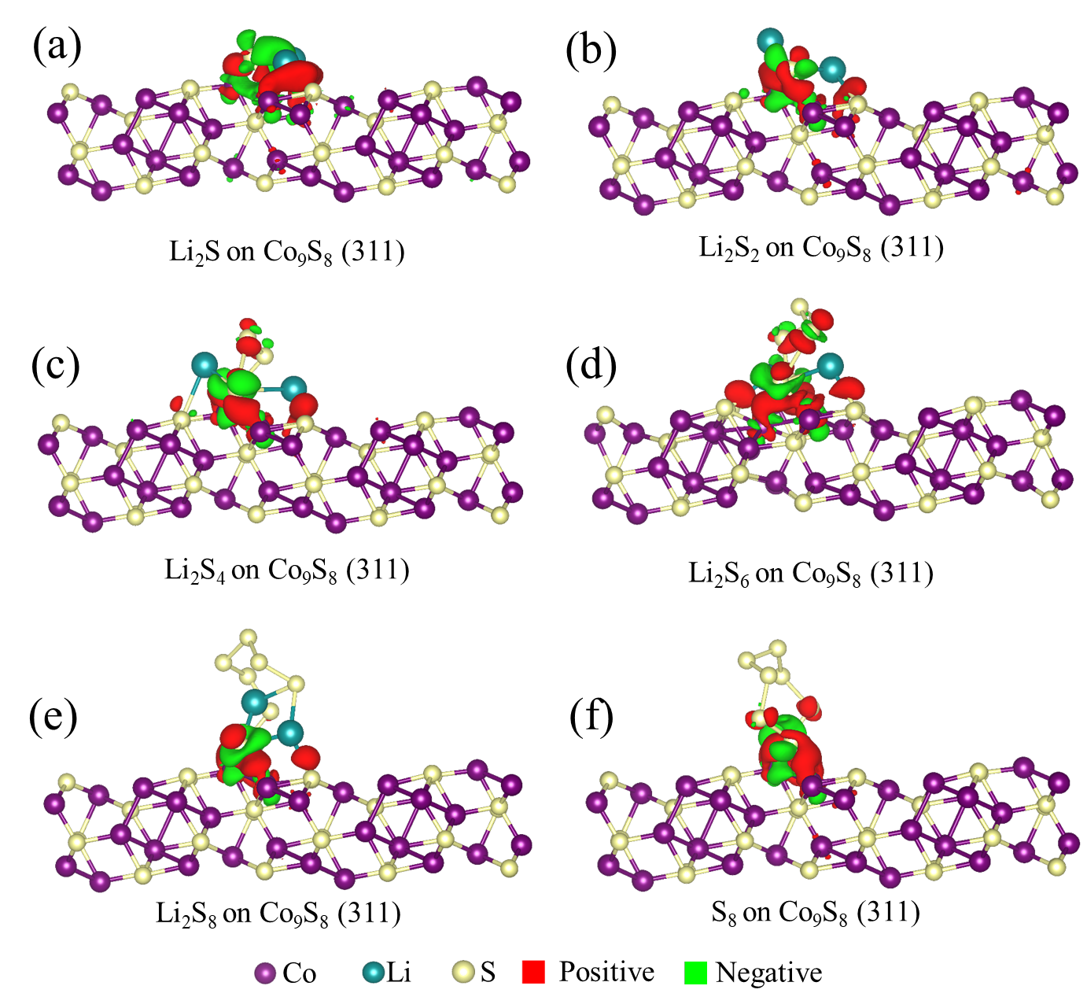
Fig. S9. Isosurface of charge density difference for optimized structures of (a) Li₂S, (b) Li₂S₂, (c) Li₂S₄, (d) Li₂S₆, (e) Li₂S₈ and (f) S₈ adsorbed on Co₉S₈ (311). The isovalues are defined as 0.005 e/Å³ in all cases.

Fig. S10. EIS curves of CC and Co₉S₈-CC symmetric cells.

Supplementary reference
- Chen SX, Luo JH, Li NY, Han XX, Wang J, Deng Q, Zeng ZL, Deng SG (2020) Multifunctional LDH/Co₉S₈ heterostructure nanocages as high-performance lithium-sulfur battery cathodes with ultralong lifespan. Energy Storage Mater 30:187-195
- Sun WW, Li YJ, Liu SK, Guo QP, Zhu YH, Hong XB, Zheng CM, Xie K (2020) Catalytic Co₉S₈ decorated carbon nanoboxes as efficient cathode host for long-life lithium-sulfur batteries. Nano Res 13:2143-2148
- Xu JL, Liu L, Sun YH, Lu RF, Wang ZR, Sun Q (2020) Engineering of three-dimensional nanohybrids: Co₉S₈ nanocrystal coated hollow carbon nanosphere for advanced lithium storage. Appl Surf Sci 514:146092
- Chen L, Xie XF, Zhang ZA, Kong XZ, Liang SQ, Pan AQ (2020) One-pot synthesis of hetero-Co₉S₈-NiS sheets on graphene to boost lithium-sulfur battery performance. Inorg Chem Front 7:2160-2167
- Liu XF, Wang D, Yang XZ, Zhao ZZ, Yang H, Feng M, Zhang W, Zheng WT (2019) Synergistic dual-confinement effect: Merit of hollowly metallic Co₉S₈ in packaging enhancement of electrochemical performance of Li-S batteries. ACS Appl Energy Mater 2:1428-1435
- Chen T, Ma LB, Cheng BR, Chen RP, Hu Y, Zhu GY, Wang YR, Liang J, Tie ZX, Liu J, Jin Z (2017) Metallic and polar Co₉S₈ inlaid carbon hollow nanopolyhedra as efficient polysulfide mediator for lithium-sulfur batteries. Nano Energy 38:239-248
- Yu Y, Zhan ZH, Tang PJ, Xu QY, Fan Q, Wang W, Shen K (2021) Promoting polysulfide redox kinetics by Co₉S₈ nanoparticle-embedded in N-doped carbon nanotube hollow polyhedron for lithium sulfur batteries. J Alloys Compd 869:159306
- Wei J, Chen B, Su H, Jiang C, Li XT, Qiao SS, Zhang H (2021) Co₉S₈ nanotube wrapped with graphene oxide as sulfur hosts with ultra-high sulfur content for lithium-sulfur battery. Ceram Int 47:2686-2693
- Wei J, Su H, Qin CM, Chen B, Zhang H, Wang JM (2019) Multifunctional Co₉S₈ nanotubes for high-performance lithium-sulfur batteries. J Electroanal Chem 837:184-190
- Tong W, Huang Y, Jia W, Wang X, Guo Y, Sun Z, Jia D, Zong J (2018) Leaf like interconnected network structure of MWCNT/Co₉S₈/S for lithium-sulfur batteries. J Alloys Compd 731:964-970
- Pang Q, Kundu DP, Nazar LF (2016) A graphene-like metallic cathode host for long-life and high-loading lithium-sulfur batteries. Mater Horiz 3:130-136

¹ These authors contributed equally to this work. ∗ Corresponding author. Tel.: +86 2768 862928, Fax: +86 2768 862928. E-mail: zhouyk@wust.edu.cn.

