Appendix A
The main page of Muta’aheb


Course categories and statistics
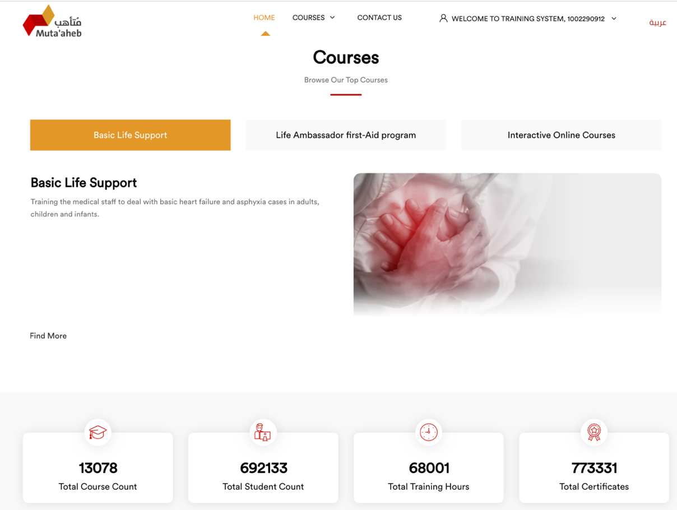

Appendix B:
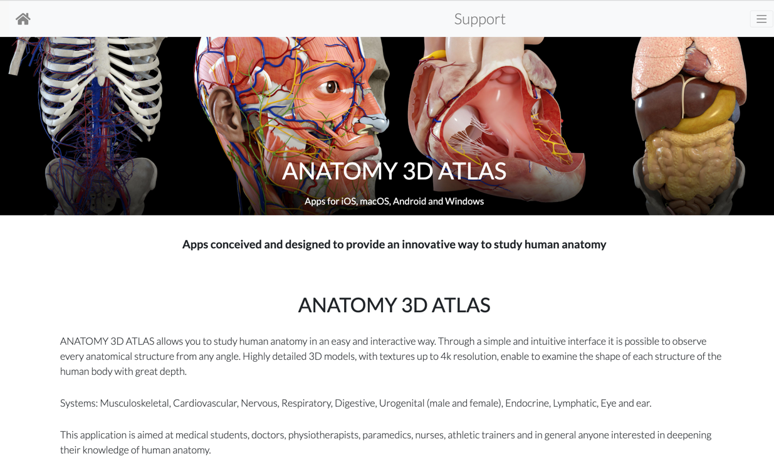
The main page of the Anatomy 3D Atlas website

Appendix C:
An example of the anatomy of an organ in the Musculoskeletal and Cardiovascular systems (adopted from Anatomy 3D Atlas application)
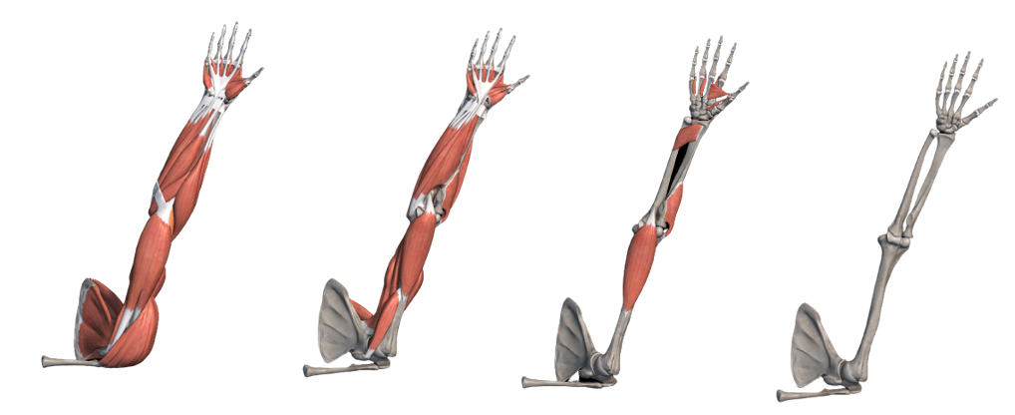

Musculoskeletal system

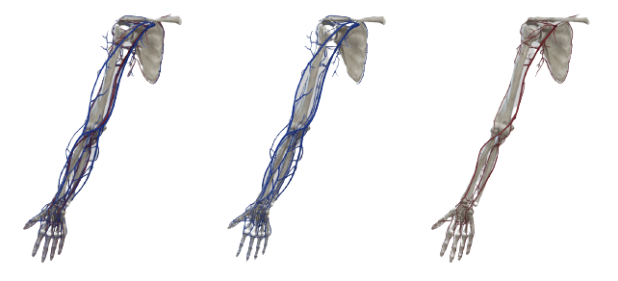

Cardiovascular system

