Table 3. Statistical distribution of millerCoef, compltResp and lnReg variables in the dataset
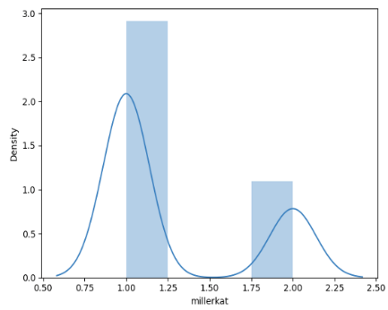 | 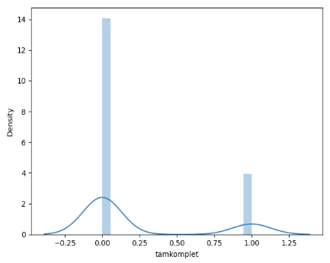 | 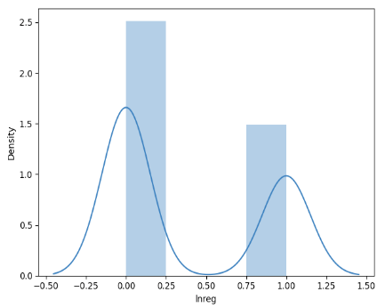
millerCoef | compltResp | lnReg

Table 5. Scenario test data classification distribution
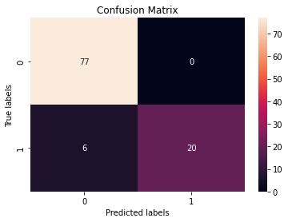 | 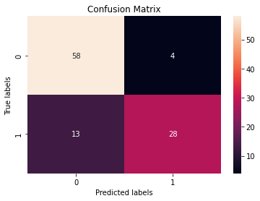 | 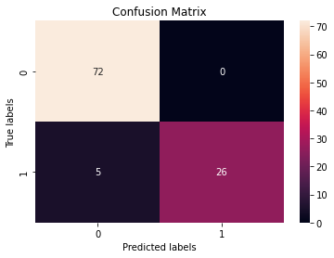
Scenario 1 Confusion Matrix | Scenario 2 Confusion Matrix | Scenario 3 Confusion Matrix

Table 7. AUC — ROC metrics

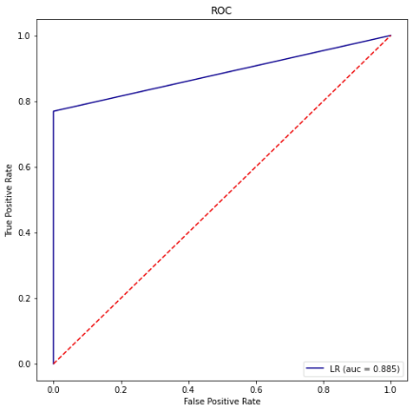 | 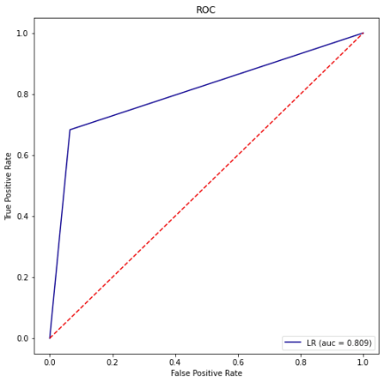 | 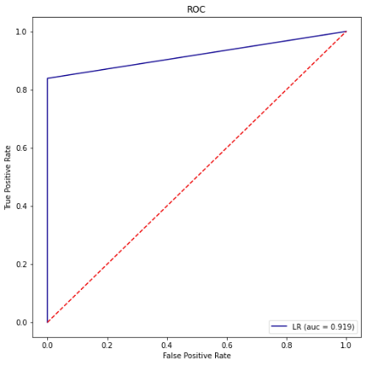
Scenario 1. ROC – AUC Score | Scenario 2. ROC – AUC Score | Scenario 3. ROC – AUC Score
Table 7. AUC — ROC metrics

