Supplementary Figures
Fig.S1 The analysis process of TCR repertoire diversity.
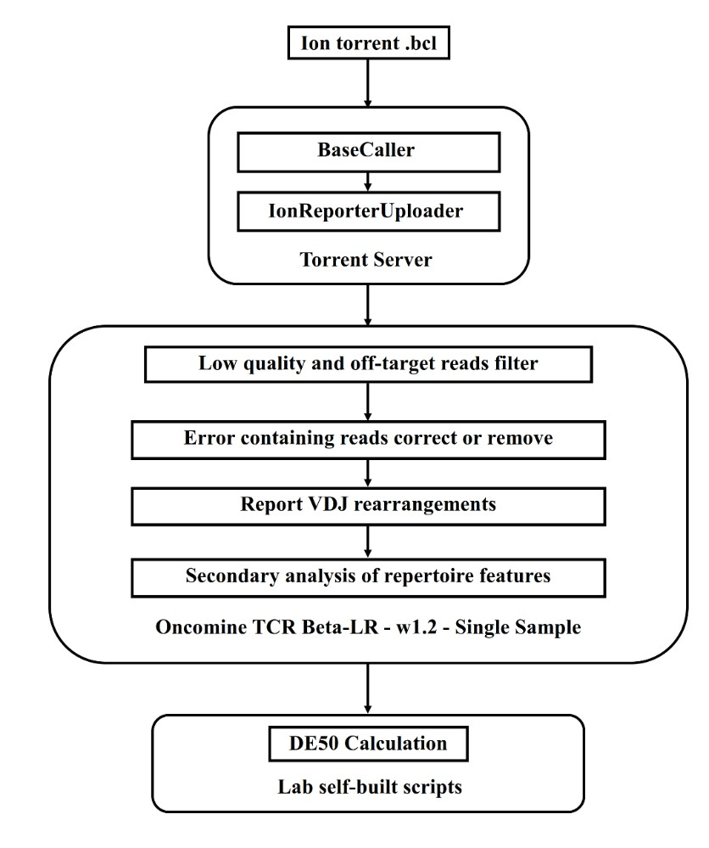

Fig.S2 Schematic graph for DE50 calculation. X-axis, clone ranks based on the frequency of each clonetype in descending order; y-axis, cumulative frequency of each clonetype.
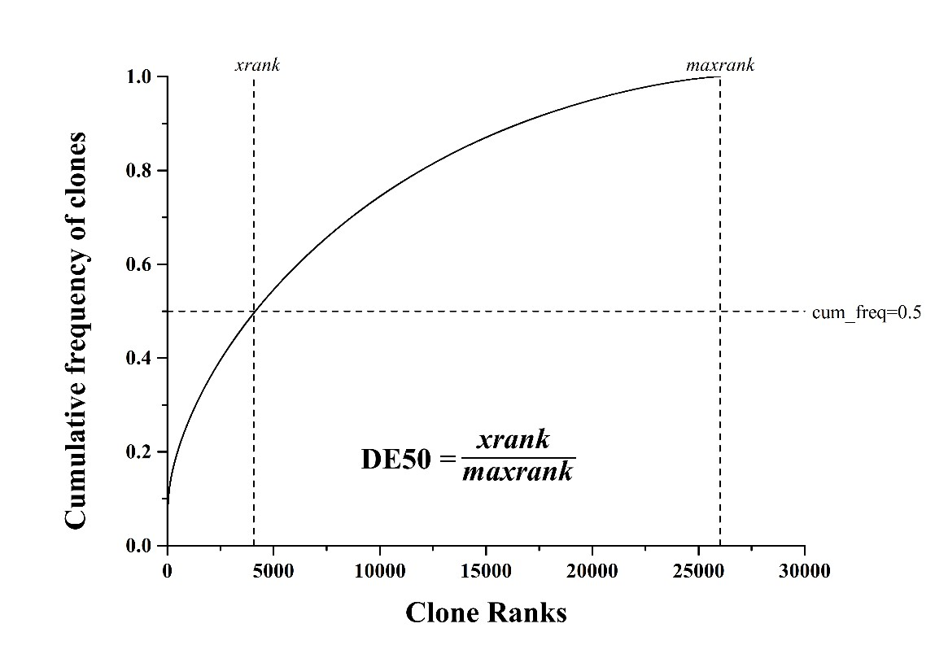

Fig.S3 Kaplan–Meier plots showing PFS probability in responders and non-responders to anti-PD-1 treatment.
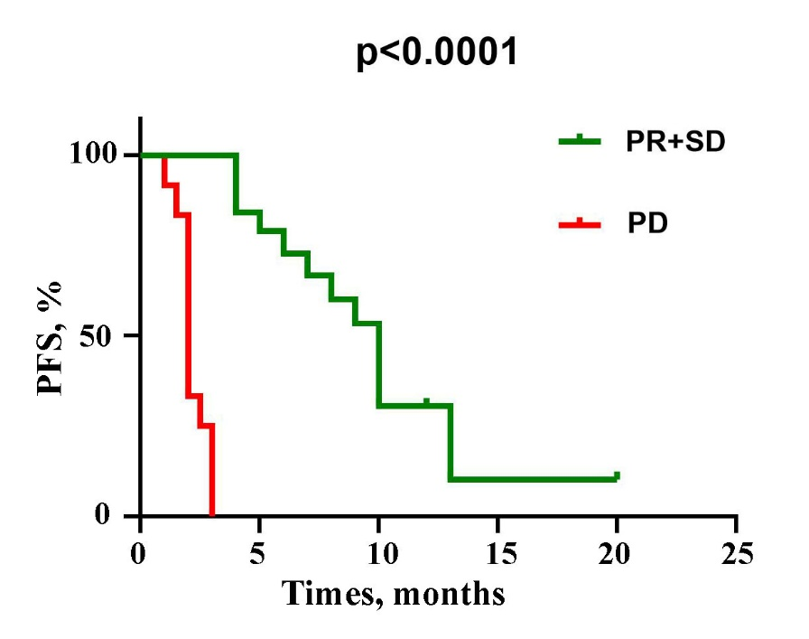

Fig.S4 Usage frequency of V and J gene segments in PR+SD and PD group. Data are presented as mean ± SEM.
