Supplementary Information(SI)
Modification of suitable electrolytes for high voltage lithium-rich manganese-based cathode with wide-temperature range

Long Zhang ^{a,b,1}，Xi Dong ^{a,b,1}，Yutong Wang ^{a,b}，Xin Wang ^{a,b}, Chunxia Wang ^{a,b}, Tiantian Cao^{c} ，Jiawei Wen ^{a,b,*}, Guoyong Huang ^{a,b,*}
a College of New Energy and Materials, China University of Petroleum, Beijing 102249, China.
b State Key Laboratory of Heavy Oil Processing, College of Chemical Engineering, China University of Petroleum, Beijing, 102249, China
c SINOPEC Research Institute of Petroleum Processing, Beijing 100083, China

* e-mail：wenjiawei1992@cup.edu.cn, huanggy@cup.edu.cn.
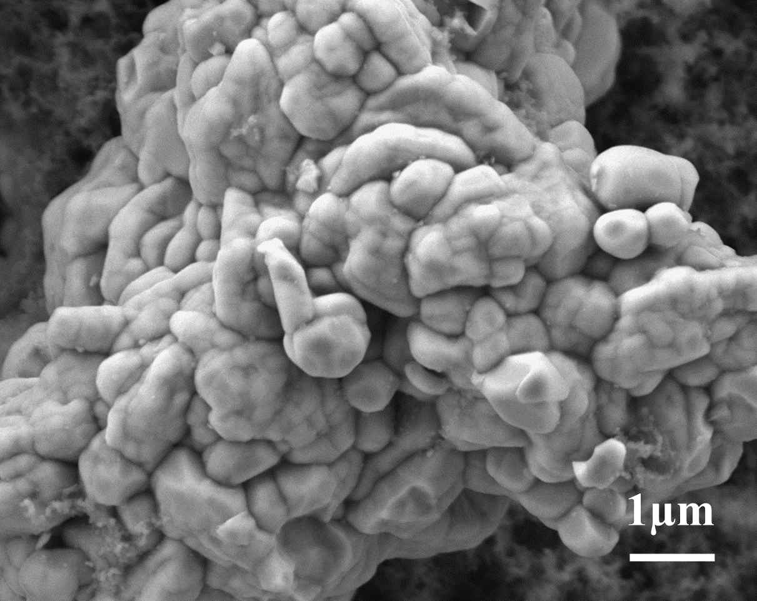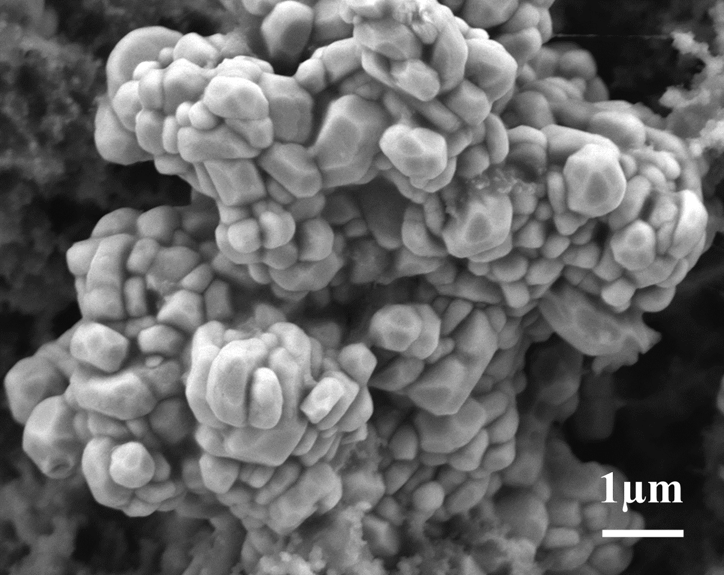
(b)
(a)
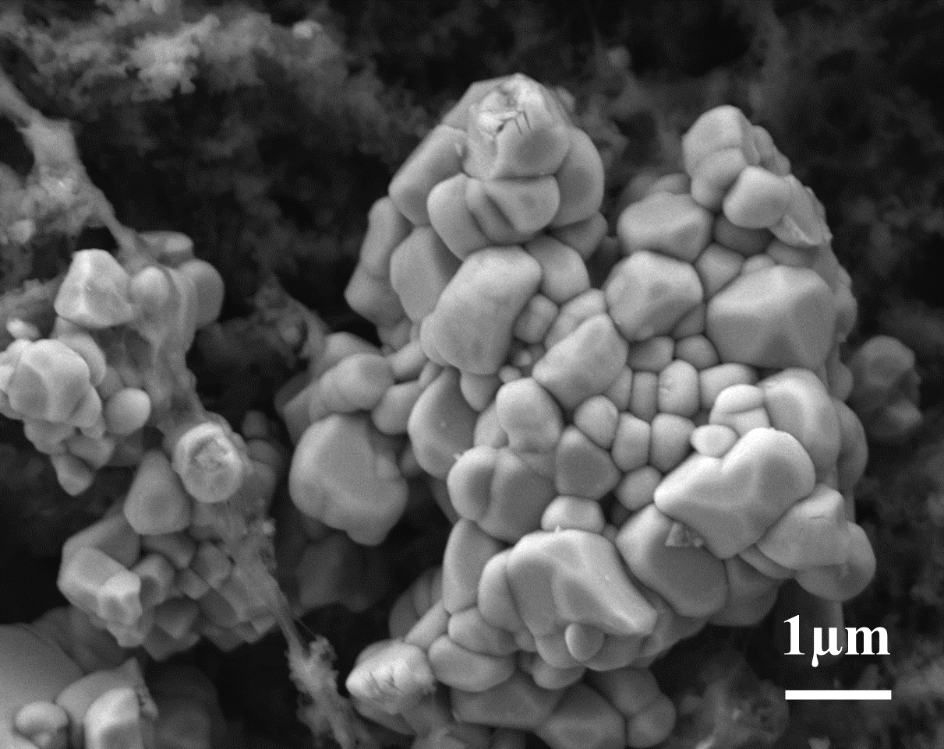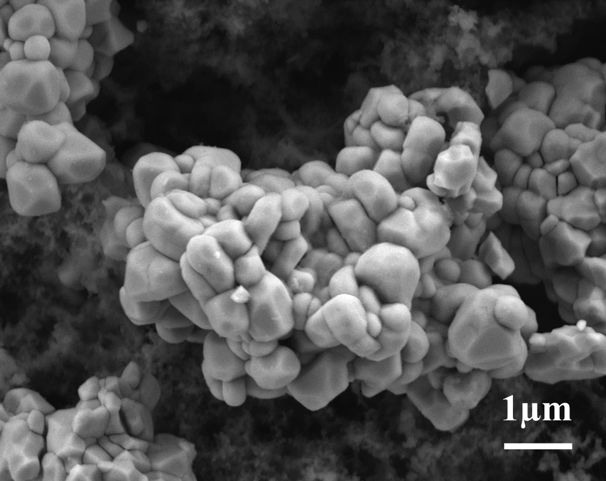
(d)
(c)
Fig. S1 SEM images of the LMR electrode. (a) Pre-Cycle (b) Base, (c) Base + FEC, (d) Base+FEC+2%LiDFOB electrolyte

