Supplementary Material
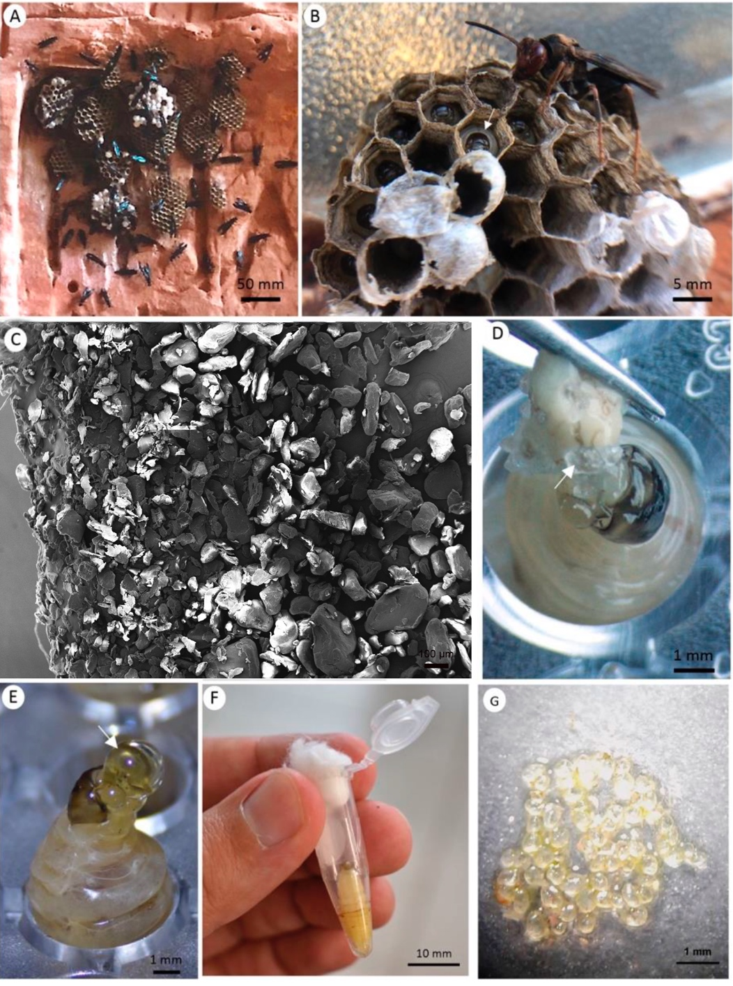
Wasps and microparticles. (A) A typical Polistes satan colony with combs independently attached to the substrate. (B) A larva (arrow) within a nest cell. (C) Polystyrene microparticles under a scanning electron microscope. (D) Hand-feeding a larva with a mashed pupa of T. molitor with MPs attached (arrow). (E) A larva feeding a drop of sugar solution (arrow). (F) A tube with a pupa. (G) Microplastics recovered from food bolus of a larva that ingested 16 mg of polystyrene microparticles.

