pH-Responsive bio erodible glipizide loaded PLA@GT-Dextran core-shell microspheres for antidiabetic drug delivery.
Sumit Singh¹, Smriti Bansal², Ankita Singh³, Deepak Poddar⁴*, Anjana Sarkar⁵
Department of Chemistry, Netaji Subhas University of Technology (N.S.U.T), Azad Hind Fauj Marg, Sector-3, Dwarka, New Delhi-110078, INDIA
¹sssumitsingh69@gmail.com, ²smritibansal45@gmail.com, ³ankitachem17@gmail.com, ⁴poddardeepakpoddar@gmail.com, ⁵anjisarkar@gmail.com
* Corresponding author

S.1. Optimization of conditions for fabrication of microparticles
S.1.1. PVA Concentration and stirring speed
To fabricate microparticles via the emulsion solvent evaporation technique, different parameters, such as the stirring rate and concentration of the emulsifier, were standardized to achieve constant results. Polyvinyl alcohol (PVA) had been used as an emulsifier because it is easily washable, non-toxic, readily available, biocompatible, and has a hydrophilic to lipophilic balance (HLB) of 18 which means it can be efficiently used to stabilize oil in water emulsions [1]. For optimum fabrication of microparticles, the concentration of PVA was optimized from 0.25 to 1.25 (w/v) %. Image J software was used to analyze the obtained microparticle images average particle size and particle size distribution.
The distribution curve (Fig.S1) shows the effect of PVA concentration on particle size distribution. Based on the findings, with increasing concentrations of PVA, a well-defined spherical geometry with a narrow particle size distribution curve was obtained due to a rise in the viscosity of the PVA solution. Along with spherical geometry, a reduction in the average particle size of PLA microparticles was observed because an increase in the viscosity of PVA solution results in high shear forces, which causes larger droplets to stretch and breakdown into smaller droplets, but this trend was observed up to a concentration, i.e., 1 (w/v) %, on further increasing the concentration of PVA, average microparticle size increases and the distribution curve become widen due to coating of PVA film over the microparticles that is easily visualized in fig.S2.
The stirring rate was optimized by keeping the optimized PVA concentration constant at 1 (w/v) %. The stirring rate varied from 200-1000 rpm. Average particle size and particle size distribution were analyzed by Image J software. Based on the results, at 200 rpm, the average particle size of 55.98 ± 12.76 µm was obtained, which decreased to 27.23 ± 4.67 µm at 800 rpm because of the application of higher shear forces that led to the conversion of bigger droplets to smaller ones as shown in fig.S3[2]. On further increasing of stirring, no significant changes were observed in average particle size and distribution as visualized in fig.S4 because it is tough to break a smaller droplet further.

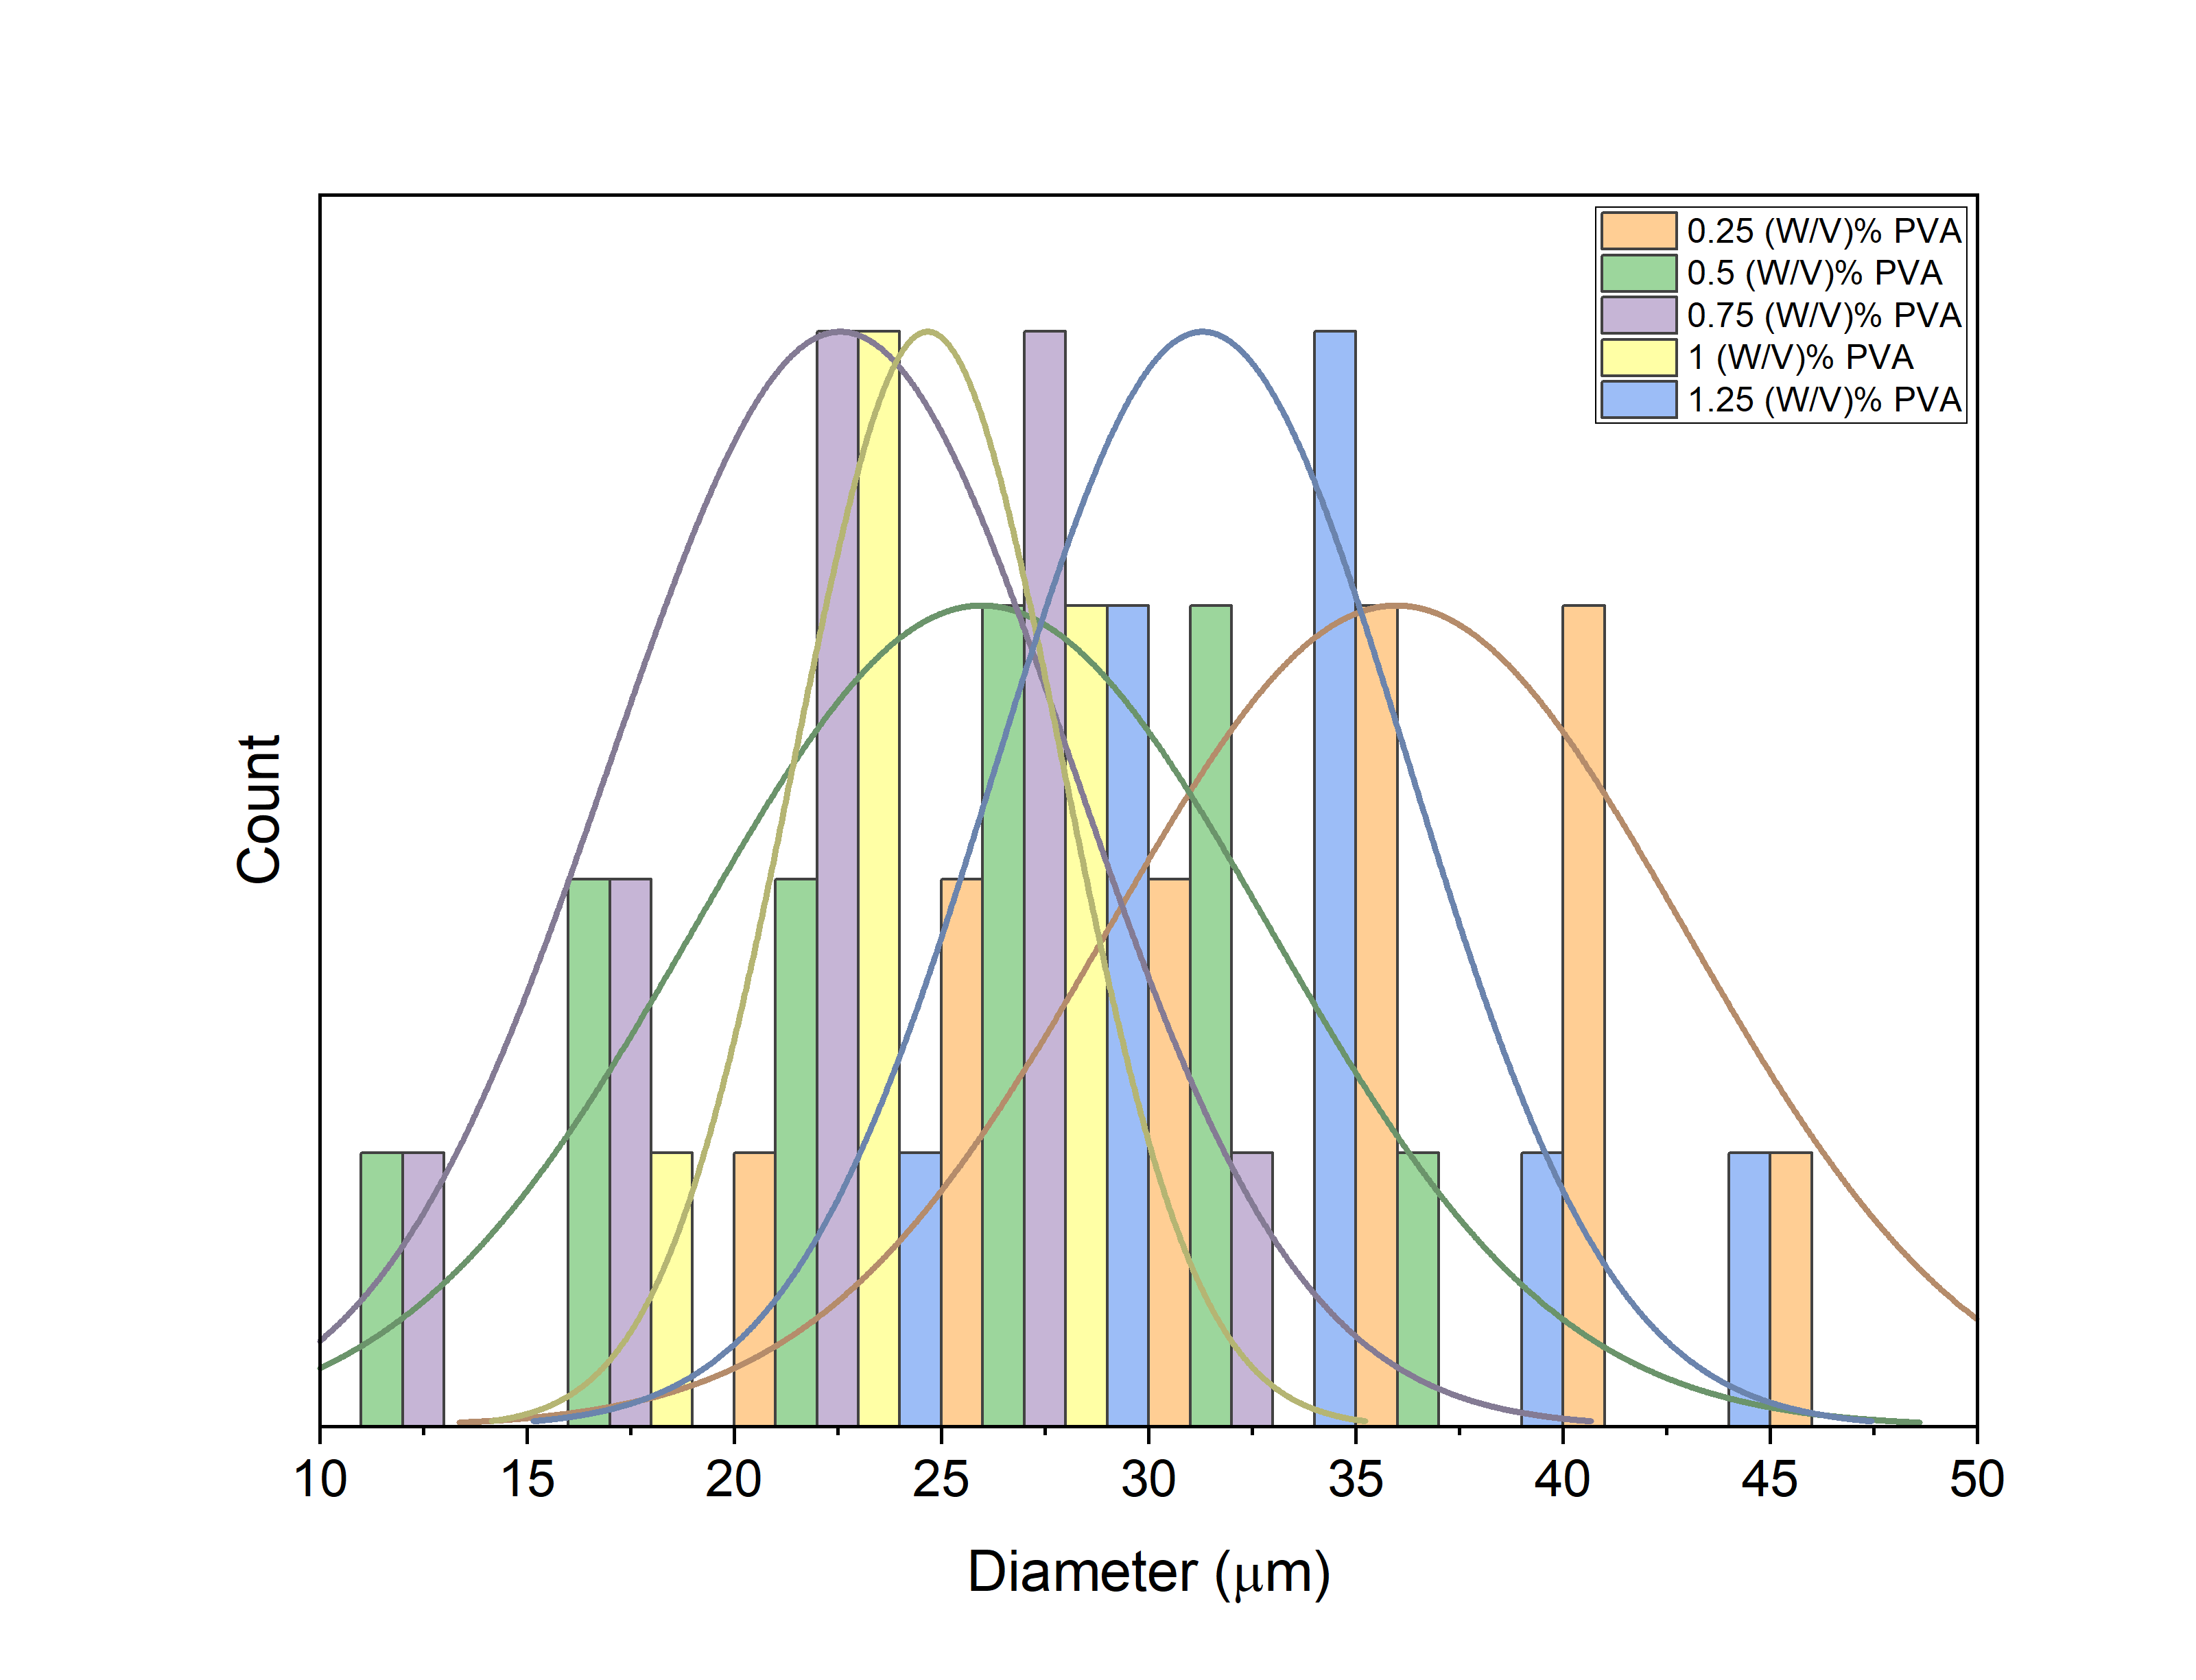
Fig.S1 Effect of PVA concentration on particle size distribution
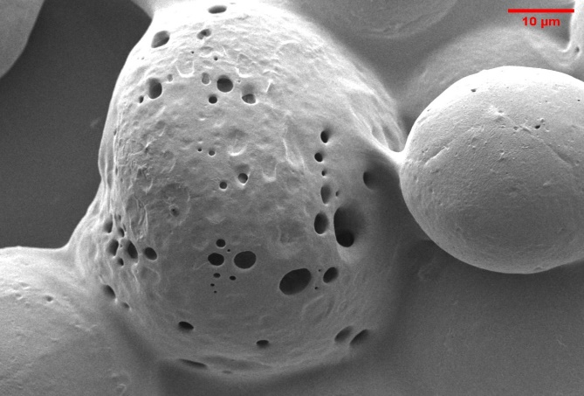
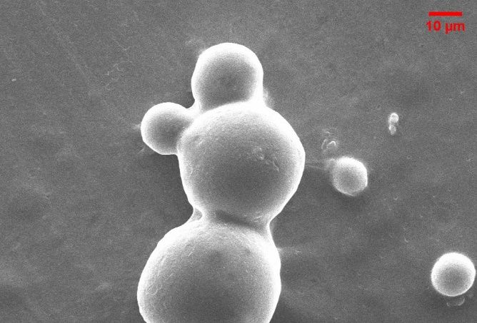
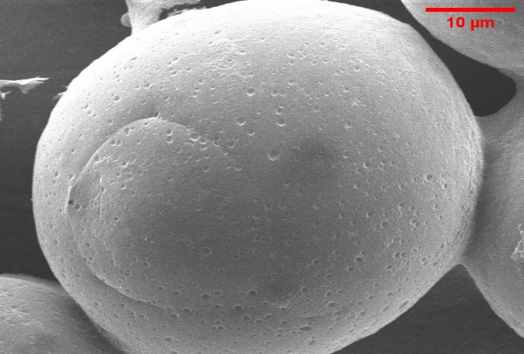
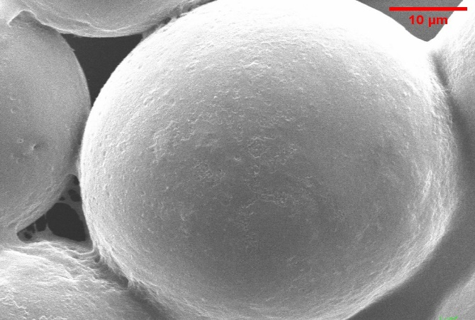
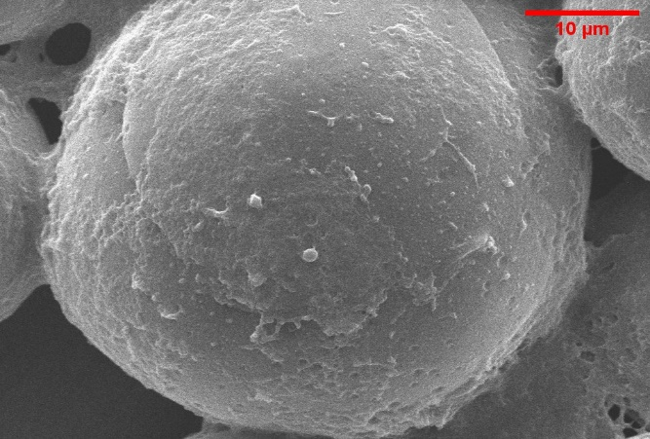

A
B
C
D
E
Fig.S2 FESEM image showing effect of increasing concentration of PVA microparticles on surface morphology

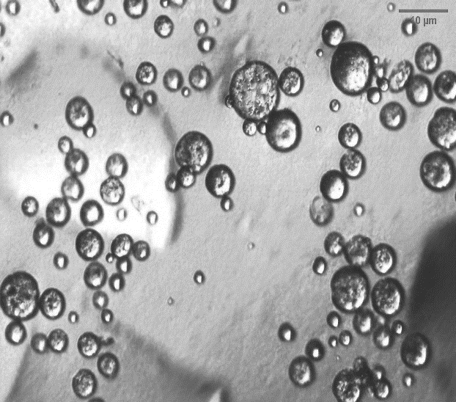
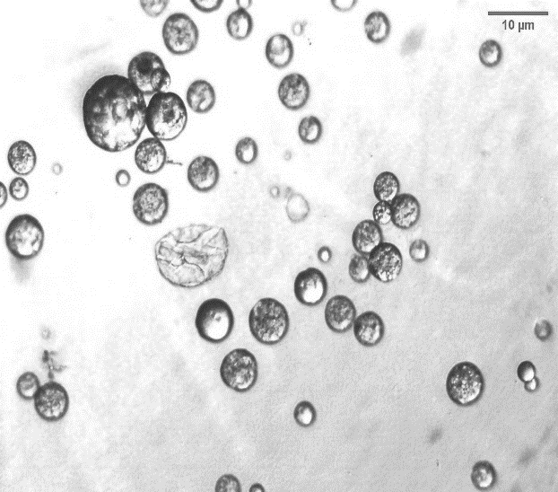
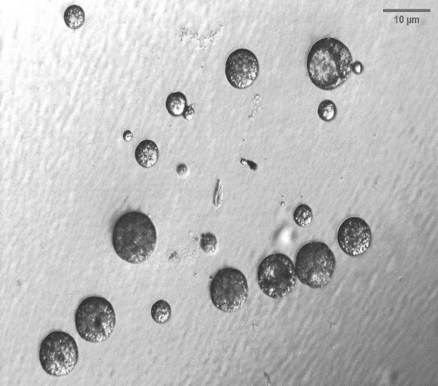
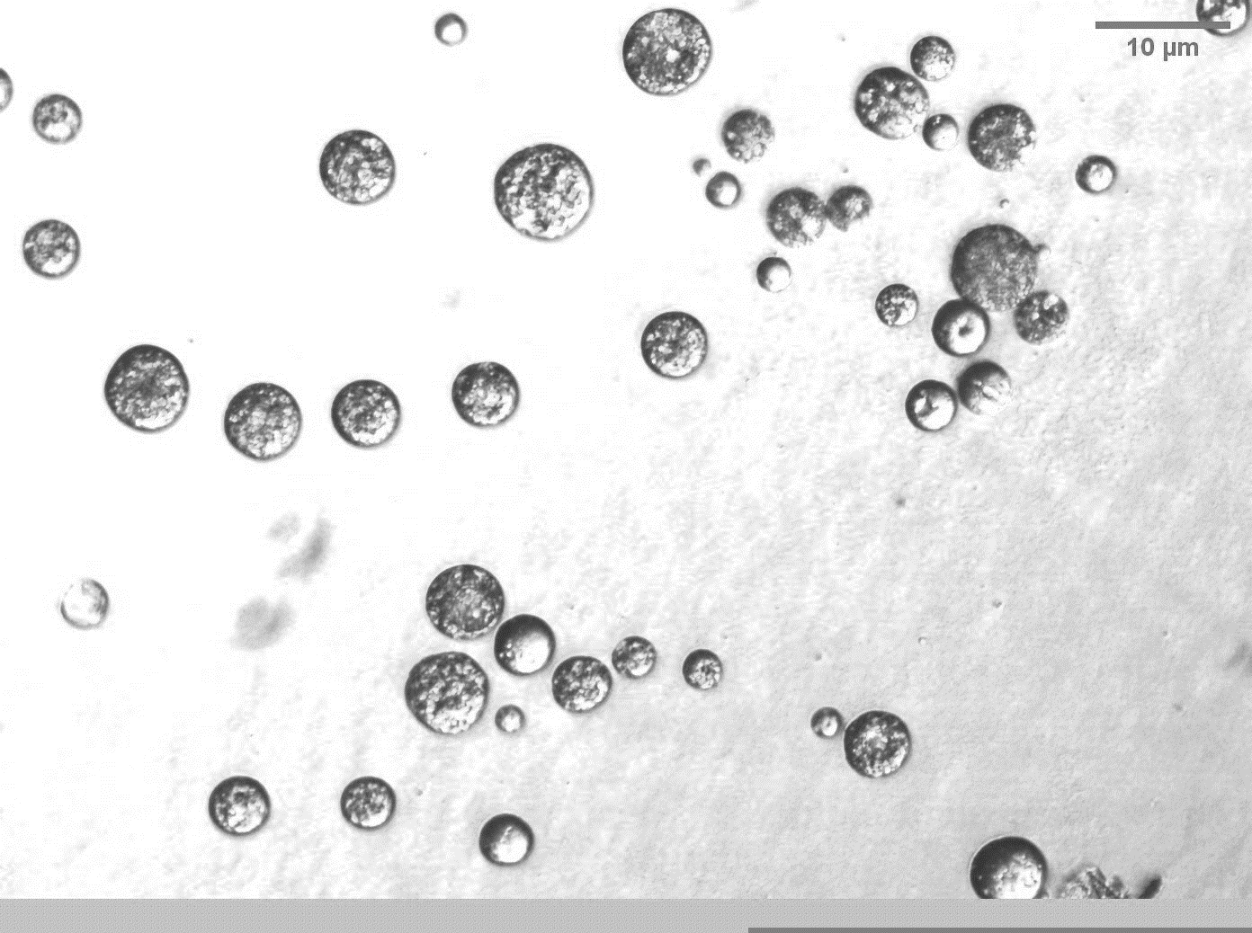
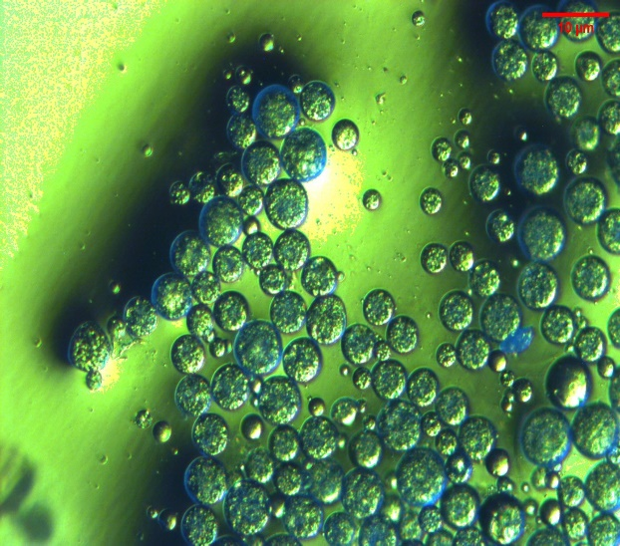
Fig.S3 Optical image representing effect of increasing Rpm change on microparticles surface morphology
A
B
C
D
E
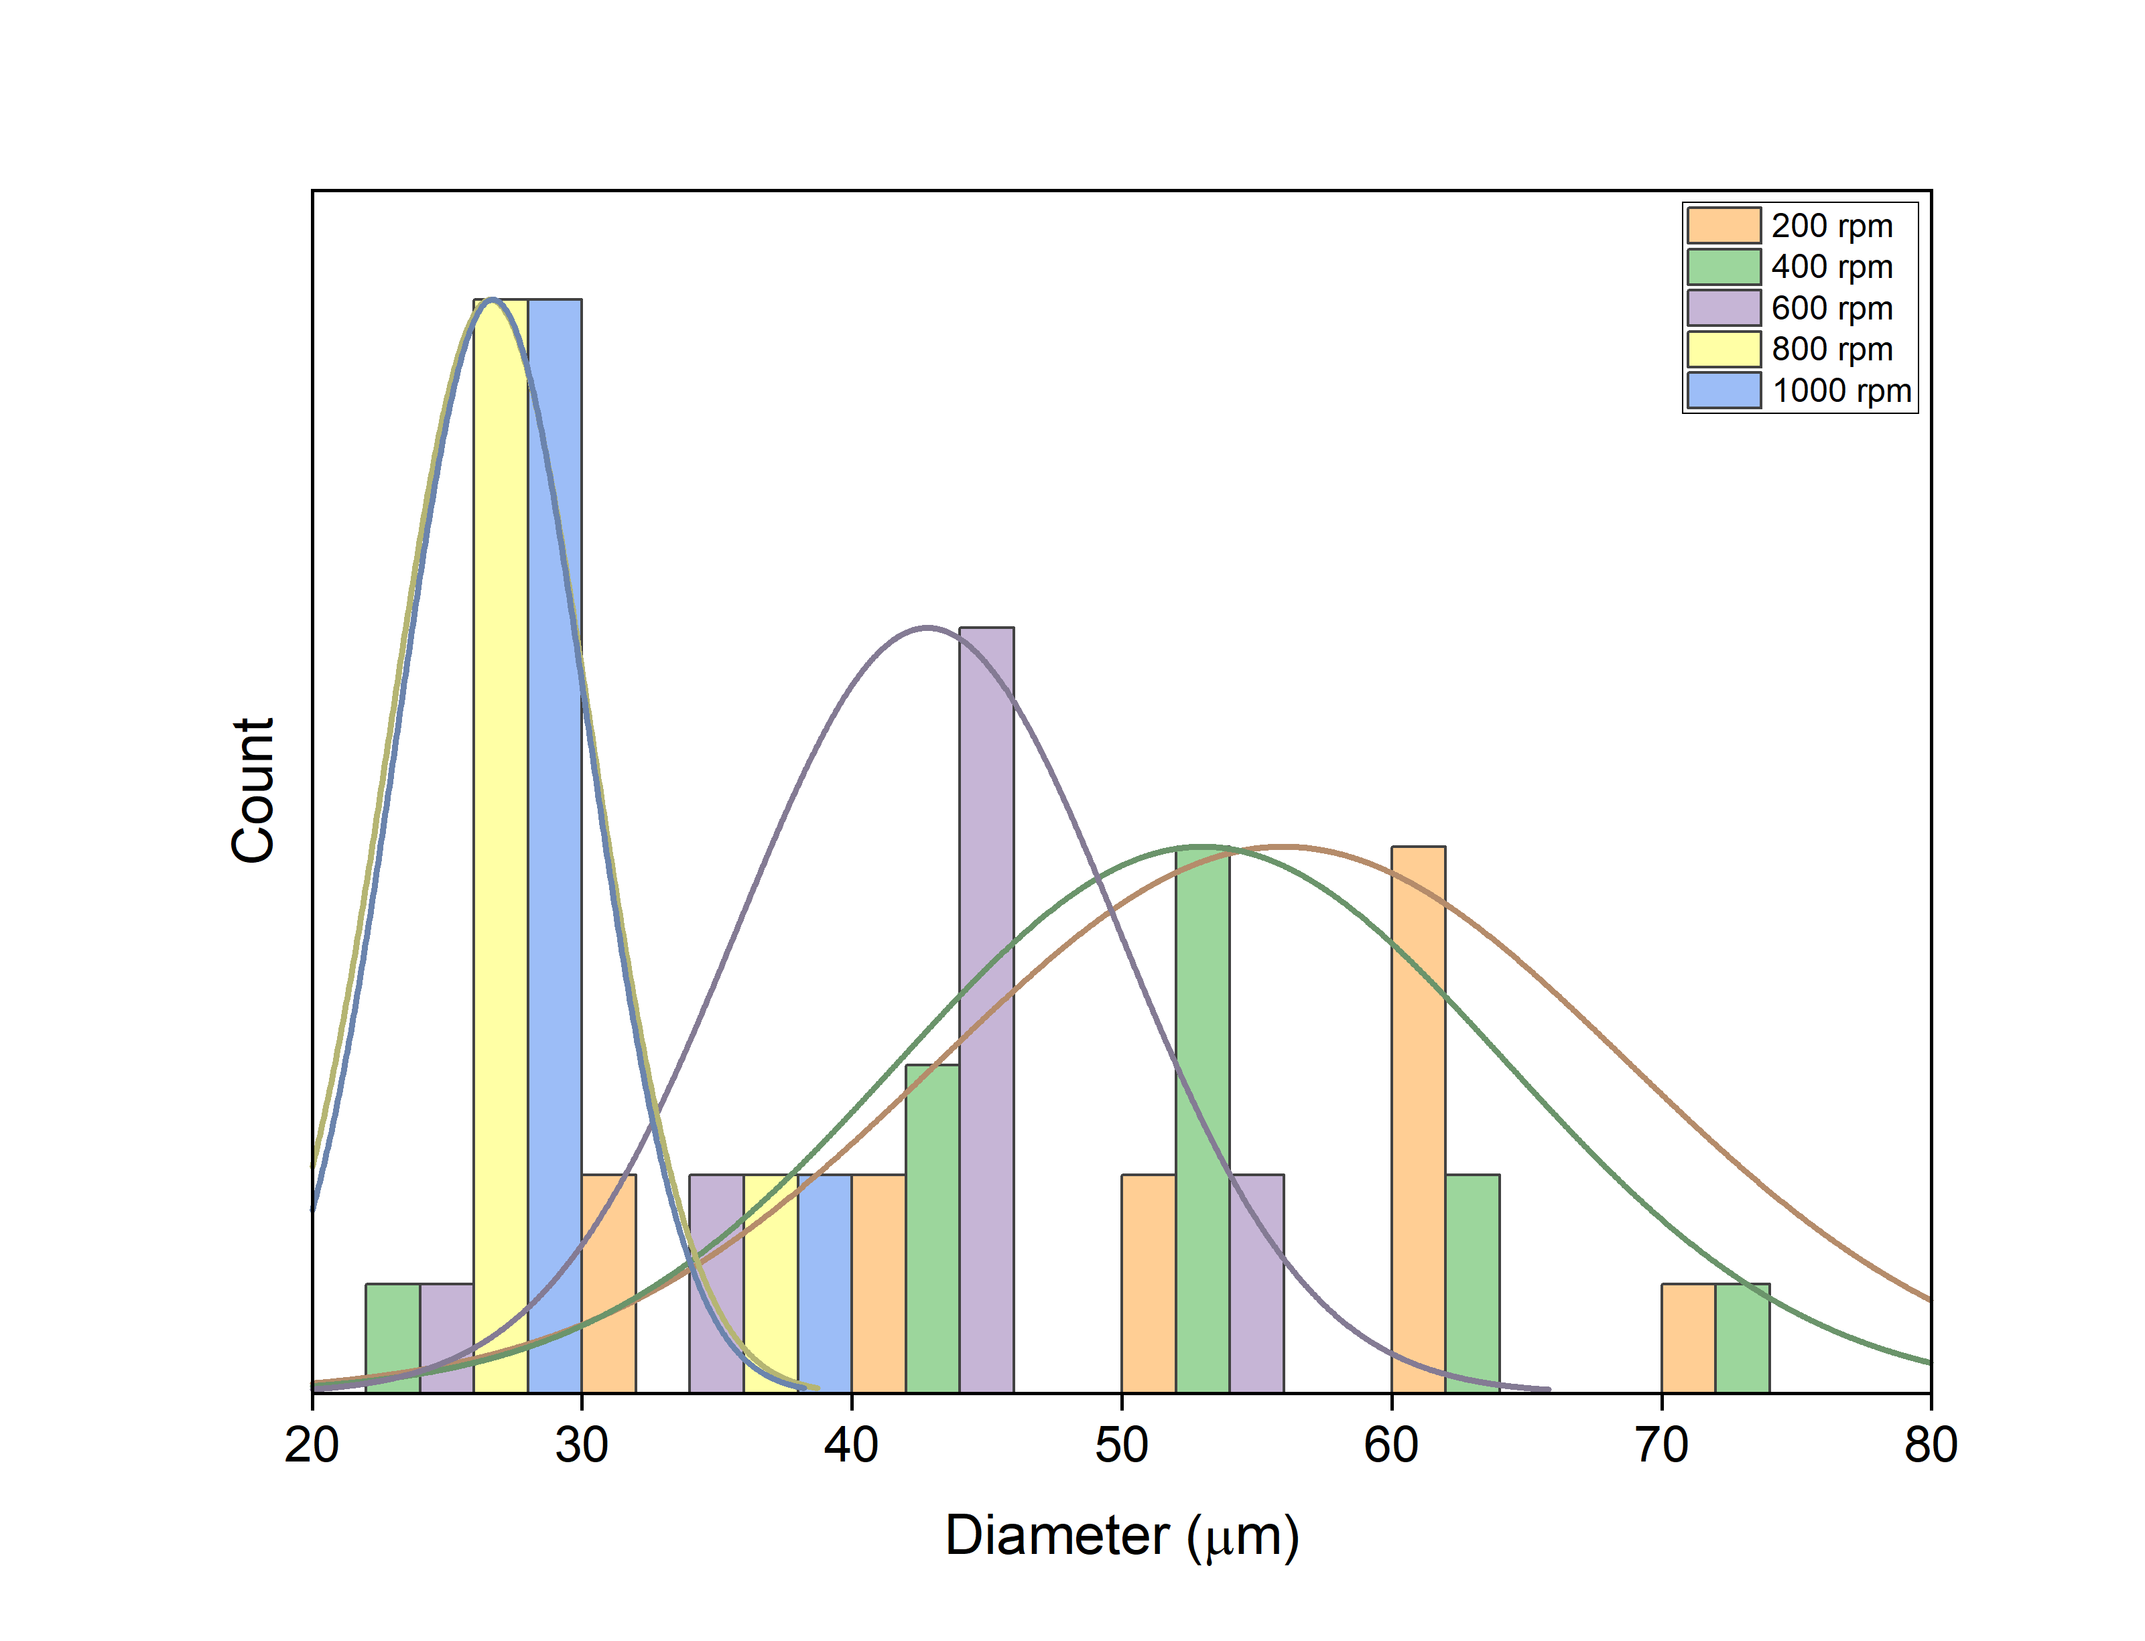
Fig.S4 Effect of increasing Rpm change on particle size distribution
S.1.2. PLA concentration
To fabricate porous microparticles by emulsion solvent evaporation technique, PLA concentrations were optimized from 0.1 to 0.3 (w/v) % by keeping the optimized PVA concentration constant (1 w/v%) and at a constant optimized stirring rate (800 rpm). Image J software was used to examine the average particle size and particle size distribution of the obtained microparticle’s FESEM images. According to the results obtained, an increment in the concentration of PLA from 0.1 to 0.3 (w/v)%, reduction in the size of the microparticle, and a monodisperse behavior was observed because on the rising concentration of PLA within a microemulsion droplet results in the slight increase in the microdroplet volume due to entropic factor, which results in higher susceptibility to stretch under constant stirring and tends to breakdown into small droplets [3]. This trend is observed up to 0.2 (w/v) %. Beyond that, the monodisperse behavior started vanishing because further increasing PLA concentration within a microdroplet leads to an increase in the number of polymer chains per microdroplet so even a smaller detachment from bigger microdroplets has a sufficient amount of polymer that can yield a smaller particle and as a result in the widening of the distribution curve was observed as shown in fig.S5.[4].
The effect of PLA concentration on surface morphology can be seen from the FESEM image in the fig.S6. With the rising concentration of PLA, the geometry of the microparticle was more spherical, and pore size increased up to a concentration of 0.2 (w/v %.) On the further increase in concentration, reduction in the average surface pore diameter was observed because the sufficient amount of PLA chains was present within a microdroplet has a higher tendency to reduce its surface energy [5]. Also, at higher concentrations of PLA, a mixed morphology is perceived, i.e., discs are also formed along with spherical microparticles which is due to the fact that at higher concentration of PLA, PLA within a microparticle get readily precipitate. As during microparticles distortion under applied shear the elongated microdroplet precipitates before separating into small droplets, which leads to formation of discs [6].
S.1.3. GT-Dextran concentration for coating
The dip coating concentration of GT-dextran was optimized by varying the ratio of PLA: GT-dextran as 1:0.25, 1:0.5, and 1:1(w/v %) to yield core-shell microparticles. The average particle size and distribution of obtained GT-dextran coated PLA microparticles (GT-dex-GI-PLA) were analyzed by FESEM images using Image J software, as shown in the fig.S7. From the analysis, an increase in average particle size from 17.17 ± 1.33 µm to 22.23 ± 2.91 µm and a widening of the distribution curve was observed because rising concentration of GT-dextran will have higher coating solution viscosity that results in the thicker coating as visualized in fig.S8. Also, from the FESEM images, GT-dex-GI-PLA microparticles having 0.25 (w/v %) shows a uniform coating with a smooth surface.

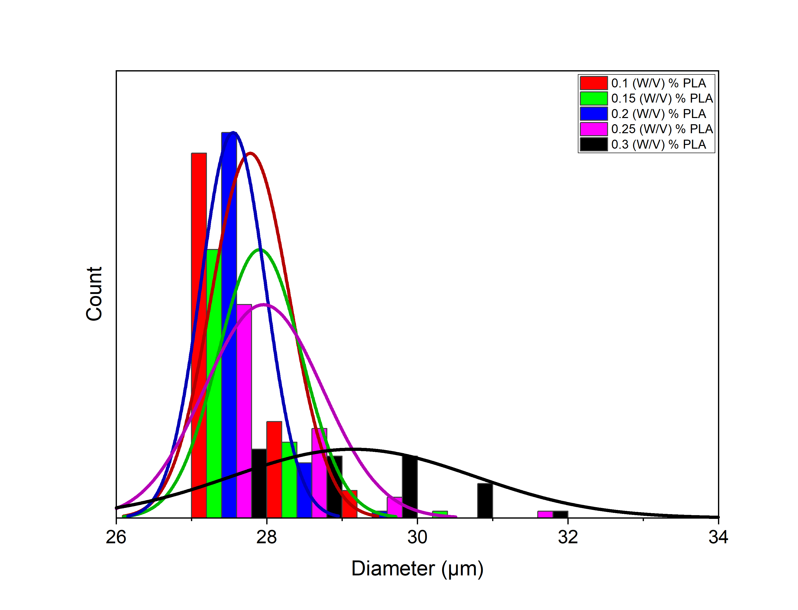
Fig.S5 Effect of PLA concentration on particle size distribution

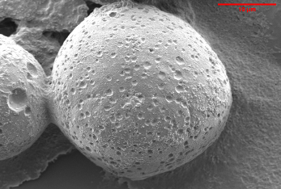
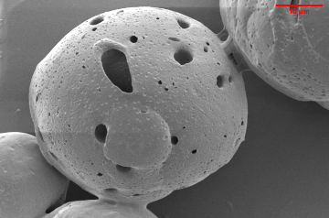
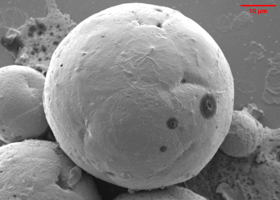
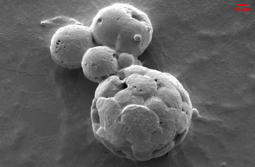
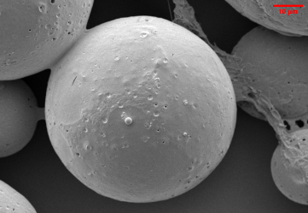
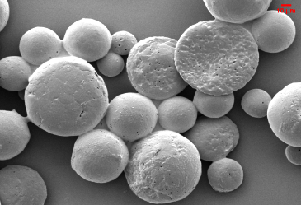

Fig.S6 FESEM image show effect of increasing concentration of PLA microparticles on surface morphology
A
B
C
D
E
F

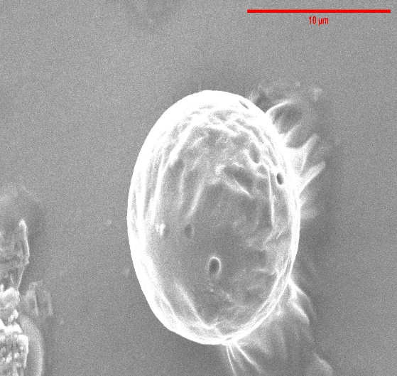
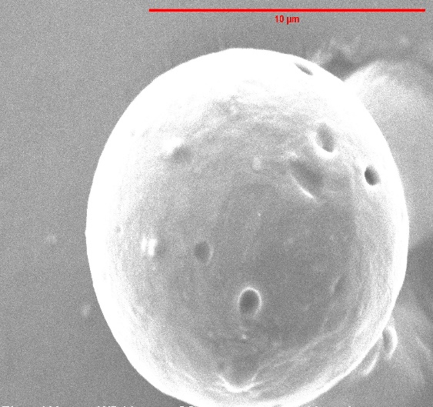
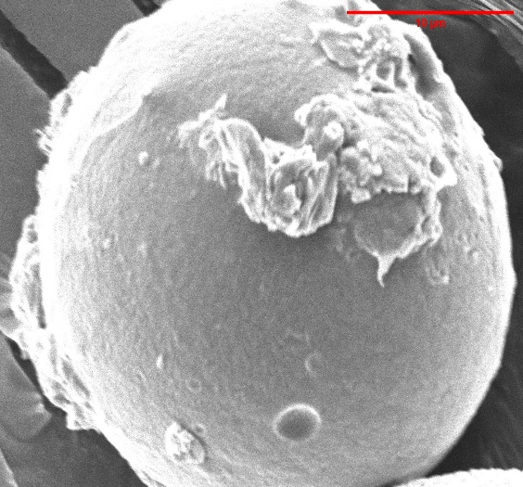

A
B
C
Fig.S7 Effect of GT-dextran on surface morphology
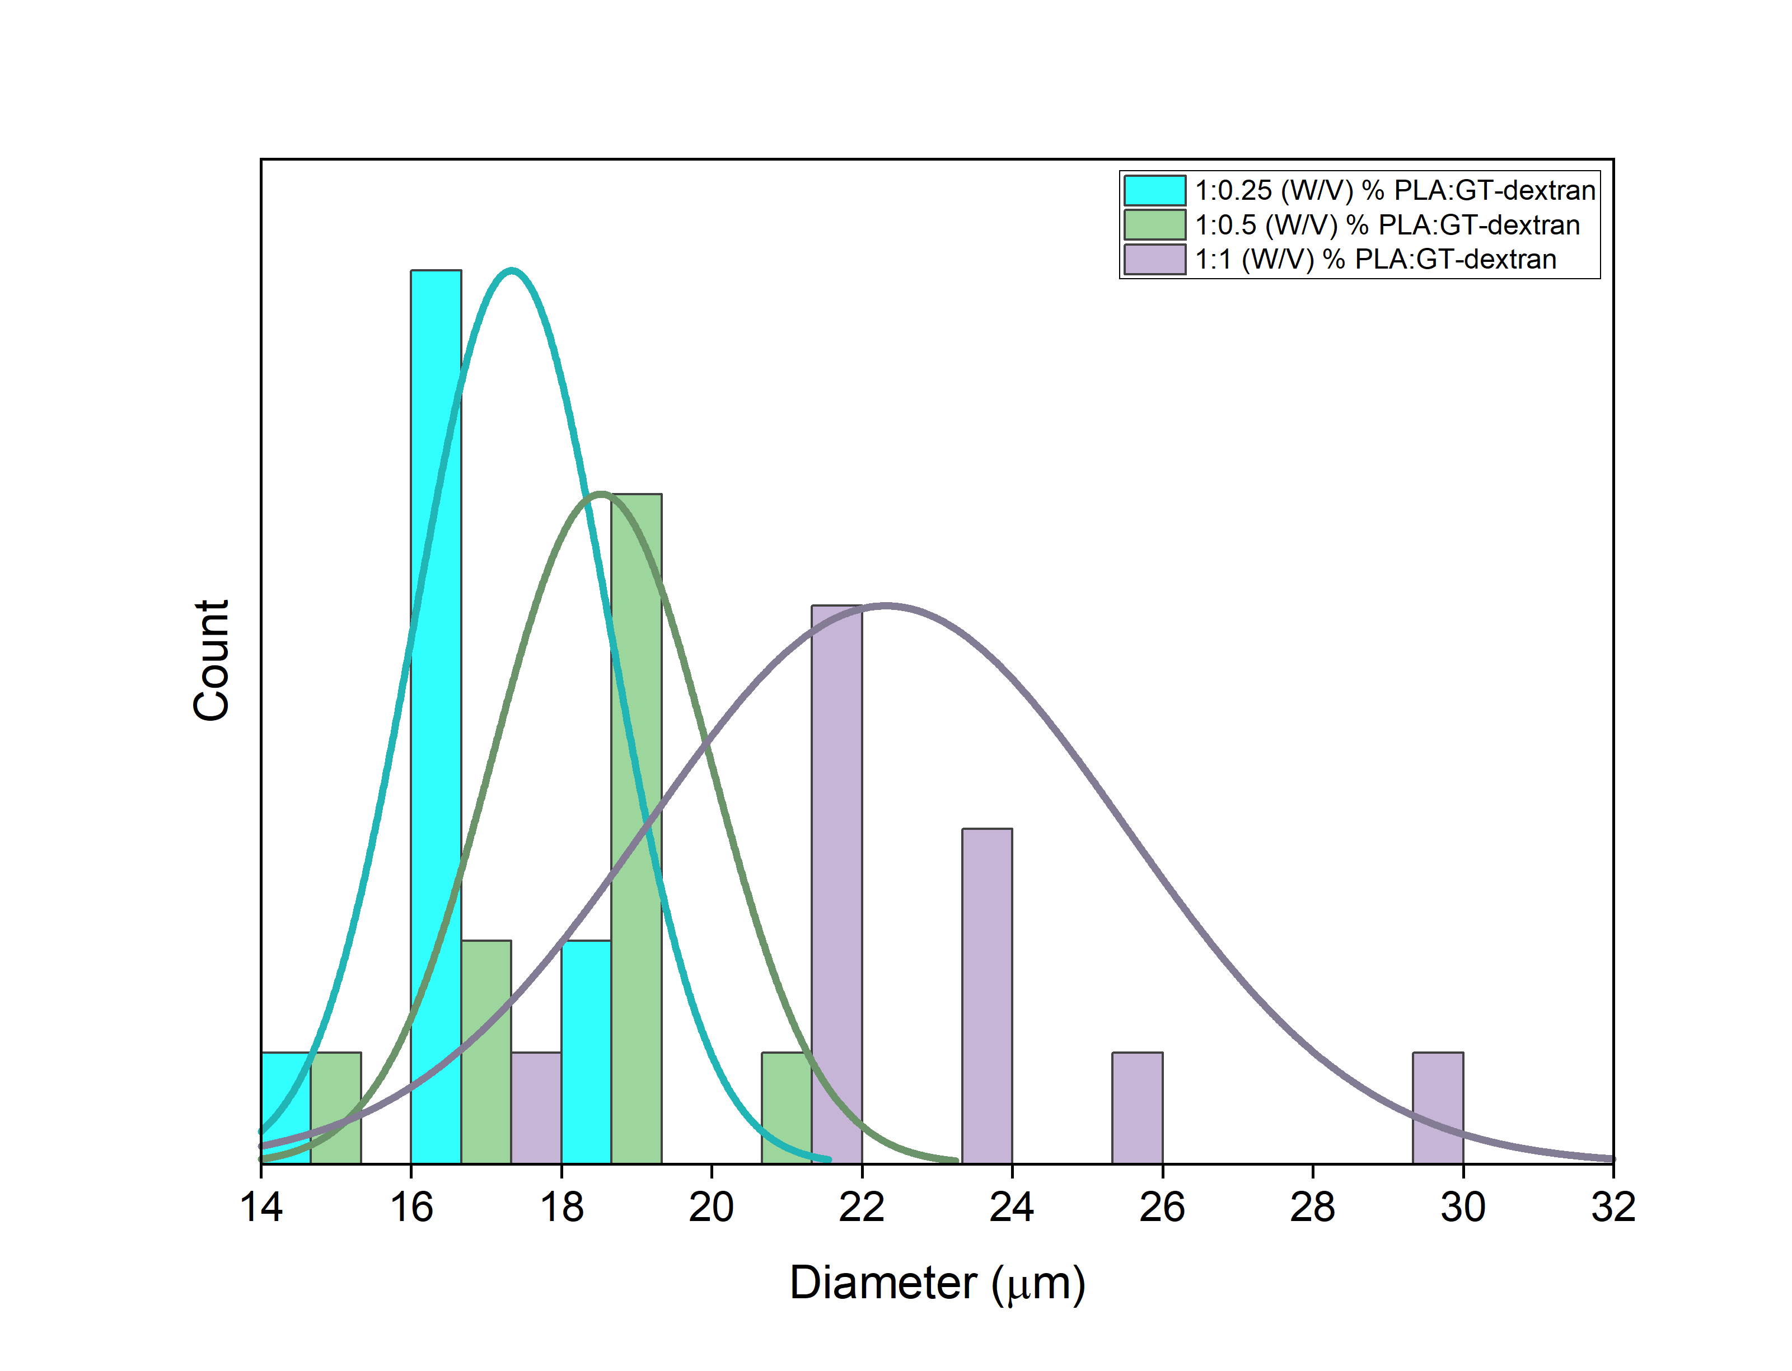
Fig.S8 Effect of concentration of GT-dextran on Particle size distribution curve

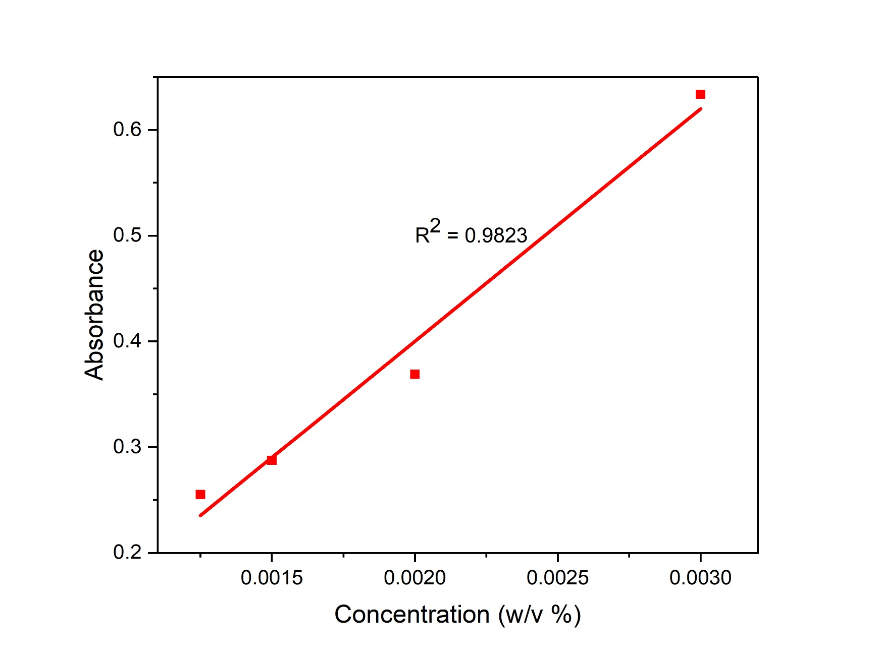
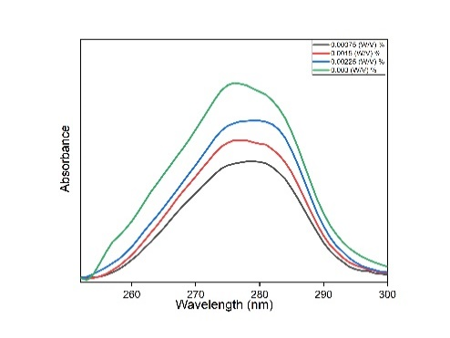
Fig.S9 Standard Curve for Glipizide at λ = 275 nm.

S.No. | Sample | Bands (cm⁻¹) | Functional group and type of vibration | Reason
1. | Dextran | 3485 | -OH stretching | -OH, group present in polysaccharide
 | Dextran | 2948 | C–H stretching | -CH₂- group
 | Dextran | 1635 | -OH bending vibration | Water absorption
 | Dextran | 1158 | -O-C- | α-(1 → 4) glycosidic bond
 | Dextran | 1016 | -O-C- | α-(1 → 6) glycosidic bond
 | Dextran | 930 | -C-O-C- bending vibration | α-glycosidic bond
2. | GT-Dextran | 1056 and 1100 | -C-O-C- bending vibration | Ether bond between GTMAC and Dextran
 | GT-Dextran | 1285 | -CN stretching vibration | -C-N(CH₃)₃ present in GTMAC
Table (S1). Characteristic band obtained from FTIR spectrum of Dextran and GT-Dextran.

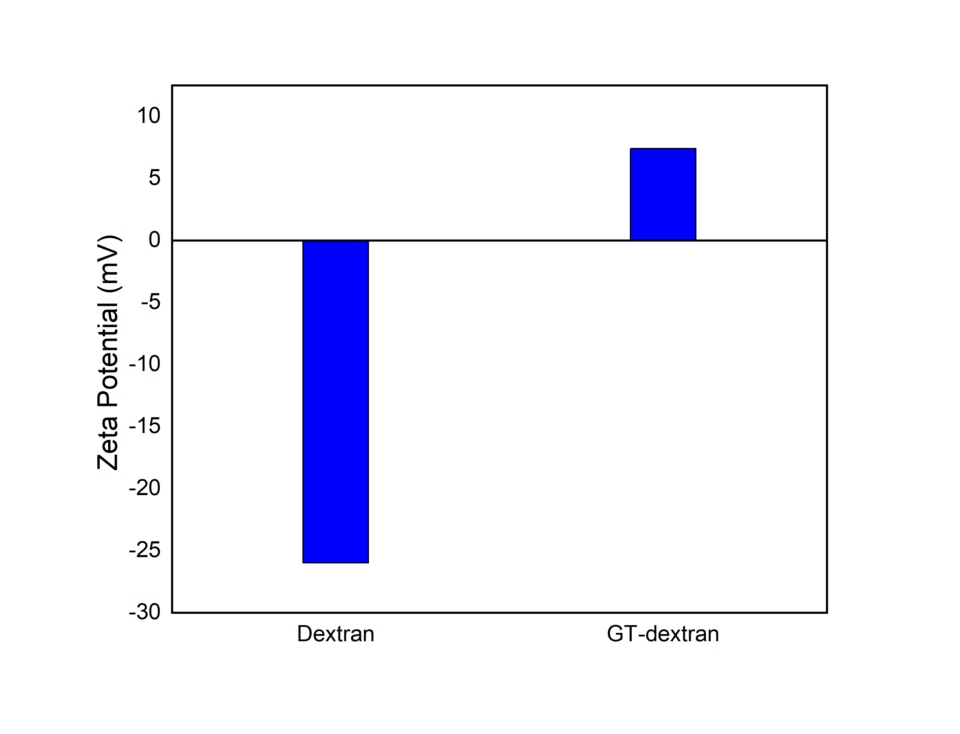
Table (S2). Thermal analysis of Dextran and GT-Dextran
Fig.S10 Zeta potential of Dextran and GT-Dextran
S.No. | Sample | Degradation onset Temperature (°C) | Total Mass loss (%) | Moisture content (%)
1. | Dextran | 330 | 73.63 | 10.55
2. | GT-Dextran | 280 | 63.05 | 25.49

Table (S3). Characteristic band obtained from FTIR spectrum of Dextran and GT-Dextran.
S.No. | Sample | Band (cm⁻¹) | Functional group and type of vibration | Reason
1. | PLA | 2995 | C-H stretching | -CH₃ Group
 | PLA | 1746 | C=O stretching | Ester bond
 | PLA | 1376 | C-H bending | -CH₃ group
 | PLA | 1080 | -C-O- | Ester bond
 | GI-PLA | 1689 | C=O stretching | Amide bond
2. | GI-PLA | 1663 | C=N stretching | Imine bond
 | GI-PLA | 1653 and 1444 | C=C | Aromatic ring
 | GI-PLA | 1540 | N-H bending | Amide bond
 | GI-PLA | 1151 | C-N stretching | Amide bond
 | GI-PLA | 1033 | S=O stretching | Sulphonyl bond
3. | GT-dex-GI-PLA | 3485 | -OH Stretching | -OH groups in dextran
 | GT-dex-GI-PLA | 2948 | C-H stretching | -CH₂- group in dextran
 | GT-dex-GI-PLA | 1658 | -OH bending | Water absorption
 | GT-dex-GI-PLA | 1138 | -O-C- bending | α-(1 → 4) glycosidic bond
 | GT-dex-GI-PLA | 1027 | -O-C- bending | α-(1 → 6) glycosidic bond
 | GT-dex-GI-PLA | 930 | -C-O-C- bending | α-glycosidic bond
 | GT-dex-GI-PLA | 1100 | -C-O-C- bending | Ether bond between dextran and GTMAC
 | GT-dex-GI-PLA | 1285 | -C-N- stretching | -C-N(CH₃)₃ present in GTMAC

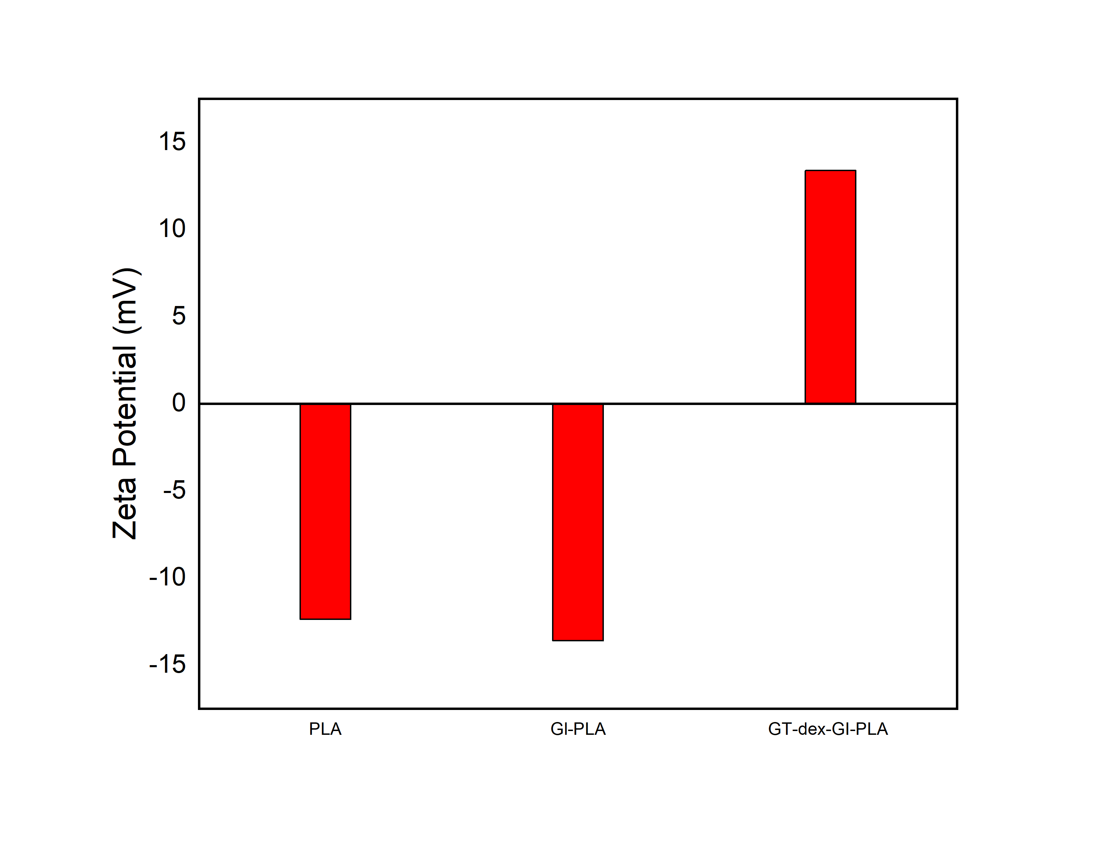
Fig.S11 Zeta Potential of PLA, GI-PLA and GT-dex-GI-PLA

Table (S4). Thermal analysis of PLA, GI-PLA and GT-dex-GI-PLA microparticles
S.No. | Sample | Degradation onset Temperature (°C) | Degradation offset Temperature (°C) | Total mass loss (%)
1. | PLA | 225 | 301 | 79.68
2. | GI-PLA | 126.7 | 286.52 | 89.47
3. | GT-dex-GI-PLA | 270.77 | 332.86 | 90.7

Table (S5). % of In-vitro release profile of glipizide
S.No. | pH |  | Phase 1 | Phase 2 | Phase 3 | Total release (%)
1. |  | 1.5 | 1.63 | 1.15 | 2.96 | 5.69
2. |  | 7.4 | 24.2 | 24.25 | 11.55 | 60
3. |  | 9.2 | 25.8 | 14.91 | 3.78 | 44.49

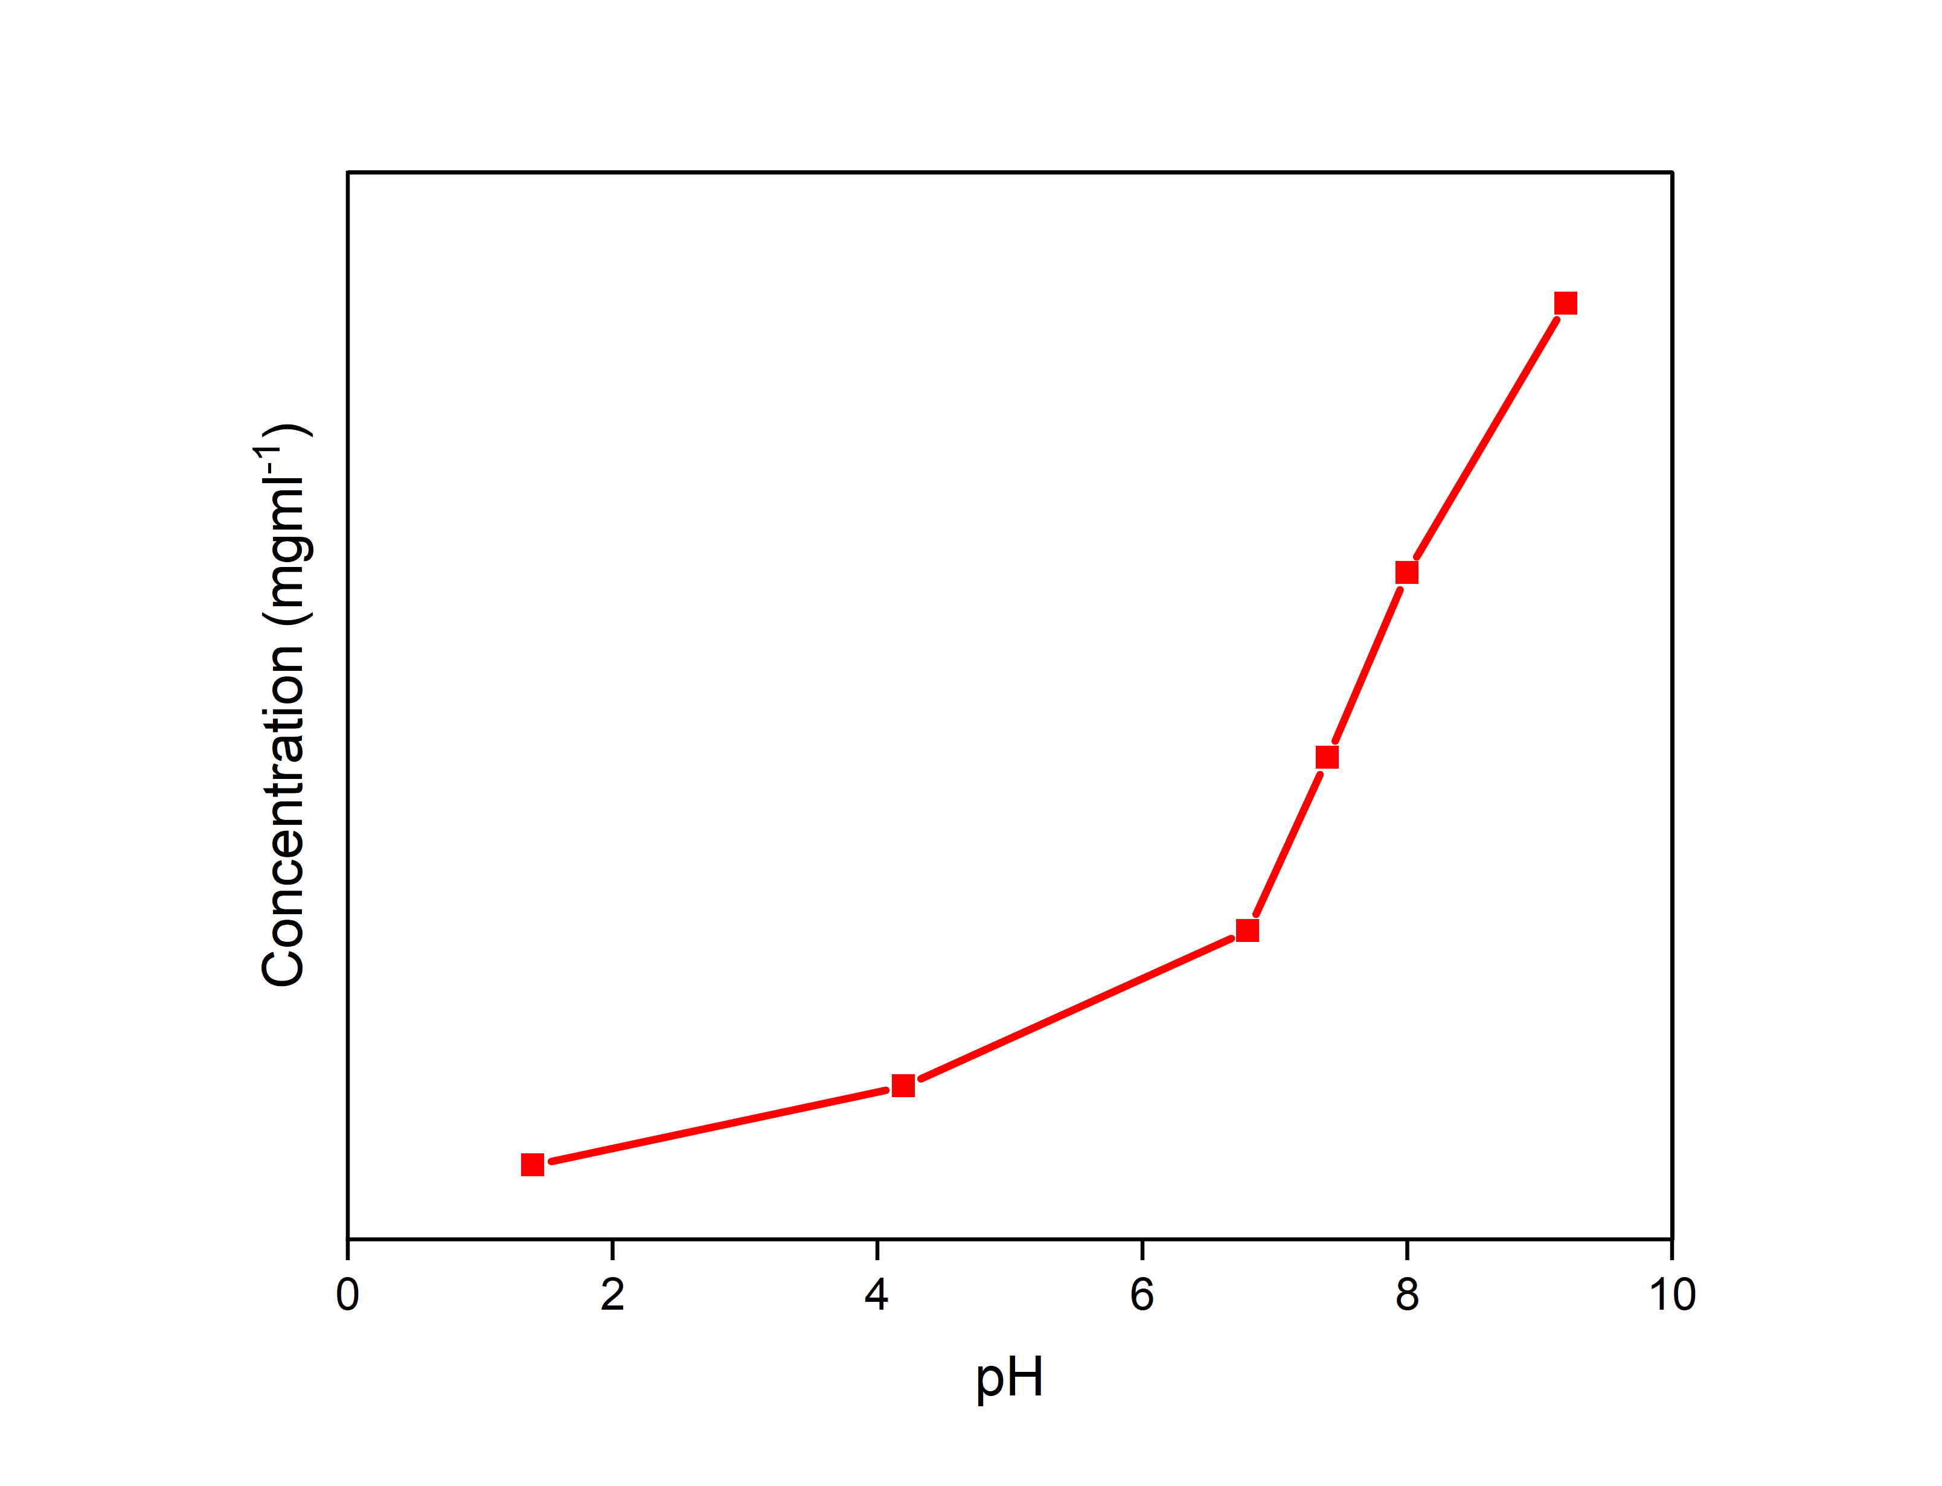
Fig.S12 Effect of pH on Glipizide solubility in water
R² = 0.9905
y=87.636x+0.0544

References
1. ~ir Chem~ M, Zaki NN, Abdel-Raouf ME, Abdel-Azim A-AA (1996) Propylene Oxide-Ethylene Oxide Block Copolymers as Demulsifiers for Water-in-Oil Emulsions, I. Effect of Molecular Weight and Hydrophilic-Lipophylic Balance on the Demulsification Efficiency
2. Maa YF, Hsu CC (1999) Performance of sonication and microfluidization for liquid-liquid emulsification. Pharm Dev Technol 4:233–240. https://doi.org/10.1081/PDT-100101357
3. Capek I (2002) Fate of excited probes in micellar systems
4. Miller-Chou BA, Koenig JL (2003) A review of polymer dissolution. Progress in Polymer Science (Oxford) 28:1223–1270
5. Freitas S, Merkle HP, Gander B (2005) Microencapsulation by solvent extraction/evaporation: Reviewing the state of the art of microsphere preparation process technology. Journal of Controlled Release 102:313–332
6. Theberge AB, Courtois F, Schaerli Y, et al (2010) Microdroplets in microfluidics: An evolving platform for discoveries in chemistry and biology. Angewandte Chemie - International Edition 49:5846–5868

