- the uncropped gel image of Figure2A
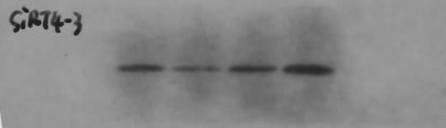
- the uncropped gel image of Figure4B
- the uncropped gel image of Figure4D
