Supporting information

- Graphene multilayer islands in AFM-tip cleaned images

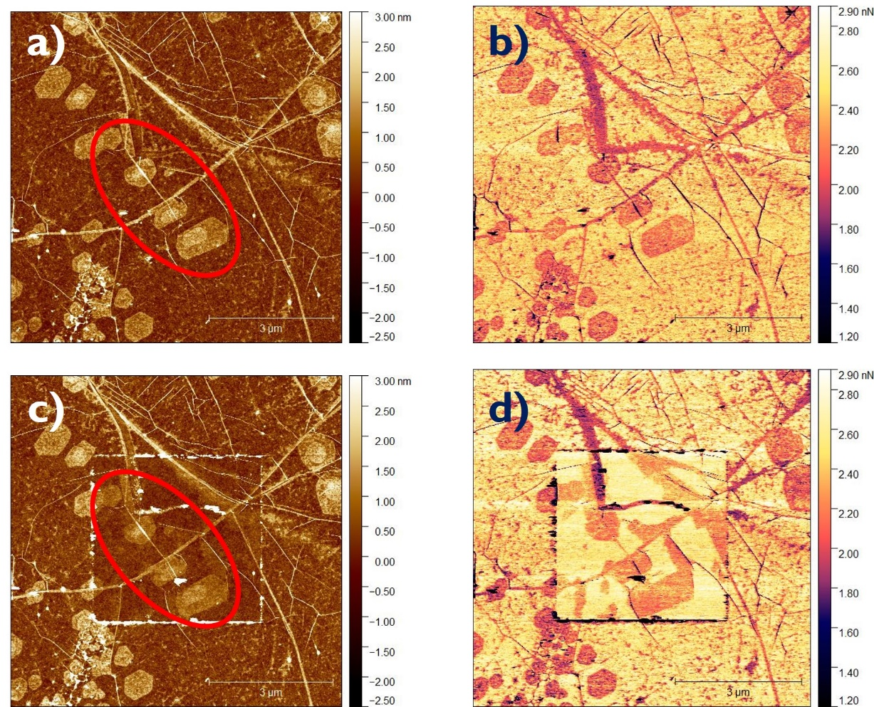

Figure S1. (10 x 10 μm²) Topography a)-c) and adhesion force b)-d) mappings measured via Atomic Force Microscopy of plasma by the red oval.

The topography AFM images both before and after tip-cleaning show multilayer islands as indicated by red oval Figure S1 (a)-(c). In addition, the adhesion force maps Figure S1 (b)-(d) show a different adhesion force for the patches compared to the surrounding surface i.e., Graphene. In general, the difference in adhesion force or frictional force measured between the AFM tip and the surface relates to both the number of Graphene layers and the adhesion force of Graphene with the underlying substrate. Moreover, the frictional force measured between the AFM tip and Graphene surface layer decreases with the number of layers, saturating at four layers where the frictional force of bulk graphite is achieved ^{1,2}. The patches specified by the red oval depict lower adhesion forces demonstrating their multilayer character.

- Raman mappings quantitative analysis

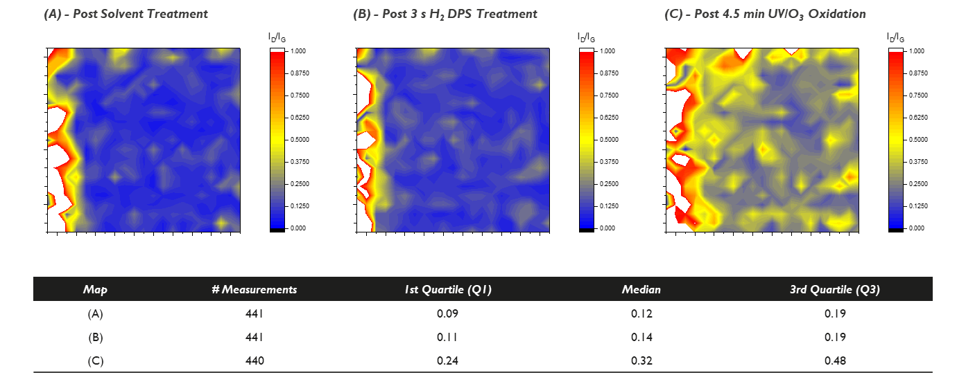

Figure S2. Raman mappings (A) post solvent treatment, (B) after 3 s H₂ DPS clean and (C) after 4.5 min UV/O₃ oxidation.

A prominent challenge when working with 2D materials is their growth-related variability. As a result, caution is imperative when single point measurements are used to make claims or statements about the 2D layer. To account for this variability, Raman mappings provide a more representative view of the surface state. A scratch is made in the Graphene layer which is used as reference point to measure approximately the same surface area after consecutive treatments. Part of this scratch can be observed on the left side of the maps indicated by the white area (no signal). Note that plotting the I_{D}/I_{G} corrects for any acquisition-related variations in peak intensities and allows to compare the spectra recorded. Quartiles are selected as statistical indicators to limit the numerical weight of the high I_{D}/I_{G} values recorded at the scratch edge.
Overall, there is a small increase in I_{D}/I_{G} going from solvent- to 3 s H₂ DPS treated Graphene as shown by the respective 1st quartile and median values. This small increase is attributed to limited hydrogenation of the Graphene surface by hydrogen radicals produced in the plasma discharge. A significant rise in I_{D}/I_{G} is quantified by an increase of all statistical indicators presented and is ascribed to the oxidation of Graphene’s basal plane by atomic oxygen generated during the UV/O₃ exposure.

- Effect of UV/O₃ treatment on Silicon Oxide wettability

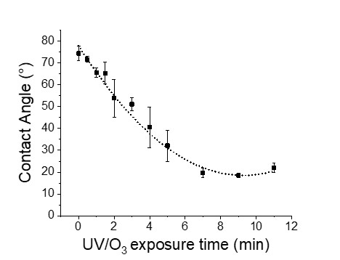

Figure S3. Water contact angle of SiO₂ as a function of UV/O₃ exposure time.

Figure S3 shows the water contact angle of SiO₂ as a function of UV/O₃ exposure time. A sigmoidal decrease is observed where a 20° WCA drop occurs during the first 2 minutes, after which the curve stabilizes around ± 15° within 10 minutes of UV/O₃ exposure. The hydrophilization observed is in agreement with experimental results obtained by Wang et al who attribute their observations to a photo-oxidation process ³.

- Demonstration Monolayer character WS₂ & Graphene via Raman- Photoluminescence Spectroscopy

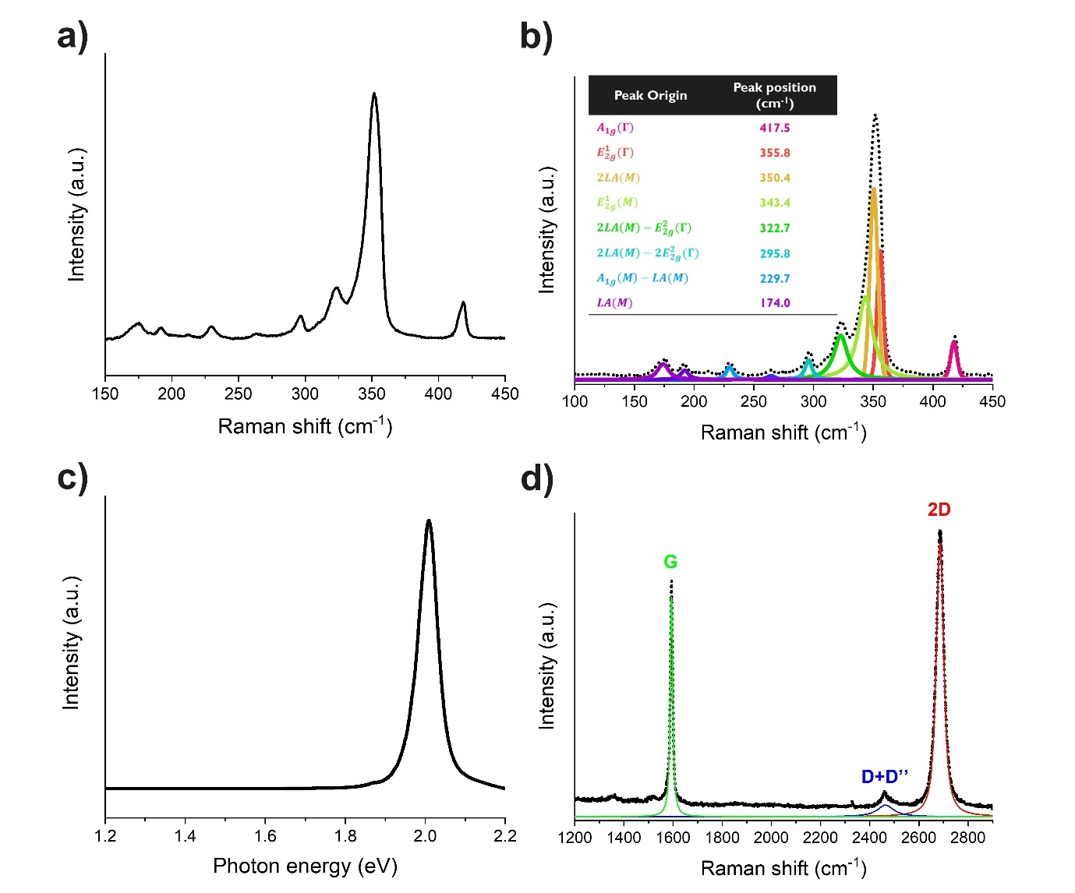
Figure S4. Raman spectrum of monolayer WS₂ (a) with peak deconvolution (b). PL spectrum monolayer WS₂ (c). Raman spectrum of Graphene with peak deconvolution (d).

Both Raman and Photoluminescence (PL) spectra were recorded to demonstrate the monolayer character of the 2D layers. Figure S4 (a)-(b) show the Raman spectrum with WS₂ peak deconvolution. Raman signatures indicating monolayer thickness include peak separation $A_{1g}$($Γ$) and $E_{2g}^{1}$(G) ~ 61.3 cm⁻¹ ^{4,5} and a $I_{2LA(M)}/I_{A_{1g}}$ ratio over 2, which in our case reaches a value of 5 ⁶. In addition, Photoluminescence spectroscopy is sensitive towards the WS₂ layer thickness due to the transition from indirect to direct bandgap when thinning to monolayer thickness. The PL spectrum depicted in Figure S4 (c) shows only 1 peak corresponding to the direct transition while no other peaks in the 1.2-1.8 eV range related to indirect transition are present in the spectrum ⁷. Figure S4 (d) shows the Raman spectrum of a Graphene layer transferred on SiO₂. The monolayer thickness is evidenced by the single Voigt fitting of the 2D peak which is known to split upon layer thickness increase ^{8,9}.
- 2D Graphene/WS₂ heterostack characterization

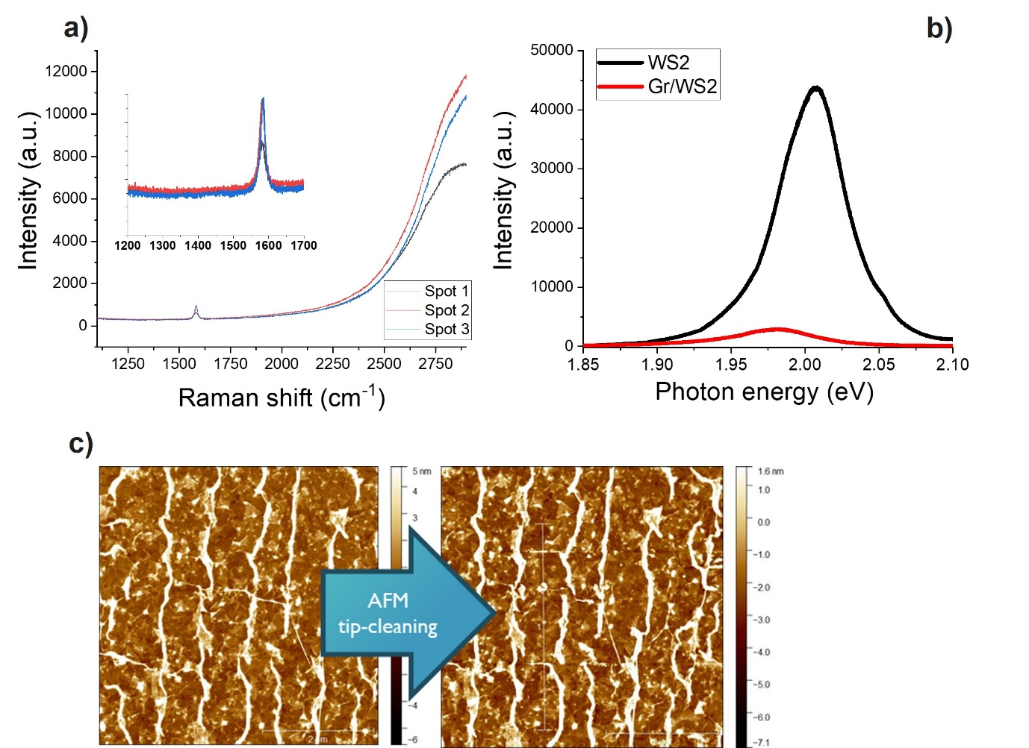

Figure S5. a) Raman spectra of Graphene layer transferred on monolayer WS₂. b) Photoluminescence spectra of monolayer WS2 before- (black) and after Graphene capping. c) Topography images (10 x 10 μm²) of transferred Graphene layer measured via Atomic Force Microscopy before and after tip cleaning.

Raman-, Photoluminescence spectroscopy and tip-cleaning Atomic Force Microscopy were carried out to demonstrate successful Gr/WS₂ heterostructure fabrication. Figure S5 (a) shows Raman spectra of three spots of the Graphene layer transferred on WS₂ coupon, where the inset plot focuses on 1200-1700 cm⁻¹ range. The strong background signal that appears ~2300 cm⁻¹ results from the PL signal from the underlying WS₂ monolayer ^{4,10}. A clear G peak (~ 1590 cm⁻¹) is observed, but no D peak (~1350 cm⁻¹) indicating a high-quality Graphene layer. Authors attribute the rather low intensity of the G peak to the interlayer coupling between the Graphene layer and WS₂ substrate, where electronic coupling with the substrate can lead to significant quenching of the Raman signal as demonstrated by Mootheri et al ¹¹. The Gr/WS₂ interlayer coupling is additionally demonstrated by Photoluminescence spectra shown in Figure S5 (b), showing a significant quenching of the PL signal originating from the WS₂ monolayer before (black) and after Graphene capping (red). The PL quenching also results from the interlayer coupling where photo-excited electrons and holes generated in WS₂ can tunnel to the Graphene layer and recombine near the Dirac points in a nonradiative manner ¹².
After Graphene transfer, H₂ DPS cleaning is applied to obtain a clean Graphene surface. Figure S5 (c) shows topography images of the transferred Graphene layer measured via Atomic Force Microscopy before and after tip cleaning. After tip-cleaning, no contamination build-up is noted on the scan edges demonstrating a clean Graphene surface. However, both before and after tip-cleaning regular white stripes are present in the images indicating elevated Graphene areas. These areas are characterized as Graphene wrinkles originating from the wet transfer process (see Method section for detailed description). Essentially, the Graphene layer is laminated on top of the WS₂ coupon using a specially designed frame and substrate holder which are both put in a deionized water bath to facilitate alignment. Next, the Graphene layer is laminated on the WS₂ coupon by gradually lowering the water level in the bath. As a result, a lot of water is trapped between the Graphene and WS₂ monolayer. An overnight vacuum anneal is performed to remove the residual water, during which wrinkles can be formed whose configuration depends on the initial wrinkle geometry and the quantity of diffused water as demonstrated by Kashyap et al ¹³.

- Atomic Force Microscopic images for HfO₂ roughness extraction.

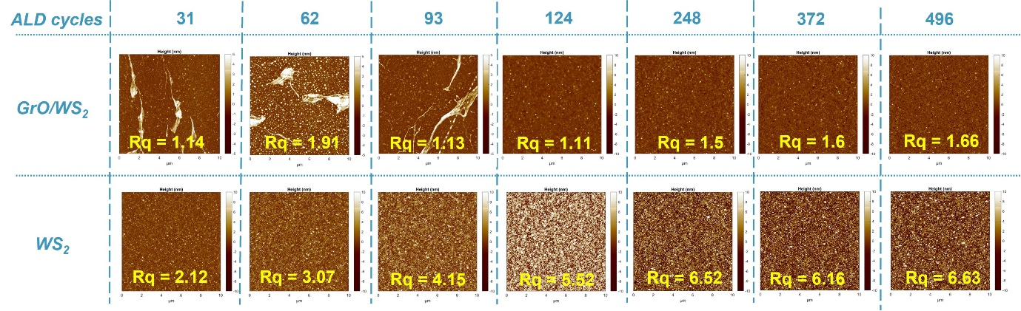
Figure S6. (10 x 10 μm²) AFM images of HfO₂ dielectric grown via ALD on GrO/WS₂ and WS₂ as function of ALD cycles.

The HfO₂ layer roughness reported here is the mean roughness based on the Arithmetic average of the absolute values of the surface height deviations measured from the mean plane in the AFM images, determined using the following formula:

$R_{a}= \frac{1}{N} \sum_{j=1}^{N}{\left|Z_{j}\right|}$

Note that for the AFM images corresponding to 31, 62 and 93 ALD cycles applied to GrO/WS₂ there are HfO₂ decorated Graphene wrinkles visible originating from the wet transfer process as explained before. Since this is an artifact of working with full 2D layers instead of flakes, it is acceptable to use a mean plane that does not contain wrinkles for the roughness extraction explained above.

- RBS plots of GrO/WS₂ and GrO/SiO₂ stacks

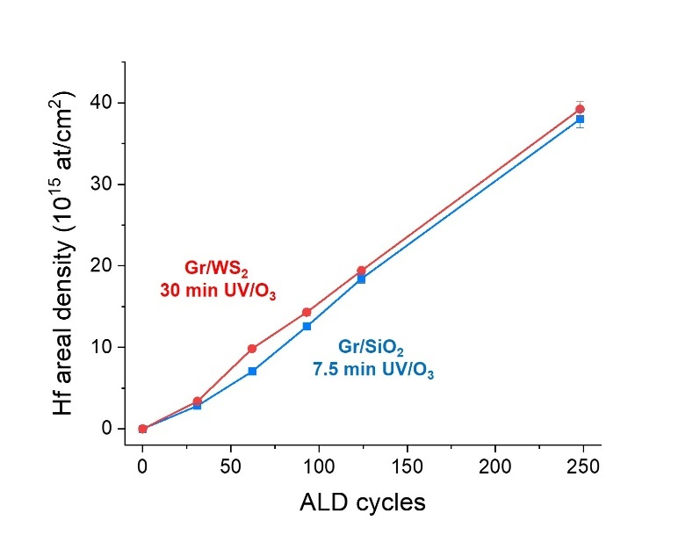
Figure S7. Hf areal density measured by Rutherford backscattering spectrometry (RBS) after various HfO₂ ALD cycles applied to 30 min UV/O₃ activated Graphene on monolayer WS₂ (red) and 7.5 min UV/O₃ activated Graphene on SiO₂ (blue). Note that error bars are confined within the data points.

The 4-probe GFET discussed in the main text only consists of a Graphene layer on 90 nm SiO₂. This way, the transport properties of the Graphene layer can be verified without any interference of the WS₂ monolayer. Figure S7 shows that similar growth rates are observed for Graphene on SiO₂ / WS₂, treated with 7.5 min / 30 min of UV/O₃ respectively. This indicates that the Graphene layer surface state is similar for both stacks and thus any claims made for the GrO/SiO₂ device are also valid for a GrO/WS₂ device.

- Optical images & Raman spectra of graphene device

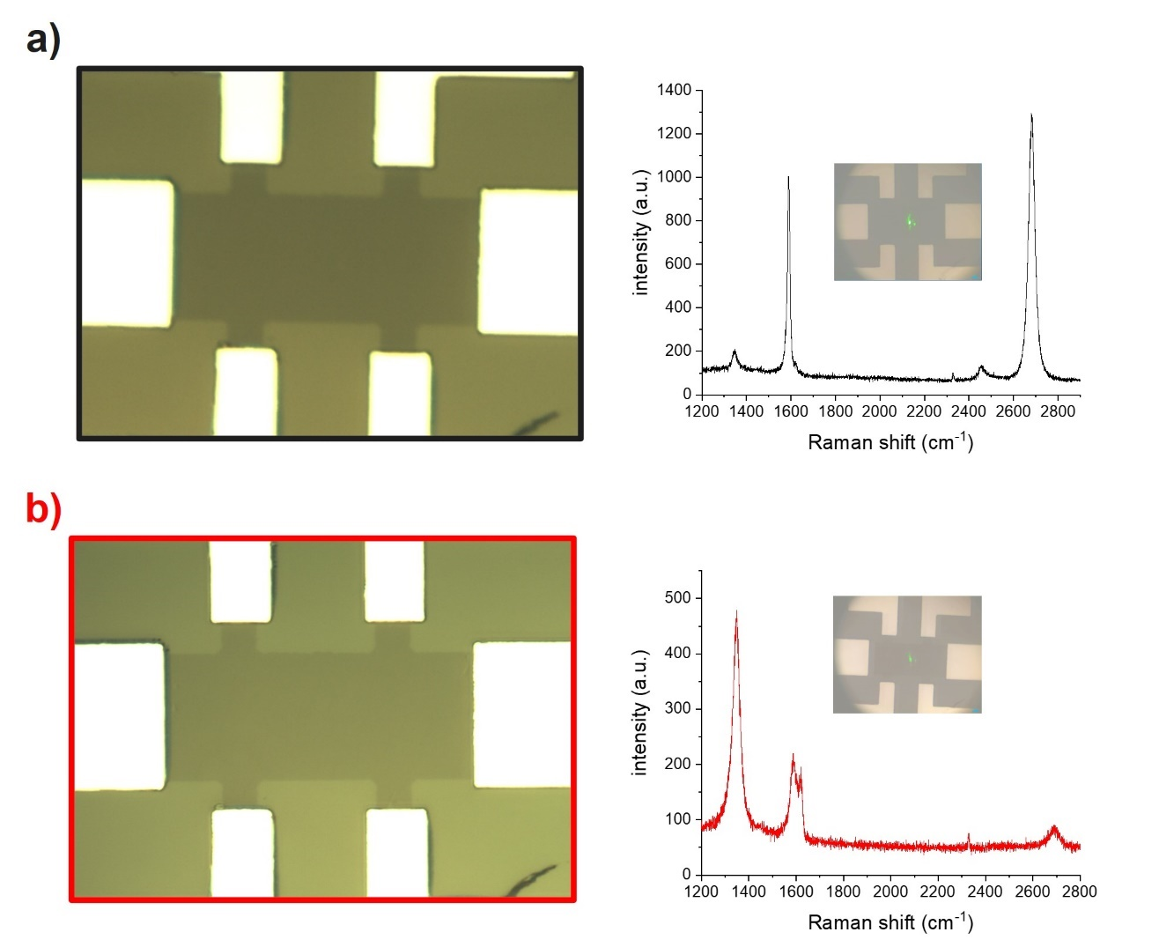
Figure S8. Optical images and Raman spectrum of the Graphene device before (a) and after 7.5 min UV/O₃ exposure (b). Insets in the Raman spectra show optical image of laser spot position during the Raman measurement.

Figure S8 shows optical images of the Graphene device reported in the main transcript before (a) and after 7.5 min UV/O₃ treatment (b). In addition, their respective Raman spectra are also provided showing again a significant D peak increase after UV/O₃ treatment as explain in the main transcript. The insets show optical images of the laser spot position during the Raman measurement.

- Quantitative analysis GFET

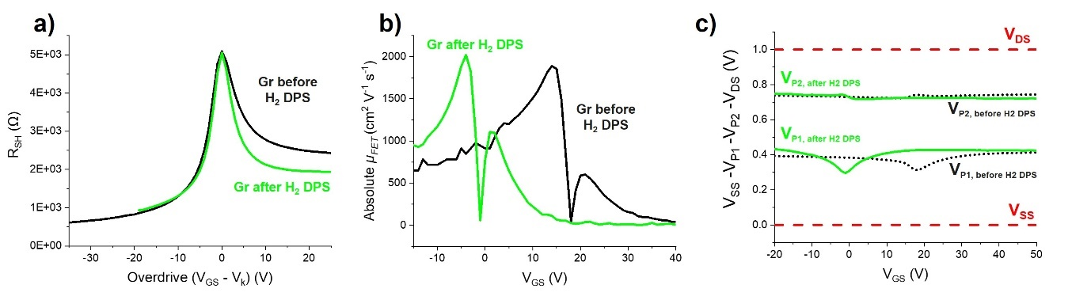
Figure S9. The calculated sheet resistance (R_{SH}) as a function of overdrive voltage (a), absolute field effect mobility (µ_{FET}) (b) and potentials measured at the source (V_{SS}), probe 1 (VP₁), probe 2 (VP₂) and drain (V_{DS}) as a function of gate voltage (V_{GS}) (c) before- (green) and after (black) H₂ DPS exposure.

Quantitative analysis of the GFET is performed as described by de la Rosa et al ¹⁴. Figure S9 provides an overview of Graphene’s sheet resistance (R_{SH}), absolute field effect mobility (µ_{FE}) and potentials measured at probe 1 (V_{P1}) and probe 2 (V_{P2}) as a function of gate voltage (V_{GS}) before- and after H₂ DPS exposure.
In a 4-probe set-up, the sheet resistance (R_{SH}) and µ_{FET} are extracted without including the effect of contact resistance (R_{C}) by measuring the channel potential (V_{CH}) via two additional probes (see Figure 7 (a)). No potential drop is assumed over the contacts between the Graphene layer and additional probes due to the low current drawn by the high impedance voltmeter (> 10¹² ohm). Consequently, the total resistance only subsists of R_{SH}, calculated via Eq $〈1〉$-$〈2〉$:

$$V_{CH}= V_{P2}- V_{P1 }〈1〉$$

$$R_{SH} = \frac{W_{CH}}{L_{4P}} × \frac{V_{CH}}{I_{D}} 〈2〉$$

Using R_{SH}, µ_{FE} is determined by differentiating the sheet conductance (G_{SH}) w.r.t back gate potential (V_{GS}) inversely multiplied by capacitance of the 90 nm (t_{OX}) SiO₂ dielectric substrate (C_{OX}) Eq $〈3〉$-$〈5〉$:

$$G_{SH} = \frac{1}{R_{SH}} 〈3〉$$

$$μ_{FE}= \frac{{dG}_{SH}}{{dV}_{GS}} × \frac{1}{C_{OX}} 〈4〉$$

$$C_{OX} = \frac{ε_{0} × ε_{r}}{t_{OX}} 〈5〉$$

With $ε_{0}$ and $ε_{1}$ being the permittivity of free space and dielectric constant of SiO₂. The respective hole- and electron mobility correspond to the local maxima noted in Figure S9 (b) before and after H₂ DPS dry cleaning. The I_{on}/I_{off} ratio reported in the main text is based on the values extracted at maximum resistance (I_{off}) and -19 overdrive potential (I_{on}).

References

- Lee, C., Wei, X., Li, Q., Carpick, R., Kysar, J. W., & Hone, J. (2009). Elastic and frictional properties of graphene. PHYSICA STATUS SOLIDI B-BASIC SOLID STATE PHYSICS, 246(11‐12), 2562–2567. https://doi.org/10.1002/pssb.200982329
- Li, Q., Lee, C., Carpick, R. W., & Hone, J. (2010). Substrate effect on thickness-dependent friction on graphene. PHYSICA STATUS SOLIDI B-BASIC SOLID STATE PHYSICS, 247(11-12), 2909–2914. https://doi.org/10.1002/pssb.201000555
- Wang, H., Yu, B., Jiang, S., Jiang, L., & Qian, L. (2017). UV/ozone-assisted tribochemistry-induced nanofabrication on Si(100) surfaces. RSC Advances, 7(63), 39651–39656. https://doi.org/10.1039/c7ra07198a
- Bradford, J., Shafiei, M., MacLeod, J., & Motta, N. (2020). Synthesis and characterization of WS2/graphene/SiC van der Waals heterostructures via WO3−x thin film sulfurization. Scientific Reports, 10(1), 17334–17334. https://doi.org/10.1038/s41598-020-74024-w
- Zhao, W., Ghorannevis, Z., Amara, K. K., Pang, J. R., Toh, M., Zhang, X., Kloc, C., Tan, P. H., & Eda, G. (2013). Lattice dynamics in mono- and few-layer sheets of WS2 and WSe2. Nanoscale, 5(20), 9677–9683. https://doi.org/10.1039/c3nr03052k
- Elías, A. L., Perea-López, N., Castro-Beltrán, A., Berkdemir, A., Lv, R., Feng, S., Long, A. D., Hayashi, T., Kim, Y. A., Endo, M., Gutiérrez, H. R., Pradhan, N. R., Balicas, L., Mallouk, T. E., López-Urías, F., Terrones, H., & Terrones, M. (2013). Controlled Synthesis and Transfer of Large-Area WS2 Sheets: From Single Layer to Few Layers. ACS Nano, 7(6), 5235–5242. https://doi.org/10.1021/nn400971k
- Li, Y., Li, X., Yu, T., Yang, G., Chen, H., Zhang, C., Feng, Q., Ma, J., Liu, W., Xu, H., Liu, Y., & Liu, X. (2018). Accurate identification of layer number for few-layer WS 2 and WSe 2 via spectroscopic study. Nanotechnology, 29(12), 124001–. https://doi.org/10.1088/1361-6528/aaa923
- Papanai, G. S., Sharma, I., & Gupta, B. K. (2020). Probing number of layers and quality assessment of mechanically exfoliated graphene via Raman fingerprint. Materials Today Communications, 22, 100795–. https://doi.org/10.1016/j.mtcomm.2019.100795
- Ferrari, A. C., & Basko, D. M. (2013). Raman spectroscopy as a versatile tool for studying the properties of graphene. Nature Nanotechnology, 8(4), 235–246. https://doi.org/10.1038/nnano.2013.46
- Rossi, A., Spirito, D., Bianco, F., Forti, S., Fabbri, F., Büch, H., Tredicucci, A., Krahne, R., & Coletti, C. (2018). Patterned tungsten disulfide/graphene heterostructures for efficient multifunctional optoelectronic devices. Nanoscale, 10(9), 4332–4338. https://doi.org/10.1039/c7nr08703a
- Mootheri, V., Arutchelvan, G., Banerjee, S., Sutar, S., Leonhardt, A., Boulon, M.-E., Huyghebaert, C., Houssa, M., Asselberghs, I., Radu, I., Heyns, M., & Lin, D. (2021). Graphene based Van der Waals contacts on MoS(2)field effect transistors. 2d Materials, 8(1). https://doi.org/10.1088/2053-1583/abb959
- Huo, N., Wei, Z., Meng, X., Kang, J., Wu, F., Li, S.-S., Wei, S.-H., & Li, J. (2015). Interlayer coupling and optoelectronic properties of ultrathin two-dimensional heterostructures based on graphene, MoS2 and WS2. Journal of Materials Chemistry. C, Materials for Optical and Electronic Devices, 3(21), 5467–5473. https://doi.org/10.1039/c5tc00698h
- Kashyap, J., Yang, E.-H., & Datta, D. (2020). Computational study of the water-driven graphene wrinkle life-cycle towards applications in flexible electronics. Scientific Reports, 10(1), 11315–11315. https://doi.org/10.1038/s41598-020-68080-5
- de la Rosa, C. J. L., Arutchelvan, G., Radu, I., Lin, D., Huyghebaert, C., Heyns, M., & De Gendt, S. (2016). Insight on the Characterization of MoS2 Based Devices and Requirements for Logic Device Integration. ECS Journal of Solid State Science and Technology, 5(11), Q3072–Q3081. https://doi.org/10.1149/2.0131611jss

