Supplementary Material 2

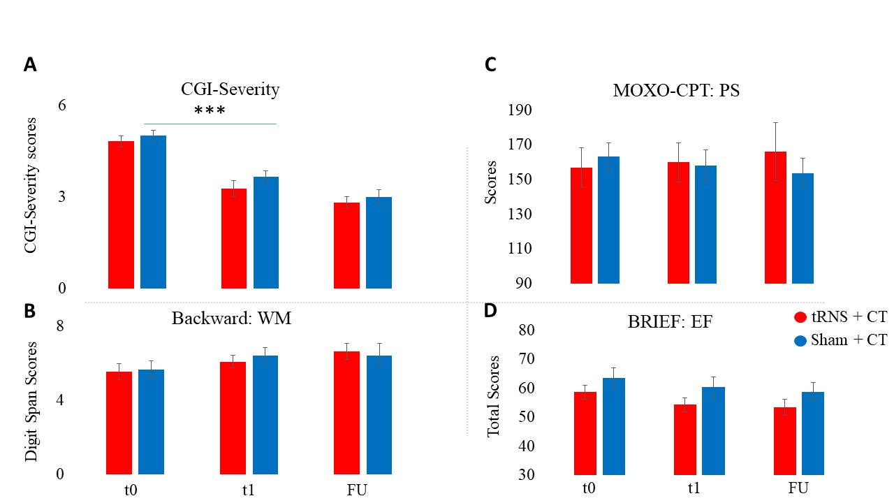

Figure S2. Clinical and behavioral symptoms following tRNS+ CT (red bars) vs. sham + CT (blue bars) at baseline (t0), post-treatment (t1) and follow-up (t2). A. Clinical symptoms (CGI-S severity). B. WM (digit backward span test of WISC). C. Processing speed (PS; MOXO-CPT timing index). D. Parent-reported EFs (BRIEF-p total score).

Supplementary Table S1. Baseline Demographic and Clinical Characteristics

Demographic characteristics of the study sample
Characteristics | tRNS + CT (n=11)  mean (SD) | Sham + CT (n=12)  mean (SD) | t/χ2/ F  (dfh, dfe) | P Value | Effect Size  (partial η²)
Age (y) | 9.25 (1.42) | 8.64 (1.43) | 1.13 | .3
Male (n, %) | 10, 90.9% | 10, 83.3% | .29 | .59
WISC subscales
Block design | 10.81 (2.36) | 8.67 (1.97) | 2.27 | 0.034*
Vocabulary | 10.09 (3.78) | 9.5 (3.75) | .359 | .72
ADHD symptoms (ADHD-RS) | Wilk’s Λ = .99 |  | .009  (1,21) | .99 | .001
Total score | 10.91(1.12) | 11.08(1.47)
Inattentiveness | 6.55 (.49) | 6.67 (.74) | .02  (1,21) | .89 | .001
Hyperactivity-Impulsivity | 4.36 (.85) | 4.42 (.83) | .002  (1,21) | .97 | .0001

M: Male; Note that all the children were unmedicated.

Supplementary Table S2. Spontaneously Reported or Observed Adverse Events during transcranial random noise stimulation (tRNS) and sham stimulation, both combined with CT. The table indicates the number of participants (N) and the percentage of sessions endorsing side effects at some point during the intervention.

Adverse event# | tRNS + CT  (n = 11) |  | Sham + CT  (n = 12)
 | N | % Sessions | N | % Sessions
Headache | 3 | 3 | 1 | 2
Tingling | 3 | 4 | 1 | 1
Itching | 9 | 27 | 10 | 33
Local redness | 1 | 2 | 0 | 0
Scalp burn | 1 | 1 | 1 | 1
Scalp pain | 2 | 2 | 1 | 2
Discomfort | 5 | 6 | 6 | 6
Sleepiness | 0 | 0 | 0 | 0
Mood change | 3 | 4 | 0 | 0
Difficulty concentrating | 4 | 5 | 4 | 5
Nausea | 0 | 0 | 0 | 0
Dizziness | 0 | 0 | 0 | 0

Supplementary Table S3. Regression model of post-treatment secondary outcome scores, after covarying for baseline scores of each measure.
 | β |  |  | Std Error |  |  | DF |  |  | t-value |  |  | p-value
Clinical symptoms (CGI-S)
Intercept | -2.36 |  |  | .98 |  |  | 22 |  |  | -2.38 |  |  | .03*
Baseline | .55 |  |  | .19 |  |  | 20 |  |  | 2.85 |  |  | .01*
Treatment | -.16 |  |  | .22 |  |  | 20 |  |  | -.73 |  |  | .48
Time | -.51 |  |  | .13 |  |  | 22 |  |  | -3.99 |  |  | .0006***
WM (backward digit span scores)
 | β |  |  | Std Error |  |  | DF |  |  | t-value |  |  | p-value
Intercept | -2.56 |  |  | .61 |  |  | 22 |  |  | -4.23 |  |  | .0003***
Baseline | .44 |  |  | .09 |  |  | 20 |  |  | 5.08 |  |  | .0001***
Treatment | .02 |  |  | .25 |  |  | 20 |  |  | .08 |  |  | .94
Time | .16 |  |  | .2 |  |  | 22 |  |  | .79 |  |  | .44
STM (forward digit span scores)
Intercept | -2.44 |  |  | .67 |  |  | 22 |  |  | -3.65 |  |  | .001**
Baseline | .38 |  |  | .1 |  |  | 20 |  |  | 3.82 |  |  | .001**
Treatment | -.28 |  |  | .32 |  |  | 20 |  |  | -.87 |  |  | .39
Time | .22 |  |  | .16 |  |  | 22 |  |  | 1.4 |  |  | .17
Executive function (BRIEF-Parents)
Intercept |  | -3.39 |  |  | 1.08 |  |  | 22 |  |  | -3.14 |  | .005*
Baseline |  | .06 |  |  | .02 |  |  | 20 |  |  | 3.55 |  | .002**
Treatment |  | -.27 |  |  | .32 |  |  | 20 |  |  | -.84 |  | .41
Time |  | -.13 |  |  | .12 |  |  | 22 |  |  | -1.08 |  | .29
Executive function (BRIEF-Teachers)
Intercept |  | -6.55 |  |  | 1.02 |  |  | 19 |  |  | -6.43 |  | .00001***
Baseline |  | .1 |  |  | .01 |  |  | 19 |  |  | 6.97 |  | .00001***
Treatment |  | .26 |  |  | .23 |  |  | 19 |  |  | 1.09 |  | .29
Time |  | -.14 |  |  | .11 |  |  | 17 |  |  | -1.27 |  | .22
Processing Speed (MOXO-CPT)
Intercept |  | -3.84 |  |  | .63 |  |  | 22 |  |  | -6.12 |  | .00001***
Baseline |  | .02 |  |  | .003 |  |  | 20 |  |  | 6.98 |  | .00001***
Treatment |  | .02 |  |  | .23 |  |  | 20 |  |  | .08 |  | .94
Time |  | -.02 |  |  | .18 |  |  | 22 |  |  | -.1 |  | .92
Periodic RS-EEG activity:
Beta power
Intercept |  |  | .04 |  |  | .2 |  |  | 56 |  |  | .22 |  | .83
Baseline |  |  | .66 |  |  | .07 |  |  | 56 |  |  | 9.8 |  | .0001***
Treatment |  |  | -.09 |  |  | .16 |  |  | 56 |  |  | -.62 |  | .54
Time |  |  | .005 |  |  | .11 |  |  | 56 |  |  | .05 |  | .95
Beta center of frequency
Intercept |  |  | -.53 |  |  | .6 |  |  | 56 |  |  | -.89 |  | .38
Baseline |  |  | .14 |  |  | .1 |  |  | 56 |  |  | 1.31 |  | .2
Treatment |  |  | .08 |  |  | .22 |  |  | 56 |  |  | .37 |  | .72
Time |  |  | -.11 |  |  | .2 |  |  | 56 |  |  | -.55 |  | .58
Std= standard; DF= degrees of freedom; **p<0.005; ***p<0.0005

Supplementary Table S5. Blinding Integrity

Intervention | Parent’s guess |  |  |  | Question could not be asked | Active stimulation guess rate
 | A | B | C | Total
tRNS + CT | 4 | 3 | 4 | 11 |  | 57%
Sham + CT | 7 | 2 | 1 | 10 | 2 | 78%

A: believe treatment is active tRNS; B: believe the treatment is sham tRNS; C: unsure.
Note: Active stimulation guess rate (Fassi & Cohen Kadosh, 2020) was calculated as the rate of parents thought their children were received active treatment in each group (while excluding ‘unsure’ guesses).

Supplementary Table S6. A regression model of primary outcome measure post-treatment (t1) and at a 3-week follow-up (t2), as predicted from subjective intervention and not objective intervention (active/ sham)
 | Β |  | Std Error | DF | t value | P value
Clinical symptoms (ADHD-RS)
Intercept | 2.69 | 4.25 |  | 15 | .63 | .53
Baseline score | .61 | .28 |  | 13 | 2.15 | .05
Subjective intervention* | .69 | 2.37 |  | 13 | .3 | .77
Time | -.88 | .87 |  | 15 | -1.01 | .33

*Subjective intervention—the participants’ subjective beliefs about receiving or not receiving an intervention

