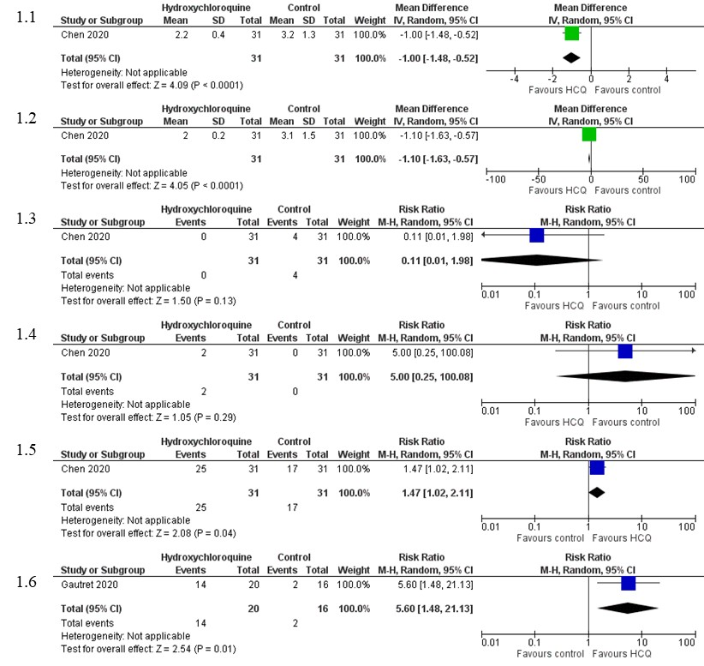

Supplementary Figure 1: Forest plot of hydroxychloroquine vs. standard treatment with reference to Supplementary Table 3. From the figure, 1.1 is hydroxychloroquine vs standard treatment, outcome: Duration of fever resolution; 1.2 is hydroxychloroquine vs standard treatment, outcome: Duration of cough resolution; 1.3 is hydroxychloroquine vs standard treatment, outcome: Number of patients who progressed to severe illness; 1.4 is hydroxychloroquine vs standard treatment, outcome: Number of patients with adverse effects; 1.5 is hydroxychloroquine vs standard treatment, outcome: Number of patients with improved chest CT appearance; 1.6 is hydroxychloroquine vs standard treatment, outcome: Number of patients with negative viral load on day 6.

