Figure 2
Nephrin
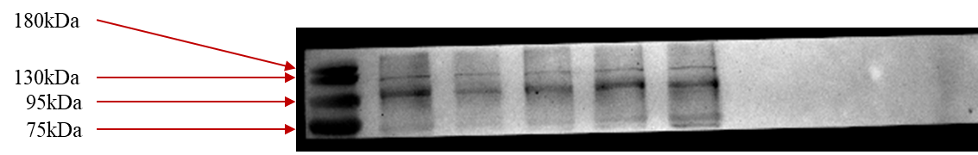
Podocin
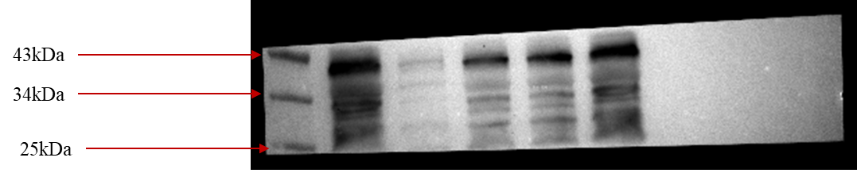
CD2AP
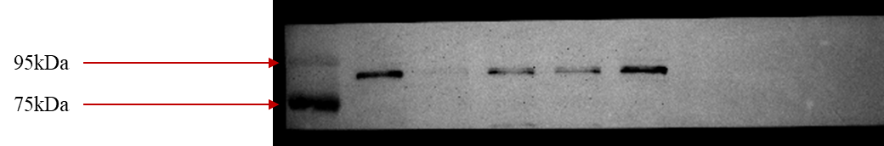
GAPDH
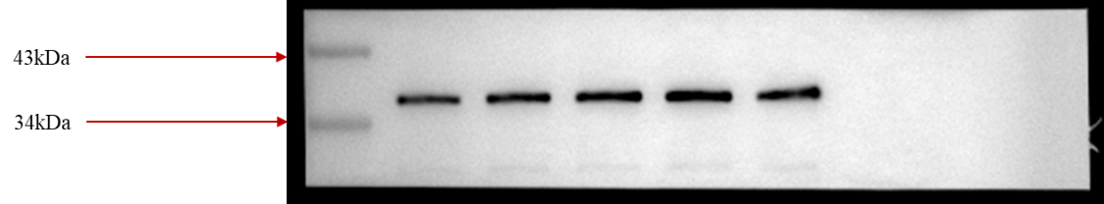
Figure 4
Bax
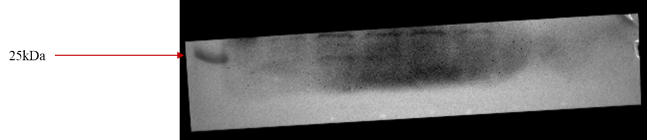
Bcl-2
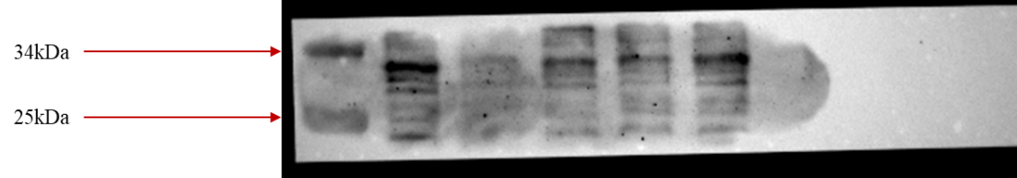
GAPDH
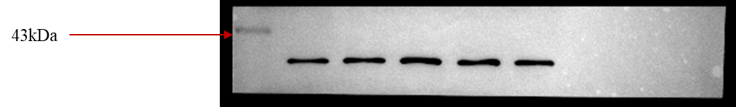
Figure 5
p-mTOR
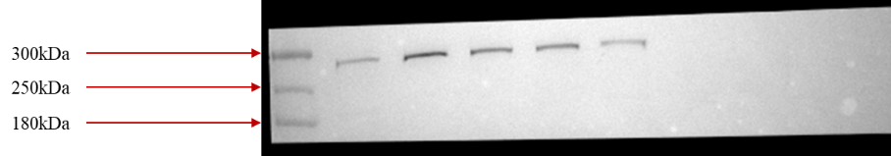
mTOR
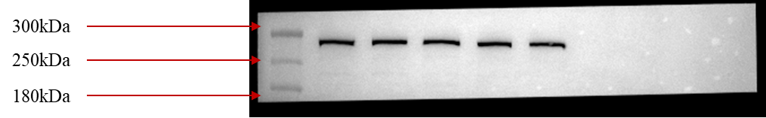
Beclin1
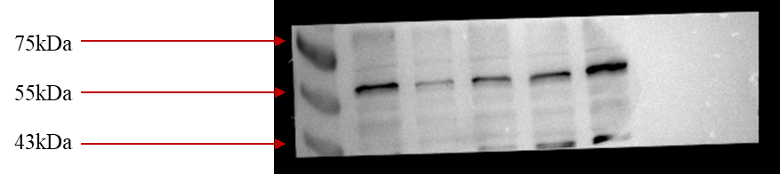
LC3
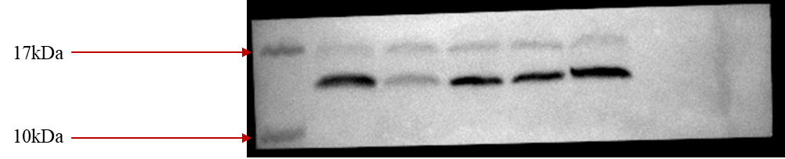
P62
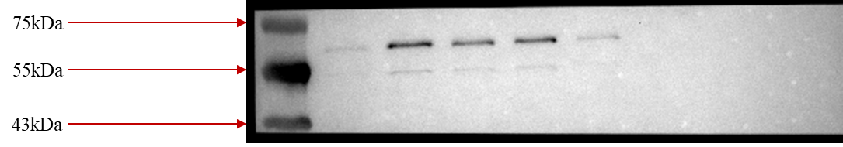
GAPDH
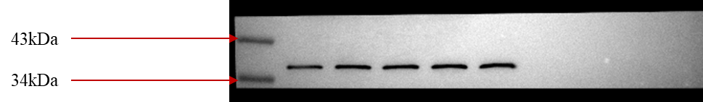
Figure 6
Podocin
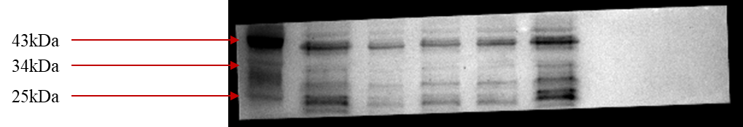
CD2AP
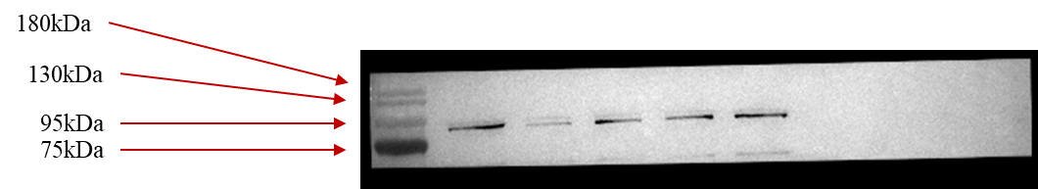
GAPDH
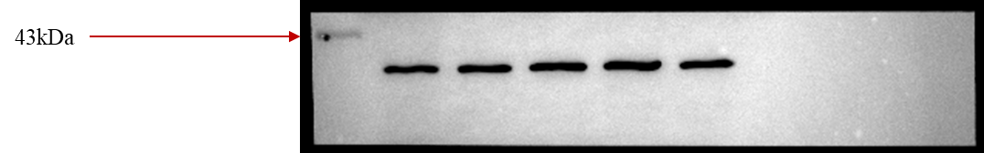
Figure 7
Bcl-2
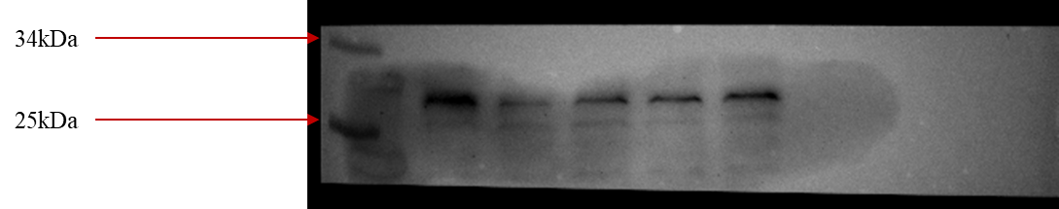
Cleaved caspase 3
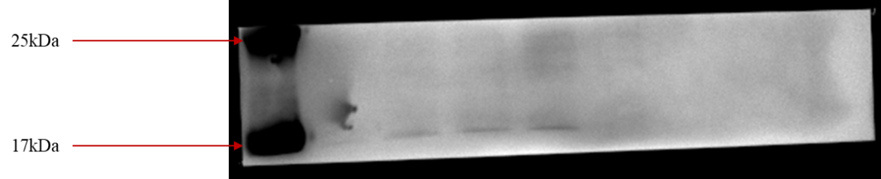
GAPDH
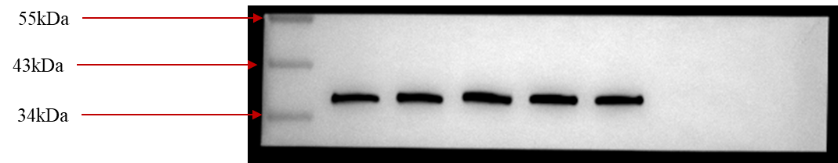
Figure 8
p-mTOR
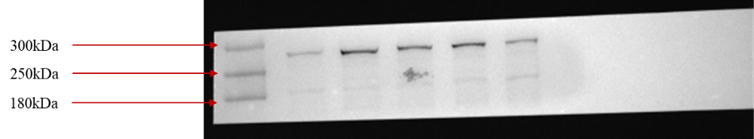
mTOR
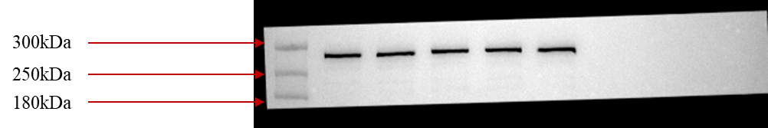
Beclin1
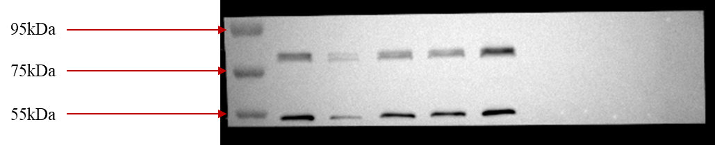
LC3
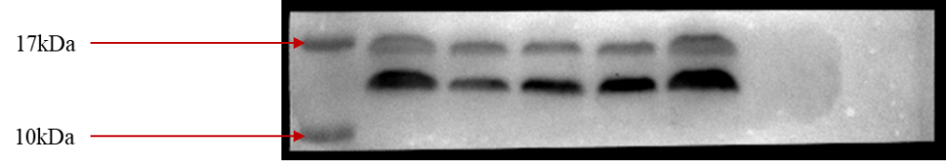
P62
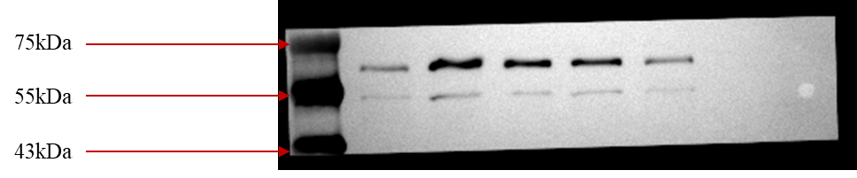
GAPDH
