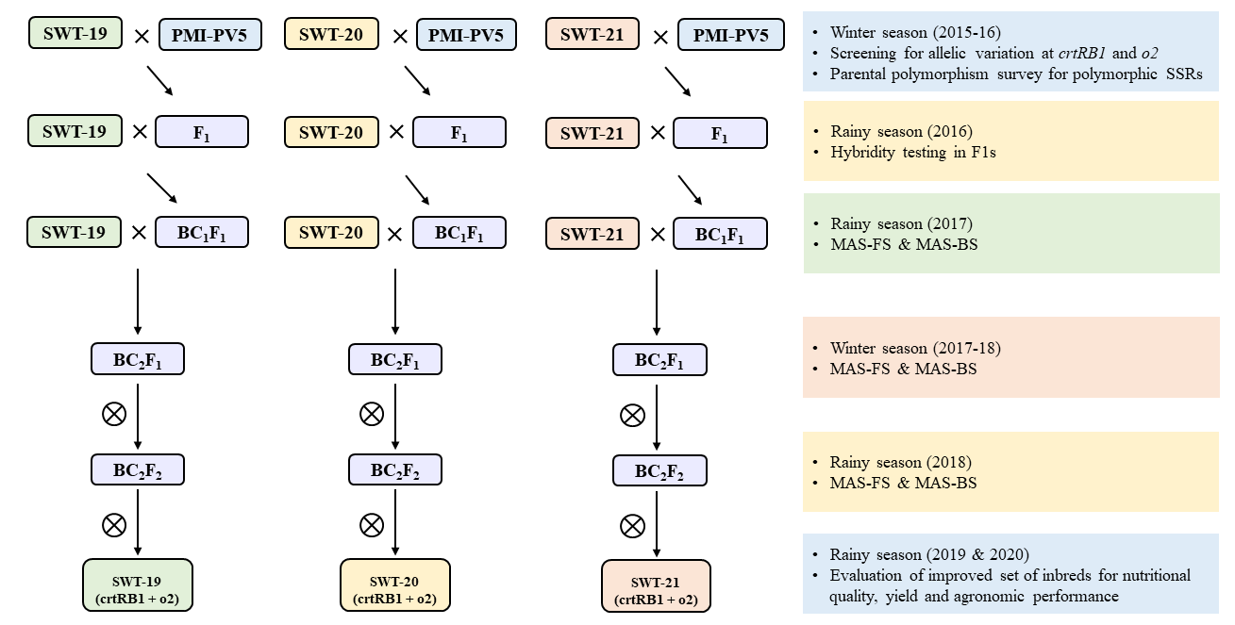
Fig. S1 MABB scheme adopted for conversion of normal sweet corn into proA, lysine and tryptophan rich versions. MAS, Marker-assisted selection; FS, Foreground Selection; BS, Background Selection; PS, Phenotypic Selection

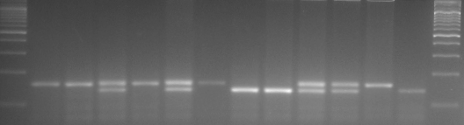
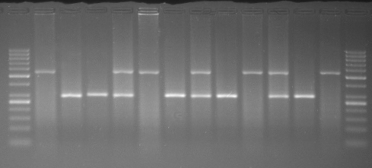
M D R SWT-19-based BC₂F₂ Progenies M
umc1066
M D R SWT-19-based BC₂F₂ Progenies M
crtRB1-3’TE
Fig. S2 Representative gel profiling for segregation of markers specific crtRB1 and o2 in BC₂F₂ generation. M: Ladder, D: Donor Parent, R: Recurrent Parent, ‘Star’ indicates foreground positive plants

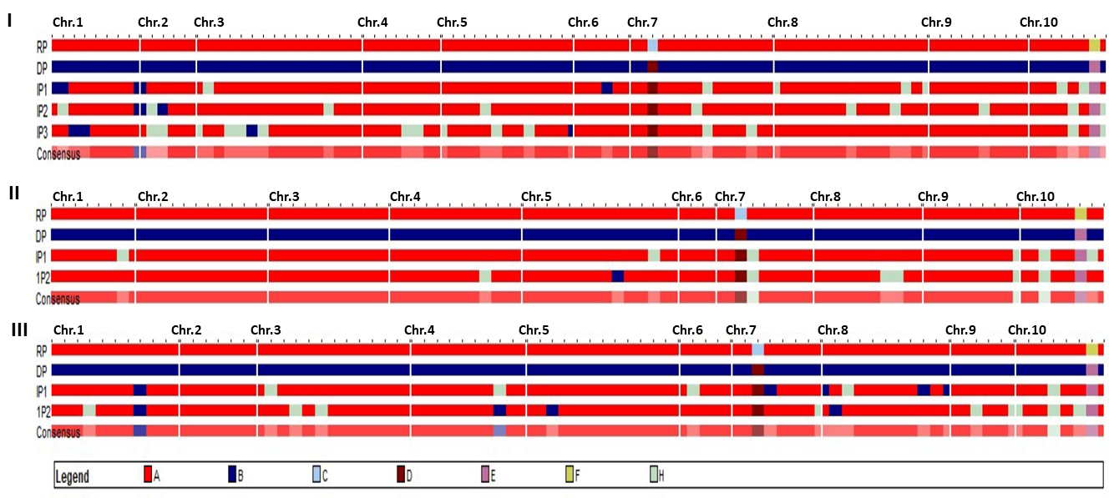
Fig. S3. Graphical genotyping (GGT) of recovery of RPG among introgressed progenies; I, introgressed progenies of SWT-19; II, introgressed progenies of SWT-20; III, introgressed progenies of SWT-21; RP, Recurrent parent; DP, Donor parent; IP, Introgressed progeny; Chr., Chromosome. A, Recurrent parent; B, Donor parent; C, O2; D, o2; E, favourable allele of crtRB1; F, unfavourable allele of crtRB1; H, heterozygous; IP1, SWT-19-3-14-94; IP2, SWT-19-62-87-43; IP3, SWT-19-62-87-49 of SWT19 background; IP1, SWT-20-54-84-4; IP2, SWT-20-54-84-52 of SWT20 background; IP1, SWT-21-3-1-65; IP2, SWT-21-3-1-70 of SWT21 background.

Table S1 Details of molecular markers used for foreground selection
S. No | Markers | Gene | Bin Location | Primer Sequence | Reference
1. | umc1066 | o2 | 7.01 | F: 5′ATGGAGCACGTCATCTCAATGG3′  R: 5′AGCAGCAGCAACGTCTATGACACT3′ | Yang et al. 2004
2. | 3′TE-InDel | crtRB1 | 10.05 | F: 5’ACACCACATGGACAAGTTCG3’  R1: 5′ACACTCTGGCCCATGAACAC3′  R2: 5′ACAGCAATACAGGGGACCAG3′ | Yan et al. 2010
F, Forward Primer; R, Reverse Primer

Table S2 Number of SSRs screened for background selection
Chromosome | No. of markers screened | SWT19 × PMI-PV5 |  | SWT20 × PMI-PV5 |  | SWT21 × PMI-PV5
Chromosome | No. of markers screened | NP | Polymorphism  (%) | NP | Polymorphism  (%) | NP | Polymorphism  (%)
1 | 19 | 9 | 47.37 | 8 | 42.11 | 10 | 52.63
2 | 15 | 7 | 46.67 | 12 | 80.00 | 7 | 46.67
3 | 23 | 14 | 60.87 | 11 | 47.83 | 13 | 56.52
4 | 19 | 8 | 42.11 | 12 | 63.16 | 10 | 52.63
5 | 31 | 13 | 41.94 | 14 | 45.16 | 13 | 41.94
6 | 9 | 6 | 66.67 | 4 | 44.44 | 6 | 66.67
7 | 17 | 13 | 76.47 | 8 | 47.06 | 8 | 47.06
8 | 23 | 15 | 65.22 | 10 | 43.48 | 11 | 47.83
9 | 15 | 9 | 60.00 | 9 | 60.00 | 6 | 40.00
10 | 12 | 6 | 50.00 | 7 | 58.33 | 7 | 58.33
Total | 183 | 100 | 54.64 | 95 | 51.91 | 91 | 49.73
NP, Number of polymorphic SSRs

Table S3 Recurrent parent genome (RPG) recovery across the segregating populations
S. No | Crosses | Generations | Genotype advanced | Gene present | % RPG recovery | Range of RPG in selected plants
1. | SWT19  ×  PMI-PV5 | BC₁F₁ | SWT-19-3 | Cc/O2o2 | 74.20 | 71.20 - 77.70
1. | SWT19  ×  PMI-PV5 | BC₁F₁ | SWT-19-62 | Cc/O2o2 | 71.29 | 71.20 - 77.70
1. | SWT19  ×  PMI-PV5 | BC₂F₁ | SWT-19-3-14 | Cc/O2o2 | 83.20 | 79.20 - 85.20
1. | SWT19  ×  PMI-PV5 | BC₂F₁ | SWT-19-62-87 | Cc/O2o2 | 85.20 | 79.20 - 85.20
1. | SWT19  ×  PMI-PV5 | BC₂F₂ | SWT-19-3-14-94 | cc/o2o2 | 92.08 | 88.10 - 93.70
1. | SWT19  ×  PMI-PV5 | BC₂F₂ | SWT-19-62-87-43 | cc/o2o2 | 88.61 | 88.10 - 93.70
1. | SWT19  ×  PMI-PV5 | BC₂F₂ | SWT-19-62-87-49 | cc/o2o2 | 92.08 | 88.10 - 93.70
2. | SWT20  ×  PMI-PV5 | BC₁F₁ | SWT-20-5 | Cc/O2o2 | 74.20 | 72.10 - 75.30
2. | SWT20  ×  PMI-PV5 | BC₁F₁ | SWT-20-54 | Cc/O2o2 | 75.30 | 72.10 - 75.30
2. | SWT20  ×  PMI-PV5 | BC₁F₁ | SWT-20-96 | Cc/O2o2 | 73.20 | 72.10 - 75.30
2. | SWT20  ×  PMI-PV5 | BC₂F₁ | SWT-20-54-62 | Cc/O2o2 | 83.20 | 80.50 - 85.30
2. | SWT20  ×  PMI-PV5 | BC₂F₁ | SWT-20-54-84 | Cc/O2o2 | 83.70 | 80.50 - 85.30
2. | SWT20  ×  PMI-PV5 | BC₂F₂ | SWT-20-54-84-4 | cc/o2o2 | 95.83 | 87.50 - 95.80
2. | SWT20  ×  PMI-PV5 | BC₂F₂ | SWT-20-54-84-52 | cc/o2o2 | 94.79 | 87.50 - 95.80
3. | SWT21  ×  PMI-PV5 | BC₁F₁ | SWT-21-3 | Cc/O2o2 | 73.10 | 69.60 - 76.40
3. | SWT21  ×  PMI-PV5 | BC₁F₁ | SWT-21-18 | Cc/O2o2 | 70.90 | 69.60 - 76.40
3. | SWT21  ×  PMI-PV5 | BC₁F₁ | SWT-21-49 | Cc/O2o2 | 76.40 | 69.60 - 76.40
3. | SWT21  ×  PMI-PV5 | BC₁F₁ | SWT-21-90 | Cc/O2o2 | 71.40 | 69.60 - 76.40
3. | SWT21  ×  PMI-PV5 | BC₂F₁ | SWT-21-3-1 | Cc/O2o2 | 81.00 | 80.40 - 85.90
3. | SWT21  ×  PMI-PV5 | BC₂F₁ | SWT-21-3-10 | Cc/O2o2 | 82.60 | 80.40 - 85.90
3. | SWT21  ×  PMI-PV5 | BC₂F₁ | SWT-21-3-18 | Cc/O2o2 | 83.20 | 80.40 - 85.90
3. | SWT21  ×  PMI-PV5 | BC₂F₂ | SWT-21-3-1-65 | cc/o2o2 | 91.67 | 89.40 - 95.00
3. | SWT21  ×  PMI-PV5 | BC₂F₂ | SWT-21-3-1-70 | cc/o2o2 | 90.56 | 89.40 - 95.00

Table S4 Mean performance of introgressed inbreds and original parents for agronomic traits across the sowing dates
S. No. | Genotypes | YLD (kg/ha) | MF  (days) | FF  (days) | PH  (cm) | EH  (cm)
1 | SWT-19-3-14-94 | 1436 | 50.8 | 54.0 | 110.8 | 52.0
2 | SWT-19-62-87-43 | 1363 | 49.7 | 52.5 | 114.5 | 50.0
3 | SWT-19-62-87-49 | 1389 | 51.0 | 53.5 | 117.8 | 50.2
4 | SWT-19 | 1433 | 49.2 | 52.7 | 113.5 | 50.5
5 | SWT-20-54-84-4 | 1313 | 52.7 | 55.7 | 143.5 | 60.7
6 | SWT-20-54-84-52 | 1310 | 52.5 | 56.5 | 143.2 | 57.7
7 | SWT-20 | 1302 | 53.0 | 56.3 | 145.7 | 61.3
8 | SWT-21-3-1-65 | 1220 | 51.5 | 55.0 | 121.5 | 52.7
9 | SWT-21-3-1-70 | 1164 | 51.5 | 54.8 | 129.8 | 53.3
10 | SWT-21 | 1191 | 52.3 | 54.8 | 124.2 | 52.5
11 | Mean | 1312 | 51.4 | 54.6 | 126.5 | 54.1
12 | S.E. | 25 | 0.7 | 0.7 | 3.1 | 1.8
13 | C.D. (5%) | 51.0 | 1.5 | 1.5 | 6.3 | 3.7
YLD, dried grain yield; MF, days to 50% male flowering; FF, days to 50% female flowering;
PH, plant height; CD, critical difference; SE, standard error

FIGURE S3 Graphical genotyping (GGT) of recovery of RPG among introgressed progenies; I, introgressed progenies of SWT-19; II, introgressed progenies of SWT-20; III, introgressed progenies of SWT-21; RP, Recurrent parent; DP, Donor parent; IP, Introgressed progeny; Chr., Chromosome. A, Recurrent parent; B, Donor parent; C, O2; D, o2; E, favourable allele of crtRB1; F, unfavourable allele of crtRB1; H, heterozygous; IP1, SWT-19-3-14-94; IP2, SWT-19-62-87-43; IP3, SWT-19-62-87-49 of SWT19 background; IP1, SWT-20-54-84-4; IP2, SWT-20-54-84-52 of SWT20 background; IP1, SWT-21-3-1-65; IP2, SWT-21-3-1-70 of SWT21 background.

Table S5 DUS characterization of introgressed inbreds and original inbreds
S.  No | Characteristics | Inbreds
S.  No | Characteristics | SWT-19 | SWT-19-3-14-94 | SWT-19-62-87-43 | SWT-19-62-87-49 | SWT-20 | SWT-20-54-84-4 | SWT-20-54-84-52 | SWT-21 | SWT-21-3-1-65 | SWT-21-3-1-70
1 | Leaf: angle between blade and stem (on leaf just above upper ear) | Small | Small | Small | Small | Small | Small | Small | Small | Small | Small
2 | Leaf: attitude of blade | Straight | Drooping | Straight | Straight | Straight | Straight | Straight | Straight | Straight | Straight
3 | Stem: anthocyanin colouration of brace root | Absent | Absent | Absent | Absent | Absent | Absent | Absent | Absent | Absent | Absent
4 | Tassel: time of anthesis | Medium | Medium | Medium | Medium | Medium | Medium | Medium | Medium | Medium | Medium
5 | Tassel: anthocyanin colouration at base of glume | Absent | Absent | Absent | Absent | Absent | Absent | Absent | Absent | Absent | Absent
6 | Tassel: anthocyanin colouration of glume excluding base | Absent | Absent | Absent | Absent | Absent | Absent | Absent | Absent | Absent | Absent
7 | Tassel: anthocyanin colouration of anthers | Absent | Absent | Absent | Absent | Absent | Absent | Absent | Absent | Absent | Absent
8 | Tassel: density of spikelets | Sparse | Sparse | Sparse | Dense | Sparse | Sparse | Dense | Dense | Dense | Sparse
9 | Tassel: angle between main axis and lateral branches | Narrow | Narrow | Wide | Narrow | Wide | Wide | Wide | Narrow | Wide | Narrow
10 | Tassel: attitude of lateral branches | Curved | Curved | Curved | Curved | Strongly curved | Strongly curved | Strongly curved | Curved | Curved | Curved
11 | Ear: time of silk emergence | Medium | Medium | Medium | Medium | Medium | Medium | Medium | Medium | Medium | Medium
12 | Ear: anthocyanin colouration of silks | Absent | Absent | Absent | Absent | Absent | Absent | Absent | Absent | Absent | Absent
13 | Leaf: anthocyanin colouration of sheath below ear | Absent | Absent | Absent | Absent | Absent | Absent | Absent | Absent | Absent | Absent
14 | Tassel: length of main axis above lowest side branch | Medium | Medium | Medium | Medium | Medium | Medium | Medium | Medium | Medium | Medium
15 | Plant length up to flag leaf | Medium | Medium | Medium | Medium | Long | Long | Long | Medium | Medium | Medium
16 | Plant: ear placement | Medium | Medium | Medium | Medium | Medium | Medium | Medium | Medium | Medium | Medium
17 | Leaf: width of blade | Medium | Broad | Broad | Medium | Medium | Medium | Medium | Medium | Medium | Medium
18 | Ear: length without husk | Medium | Medium | Medium | Medium | Medium | Medium | Medium | Medium | Medium | Medium
19 | Ear: diameter | Small | Small | Small | Small | Small | Small | Small | Small | Small | Small
20 | Ear: shape | Conical | Conical | Conical | Conical | Conical | Conical | Conical | Conical | Conical | Conical
21 | Ear: number of rows of grains | Medium | Medium | Medium | Medium | Medium | Medium | Medium | Medium | Medium | Medium
22 | Ear: type of grains | Dent | Dent | Dent | Dent | Dent | Dent | Dent | Dent | Dent | Dent
23 | Ear: colour of top of grain | Yellow | Yellow | Yellow | Yellow | Orange | Orange | Orange | Yellow | Yellow | Yellow
24 | Ear: colouration of glume of cob | White | White | White | White | White | White | White | White | White | White
25 | Kernel: row arrangement | Spiral | Spiral | Spiral | Spiral | Straight | Straight | Straight | Straight | Straight | Straight
26 | Kernel: poppiness | Absent | Absent | Absent | Absent | Absent | Absent | Absent | Absent | Absent | Absent
27 | Kernel: sweetness | Absent | Absent | Absent | Absent | Absent | Absent | Absent | Absent | Absent | Absent
28 | Kernel: waxiness | Absent | Absent | Absent | Absent | Absent | Absent | Absent | Absent | Absent | Absent
29 | Kernel: opaqueness | Present | Present | Present | Present | Absent | Absent | Absent | Present | Present | Present
30 | Kernel: shape | Shrunken | Shrunken | Shrunken | Shrunken | Shrunken | Shrunken | Shrunken | Shrunken | Shrunken | Shrunken
31 | Kernel: 1000 kernel weight | Very small | Very small | Very small | Very small | Very small | Very small | Very small | Very small | Very small | Very small

