Supplementary figure
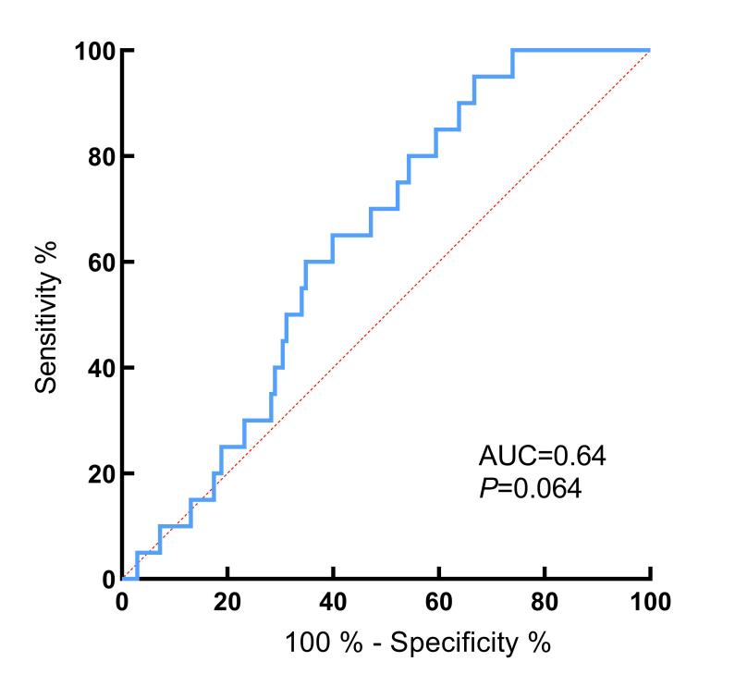
Based on the results of the ROC analysis, change in lymphocyte counts before and after radiotherapy was somewhat predictive of grade 2 radiation pneumonitis, but the overall predictive value was faint.

