original, unedited images
Dear Editorial Office，
I have changed the conflicting housekeeping genes in the manuscript from GADPH to β-actin, and the microscopic images in the manuscript have indicated the scale. In addition, as for the part of Figure2I, different samples were added to the left and right parts of my Western blot results, and only part of the results were available, so only the original strips used in the manuscript were uploaded this time.
α-SMA for fig1b 42kda
GADPH
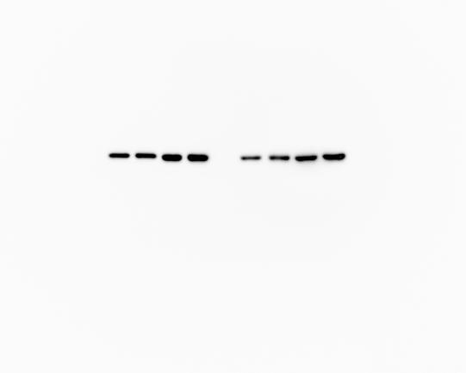
0.3466532 | 1.239773397
0.382847091 | 1.222245804
0.636855725 | 1.004493778
0.53312223 | 0.961082336
0.419053857 | 1.02180497
0.666125479 | 1.036422061
0.339899063

Table Analyzed | α-sma
Column B | Data Set-B
vs. | vs.
Column A | Data Set-A
Unpaired t test
P value | <0.0001
P value summary | ****
Significantly different (P < 0.05)? | Yes
One- or two-tailed P value? | Two-tailed
t, df | t=8.438, df=11
How big is the difference?
Mean of column A | 0.4749
Mean of column B | 1.081
Difference between means (B - A) ± SEM | 0.6060 ± 0.07182
95% confidence interval | 0.4479 to 0.7641
R squared (eta squared) | 0.8662
F test to compare variances
F, DFn, Dfd | 1.322, 6, 5
P value | 0.7770
P value summary | ns
Significantly different (P < 0.05)? | No
Data analyzed
Sample size, column A | 7
Sample size, column B | 6

Collagen1 for fig1d 140kda
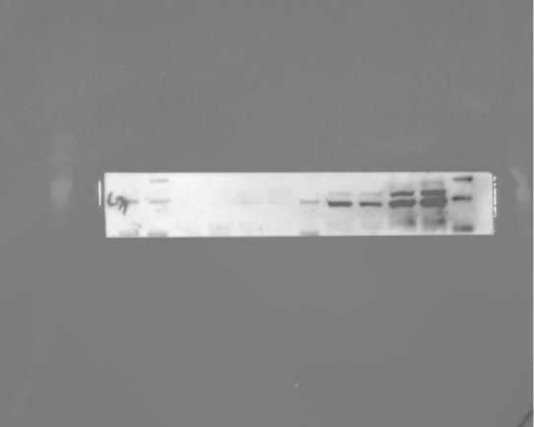
GADPH
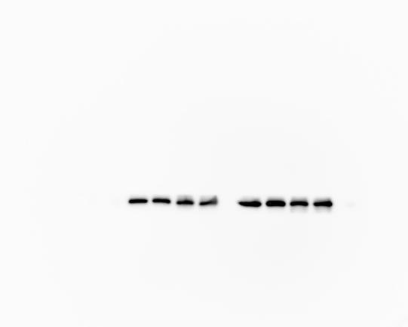
 | 0.616859614
 | 0.542559478
 | 0.845424986
 | 0.981972934
0.512487317 | 1.406092373
0.573657769 | 1.266496917
0.36023739 | 0.771469716
 | 0.82131379
 | 0.953904225

Column B | Data Set-B
vs. | vs.
Column A | Data Set-A
Unpaired t test
P value | 0.0306
P value summary | *
Significantly different (P < 0.05)? | Yes
One- or two-tailed P value? | Two-tailed
t, df | t=2.515, df=10
How big is the difference?
Mean of column A | 0.4821
Mean of column B | 0.9118
Difference between means (B - A) ± SEM | 0.4297 ± 0.1708
95% confidence interval | 0.04903 to 0.8103
R squared (eta squared) | 0.3875
F test to compare variances
F, DFn, Dfd | 6.545, 8, 2
P value | 0.2785
P value summary | ns
Significantly different (P < 0.05)? | No
Data analyzed
Sample size, column A | 3
Sample size, column B | 9

Collagen3 for fig1f 120kda
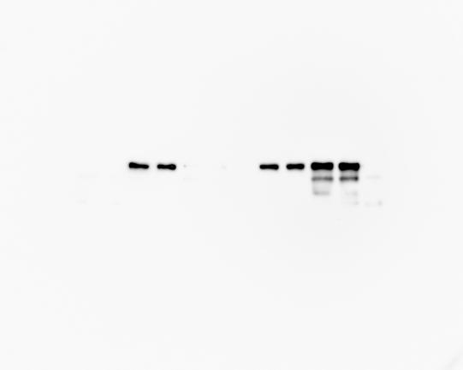
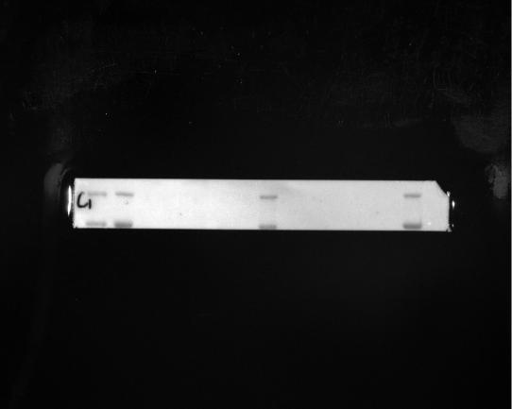
GADPH
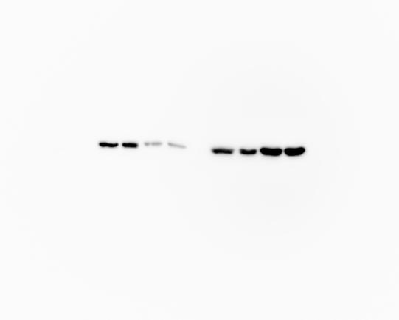
0.794612434 | 0.63120487
0.776851102 | 0.506654941
1.204791765 | 0.794426524
0.689528523 | 0.840853712
1.470534457 | 0.308259446
0.625474432 | 0.308968522
 | 1.087898795
 | 1.337527807

Column B | Data Set-B
vs. | vs.
Column A | Data Set-A
Unpaired t test
P value | 0.3137
P value summary | ns
Significantly different (P < 0.05)? | No
One- or two-tailed P value? | Two-tailed
t, df | t=1.052, df=12
How big is the difference?
Mean of column A | 0.9270
Mean of column B | 0.7270
Difference between means (B - A) ± SEM | -0.2000 ± 0.1902
95% confidence interval | -0.6144 to 0.2144
R squared (eta squared) | 0.08437
F test to compare variances
F, DFn, Dfd | 1.184, 7, 5
P value | 0.8825
P value summary | ns
Significantly different (P < 0.05)? | No
Data analyzed
Sample size, column A | 6
Sample size, column B | 8

α-SMA for fig2d 42kda
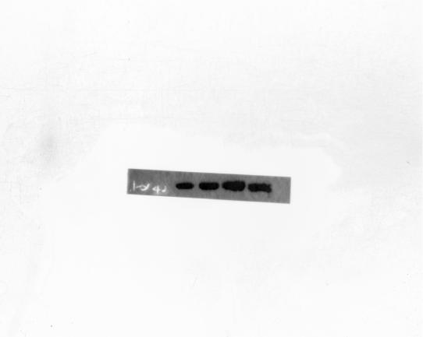

β-actin
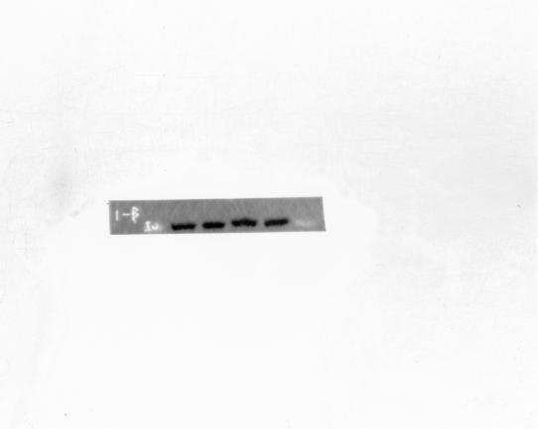
0.236035335 | 1.63049852
0.968304928 | 1.196001106
0.740203663 | 1.313986811
1.01205408 | 2.428186388
1.067989014 | 1.34482357
Column B |  |  | Data Set-B
vs. |  |  | vs.
Column A |  |  | Data Set-A
Unpaired t test
P value |  |  | 0.0206
P value summary |  |  | *
Significantly different (P < 0.05)? |  |  | Yes
One- or two-tailed P value? |  |  | Two-tailed
t, df |  |  | t=2.877, df=8
How big is the difference?
Mean of column A |  |  | 0.8049
Mean of column B |  |  | 1.583
Difference between means (B - A) ± SEM |  |  | 0.7778 ± 0.2704
95% confidence interval |  |  | 0.1543 to 1.401
R squared (eta squared) |  |  | 0.5085
F test to compare variances
F, DFn, Dfd |  |  | 2.133, 4, 4
P value |  |  | 0.4811
P value summary |  |  | ns
Significantly different (P < 0.05)? |  |  | No
Data analyzed
Sample size, column A |  |  | 5
Sample size, column B |  |  | 5

DNMT1 for figure3a 200kda
β-actin
1.058534708 | 0.623364529
0.88561851 | 0.56136761
0.998637569 | 0.538115157
0.837584875 | 0.661722292
Column B |  |  | Data Set-B
vs. |  |  | vs.
Column A |  |  | Data Set-A
Unpaired t test
P value |  |  | 0.0010
P value summary |  |  | ***
Significantly different (P < 0.05)? |  |  | Yes
One- or two-tailed P value? |  |  | Two-tailed
t, df |  |  | t=6.010, df=6
How big is the difference?
Mean of column A |  |  | 0.9451
Mean of column B |  |  | 0.5961
Difference between means (B - A) ± SEM |  |  | -0.3490 ± 0.05806
95% confidence interval |  |  | -0.4910 to -0.2069
R squared (eta squared) |  |  | 0.8576
F test to compare variances
F, DFn, Dfd |  |  | 3.206, 3, 3
P value |  |  | 0.3643
P value summary |  |  | ns
Significantly different (P < 0.05)? |  |  | No
Data analyzed
Sample size, column A |  |  | 4
Sample size, column B |  |  | 4

DNMT1 for fig3d 200kda

0.80962277 | 0.626395291
1.212176621 | 0.209263339
1.378490136 | 0.593462803
0.992711112 | 0.361925757
1.373448654 | 0.537793605
1.610440007 | 0.434114986
1.097614183 | 0.577770731
 | 0.477059621
Column C |  |  | Data Set-C
vs. |  |  | vs.
Column B |  |  | Data Set-B
Unpaired t test
P value |  |  | <0.0001
P value summary |  |  | ****
Significantly different (P < 0.05)? |  |  | Yes
One- or two-tailed P value? |  |  | Two-tailed
t, df |  |  | t=6.755, df=13
How big is the difference?
Mean of column B |  |  | 1.211
Mean of column C |  |  | 0.4772
Difference between means (C - B) ± SEM |  |  | -0.7334 ± 0.1086
95% confidence interval |  |  | -0.9680 to -0.4989
R squared (eta squared) |  |  | 0.7783
F test to compare variances
F, DFn, Dfd |  |  | 3.723, 6, 7
P value |  |  | 0.1092
P value summary |  |  | ns
Significantly different (P < 0.05)? |  |  | No
Data analyzed
Sample size, column B |  |  | 7
Sample size, column C |  |  | 8

GADPH for fig3d

CTGF fog fig3e

α-SMA for fig3e

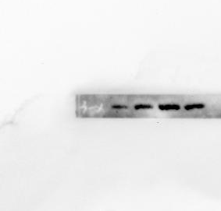
0.667158376 | 1.702728463
0.867458126 | 0.986264417
0.703317374 | 1.318320673
0.874642276 | 1.491164441
 | 1.7255232
Column B |  |  | Data Set-B
vs. |  |  | vs.
Column A |  |  | Data Set-A
Unpaired t test
P value |  |  | 0.0045
P value summary |  |  | **
Significantly different (P < 0.05)? |  |  | Yes
One- or two-tailed P value? |  |  | Two-tailed
t, df |  |  | t=4.112, df=7
How big is the difference?
Mean of column A |  |  | 0.7781
Mean of column B |  |  | 1.445
Difference between means (B - A) ± SEM |  |  | 0.6667 ± 0.1621
95% confidence interval |  |  | 0.2833 to 1.050
R squared (eta squared) |  |  | 0.7072
F test to compare variances
F, DFn, Dfd |  |  | 7.962, 4, 3
P value |  |  | 0.1198
P value summary |  |  | ns
Significantly different (P < 0.05)? |  |  | No
Data analyzed
Sample size, column A |  |  | 4
Sample size, column B |  |  | 5

GADPH

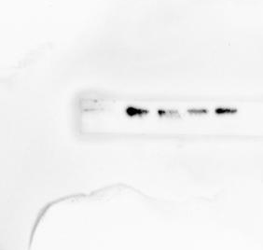
DNMT1 for fig3e

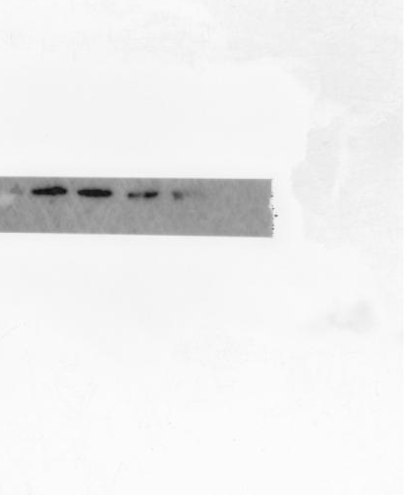
1.913340093 | 0.638581149
1.180675448 | 0.6176389
1.162224745 | 0.581564151
1.600131245 | 0.92813747
1.087492735 | 0.574564278
1.416523738
1.35603113
Table Analyzed |  |  | DNMT1(低刚度5’AZA处理）
Column B |  |  | Data Set-B
vs. |  |  | vs.
Column A |  |  | Data Set-A
Unpaired t test
P value |  |  | 0.0005
P value summary |  |  | ***
Significantly different (P < 0.05)? |  |  | Yes
One- or two-tailed P value? |  |  | Two-tailed
t, df |  |  | t=5.043, df=10
How big is the difference?
Mean of column A |  |  | 1.388
Mean of column B |  |  | 0.6681
Difference between means (B - A) ± SEM |  |  | -0.7200 ± 0.1428
95% confidence interval |  |  | -1.038 to -0.4019
R squared (eta squared) |  |  | 0.7178
F test to compare variances
F, DFn, Dfd |  |  | 3.873, 6, 4
P value |  |  | 0.2109
P value summary |  |  | ns
Significantly different (P < 0.05)? |  |  | No
Data analyzed
Sample size, column A |  |  | 7
Sample size, column B |  |  | 5

fig4a
 | dnmt1 | Rmdn1 | Mastl | Map1lc3b | Mark2 | Map4 | 1425153_at | Mylip | Mical1 | Mast2 | Mapt | Mark3 | Myh2 | X1425504_at | X1434396_a_at
dnmt1 | 1 | 0.64288812 | -0.20861996 | 0.47335133 | 0.31622286 | -0.15081885 | 0.45830296 | 0.13440261 | 0.12485116 | 0.52500443 | -0.041741145 | 0.70934169 | -0.09153846 | -0.34877601 | -0.190895443
Rmdn1 | 0.64288812 | 1 | -0.20124227 | 0.65243538 | 0.29672418 | -0.09559821 | 0.42799512 | 0.28076339 | -0.34236743 | 0.29457962 | 0.055621088 | 0.5792887 | -0.09451958 | -0.22627744 | -0.27812418
Mastl | -0.20861996 | -0.20124227 | 1 | -0.33236754 | -0.22644414 | 0.23893108 | -0.02692148 | 0.01403937 | 0.08388775 | -0.05695698 | 0.216036205 | -0.18028337 | 0.1465893 | -0.18880518 | 0.261400066
Map1lc3b | 0.47335133 | 0.65243538 | -0.33236754 | 1 | 0.04830722 | -0.22050159 | 0.42807715 | 0.13331156 | 0.09161916 | 0.28692953 | 0.032741315 | 0.66331472 | -0.27861398 | -0.29491552 | 0.166511017
mark2 | 0.31622286 | 0.29672418 | -0.22644414 | 0.04830722 | 1 | 0.08850647 | 0.42691602 | 0.20497975 | -0.19968734 | 0.51990738 | 0.092130442 | 0.26781741 | 0.03949849 | 0.06715394 | -0.299032665
Map4 | -0.15081885 | -0.09559821 | 0.23893108 | -0.22050159 | 0.08850647 | 1 | 0.14997115 | 0.15589043 | 0.04156395 | 0.08789547 | 0.30121945 | -0.2504322 | 0.15995086 | -0.12488659 | 0.134607414
1425153_at | 0.45830296 | 0.42799512 | -0.02692148 | 0.42807715 | 0.42691602 | 0.14997115 | 1 | 0.09302281 | 0.12612391 | 0.41037512 | 0.244581113 | 0.57742994 | -0.24831576 | -0.09254427 | -0.098497128
Mylip | 0.13440261 | 0.28076339 | 0.01403937 | 0.13331156 | 0.20497975 | 0.15589043 | 0.09302281 | 1 | -0.26379505 | 0.05171982 | -0.195073936 | -0.13344205 | 0.15935864 | -0.03442199 | 0.054107623
Mical1 | 0.12485116 | -0.34236743 | 0.08388775 | 0.09161916 | -0.19968734 | 0.04156395 | 0.12612391 | -0.26379505 | 1 | 0.36032549 | -0.094852509 | 0.37733744 | -0.02266456 | -0.17787099 | 0.413799091
Mast2 | 0.52500443 | 0.29457962 | -0.05695698 | 0.28692953 | 0.51990738 | 0.08789547 | 0.41037512 | 0.05171982 | 0.36032549 | 1 | -0.043757658 | 0.56072755 | -0.18617878 | -0.31537147 | -0.145095503
Mapt | -0.04174114 | 0.05562109 | 0.2160362 | 0.03274131 | 0.09213044 | 0.30121945 | 0.24458111 | -0.19507394 | -0.09485251 | -0.04375766 | 1 | 0.04615872 | -0.39483146 | 0.03388872 | 0.005002758
Mark3 | 0.70934169 | 0.5792887 | -0.18028337 | 0.66331472 | 0.26781741 | -0.2504322 | 0.57742994 | -0.13344205 | 0.37733744 | 0.56072755 | 0.046158718 | 1 | -0.2809741 | -0.44015134 | 0.054207393
Myh2 | -0.09153846 | -0.09451958 | 0.1465893 | -0.27861398 | 0.03949849 | 0.15995086 | -0.24831576 | 0.15935864 | -0.02266456 | -0.18617878 | -0.394831458 | -0.2809741 | 1 | 0.08116297 | -0.120991994
X1425504_at | -0.34877601 | -0.22627744 | -0.18880518 | -0.29491552 | 0.06715394 | -0.12488659 | -0.09254427 | -0.03442199 | -0.17787099 | -0.31537147 | 0.033888718 | -0.44015134 | 0.08116297 | 1 | -0.496579467
X1434396_a_at | -0.19089544 | -0.27812418 | 0.26140007 | 0.16651102 | -0.29903266 | 0.13460741 | -0.09849713 | 0.05410762 | 0.41379909 | -0.1450955 | 0.005002758 | 0.05420739 | -0.12099199 | -0.49657947 | 1

DNMT1for fig4d

GADPH
α-sma for fig4d
0.970320451 | 0.723540547
1.40286198 | 0.827719521
1.5234587 | 0.67849378
Column B |  |  | Data Set-B
vs. |  |  | vs.
Column A |  |  | Data Set-A
Unpaired t test
P value |  |  | 0.0329
P value summary |  |  | *
Significantly different (P < 0.05)? |  |  | Yes
One- or two-tailed P value? |  |  | Two-tailed
t, df |  |  | t=3.200, df=4
How big is the difference?
Mean of column A |  |  | 1.299
Mean of column B |  |  | 0.7433
Difference between means (B - A) ± SEM |  |  | -0.5556 ± 0.1736
95% confidence interval |  |  | -1.038 to -0.07351
R squared (eta squared) |  |  | 0.7191
F test to compare variances
F, DFn, Dfd |  |  | 14.44, 2, 2
P value |  |  | 0.1295
P value summary |  |  | ns
Significantly different (P < 0.05)? |  |  | No
Data analyzed
Sample size, column A |  |  | 3
Sample size, column B |  |  | 3
CTGF for fig4d

1.240459458 | 0.615677861
1.188351344 | 0.489681732
1.2067382734 | 0.5472849
Column B |  |  | Data Set-B
vs. |  |  | vs.
Column A |  |  | Data Set-A
Unpaired t test
P value |  |  | <0.0001
P value summary |  |  | ****
Significantly different (P < 0.05)? |  |  | Yes
One- or two-tailed P value? |  |  | Two-tailed
t, df |  |  | t=16.74, df=4
How big is the difference?
Mean of column A |  |  | 1.212
Mean of column B |  |  | 0.5509
Difference between means (B - A) ± SEM |  |  | -0.6610 ± 0.03948
95% confidence interval |  |  | -0.7706 to -0.5513
R squared (eta squared) |  |  | 0.9859
F test to compare variances
F, DFn, Dfd |  |  | 5.696, 2, 2
P value |  |  | 0.2987
P value summary |  |  | ns
Significantly different (P < 0.05)? |  |  | No
Data analyzed
Sample size, column A |  |  | 3
Sample size, column B |  |  | 3

β-actin for fig4d

DNMT1 for fig4d

α-SMA for fig5c
0.86388349 | 0.529580867
1.415237854 | 0.850559382
0.946534577 | 0.590164573
1.196001106 | 0.490052185
1.34482357 | 0.401049464

Column B | Data Set-B
vs. | vs.
Column A | Data Set-A
Unpaired t test
P value | 0.0023
P value summary | **
Significantly different (P < 0.05)? | Yes
One- or two-tailed P value? | Two-tailed
t, df | t=4.396, df=8
How big is the difference?
Mean of column A | 1.153
Mean of column B | 0.5723
Difference between means (B - A) ± SEM | -0.5810 ± 0.1322
95% confidence interval | -0.8858 to -0.2763
R squared (eta squared) | 0.7073
F test to compare variances
F, DFn, Dfd | 2.020, 4, 4
P value | 0.5127
P value summary | ns
Significantly different (P < 0.05)? | No
Data analyzed
Sample size, column A | 5
Sample size, column B | 5

CTGF for fig5c
0.947303757 | 0.420823088
0.84933682 | 0.624115823
1.028745928 | 0.532347194
Column B |  |  | Data Set-B
vs. |  |  | vs.
Column A |  |  | Data Set-A
Unpaired t test
P value |  |  | 0.0061
P value summary |  |  | **
Significantly different (P < 0.05)? |  |  | Yes
One- or two-tailed P value? |  |  | Two-tailed
t, df |  |  | t=5.307, df=4
How big is the difference?
Mean of column A |  |  | 0.9418
Mean of column B |  |  | 0.5258
Difference between means (B - A) ± SEM |  |  | -0.4160 ± 0.07839
95% confidence interval |  |  | -0.6337 to -0.1984
R squared (eta squared) |  |  | 0.8757
F test to compare variances
F, DFn, Dfd |  |  | 1.284, 2, 2
P value |  |  | 0.8755
P value summary |  |  | ns
Significantly different (P < 0.05)? |  |  | No
Data analyzed
Sample size, column A |  |  | 3
Sample size, column B |  |  | 3

β-actin for fig5c
DNMT1 for fig5d

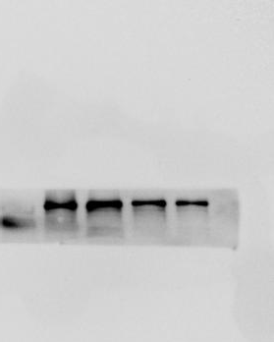
0.778093631 | 1.790141318
0.80962277 | 0.950932335
0.509495334 | 1.206732056
0.537793605 | 0.889973861
0.961806803 | 1.152977748
Column B |  |  | Data Set-B
vs. |  |  | vs.
Column A |  |  | Data Set-A
Unpaired t test
P value |  |  | 0.0295
P value summary |  |  | *
Significantly different (P < 0.05)? |  |  | Yes
One- or two-tailed P value? |  |  | Two-tailed
t, df |  |  | t=2.644, df=8
How big is the difference?
Mean of column A |  |  | 0.7194
Mean of column B |  |  | 1.198
Difference between means (B - A) ± SEM |  |  | 0.4788 ± 0.1811
95% confidence interval |  |  | 0.06114 to 0.8964
R squared (eta squared) |  |  | 0.4663
F test to compare variances
F, DFn, Dfd |  |  | 3.451, 4, 4
P value |  |  | 0.2575
P value summary |  |  | ns
Significantly different (P < 0.05)? |  |  | No
Data analyzed
Sample size, column A |  |  | 5
Sample size, column B |  |  | 5

GADPH for fig5d

