Supplementary Information

A synergistic biomimetic optical structure for household health monitoring
Shan Zhang¹, Guanglin Zhang¹, Guqiao Ding², Zhiduo Liu³, Bingkun Wang¹, Huijuan Wu¹, Zhengyi He¹, Genwang Wei⁴, Zhiwen Jin⁵, Jipeng Li⁶, Caichao Ye^{4,*}, Siwei Yang^{2, *} and Gang Wang^{1,*}
¹Department of Microelectronic Science and Engineering, School of Physical Science and Technology, Ningbo University, Ningbo 315211, P. R. China.
²State Key Laboratory of Functional Materials for Informatics, Shanghai Institute of Microsystem and Information Technology, Chinese Academy of Sciences, Shanghai 200050, P. R. China.
³Key Laboratory of Advanced Optoelectronic Quantum Architecture and Measurement, School of Physics, Beijing Institute of Technology, Beijing 100081, P. R. China.
⁴Academy for Advanced Interdisciplinary Studies & Department of Materials Science and Engineering, Guangdong Provincial Key Laboratory of Computational Science and Material Design, Southern University of Science and Technology, Shenzhen, Guangdong 518055, P. R. China.
⁵School of Physical Science and Technology, Lanzhou University, Lanzhou 730000, P. R. China.
⁶Department of Ophthalmology, Shanghai Ninth People’s Hospital, Shanghai Jiaotong University School of Medicine, Shanghai 200011, P. R. China.
Supplementary Note I. Fabrication of 3D-graphene/Al-AAO
3D-graphene growth was achieved via the low-temperature PACVD technology. Put the Al-AAO substrate into the target position of the chamber, first vacuum the chamber to about 7 Pa, then add 1 sccm hydrogen (H₂) and 10 sccm argon (Ar) mixed gas flow before heating the PACVD temperature zone system. When the temperature reaches 550 ºC, turn off the H₂ and Ar, and pass through the growth gas of 10 sccm methane (CH₄). Turn on the plasma source and set its power to 250 W for 120 min growth. After the growth is finished, turn off the CH₄ gas, cool the growth chamber to room temperature by passing 10 sccm of Ar gas. Turn off the vacuum pump, wait until the chamber reaches atmospheric pressure, then turn off the Ar gas and remove the grown Al-AAO sample.
Note: The Al-AAO will be damaged when the working temperature is higher than 600 °C (melting temperature of Al: 660 °C)!
For 3D-graphene (height: 0.2 μm)
When the temperature reaches 550 ºC, turn off the H₂ and Ar, and pass through the growth gas of 10 sccm methane (CH₄). Turn on the plasma source and set its power to 250 W for 20 min growth.
For 3D-graphene (height: 0.4 μm)
When the temperature reaches 550 ºC, turn off the H₂ and Ar, and pass through the growth gas of 10 sccm methane (CH₄). Turn on the plasma source and set its power to 250 W for 40 min growth.
For 3D-graphene (height: 0.6 μm)
When the temperature reaches 550 ºC, turn off the H₂ and Ar, and pass through the growth gas of 10 sccm methane (CH₄). Turn on the plasma source and set its power to 250 W for 60 min growth.
For 3D-graphene (height: 0.8 μm)
When the temperature reaches 550 ºC, turn off the H₂ and Ar, and pass through the growth gas of 10 sccm methane (CH₄). Turn on the plasma source and set its power to 250 W for 90 min growth.
For 3D-graphene (height: 1.0 μm)
When the temperature reaches 550 ºC, turn off the H₂ and Ar, and pass through the growth gas of 10 sccm methane (CH₄). Turn on the plasma source and set its power to 250 W for 120 min growth.

Supplementary Note II. Simulation Method
Supplementary Note II-1. FDTD Simulation
The finite element method simulations were employed to simulate the spatial distributions of electromagnetic field intensity and power loss density of Al-AAO and the 3D-graphene/Al-AAO structure. The incident light (532 nm) was set with an electric field (E₀=1 V/m) with X-polarization traveled along the Z-direction. The optical properties of graphene were calculated with the Lorentz-Drude model.
Supplementary Note II-2. DFT Simulation
All calculations were carried out using DFT with the Perdew–Burke–Ernzerhof (PBE) form of the generalized gradient approximation (GGA) functional.¹ The Vienna ab-initio simulation package (VASP) was employed.²⁻³ The energy cut-off for plane wave expansions was set to 400 eV, and the energy (converged to 1 e⁻⁵ eV/atom) and force (converged to -2 e⁻² eV/Å) were set as the convergence criteria for geometry optimization. A 6×6 periodic Al (111) slab model with 108 Al atoms was constructed to simulate the Al (111) surface, and 4×4 periodic rectangle graphene model with 80 C atoms was constructed to simulate the 3D-graphene and perpendicular to Al (111) surface. After structural optimization, the 3D-graphene/Al (111) model was constructed, and the 3D-graphene will be connected to Al (111) surface through Al-C single bonds. The Brillouin zones were sampled with the gamma-centered Monkhorst-Pack (5×5×1) k-points meshes for the models above.⁴ As for the slab models, a vacuum space of 15 Å was added to the nonperiodic direction to avoid interaction between periodic images. In addition, the DFT-D3 method was included to improve the description of the long-range weak van der Waals (vdW) interaction for all DFT calculations.⁵
To understand the charge redistribution mechanism in 3D-graphene/Al (111) interaction with the Erythrosine B molecule, the Erythrosine B & 3D-graphene/Al (111) model was built. Charge redistribution was defined as Δρ = ρ_{Erythrosine B & slab} – ρ_{Erythrosine B} – ρ_{slab}, where ρ_{Erythrosine B & slab}, ρ_{Erythrosine B} and ρ_{slab} denote the charge distribution of the whole Erythrosine B & 3D-graphene/Al (111) system, Erythrosine B molecule and 3D-graphene/Al (111). To give a direct comparison of numerical values for electron transfer, Bader analysis was used to calculate the charge transfer in atoms.
Supplementary Note III. Enhancement factor (EF) calculation.
The enhancement factor (EF) value of the SERS substrate is calculated by the following formula.
EF= (I_{SERS} × C_{RS}) / (I_{RS} × C_{SERS})⁶⁻⁷
where I_{SERS} represents the enhanced Raman intensity of the molecule under test on the SERS substrate, and I_{RS} represents the normal Raman intensity of the molecule without Raman enhancement. In addition, C_{RS} is the concentration of analytes without Raman enhancement on the substrate, and C_{SERS} is the concentration of analytes adsorbed on the SERS substrate. In our work, normal Raman spectra were obtained from model compounds on transparent glass slides.

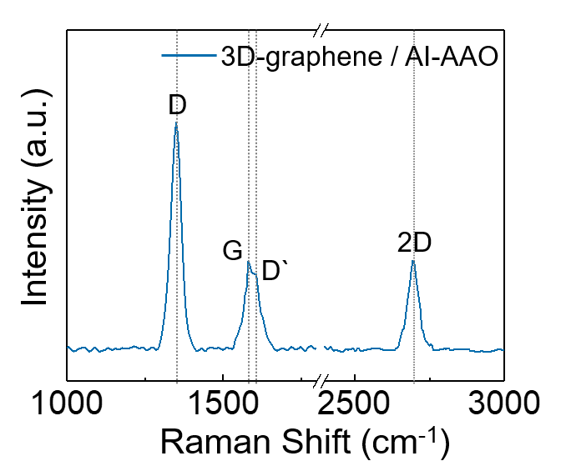
Supplementary Figure 1. Raman spectrum of 3D-graphene/Al-AAO. The 3D-graphene produces four significant Raman peaks: namely, the D peak (1,349 cm⁻¹), the G peak (1,580 cm⁻¹), the D` peak (1,610 cm⁻¹), and the 2D peak (2,698 cm⁻¹).
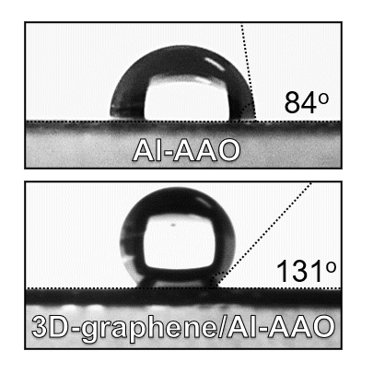
Supplementary Figure 2. The water contact angle images were obtained on the 3D-graphene/Al-AAO surface versus those obtained on the Al-AAO. The 3D-graphene is highly hydrophobic (water contact angle of 131º) compared to Al-AAO (water contact angle of 84º).

Supplementary Figure 3. a, Schematic diagram of the interaction of incident light with Al-AAO. b, The power loss density distribution of Al-AAO based on FDTD simulation. c, Local electric field of Al-AAO based on FDTD simulation. Weak the power loss density distribution and local electric field of Al-AAO compared to 3D-graphene/Al-AAO.
Supplementary Figure 4. a, The power loss density distribution of the Al-AAO array. b, The local electric field of the Al-AAO array. c, The power loss density distribution of the 3D-graphene/Al-AAO array. d, The local electric field of 3D-graphene/Al-AAO array. Weak the power loss density distribution and local electric field of Al-AAO array compared to 3D-graphene/Al-AAO array.
Supplementary Figure 5. The optical absorption spectra of 3D-graphene/Al-AAO (blue line) and Al-AAO (red line). The optical absorption of the 3D-graphene/Al-AAO system (blue line) is significantly higher than that of the Al-AAO (red line) system.
Supplementary Figure 6. Raman spectra for the calculation of EFs of R6G, RB, and MB. a, Raman spectra for 10⁻² M R6G/Glass and 10⁻⁸ M R6G/3D-graphene/Al-AAO substrate (I_{SERS}: 1004.6379, I_{RS}: 172.96764 at 1,360 cm⁻¹; C_{SERS}: 10⁻⁸ M, C_{RS}: 10⁻² M for R6G concentration). b, Raman spectra for 10⁻² M RB/Glass and 10⁻⁸ M RB/3D-graphene/Al-AAO substrate (I_{SERS}: 947.73248, I_{RS}: 141.00363 at 1,349 cm⁻¹; C_{SERS}: 10⁻⁸ M, C_{RS}: 10⁻² M for RB concentration). c, Raman spectra for 10⁻² M MB/Glass and 10⁻⁸ M MB/3D-graphene/Al-AAO substrate (I_{SERS}: 325.01184, I_{RS}: 90.145401 at 1,349 cm⁻¹; C_{SERS}: 10⁻⁸ M, C_{RS}: 10⁻² M for MB concentration).
Supplementary Figure 7. Raman spectra for the calculation of EF of AAO without Al coating. Raman spectra for 10⁻² M EB/Glass and 10⁻³ M EB/AAO substrate (I_{SERS}: 580.38, I_{RS}: 429.81 at 1,605 cm⁻¹; C_{SERS}: 10⁻³ M, C_{RS}: 10⁻² M for EB concentration).
Supplementary Figure 8. a-d, SERS spectra with an Al-AAO aperture size of 50 nm, 100 nm, 150 nm, and 250 nm, respectively. When the aperture size is 250 nm, the characteristic peak at 1,605 cm⁻¹ (EB) is the highest, thus indicating the highest EF.
Supplementary Figure 9. a-d, SERS spectra with an Al-AAO aperture size of 300 nm, 400 nm, 520 nm, and 600 nm, respectively. When the aperture size is 520 nm, the characteristic peak at 1,605 cm⁻¹ (EB) is the highest, thus indicating the highest EF.
Supplementary Figure 10. Raman spectra for the calculation of EFs of Al-AAO with different pore sizes. a, Raman spectra for 10⁻² M EB/Glass and 10⁻⁵ M EB/Al-AAO (50 nm) substrate (I_{SERS}: 781.89, I_{RS}: 429.81 at 1,605 cm⁻¹; C_{SERS}: 10⁻⁵ M, C_{RS}: 10⁻² M for EB concentration). b, Raman spectra for 10⁻² M EB/Glass and 10⁻⁵ M EB/Al-AAO (100 nm) substrate (I_{SERS}: 476.84, I_{RS}: 429.81 at 1,605 cm⁻¹; C_{SERS}: 10⁻⁵ M, C_{RS}: 10⁻² M for EB concentration). c, Raman spectra for 10⁻² M EB/Glass and 10⁻⁵ M EB/Al-AAO (150 nm) substrate (I_{SERS}: 305.42, I_{RS}: 429.81 at 1,605 cm⁻¹; C_{SERS}: 10⁻⁵ M, C_{RS}: 10⁻² M for EB concentration). d, Raman spectra for 10⁻² M EB/Glass and 10⁻⁵ M EB/Al-AAO (250 nm) substrate (I_{SERS}: 934.48, I_{RS}: 429.81 at 1,605 cm⁻¹; C_{SERS}: 10⁻⁵ M, C_{RS}: 10⁻² M for EB concentration).
Supplementary Figure 11. Raman spectra for the calculation of EFs of Al-AAO with different pore sizes. a, Raman spectra for 10⁻² M EB/Glass and 10⁻⁵ M EB/Al-AAO (300 nm) substrate (I_{SERS}: 685.31, I_{RS}: 429.81 at 1,605 cm⁻¹; C_{SERS}: 10⁻⁵ M, C_{RS}: 10⁻² M for EB concentration). b, Raman spectra for 10⁻² M EB/Glass and 10⁻⁵ M EB/Al-AAO (400 nm) substrate (I_{SERS}: 206.42, I_{RS}: 429.81 at 1,605 cm⁻¹; C_{SERS}: 10⁻⁵ M, C_{RS}: 10⁻² M for EB concentration). c, Raman spectra for 10⁻² M EB/Glass and 10⁻⁵ M EB/Al-AAO (520 nm) substrate (I_{SERS}: 817.71, I_{RS}: 429.81 at 1,605 cm⁻¹; C_{SERS}: 10⁻⁵ M, C_{RS}: 10⁻² M for EB concentration). d, Raman spectra for 10⁻² M EB/Glass and 10⁻⁵ M EB/Al-AAO (600 nm) substrate (I_{SERS}: 727.95, I_{RS}: 429.81 at 1,605 cm⁻¹; C_{SERS}: 10⁻⁵ M, C_{RS}: 10⁻² M for EB concentration).
Supplementary Figure 12. a-b, The heights of 0.2, and 0.4 µm for the 3D-graphene, respectively. c-d, SERS spectra with the 3D-graphene heights of 0.2, and 0.4 µm, respectively.
Supplementary Figure 13. a-b, The heights of 0.6, 0.8, and 1.0 µm for the 3D-graphene, respectively. d-f, SERS spectra with the 3D-graphene heights of 0.6, 0.8, and 1.0 µm, respectively. The characteristic peak at 1,605 cm⁻¹ (EB) is highest when the 3D-graphene height is 1.0 µm, thus indicating the best SERS performance.
Supplementary Figure 14. Raman spectra for the calculation of EF of 3D-graphene heights of 0.2 µm. Raman spectra for 10⁻² M EB/Glass and 10⁻⁸ M EB/3D-graphene substrate (I_{SERS}: 784.01, I_{RS}: 429.81 at 1,605 cm⁻¹; C_{SERS}: 10⁻⁸ M, C_{RS}: 10⁻² M for EB concentration).
Supplementary Figure 15. Raman spectra for the calculation of EFs of 3D-graphene with different heights. a, Raman spectra for 10⁻² M EB/Glass and 10⁻⁸ M EB/3D-graphene (0.4 µm) substrate (I_{SERS}: 1121.08, I_{RS}: 429.81 at 1,605 cm⁻¹; C_{SERS}: 10⁻⁸ M, C_{RS}: 10⁻² M for EB concentration). b, Raman spectra for 10⁻² M EB/Glass and 10⁻⁸ M EB/3D-graphene (0.6 µm) substrate (I_{SERS}: 1576.99, I_{RS}: 429.81 at 1,605 cm⁻¹; C_{SERS}: 10⁻⁸ M, C_{RS}: 10⁻² M for EB concentration). c, Raman spectra for 10⁻² M EB/Glass and 10⁻⁸ M EB/3D-graphene (0.8 µm) substrate (I_{SERS}: 1860.46, I_{RS}: 429.81 at 1,605 cm⁻¹; C_{SERS}: 10⁻⁸ M, C_{RS}: 10⁻² M for EB concentration). d, Raman spectra for 10⁻² M EB/Glass and 10⁻⁸ M EB/3D-graphene (1.0 µm) substrate (I_{SERS}: 2226.67, I_{RS}: 429.81 at 1,605 cm⁻¹; C_{SERS}: 10⁻⁸ M, C_{RS}: 10⁻² M for EB concentration).
Supplementary Figure 16. The statistical plot of EF of 3D-graphene with different heights (0.2 µm: 1.82×10⁶; 0.4 µm: 2.61×10⁶; 0.6 µm: 3.67×10⁶; 0.8 µm: 4.33×10⁶; 1.0 µm: 5.18×10⁶).
Supplementary Figure 17. The optical absorption spectra of 3D-graphene with the heights of 0.2, 0.4, 0.6, 0.8, and 1.0 µm, respectively.
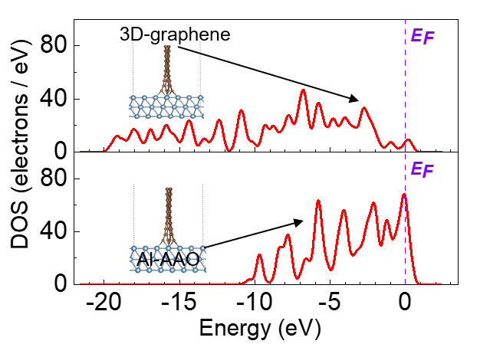
Supplementary Figure 18. The DOS of 3D-graphene and Al-AAO systems were calculated by using DFT simulation.
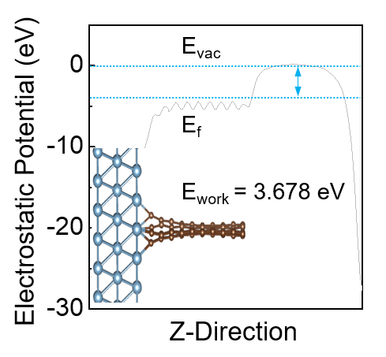
Supplementary Figure 19. The work function of the 3D-graphenen/Al-AAO system and the slab model of the 3D-graphenen/Al-AAO system. The work function of the 3D-graphenen/Al-AAO system simulated using DFT calculation is 3.678 eV, where E_{vac} represents the vacuum energy level, E_{f} represents the Fermi energy level, and E_{work} represents the work function.
Supplementary Figure 20. The device of the prepared home detection system. From left to right 3D-graphene/Al-AAO substrate, a homemade centrifugal device, blood burette, blood collection needle, blood collection pen, and hand-held Raman spectrometer.
Supplementary Figure 21. a, The linear relationship between the Raman intensity at a peak of 1,314 cm⁻¹ and UA concentrations. The concentration of UA was calculated to show a relatively good linear relationship with the intensity of the Raman characteristic peak (1,134 cm⁻¹) in the range of 50-500 µM, with the linear equation y=91.07+0.60x and the correlation coefficient R²=0.991. According to the measured standard curve, it is possible to quickly detect whether the UA level in human is over the limit. b, SERS spectra of UA in 1% PBS and serum. All serum obtained were subjected to the same dilution for Raman detection. The intensities of the two characteristic peaks measured in the serum were consistent with those of the UA at the same concentration, indicating that the method is suitable for the quantitative analysis of UA.
Supplementary Figure 22. SERS mapping (500 × 500 μm², step size of 20 μm) of the peak at 1,360 cm⁻¹, 1,280 cm⁻¹, and 1,621 cm⁻¹ recorded from the 3D-graphene/Al-AAO substrate modiﬁed with a R6G, b RB, and c MB. d-f show a plot of the corresponding intensity distribution of all 600 points, respectively, and a quantitative RSDs value of about 3.87%, 3.65%, and 4.88%.
Supplementary Figure 23. a-c, SERS spectra of R6G, RB, and MB (concentration of 10 µM, 10 µM, and 10² µM) on 3D-graphene/Al-AAO substrate during storage for 8 weeks. d-f, Long-term stability of the R6G (at 1,646 cm⁻¹), RB (at 1,507 cm⁻¹), and MB (at 1,621 cm⁻¹) spectra recorded on 3D-graphene/Al-AAO SERS substrate (Note: We used a total of 24 SERS substrates and randomly divided them into 3 groups of 8 samples each, with storage times of 1-8 weeks, respectively. Then, six points of each sample were randomly selected in an area of 10 × 10 mm², and R6G, RB, and MB were detected).
Supplementary Figure 24. a, SERS spectra of 3D-graphene/Al-AAO substrates before using and after cleaning and SERS spectra of adsorbed R6G molecules. b, Water contact angle images of 3D-graphene/Al-AAO substrates before using and after cleaning.
Supplementary Figure 25. a-c, SERS spectra of R6G, RB, and MB (concentration of 10 µM, 10 µM, and 10² µM) on 3D-graphene/Al-AAO substrate during the ethanol washing. d, The AFM images of 3D-graphene during 30 ethanol washing cycles.
Supplementary Figure 26. The EF was calculated after 0, 10, 20, and 30 washes, respectively.

Supplementary Table 1. Summary of detection additives, substrates, LOD, and linearity range.
Additives | SERS substrate | LOD | Linear range | References
R6G | SLG/Au@Ag core-shell | 10⁻⁴ µm | 10⁻³ - 10⁻⁵µm | 8
R6G | AuNPs/graphene/SiO₂ | 8×10⁻¹ µm | 10¹ - 10⁻¹µm | 9
R6G | MoO₃ | 2×10⁻² µm | 10¹ - 10⁻²µm | 10
R6G | PMMA/AgNPs/graphene | 5×10⁻² µm | 10¹ - 10⁻²µm | 11
RB | W18O49-H2 nanowire | 10⁻¹ µm | N/A | 12
RB | silver nano-cube | 10⁻⁴ µm | 10² - 10⁻⁴µm | 13
RB | AgNWs@AgNPs | 10⁻⁴ µm | 10¹ - 10⁻⁴µm | 14
RB | Au@Ag nanoparticles | 5×10⁻³ µm | N/A | 15
MB | MoS₂QD/rGO | 1×10⁻² µm | N/A | 16
MB | AgNPs/GF | 10⁻³ µm | 10² - 10⁻³µm | 17
MB | CFP@PDA@AuNPs | 10⁻¹ µm | 10³ - 10⁻¹µm | 18
UA | HfTe₂ | 100 µm | 100-1000µm | 19
UA | Au/Ag Substrate | 100 µm | 100-1000µm | 20
UA | Au nanoparticlecoated paper | 110 µm | 0-3500µm | 21
R6G | 3D-graphene/Al-AAO | 10⁻⁵ µm | 10² - 10⁻⁵ µm | This work
RB | 3D-graphene/Al-AAO | 10⁻⁵ µm | 10² - 10⁻⁵ µm | This work
MB | 3D-graphene/Al-AAO | 10⁻² µm | 10² - 10⁻² µm | This work
UA | 3D-graphene/Al-AAO | 50 µm | 50 - 500 µm | This work
N/A: Not applicable
Supplementary Table 2. The UA levels in clinical samples were calculated using the suggested method and detected by the gold standard method (female).
Clinical Samples | Calculated Concentration (µM) | Gold Standard Concentration (µM) | Gender | Negative/Positive
1 | 119.8586 | 120.24 | Female | Negative
2 | 236.1328 | 236.05 | Female | Negative
3 | 120.6167 | 121.38 | Female | Negative
4 | 174.48 | 172.31 | Female | Negative
5 | 184.97 | 186.05 | Female | Negative
6 | 276.1019 | 274.58 | Female | Negative
7 | 331.5725 | 332.16 | Female | Positive
8 | 459.6759 | 451.75 | Female | Positive
9 | 392.3069 | 394.41 | Female | Positive
10 | 584.7784 | 491.37 | Female | Positive
11 | 397.0274 | 395.04 | Female | Positive
12 | 551.2295 | 564.57 | Female | Positive
13 | 442.1541 | 447.36 | Female | Positive
14 | 439.6931 | 433.56 | Female | Positive
15 | 488.1999 | 488.02 | Female | Positive
16 | 405.3437 | 405.33 | Female | Positive
17 | 518.5329 | 517.63 | Female | Positive
18 | 499.3846 | 500.16 | Female | Positive
19 | 391.4024 | 392.77 | Female | Positive
20 | 478.0882 | 475.53 | Female | Positive
21 | 431.2411 | 435.62 | Female | Positive
22 | 436.9561 | 429.03 | Female | Positive
23 | 397.9353 | 397.18 | Female | Positive
24 | 437.1877 | 435.28 | Female | Positive

Supplementary Table 3. The UA levels in clinical samples were calculated using the suggested method and detected by the gold standard method (male).
Clinical Samples | Calculated Concentration (µM) | Gold Standard Concentration (µM) | Gender | Negative/Positive
1 | 292.3754 | 285.31 | Male | Negative
2 | 343.2905 | 347.81 | Male | Negative
3 | 308.5103 | 305.47 | Male | Negative
4 | 297.92 | 296.12 | Male | Negative
5 | 328.78 | 328.59 | Male | Negative
6 | 260.42 | 260.11 | Male | Negative
7 | 241.28 | 240.53 | Male | Negative
8 | 250.42 | 251.4 | Male | Negative
9 | 745.3601 | 740.34 | Male | Positive
10 | 735.1737 | 731.21 | Male | Positive
11 | 426.4473 | 429.58 | Male | Positive
12 | 400.0208 | 402.38 | Male | Positive
13 | 653.3539 | 651.27 | Male | Positive
14 | 519.4013 | 519.35 | Male | Positive
15 | 912.6162 | 911.48 | Male | Positive
16 | 393.6016 | 391.24 | Male | Positive
17 | 413.4341 | 411.08 | Male | Positive
18 | 675.8668 | 667.57 | Male | Positive
19 | 665.5725 | 664.57 | Male | Positive
20 | 437.0347 | 439.26 | Male | Positive
21 | 440.1139 | 441.33 | Male | Positive
22 | 633.9838 | 638.28 | Male | Positive
23 | 411.1831 | 409.65 | Male | Positive
24 | 453.4844 | 452.38 | Male | Positive
25 | 511.3994 | 505.84 | Male | Positive
26 | 517.8204 | 511.39 | Male | Positive
27 | 504.1093 | 505.57 | Male | Positive
28 | 696.0932 | 697.81 | Male | Positive
29 | 414.0597 | 412.29 | Male | Positive
30 | 405.1524 | 403.28 | Male | Positive
31 | 585.0888 | 584.55 | Male | Positive
32 | 516.4495 | 517.51 | Male | Positive

Supplementary Table 4. The cTn levels in clinical samples were calculated using the suggested method and detected by the gold standard method.
Clinical Samples | Calculated Concentration (µM) | Gold Standard Concentration (µM) | Negative/Positive
1 | 0.002 | 0.0022 | Negative
2 | 0.003 | 0.0031 | Negative
3 | 0.002 | 0.0018 | Negative
4 | 0.0012 | 0.0013 | Negative
5 | 0.001 | 0.0009 | Negative
6 | 0.001 | 0.0011 | Negative
7 | 0.002 | 0.0022 | Negative
8 | 0.0011 | 0.0013 | Negative
9 | 0.002 | 0.0018 | Negative
10 | 0.002 | 0.0021 | Negative
11 | 0.0011 | 0.0012 | Negative
12 | 0.002 | 0.0024 | Negative
13 | 1.57 | 1.56 | Positive
14 | 2.44 | 2.46 | Positive
15 | 0.35 | 0.35 | Positive
16 | 0.84 | 0.82 | Positive
17 | 1.78 | 1.78 | Positive
18 | 0.96 | 0.95 | Positive
19 | 1.33 | 1.31 | Positive
20 | 0.62 | 0.64 | Positive
21 | 1.71 | 1.66 | Positive
22 | 2.08 | 1.98 | Positive
23 | 0.62 | 0.67 | Positive
24 | 1.03 | 1.05 | Positive

Supplementary References
1. Perdew, J. P., Burke, K. & Ernzerhof, M. Generalized gradient approximation made simple. Phys. Rev. Lett. 77, 3865-3868 (1996).
2. Kresse, G. & Furthmüller, J. Efficient iterative schemes for ab initio total-energy calculations using a plane-wave basis set. Phys. Rev. B 54, 11169-11186 (1996).
3. Kresse, G. & Furthmüller, J. Efficiency of ab-initio total energy calculations for metals and semiconductors using a plane-wave basis set. Comp. Mater. Sci. 6, 15-50 (1996).
4. Monkhorst, H. J. & Pack, J. D. Special points for Brillouin-zone integrations. Phys. Rev. B 13, 5188-5192 (1976).
5. Grimme, S. Semiempirical GGA-type density functional constructed with a long-range dispersion correction. J. Comput. Chem. 27, 1787-1799 (2006).
6. He, Q., Han, Y., Huang, Y., Gao, J., Gao, Y., Han, L. & Zhang, Y. Reusable dual-enhancement SERS sensor based on graphene and hybrid nanostructures for ultrasensitive lead (Ⅱ) detection. Sensor Actuat B-Chem 341, 130031 (2021).
7. Wang, D., Xu, G., Zhang, X., Gong, H., Jiang, L., Sun, G., Li, Y., Liu, G., Li, Y., Yang, S. & Liang, X. Dual-functional ultrathin wearable 3D particle-in-cavity SF-AAO-Au SERS sensors for effective sweat glucose and lab-on-glove pesticide detection. Sensor Actuat B-Chem 359, 131512 (2022).
8. Prasada, A., Chaichia, A., Mahigircd, A., Sahua, S. P., Gantab, D., Veroniscd, G. & Gartia, M. R. Ripple mediated surface enhanced Raman spectroscopy on graphene. Carbon 157, 525-536 (2020).
9. Goula, R., Das, S., Liu, Q., Xin, M., Lu, R., Hui, R., Wu, J. Z. Quantitative analysis of surface enhanced Raman spectroscopy of Rhodamine 6G using a composite graphene and plasmonic Au nanoparticle substrate. Carbon 111, 386-392 (2017).
10. He, R., Lai, H., Wang, S., Chen, T., Xie, F., Chen, Q., Liu, P., Chen, J. & Xie, W. Few-layered vdW MoO₃ for sensitive, uniform and stable SERS applications. Appl. Surf. Sci. 507, 145116 (2020).
11. Sun, H., Liu, H. & Wu, Y. A green, reusable SERS film with high sensitivity for in-situ detection of thiram in apple juice. Appl. Surf. Sci. 416, 704-709 (2017).
12. Wang, X., Li, J., Shen, Y. & Xie, A. An assembled ordered W₁₈O₄₉ nanowire film with high SERS sensitivity and stability for the detection of RB. Appl. Surf. Sci. 504, 144073 (2020).
13. Phuong, N. T. T., Hoang, T. X., Tran, N. L. N., Phuc, L. G., Phung, V., Ta, H. K. T., Bach, T., Tran, N. H. T. & Trinh, K. T. L. Rapid and sensitive detection of Rhodamine B in food using the plasmonic silver nanocube-based sensor as SERS active substrate. Spectrochim. Acta A Mol. Biomol. Spectrosc. 263, 120179 (2021).
14. Wang, J. & Yi, G. Flexible and superhydrophobic silver nanoparticles decorated aligned silver nanowires films as surface-enhanced Raman scattering substrates. Nanoscale Res Lett 14, 292 (2019).
15. Wang, H., Guo, X., Fu, S., Yang, T., Wen, Y. & Yang, H. Optimized core–shell Au@Ag nanoparticles for label-free Raman determination of trace Rhodamine B with cancer risk in food product. Food Chem. 2015, 137-142.
16. Wu, D., Chen, J., Ruan, Y., Sun, K., Zhang, K., Xie, W., Xie, F., Zhao, X. & Wang, X. A novel sensitive and stable surface enhanced Raman scattering substrate based on a MoS₂ quantum dot/reduced graphene oxide hybrid system. J. Mater. Chem. C 188, 6, 12547-12554 (2018).
17. Srichan, C., Ekpanyapong, M., Horprathum, M., Eiamchai, P., Nuntawong, N., Phokharatkul, D., Danvirutai, P. & Bohez, E. Highly-sensitive surface-enhanced Raman spectroscopy (SERS)-based chemical sensor using 3D graphene foam decorated with silver nanoparticles as SERS substrate. Sci Rep 6, 23733 (2016).
18. Dong, J., Wang, T., Xu, E., Bai, F., Liu, J. & Zhang, Z. Flexible hydrophobic CFP@PDA@AuNPs stripes for highly sensitive SERS detection of methylene blue residue. Nanomaterials 12, 2163 (2022).
19. Li, Y., Chen, H., Guo, Y., Wang, K., Zhang, Y., Lan, P., Guo, J., Zhang, W., Zhong, H., Guo, Z., Zhuang, Z. & Liu, Z. Lamellar hafnium ditelluride as an ultrasensitive surface-enhanced Raman scattering platform for label-free detection of uric acid. Photon. Res. 9, 1039-1047 (2021).
20. Zhao, L., Blackburn, J. & Brosseau, C. L. Quantitative detection of uric acid by electrochemical-surface enhanced Raman spectroscopy using a multilayered Au/Ag substrate. Anal. Chem. 87, 441-447 (2015).
21. Villaa, J. E. L. & Poppi, R. J. A portable SERS method for the determination of uric acid using a paper-based substrate and multivariate curve resolution. Analyst 141, 1966-1972 (2016).

